


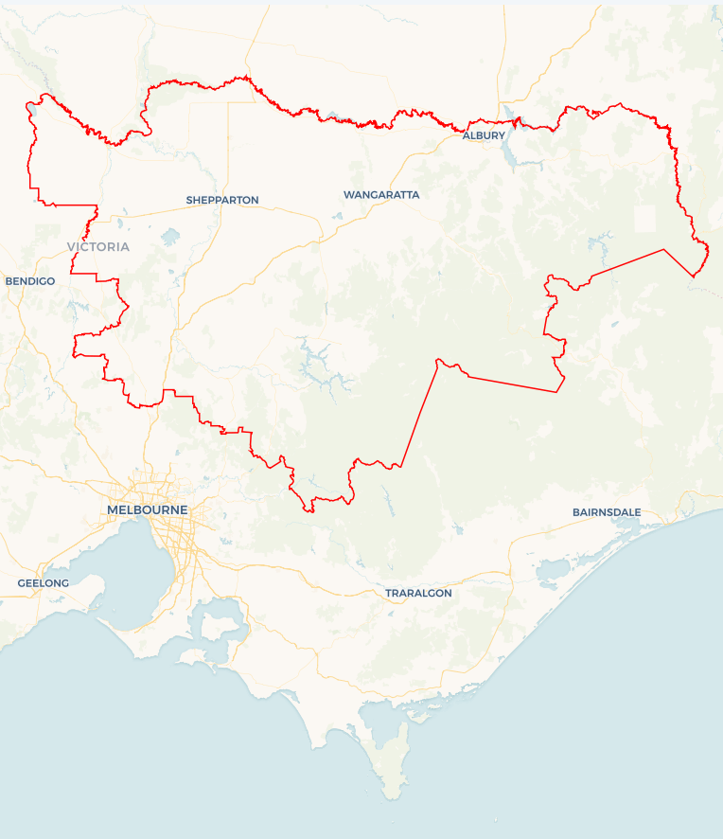
Local Jobs Plan
  - Goulburn Murray Employment Region | VIC | September 2026
Workforce Australia Local Jobs (Local Jobs) is a program that creates partnerships between business
and communities to meet local workforce needs, thereby improving employment outcomes.
Local Jobs operates in all 51 Employment Regions in Australia.

Local Jobs Overview

Local Jobs Plan
Each Employment Region has a Local Jobs Plan which outlines the labour market challenges in the region and the strategies to address these challenges.

Job Coordinators
Each Employment Region has a dedicated Job Coordinator who leverages existing resources, supports local labour markets through structural adjustments and retrenchments, and creates opportunities for collaboration between business and communities.

Local Jobs and Skills Taskforce
Each Employment Region has its own taskforce that meets regularly with the Job Coordinator to develop an understanding of challenges in the region and implement solutions. The taskforce is comprised of representatives from the region.

Local Jobs, Local People Grant
The Local Jobs, Local People grant funds activities that help people into ongoing employment or training. Activities must support local labour market needs.
Explore labour market insights for the
Goulburn Murray Employment Region

Local labour market challenges

- Labour and skills shortages across various industries are impacting the ability of businesses to find suitable workers to operate and grow their business.
- Youth unemployment in the region remains high and limited awareness among young people of local career pathways and employment opportunities.
- Growing numbers of workers impacted by business closures, restructuring and redundancies across the region.
- Mature age individuals need support to meet changing workforce needs.
- First Nations awareness of employment and local support services is limited across the region.
- People from culturally and linguistically diverse (CALD) backgrounds encounter difficulties finding secure employment due to language and skills recognition.
- Limited public transport options and challenges in obtaining driver’s licences affects workforce participation, especially in smaller regional areas.

Local priorities

Priority 1 – Emerging industries and skills shortages

What are our challenges?

Goulburn Murray growth continues to experience workforce shortages, recruitment difficulties and skills pipeline constraints. Emerging sectors, like the electricity and energy sector, will require reskilling and upskilling of the current and future workforce.

How are we responding?
- We are showcasing local career opportunities through industry events, local jobs expos and sector-specific workforce initiatives. In 2025–26, we supported North East Victoria’s Careers Day Out, the Seymour Careers and Jobs Expo and targeted industry engagement activities that promoted opportunities in health care, manufacturing and clean energy.
- We are supporting businesses to improve recruitment and retention practices, including workforce planning, entry-level job design and flexible work arrangements. This includes connecting businesses to existing programs that grow and diversify their workforce.
- We are working with industry stakeholders, community organisations, Registered Training Organisations (RTOs) and Workforce Australia Employment Services Providers to develop industry-led pathways to employment.
- We are coordinating local responses to business closures, restructuring, redundancies and natural disasters to support local workforce transitions and employment pathways. In 2025-2026, we worked with employers Bega Group and Seeley International, alongside Services Australia, Workforce Australia Employment Services Providers and RTOs to support workers with local job opportunities, skills development and career guidance.
- We are promoting clean energy employment pathways and net zero events with community organisations and businesses across the region.

Priority 2 – Improving youth transitions into employment

What are our challenges?

Youth unemployment (people aged 15 - 24 years) rates remain significantly higher than the total unemployment rate in the Goulburn Murray Employment Region. Young people can face challenges moving from education and training into employment due to limited work experience, low awareness of local career opportunities and barriers such as transport. At the same time, employers across priority industries report ongoing workforce shortages. Strengthening pathways between education, training and employment is critical to retaining young people in the region and building a sustainable local workforce.

How are we responding?
- We are partnering with Workforce Australia Employment Services Providers, local businesses, Apprentice Connect Australia Providers and RTOs and Group Training Organisations to identify and promote apprenticeship, traineeship and entry‑level employment opportunities for young people.
- We are collaborating with School to Work Providers, Apprentice Connect Australia Providers, industry peak bodies and Local Government to deliver career expos and employer engagement activities that promote local employment pathways.

Priority 3 – Improving employment outcomes for First Nations peoples

What are our challenges?
Awareness of available services and employment pathways can be limited. There is an opportunity to increase awareness of local support services to improve outcomes and economic participation for First Nations peoples across the region.

How are we responding?
- We are continuing to build on relationships with Aboriginal Community Controlled Organisations, First Nations people and communities to better understand local priorities and employment needs.
- We are consulting with the First Nations peoples and community, RTOs, industry and businesses to assist the development of culturally appropriate recruitment models, activities and pre-employment programs.
- We continue to promote existing programs with the First Nations community that empower and upskill First Nations peoples to meet current and future workforce demands.
- We are promoting awareness of available supports through Workforce Australia Employment Services Providers, RTOs, councils and community organisations.

Priority 4 – People from culturally and linguistically diverse backgrounds

What are our challenges?

People from culturally and linguistically diverse backgrounds can experience barriers to employment, including English language proficiency, transport challenges, digital literacy, limited professional networks and recognition of overseas qualifications. Employers can also benefit from support to strengthen cultural capability, improve inclusive recruitment practices and create culturally safe workplaces.

How are we responding?
- We are promoting new and existing programs and initiatives that support employment and training pathways for people from culturally and linguistically diverse (CALD) backgrounds. This includes promoting people from CALD backgrounds as a local talent pool for growth industries and seasonal employment opportunities.
- We are supporting collaboration between settlement services, Workforce Australia Employment Services Providers, local government and RTOs to improve referral pathways and awareness of available employment services. We are collaborating with the Ethnic Council of Greater Shepparton, Committee for Greater Shepparton and settlement services to produce a localised Settlement Services Guide. We will also support the development of a localised Settlement Services Guide for Albury Wodonga.
- We are consulting with local RTOs and culturally and linguistically diverse community groups to co-design solutions and activities that create upskilling, training and employment opportunities that address local workforce needs.

Priority 5 – Mature age individuals

What are our challenges?
As industry needs continue to evolve, there are opportunities to support mature age individuals in building on their transferable skills, strengthening digital capability, and accessing training that aligns with current workforce needs.

How are we responding?
- We are engaging RTOs, businesses and industry representatives to develop activities that support mature age individuals to create upskilling and training opportunities, identify their transferable skills and build digital competency and self-esteem to create pathways into sustainable employment.
- We continue to deliver employment support workshops that connect mature age individuals to local supports, leveraging existing programs that have provided sustainable employment outcomes across the region.
- We will promote age-inclusive recruitment practices and workforce planning with employers, while recognising the value and experience of mature age workers.

Want to know more?
- Contact Faye D’Helin, Goulburn Murray Job Coordinator at faye.dhelin@goulburnmurraylocaljobs.com.au
- Visit Local Jobs or Workforce Australia

