

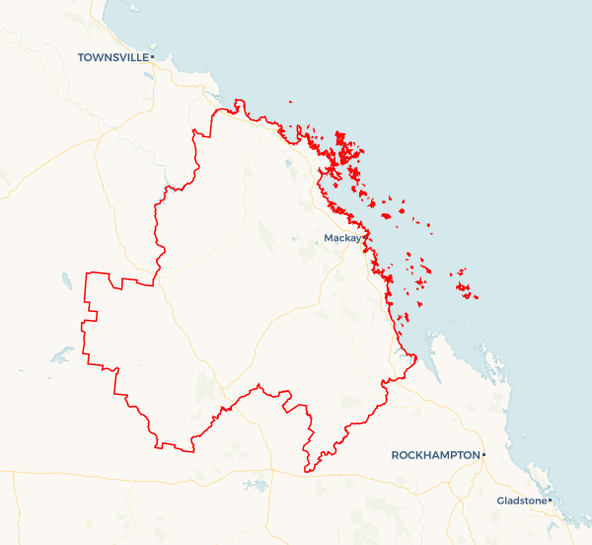Local Jobs Plan

Mackay Employment Region | QLD | ****July 2025****

Workforce Australia Local Jobs (Local Jobs) is a program that supports tailored approaches to accelerate   
reskilling, upskilling, and employment pathways in response to current and emerging local workforce needs.

## Local Jobs elements

### Local Jobs Plan

The Local Jobs Plan sets out the skills and employment challenges and priorities of the region, and associated strategies that will drive the design and implementation of activities to be implemented to address these challenges.

### Job Coordinators

Job Coordinators and Support Officers support the delivery of the program by bringing together key stakeholders including businesses, employment services providers, higher education and training organisations.

### Local Jobs and Skills Taskforce

Each Employment Region has its own Taskforce. Representatives include local stakeholders who have demonstrated experience in upskilling, reskilling, and an ability to represent, connect and collaborate with others in the region to meet labour market needs.

### Program Funds

The Local Initiatives Fund enables targeted local investments that support local labour market functioning. Further, from 2025/26, a central grants-based fund will respond to local needs and help progress broader employment service reform objectives.

Explore labour market insights for the  
[Mackay](https://www.jobsandskills.gov.au/work/employment-region-dashboards-and-profiles/monthly-labour-market-dashboards) Employment Region

Mackay Region (including Isaac & Whitsundays)

## Local labour market challenges in the region

* Labour market disadvantage persists for cohorts including young people, First Nations people, mature aged people, people with a disability, and the long-term unemployed.
* There is a need to upskill the available labour pool to meet current and future workforce needs.
* There is labour demand for major projects such as the Mackay Hospital Expansion and Mackay Port Access (which involves building a new road between the Mackay Port and Bruce Highway). If demand cannot be met locally employers may use fly-in-fly out workers.
* There is demand for skilled operators, truck drivers and tradespeople in the mining, manufacturing, construction, agriculture, and transport and logistics industries.
* Health care and social assistance is the largest and fastest growing industry, with skill shortages across the nursing, aged care, disability care and child care sectors.
* A lack of public transport in the region represents a significant challenge for people who don’t have a licence or their own vehicle. Support for learner drivers is also limited and long waitlists and a shortage of driving instructors make it difficult for leaners to obtain the 100 hours required to gain a licence.
* A lack of available and affordable housing makes it challenging to attract and retain workers in the region. There is a rising rate of homelessness.
* Limited child care access, with long waitlists in smaller communities, creates significant challenges for parents and carers trying to enter or re-enter the workforce.

## Local jobs and skills priorities and strategies in the region

### Priority 1 – Diversity and inclusion

#### What are our challenges and opportunities?

Labour market disadvantage persists for cohorts including young people, First Nations people, mature aged people, people with a disability and the long-term unemployed. Opportunities exist to support greater inclusion of these cohorts within the local labour market and provide more equitable access to training and employment pathways.

#### How are we responding?

* We are fostering relationships between Workforce Australia Employment Services Providers and local industry, training organisations, and community stakeholders to ensure Workforce Australia participants are aware of and have access to a broad range of opportunities.
* We are working with Workforce Australia Employment Services Providers to understand caseload demographics and the challenges experienced by priority cohorts.
* We are ensuring that people in pre-employment programs or post-placement support initiatives have access to a mentor to support them.
* We are raising awareness among employers about the availability of state and federal government wage subsidies and incentives that encourage businesses to hire people from priority cohorts.
* We are raising awareness among employers of recruitment strategies that support people with a disability, such as job carving and workplace modifications.
* We are supporting mature age participants to re-enter the workforce by raising awareness of transferable skills across industries, raising awareness of employment opportunities, and raising awareness of the Career Transition Assistance program which helps people aged over 45 to become more competitive in the local labour market.
* We are working with stakeholders to increase the participation of young people in existing soft skills, employability, and digital literacy training programs to support job readiness.
* We are helping First Nations people gain and maintain employment by collaborating with the community, First Nations organisations, and local industry to identify suitable, secure employment opportunities and culturally appropriate supports.
* We are connecting individuals interested in self-employment to programs such as Self-Employment Assistance and the Many Rivers program.
* We ensure registered training organisations and Workforce Australia Employment Services Providers consider people’s nonvocational barriers when designing activities. This means scheduling activities at family-friendly times, using locations that are accessible by public transport, and connecting participants to relevant support services.
* We are providing local intelligence and ideas to government and other organisations to address structural challenges.

### Priority 2 – Upskilling the local labour pool

#### What are our challenges and opportunities?

Industries in the region are struggling to fill positions that require qualifications and certain skills. Opportunities exist to upskill the local labour pool to fill these positions.

#### How are we responding?

* We are working with stakeholders to deliver tailored Local Initiative Fund projects and place-based strategies that provide people with the qualifications and skills needed for in-demand industries.
* We are promoting entry-level training opportunities that are available in the region, such as the BHP FutureFit Academy, the Women Up Front Trainee Bus Driver program, and regional council apprenticeship and traineeship programs.
* We are leveraging existing skills initiatives such as the Skilling Queenslanders for Work program, the Back to Work program, the Launch into Work program, and the Workforce Connect Fund.

### Priority 3 – Major projects and emerging industries

#### What are our challenges and opportunities?

There is labour demand for major projects and emerging industries in the region, including renewable energy projects. There are opportunities to leverage existing programs and initiatives to ensure the local workforce is equipped to meet these demands.

#### How are we responding?

* We are engaging with employers of major projects in the region to develop an understanding of their workforce requirements.
* We are co-designing industry specific pre-employment programs with stakeholders.
* We leverage regional initiatives such as the Resource Centre of Excellence’s virtual reality training laboratory.
* We partner with the Greater Whitsunday Alliance to support future workforce initiatives and prepare the workforce for the needs of emerging sectors.
* We promote initiatives such as skillset transitioning and micro-credentialing.
* We are collaborating with Workforce Australia Employment Services Providers and registered training organisations to ensure Workforce Australia participants are suitably skilled and qualified for infrastructure projects.

### Priority 4 – High demand industries

#### What are our challenges and opportunities?

There is demand for skilled operators, truck drivers and tradespeople in the mining, manufacturing, construction, agriculture, and transport and logistics industries. There are also skills shortages in the health care and social assistance industry, which is the largest and fastest growing industry in the region. There are opportunities to leverage existing programs and initiatives to create **pathways to these industries.**

#### How are we responding?

* We are collaborating with industry peak bodies to identify employment opportunities and develop recruitment strategies.
* We are working with stakeholders including TAFE Queensland, CQ University, registered training organisations and the Queensland Government Department of Trade, Employment and Training to establish pre-apprenticeship training programs across all industries.
* We are working with local stakeholders to coordinate a range of pathways directly linked to current labour demand in the region.
* We are coordinating industry-specific jobs fairs and career expos to provide training and job opportunities for the local community.

### Priority 5 – Reducing transport barriers

#### What are our challenges and opportunities?

* There is a need for better public transport services across the region. There is little or no reliable public transport to access jobs in the Whitsunday region, the mining sector to the south and west of Mackay, or industrial areas.

#### How are we responding?

* We are collaborating with key stakeholders, including all three levels of government, to improve public transport in the region.
* We are engaging with stakeholders to develop and deliver driver education, licencing and mentoring programs.

## Want to know more?

* Contact: Roxanne Birse, Mackay Australian Government Job Coordinator: roxanne.birse@dewr.gov.au
* Visit: [Local Jobs](https://www.dewr.gov.au/local-jobs) or [Workforce Australia](https://www.workforceaustralia.gov.au/businesses/)