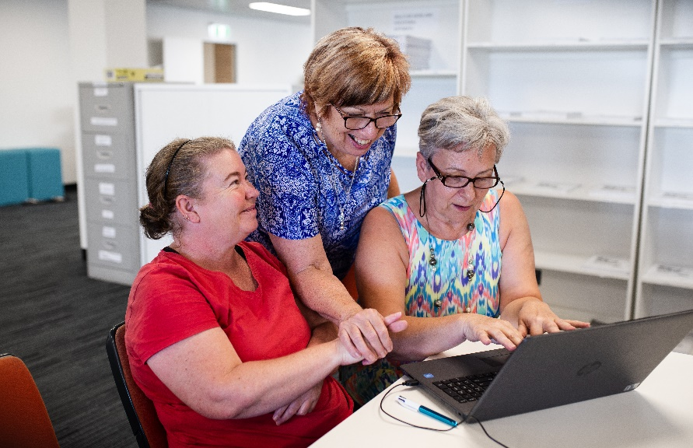Employability Skills Training

Helping you with real skills   
that lead to real jobs.

# EST Participant Service Delivery Plan

The Designer Life Employability Skills Training (EST) course will help you discover the right pathway in to work and a great career.

# Is EST for me?

Designer Life offers EST courses as follows, allowing us to focus on specific career stages:

* for young people 15 to 24 years of age
* for all ages over 25 years

We also run courses to meet the needs of groups within the community such as Indigenous Australians, Refugees/Migrants, Parents and Carers.

You can complete a Designer Life EST course if you are participating in Workforce Australia Services (including Digital Services or Enhanced Services), Transition to Work or Disability Employment Services and we ensure accessibility for people with a disability.

We will design a program that improves your capacity to search for work, navigate interviews, support your career interests and build confidence to gain real skills. We will also support you to maintain resilience, give you feedback and prepare you for your work transition.

# Which EST course is right for me?

EST courses are delivered in Blocks – Block 1 and Block 2. Both blocks, or only one block may be suitable for you, and you can do them in any order.

A group of young students sitting at a table reading documents on the table.




## EST Block One Courses

Our Block One course will develop your job search and workplace skills and incorporates core employability skills such as problem solving, collaboration, self-management, communication and information technology. Training is conducted in small groups through a project-based theme aligned to local industries that are hiring.

**Block One sessions include:**

1. A personalised Readiness for Work Assessment, so we understand your employment interests and current job searching activities.
2. A Job Search Support Plan that will support your job search by assisting you to identify opportunities in the local labour market.

A designated Trainer will assist you with job search skills and local labour market opportunities, including Industry Awareness experiences. We offer personalised, hands-on training at our Career Centres that blends job search training with work-like experiences delivered in a simulated workplace.

Our approach combines traditional skills training with practical “work like” learning and you will be supported to:

* understand employer expectations
* prepare a resume, job applications, cover letters and learn how to address selection criteria
* digital skills training
* assistance in completing online career programs
* industry-focused job searching, industry awareness exploration and job creation
* confidence in job interview skills including online and virtual
* access to our Employment 360 program which supports daily assisted job searches focusing on local labour market opportunities and training plans that promote pathways into growth sectors
* exploring solutions to common challenges such as lack of transport or carer responsibilities
* career mapping and exploring careers through virtual reality, using our Career Gazers.

## EST Block Two Courses

Supported by a designated trainer, you will complete industry-focused activities designed to help you understand the jobs in demand in your local region, including those with entry-level employment opportunities.

In Cairns and Mackay (and surrounding regions) growth industries include: building and construction, mining, cleaning operations, hospitality, community services, disability support, retail, business and transport.

**Block Two courses will be either:**

* a Generalist course with the focus on providing you with a taste of a few industries
* a Specialist course focused on a single industry where we will partner with employers who have opportunities available, such as job vacancies.

Activities undertaken in these courses will include virtual job exploration experiences and work place visits. This will help you to understand the duties, job requirements, career pathways and employer expectations.

To support the conversion into permanent jobs, both Generalist and Specialist courses will provide:

* Industry awareness experiences and employer tours and presentations
* Job creation strategies to seek and apply for work in the industries covered
* Tailored industry-specific resumes, job applications, cover letters and interview coaching
* Assistance with industry-required psychometric and aptitude screening
* Digital skill assessments relevant to entry-level employment opportunities
* Assistance to access micro-credential skills to meet entry requirements and accredited training by our Registered Training Organisation.

In partnership with employers, we will work with you to develop the skills needed to become competitive in the job market and you will learn how to best market yourself for selected job opportunities.

**FOR MORE INFORMATION Call: 07 3333 2055 or Email:** [**est@designerlife.com.au**](mailto:est@designerlife.com.au)