


Online Employment Services
Evaluation 2020 - 2022
  - 20 December 2024

ISBN
978-1-76114-167-6 [PDF]
978-1-76114-166-9 [DOCX]
With the exception of the Commonwealth Coat of Arms, the department’s logo, any material protected by a trade mark and where otherwise noted all material presented in this document is provided under a Creative Commons Attribution 4.0 International (https://creativecommons.org/licenses/by/4.0/) licence.
The details of the relevant licence conditions are available on the Creative Commons website (accessible using the links provided) as is the full legal code for the CC BY 4.0 International (https://creativecommons.org/licenses/by/4.0/legalcode).
The document must be attributed as the Online Employment Services Evaluation report.

Contents
Executive summary 6
Background 6
This report 6
Key findings 6
Summary 11
Departmental response to the evaluation findings 12
List of abbreviations 16
Glossary 17
List of tables 19
List of figures 20
Chapter 1 Introduction 22
1.1 Background 22
1.2 About Online Employment Services 22
1.3 Participant journey in OES 23
1.4 Labour market environment 26
1.5 Report structure 30
Chapter 2 Evaluation of Online Employment Services 32
2.1 Evaluation objectives 32
2.2 Key evaluation questions 33
2.3 Evaluation methodology 33
2.4 OES referral and participant population 37
Chapter 3 Appropriateness 40
3.1 Referral process 40
3.2 Preference for online services 41
3.3 Confidence in self-sufficiency 42
3.4 Segmentation of OES participants based on preference and confidence 45
3.5 Perceived advantages and disadvantages of online services 47
3.6 Stakeholder and jobactive provider views on appropriateness 50
Chapter 4 Effectiveness of OES core functionality and enhancements 53
4.1 jobactive/JobSearch website and app 53
4.2 OES dashboard 56
4.3 Profile 57
4.4 Digital Services Contact Centre 59
4.5 Other enhancements in OES 69
4.6 Participant use of sites other than jobactive/JobSearch 70
4.7 Employer views of and experience with the jobactive/JobSearch website 74
4.8 Participant overall satisfaction with OES 74
Chapter 5 Effectiveness of OES safeguards 76
5.1 Digital Assessments 76
5.2 The opt-out feature 79
5.3 Digital Services Reviews 83
5.4 Maximum time in OES safeguard 88
5.5 Experience of opting out and transferring to a provider 90
Chapter 6 Impacts on outcomes and program efficiency 93
6.1 Impact on job search 93
6.2 Meeting Mutual Obligation Requirements 94
6.3 Six-Month Activity Requirement 95
6.4 Exits from income support and employment services, and reduction in income support reliance 96
6.5 Sustainability of exits from income support 99
6.6 Did online services make a difference to participant outcomes? 100
6.7 Employment after exiting income support 103
6.8 Cost-effectiveness of online services 103
Chapter 7 Employer views of and experiences with OES 109
7.1 Awareness of and familiarity with the JobSearch website 109
7.2 OES usage and reasons for use 110
7.3 jobactive/JobSearch website usage barriers 112
7.4 Usage of the Find Candidates feature 114
7.5 OES user ratings of the website 114
7.6 OES user segmentation 115
7.7 Recruitment platform features valued by employers 116
Chapter 8 Conclusion 118
8.1 What worked well 118
8.2 What did not work well 119
8.3 Limitations 120
Bibliography 121
Appendices 122
Appendix A Policy detail – Targeted Compliance Framework 122
Appendix B OES evaluation methodology 125
Appendix C Detailed statistical tables and analysis 131
Appendix D Longitudinal insights 142
Appendix E Infographic summary of the OES Evaluation 144

Executive summary

Background
Online Employment Services (OES) commenced on 16 April 2020 as the mainstream employment services for job-ready job seekers in response to dramatic increases in the number of job seekers registering for employment services resulting from the impacts of the COVID-19 pandemic. Job seekers who were referred to OES had been assessed as the most job ready and as not requiring any specialised assistance, as well as having the capability to self-manage using an online platform. Those who commenced in OES self-managed their job search and reported their Mutual Obligation Requirements (MORs) through the jobactive/JobSearch website and/or app; however, they were able to opt out and switch to services from a jobactive provider at any time. Participation in OES was also limited to a maximum of 12 months, with some exceptions – participants who were earning or learning could remain in OES for longer.

This report
This report presents the findings of the OES evaluation based on research and analyses conducted over the period from 1 May 2020 to 30 June 2022. It addresses the appropriateness, effectiveness and efficiency of OES in assisting and enabling participants to meet and report their job search requirements and achieve employment outcomes. Findings in this report are based on information gathered and synthesised from multiple sources including administrative data, OES participant surveys and qualitative fieldwork research with OES participants, jobactive providers, employers and a range of other internal and external stakeholders.

Key findings

Impact on employment outcomes
In the absence of information on the employment status of OES participants after they had exited employment services, exits from income support and exits from employment services were used as proxies for employment.
Analysis of administrative data showed that around 60% of OES participants exited income support or employment services within 6 months from commencement and around 80% exited income support or employment services within 12 months. Around 88% of those exiting income support did not return to income support within 12 months of exit, suggesting high sustainability of employment outcomes.
The difference-in-difference estimator was applied to administrative data to examine whether online services made a difference to participants’ employment outcomes, as compared with provider services. The results showed that online services did not make a difference to the probability of exiting income support or employment services compared with provider services. For example, when data on inflow job seekers was used, use of online services was estimated to reduce income support exits by 0.3 percentage points and increase employment services exits by 0.9 percentage points. These estimates were small in magnitude and statistically insignificant. This suggested that OES participants could achieve similar employment outcomes in either OES or the alternative, jobactive provider services.

Appropriateness
Measured by OES participants’ preferences for online services and confidence in their ability to self-manage job search on an online platform, online services appeared to be appropriate for most OES participants. For example, the OES Participant Survey revealed that over 80% of OES participants preferred online services, with a similar proportion of participants feeling confident in self-managing their job search. Nearly 70% of OES participants who responded in the surveys not only preferred online services but also were confident in self-managing on an online platform, while only just over 5% of the participants did not prefer online services and were not confident in self-managing. A few (13%) participants preferred face-to-face services even though they reported that they were confident in self-managing their job search. These findings suggest that online services were largely appropriate for job seekers who were referred to OES.
The OES Participant Survey revealed that participants generally viewed online services more positively than provider services, with a much larger percentage of the participants identifying advantages compared to disadvantages. Positive views of online services were also reported among participants from a culturally and linguistically diverse (CALD) background; however, Aboriginal and/or Torres Strait Islander participants and people with disability were concerned about the lack of assistance or feedback on job search, job applications, résumés and cover letters, the lack of career guidance and advice, and technological issues.
Qualitative research findings revealed that jobactive providers also thought that OES was an appropriate service option for job seekers who were job ready and digitally capable, and largely agreed with the concept that OES freed up their time and capacity to focus on assisting job seekers who needed more intensive support. However, many providers also commented that the assessment process needed to be streamlined to ensure that only those who could effectively self-manage on an online platform were referred to OES.

Effectiveness of OES core functionality and enhancements
The evaluation of the effectiveness of OES involved examining participants’ awareness and use of various tools and resources in OES, including core functionalities continued from the Online Employment Services Trial (OEST) and enhanced features that were introduced in OES resulting from OEST learnings.

jobactive/JobSearch website and/or app and the OES dashboard
Participants accessed OES through the jobactive/JobSearch website and/or app. Their views were mixed, with more than half (58.2%) indicating that OES was good or excellent in terms of its ease of use and almost half (49.9%) reporting that it gave them the flexibility to do what they needed to do. However, only 46.6% agreed that there was sufficient information on how to get help if they needed it.
Qualitative research findings consistently indicated that the overall impression was that OES was easy enough to use but did not present anything new or extraordinary, so most participants preferred to use other commercial online platforms such as SEEK and used OES solely for managing their MORs. This accounts for the fact that a majority (76.4%) of participants reported that the dashboard was the most useful tool as it helped them to monitor and report their job search requirements.

Profile function
According to administrative data, most (79.0%) OES participants had completed a profile. This proportion increased to 96.8% among participants who were still in OES on 30 June 2022, likely reflecting the effectiveness of the mandatory requirement that came into effect in December 2021. According to Wave 1 of the OES Participant Survey, 71% of participants who recalled completing a profile agreed that the Profile function was easy to use and 65% agreed that creating/uploading a résumé on their profile was useful.

Digital Services Contact Centre
Wave 2 of the OES Participant Survey revealed that fewer than half (47.4%) of OES participants were aware of department helplines. The low awareness was perhaps because the need for assistance was low among OES participants. Wave 2 of the OES Participant Survey found that only 27.7% of participants needed assistance with OES, and 65.8% reported that they had not required any assistance at all. (The remaining 6.5% responded ‘prefer not to say’ or ‘don’t know’)
Among participants who had actually contacted a helpline (either the Digital Services Contact Centre (DSCC) or the National Customer Service Line (NCSL)), satisfaction ratings were high in terms of:
- resolution of issue or query (75.1% satisfied)
- the politeness of the operator (93.4%)
- getting individualised advice (75.4%)
- the overall service provided (78.3%).

Other enhancements in OES
JobTrainer, online self-booking, and Job Switch were new functions introduced into OES. Qualitative research with OES participants revealed an overall low awareness of these enhanced features, even though some research participants expressed an interest in using these tools after they were alerted to them by the interviewer/facilitator.

Effectiveness of safeguards in OES
Like those in OEST, OES participants could opt out to a jobactive provider at any time. Unlike OEST participants, who had a maximum of 6 months in online services, OES participants normally had a maximum of 12 months in OES. The Digital Assessment (DA) and Digital Services Reviews (DSRs) were additional safeguard measures for OES participants, which were not available for OEST. Generally, and similar to other OES features, participants’ awareness of the opt-out feature and other safeguards was low.

Opt-out feature and maximum 12-month online services limit
Analysis of departmental administrative data showed that 7.3% of OES participants who commenced in OES from 5 December 2020 to 31 December 2021 opted out after commencing in OES. Most (69.9%) participants who opted out of OES did so within the first 3 months and a further 17.3% opted out within 3 to 6 months from commencement, indicating that the opt-out feature was likely an effective safeguard as most participants who should have opted out had opted out early. Subsequent low opt-out rates also suggested that OES was appropriate for its participants. However, it should be noted that the general low awareness of the opt-out feature could also have contributed to these observations. Surveys of OES participants showed that only 43% of participants were aware that they could opt out of OES at any time.
Only 4.3% of OES participants who commenced in OES over the period from 5 December 2020 to 31 December 2021 remained in online services for the full duration of 12 months or more. The vast majority (79.2%) either opted out or were transferred to a jobactive provider or exited employment services before reaching the maximum 12-month limit.
When asked about whether the 12-month limit before being transferred out of OES to a provider was appropriate, just over half (53%) of the participants in Wave 2 of the OES Participant Survey agreed that the 12-month timeframe was appropriate. One in 5 (19%) indicated that they should have been transferred to a provider earlier, and 1 in 10 (11%) indicated that the timeframe should have been longer.
The OES Participant Survey also revealed that over half (52%) of OES participants who transferred to a jobactive provider as a result of opting out of OES or completing the maximum 12 months in online services agreed that they were given enough support and received sufficient information about what to expect before being transferred to a provider.

Digital Assessment
Analysis of administrative data showed that, of the OES participants who commenced in OES between 5 December 2020 and 31 December 2021, a majority (77.3%) had attempted and completed at least one DA. This was a reasonably high completion rate, considering that the DA was an optional task. Of the DAs completed, most (92.7%) had resulted in the outcome of ‘No action required’, suggesting that the vast majority of the job seekers who were referred to OES based on their Job Seeker Classification Instrument (JSCI) score had good digital skills and were suitable for OES. Only a small percentage (7.3%) of job seekers were identified as having difficulty self-managing their job search on an online platform and were encouraged to opt out; however, only 26.6% (of the 7.3%) actually opted out.

Digital Services Reviews
Analysis of administrative data showed that of the OES participants who commenced between 5 December 2020 and 31 December 2021 and had been asked to complete a DSR after being in OES for 4 months, 29.1% completed a 4-month DSR. Of those who completed the 4-month DSR, only 12.5% were encouraged to opt out; and of these only around a fifth actually opted out.
Of those who had been in OES for 8 months, about a quarter (25.8%) completed an 8-month DSR and about a ninth of those who were nudged to opt out actually opted out.

Impacts on participant outcomes and program efficiency

Impacts on job search
While there is evidence to suggest that most (85%) of the OES participants in the study population were subsequently in employment after exiting income support (Chapter 6), it is difficult to establish the extent to which OES had helped the participants to find employment. Nonetheless, there is evidence to suggest that OES helped participants’ job search and/or improved their job search skills. For example, Wave 1 of the OES Participant Survey showed that a majority (56.0%) of participants thought that OES made it easier to submit job applications online, 53.6% thought their persistence with job search had improved, 52.8% had a better understanding of different ways to search and apply for jobs, and 51.6% were more open to look for work online. Also, 41.7% indicated that OES helped them identify existing skills that could be useful for other jobs or industries.

Cost-effectiveness of online services
Cost per participant in online services was found to be lower than cost per job-ready participant in jobactive provider services. This, together with the finding that OES participants would achieve similar employment outcomes if they were serviced by jobactive providers, suggests online services are more cost-effective than jobactive provider services for job-ready job seekers. The ease of scaling up online services within a short timeframe and at a low marginal cost was demonstrated by the rapid rollout of OES across the nation in response to the impacts of the COVID-19 pandemic, providing further evidence of the efficiency of online services.

Employers’ views and experiences of OES
The OES Employer Research was conducted from August to November 2021 and included employers who had registered with and/or used OES on the jobactive/JobSearch website (OES user employers) and those who had not used the jobactive/JobSearch website (general employers). The research showed that awareness of OES was low among general employers, with only a third of them indicating that they were aware of the jobactive/JobSearch website.
Among OES user employers who had recruited candidates in the 2 years before the research, most (73%) had used OES as one of their recruitment platforms in the past year, but only a few (6%) general employers indicated that they had used OES. SEEK was the predominant recruitment platform for OES users, with 83% using it in the past year, followed by word of mouth (60%) and Indeed (53%).
The research also found that only 40% of OES user employers had used the ‘Find Candidates’ feature and many OES user employers who participated in the qualitative research reported that they had never even noticed it.
The lack of quality/suitable candidates was identified as the biggest barrier to using OES to recruit staff. Employer OES users also reported difficulties in filtering out unsuitable applicants on the jobactive/JobSearch website.
Employers participating in the research identified the following 2 most important features when determining which job search websites they would use to meet their recruitment needs:
- ability to search for candidates, filtering by location, industry, occupation and skills
- ability to contact candidates directly.

Summary
Notwithstanding the impact of COVID-19 and other emergency events on OES, there is evidence that OES was appropriate, effective and efficient in enabling job-ready and digitally capable participants to self-manage their job search online, thereby enabling employment services providers to focus their resources on supporting participants who need additional assistance and support. Importantly a statistical analysis found that outcomes were similar. Aspects of OES that worked well and as intended included the referral and onboarding processes, monitoring and reporting MORs through the OES dashboard, assistance from the DSCC and cost-efficiency. When looking forward, things to remain aware of include further refining the referral process and enhancing safeguards for online services to better identify participants who may be eligible for online services but may possibly struggle online. More effective ways of communicating with participants, including ways to provide information to them about tools and resources available online, are also important.

Departmental response to the evaluation findings
Technological advancements have reshaped the labour market and opened up opportunities for more comprehensive and tailored employment services. The way that people look for work and how employers connect with potential employees have changed significantly over the past 20 years.
To test whether job-ready job seekers could effectively self-manage their job search requirements and mutual obligations using an online platform, the government commenced an Online Employment Services Trial (OEST) from 2 July 2018.
The OEST in effect became Online Employment Services (OES from April 2020. COVID-19 and the measures adopted to reduce its transmission had sudden and significant impacts on the Australian labour market. The number of job seekers accessing employment services increased, many of whom were job ready and had limited or no previous experience with employment services.
A range of initial IT enhancements were urgently progressed to create OES. These were designed to move beyond the basic changes implemented for the OEST to test whether job seekers could self-service. A more comprehensive range of supports were required to help job seekers for a longer period of time (now 12 months rather than 6 months).
Key changes/enhancements incorporated into OES included:
- additional assessment points to make sure job seekers remained suitable for online servicing
- a new Digital Services Review conducted every 4 months to help ensure that job seekers were successfully managing their online job search requirements
- participation time limited to a maximum of 12 months unless a job seeker was undertaking study or training or was in employment
- support to upskill or reskill through links to subsidised training offered through JobTrainer and higher education short courses
- support to connect job seekers to complementary programs such as New Enterprise Incentive Scheme, Employability Skills Training, Career Transition Assistance and training opportunities.
The evaluation shows that OES was effective in the sense that around 60% of OES participants exited income support or employment services within 6 months from commencement and around 80% exited income support or employment services within 12 months. That is, most OES participants were finding work and leaving the service. Further, the evaluation shows that OES participants could achieve similar employment outcomes in either OES or the alternative, jobactive provider services. In addition, only 1 in 10 of those studied in the specific reference period returned to income support within a year of exiting OES. These findings continue to build the evidence base that online services can be an effective component of employment services.
It should be noted that the department has always acknowledged that online services are not suitable for all participants and, as outlined above, introduced extra safeguards on top of those that existed for the OEST. The evaluation shows that these safeguards were generally fit for purpose. In particular:
- surveyed participants indicated high levels of preference for the mode of delivery and confidence in their ability to self-manage
- less than 5% of OES participants who commenced from 5 December 2020 to 31 December 2021 remained in online services for 12 months or more
- results from the Digital Assessments show that the majority of job seekers who were referred to OES based on their JSCI score had good digital skills and were suitable for OES.
In moving to Workforce Australia Online the department has focused on key areas to consistently monitor and seek to improve. These include:
Communication with participants
The feedback in this evaluation and the evaluation of the OEST is that participants have low awareness of important supports such as the ability to move to provider servicing at any point in time and the existence of the DSCC to help participants access a range of additional supports and navigate OES generally.
The department has refined and will continue to refine the way it communicates with Workforce Australia Online participants so that they are aware of key supports and milestones. Feedback from stakeholders is considered from a range of sources, such as behavioural studies, website feedback and analysis of contact centre discussions, which is then used to ensure effectiveness of messaging.
In addition, the range of ways in which participants can access information about online services has increased. Participants in Workforce Australia Online now have access to a Digital Assistant that can respond to participant questions about Workforce Australia Online, within the digital platform, without having to call the DSCC.
Safeguards
The department recognises that online services work well for participants assessed as meeting the requirements for this type of servicing. However, the evaluation found that some participants, such as those with disability and Aboriginal and Torres Strait Islander people had lower exit rates from OES. Aboriginal and Torres Strait Islander people and those with disability were also more likely to be concerned about the lack of assistance with or feedback on job search, job applications, résumés and cover letters; the lack of career guidance and advice; and technological issues. The department will continue to engage with and monitor these groups’ experiences of Workforce Australia Online to ensure that safeguard mechanisms are working as intended.
Activity requirement
The department recognises that there was low awareness of the 6-month activity requirement in OES and notes the broad impacts of COVID which played a role in this. For the equivalent activity requirements in Workforce Australia Online the department has improved visibility of the requirements and the supports available to participants through dashboard tasks and telephone-based support through the DSCC. Incentives have also been provided to encourage engagement. Participants can receive bonus Points Based Activation System (PBAS) points when they participate in activities.
Activities
The range of activities and how they are surfaced to participants has been enhanced following the findings of low awareness among OES participants. Uptake of activities such as Employability Skills Training and Career Transition Assistance by participants in online services is higher in Workforce Australia. The department will continue to monitor awareness and uptake to ensure that those who may benefit from activities are aware of these supports.
Points Based Activation System
It should be noted that while some key facets of OES are also features of Workforce Australia Online, there have been significant changes. Key among these is the introduction of the PBAS. In OES participants were required to report job searches, usually 20 per month, although this could be adjusted depending on the participant’s circumstances. In Workforce Australia, the PBAS enables participants to undertake more than just job search to meet their MORs.
Employers
The feedback in the evaluation shows that awareness of OES was low for general employers and that the lack of quality/suitable candidates was the biggest barrier to using the jobactive/JobSearch website and the government’s employment services in general. These outcomes are often measured at the program level, and the department notes that there are many possible contributors to this including:
- technological advancements and the increased availability of online recruitment websites, social media and other online networks
- the diversification of employment services, resulting in relationships with distinct provider organisations and their brands, not the government-funded employment service brand
- administration and red tape hindering involvement in government programs
- reluctance of employers to engage with providers and their caseloads or of candidates to disclose that they are supported by a provider, due to the stigma of unemployment.
Workforce Australia has taken steps to address these barriers and increase employer business engagement and satisfaction with its services and programs by:
- investing in the development of Workforce Australia Online, where businesses can advertise jobs for free; easily find, review and shortlist candidates; and access information, resources and support for workforce planning and recruitment
- including a business service quality measure in the provider performance framework and reducing provider caseloads so more resources can be dedicated to demand-type business activities such as building relationships with employers, delivering appropriate candidates for vacancies, and providing post-placement support
- reducing the incidence of inappropriate or unsuitable applications being submitted, given the lesser incentives for Workforce Australia participants to do so under the PBAS
- offering concierge services to raise awareness of and help businesses to understand and effectively navigate the range of services available.

List of abbreviations
CALD | Culturally and linguistically diverse
CATI | Computer assisted telephone interview
CTA | Career Transition Assistance
DEWR/the department | Department of Employment and Workplace Relations
DA | Digital Assessment
DiD | Difference-in-differences
DSCC | Digital Services Contact Centre
DSR | Digital Services Review
ESS | Employment Services System
EST | Employability Skills Training
EWG | Evaluation Working Group
JSCI | Job Seeker Classification Instrument
JSS | Job Seeker Snapshot
LMT | Labour market testing
MOF | Mutual Obligation Failure
MORs | Mutual Obligation Requirements
NCSL | National Customer Service Line
NEST | New Employment Services Trial
OES | Online Employment Services
OEST | Online Employment Services Trial
PBAS | Points Based Activation System
PEES | Participant Experiences of Employment Services
POA | Period of assistance
PPM | Post Program Monitoring
RED | Research and Evaluation Database
SMAR | Six-Month-Activity Requirement
TAFE | Technical and Further Education
TCF | Targeted Compliance Framework
VOEST | Volunteer Online Employment Services Trial

Glossary
Caseload | Caseload refers to the number of participants in services and information about this group captured at a point in time.
Commencement | Commencement is the date the job seeker agrees to a Job Plan on the jobactive/JobSearch website and/or app. For job seekers who are receiving provider-based servicing, commencement is the date the job seeker participates in an initial interview.
Inflow period | The time period over which new participants are included in analysis. The inflow period for most of the comparisons in this report is from 4 November 2019 to 31 December 2020. This enables 6-month outcome measures to be calculated for the population before the end of the study period (30 June 2021).
Job Plan | A Job Plan is an agreement by a participant in employment services in return for income support payments and services. It details actions they need to take to meet their Mutual Obligation Requirements – for example, applying for jobs, attending appointments with the provider and participating in approved activities.
jobactive | jobactive was the Australian Government’s mainstream employment services system. It connected job seekers with employers and was delivered by a network of jobactive providers in over 1,700 locations across Australia. jobactive commenced on 1 July 2015 and ended on 30 June 2022.
Mutual Obligation Requirements | Mutual Obligation Requirements (MORs) are tasks and activities participants on certain types of activity-tested income support agree to do to receive income support payments. Penalties apply to participants who fail to meet their MORs as outlined in the Targeted Compliance Framework. MORs were fully or partially suspended for NEST participants because of COVID-19 and/or natural disasters over much of the period covered by this report.
OES participants | OES participants are job seekers who commenced in Online Employment Services, including those who were still in the services at the time of analysis, those who had exited employment services, those who had completed the full 12 months of digital services and were transferred to provider servicing and those who opted out after commencing in OES.
Opt-outs | Opt-outs are job seekers referred to OES who opted out before or after commencing in OES to provider-based jobactive employment services.
Period of assistance | A period of assistance (POA) is the duration a participant has been in a specific employment services program, such as jobactive, Transition to Work, or ParentsNext. A participant will have a separate POA for each program (though NEST and jobactive are generally considered to be the same program when defining a POA). A POA begins from the participant’s first contract referral and ends when a participant exits the program, including if they transfer to another program. If a participant returns to the program after 91 days (within the allowable break period) they will begin a new POA. If a participant returns to the program within 91 days, they will resume their former POA.
Profile | OES participants were prompted to create and update an online profile and upload a résumé in order to help them connect with employers. Maintaining and sharing an up-to-date profile on the jobactive/JobSearch site and/or app had the potential to improve job matching for the participant, particularly with employers who use the Find Candidates feature.
RapidConnect | RapidConnect is a policy that encourages rapid connection with an employment services provider or OES after a participant contacts Services Australia about claiming Job Seeker Payment (JSP) or Youth Allowance (YA). Unless exempt from RapidConnect, a person claiming JSP or YA (as a job seeker) who is referred to an employment services provider is required to attend an interview with their employment services provider before their payment becomes payable. Since 2021, people who have been referred to Online Employment Services must agree to their Job Plan before their payment can commence.
Referral | A referral is when a job seeker is referred to OES or a jobactive provider before commencing in employment services.
Stream A jobactive participants | Stream A jobactive participants are the most job ready. They receive services to help them understand what employers want and how to navigate the local labour market, build résumés and look for jobs.
Six-Month Activity Requirement | The Six-Month-Activity Requirement (SMAR) aims to activate job seekers earlier than the Annual Activity Requirement to keep them engaged in the labour market and help them develop skills and stay motivated. Participants who had been participating in jobactive and OES for 6 months were required to undertake an activity such as study and/or work, for up to 25 hours per week for up to 8 weeks, depending on individual circumstances and assessed work capacity.
Targeted Compliance Framework | The Targeted Compliance Framework (TCF) is a compliance framework that applies to participants in jobactive, ParentsNext, Disability Employment Services and the NEST. The TCF applies 3 different levels of penalty ‘zones’ – the Green Zone, the Warning Zone and the Penalty Zone – for participants subject to this policy.
Workforce Australia Employment Service | This refers to Workforce Australia Online and Workforce Australia Services, which provide mainstream employment services to individuals in non-remote areas of Australia.

List of tables
Table 1.1 Key labour market indicators between December 2020 and June 2022 28
Table 2.1 Terms of reference and evaluation questions 32
Table 2.2 Breakdown of qualitative consultations conducted by Wallis 34
Table 2.3 Breakdown of quantitative surveys with OES participants conducted by Wallis 35
Table 2.4 Breakdown of employer survey respondents 36
Table 2.5 PEES Survey respondent breakdown by program 37
Table 2.6 Characteristics of participants with pure OES experience 39
Table 3.1 Experiences with the process of completing JSS – % of good/excellent ratings 40
Table 4.1 OES participant use of tools and resources on the jobactive/JobSearch website in the 6 months before the survey (%) 56
Table 5.1 Time lapse between commencement in OES and opt-out 79
Table 5.2 Opt-out reasons after commencement in OES compared to OEST 81
Table 5.3 Comparison of types of messages sent to participants and their opt-out decisions between DSR4 and DSR8 85
Table 5.4 Characteristics of OES participants who completed 12 months in OES 91
Table 6.1 Sustainability of exits from income support 100
Table 6.2 Difference-in-differences estimation of the effect of OES on exits from income support and exits from employment services 102
Table 6.3 Difference-in-differences estimation of the effect of OES for vulnerable groups based on inflow data 102
Table 6.4 Difference-in-differences estimation of the effect of OES for vulnerable groups based on monthly caseload data 103
Table 6.5 Employment outcomes after exiting income support and OES 103

List of figures
Figure 1.1 OES participant journey 24
Figure 1.2 Annual employment growth and 10-year annualised employment growth before COVID-19 (%) 27
Figure 1.3 Unemployment rate and participation rate (%) 28
Figure 1.4 jobactive monthly caseload, referrals and exits: January 2020 to June 2022 29
Figure 1.5 Types of monthly referrals to jobactive 30
Figure 2.1 The evaluation approach 34
Figure 2.2 Employment services status of the job seeker population in scope for the evaluation as of 30 June 2022 38
Figure 3.1 Proportion of participants who preferred online services 43
Figure 3.2 Proportion of participants who were confident in finding a job independently 44
Figure 3.3 Segmentation of OES participants 46
Figure 3.4 Perceived main advantages of online services 47
Figure 3.5 Perceived main disadvantages of online services 48
Figure 3.6 Perceived main disadvantages of online services for Aboriginal and/or Torres Strait Islander people and people with disability 50
Figure 4.1 Participant experience with JobSearch (%) 53
Figure 4.2 Cumulative % of OES participants who completed a profile relative to referral to OES 58
Figure 4.3 Participants’ ratings of the Profile function 59
Figure 4.4 Participants’ need for assistance in the 6 months before the survey 61
Figure 4.5 Participants’ need for assistance in the 6 months before the survey, by demographic 62
Figure 4.6 Participants’ preferred points of contact when assistance with OES was needed 63
Figure 4.7 Reasons for using sources other than the department helplines 64
Figure 4.8 Proportion of OES participants who contacted the department helplines, by key cohort 66
Figure 4.9 Cumulative proportion of OES participants who had contacted the department helplines by number of weeks following referral to OES 67
Figure 4.10 Satisfaction with department helplines among participants who had contacted a helpline 6 months before the survey 68
Figure 4.11 Comparison of the use of the jobactive/JobSearch website with other sites 71
Figure 4.12 Overall satisfaction with OES 75
Figure 5.1 Opt-out results of DA by demographic characteristics 78
Figure 5.2 Opt-outs as a percentage of commencements by demographics 80
Figure 5.3 DSR4 process flow 83
Figure 5.4 Opt-out rates among OES participants who received a DSR4 message to opt out by sub-populations 87
Figure 5.5 DSR4 recommendations and exits from income support – pathways, events and observation periods 88
Figure 5.6 Agreement with the level of support while transferring or opting out from OES 92
Figure 6.1 Outcome rates within 3, 6, 9 and 12 months from commencement in OES 97
Figure 6.2 Exits from income support within 12 months from commencement in OES, by demographics 98
Figure 6.3 Difference-in-differences estimating the effect of OES on participant outcomes 101
Figure 6.4 Average cost per participant serviced in jobactive Stream A* and online services** 104
Figure 7.1 The avenues through which employers heard about jobactive/JobSearch 110
Figure 7.2 Recruitment platforms used in the past year 111
Figure 7.3 Reasons for selecting the jobactive/JobSearch website to advertise a position – OES users 112
Figure 7.4 Ratings of the jobactive/JobSearch website by OES users 114
Figure 7.5 Satisfaction with overall jobactive/JobSearch website usage experience – OES users 115
Figure 7.6 Importance of features in encouraging use of OES in the future (% very important) 117

Chapter 1 Introduction
The Department of Employment and Workplace Relations (DEWR) conducted an evaluation of OES over the period from 1 May 2020 to 30 June 2022. The evaluation incorporates and synthesises stakeholder and participant feedback and DEWR administrative data analysis between 5 December 2020 and 30 June 2022 (unless otherwise stated). This report presents the evaluation findings. In this report, DEWR (and previous iterations) is referred to as ‘the department’.

1.1 Background
With digital technology transforming the global and Australian economy, workplaces and jobs, the Australian Government has adopted an e-government agenda and digital strategy. In 2015, the Digital Transformation Agency was formed to focus on enhancing service delivery and as a central repository for open government data, including myGov, which is designed to be a simple and secure way to access government services online with 2-factor authentication.
To inform the development of the new employment services model, the department commenced 2 trials on 1 July 2018, the Online Employment Services Trial (OEST) and the Online Job Seeker Classification Instrument (JSCI) Trial, to test the online delivery of some elements of employment services. The evaluation reports of the 2 trials are available from the department’s website.
Key elements of the new employment services model were tested through the New Employment Services Trial (NEST), which commenced for Digital Services on 1 July 2019 in 2 Employment Regions, Mid North Coast in New South Wales and Adelaide South in South Australia. The department has evaluated this trial and the NEST Evaluation Phase 1 report is available from the department’s website.
Workforce Australia, the new employment services model, was launched in July 2022. The department will undertake an evaluation of Workforce Australia Employment Services with the aim of publishing the evaluation report in due course.

1.2 About Online Employment Services
OES commenced on 16 April 2020 as the mainstream employment service on the jobactive/ JobSearch website and/or app in response to the increased demand for Centrelink payments and employment services following the start of the COVID-19 pandemic. New job seekers who applied for income support payments and were eligible for employment services were referred to OES in order to streamline and fast track their income support payments and access to employment services. Participants who were assessed as the most job ready, did not require any specialised assistance, and had the capability to self-manage on an online platform remained in OES, while participants with high levels of labour market disadvantage were referred to jobactive provider services. OES participants could opt out of OES and be transferred to a jobactive provider at any time.
Participants in OES self-managed their job search and reported MORs on an online platform; however, participation in OES was time limited to 12 months, with some exceptions – for example, participants who were earning or learning could remain in OES for longer.

1.3 Participant journey in OES
A participant’s journey through OES is depicted in Figure 1.1.

Phase 1: the job seeker is referred to OES
A job seeker is eligible for OES if they:
- applied for a Centrelink payment with Services Australia on or after 3 March 2020
- were granted a Centrelink payment and were eligible for employment services on/after 16 April 2020
- did not reside in a NEST Employment Region – namely, Mid North Coast in New South Wales or Adelaide South in South Australia.

Phase 2: the job seeker logs into myGov
Upon referral, the job seeker would log into myGov and complete a Job Seeker Snapshot (JSS) followed by a DA.

Job Seeker Snapshot
The JSS is the online version of the Job Seeker Classification Instrument (JSCI), which is a questionnaire used to:
- measure a job seeker’s relative difficulty in gaining and maintaining employment
- help identify what level of support the job seeker will need to help them find work
- identify job seekers with complex or multiple barriers to employment who require further assessment.
The JSCI score quantifies the relative level of labour market disadvantage expected to be experienced by the job seeker. A higher JSCI score indicates a higher likelihood of the job seeker remaining unemployed for 12 months or longer; hence, those with high JSCI scores were referred to jobactive for extra support. Job seekers with low JSCI scores were assessed as more job ready and were asked to complete a DA.
While the wording and sequence of questions in the JSS were adjusted for online use, both the JSS and JSCI collect the same information. The JSS was rolled out broadly as part of OES in April 2020 after a trial of the online instrument indicated that job seekers who are digitally literate and are able to do so should be encouraged to complete their JSCI online.
Figure 1.1 OES participant journey
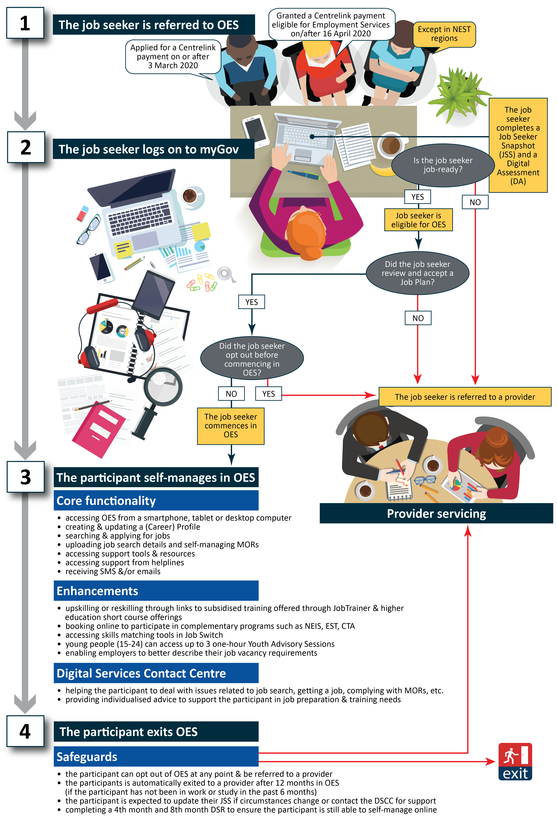
Digital Assessment
Job seekers assessed as job ready (from their JSCI scores) were then asked to complete a DA to assess their levels of digital literacy and gauge their ability to effectively self-manage and report their job search efforts on an online platform. From the time it was introduced in September 2019, there have been 2 revisions to the DA based on participant feedback and DA responses. The most recent iteration occurred in October 2020. It includes a basic rules-based assessment and prompts job seekers to consider opting out to provider services if their responses indicate that they may benefit more from a provider-based services (the DA is discussed in Section 5.1).

Job Plan
Once a job seeker was assessed as job ready, they would be asked to review and accept a system-generated Job Plan. At this stage, the job seeker could opt out before commencing in OES, or at any time after commencement (once a Job Plan was accepted). The job seeker had to review and accept their Job Plan within 2 days, or their income support payments could be suspended, after which they would have to contact the DSCC to lift their payment suspension.
A Job Plan is an employment pathway plan for the purpose of social security law. All job seekers with MORs are required to enter into and comply with the compulsory terms of a Job Plan in order to receive income support and commence in employment services, including OES. The Job Plan details what a job seeker must do to meet their MORs, with a focus on achieving sustainable paid employment. This includes looking for a specified number of jobs each month and/or undertaking approved education or training, or defined activities to improve their employment prospects. Participants could incur demerit points for not complying with their MORs and could be transferred to a provider if they had accumulated 3 demerit points or more.

Phase 3: the participant self-manages in OES
Once commenced in OES, the participant had access to a range of online tools and functions to help them look for a job and/or improve their job readiness from the jobactive/JobSearch website or app, including:
- accessing OES from a smartphone, tablet or desktop computer
- creating and updating an online profile
- searching and applying for jobs
- uploading job search details to meet their MORs
- accessing online support tools and resources
- upskilling or reskilling through links to subsidised training offered through JobTrainer and higher education short course offerings
- online self-booking to participate in complementary programs such as the New Enterprise Incentive Scheme (NEIS), Employability Skills Training (EST) and Career Transition Assistance (CTA)
- accessing skills-matching tools in Job Switch.
Participants could also obtain more individualised advice, support and help by contacting the department helplines, namely the DSCC and the National Customer Service Line (NCSL).

Phase 4: the participant exits OES
Participants could exit OES if:
- they found a job (and left income support)
- they opted out of OES to a jobactive provider
- they were transferred to a jobactive provider after reaching the maximum time limit in OES
- they became ineligible for online services.

1.4 Labour market environment
This section provides information about the labour market and employment services environment in which OES operated. While the COVID-19 pandemic initially had a substantial negative impact on the Australian labour market, conditions quickly improved (according to key employment and unemployment indicators). Indeed, the period mainly used for OES analysis (covering job seekers who were referred to OES between 5 December 2020 and 31 December 2021, and with outcomes measured up to June 2022) was characterised by a strong labour market (Figure 1.2). Over the period, alongside a low unemployment rate, employment grew strongly, by 3.7% in annualised terms, compared with the 1.7% recorded over the 10 years to March 2020 (before the onset of COVID-19).

Impact of COVID-19 on the labour market
Following the onset of the pandemic and after the shutdown of non-essential services, internal border and trading restrictions took effect, employment decreased by 874,300 (6.7%) between March 2020 (the month in which Australia recorded its 100th COVID-19 case and the initial round of restrictions began) and the trough in the labour market in May 2020. Over the same period, 673,300 people left the labour force, with trading restrictions and school closures substantially impacting participation in the workforce and resulting in the participation rate falling by 3.3 percentage points (%pts) to 62.5% (Figure 1.3). As a result, the increase in unemployment (of 201,000 or 28.2%) was smaller than the fall in employment, while the unemployment rate rose by 1.8%pts to 7.0%.
Figure 1.2 Annual employment growth and 10-year annualised employment growth before COVID-19 (%)
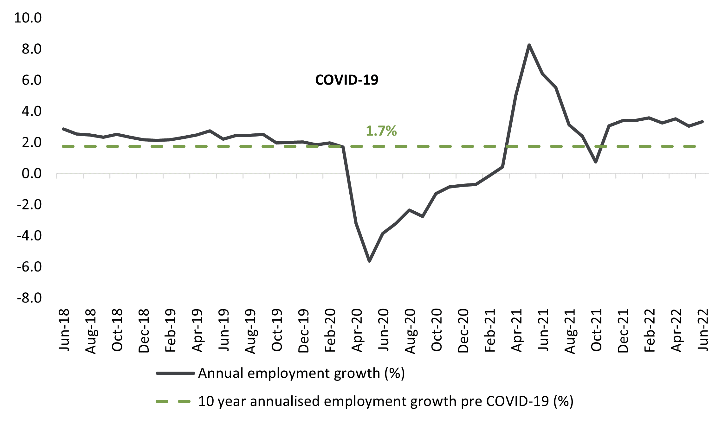
Source: Australian Bureau of Statistics (ABS), Labour Force, Australia, September 2022 release, seasonally adjusted data.
With fewer COVID-19 cases and easing restrictions, employment rebounded quickly after May 2020. By the beginning of the data period mainly used for OES analysis (i.e., December 2020), employment was 754,100 (or 6.2%) higher than during the trough in May 2020. Over the same period, unemployment fell by 8,000 (or 0.9%), a decline offset by the 746,200 who had entered the labour force, while the unemployment rate decreased to 6.6%.

Labour market conditions over the OES analysis period
Over the period mainly used for OES analysis, despite some fluctuations in the level of employment, labour market conditions were strong. Employment grew by 715,700 (or 5.6%) between December 2020 and June 2022 to a record high at the time of 13,590,300 (Table 1.1). This rate of growth is equivalent to an annualised rate of employment growth of 3.7% and compares with an annualised growth rate of 1.7% over the 10 years to March 2020.
Encouragingly, the employment growth recorded over the period was entirely accounted for by a rise in full-time employment, which grew by 730,400 (or 8.3%) to a record high of 9,479,200 in June 2022.
Employment over the period grew for women (up by 380,100 or 6.2%) and men (up by 335,600 or 5.0%), with the level of employment at a record high at the time for both cohorts in June 2022.
Figure 1.3 Unemployment rate and participation rate (%)
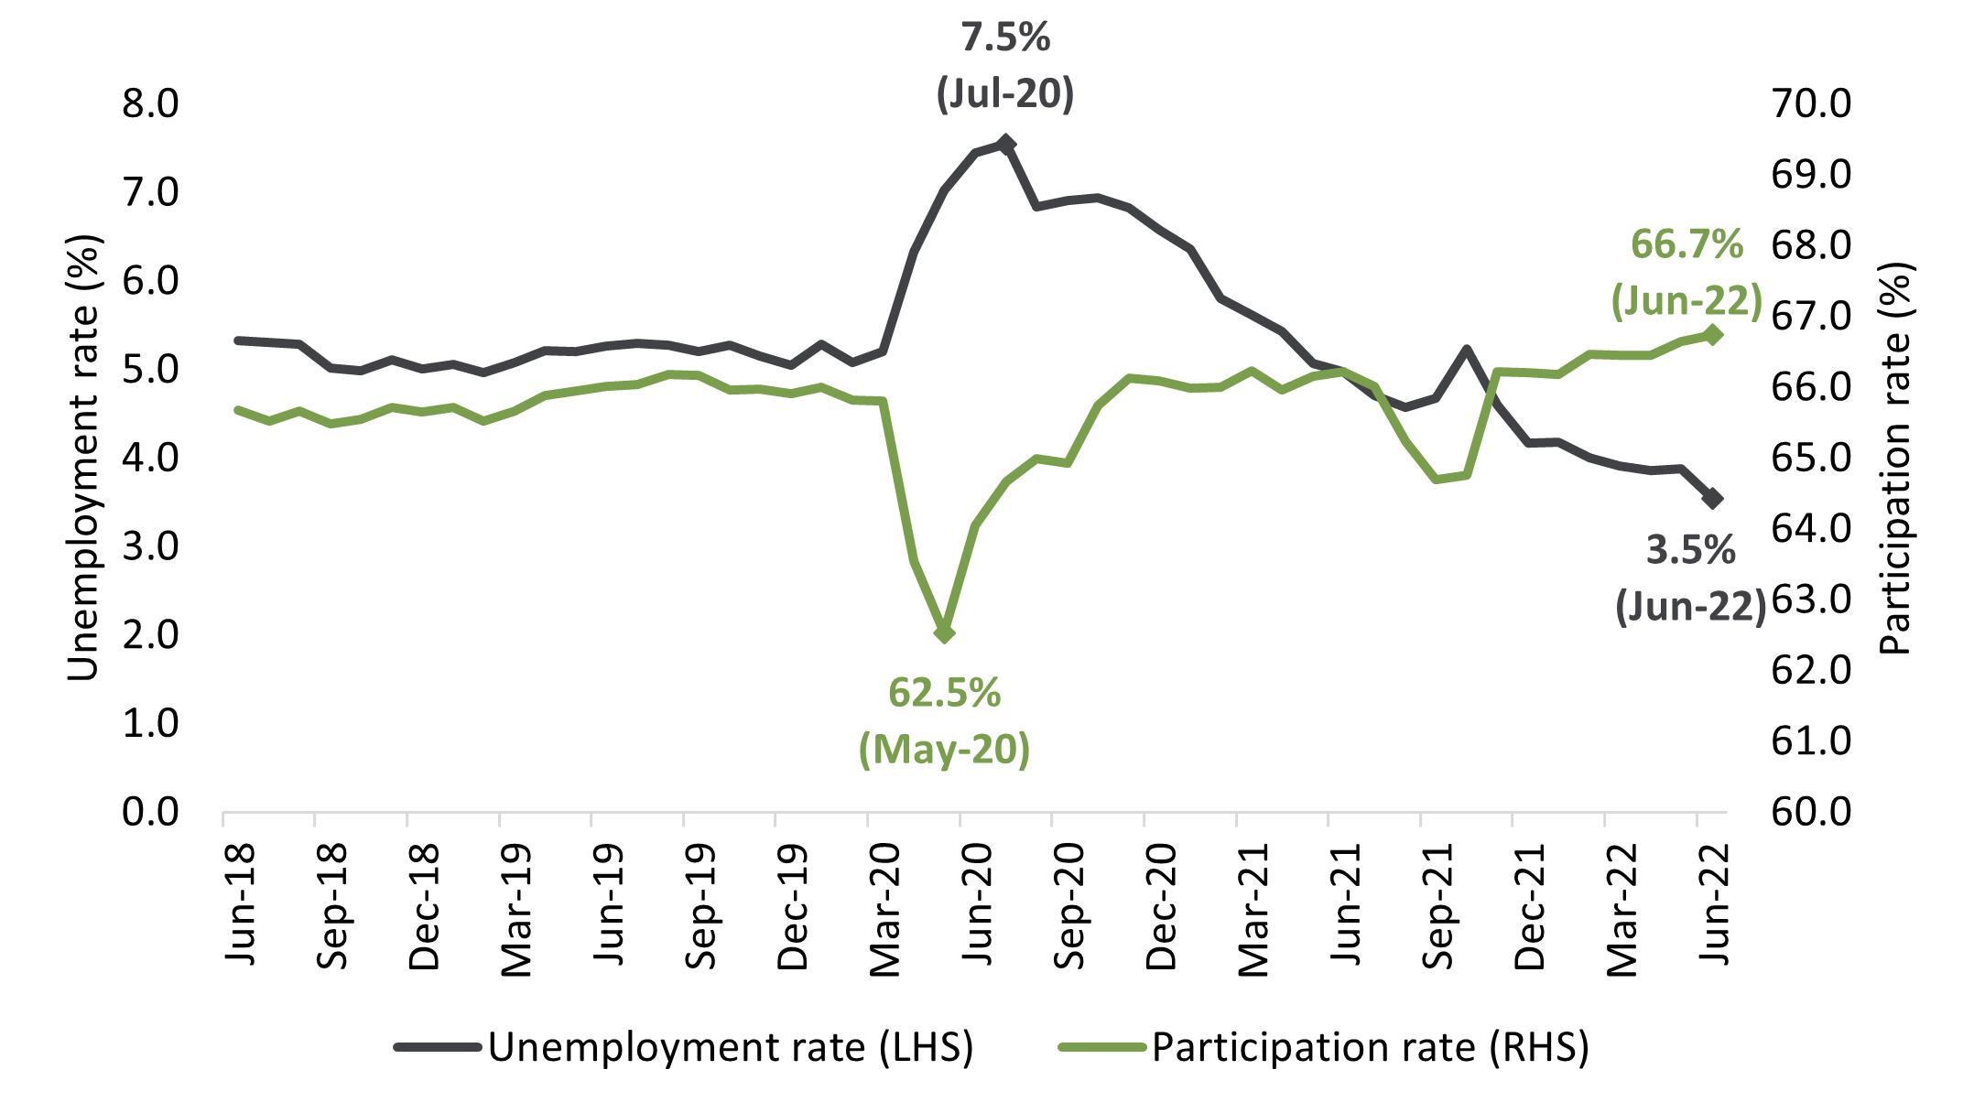
Source: ABS, Labour Force, Australia, September 2022 release, seasonally adjusted data.
Table 1.1 Key labour market indicators between December 2020 and June 2022
 | June 2022 | Change between December 2020 and June 2022 |  |  | 10-year annualised change to March 2020
 | (’000) | (’000) | (%) | Annualised (%) | Annualised (%)
Employment | 13,590.3 | 715.7 | 5.6 | 3.7 | 1.7
Full-time employment | 9,479.2 | 730.4 | 8.3 | 5.5 | 1.5
Part-time employment | 4,111.1 | –14.7 | –0.4 | –0.2 | 2.3
Male employment | 7,109.2 | 335.6 | 5.0 | 3.3 | 1.4
Female employment | 6,481.2 | 380.1 | 6.2 | 4.1 | 2.2
Unemployment | 499.2 | –407.5 | –44.9 | –32.8 | 1.3
Labour force | 14,089.5 | 308.2 | 2.2 | 1.5 | 1.7
 | (%) |  | (%pts)
Unemployment rate | 3.5 | - | –3.0 | - | -
Participation rate | 66.7 | - | 0.7 | - | -
Underemployment rate | 6.1 | - | –2.4 | - | -
Source: ABS, Labour Force, Australia, September 2022 release, seasonally adjusted data.
Note: %pts = percentage points.
Alongside growth in employment, many people entered the labour force between December 2020 and June 2022 (up by 308,200 or 2.2%), resulting in an increase in the participation rate (up by 0.7%pts to a record high of 66.7%) (Figure 1.3), while unemployment decreased substantially (by 407,500 or 44.9%). In addition, despite the large increase in the labour force, decreases were recorded in the unemployment rate (down by 3.0%pts to stand at 3.5%) and the underemployment rate (down by 2.4%pts to stand at 6.1%). Highlighting the strength of the labour market, the unemployment rate had not been lower in almost 50 years (since August 1974). Over the same period, monthly hours worked in all jobs grew by 101.6 million hours (5.8%).

Impacts of COVID-19 on job seekers in employment services
Reflecting the dramatic fall in employment at the early stage of COVID-19, referrals to and caseload in jobactive experienced substantial increases over the same period, as shown in Figure 1.4. The figure presents monthly caseload of and initial referrals to jobactive, and the number of job seekers exiting jobactive from January 2020 to June 2022. The jobactive caseload peaked at 1,488,462 in September 2020, with initial referrals peaking at 472,496 in April 2020. The number of job seekers exiting jobactive peaked at 129,722 in September 2020. From October 2020 to December 2021, jobactive referrals stabilised at an average of 50,000 referrals per month.
Figure 1.4 jobactive monthly caseload, referrals and exits: January 2020 to June 2022
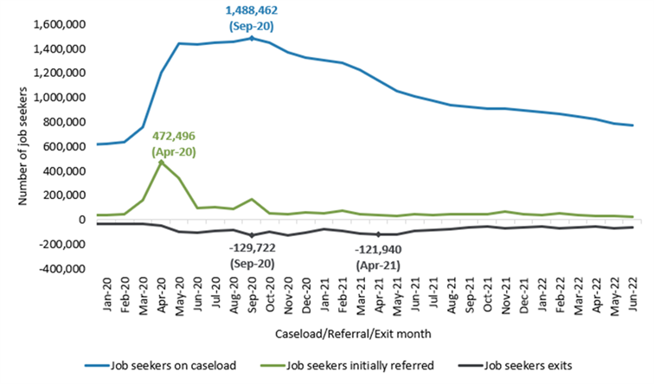
Source: DEWR administrative data.
Figure 1.5 shows that during March 2020 to May 2020, the months mostly affected by COVID-19, the vast majority of the initial referrals were to OES. Until the end of 2021, referrals to OES were more than twice those to provider services.
As a result of the unprecedented negative impact of the COVID-19 pandemic and subsequent labour market strength, many job seekers with lower levels of disadvantage would have had extensive experience in the labour market, particularly in the early part of the OES analysis period. Accordingly, the participants included in the OES evaluation may have had lower levels of labour market disadvantage (e.g., longer past work and/or educational attainment) than those who would typically use online employment services in the absence of the impact of COVID-19.
Figure 1.5 Types of monthly referrals to jobactive
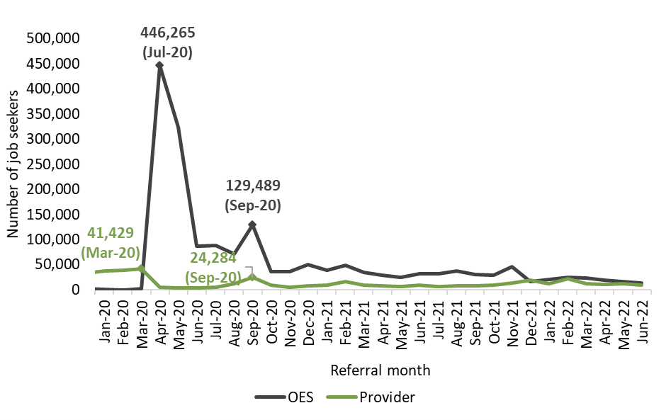
Source: DEWR administrative data.

1.5 Report structure
This report is divided into 8 chapters.
Chapter 1 outlines the background of OES and provides the context in which it was implemented and evaluated.
Chapter 2 outlines the evaluation objective, key evaluation questions, methodology and data sources.
Chapter 3 assesses the appropriateness of OES and suitability of participants from participants’ and providers’ perspectives.
Chapter 4 examines the effectiveness of OES core functionality and enhancements in enabling participants to self-manage their job search on an online platform. It discusses participants’ awareness and use of tools and resources in OES including the jobactive/JobSearch website and/or app, the OES dashboard, the Profile function and the DSCC. This chapter also discusses participants’ overall satisfaction with OES.
Chapter 5 examines effectiveness of online safeguards in ensuring that OES participants were capable and able to self-manage on an online platform.
Chapter 6 discusses the impact of OES on participant outcomes, in improving their job search skills and ability to meet job search requirements, on exits from income support and employment services, and in reducing reliance on income support. It also discusses the cost-effectiveness of online services as a whole.
Chapter 7 discusses employers’ views of and experiences with OES.
Chapter 8 synthesises the evaluation findings and summarises the appropriateness, effectiveness and efficiency of online services overall – what worked well, what did not work well, and limitations.

Chapter 2 Evaluation of Online Employment Services
This chapter outlines the objectives of the evaluation and key evaluation questions and details the evaluation approach, which includes the use of mixed-methods research and analyses incorporating administrative data and data collected through qualitative and quantitative research activities. Characteristics of the study populations are described, including details of the population’s size and profile.

2.1 Evaluation objectives
In line with public accountability provisions, employment services have been subject to regular evaluation. In particular, the Public Governance, Performance and Accountability Act 2013 encourages evaluation of all government programs.
The objectives of the evaluation were to:
- assess the appropriateness, effectiveness and efficiency of OES
- contribute to the evidence base for the development and improvement of online services.
The evaluation of OES built upon the findings of the evaluation of OEST. Informed by the evaluation of OEST and early findings of the evaluation of NEST, significant changes were made to OES compared to the OEST, in the form of enhancements and additional safeguards. Furthermore, OES participants could stay in online services for 12 months, compared to 6 months in OEST. With these changes, an evaluation of OES was warranted to gather new evidence.
The evaluation was managed by the Digital Services Evaluation and Research and Evaluation Database (RED) Support team within the Employment Evaluation Branch of the department, in consultation with an OES Evaluation Working Group (EWG). With representatives from the policy and program areas designing and delivering employment services within the department, the EWG was established to provide advice to the evaluation team and ensure that the scope and direction of the evaluation fulfilled the objectives of the Australian Government and that the evaluation project deliverables were fit for purpose.
Table 2.1 Terms of reference and evaluation questions
Term of reference |  | Key evaluation question
Appropriateness | KEQ1 | How well did OES meet the needs of the targeted cohort of job seekers?
Effectiveness | KEQ2 | How effective are OES core functionalities and enhancements in enabling participants to self-manage their job search and MORs, and improve their employability to find relevant and sustainable employment?
Effectiveness | KEQ3 | Are OES safeguards sufficient in ensuring that participants are in the right service and can effectively self-manage?
Effectiveness | KEQ4 | How effective is the DSCC in assisting participants to overcome barriers and remain engaged in OES?
Effectiveness | KEQ5 | What worked well and not so well in enhancing participant experience in and engagement with OES?
Efficiency | KEQ6 | Do the referral and onboarding processes ensure that job seekers get the most appropriate support to find employment?
Efficiency | KEQ7 | Has OES achieved value for money?

2.2 Key evaluation questions
The evaluation questions were developed around the appropriateness, effectiveness and efficiency of OES, as outlined in Table 2.1.

2.3 Evaluation methodology
The OES evaluation adopted a mixed-methods approach and included:
- administrative data analysis using data from the department’s Employment Services System (ESS) and the RED from 1 May 2020 to 30 June 2022
- 2 main waves of quantitative (survey) and qualitative research with OES participants, including 4 rounds of intermediate small surveys with participants from June 2021 to May 2022
- qualitative research with internal and external stakeholders from June 2021 to May 2022, including jobactive providers, department helpline staff, the EWG members, Services Australia representatives and peak bodies
- a longitudinal study with 4 rounds of qualitative interviews with 8 OES participants
- a quantitative survey and qualitative interviews with employers conducted between September and October 2021.
The evaluation also utilised findings from the Participant Experiences of Employment Services (PEES) research which was undertaken between April and May 2021.
Figure 2.1 outlines the evaluation approach visually by linking data sources with the evaluation terms of reference.

Qualitative research
The department commissioned Wallis Social Research to conduct qualitative fieldwork (Figure 2.1) with OES participants, employment services providers, peak bodies, departmental staff and stakeholders to collect information about their views and experience with OES. Table 2.2 shows the breakdown of qualitative research activities undertaken by Wallis across various participant and stakeholder groups and over 2 waves of research. The first wave of the qualitative research was conducted between August and October 2021, and the second wave was between March and May 2022. In addition, 4 waves of qualitative longitudinal in-depth interviews were also conducted with 8 OES participants over the period from September 2021 to July 2022.
Figure 2.1 The evaluation approach
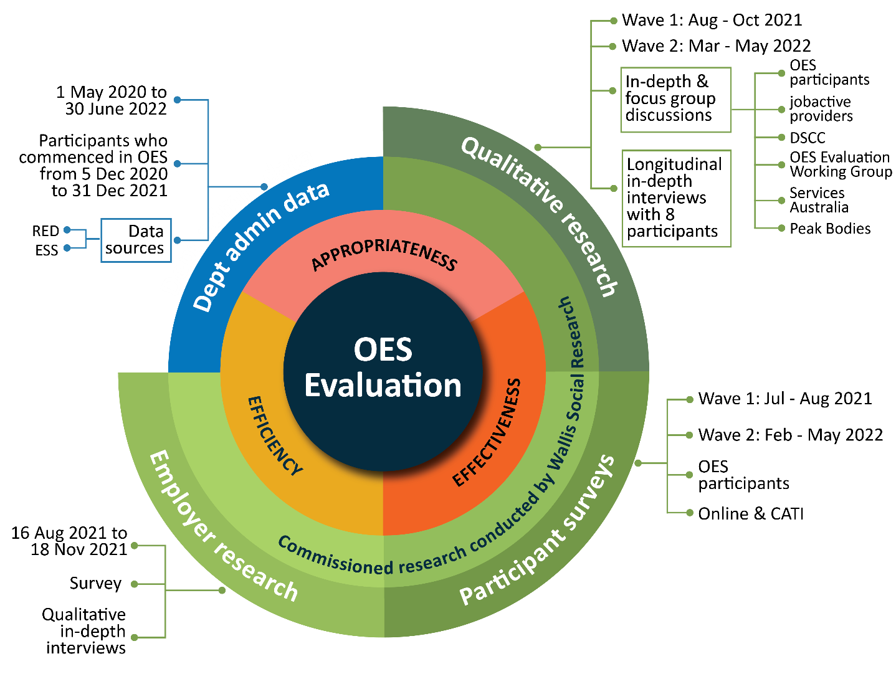
Table 2.2 Breakdown of qualitative consultations conducted by Wallis
 | In-depth interviews with OES participants | Focus group discussions with participants | In-depth interviews with jobactive providers | Focus groups and interviews with stakeholders (departmental staff, helpline staff, peak bodies)
Wave 1 | 25 | 10 | 7 | 5
Wave 2 | 25 | 12 | 8 | 4
Qualitative longitudinal in-depth interviews (4 waves) | 8
Source: OES qualitative research.

Quantitative survey
Wallis was commissioned to conduct 2 waves of quantitative research with OES participants through either Computer Assisted Telephone Interview (CATI) or online surveying. The first survey was conducted between July and August 2021 and the second wave between February and May 2022. Interim surveys were also conducted between the first and second waves (Table 2.3). These surveys are referred to in this report as the OES Participant Survey Waves 1 and 2, and the OES Participant Interim Survey.
Table 2.3 Breakdown of quantitative surveys with OES participants conducted by Wallis
Survey round | Description of the survey | Number of respondents
Wave 1 | A cross-sectional survey of OES participants between July and August 2021 | 4,229
Interim surveys | A monthly cross-sectional interim survey of OES participants from September 2021 to January 2022 | 1,002
Wave 2 | A cross-sectional survey of participants between February and May 2022 | 4,147
Source: OES Participant Survey, Waves 1 and 2.

Quantitative analysis of departmental administrative data
The administrative data included in the analysis was mostly for the period from 5 December 2020 to 30 June 2022. In most analyses, OES referrals before December 2020 were excluded, to discount the ‘one-off’ COVID-19 referral phase. This data is unsuitable for evaluation purposes due to the significant ‘noise’ in administrative data resulting from rapid changes to the application, assessment, referral and commencement processes for job seekers in employment services. Public health lockdowns from the onset of the COVID-19 pandemic in March 2020 contributed to substantial loss of employment, with hundreds of thousands of people losing much of their income virtually overnight. This created an influx of people claiming income support, mainly JobSeeker Payment and Youth Allowance (other). This in turn caused an influx of people being referred to the employment services caseload, which climbed from around 635,000 in February 2020 to 1,488,000 in September 2020 (Figure 1.4). To accommodate the increased need for economic support and demands on the employment services caseload, changes were made to the JobSeeker Payment eligibility criteria, application process and rules.
Unless otherwise specified, the administrative data analyses are also limited to eligible participants who were referred to and commenced in OES up to 31 December 2021 and were on income support. These participants were observed up to 30 June 2022 to allow a reasonable amount of time to observe for the occurrence of events such as opting out to a provider or exiting jobactive employment services or income support.

Employer research
To assess employer views and experiences with OES, the department commissioned Wallis Social Research to conduct the OES Employer Research in 2021, which included a quantitative survey and qualitative interviews. The employers participating in the research were drawn from 2 employer groups:
- a sample provided by the department of the employers who had registered on the OES platform on the jobactive/JobSearch website from August 2020 to August 2021 (denoted as ‘OES user employers’ in the rest of this report)
- a general Australian employer sample sourced from a commercial sample pool supplied by Ilion, which is a provider of data and analytics products (denoted as ‘general employers’).

Quantitative survey
A multi-mode approach was adopted for the quantitative survey of employers, using CATI, an online survey and a paper-based questionnaire. The sample of employers supplied by the department (OES user employers) were invited to complete either a CATI or the online survey, while the paper-based questionnaire was sent to all employers from the commercial sample pool. The survey was conducted between October and November 2021.
A total of 2,962 employers participated in the survey, with 1,087 from the OES user group, and 1,875 from the general employers group (Table 2.4). From the general employers group, 187 (10.0%) employers were also OES users. They were included in both groups for the results in this report.
Table 2.4 Breakdown of employer survey respondents
 | JobSearch users | General employers | Total
Sample from the department | 1,087 | Nil | 1,087
Illion sample | 187* | 1,875 | 1,875
Total | 1,274 | 1,875 | 2,962
Source: OES Employer Survey.
Note: *187 employers identified in the Illion sample as having used the jobactive/JobSearch website and reported as part of both the OES user and general employer groups.

Qualitative research
A total of 45 in-depth interviews for the qualitative component of the employer research were conducted between August and September 2021. Interviews ran for up to an hour with 15 general employers and 30 OES users, using video calls through Microsoft Teams or telephone.

Participant Experiences of Employment Services research
The PEES research was undertaken between April and May 2021. While the PEES research explored a range of participant experiences with employment services including OES, NEST, Volunteer Online Employment Services Trial (VOEST) and jobactive provider services participants, this report focuses only on PEES research findings relevant to OES. The research provided some insights into participant experiences with service elements such as the onboarding process, activities and training undertaken, and job search and employment-related activities, including the use of the OES platform and other resources. The PEES research adopted both quantitative and qualitative approaches.

Quantitative survey
The quantitative component of the PEES research involved online and CATI surveys. The numbers of survey respondents by program are presented in Table 2.5.

Qualitative research
The PEES qualitative research component involved 14 focus group and 34 in-depth discussions with OES, NEST, VOEST and jobactive participants using a combination of face-to-face and Microsoft Teams virtual meeting approaches.

Table 2.5 PEES Survey respondent breakdown by program
Sample group | Complete (n=)
jobactive | 1,042
jobactive comparison regions* | 471
NEST Enhanced Services (provider services) | 1,059
NEST Digital Services | 1,068
OES comparison regions** | 379
OES*** | 967
VOEST | 302
Total | 5,288
Source: PEES Survey, 2021.
Note:
*jobactive comparison regions include participants who were with a jobactive provider in non-NEST regions with key matching characteristics to those in NEST Enhanced Services.
**OES comparison regions include participants using OES in non-NEST regions with key matching characteristics to those in NEST Digital Services.
***OES participants using the mainstream online platform on the jobactive/JobSearch website.

2.4 OES referral and participant population
Almost 1.8 million job seekers entered the mainstream employment services from 1 May 2020 to 30 June 2022, of whom 637,155 (36%) did so over the period from 5 December 2020 to 31 December 2021. As discussed earlier, job seekers who commenced OES over this period were the main study population for this evaluation.
Of the 1.8 million job seekers, 457,163 were referred to OES. However, 211,505 of these had indeterminate eligibility for OES and thus were excluded from the analysis. Furthermore, 42,760 (9.4%) job seekers were excluded from the analysis because they moved between OES and NEST or VOEST or had multiple OES placements within the same period of assistance. After applying these exclusions, 202,898 job seekers were in scope for analysis for this evaluation. Figure 2.2 shows a breakdown of the service status of these job seekers as of 30 June 2022.
Of the 202,898 job seekers in scope for analysis for this evaluation, 107,464 commenced in OES and were on income support at the commencement. Of those who commenced, 89,337 participants had ‘pure OES experience’. This means that they did not opt out; nor were they transferred to a provider before reaching the maximum online servicing limit (12 months or more for those with exemptions); nor were they paused while in OES. Full characteristics of this cohort are presented in
Table 2.6.
Figure 2.2 Employment services status of the job seeker population in scope for the evaluation as of 30 June 2022
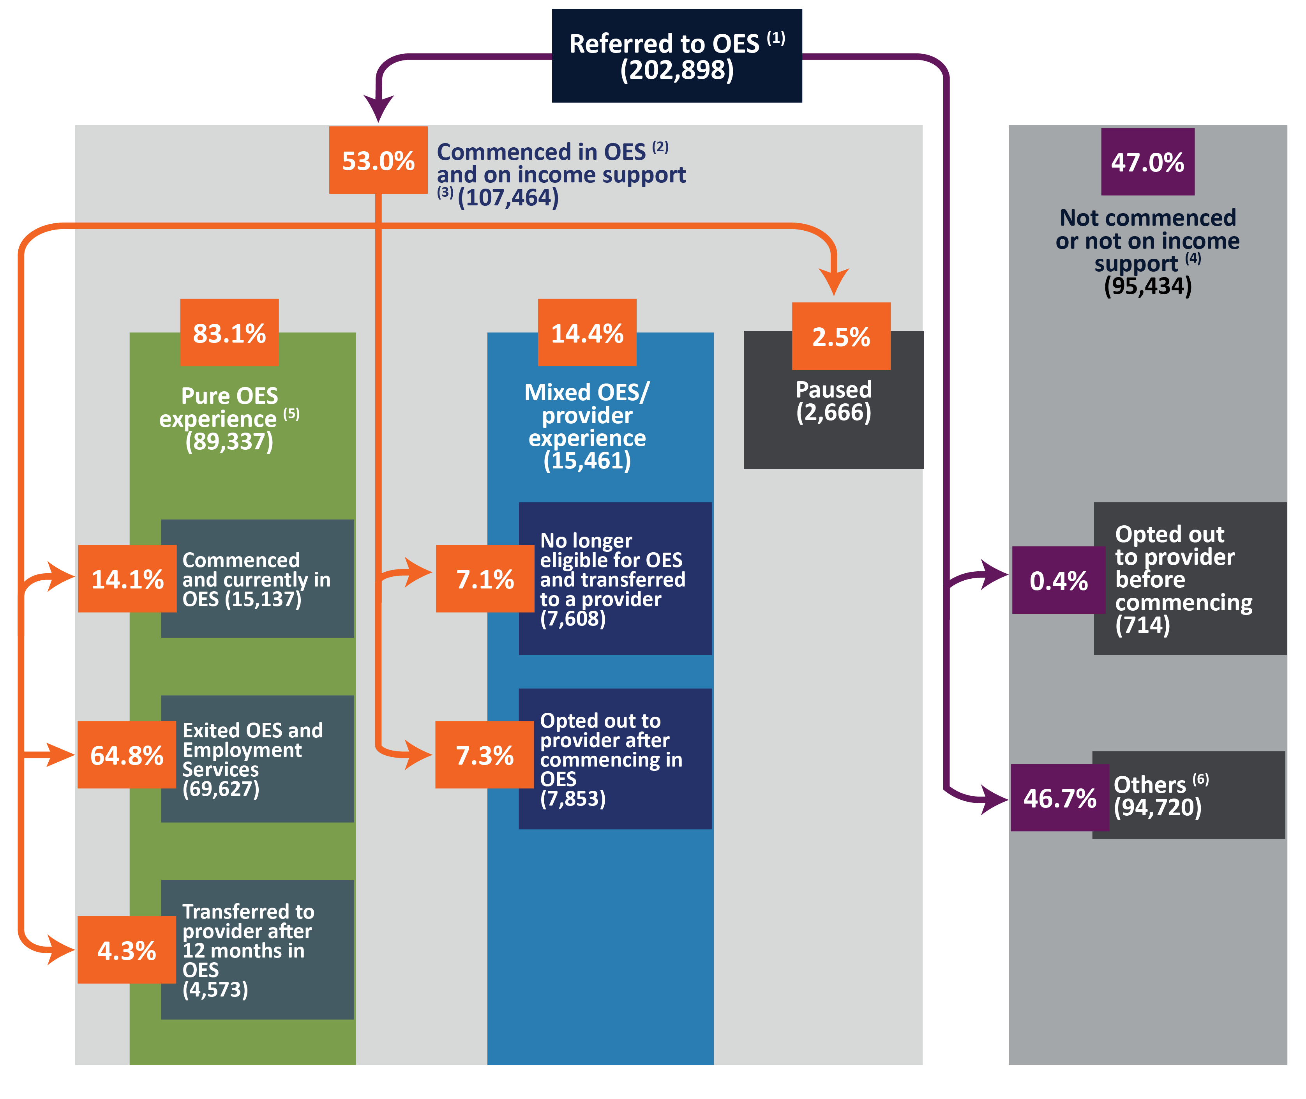
Source: DEWR administrative data.
Note: Excluding NEST/VOEST and multiple OES contract referral placements in the same POA. Percentages were calculated from the total referral figure of 202,898. The main study population is represented by the green boxes.
⁽¹⁾ Referred to OES between 5 December 2020 and 31 December 2021, limited to those eligible for OES.
⁽²⁾ If commenced, they commenced in OES between 5 December 2020 and 31 December 2021.
⁽³⁾ Received income support within 28 days from commencement.
⁽⁴⁾ Either did not commence, commenced after 31 December 2021, or had a pending commencement or were not on income support within 28 days from commencement.
⁽⁵⁾ Only had OES experience in the first 12 months from commencement. They were considered to have had pure OES experience for up to the 12-month outcome analyses.
⁽⁶⁾ Includes all other cases such as pending, exited or transferred without commencing OES.

Table 2.6 Characteristics of participants with pure OES experience
 | Number of participants | (%)
All OES participants | 89,337 | 100
Gender
Female | 37,751 | 42.3
Male | 51,586 | 57.7
Age group
Under 25 years | 30,893 | 34.6
25 to 29 years | 18,952 | 21.2
30 to 39 years | 17,821 | 19.9
40 to 49 years | 11,691 | 13.1
50+ years | 9,980 | 11.2
Educational attainment
Under Year 12 | 10,940 | 12.2
Year 12 | 24,278 | 27.2
University | 29,283 | 32.8
Vocational | 24,836 | 27.8
Remoteness
Major Cities | 68,754 | 77.0
Inner Regional | 14,387 | 16.1
Outer Regional | 6,196 | 6.9
Recent work experience
Not in the labour force | 20,533 | 23.0
Not working but looking for work | 2,976 | 3.3
Paid full-time work (30 hours+) | 46,539 | 52.1
Some work experience | 19,289 | 21.6
Previous jobactive experience
No previous experience | 62,433 | 69.9
Previous online experience | 9,625 | 10.8
Previous provider-serviced experience | 17,279 | 19.3
Other cohorts
CALD | 14,132 | 15.8
Aboriginal and/or Torres Strait Islander people | 2,107 | 2.4
People with disability | 3,457 | 3.9
Without own transport | 24,348 | 27.3
Mixed/poor English proficiency | 1,853 | 2.1
Lone parent | 1,837 | 2.1
Partnered parent | 3,277 | 3.7
Ex-offender | 2,643 | 3.0
Source: DEWR administrative data.

Chapter 3 Appropriateness
This chapter assesses the appropriateness of OES from 2 angles. It discusses the referral process for ensuring that job seekers were appropriately referred to OES. Participants’ perceived suitability for online services is explored by examining their preferences for online services and confidence in being able to self-manage on an online platform. Finally, this chapter investigates how OES met participants’ needs, by examining the advantages and disadvantages of online services as perceived by participants.

3.1 Referral process
As noted in Section 1, upon submitting their application for income support, job seekers were directed to the myGov website to complete a JSS. Wave 1 of the OES Participant Survey indicated that most participants were able to manage the JSS process easily and were satisfied with it. Around 4 in 5 participants who recalled completing the JSS indicated that their experience was generally positive (77.7% to 87.6% rated it as good/excellent). A majority (85.2% and 87.6% respectively) of participants indicated that the JSS was easy to complete and that they understood the reason why they were asked to disclose personal information. A majority (80.0% and 77.7% respectively) of OES participants also stated that they understood the purpose of the JSS and felt comfortable that their claims had progressed appropriately (Table 3.1). This indicates that one of the issues identified from the Online JSCI Trial evaluation was addressed in OES. The issue reported by Online JSCI Trial participants was that they were uncertain about the purpose of completing a JSS and they did not feel assured that their income support claim had been progressed.
Table 3.1 Experiences with the process of completing JSS – % of good/excellent ratings
 | Understood the reason you were asked to disclose personal information | Were able to complete the JSS easily | Purpose of the JSS was clear to you | Felt comfortable your claim progressed appropriately | Base number
All participants | 87.6 | 85.2 | 80.0 | 77.7 | 1,645
Disability
Yes | 80.5 | 83.2 | 59.8 | 61.3 | 42
No | 87.8 | 85.2 | 80.6 | 78.2 | 1,603
Education
Under Year 12 | 84.1 | 81.3 | 72.9 | 79.8 | 99
Year 12 | 89.6 | 84.4 | 81.9 | 78.1 | 437
Vocational | 85.7 | 84.7 | 81.4 | 77.7 | 393
University | 88.9 | 88.1 | 80.1 | 76.5 | 716
Source: OES Participant Survey, Wave 1.
Note: These questions were only asked of participants who recalled completing a JSS.
About 3 in 5 (71.2%) OES participants who completed the PEES Survey agreed that the online registration process was straightforward and easy to follow, with only 12.7% disagreeing.
OES qualitative participant research confirmed that participants found the JSS process to be easy and not too demanding.
From memory it was pretty simple to complete, it wasn’t overly difficult, and it did what it needed to do, it was easy enough. (OES qualitative research, participant interview)
Analysis of administrative data showed that very few (7.3%) participants who commenced in OES opted out, indicating that the referral process worked effectively in ensuring job seekers were appropriately referred to OES. The opt-out feature is discussed in Chapter 5.

3.2 Preference for online services
Preference for online services should be a good indicator of a job seeker’s suitability for the service from the participant’s perspective. Across both waves of the OES Participant Survey, a large majority (81.5%) of OES participants indicated that they preferred online services. Figure 3.1 shows how this preference differed across groups. Most (82.6% to 86.0%) participants with pure OES experience preferred online services. While it is unsurprising that many (41.0% to 43.8%) participants who opted out to a provider, according to administrative data, indicated a lower preference for online services, it is interesting to note that most OES participants (83.5%) who transferred to a provider after completing 12 months in OES reported a preference for online services.
Further analysis of the survey data indicates that the following cohorts preferred online services (Figure 3.1):
- female participants (83.5%)
- participants under 40 years of age (around 84.0%)
- participants with a university qualification (85.8%)
- participants in metropolitan regions (82.9%)
- participants from a CALD background (83.0%).
In contrast, the following participant groups had a relatively lower proportion preferring online services:
- participants aged 50 years or above (72.5%)
- participants who had not completed secondary education (72.9%)
- participants located in regional areas (around 77.0%)
- Aboriginal and/or Torres Strait Islander participants (75.8%)
- participants with disability (66.3%).
These results were largely consistent with the OEST evaluation, which found that the following showed a strong preference for online services:
- participants aged 24 years or below
- participants with high levels of educational attainment
- participants in metropolitan locations
- participants with high levels of internet usage
- participants who had not previously used jobactive services.

3.3 Confidence in self-sufficiency
As preference for service type alone is insufficient as a measure to assess whether participants were able to self-manage their job search online, the evaluation also explored other factors that could have determined an individual’s suitability for online services. A participant segmentation analysis conducted in the OEST evaluation identified a second influencing factor: participants’ confidence and perceived self-sufficiency in finding a job independently. Waves 1 and 2 of the OES Participant Survey explored participants’ confidence, and results are presented in Figure 3.2. The relationship between preference and confidence factors is discussed in Section 3.3.
It is reasonable to assume that if a participant feels confident that they can find a job independently, then online services are likely a good option for them. Broadly speaking, 4 in 5 (81.2%) participants across both waves of the OES Participant Survey reported feeling confident in finding a job themselves. This percentage was higher (85.0%) among participants who had exited OES and employment services (Figure 3.2).
As expected, fewer (65.4% to 79.2%) participants who transferred or opted out to provider services felt confident finding their own job. Similarly, fewer (75.9%) participants who later transferred to a provider after completing the maximum 12 months in OES were confident that they could find their own job.
Figure 3.1 Proportion of participants who preferred online services
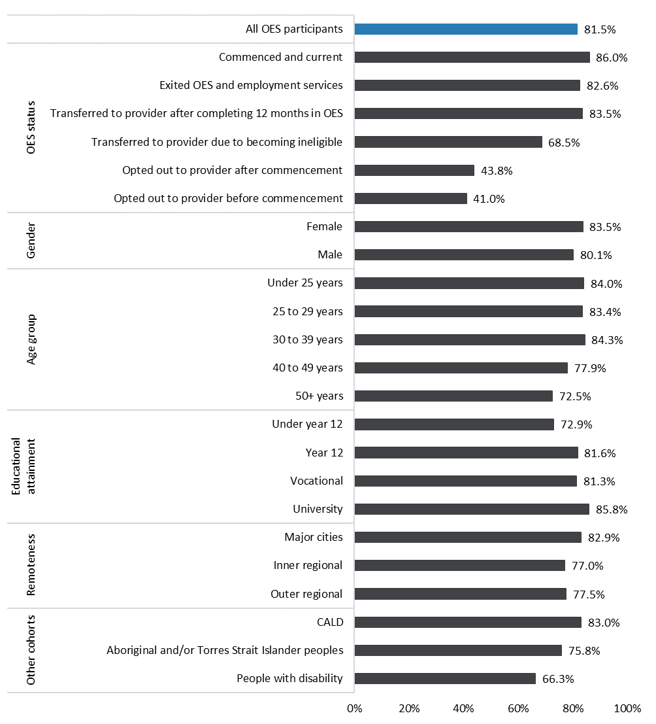
Source: OES Participant Survey, Waves 1 and 2.
Base: n=8,376, weighted results.
Note: Q. Would you say you prefer (1) self-managed online job search (2) Face-to-face with help from an employment services provider (jobactive) (3) I have not used any government-provided online employment services.
Figure 3.2 Proportion of participants who were confident in finding a job independently
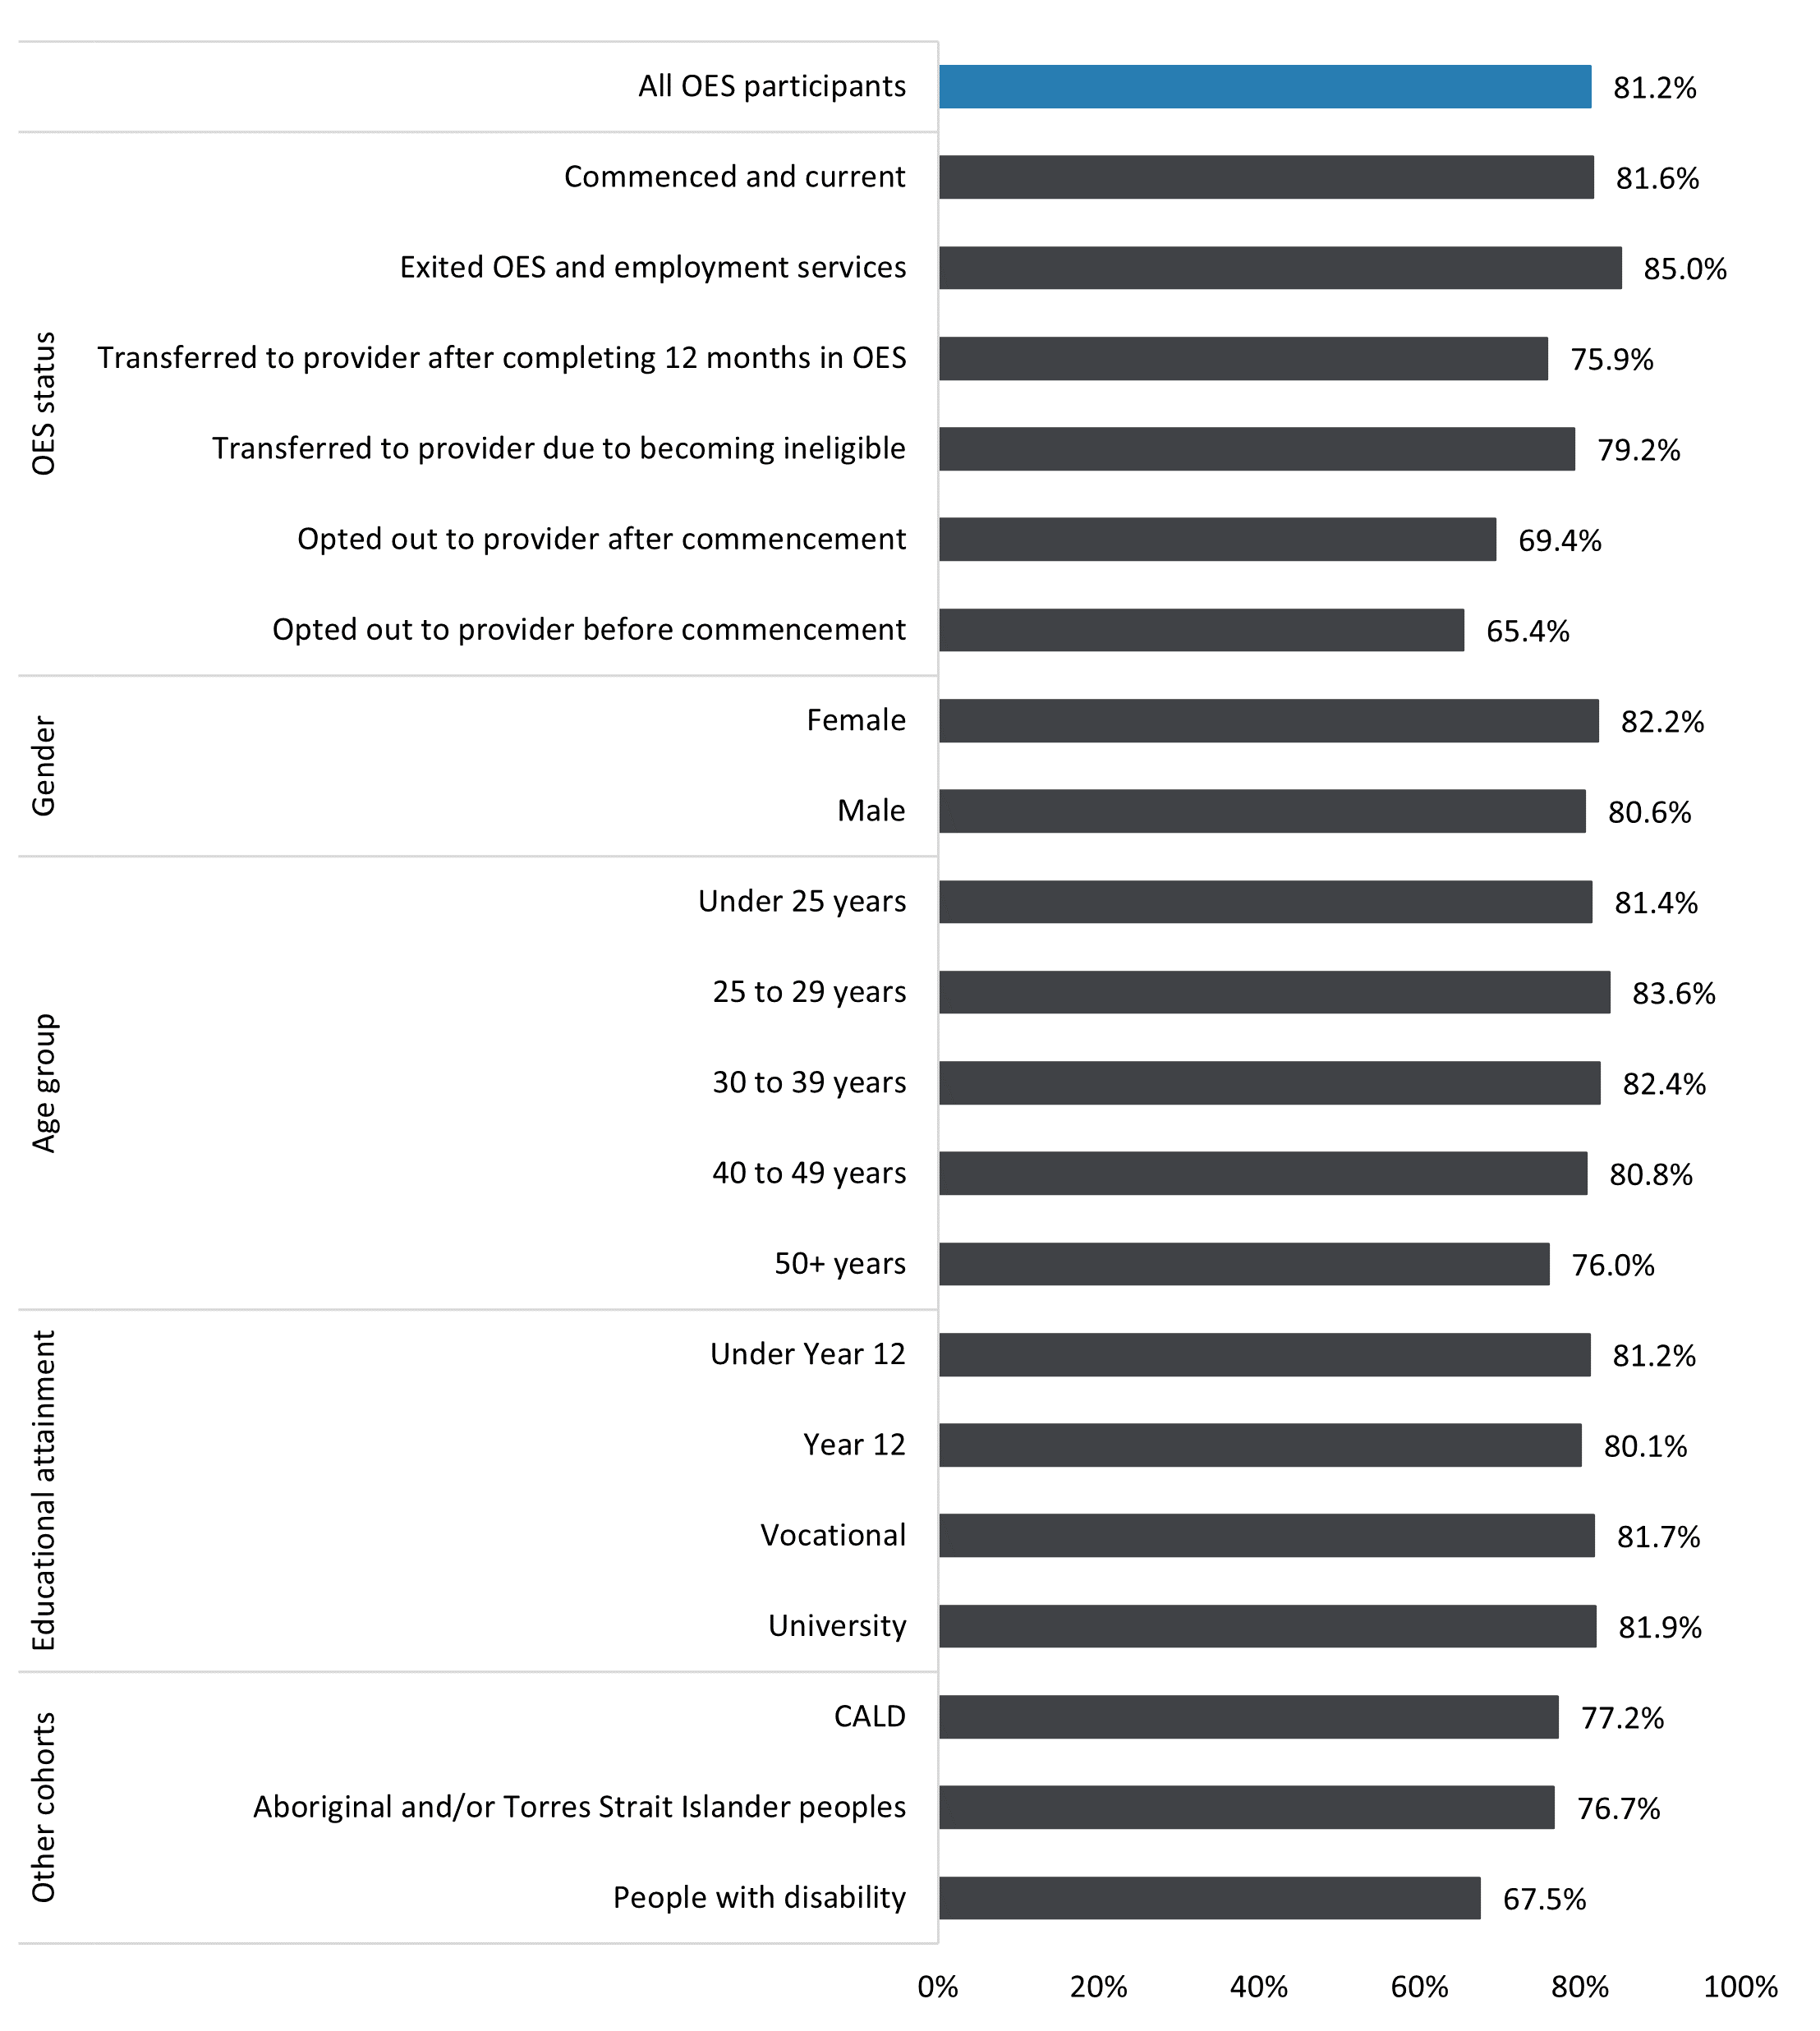
Source: OES Participant Survey, Waves 1 and 2.
Base: n=8,376, weighted results.
Note: Q. To what extent do you agree or disagree with the following statements about looking for work – I am confident I can find a job myself.
In addition, the proportion of participants who perceived themselves as confident and self-sufficient also tended to be lower for:
- participants aged 50 years and over (76.0%)
- participants with a CALD background (77.1%)
- Aboriginal and/or Torres Strait Islander participants (76.7%)
- participants with disability (67.5%).
While a larger proportion of participants who were transferred to a provider after 12 months preferred online services, a smaller proportion of these participants were confident in finding a job independently. This is most likely because individuals tend to lose confidence over time. This was observed during the OEST evaluation.
My confidence decreased … I didn’t think anything would come of [my job search] … I wasn’t really getting any feedback. (OEST participant)

3.4 Segmentation of OES participants based on preference and confidence
While a preference for online services and confidence in self-managing job search on an online platform can be good indicators of suitability for online services, the 2 measures do not always align. For example, a larger proportion of CALD participants (83.0%) indicated a preference for online services, but a smaller proportion (77.2%) of this cohort expressed confidence in finding a job independently.
Figure 3.3 illustrates the segmentation of participants’ suitability for online services based on the combination of their preference for online services and confidence in self-managing their job search. It also shows the proportion of participants categorised into each segment based on data from the OES Participant Survey.

Segment A
Participants in this segment had a strong preference for online services and perceived themselves as self-sufficient in finding employment; therefore, they were most likely to effectively self-manage on an online platform. Segment A is the largest group, with 68% of OES participants. This indicates that most participants were indeed suitable for OES. Nine in 10 (89%) of Segment A participants reported that they could write a good job application and résumé that addressed the selection criteria.

Segment B
This segment comprised around 13% of OES participants. While these participants preferred online services, they perceived that they lacked self-sufficiency in finding employment by themselves. Compared to Segment A, only a little over half (53%) of these participants reported that they could write a good job application and résumé that addressed the selection criteria. Nearly 1 in 5 (24%) participants agreed that their job search skills improved because of OES, which indicates there was scope to assist more Segment B participants to improve their job search skills through online services.

Segment C
These participants were the least suitable for online services; however, this segment was also the smallest, comprising just 5% of OES participants. Provider services were more suitable for these participants as they preferred face-to-face services and lacked self-sufficiency in finding a job. Only 46% of participants in this segment indicated that they could write a good job application and résumé; therefore, they could have benefited more from further support and assistance from a provider. Lack of awareness was the most likely reason why participants in this segment did not opt out. Very few (29.7%) Segment C participants were aware that they could opt out at any stage in OES.
Figure 3.3 Segmentation of OES participants
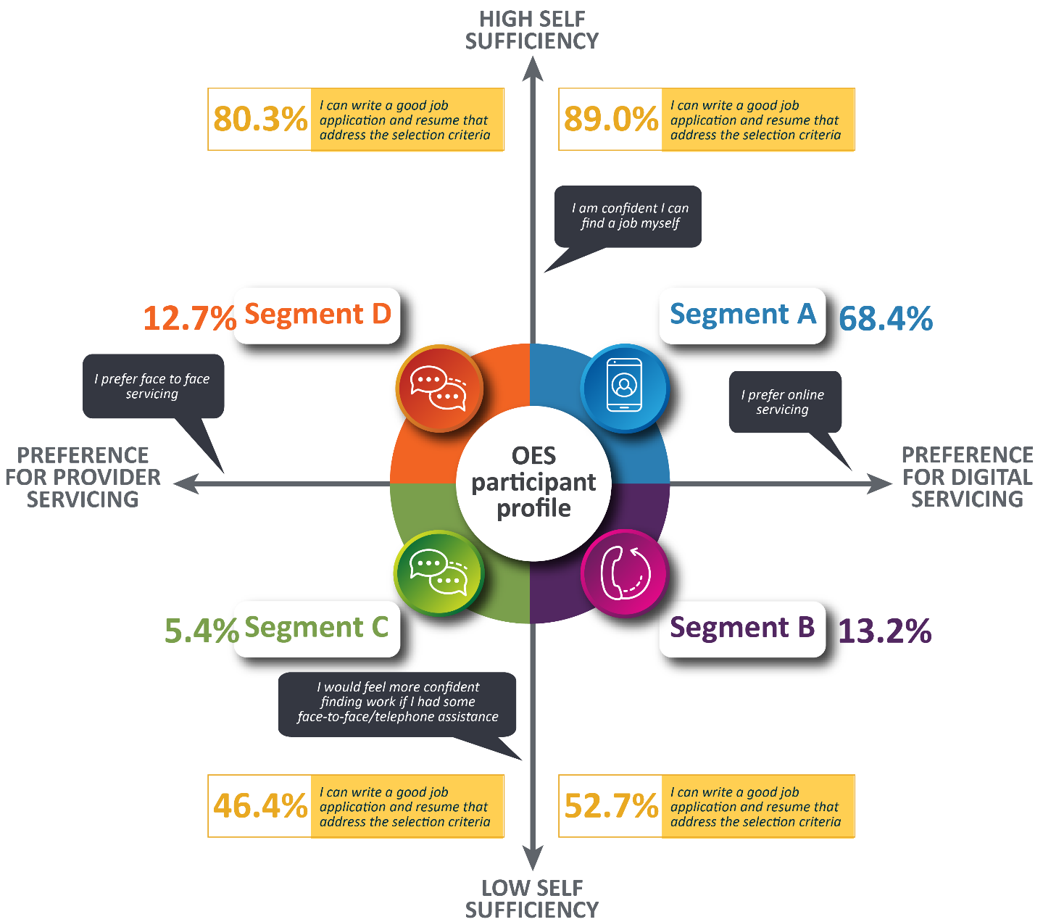
Source: OES Participant Survey, Waves 1 and 2.
Base: n=8,285, weighted.
Note: Excludes survey respondents who opted out to provider services before commencing in OES.

Segment D
This segment comprised around 13% of OES participants. These participants expressed a preference for face-to-face services but also had high perceived self-sufficiency. Most (80%) reported that they could write a good job application and résumé. While more tailored online services, including online skills training, could retain some of these participants in OES, they generally preferred face-to-face interactions and most likely would have opted out of OES had they been aware of the opt-out feature.

Comparative suitability for online services
Arguably those who preferred online services and were also confident in self-managing their job search on an online platform (Segment A) were more suitable for online services, compared with those who preferred provider services and were not confident in self-managing their job search independently (Segment C). Those who preferred online services but were not confident in job searching independently (Segment B) and those who preferred provider services but were confident in self-managing their job search (Segment D) could benefit from assistance from the DSCC in order to remain in online services.

3.5 Perceived advantages and disadvantages of online services
Participants’ perceptions of the advantages of online services served as a good measure of the appropriateness of OES to them. On the other hand, perceptions of the disadvantages of OES provide insights into what aspects of the service could be barriers to participation.

Advantages
Figure 3.4 shows that more than half (53.7%) of the participants who responded in Wave 2 of the OES Participant Survey identified the convenience of being able to access services any time and anywhere as the main advantage of online services. Cost and time efficiencies (38.7% and 43.1%) were identified as other main advantages, along with greater autonomy over the job search process (42.1%). However, 14.5% of OES participants thought online services offered no clear advantage, while another 7% were uncertain.
Figure 3.4 Perceived main advantages of online services
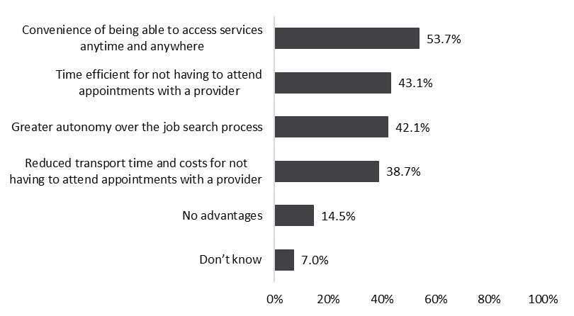
Source: OES Participant Survey, Wave 2.
Base: n=4,147, weighted results.
Note: The categories are not mutually exclusive and do not add to 100%. Q. What do you think are the main advantages of the jobactive/JobSearch website compared with provider-based employment services for you? (multiple selections are possible).
Qualitative research revealed that online services had made the job search process easier for participants. For example, the following participants perceived online services as time-efficient and less laborious:
I think it’s good … You can just attach [the application] instead of having to print and drive and go around, so where possible, I think it’s definitely better. (OES qualitative research, participant focus group)
So it’s nice to be able to apply to jobs when they pop up as soon as they pop up and not wait to go in person and see what they’re going to give you. (OES qualitative research, participant focus group)
Well as I say, it cuts down the travel requirements to get from where you live to where jobs are, to get in, present your résumé, that sort of thing. (OES qualitative research, Interview 16)

Disadvantages
However, online services were not without perceived disadvantages, as depicted in Figure 3.5. The most common (29.1%) disadvantage identified by participants in Wave 2 of the Participant Survey was a lack of assistance or feedback on job search, job applications, résumés and/or cover letters. This was closely followed by issues with job availability (28.5%) in terms of access – or a lack thereof – to unadvertised jobs.
One in 4 (23.3%) participants highlighted a lack of career guidance and advice, as well as a lack of social connection and contact (23.0%) as the main disadvantages of online services. A similar proportion (22.6%) also highlighted technological issues including technical problems with the jobactive/JobSearch website and issues using online services and computers in general.
However, it should be noted that almost a quarter (23.1%) of participants indicated that there were no disadvantages to online services when compared with provider services.
Figure 3.5 Perceived main disadvantages of online services
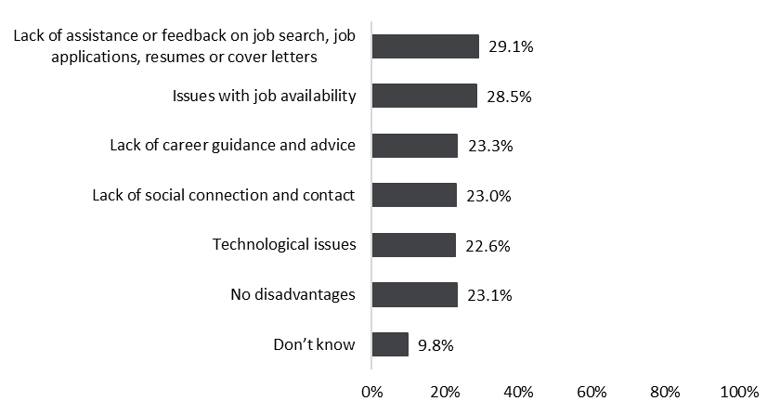
Source: OES Participant Survey, Wave 2.
Base: n=4,147, weighted results.
Note: The categories are not mutually exclusive and do not add to 100%. Q. What do you think are the main disadvantages of self-managed job searching on the jobactive/JobSearch website compared with provider-based employment services for you? (multiple selections are possible).
Of these identified disadvantages, the lack of social connection and contact emerged as prominent in the qualitative research. The following evidence highlighted its impacts on participant experience and engagement in online services.
I think a little bit of the human connection that you’d get from an actual job search provider; it does miss that a little bit in some situations. (OES qualitative research, focus group)
… to discuss my situation with people, like I found the robot was a robot, and it wasn’t intuitive in anyway, so if you had a situation where you were spending 2 days at TAFE, it didn’t care. And that’s you know, usually if you had a human, you can actually make allowance, maybe shave off like 3 jobs you’re linked to look for or whatever, so … I found that really difficult. At first, I found it hard to log my jobs, I remember the first day, where the heck do I go, and I was a bit lost. Once you get there, it’s fine, but yeah, log in … (OES qualitative research, participant interview)
The advantage totally it online is I’m not being annoyed by heaps of phone calls, but I missed someone following up. That’s what was lacking. So, following up on me and checking if I’m okay. (OES qualitative research, participant)
This lack of social connection and contact in online services compared to provider services was raised by providers in the qualitative research.
It’s more of a personal service, yes. And especially when you build a rapport with your consultant, you can call them anytime, or you can show up to the office anytime, and you get the assistance. I think that’s probably the downside of the online services – not having that instant customer service. (OES qualitative research, provider)
On the whole, OES Participant Survey results suggest that participants viewed online services more positively than provider services, with a much larger percentage identifying advantages than disadvantages (Figure 3.4). This finding is perhaps not surprising given the strong preference for online services among the participants noted earlier.
Further analysis showed that participants with a CALD background had more favourable views of online services compared to provider services; however, Aboriginal and/or Torres Strait Islander participants and people with disability were more concerned about the lack of assistance or feedback on job search, job applications, résumés and/or cover letters; the lack of career guidance and advice; and technological issues (Figure 3.6).
Participants with disability were also more likely to identify other main disadvantages of online services (Figure 3.6).
In addition to lower preferences for self-managed online job search, these results possibly reflect earlier findings that Aboriginal and/or Torres Strait Islander people and those with disability were less confident that they could find a job themselves. These participants might need more tailored services online to retain them in online services. They might also benefit from more assistance from a provider.
Figure 3.6 Perceived main disadvantages of online services for Aboriginal and/or Torres Strait Islander people and people with disability
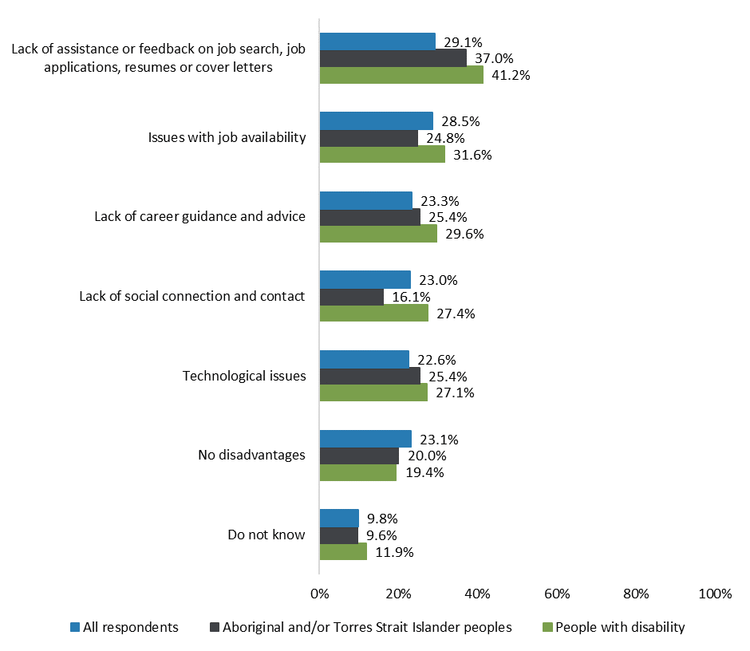
Source: OES Participant Survey, Wave 2.
Base: n=4,147, weighted results.
Note: The categories are not mutually exclusive and do not add to 100%. Q. What do you think are the main disadvantages of self-managed job searching on the jobactive/JobSearch website compared with provider-based employment services for you? (multiple selections are possible).

3.6 Stakeholder and jobactive provider views on appropriateness
Overall, there was consensus among jobactive providers and internal stakeholders that OES was appropriate as an online platform for delivering government employment services for the most job-ready and digitally capable job seekers.
I think it definitely proved that job seekers can self-serve, and even, I think it showed that they didn’t have to have face-to-face interviews, as well, with providers... it backed up what the OEST evaluation told us, which was that people could cope online and be successful in terms of moving through employment services, so it’s re-affirmed that. (OES qualitative research, EWG roundtable)
I would say most job seekers who are referred to the OES are capable and that that group is bigger than we thought it was. (OES qualitative research, EWG roundtable)
Look, I think it’s a great option to relieve some resources, with, for example, face-to-face providers. If a job seeker’s more than capable of handling job searches and looking for their own employment, this platform enables them to do that. To be – if they’re at least a little bit tech savvy and they learn how to navigate the jobactive website, I think it’s a great option. And also, the job seeker’s able to utilise their time effectively, to work around their day or however it suits them, just a great platform for the self-sufficient job seekers. (OES qualitative research, EWG roundtable)
The 2 waves of qualitative research included in-depth discussions with 15 jobactive providers where their views and opinions about OES were explored. Providers acknowledged that there were job seekers who could self-manage their job search on an online platform without further support from a provider, particularly when these job seekers have been appropriately assessed for their eligibility and capability for digital services.
Yes, yes. So to be honest I think it could work for anyone. I definitely think there are some people that prefer the more personal … the one on one, face to face servicing, and that’s more effective for them, but there are a lot of people that are very independent in looking for work and feel quite capable of using all of the online technology and just independent in that whole you know, meeting their requirements, ticking everything off … (OES qualitative research, jobactive provider interview)
I think it actually works fine if the job seeker is assessed appropriately. (OES qualitative research, jobactive provider interview)
However, providers also raised some concerns. For example, some thought that OES was less suitable for job seekers in regional areas where IT access was questionable.
… so for our more metro regions or sites, it’s really good for a lot of our customers to come through the online. In the same token, in our more regional areas, where it lacks IT, not so good. And they’re more the face-to-face engagements. (OES qualitative research, jobactive provider interview)
They were also concerned that job seekers from a CALD background might not have fully understood JSS questions and as a result could have been incorrectly referred to OES.
It is a language literacy issue. Because it is a high CALD refugee cohort. And they’re being pushed into these online services when they have no understanding, or limited understanding, of what that snapshot means. (OES qualitative research, jobactive provider interview)
[The participants] haven’t identified enough barriers for them to be really referred appropriately … So, the most common ones that are there, for example, depression, anxiety. But there are some that it’s things beyond that. Like, we have schizophrenia, they have psychotic episodes, there’s homelessness. And the education, it’s not as high as some of them stipulate [in their JSS]... Maybe it’s just the case that the client didn’t want to disclose that or didn’t disclose it. (OES qualitative research, jobactive provider interview)
The safeguards provided in OES (discussed in Chapter 5), particularly the opt-out feature, were designed to address these potential issues raised by providers.

Chapter 4 Effectiveness of OES core functionality and enhancements
This chapter addresses the effectiveness of OES in enabling participants to self-manage and meet their MORs on an online platform. It examines participants’ awareness and use of various tools and resources in OES, including core functionalities that were replicated from OEST and enhanced features that were introduced in OES resulting from OEST learnings. Chapter 1 provided an overview of these functionalities and enhancements.

4.1 jobactive/JobSearch website and app
Through the jobactive/JobSearch website and/or app, participants were able to access a number of online tools and resources to search for jobs and submit job applications. The website and app also included an OES dashboard to help participants monitor their progress towards meeting their MORs. Participants’ views about the website and app were mixed. Results from Wave 1 of the OES Participant Survey (Figure 4.1) showed that the majority (58.2%) of participants felt the website and/or app were good or excellent in terms of their ease of use. Half (49.9%) thought they were useful, and 49.4% thought they had the flexibility to do what they needed to do, but slightly fewer (46.6%) agreed that there was sufficient information on how to get help if they needed it. Overall, around 30% of participants rated the jobactive/JobSearch website and/or app as fair and 11.1% to 18.4% rated them as poor or very poor.
Figure 4.1 Participant experience with JobSearch (%)
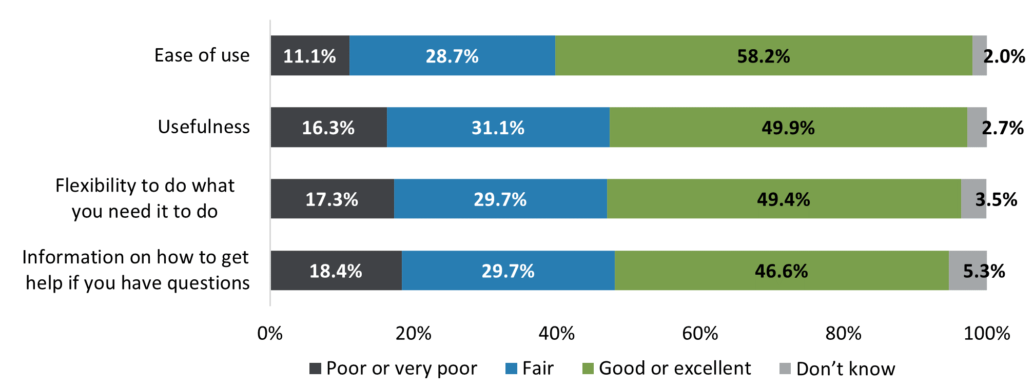
Source: OES Participant Survey, Wave 1.
Base: n=4,229, weighted results.
Note: Q. Thinking about the jobactive/JobSearch website or app, how would you rate …
These results were generally confirmed by qualitative research, which broadly found that while participants felt that the jobactive/JobSearch website and/or app were easy enough to use, they did not present anything new or extraordinary. Most found the website and/or app similar to other commercial online platforms and many used the jobactive/JobSearch website and/or app mainly for compliance and did not explore other OES features.
Well, when you log in, it’s fine, to upload evidence – do what you need to do on the basic page, but I wouldn’t really go looking elsewhere. (OES qualitative research, participant focus group)
In terms of navigation, it was pretty straightforward. (OES qualitative research, participant interview)
The impression of the dashboard as a compliance tool was also echoed by participants in the NEST evaluation, which found that participants did not navigate much beyond the dashboard because they used the website and/or app primarily for compliance purposes.
When you log on, all you got was the big compliance thing, right in the middle of the screen … And considering that’s what you generally log on for in the first place, you don't really scroll to the bottom of the screen to see if there’s anything else down there for you. (NEST Longitudinal Survey, Digital First participant interview)

Challenges with using the jobactive/JobSearch website and/or app
Results from Wave 2 of the OES Participant Survey showed that a little over a third (36.3%) of participants agreed that they had sometimes experienced problems submitting their evidence of job searches online, while a little under a third (31.3%) reported that they sometimes experienced problems providing evidence of approved activities online. The PEES Survey also showed that more than 1 in 10 (13.5%) OES participants had unreliable or no internet access at the time of the survey.
Qualitative research shed some light on factors that may have contributed to the problems participants encountered with the website and/or app, such as poor internet connection and a lack of customisation to meet individual needs. Some participants were frustrated with broken links and outdated information on the website.
It probably didn’t help with the low quality of my internet connection, just like trying to upload the information as well as contact details and stuff like that. A very slow, painful process. (PEES qualitative research, OES participant interview)
It wasn’t … government websites, they’re all very – because there’s so many pages linking off to different things, it wasn’t the easiest to find. Just because there’s so many different hyperlinks to other things. (OES qualitative research, participant longitudinal interview)
Several qualitative participants expressed frustration with the lack of job filtering in JobSearch, where job recommendations resulting from their searches were not related to their skill sets or what they were looking for.
It’s not my first choice, but it’s not terrible. It’s pretty easy … but it doesn’t let you filter jobs; it does a ‘related’ search instead of an accurate search. So if you search – say it’s a sales job, it will give you everything related to sales. (OES qualitative research, participant interview)
Maybe more filters that you can put in for your job search; so you can narrow your search even more, so, as I said, you’re not going through too many jobs looking for one. (OES qualitative research, participant interview)
This issue was particularly relevant for participants who were recently unemployed with extensive experience in specialised industries. These participants were unable to narrow their search down to the specific industry of relevance to their experience.
I work as an information systems architect, or a solutions architect, or a data architect, technical architect, and the Job Seeker services don’t have any … anything to do with what I work in. They don’t even have the categories listed in there. (OES qualitative research, participant interview)
I’m applying for relatively specific job roles and industries, so … it was quite limited particularly because there was a pandemic on, and you were limited to Victoria or at least close to Melbourne. So, I did find other job platforms like SEEK and there’s a few specific design places that usually just had a much wider range of job roles for my particular industry. (OES qualitative research, focus group)
Some DSCC frontline staff identified a risk associated with participants who struggled to navigate or use the jobactive/JobSearch website. Participants with initial high levels of self-motivation could lose their motivation if they became frustrated trying to use a website that was not user friendly.
It’s one of the things I said, like pretty much at the start is that there are a lot of them are self-motivated, they want to do these things, they just don’t know how to find the information that they need for it. And being struggling through our website and not finding what they want, is just going to mean that they don’t want to do it again. Like if they struggled to do it the first time and they can’t find it easily. They’re gonna think about it and go, well, I’d love to do this. But I can’t be bothered going through the pages and pages of information that’s not relevant. When I can’t find anything. (OES qualitative research, DSCC focus group)
The DSCC frontline staff also voiced frustration at frequently receiving the same enquiries for information that could be made available on the jobactive/JobSearch website and/or app instead. If information such as how to complete a study declaration or paid work declaration were easy to find on the website and app, this would free up their time to assist participants with other queries.
We often get calls with cases where they’ve commenced some employment, or maybe they’re studying, so now they’ve got some questions regarding completing a study declaration or a paid work declaration to potentially reduce their job search efforts and make things a bit more manageable. I think those types of things might be better highlighted on the jobactive website to … prevent calls of that nature. (OES qualitative research, DSCC focus group)
We do get those constant calls about: that’s a really common one, where I feel like the rules, if they were stated somewhere on our site, would be really handy for people to know, because it is information that we typically find ourselves giving out fifteen or twenty times a day, if you’re, perhaps, doing inbound all day. So yeah; I feel like that would be handy to have on our site. (OES qualitative research, DSCC focus group)
Or even just a notification that pops up if the system sees that they’re potentially meeting those requirements; say it finds that they’re hitting forty hours of work, it might come up with a little pop up that says ‘maybe you should put in a paid work declaration’ or suggest a few things in that way; that could be handy. (OES qualitative research, DSCC focus group)

4.2 OES dashboard
As noted earlier, while participants had access to a range of functions through the jobactive/JobSearch website and/or app, not all OES functions were utilised. The PEES Survey found that the OES dashboard was the most frequently used, with a majority (73.9%) of participants in the survey reporting that they had used the dashboard (Table 4.1). This most likely reflects the fact that the dashboard was used by participants to monitor and report their MORs.
Table 4.1 OES participant use of tools and resources on the jobactive/JobSearch website in the 6 months before the survey (%)
Resource | (%)
OES dashboard | 73.9
Profile* | 26.4
Videos/links to videos | 16.1
Résumé builder | 15.7
Blogs | 4.4
Job Switch | 3.6
None of these tools/resources used | 17.9
Source: PEES Survey, 2021.
Base: n=1,345 OES participants, weighted results.
Note: Multiple responses were allowed, so percentages do not add to 100%.
*The PEES Survey data on the proportion of OES participants completing the profile differs notably from administrative data on its usage as reported in Section 4.3. It should be noted that the PEES Survey relied on respondents being able to recall completing the profile and also recognising the name of the tool itself. Furthermore, the PEES Survey was conducted before the introduction in December 2021 of the mandatory requirement to complete the profile. Q. In the last 6 months have you used any of the following tools or resources on the jobactive/JobSearch website or app?
Wave 2 of the OES Participant Survey revealed that more than three-quarters (76.4%) of participants agreed the dashboard was effective in helping them monitor their job search requirements.
Qualitative research findings were consistent with these findings. Participants reported that they regularly used the OES dashboard to report their job search efforts. Almost all participants in the qualitative research reported that the OES dashboard was easy to use and helped them monitor their MORs.
It was useful, especially cos it gives you prompts when you’re behind, so it’s easier to keep track. So it sends you text messages and emails. (OES qualitative research, participant interview)
Because you have everything in front of you and you can just check like, ‘Have I reached this months’ thing? No, okay,’ right, so I start searching for jobs again. (OES qualitative research, participant interview)
I like the little thing that reminds you how many jobs you’ve still got to go for the month. And then it goes red if you’re getting too close and you still haven’t completed it. So, I find that’s a good help. (OES qualitative research
, participant interview)

4.3 Profile
Following commencement in OES, participants were prompted to create and update an online profile and upload a résumé detailing their:
- work experience history: past employment details such as job title, job description, employer name and period of employment
- educational history: education and qualification (including licences and accreditations) details such as qualification title, qualification type, institution name and qualification year
- skills acquired: a list of skills attained.
Participants could also upload other information such as their preferred occupations, tenure types and job types, as well as their access to transport and hours of availability for work. Participants received job suggestions and job alerts based on the occupation and location preferences and other information disclosed in their profile. In addition, participants could choose to make their profile publicly visible and/or share it with employers.
The purpose of creating a profile on the OES platform is to help participants connect with employers. Maintaining and sharing an up-to-date profile had the potential to improve job matching for the participant, particularly with employers who use the Find Candidates feature.
Before 4 December 2021, completion of a profile was optional; however, from 4 December 2021, it became mandatory for all new OES participants to complete the work experience, education history and skills components of the profile in order to receive income support payments unless they had a valid exemption reason. Participants were also required to update their profile (or indicate that no updates were required) every 6 months as part of their Job Plan requirements.

Completion and sharing of the profile
According to administrative data, 4 in 5 (79.0%) participants referred to OES between 1 December 2020 and 31 December 2021 had completed a profile either before or during their time in OES. Almost all (96.8%) participants still in OES on 30 June 2022 had completed a profile.
Many (42.0%) OES participants had already created a profile before they were referred to OES and most (68.2%) had completed a profile within 4 weeks of referral (see Figure 4.2).
Figure 4.2 Cumulative % of OES participants who completed a profile relative to referral to OES
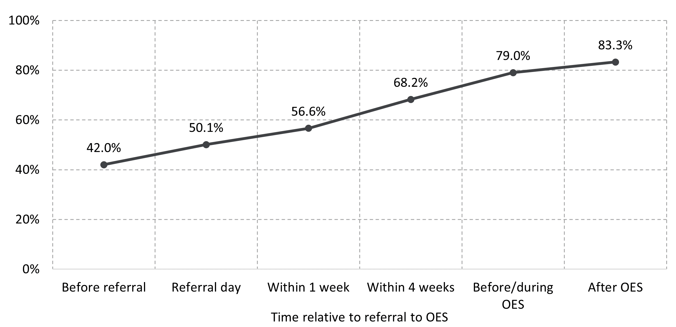
Source: DEWR administrative data, extracted on 30 June 2022.
Base: Participants referred to OES between 1 December 2020 and 31 December 2021.
Note: Timing of the completion of the profile relative to participant’s referral to OES. If a participant completed a profile after exiting OES but within (say) 6 months of referral to OES they were counted in the ‘After OES’ category.
Administrative data analysis showed that more than half (57.7%) of all OES participants referred to OES between 1 December 2020 and 31 December 2021, the period on which most of the analysis using administrative data was based, created or updated their profile at least once during OES, likely indicating that the profiles of these participants were generally up to date and reliable.
Wave 2 of the OES Participant Survey showed that, of those participants who recalled completing a profile, 3 in 5 (59.8%) had shared an online résumé link with potential employers, while about the same proportion (59.5%) had made their profile public, enabling employers to find them through the Find Candidates feature (discussed in Chapter 7).
While participants could receive job match notifications after completing a profile, qualitative research conducted for the NEST evaluation found that awareness and use of the profile was low among NEST Digital Services participants.

Participants’ ratings of the Profile function
According to Wave 1 of the OES Participant Survey, a majority (71.2%) of participants who recalled completing a profile agreed that the function was easy to use, and most (65.1%) agreed that creating and/or uploading a résumé on their profile was useful (Figure 4.3). Participants who were satisfied with OES overall were more likely to rate the Profile function highly as well, with 87.5% of this cohort agreeing that it was easy to use and 82.1% agreeing that creating and/or uploading a résumé on their profile was useful.
Figure 4.3 Participants’ ratings of the Profile function
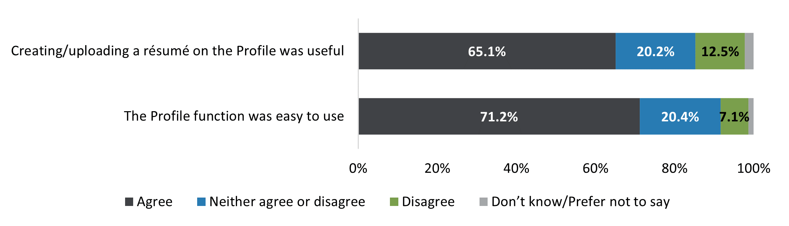
Source: OES Participant Survey, Wave 1.
Base: n=2,735.
Note: Excludes 892 who responded ‘no’ or ‘don’t know’ when asked if they recalled completing the profile. Agree combines ratings of ‘agree’ and ‘strongly agree’, and disagree combines ratings of ‘disagree’ and ‘strongly disagree’.

4.4 Digital Services Contact Centre
The DSCC was initially set up as a service centre for NEST Digital Services participants to receive telephone and email assistance. When first introduced on 1 October 2019, this service was provided by the department’s NCSL. The dedicated DSCC helpline began on 21 September 2020 and operates from 2 centres – one in Adelaide and one in Brisbane. The DSCC also provided support to OES participants, including:
- information and technical support
- opting out of online services
- understanding and managing MORs
- connecting to complementary programs, activities and/or other support services
- updating their JSS if their circumstances changed.
In addition to handling inbound calls, the DSCC made outbound calls, including in relation to discussing MORs with OES participants. The DSCC contacted these participants to offer assistance and, where necessary, helped them opt out to provider services.
I have been on some outbound projects as well. And currently doing capability interviews over the phone with job seekers. (OES qualitative research, DSCC Focus Group)
… some key roles in some of the key steps that people need to take, such as the … capability interview: if people are starting to get demerits, when they hit that point, the DSCC steps in and has a role there at looking at whether people – where they’re at. They also have a function of opting people out of that service if it’s not suiting them as well. (OES qualitative research, DSCC Focus Group)

Awareness of department helplines
According to Wave 2 of the OES Participant Survey, less than half (47.4%) of OES participants were aware of the department helplines. There was little variation in the level of awareness across key demographics, with the exception of people with disability, of whom 38.2% were aware of the helplines.
Encouragingly, despite low awareness of the department helplines, most participants in qualitative discussions reported that they knew how to get help if required, with helplines and the chat box most frequently mentioned. However, when prompted, it was revealed that while some were aware specifically of the DSCC and NCSL, most participants were not clear on the difference between the 2 helplines, or which one they had used to contact the department.
If I needed something then I would call … I know there’s a lot of different numbers for different things, like especially helplines if you’re feeling a certain way or you’re struggling in some way, I know there’s a lot of options that you can call and just get some help. (OES qualitative research, participant interview)
Many participants also confused the department helplines with those of Services Australia. This was a deterrent for those who had experienced, or heard negative feedback about, Services Australia helplines, such as long wait times.
Generally, it’s not something that people want to do, to actually contact any Centrelink-related organisations on the phone, because of wait times, and I think a lot of people experience difficulty getting adequate support from these services by calling. While the sites are quite good and helpful, there is an issue trying to contact a person to talk to when it comes to these services. (OES qualitative research, participant focus group)
OES participants often said that they had located a phone number to call for assistance at the bottom of the webpage without necessarily being aware of which helpline they were contacting.

Needs for assistance
Wave 2 of the OES Participant Survey found that only a few (27.7%) OES participants had needed assistance with OES in the 6 months before the survey, perhaps explaining, at least to some extent, why less than half of OES participants were aware of the department helplines. A further 65.8% of participants reported that they did not need assistance with OES, while the remaining 6.5% responded ‘prefer not to say’ or ‘don’t know’ (Figure 4.4). It may be that those who had not needed assistance before the survey would have been able to find where to go for help had they needed it.
Understandably, those who opted out after commencing in OES were more likely to have needed assistance (54.6%). This could reflect the fact that the DSCC was a preferred method for participants to opt out of OES (with some others choosing to opt out without assistance through the jobactive/JobSearch website). Participants who struggled to self-manage their job search requirements in OES and eventually opted out were also more likely to have needed assistance while they were in OES. By comparison, those participants who remained in OES were likely to have been a better fit for the service and therefore had less need for assistance than those who opted out.
Figure 4.4 Participants’ need for assistance in the 6 months before the survey
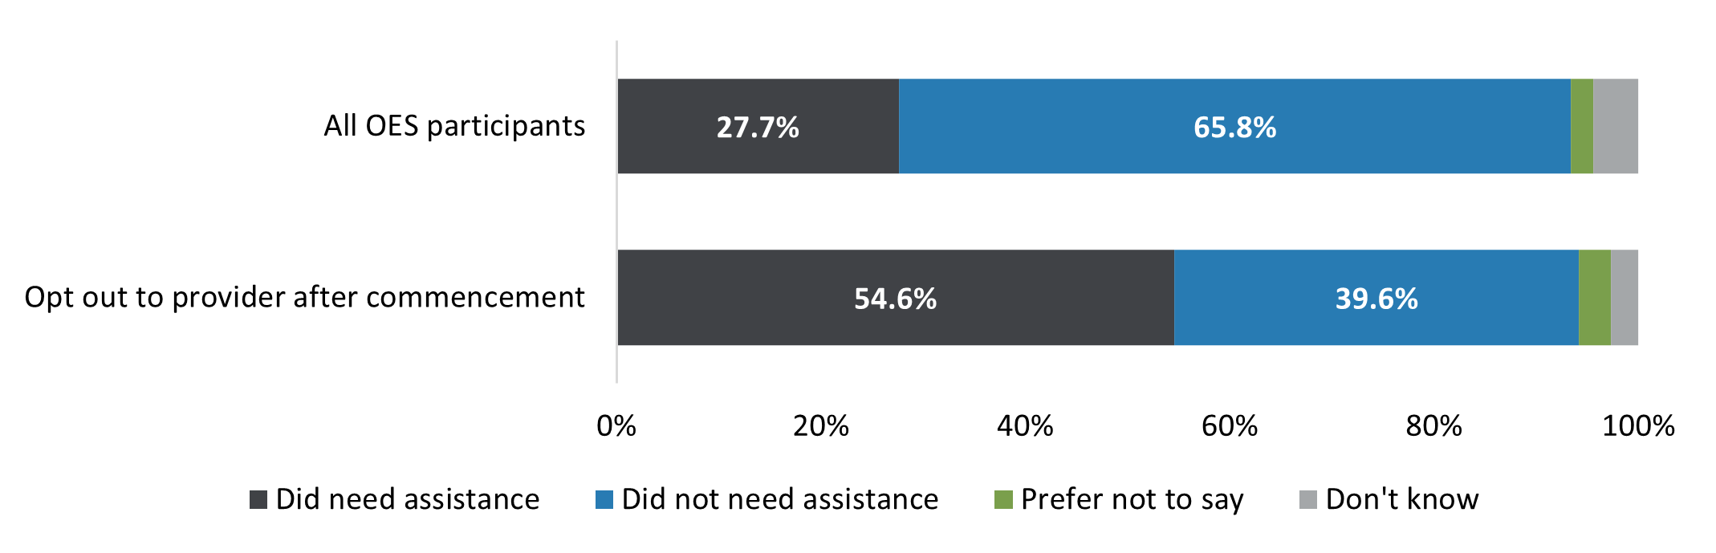
Source: OES Participant Survey, Wave 2.
Base: n=4,147.
Figure 4.5 shows that the proportion requiring assistance was higher among participants who reported a preference for provider assistance and were not confident that they could find a job themselves (51.9%), people aged 50 years and over (37.5%) and people with disability (34.2%). Surprisingly, the proportion requiring assistance among those with a CALD background (24.1%) was lower than for all OES participants.
Of those who had needed assistance with OES in the 6 months before the OES Participant Survey, 26.8% indicated that they would contact one of the department helplines, while 47.3% identified Services Australia and 40.7% identified a jobactive provider as points of contact (Figure 4.6). Similarly, participants who had not needed any assistance also identified Services Australia and a jobactive provider as potential sources of help.
Figure 4.5 Participants’ need for assistance in the 6 months before the survey, by demographic
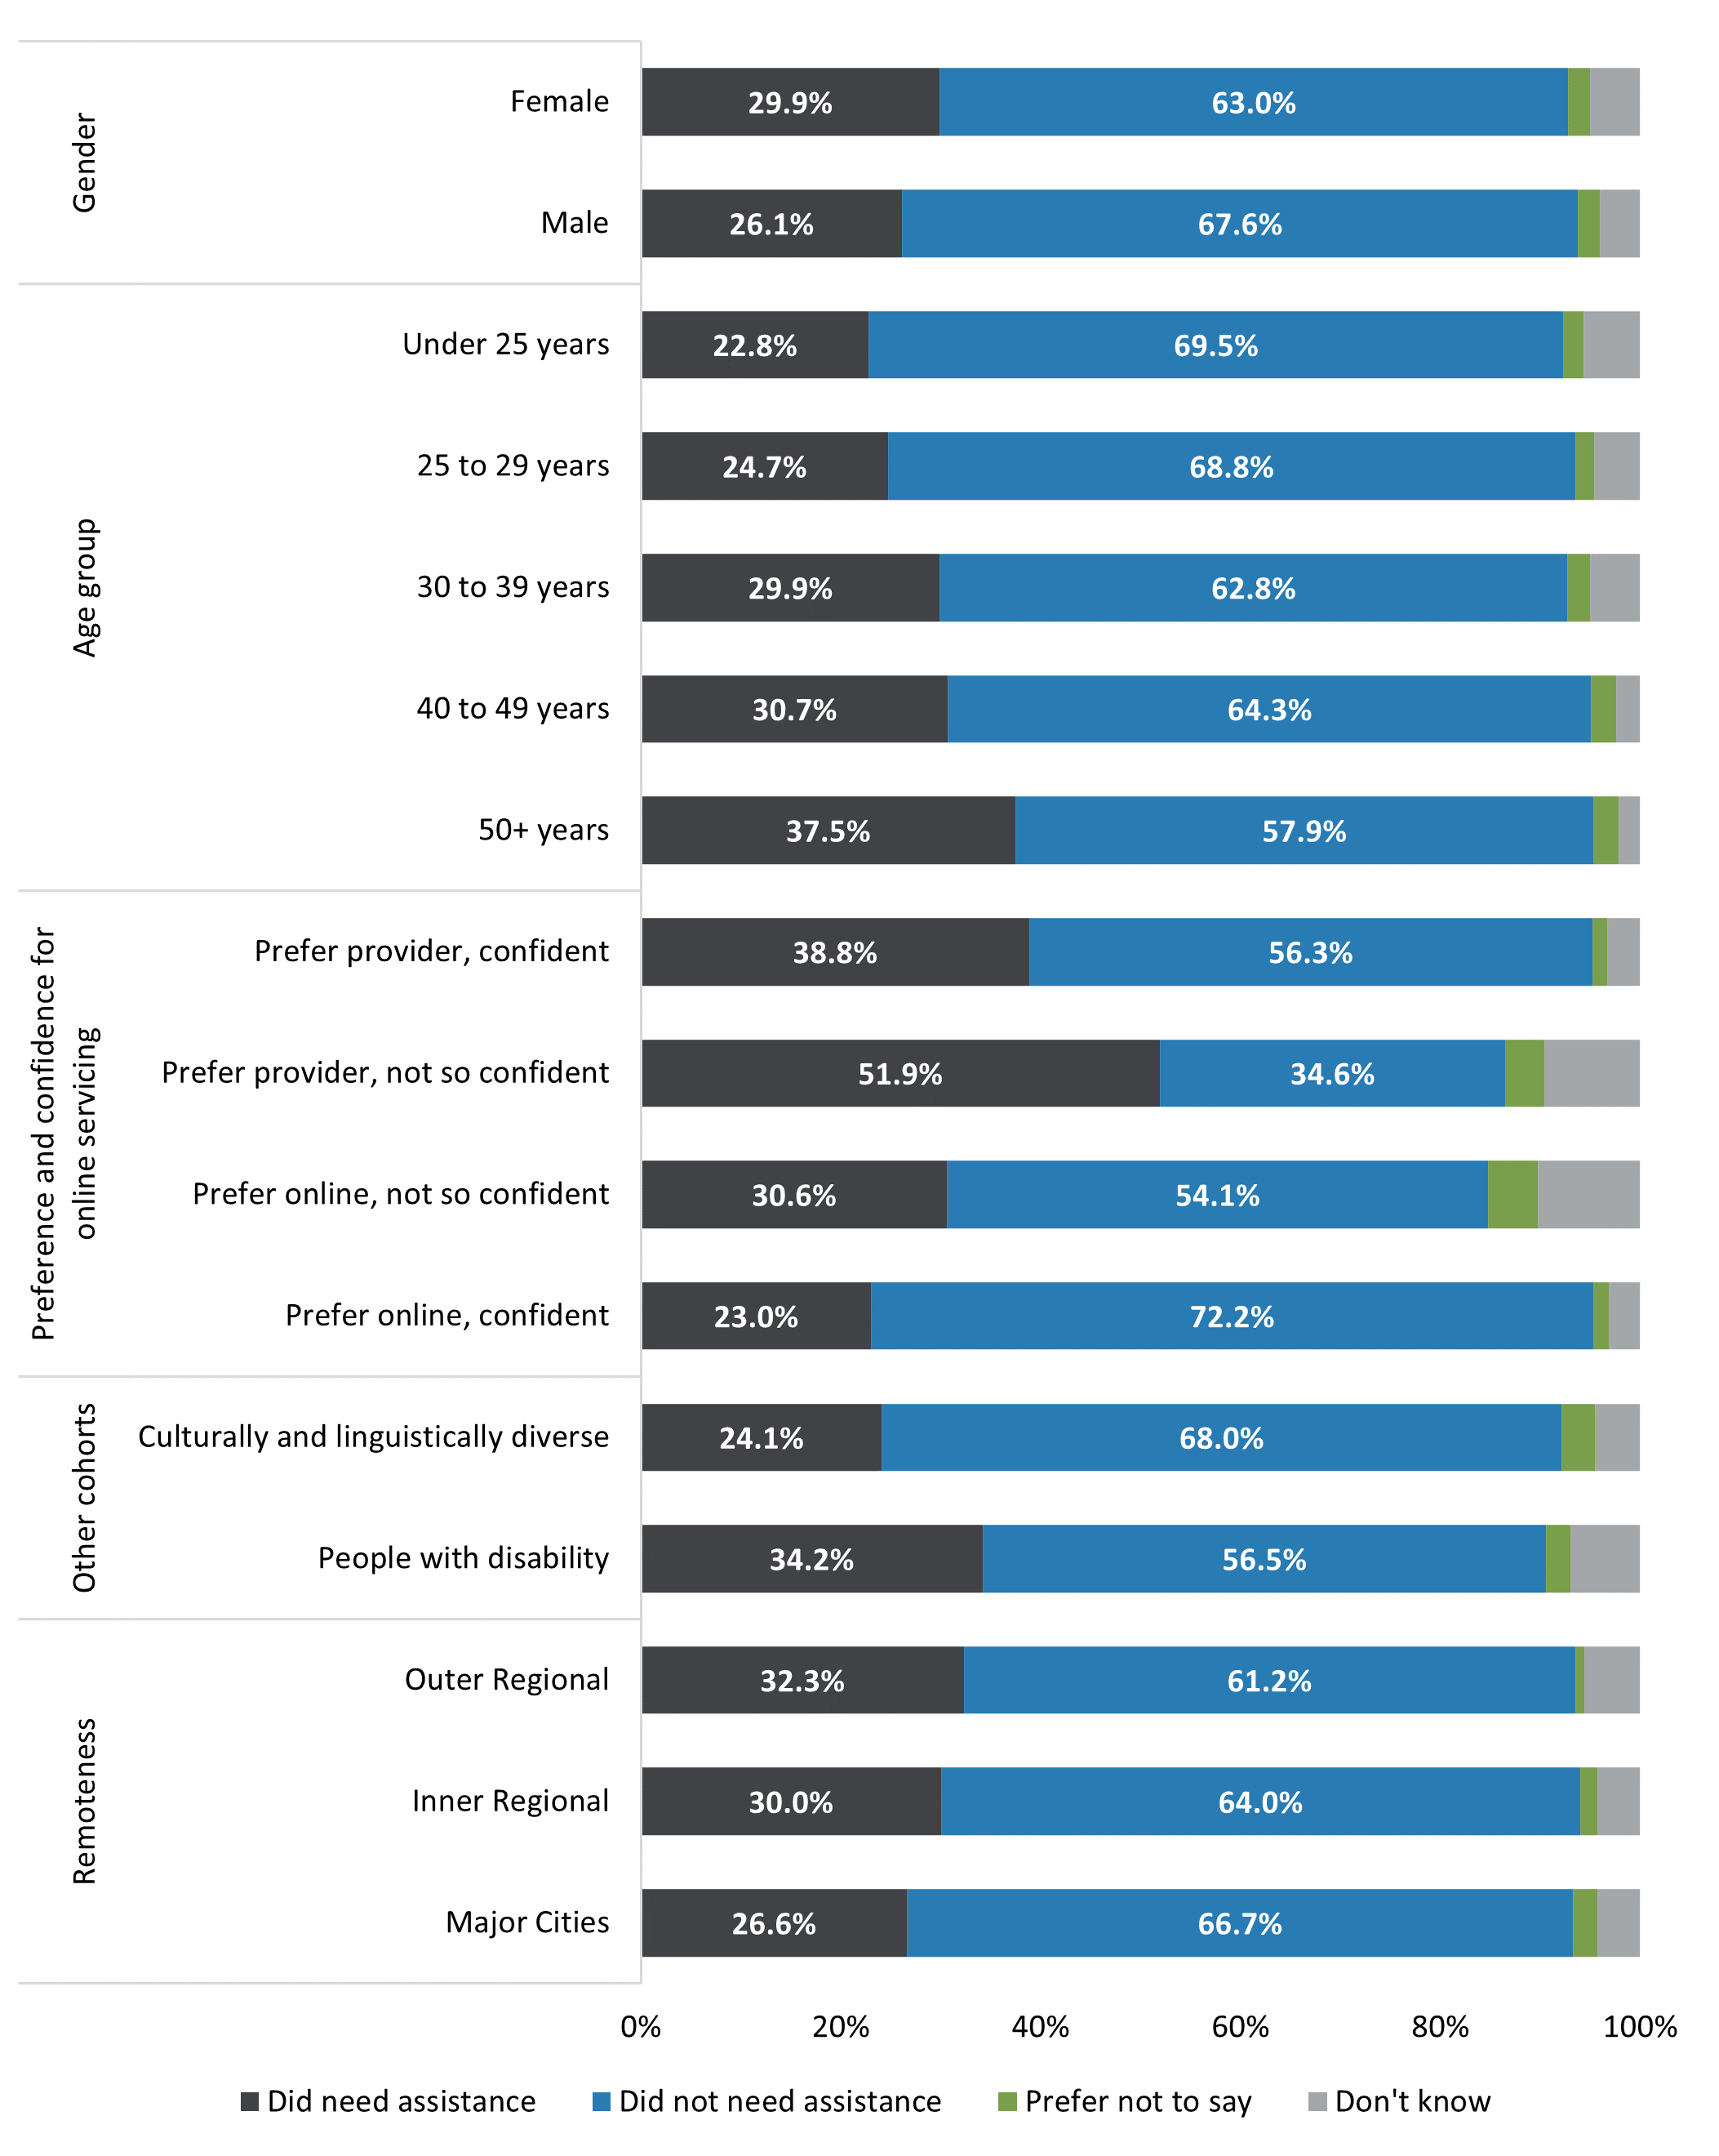
Source: OES Participant Survey, Wave 2.
Base: n=4,147.
Figure 4.6 Participants’ preferred points of contact when assistance with OES was needed
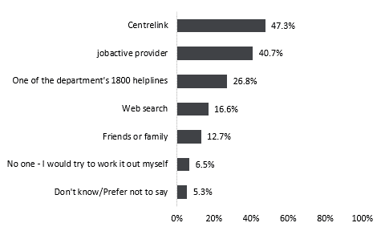
Source: OES Participant Survey, Wave 2
Base: n=1,223.
Note: Excludes 2,924 respondents who, when asked if they had needed assistance with OES in the 6 months before the survey, had answered ‘no’, ‘prefer not to say’ or ‘don’t know’. The categories are not mutually exclusive, and as such add to more than 100%.
Participants who were aware of the department helplines gave the following main reasons for turning to other sources of support (Figure 4.7):
- expecting long waiting time with the helplines (46.8%)
- not confident the helplines would fix their issues (21.0%)
- poor prior experience with the helplines (15.7%)
- expecting impersonal customer service on the helplines (15.2%).
The NEST evaluation also found that several participants thought that the department website needed to better distinguish the frontline services and supports that the department delivered from those provided by other agencies such as Centrelink or Services Australia, so that participants had a better understanding of:
- which department they were dealing with and the relationship between employment services and income support
- who to contact for questions about their employment pathways, their activation options, and/or the service offering, or for feedback/complaints about either the website or the DSCC/NCSL.
Figure 4.7 Reasons for using sources other than the department helplines
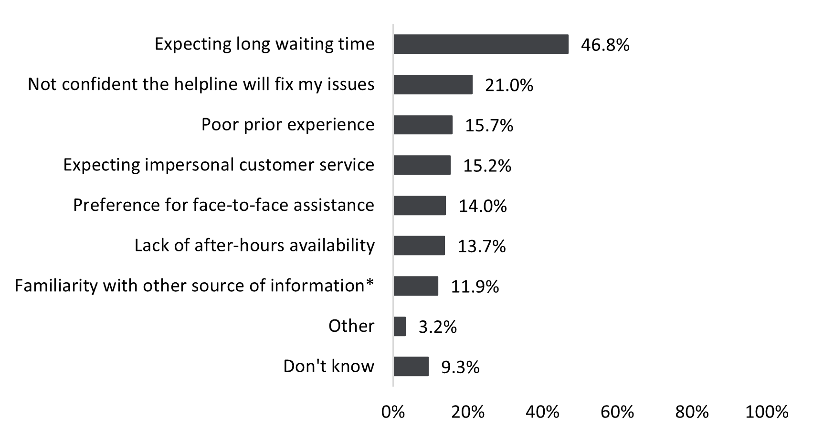
Source: OES Participant Survey, Wave 2.
Base: n=873.
Note: Excludes 3,274 respondents who were not aware of the department’s helplines and/or specified the department helplines as a source of assistance when needing help with OES. The categories are not mutually exclusive, and as such add to more than 100%. *Responses indicated by an asterisk were included in the qualitative ‘other’ category and coded into separate categories after the finalisation of the survey; therefore, they may have been less likely to be chosen by respondents.

Use of department helplines
Analysis of administrative data between 5 December 2020 and 6 December 2021 (the analysis period) revealed that the majority (91.9%) of total contacts by OES participants to the department were made to the DSCC, reflecting its intended use by online-serviced participants. Some (6.4%) participants also called the NCSL, some (1.6%) emailed the department, and a small number used other contact methods such as an employer hotline. During the analysis period, 37.2% of OES participants contacted the department using one of the above methods (referred to as ‘department helplines’ for simplicity). Of those participants who contacted a helpline, each made contact twice on average (Figure 4.8)
Focus group discussions with DSCC frontline staff revealed that some participants preferred to email rather than call:
Sometimes, people don’t like to be on the telephone, so they use the email system, so it works really well, both ways. (OES qualitative research, DSCC focus group)
About three-quarters (75.8%) of participants who had opted out of OES after commencement had contacted a department helpline while in OES, compared with all OES participants. As mentioned earlier, this is likely a reflection that the DSCC is the preferred method for a participant to opt out of OES, as well as this cohort’s greater need for assistance while in OES. By comparison, a smaller proportion of participants who commenced in OES during the analysis period and were still in OES as of 30 June 2022 had made contact with the department (29.1%), likely reflecting their ability to use OES to self-manage their job search online.
The proportion of all OES participants who contacted the department helplines increased with the age of the participant, with 32.8% of those aged under 25 years making contact, compared with 51.7% of those aged 50 years and over. Other cohorts with a larger proportion making contact included single parents (47.8%), people living in outer regional areas (45.3%), people with a duration of income support of less than a year at commencement in OES (43.9%), people with mixed or poor English proficiency (43.9%), people with disability (43.6%) and Aboriginal and/or Torres Strait Islander people (42.8%). Notably, many of these cohorts are those that are often associated with higher levels of disadvantage in the labour market (Figure 4.8). This indicates that participants in some cohorts struggled to self-manage in OES and this should be a factor for consideration when strengthening online services safeguards.

Reasons for contacting the department helplines
According to administrative data, the most common reasons for contacting the department helplines involved employment services enquiries related to:
- MORs in the participant’s Job Plan (56.6% of all contacts)
- action(s) required under the Targeted Compliance Framework (TCF) such as re-engagement or agreeing to a Job Plan (15.3%)
- providing a valid reason for not meeting MORs under the TCF (14.8%)
- assistance with IT such as navigating the jobactive/JobSearch website and/or app, linking to myGov, reporting job search efforts, and reporting technical issues and outages (11.7%).
Focus group discussions with DSCC frontline staff confirmed that enquiries relating to MORs and the TCF were the most frequent types of calls they received.
Sometimes it’s because they don’t know why they have been suspended as they were unsure of what mutual obligations they had; sometimes they haven’t been educated on how to submit that evidence to us. (OES qualitative research, DSCC focus group)
The top reasons for contacting the department helplines, according to the categories used in administrative data, do not seem to vary by participant characteristics.

Timing of contact
Consistent with the low awareness and low need for and usage of the department helplines found in the OES Participant Survey, administrative data showed that few participants had contacted the department helplines shortly after being referred to OES. Of all OES participants, only 3.3% had made at least one contact within one week from their referral date, 18.8% had made at least one contact within 8 weeks from their referral date, and 34.2% had made at least one contact within 26 weeks from their referral date (Figure 4.9). As expected, a higher proportion of those who opted out of OES contacted the department helplines, compared to all OES participants.
Figure 4.8 Proportion of OES participants who contacted the department helplines, by key cohort
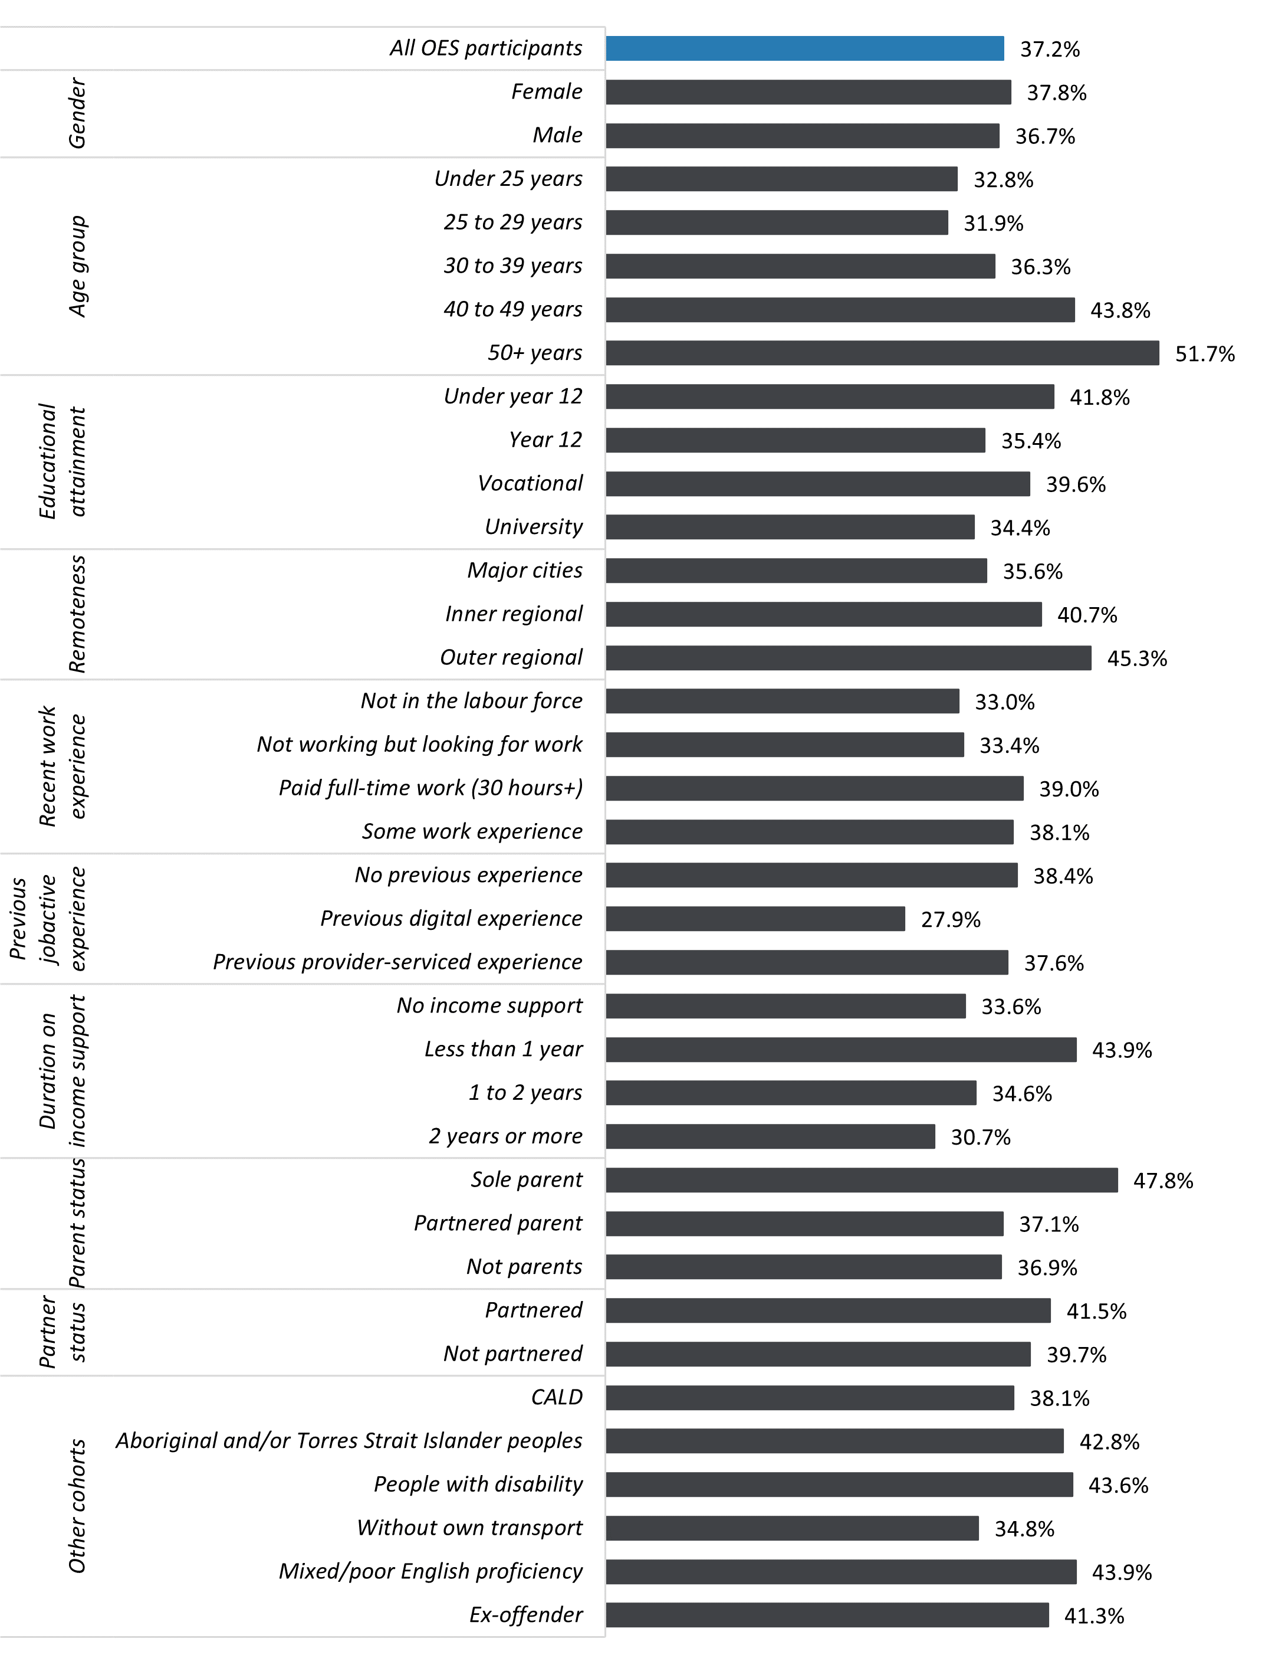
Source: DEWR administrative data, extracted as at 30 June 2022.
Base: Commenced participants referred to OES, and enquiries made between 5 December 2020 and 6 December 2021.
Note: Enquiries are limited to those made between the date the participant was referred to OES and the date they left OES. Excludes missing equity groups where the status is unknown.
Figure 4.9 Cumulative proportion of OES participants who had contacted the department helplines by number of weeks following referral to OES
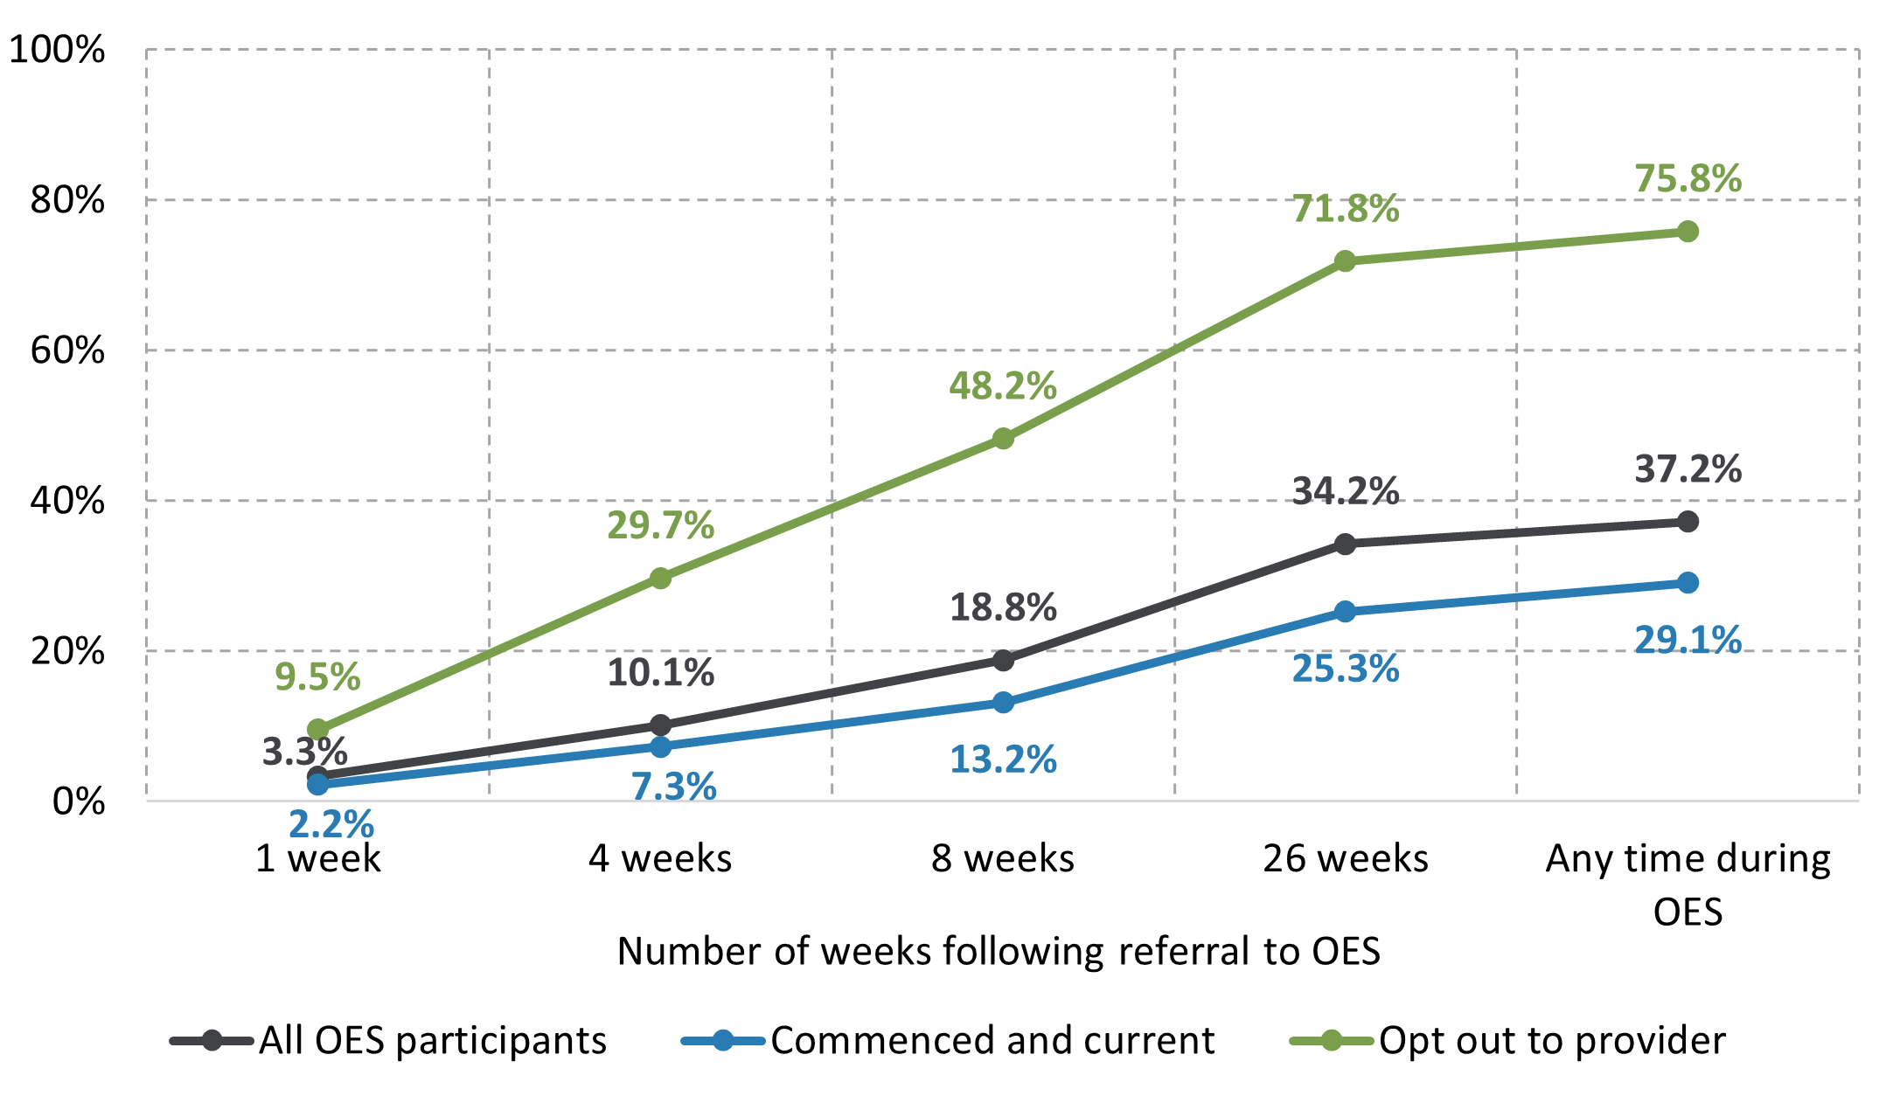
Source: DEWR administrative data, extracted as at 30 June 2022.
Base: Commenced participants referred to OES, and enquiries made between 5 December 2020 and 6 December 2021.
Note: Enquiries were limited to those made between the participant’s referral date and their contract replacement placement end date. Proportions are of those who made at least one contact within the referenced time following referral to OES.

Satisfaction with the department helplines
While awareness of the helplines was low and, when aware of the service, many participants were hesitant to use it (as discussed earlier), among those who had actually contacted a helpline in the 6 months before Wave 1 of the OES Participant Survey, satisfaction ratings were high (Figure 4.10) in terms of:
- resolution of the issue or query (75.1% satisfied)
- politeness of the operator (93.4%)
- getting individualised advice (75.4%)
- the overall service provided (78.3%).
Participants who were satisfied with OES overall were also satisfied with the department helplines, with 96.0% of this cohort satisfied with the overall service provided by the helplines.
These results are consistent with findings from qualitative discussions, where most participants indicated they were enthusiastic about their experiences with the department helplines. Overall, qualitative research participants who contacted a helpline were very satisfied with the service and agreed that their queries had been resolved. In particular, participants thought their calls were answered quickly and the quality of service was high.

Figure 4.10 Satisfaction with department helplines among participants who had contacted a helpline 6 months before the survey
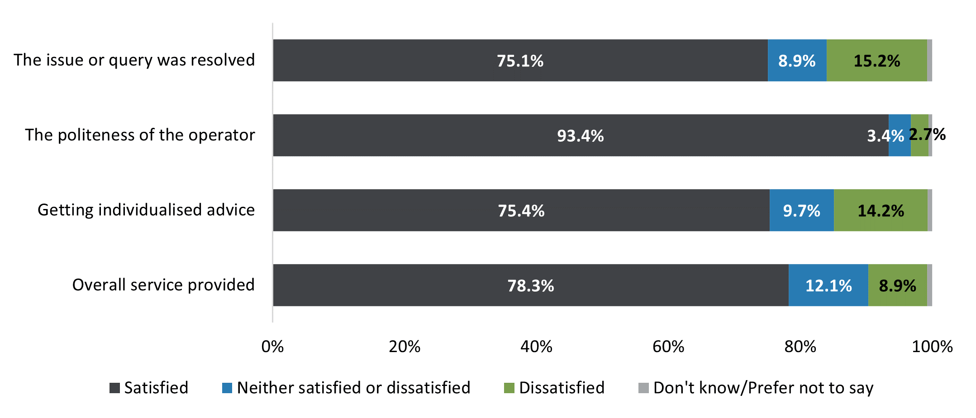
Source: OES Participant Survey, Wave 1.
Base: n=460.
Note: Excludes 4,229 respondents who had not contacted a department helpline in the 6 months before the survey or who answered ‘don’t know’ or ‘prefer not to say.’ Satisfied is a combination of ‘satisfied’ and ‘very satisfied’, and dissatisfied is a combination of ‘dissatisfied’ and ‘very dissatisfied’.
Participants reported that in circumstances where the operator who took the call was unable to answer the question, they were transferred to someone who could, and that the operator who transferred the call would explain the situation to the next person so that they did not have to explain the issue or query again.
But I did call initially when none of my info was importing. And the guy spent, like, an hour on the phone with me just trying to work it out. So, yeah, he was super helpful. (OES qualitative research, participant focus group)
… I was a bit actually scared ’cos part of the message was if I don’t fulfill my mutual obligations, I could be fined … I explained my situation and the man I talked to was very patient and he explained everything and fixed my online mutual obligations as well. (OES qualitative research, participant interview)
Feedback from members of the OES EWG confirmed that participants were generally satisfied with the DSCC.
I’ve not heard a lot of negative feedback about the DSCC. Job seekers who do use it, they get the information they need and … more often than not, it’s acted on by the DSCC in terms of referrals or whatever … helping that job seeker with that specific problem. (OES qualitative research, EWG roundtable)
Finally, members of the OES EWG indicated that it would be helpful to manage participant expectations, particularly of the role of the DSCC as a helpline and not as a replacement for provider services.
I don’t think the intention of the contact centre was ever to become a new government provider, essentially. And what I was saying before: there is a temptation to load it up with all sorts of things – provider-like services – getting it to deliver provider like services; and I don’t think that was ever – I don’t think it should or should ever be the intention for it. It’s got to – it’s a contact centre; it can help job seekers solve problems, but it shouldn’t be a counselling service or it shouldn’t be an employment service as such, like a provider is. (OES qualitative research, EWG roundtable)

4.5 Other enhancements in OES
Enhancements were introduced to OES during the study period, such as access to JobTrainer and Job Switch. As shown in Table 4.1 (in Section 4.2), PEES Survey results showed that apart from the OES dashboard, usage of other OES tools and resources was low. However, qualitative research found that some participants expressed interest in using the tools after they were alerted to them during the research.

JobTrainer
JobTrainer provides access for eligible participants to free or low-fee vocational education and training (VET) courses, including accredited diplomas, certificates or short courses. Through JobTrainer, participants can reskill or upskill in fast-growing and in-demand industries looking for skilled workers, such as health, aged care and disability support, digital skills and trades.
Qualitative research revealed that awareness of JobTrainer among OES participants was low. While some participants were aware of JobTrainer, they had not found the courses available for funding to be suitable or relevant to them.
There were one or things in there that I thought I might look at, but I wasn’t sure if they were actually available in my set. (OES qualitative research, participant interview)
No, I didn’t. Because actually, I’ve been looking at something I have lots of experience in. Stuff that I’ve been doing for like ten years … So, I would like something at my level, because I already have the knowledge. (OES qualitative research, participant interview)

Online self-booking
The online self-booking feature enabled participants to book into complementary employment services such as EST, CTA and NEIS through the jobactive/JobSearch website and/or app. Qualitative research revealed that awareness of this feature was low among OES participants.
Some of those who were aware of the online self-booking feature reported that they had just briefly skimmed over the offering, with a few participants stating that they had tried the feature. Those who had self-booked into a program were positive about their experience.

Very easy and much quicker than I expected. Booked it online and then, within 2 hours, I had them doing the phone interview to book me into the course … called CTA … absolutely amazing course... (OES qualitative research, participant interview)
Yes; and also on the website, through the app – the attached courses, as well – I’m actually doing a course, as well, called CTA, which is how to – it’s revitalising how I do my résumé; interviewing skills and things like that. I found that myself, through the site, and I was accepted into it; I think next week is my final week. (OES qualitative research, participant interview)

Job Switch
Another enhanced feature in OES was Job Switch, an online tool to help participants consider a change of job. The purpose of Job Switch is to match participants with suitable jobs based on the skills and experience they have identified in their profile. Through Job Switch, participants can compare and explore jobs they might not have considered but already have the skills for. Participants can also obtain information on market demand for similar jobs and average income for any jobs they might be interested in. Furthermore, Job Switch can help participants identify training needs and options in order to upskill for jobs they could potentially apply for in future.
Awareness of this tool was extremely low. When asked in qualitative discussions, almost all participants could not recall seeing or using Job Switch. Nevertheless, upon hearing a description of Job Switch, many showed an interest and indicated that they would try using it.
Right; job switch; I’m going to write that down to make sure that I investigate that further. it’s just a search part of it; I’m definitely going to investigate this further... (OES qualitative research, participant interview)
The main reason for low awareness was consistent with findings of low awareness of other tools, namely that the jobactive/JobSearch website and/or app were used for reporting job search efforts. Very few participants reported using Job Switch, and those who did had found it to be unproductive.
I saw it online, and I searched through it, as well. ’Cos there was a link for it. And I looked at the jobs and the skills that I had that could match to other jobs that I could switch to, but the jobs that I wanted I could not match the skills that I had. (OES qualitative research, participant interview)

4.6 Participant use of sites other than jobactive/JobSearch
While the jobactive/JobSearch website offered functionalities to search for jobs, several commercial websites are already established in the market. Wave 2 of the OES Participant Survey compared the usage of the jobactive/JobSearch website with the usage of commercial websites. This comparison could provide insight into the quality and efficiency of the website.
The usage of the jobactive/JobSearch website was high, but external sites were more popular. The OES Participant Survey results showed that while a majority (79%) of OES participants who were actively looking for paid work used the website at least once a month, a higher percentage (92%) used sites other than jobactive/JobSearch (Figure 4.11).
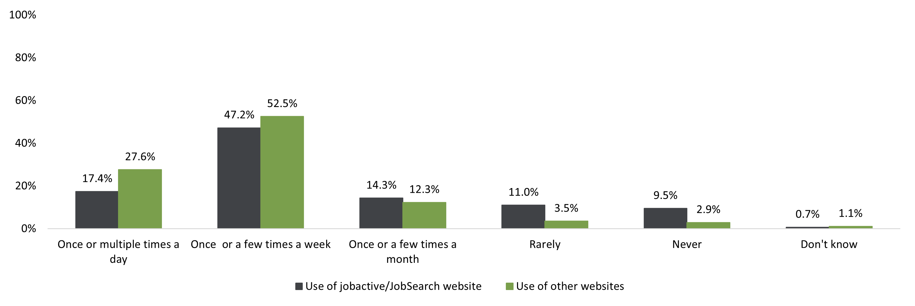
Figure 4.11 Comparison of the use of the jobactive/JobSearch website with other sites
Source: OES Participant Survey, Wave 2.
Base: n=1,334, weighted results.
Note: Only asked to those who were looking for paid work. Q. How often do you … A Search for jobs online using government-provided online employment services (i.e., jobactive or jobsearch), B Apply for jobs online using other job search websites.
Feedback from the qualitative research with OES participants confirmed these results and that participants mostly used the jobactive/JobSearch website to report their job search activities and MORs.
But normally I do not use it [JobSearch] to look for jobs. I look for jobs through my phone or just on the internet. (OES qualitative research, participant focus group)
I mainly use SEEK; I think they’re usually the same jobs, so I don’t want to get the same email twice. It stresses me out a bit when I have too [many] unread emails. (OES qualitative research, participant focus group)
I’ve gone to SEEK or Jora or some other site and have found a job and then I go back to MyGov and fill in the jobs that I’ve applied for. (OES qualitative research, participant interview)
These findings are reflected in the NEST evaluation, which found that most (85.2%) participants in the PEES Survey indicated that they had used SEEK to look for jobs in the last 6 months, compared to almost half (46.85%) who had used the jobactive/JobSearch website.

Reason for using websites other than jobactive/JobSearch
Main reasons given by survey participants for preferring websites other than jobactive/JobSearch were (details in Appendix C):
- other job search websites had more suitable jobs (56.5%)
- it was easier to apply for jobs directly on other sites (50.5%)
- other sites had better search capability (48.2%)
- they had already set up their profile on another website (43.8%)
- other websites were easier to navigate (42.5%)
- it was easier to keep track of job applications on other sites (28.7%)
- other sites helped pre-fill questions on job applications (23.6%).
There were some variations across education levels and age groups. Participants with higher levels of educational attainment were generally more likely to prefer other job search websites, compared with participants with lower educational levels. Notably, nearly 2 in 3 (63.1%) participants with a university qualification, compared to 1 in 3 (35.2%) participants with less than Year 12 educational attainment, mentioned that other sites had more suitable jobs. Likewise, 1 in 2 (54.6%) participants with university-level educational attainment, compared to just over one-fourth (27.6%) of participants with less than Year 12 educational attainment, agreed that other sites had better search capability.
Survey findings also showed that younger participants preferred other job search websites because they could pre-fill questions on job applications and it was easier to navigate and apply for jobs directly. Speculation from internal stakeholders confirmed that user experience was a determining factor for participants preferring other sites, as is evident from the following comment from a roundtable discussion with EWG members.
The website is old; it’s been around a long time; it’s just got bits built on top of bits built on top of bits. So, the user experience itself is quite clunky and confusing and people ignore a lot of their notifications; we try to nudge them and notify them. (OES qualitative research, EWG roundtable)
Qualitative research results were consistent with survey results and revealed several reasons why participants prefer other online platforms to search and apply for jobs. A main reason was the poor filtering function on the jobactive/JobSearch site.
I mean you put in what you want to apply for, and your parameters, it sends me out to bloody the Blue Mountains, as a gardener, I mean do you want me to drive all the way to Blue Mountains to be a gardener? Then I have [to] drive back. (OES qualitative research, participant interview)
Other reasons cited by participants were that compared to the jobactive/JobSearch website, commercial websites such as SEEK had better parameters and filters, direct links to job applications, more options to set up automatic notifications, and also more relevant information.

Mostly it’s much more strict with cutting out things that don’t apply to you. So if you select ‘entry level’, or if you search ‘graduate’ in the search, at least the first page or 2 will only show you entry level positions. Past that it can show you some more experience required ones, but it’s much more exact about showing you what you searched. (OES qualitative research, participant focus group)
When you go into SEEK and you click ‘apply for this job,’ and you can do quick apply, and then you just choose, ‘Yep, I wanna upload my résumé,’ and then you click, ‘I wanna update, I wanna add a cover letter’ – you can have a cover letter saved. (OES qualitative research, participant interview)
One thing that I use from SEEK all the time is whenever I search up a kind of job, either an area or in a specific field or anything like that, I was able to set up an automatic email notification, and even several of those up once, so every single day, whenever a new job in one of those requirements which was set up, I would get immediate notification of it. I could not find something like that in the jobactive system. (OES qualitative research, participant interview)
’Cause on the SEEK website, they actually have links to schools, as well. Cos if you want to do further study and stuff to get the skills to get the job that you want. So they link you to the courses that you need to take, and they link you to the schools straight away, and how much it is, and stuff like that. (OES qualitative research, participant interview)
You’ve got the information there. The award rates are all linked in; industries – is it a smart industry to be heading towards and everything else. Shaping and figuring out my goals and what is a smart opportunity to be targeting the work. (OES qualitative research, participant interview)
The NEST evaluation findings were also consistent and revealed similar sentiments among participants who undertook online job search. Participants found it easier to log into and use commercial job search platforms, compared to the jobactive/JobSearch website.
If I go and apply for jobs, then I have to open myGov, login with my phone code, and then go onto jobactive and Centrelink and put in the job things; it’s just … it can be a little annoying (NEST Longitudinal Study, Digital First participant interview)
I go on the Indeed website, and a lot of their jobs, you just apply on Indeed – that’s it, you don’t need to go to a secondary website. (NEST Longitudinal Study, Digital Plus participant interview)

4.7 Employer views of and experience with the jobactive/JobSearch website
OES had functionalities for employers to advertise vacancies on and search and recruit suitable candidates from the jobactive/JobSearch website. To assess employers’ views and experiences with OES, the department commissioned Wallis Social Research to conduct research with employers in 2021. The findings are summarised in Chapter 7.

4.8 Participant overall satisfaction with OES
Waves 1 and 2 of the OES Participant Survey showed that online services were fairly well received among OES participants, of whom 54.0% indicating that they were either satisfied or very satisfied with the service (Figure 4.12).
Satisfaction with OES varied with participants’ employment services status at the time of the survey. Participants who transferred to a provider after completing 12 months in OES (61.1%) were the most satisfied, whereas those who had exited OES and employment services (47.6%) or opted out to a provider after commencement (43.5%) were the least satisfied.
Satisfaction with OES also varied with participants’ characteristics. Participants under 25 years of age (60.5%) were also more satisfied, as were those from a CALD background (65.6%) and Aboriginal and/or Torres Strait Islander people (63.5%). By contrast, participants with a higher level of educational attainment (around 51%) and those with disability (43.5%) were less satisfied with OES.
There did not seem to be a consistent pattern between preference for online services and satisfaction with OES. On one hand, participant groups with a larger proportion who indicated they preferred online services also had a higher OES satisfaction rate, such as among participants aged under 25 years and those from a CALD background. On the other hand, some groups had a small proportion of participants who preferred online services but had a higher OES satisfaction rate, such as Aboriginal and/or Torres Strait Islander people.
The OEST evaluation reported a satisfaction rate of 71% among participants in online services. However, it should be noted that this rate excluded participants who opted out of OEST or were transferred to a provider, while the 54% satisfaction rate with OES as reported in this evaluation included such groups. Nevertheless, even if the participants who opted out or transferred to a provider were excluded from analysis, the satisfaction rate with OES would still be lower than that with OEST. This lower satisfaction rate could be due to the changed composition of participants in OES. For example, because of the impact of COVID-19, OES participants were likely to have more recent work experience and have higher levels of educational attainment. As a result, these participants could have had higher expectations as they were familiar with features from more established commercial job search platforms.
I was put in the digital category only and … I’m intelligent, double degree holding person and I struggled with how not intuitive it was, and the UI’s crap too. (OES qualitative research, participant interview)
Figure 4.12 Overall satisfaction with OES
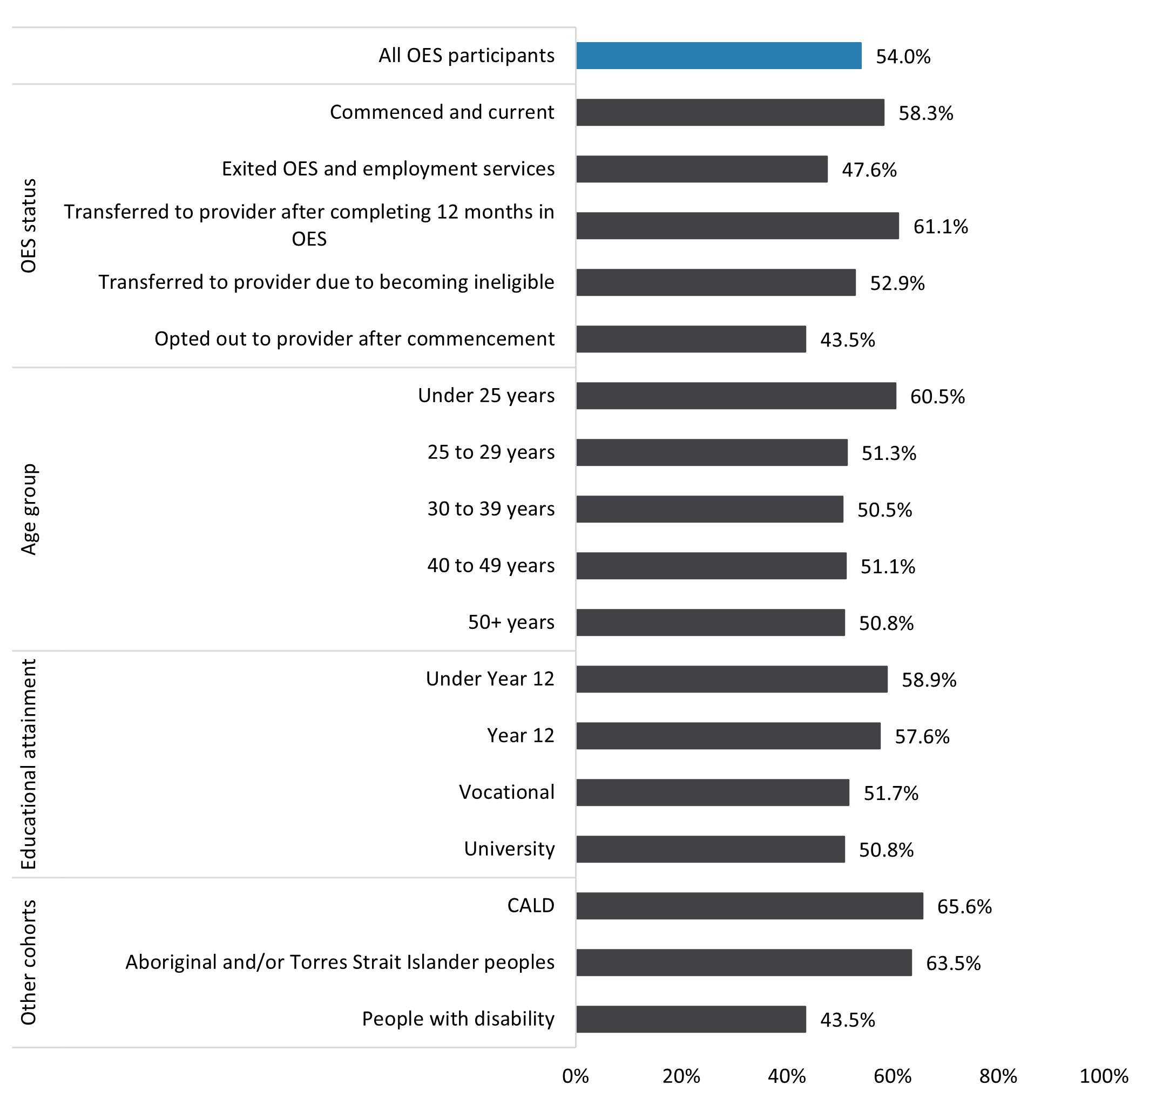
Source: OES Participant Survey, Waves 1 and 2.
Base: n=8,285, weighed results.
Note: Excluded 91 respondents who opted out to a provider before commencement and had not used OES. As the categories are not mutually exclusive, they add to more than 100%. Q. Overall, how satisfied are you with the Online Employment Services?

Chapter 5 Effectiveness of OES safeguards
Online safeguards are designed to identify OES participants who are at risk of becoming disengaged or who may be experiencing difficulties self-managing their MORs. These participants are then made aware of the option of further assistance including, if needed, transferring to a provider for more intensive servicing. This chapter discusses the effectiveness of online safeguards in OES in identifying and providing further options to disengaged participants or those struggling in OES.
Safeguards trialled in OEST were adopted in OES, including the ability to opt out of OES at any point and be referred to a jobactive provider. New safeguards introduced in OES included:
- prompting participants to consider opting out of online services based on their responses to the DA (discussed in Section 5.4)
- prompting participants to opt out of OES based on their responses to Digital Services Reviews (DSRs) at the 4th and 8th month since their commencement in OES (discussed in Section 5.5).

5.1 Digital Assessments
Since the JSS did not directly assess job seekers’ digital skills and ability to self-manage their job search on an online platform, the department added a DA to identify if participants could self-manage in OES, consisting of the following questions:
- Can you access the internet at least once a week to look for work?
- Are you able to access job search websites and submit job applications and résumés online or via email?
- In the past month, how often did you use the internet (e.g., for social media, emails, Google, online shopping)?
- Thinking about paying bills online, select the answer that best describes you.
- Thinking about sending emails, select the answer that best describes you.
Based on their responses to the DA questions, job seekers were classified as either:
- ‘No action required’ – confirming that they were suitable for OES
- ‘Opt out’ – suggesting that they were likely to struggle in online services. These job seekers were encouraged to opt out of online services to provider services. It should be noted that opting out was voluntary.

Digital Assessments completion
Analysis of administrative data showed that, of all 107,464 OES participants who commenced in OES between 5 December 2020 and 31 December 2021, 83,027 (77.3%) attempted and completed at least one DA. This is a reasonably high completion rate, considering the DA was an optional task.
Of the 83,027 completed DAs, 76,937 (92.7%) resulted in the outcome of ‘No action required’, suggesting that the vast majority of the job seekers referred to OES based on their JSS had good digital skills and were suitable for OES. Only 6,090 (7.3%) job seekers were identified to have difficulty self-managing their job search on an online platform. These job seekers received a message suggesting that they opt out to provider services.

Opt-out results for Digital Assessments
Analysis based on administrative data shows that of the 6,090 who received the ‘Opt out’ message, only 1,620 (26.6%) actually opted out.
The opt-out rate varied with some job seekers’ characteristics. Job seekers with the following characteristics had a higher opt-out rate than the average (Figure 5.1)
- aged 40 years and over
- educational attainment under Year 12
- living in an outer regional area
- some previous jobactive (digital services) experience
- mixed or poor English proficiency
- from a CALD background
- Aboriginal and/or Torres Strait Islander.
On the other hand, job seekers with the following characteristics had a lower opt-out rate:
- under 30 years of age
- university degree
- either not in labour force or not working but looking for work
- partnered parent
- living in a metropolitan city.

Figure 5.1 Opt-out results of DA by demographic characteristics
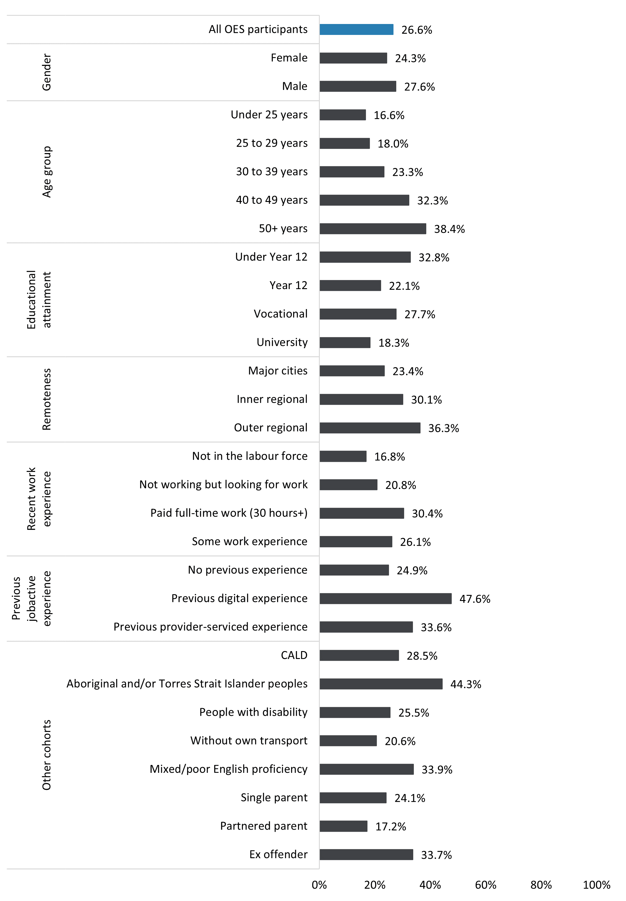
Source: DEWR administrative data.
Base: n=6,090.

5.2 The opt-out feature
Table 5.1 shows that 7.3% of OES participants who commenced in OES between 5 December 2020 and 31 December 2021 opted out after commencing in OES. This rate was slightly higher than the opt-out rate in OEST (5.5%). This probably reflects the fact that the composition of OES participants was different from that of OEST, particularly as a result of the impact of COVID-19 pandemic.
Most (69.9%) of those who opted out did so within the first 3 months, and a further 17.3% opted out between 3 and 6 months from commencement. This indicates that the opt-out feature was an effective safeguard as most participants who should have opted out had opted out early.
Table 5.1 Time lapse between commencement in OES and opt-out
Days from commencement to opt-out | Number of participants | (%)
Did not opt out | 99,611 | 92.7
Total opt-outs | 7,853 | 7.3
0–3 months | 5,488 | 5.1
3–6 months | 1,355 | 1.3
6–9 months | 725 | 0.7
9–12 months | 240 | 0.2*
12+ months | 45 | 0
Source: DEWR administrative data.
Base: n=107,464.
Note: *It is possible that some participants opted out after 9 to 12 months in OES after being notified of the maximum 12-month limit and that their time in OES was coming to an end.
Figure 5.2 shows that opt-out rates were higher among some cohorts, when compared with the population average of 7.3% (represented by the blue bar in Figure 5.2). Notably, these cohorts included people aged over 40 (10.3% for 40–49 and 15.4% for over 50), people with less than Year 12 educational attainment (14.1%), people living in inner regional (10.8%) or outer regional areas (14.4%), people with previous experience in provider services (10.4%), Aboriginal and/or Torres Strait Islander people (16.3%), people with disability (10.4%), people with mixed or poor English proficiency (20.3%) and ex-offenders (15.9%).
As noted earlier, some of the participants in these groups were more likely to need assistance and/or lack confidence in self-managing job search on an online platform. Therefore, it is not surprising that they were more likely to opt out.
Figure 5.2 Opt-outs as a percentage of commencements by demographics
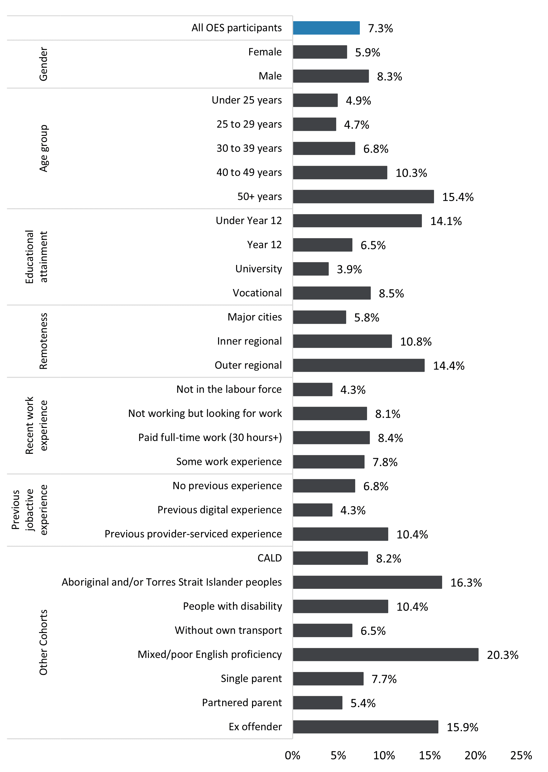
Source: DEWR administrative data.
Base: n=107,464.

Reasons for opting out
Of the 7,853 participants who opted out after commencing in OES, 51.2% preferred face-to-face services, 20.4% did not feel confident using computers and/or the internet, and 12.2% thought online services did not meet their needs (Table 5.2). The top opt-out reasons in OES were similar to those in OEST.
Table 5.2 Opt-out reasons after commencement in OES compared to OEST
Reasons | OES opt-outs | (%) | OEST opt-outs | (%)
Preferred face-to-face services | 4,024 | 51.2 | 618 | 49.0
Not confident in using computers and/or the internet | 1,604 | 20.4 | 146 | 11.5
Online service is not meeting my needs | 961 | 12.2 | 178 | 14.1
Online service is confusing | 434 | 5.5
Online service is too difficult to use | 429 | 5.5 | 158 | 12.5
Unable to access goods or services needed for work | 248 | 3.2
Unable to access internet from home | 95 | 1.2 | 50 | 4.0
Concerned about providing personal details online | 39 | 0.5 | 0 | 0.0
Unable to access internet from elsewhere | 19 | 0.2 | 2 | 0.2
Total | 7,853 | 100
Source: DEWR administrative data.
Base: n=7,853.

Awareness of the opt-out feature
Participants’ decision to opt out could be affected by their awareness of this option. Wave 2 of the OES Participant Survey revealed that 2 in 5 (43%) participants were aware that they could opt out of OES at any time and transfer to an employment services provider, and those who had exited OES and employment services altogether were the least likely (35%) to be aware that they could opt out.
Awareness of the opt-out feature was higher in OEST (72% compared to 43% of OES participants). One reason for the lower awareness among OES participants could be that in OEST, at the point of referral Services Australia explained that participation in OEST was voluntary and that participants could opt out. For most OES participants, the income support application and assessment and referral to service happened online, without direct contact with Services Australia staff.
The finding of low awareness of the opt-out option was supported by qualitative research responses where a number of participants reported that they were not aware of the opt-out feature.
Yeah, no, completely unfamiliar with this. It might have been one of the many bullet points on one of the many things that I had to click accept on before I was able to move on through. But no big deal was made about it, and they made you click on a lot of things that aren’t really worth reading. It’s one of things, it’s super easy to bury important information in unimportant information if you just throw enough at somebody. (OES qualitative research, participant interview)
Providers also shared the same sentiment:
Yeah. I think a lot of them don’t actually know about providers, or … like, I think they just assume that that’s how it is. They just have to online thing, they put in their job searches and that’s just how it is. I don’t think … I haven’t come across anyone who’s opted to be put with a provider. (OES qualitative research, jobactive provider interview)
Similarly, internal stakeholders identified a need to help participants understand how they could benefit more from providers.
Yeah. What’s their … how do they attract job seekers who might prefer the digital service? And we know job seekers – we get feedback from job seekers who – the attraction of the digital service is they don’t have to go to a provider, because they don’t see value in the provider service. (OES qualitative research, EWG roundtable)
Conversely, according to a few providers, some participants who had prior experience with a provider may have assumed they would be referred to a provider again but were referred to OES and were not aware they could opt out to a provider.
If they knew that they had the option, I imagine that they’d be opting out and wanting to come to a provider, because it’s too complex for them to navigate through; it doesn’t suit their individual circumstances; they might struggle with the IT components; their English might not be very good; they might not have access to the IT stuff that they need; they could be just needing more support and more direction with their job search requirements. They could be – they could have been through a provider before and they understand how the system works and they don’t understand why they’re now stuck in online when they want to go back to that same provider. (OES qualitative research, jobactive provider interview)

5.3 Digital Services Reviews
DSRs were designed as a safeguard to identify participants who might be struggling to self-manage their MORs and/or were no longer suitable for online services due to a change in their circumstances. The DSR appeared on the participant’s dashboard as a pop-up inviting them to complete a short questionnaire at their 4th and 8th month in online services.
The 4-month DSR (DSR4) was implemented on 14 October 2020. Participants who had been in OES for 4 months (120 days) and were not in employment, study or training were prompted to complete a DSR4. A pop-up appeared on their dashboard. If the participant dismissed the pop-up, the prompt would remain on the ‘To-do’ list on the dashboard until the DSR4 was either completed, deleted by the participant, or removed from the list after 14 days.
As depicted in Figure 5.3, questions in the DSR4 aligned with the DA, reflecting its function as a safeguard to ensure that participants were still suitable for online services after 4 months in OES.
Figure 5.3 DSR4 process flow
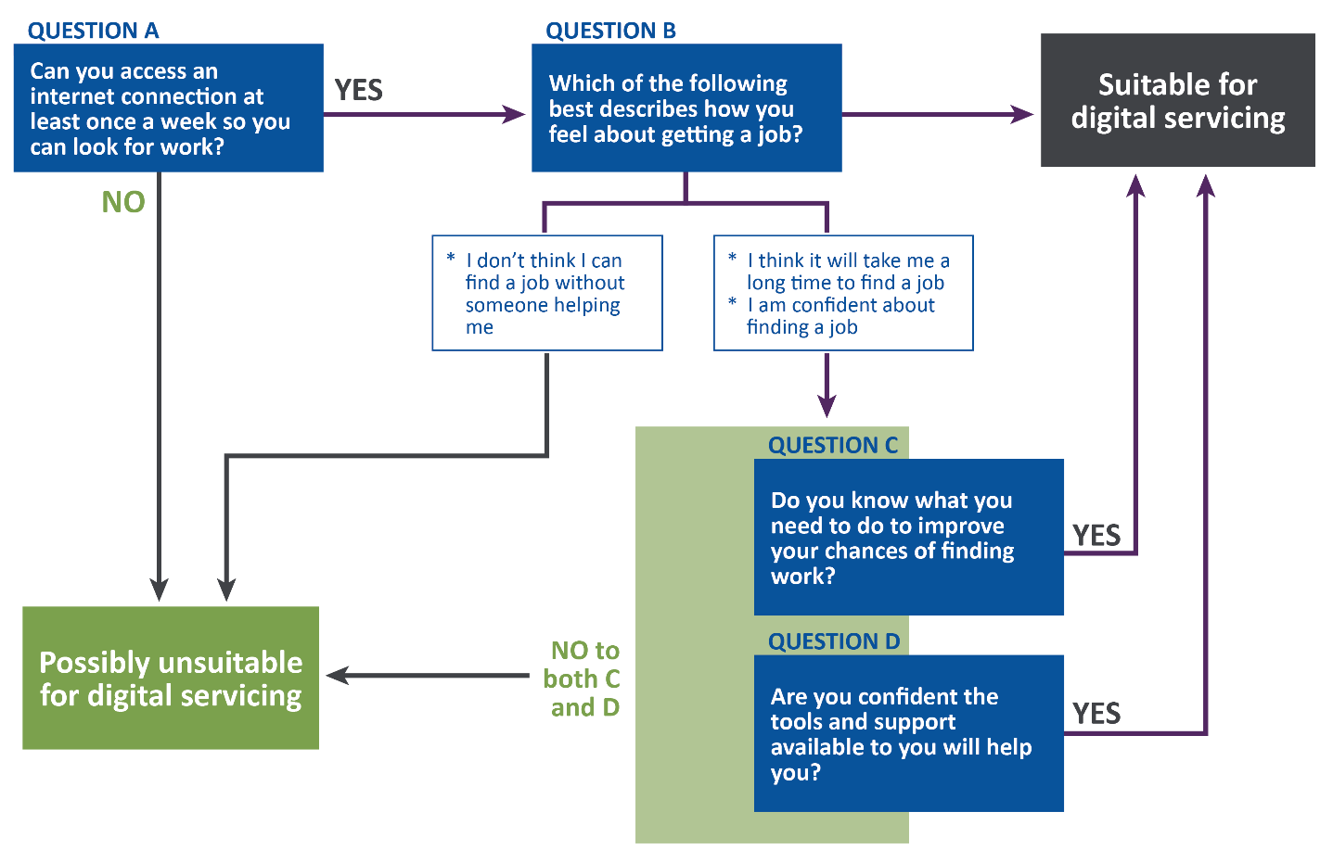
Source: DEWR policy guidelines.
The 8th month DSR (DSR8) was introduced on 31 March 2021 as an additional safeguard measure to further ensure that participants were still self-managing effectively after 8 months in OES. The DSR8 broadly replicated the DSR4 process and was presented in the same pop-up format to eligible participants upon their first login after reaching 8 months (240 days) in OES.
There was an expectation that participants would be adept at using the jobactive/JobSearch website and/or app by the time they had been in OES for 8 months; therefore, the DSR8 focused on reviewing participants’ level of engagement on the online platform, rather than whether they were familiar with and able to use the online services.

Awareness of Digital Services Reviews
Results from Wave 2 of the OES Participant Survey indicated that awareness of the DSRs was low among survey respondents who were eligible to complete a DSR4, with around a third (31.5%) stating that they were not sure if they had completed a DSR4.
Qualitative research findings were very similar, with only a few participants able to recall completing a DSR. With probing, some could recall receiving a phone call in which they were asked how things were going but were vague as to details. So, these experiences might not be related to the DSR at all.
I think I might have done that right at the start. I think I have done it; I’m really not that sure. (OES qualitative research, participant interview)
Probably just introducing me to what they do and how we can go ahead and do the job search and that … ’cos I followed it. And it was good to know how I was going with it … you’re just reviewing what you’re doing. And you’re seeing how you can improve. And what not to do. (OES qualitative research, participant interview)

Digital Services Review completion and outcomes
Administrative data analysis revealed that of the 40,997 OES participants who commenced in OES between 5 December 2020 and 31 December 2021 and who received a DSR4 pop-up, about 11,909 (29.1%) completed one. Similarly, of the 15,515 OES participants who received a DSR8 pop-up, 4,003 (25.8%) completed one.
Table 5.3 summarises the types of messages sent to participants based on their responses to DSR4 and DSR8 and their decisions to opt out. Among the 11,909 OES participants who completed a DSR4, 87.5% were not encouraged to opt out, 4.4% got a ‘soft’ opt-out message (to consider opting out) and 8.1% got a ‘hard’ opt-out message.
Among the 4,003 OES participants who completed a DSR8, 53.0% were not encouraged to opt out, 36.7% got a soft opt-out message (including both with and without resource information) and 10.3% were strongly encouraged to opt out.
Among participants who received a hard opt-out message (DSR4) or were strongly encouraged to opt out (DSR8), only around a quarter (22.5% and 28.7% respectively) opted out. Again, the opt-out rates were low. The opt-out rates among those who received soft opt-out messages were even lower.

Table 5.3 Comparison of types of messages sent to participants and their opt-out decisions between DSR4 and DSR8
DSR4 message | Participants who received a DSR4 message (%) | Participants who opted out after DSR4 (%)* | DSR8 message | Participants who received a DSR8 message (%) | Participants who opted out after DSR8 (%)*
No action required | 74.5 | 3.1 | No action required | 53.0 | 1.6
Information only | 13.1 | 4.8 | Consider opt out with further resource information | 21.9 | 5.0
Soft nudge to opt out | 4.4 | 14.3 | Consider opt out without resource information | 14.8 | 7.4
Hard nudge to opt out | 8.1 | 22.5 | Strongly encouraged to opt out | 10.3 | 28.7
Source: DEWR administrative data.
Base: DSR4 n=11,909, DSR8 n=4,003.
Note: *Percentages were calculated over the number of participants who received the DSR message(s).
The purpose of hard and soft opt-out messaging was to encourage participants to make their own decision about whether they felt they should remain in OES or move to provider services, based on the information received in the message.
They’re not being forced to go back to a provider; they’re not being harassed to do things that they feel is not adding any value to their chances of finding work and really is just an extra layer of compliance. (OES qualitative research, EWG roundtable)
Especially at the moment when you’ve got cohorts that can’t travel or can’t visit a provider or don’t want to; it removes those barriers to accessing this sort of service if you don’t have to go into a provider for those appointments. (OES qualitative research, EWG roundtable)

Opt-out results for DSR4
Analysis of administrative data shows that only 290 (19.6%) participants out of the 1,482 (both soft- and hard-nudged participants) who received an opt-out message actually opted out.
The DSR4 opt-out rates varied according to participant characteristics. Participants with the following characteristics had a higher opt-out rate than the average (Figure 5.4):
- aged 40 to 49 years
- educational attainment under Year 12
- living in an outer regional area
- some previous jobactive experience
- mixed or poor English proficiency
- disability.
On the other hand, participants with the following characteristics had a lower opt-out rate:
- under 30 years of age
- university degree
- not in the labour force
- living in a major city
- previous experience with online employment services

DSR4 outcomes and income support exit rate
Figure 5.4 illustrates the pathways, events and observation periods of the above 2 groups. Among the participants who opted out to a provider between 4 months and 6 months from commencement following a DSR4 opt-out message, 55.6% exited income support during the 6- to 12-month period from commencement; slightly more than 51.9% exited among those who did not opt out despite the DSR4 recommendation to opt out to provider services. However, this difference was not significant at α=0.05 (chi-square p=0.5307).

Figure 5.4 Opt-out rates among OES participants who received a DSR4 message to opt out by sub-populations
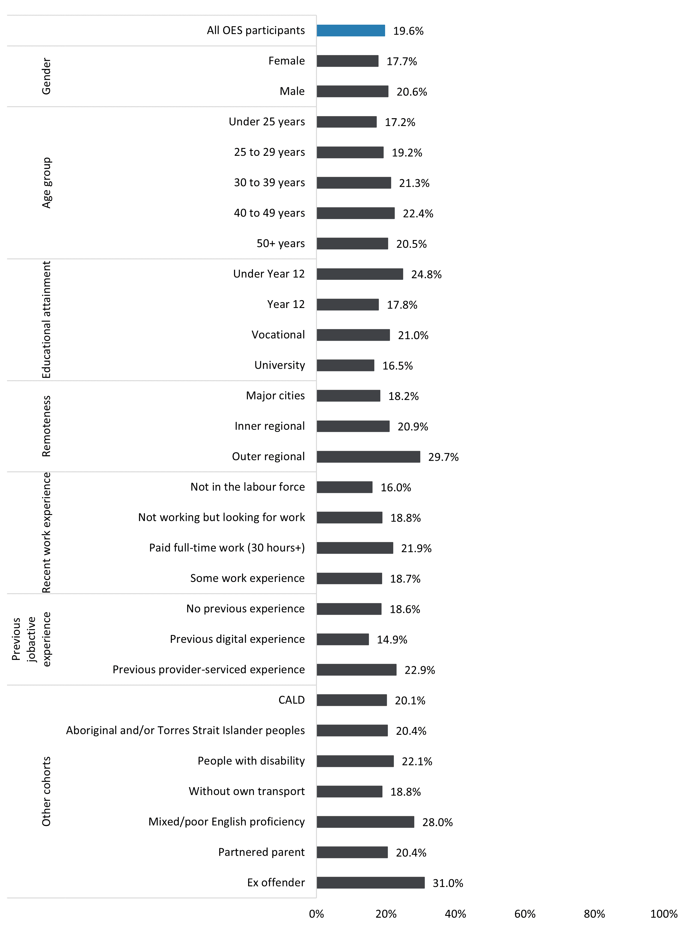
Source: DEWR administrative data.
Figure 5.5 DSR4 recommendations and exits from income support – pathways, events and observation periods
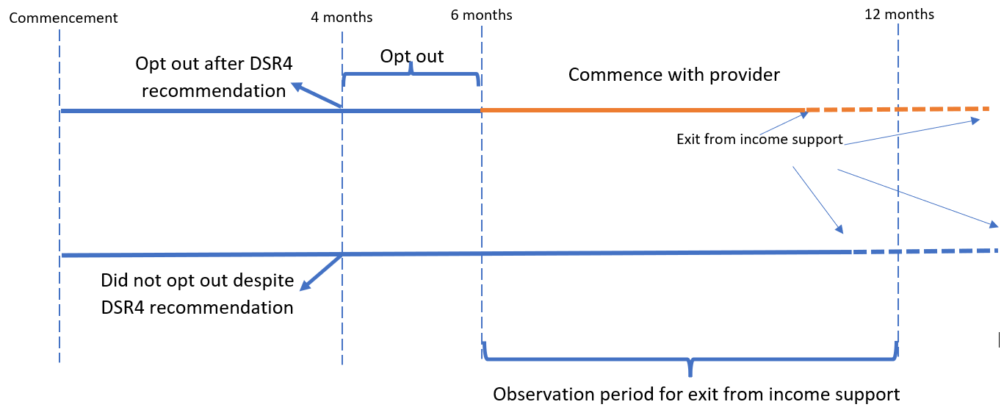
Source: DEWR administrative data.

5.4 Maximum time in OES safeguard
OES participants were automatically transferred to a jobactive provider after 12 months in online services if they had not worked or studied in the previous 6 months. This safeguard was designed to provide participants with opportunities to opt into more personalised services with a provider.

Appropriateness of maximum time in OES
Wave 2 of the OES Participant Survey found that just over half (53%) of participants surveyed agreed that the 12-month timeframe was appropriate before being transferred out of OES to a provider. One in 5 (19%) indicated that they should be transferred to a provider earlier, and 1 in 10 (11%) indicated that the timeframe should have been longer. Similar views were expressed in Wave 1 of the OES Participant Survey, where more than half (59%) of participants who were subsequently transferred to a provider after 12 months in OES agreed that they were given the right length of time before the transfer. One in 5 (21%) respondents felt the length of time was inadequate. The surveys also found that participants aged under 25 years were more likely (58%) than older participants to indicate that 12 months was the appropriate amount of time.
Providers identified a risk associated with the 12-month duration for participants who needed more intensive support and were not referred earlier than the maximum time in OES. Providers shared their frustration about having to case manage participants who had additional barriers resulting from being unemployed for at least 12 to 18 months.
… let someone sit for that long [12 months]? There’s got to be some point during that online servicing when a certain behaviour occurs that would indicate they’re better of[f] being served with a provider and not staying in online service. (OES qualitative research, jobactive provider interview)
And the other that we have is that job seekers can be in that service for over 18 months. It’s meant to be only 18 months and we actually think more than 12 months is probably an issue. Because I think once you’ve been unemployed for 12 to 18 months, you become a long-term unemployed job seeker, which naturally brings other barriers. (OES qualitative research, jobactive provider interview)

Completing 12 months in OES
Notwithstanding the above concerns, only 4.3% of the total 107,464 participants who commenced in OES over the period 5 December 2020 to 31 December 2021 remained in online services for the full duration of 12 months or more (
Table 5.4). A majority (79.2%) of participants had either opted out, been transferred before the maximum time limit, or exited online services within 12 months. A few (16.6%) of these participants were either still in OES or were paused at the time of analysis.
While the percentages varied across cohorts, they were within a small range (3% to 6.5%), implying that the 12-month timeframe was adequate and worked effectively as a safeguard.

5.5 Experience of opting out and transferring to a provider

Participant experience
Survey results showed that OES supported a smooth opt-out or transfer process to provider services for most participants. The OES Participant Survey asked participants who confirmed that they had transferred or opted out to a provider for their level of agreement with a series of statements about that process (Figure 5.6). Most participants agreed that they found it easy to adapt to provider services (58.4%), were given enough support (54.8%) and received enough information before their transfer (52.1%). However, more than 1 in 4 (25.2%) participants disagreed that their provider gave them enough support at the point of transfer, 27.5% disagreed that they were informed about what would happen when they transferred, and nearly 1 in 5 (18.1%) did not find it easy to adapt to the change from OES to provider services. This suggests that more can be done to facilitate a smoother transfer from online to provider services.

Provider experience
While participant opt-out and maximum time in OES were 2 separate processes for moving to a provider, qualitative feedback from jobactive providers indicated that they did not treat participants who opted out differently from those who transferred after the maximum time in OES. Most providers also reported that they interacted with and managed ex-OES participants in very similar ways to their non-OES caseload.
One common challenge providers reported with an ex-OES participant was the pushback because these participants were not accustomed to having appointments with a provider or undertaking Work for the Dole activities.
Yeah … a majority of them, like 90 percent of them, are very hesitant. Whether that is because kind of their obligations are a bit more like participation, like you have to have appointments, like this, that, and then it’s also really hard as well because once they hit the year and then they’re automatically pretty much ready for work for the dole, and then it’s kind of like, oh well, I’ve been doing this for a year, like why am I now put with you and I need to do this now, and do that. And … yeah, [it’s] tough. (OES qualitative research, jobactive provider interview)

Table 5.4 Characteristics of OES participants who completed 12 months in OES
 | Total OES commencements | Completed 12 months in OES
 | Number of participants | Number of participants | (%)
All OES participants | 107,464 | 4,573 | 4.3
Gender
Female | 45,320 | 1,427 | 3.1
Male | 62,144 | 3,146 | 5.1
Age group
Under 25 years | 36,116 | 1,494 | 4.1
25 to 29 years | 21,500 | 935 | 4.3
30 to 39 years | 21,111 | 903 | 4.3
40 to 49 years | 14,831 | 684 | 4.6
50+ years | 13,906 | 557 | 4.0
Educational attainment
Under Year 12 | 14,825 | 800 | 5.4
Year 12 | 29,058 | 1,473 | 5.1
University | 33,131 | 997 | 3.0
Vocational | 30,450 | 1,303 | 4.3
Remoteness
Major Cities | 80,932 | 3,608 | 4.5
Inner Regional | 18,290 | 702 | 3.8
Outer Regional | 8,242 | 263 | 3.2
Recent work experience
Not in the labour force | 24,643 | 930 | 3.8
Not working but looking for work | 3,883 | 254 | 6.5
Paid full-time work (30 hours+) | 55,386 | 2,375 | 4.3
Some work experience | 23,550 | 1,014 | 4.3
Previous jobactive experience
No previous experience | 74,776 | 3,292 | 4.4
Previous online experience | 10,781 | 193 | 1.8
Previous provider-serviced experience | 21,907 | 1,088 | 5.0
Other cohorts
CALD | 17,438 | 752 | 4.3
Aboriginal and/or Torres Strait Islander people | 2,921 | 129 | 4.4
People with disability | 4,652 | 178 | 3.8
Without own transport | 29,830 | 1,583 | 5.3
Mixed/poor English proficiency | 2,769 | 119 | 4.3
Lone parent | 2,526 | 57 | 2.3
Partnered parent | 3,767 | 130 | 3.5
Ex-offender | 3,713 | 182 | 4.9
Source: DEWR administrative data.
Base: n=107,464.
Figure 5.6 Agreement with the level of support while transferring or opting out from OES
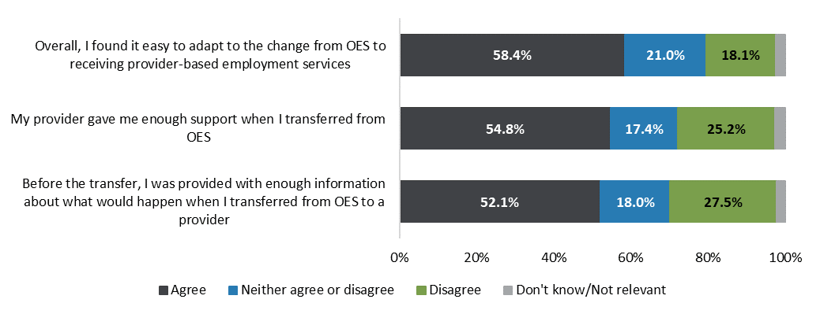
Source: OES Participant Survey, Waves 1 and 2.
Base: n=1,685.
Note: Excludes those who had not been transferred from OES to a provider. Agree combines ratings of ‘agree’ and ‘strongly agree’, and disagree combines ratings of ‘disagree’ and ‘strongly disagree’. Q. To what extent do you agree or disagree with the following statements …

Chapter 6 Impacts on outcomes and program efficiency
This chapter examines the impacts of participating in OES on participant outcomes in terms of improving their job search and online skills, meeting their MORs and activity requirements, exiting income support and jobactive employment services, and the sustainability of exits. A discussion on the cost-effectiveness of online services is also presented in this chapter.

6.1 Impact on job search
In addition to enabling participants to effectively self-manage and report their job search on an online platform, findings from Wave 1 of the OES Participant Survey showed that OES had also helped some participants to improve their job-seeking skills in several ways (details in Appendix C).
About half (56.0%) of OES participants thought that OES made it easier to submit job applications online. Similarly, participants also thought that OES improved their approach to job search and helped them to be persistent (53.6%), understand the different ways to search and apply for jobs (52.8%), and be more open to look for work online (51.6%). Further, 41.7% indicated that OES helped them to identify existing skills that could be useful for other jobs or industries.
Additional analysis of the impacts by participant demographics revealed interesting patterns across online services status, age groups, educational attainment, CALD background, Indigeneity and disability status, as summarised in Appendix C.
OES participants with the following characteristics appeared to benefit more in terms of improved job-seeking skills from OES:
- transferred to a provider after 12 months in OES
- aged under 25 years
- CALD background
- Aboriginal and/or Torres Strait Islander.
On the other hand, participants with the following characteristics seemed to benefit less:
- exited OES and employment services altogether
- university degree
- disability.
Members of the OES EWG agreed that further research is required to explore how online services could be benefiting the CALD cohort.
CALD job seekers, I think. The data shows they’re actually doing quite well, but I’m not sure to what extent – I think we do get a lot of feedback about non-English speaking people in the service who I think we automatically think are not suited but are actually managing quite well because they’re using a family member or something like that to help them navigate the service. But I think there’s probably something to be explored in that. (OES qualitative research, EWG roundtable)

6.2 Meeting Mutual Obligation Requirements
OES participants operated under the same Targeted Compliance Framework (TCF) as jobactive – they needed to meet the requirements in their Job Plans, and failing to do so would incur demerits. These requirements included a minimum job search of 20 jobs a month, which was automatically adjusted by the department or in some cases paused in response to natural disasters such as floods and bushfires. Details on the TCF policy are in Appendix A.
As discussed in Chapter 5, the OES dashboard was designed to help OES participants to monitor and report their MORs. Most OES participants found that the dashboard was effective for this purpose. However, it could be argued that without assistance from an employment services provider, OES participants might be more likely to fail to meet their MORs and thus incur demerits.
Analysis from the administrative data showed that of the 45,056 OES participants who commenced between 5 December 2020 and 30 April 2021, 30.0% incurred one or more demerits during their time in OES. Among the participants who incurred demerits, 76.2% accumulated one demerit and 22.9% accumulated 2 demerits.
It is difficult to assess if the demerit rates were high or low in the absence of a proper comparator for OES participants. These rates could not be compared with those of job seekers in provider services, since the eligibility rules for OES meant that OES participants and job seekers in provider services needed different levels of assistance. From the OEST evaluation, where OEST participants were randomly selected for the trial, no difference was found in terms of the likelihood of incurring demerits between OEST participants and their comparators in provider services.
The demerit rates for OEST participants ranged from 20.0% to 33.8% depending on when OEST participants commenced servicing. But these were not directly comparable with the demerit rates for OES participants because of the different duration in services (6 months in OEST versus 12 months in OES). An analysis of OES administrative data during their first 6 months in service revealed that only 23.7% of the 45,056 participants incurred demerits. This is at the lower end of the demerit rate range of OEST participants.
It should also be noted that when OES was in operation, many areas experienced lockdowns and consequently suspensions of MORs because of the COVID-19 pandemic. This probably watered down the analysis of demerit rates, particularly in terms of understanding the impacts of OES on participants’ compliance with MORs.

6.3 Six-Month Activity Requirement
Introduced on 1 October 2021, the Six-Month-Activity Requirement (SMAR) was designed to activate job seekers earlier than the Annual Activity Requirement to keep them engaged in the labour market and help them develop skills and stay motivated. Participants who had been participating in jobactive and OES for 6 months were required to undertake an activity, such as study and/or work, for up to 25 hours per week for up to 8 weeks, depending on individual circumstances and assessed work capacity. The SMAR was broadly impacted by periodic COVID lockdowns in each state, resulting in a significant portion of the caseload having their requirements waived.
Qualitative research revealed that OES participants who had been required to comply with the SMAR were generally unaware of the requirement to undertake an activity at 6 months; however, they recalled booking into training/workshops when prompted. Some participants recalled being notified to complete an activity through the OES dashboard and a phone call but indicated that it would have been more useful to receive these notifications earlier in their period in service.
And that’s where doing the course straight away would be beneficial to actually get that level of computer literacy to actually use it. (OES qualitative research, participant interview)
Most qualitative respondents could recall information on the SMAR but were vague about what was expected. Some felt there could be more information on the activities.
… one paragraph outline of the activity was a little bit light. It didn’t actually describe what the outcomes were, and I’m an outcome-focused person. These are the lists of activities – and they give a really broad overview, but not into the depth of what’s going to come out of it. (OES qualitative research, participant interview)
Views were mixed among qualitative participants who recalled the SMAR. One participant noted that they called a helpline after receiving an email about the SMAR as they were not aware that they had to undertake activities after 6 months in OES. Nevertheless, the participant achieved a good outcome.
It was just something you had to do … They had a few options to choose from … I just found what suited me most … I learnt about what skills you can use to get interviews. I also learnt how to write résumés and cover letters and spreadsheets. Pretty useful. (OES qualitative research, participant interview)

6.4 Exits from income support and employment services, and reduction in income support reliance
The key objective of employment services is to help job seekers to find and maintain employment. However, since job placement data is only captured when it is related to a provider outcome payment, there was no administrative data on the employment status of OES participants after they exited employment services. In this case, the following outcome measures were used as proxies for employment:
- exits from income support
- exits from jobactive employment services
- reduction of income support reliance.

Data used for the analysis
To account for allowable breaks, the outcome analysis focused on participants who were referred to and commenced in OES and were on income support between 5 December 2020 and 31 December 2021. These participants were tracked until 30 June 2022 in order to examine any exits from employment services and/or income support, as well as any reductions in income support reliance. When examining exits, the cohort of participants included in the analyses was further adjusted depending on the timing, as follows:
- for exits within 3 months from commencement, the commencement date of the cohort of participants included was between 5 December 2020 and 31 December 2021 (n=88,597)
- for exits within 6 months from commencement, the commencement date of the participant cohort was between 5 December 2020 and 30 September 2021 (n=67,663)
- for exits within 9 months from commencement, the commencement date of the participant cohort was between 5 December 2020 and 30 June 2021 (n=49,284)
- for exits within 12 months from commencement, the commencement date of the participant cohort was between 5 December 2020 and 31 March 2021 (n=31,296).
These adjustments allowed sufficient time for the respective measures of exits to be determined.

Outcome rates
Figure 6.1 shows the results of the exit analysis:
- the proportion of participants who exited income support within 3 months of commencing in OES was 43.4%: 64.2% within 6 months, 73.2% within 9 months, and 79.1% within 12 months
- the proportion of participants who exited jobactive employment services increased from 31.2% within 3 months following commencement to 80.7% within 12 months
- the average reduction in income support reliance increased from 41.2% within 3 months following commencement to 68.5% within 12 months.
Figure 6.1 Outcome rates within 3, 6, 9 and 12 months from commencement in OES
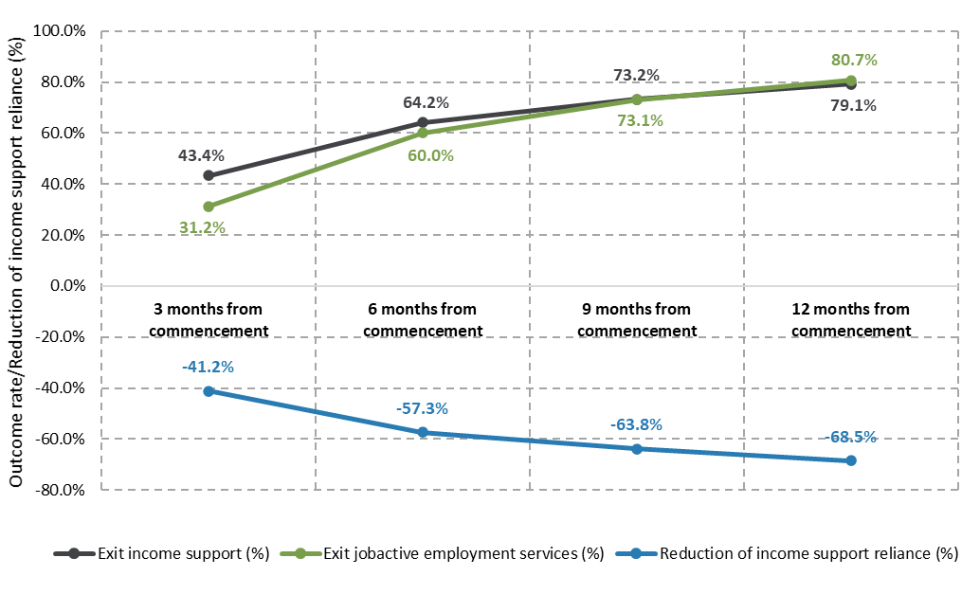
Source: DEWR administrative data.

Exits by demographics
Figure 6.2 shows exit rates from income support within 12 months from commencement in OES for various demographic groups.
Figure 6.2 Exits from income support within 12 months from commencement in OES, by demographics
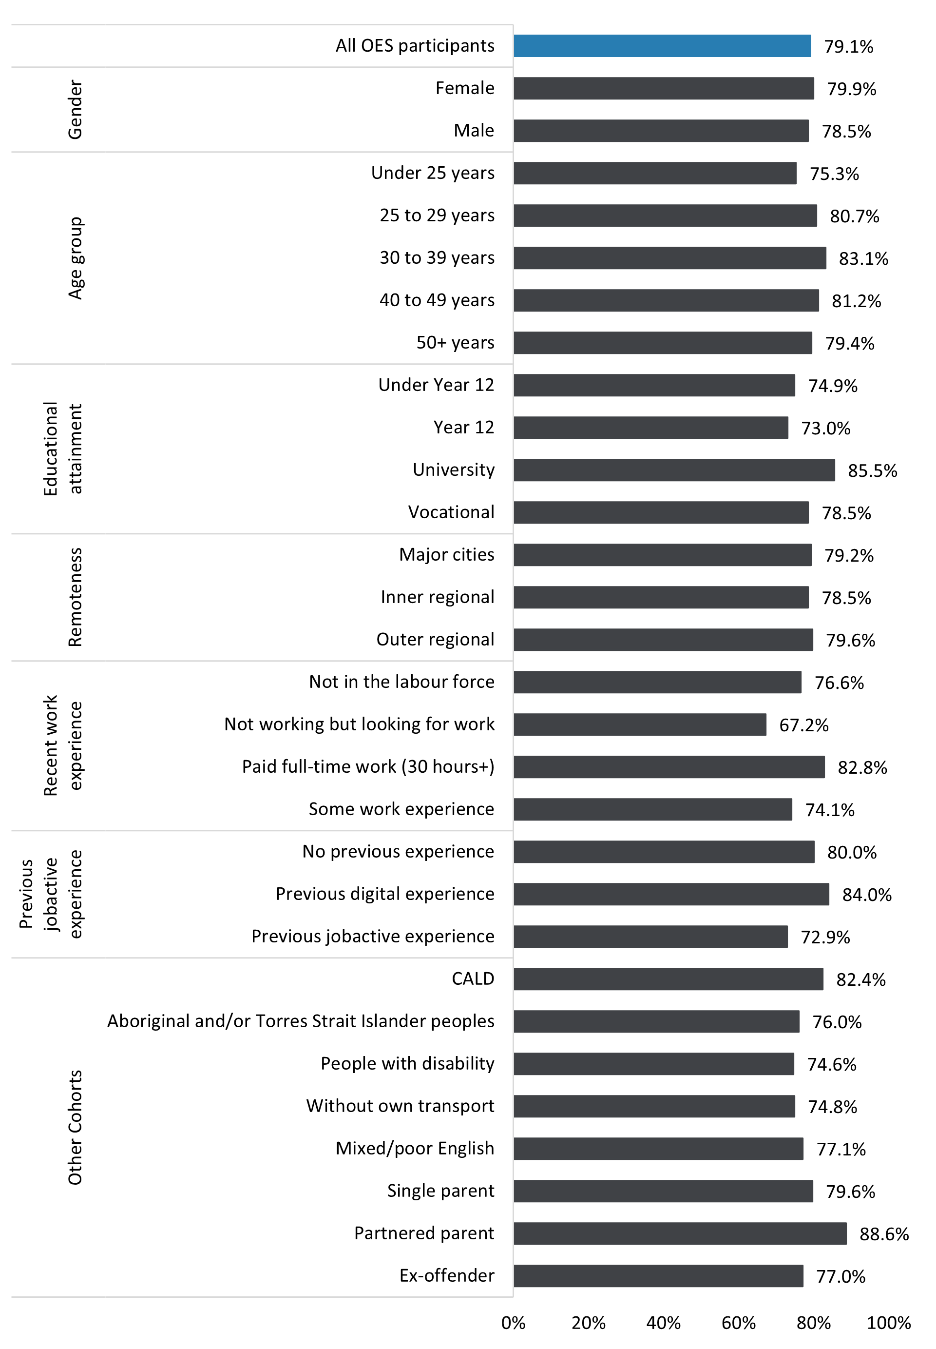
Source: DEWR administrative data.
Base: n=31,296.
The average exit rate is 79.1%. Cohorts with a larger proportion of participants exiting income support within 12 months, compared to the population, included people:
- aged from 30 to 39 (83.1%)
- with a university-level educational attainment (85.5%)
- with previous full-time work experience (82.8%)
- with previous jobactive online experience (84%)
- with a CALD background (82.4%)
- who are partnered parents (88.6%).
Conversely, cohorts with lower exit rates included people:
- under 25 years old (75.3%)
- with Year 12 or lower educational attainment (73%–75%)
- without work experience (67.2%)
- with part-time/casual work experience (74.1%)
- with previous provider-serviced experience (72.9%)
- who are Aboriginal and/or Torres Strait Islander (76%)
- with disability (74.6%)
- without their own transport (74.8%).

6.5 Sustainability of exits from income support
Another relevant outcome measure is the sustainability of exits from income support – that is, whether participants stayed off income support over time. This measure serves as a proxy for sustainability of employment.
Focusing on those who commenced OES between 1 May 2020 and 30 June 2021 and exited income support between 1 January 2021 and 30 June 2021, the analysis calculated the percentage of participants who returned to income support by 30 June 2022 (Table 6.1). Of these participants, only around 1 in 10 (12.5%) returned to income support within a year of their exit, mostly between 3 and 9 months. On the other hand, the large majority (87.5%) of participants stayed off income support for at least 12 months. Notably, 91.8% of OEST participants did not return to income support within 6 months from exit; by comparison, 94% of OES participants did not return to income support within 6 months from exit.
This high off-income-support rate after exit could be explained by the fact that these participants were relatively advantaged in the labour market because (a) they had relatively low labour market disadvantage, as calculated through their lower JSS, (b) they had recent work experience as they were largely new to income support/employment services, and/or (c) labour market conditions were strong following the adverse impacts of COVID-19.
Table 6.1 Sustainability of exits from income support
Return to income support | Number of participants | (%)
Did not return to income support within 12 months from exit | 70,748 | 87.5
Returned within 12 months | 10,109 | 12.5
Returned between 6 weeks and less than 3 months | 1,538 | 1.9
Returned between 3 and 6 months | 3,342 | 4.1
Returned between 6 and 9 months | 2,905 | 3.6
Returned between 9 and 12 months | 2,324 | 2.9
Total | 80,857
Source: DEWR administrative data.
Base: n=80,857.

6.6 Did online services make a difference to participant outcomes?

Analysis approach
As with other newly implemented policies and programs, the effect of OES on participants’ ability to achieve an outcome is a major area of interest. However, it is important to note that OES was rolled out in April 2020 as an expansion of OEST in response to the large increase in the number of job seekers requiring employment services at the onset of the COVID-19 pandemic. While OEST was implemented as a randomised controlled trial (RCT), as it randomly placed job seekers who were eligible for online services into a treatment and a comparison group, OES was not an RCT since all eligible job seekers were placed into online services for a rapid rollout of OES. Consequently, there were no readily available comparison groups to assess the effect of OES on participant outcomes. Additionally, direct comparisons with comparable groups of job seekers before the introduction of OES could not separate the effect of OES from the effect of other changes in the overarching economic context during this period. Direct comparisons of OES participants’ outcomes with those of job seekers in provider services were not valid either, because job seekers in provider services had higher JSCI scores and were more disadvantaged in the labour market than OES participants.
To address these difficulties, a quasi-experimental approach known as difference-in-differences (DiD) regression was employed to assess the effect of OES on participant outcomes. DiD is widely used to estimate the effect of a treatment on the treated group against the backdrop of other changes in the broader environment. DiD isolates the treatment effect from other effects by comparing the outcomes of the treated group before and after the treatment to those of a group that would have been subject to the other changes but not the treatment. In the context of OES the treatment effect was estimated by comparing the treated group to a group who were not eligible for online services and instead participated in provider services. Figure 6.3 illustrates the method visually.
Figure 6.3 Difference-in-differences estimating the effect of OES on participant outcomes
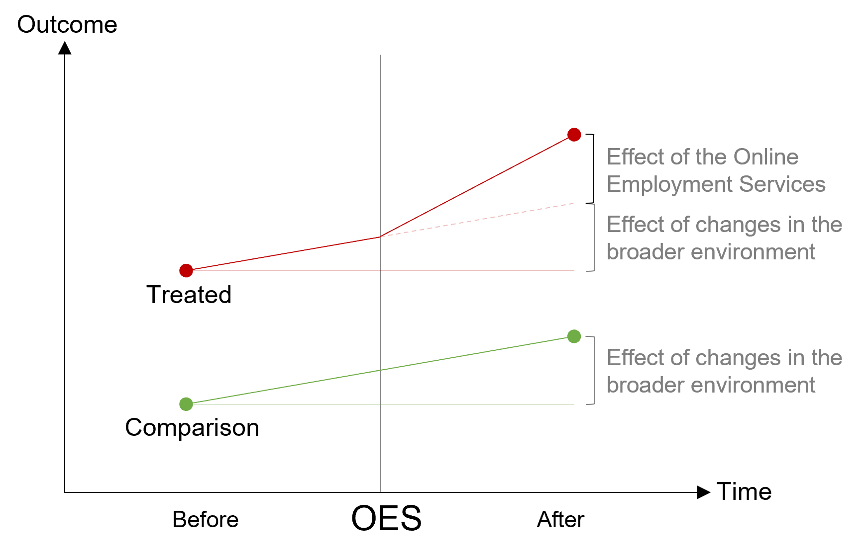
To ensure the robustness of the analysis, the DiD regression was conducted using 2 sources of administrative data: the inflow data and the monthly caseload data. The pre-treatment period was from December 2018 to March 2019, while the post-treatment period was from December 2020 to March 2021. ‘Inflow’ refers to participants who commenced in OES over the pre- and post-treatment periods; ‘caseload’ refers to participants who were already in services. Exits from income support and exits from employment services were used as the dependent variable. The control variables included in the regression were age groups, gender, Aboriginal and/or Torres Strait Islander status, CALD background, English language proficiency, disability status, parental status, educational attainment, recent work experience, duration of unemployment, previous convictions, geographic location, and mode of transport. A detailed description of the methodology is in Appendix C.

Estimation results
Table 6.2 presents the effect of OES on exits from income support and exits from employment services as estimated using linear DiD. The results overall show that OES did not have a statistically significant effect on exits from income support or exits from employment services. While the results based on monthly caseload data indicate a statistically significant improvement in exits from income support, the effect was nevertheless small (1.8%pts). Taken together, the findings suggest that participants were likely to achieve similar outcomes in either OES or provider services.
Table 6.2 Difference-in-differences estimation of the effect of OES on exits from income support and exits from employment services
Data | Number of observations | Exits from income support |  | Exits from jobactive employment services
Data | Number of observations | Estimate (%pts) | Standard error | Estimate (%pts) | Standard error
Inflow | 75,856 | –0.003 | 0.011 | 0.009 | 0.011
Monthly caseload | 1,335,006 | 0.018* | 0.001 | –0.001 | 0.001
Source: DEWR administrative data.
Note: *Indicates statistically significant effect at a significance level of 0.05 (p ≤ 0.05). Outcome for inflow is defined as whether a participant exited within 12 months from commencement. Outcome for monthly caseload is defined as whether a participant exited in the following month.
The analysis was repeated for 3 sub-groups – (1) Aboriginal and/or Torres Strait Islander participants, (2) participants with a CALD background, and (3) participants with disability – to find out if OES affected these groups differently. The results are presented in Table 6.3 and Table 6.4. Table 6.3 shows that the results based on inflow data indicate a general lack of statistically significant effect, except for exits from income support among Aboriginal and/or Torres Strait Islander people. While the 9.0 percentage point estimate was large and statistically significant when exit from income support was used as the outcome variable for this group, the estimate (1.1 percentage points) was small and statistically insignificant when exit from employment services was used as the outcome variable.
The results based on monthly caseload data (Table 6.4) indicate some statistically significant effects, but these effects, again, are generally small.
Table 6.3 Difference-in-differences estimation of the effect of OES for vulnerable groups based on inflow data
Group | Number of observations | Exits from income support |  | Exits from jobactive employment services
Group | Number of observations | Estimate (%pts) | Standard error | Estimate (%pts) | Standard error
Aboriginal and/or Torres Strait Islander people | 3,570 | 0.090* | 0.039 | 0.011 | 0.039
People with CALD background | 12,057 | –0.040 | 0.027 | –0.018 | 0.027
People with disability | 4,407 | 0.057 | 0.036 | 0.068 | 0.035
Source: DEWR administrative data.
Note: *Indicates statistically significant effect at a significance level of 0.05 (p ≤ 0.05). Outcome for inflow is defined as whether a participant exited within 12 months from commencement.
Table 6.4 Difference-in-differences estimation of the effect of OES for vulnerable groups based on monthly caseload data
Group | Exits from income support |  |  | Exits from employment services
Group | Number of observations | Estimate (%pts) | Standard error | Number of observations | Estimate (%pts) | Standard error
Aboriginal and/or Torres Strait Islander people | 70,999 | 0.009* | 0.004 | 77,240 | –0.004 | 0.005
People with CALD background | 250,330 | 0.015* | 0.002 | 298,813 | –0.009* | 0.002
People with disability | 74,141 | 0.009* | 0.004 | 83,240 | –0.006 | 0.005
Source: DEWR administrative data.
Note: *Indicates statistically significant effect at a significance level of 0.05 (p ≤ 0.05). Outcome for monthly caseload is defined as whether a participant exited in the following month.
Taken together, the results suggest that participants in OES were not disadvantaged in achieving labour market outcomes, similar to the findings of the OEST evaluation.

6.7 Employment after exiting income support
While administrative data does not capture the employment status of participants after they exit employment services, the OES Participant Survey collected information on whether a participant was employed at the time of the survey. By linking the survey data with administrative data, it was found that 1,607 OES participants who commenced and exited OES and income support between 5 December 2020 and 31 January 2022 were identified in both datasets. Among them, 1,362 (85%) were employed at the time of the survey (Table 6.5). This figure is consistent with results from the Post Program Monitoring (PPM) surveys, where 82.5% of participants were in employment around 3 months after exiting OES between 1 January 2021 and 31 December 2021.
Results from both waves of the OES Participant Survey also showed that 59.2% of participants were in permanent employment with paid holiday and sick leave, while 35.2% were either employed temporarily or in seasonal or casual work and 5.5% were self-employed (Table 6.5).
Table 6.5 Employment outcomes after exiting income support and OES
Employment status and conditions at the time of the survey | %
Proportion of participants who were employed* | 84.7
Employment type:
Permanent, with paid holiday and sick leave | 59.2
Temporary, seasonal or casual | 35.2
Self-employed | 5.5
Source: DEWR administrative data and OES Participant Survey, Waves 1 and 2.
Base: n=1,607, weighted results.

6.8 Cost-effectiveness of online services
Previous evaluations of mainstream employment services have used cost per employment outcome to assess the efficiency of an employment services program. The measure was calculated by dividing total government expenditure on an employment services program by the number of employment outcomes achieved by participants. Employment outcomes were measured based on exits from the program or PPM employment outcome measures. If a program had a lower cost per employment outcome than its comparator, then the program was considered to be more cost-effective and thus more efficient than the comparator.
Alternatively, average cost per participant serviced, combined with the effectiveness of online services in assisting participants to achieve outcomes, could be used to assess the cost-effectiveness of online services.
Section 6.6 shows that participants in online services are as likely as those in provider services to achieve employment outcomes as measured by exit from employment services and exit from income support. At the same time, if online services cost less than provider services, as measured by cost per participant, then the online services are more cost-effective (i.e., more efficient) than provider services.
Figure 6.4 presents the estimation results of cost per participant serviced, followed by a description of the methodology used to derive these results.
Figure 6.4 Average cost per participant serviced in jobactive Stream A* and online services**
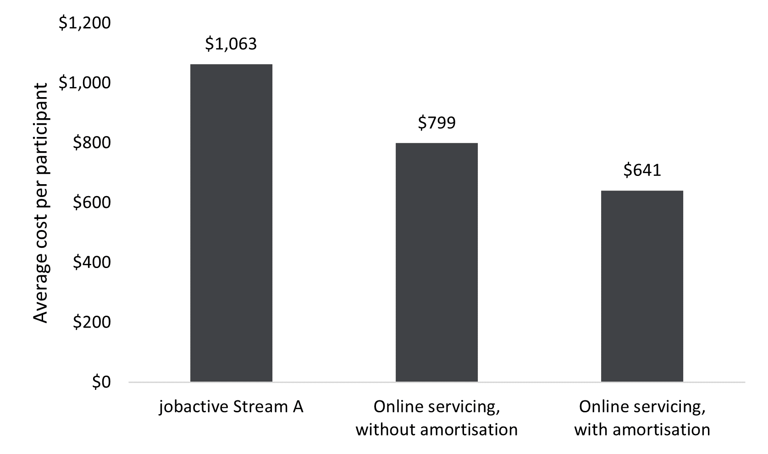
Source: DEWR financial and administrative data.
Note: *The jobactive Stream A comparator group comprises jobactive Stream A participants who received services between July 2015 and June 2019 and had the same JSCI score range as that used to allocate job seekers into online services. **The online services group comprises participants in online services between July 2018 and June 2022.
Calculating the average cost per participant in online services involved collecting data on federal Budget allocations to online services measures (to determine their cost from the initial investment in OEST to all follow-up allocations until 30 June 2022, when OES ended), as well as collecting data on participants in online services. The Budget allocations included both departmental capital investments (into building the online platform) and expenses (such as for running the DSCC). While actual costs of services would be a more accurate measure, budgeted costs were used here because actual expenditure was not available at the time of conducting the evaluation. This means that future work may be necessary to improve the accuracy by using actual costs if these can be reliably collated.
Reflecting the interdependent and iterative steps of funding online employment services, the Budget allocation data collected for calculating cost per participant in online services here is subject to caveats. Some functionalities in the online platform were for employers and services providers; job seekers who were not on income support and those in provider services could use the online services as well. No costs had been attributed to servicing these stakeholders in the calculation of these estimates because it was difficult to do so. Ignoring these costs meant that we would overestimate the costs attributable to OES participants. This is consistent with the intended approach to providing an upper-bound estimate of cost per participant in pre-July 2022 online services.
Calculating the average cost per participant in jobactive Stream A (the jobactive provider-based services counterfactual) involved collecting financial and service participation data on the jobactive Stream A comparator group. The analysis then compared the calculated cost of online service measures per participant in online services with the jobactive provider-based services counterfactual.
Over the Budgets from the 2017–18 to 2021–22 financial years, total government Budget allocations for online services measures were $499.2 million in departmental funding, including capital investment of $163.2 million and expenses of $336.0 million. Over the period from 1 July 2018 to 30 June 2022, a total of 624,453 participants were serviced in online services.,
Based on the total investment and number of participants serviced through the online platform, the cost per participant of online services was $799, if it was assumed that all capital investments to the end of the 2021–22 financial year, mostly in the form of the online services platform, realised their full value over the same period.
High-value capital investments such as online platforms are generally used for a number of years after they are built, meaning their value can be realised (or amortised) over an extended period. In fact, the online platform as it was in June 2022 formed the base for online services under the new employment services model, Workforce Australia, from 1 July 2022. Consequently, the above assumption appears unrealistic since the value of pre-July 2022 capital investment was not fully realised in terms of the use of the platform when OES ended. Nevertheless, cost per participant serviced based on this assumption can serve as an upper bound.
Because the use of the existing online platform was transferred to Workforce Australia at the end of June 2022, the question is: What was the remaining value of the online platform that was transferred if we considered the effect of the amortisation of capital investment over time? Using the conventional amortisation rate of IT infrastructure of 20%, the value of the online platform transferred to Workforce Australia would be $98.9 million. This means that $64.3 million of the capital investment could be attributed to online services participants up to 30 June 2022. Deducting the value of investment transferred to Workforce Australia, average cost per participant serviced in pre-July 2022 online services becomes $641. This could serve as a lower bound of the cost.
Since without online services those participants would have been serviced by jobactive providers as Stream A participants, the natural counterfactual is average cost per participant serviced in Stream A. Further, only participants with a JSCI score below a threshold were eligible for online services, and the analysis restricted the comparable participants in provider services to Stream A participants with the same JSCI score range as that used to allocate job seekers into online services (the comparator group). Based on departmental expenditure data on employment services participants and the number of participants who were serviced over the period from 1 July 2015 to 30 June 2019 (and who were eligible for online services), average cost per participant of jobactive Stream A services (the counterfactual) was $1,083. Note that expenditure on jobactive services for the comparator group included all the relevant costs, such as administration fees and outcome payments paid to jobactive providers, expenses from the Employment Fund, and costs of wage subsides.
Comparing average cost per participant serviced between online services and the counterfactual (jobactive Stream A services), when amortisation of online platform investment is accounted for, online services were $442 cheaper per participant serviced than provider services. In the scenario in which amortisation is not accounted for, online services were $284 cheaper per participant serviced than provider services.
The savings of cost per participant serviced in online services with the more realistic assumption of capital amortisation, combined with the total number of participants serviced in online services, indicate that the net savings from online services amounted to $276.3 million for the period from 1 July 2018 to 30 June 2022.
In summary, online services are estimated to be less costly than provider services based on cost per participant serviced. This lower unit cost, together with the findings presented earlier that participants in online services were not disadvantaged in achieving labour market outcomes, means that online services were more cost-effective (or efficient) than provider services for job-ready employment services participants.
Another aspect of the efficiency of online services is its ease of scaling up, as demonstrated in the transition from OEST to OES. Without OES, it would have been very difficult for providers to expand their services to cope with the surge of job seekers resulting from the impacts of COVID-19, even if funding had been available.
Analysis in Section 6.6 used exit from employment services as a proxy for employment in the absence of paid employment outcomes. It may be argued that if exit from services is a proxy for employment, cost per exit could be a proxy for cost per employment outcome and thus used as a measure of cost-effectiveness.
Figure 6.5 presents cost per exit estimates. Based on this measure, without capital amortisation, cost per exit for online participants (at $1,237) was about $670 lower than for Stream A participants in provider services. With capital amortisation considered, cost per exit for online services was over $900 lower than for Stream A participants in provider services.
Figure 6.5 Average cost per exit from jobactive Stream A and online services
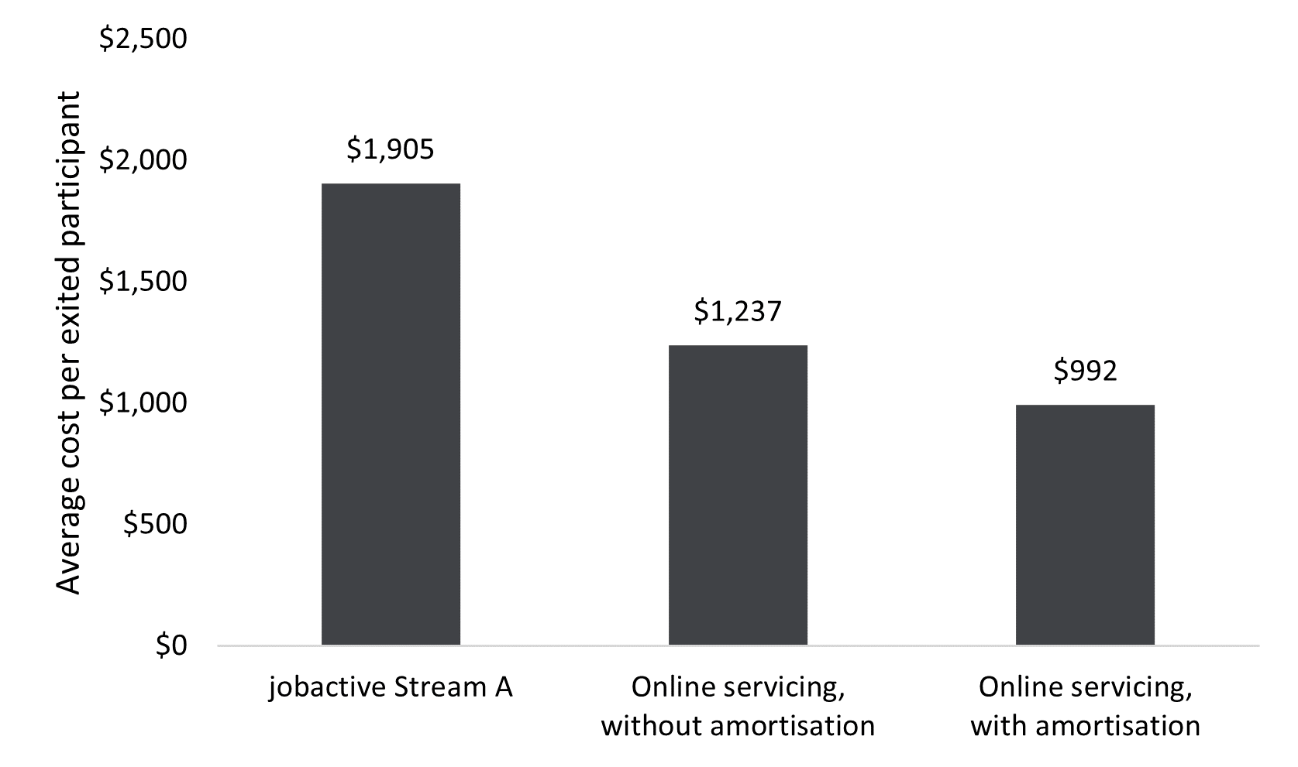
Source: DEWR financial and administrative data.
OES operated in an unusual circumstance when an unprecedent number of job seekers entered employment services, particularly during the early stage of the program. Because the new job seeker cohort tended to have recent work experience, they were more likely to be referred to online services. The lower cost per participant in online services, as shown in Figure 6.4, was driven by the substantial increase in job-ready job seekers over the unusual period. Then a question arises: What would be the cost per participant for online services in a ‘normal’ circumstance (without COVID-19)? To address this question, we conducted 2 scenario analyses:
- Scenario 1: What would be the number of OES participants if the monthly numbers of OES participants over the period March 2020 to June 2022 were the same as the average monthly number of Stream A jobactive participants with a JSCI score eligible for OES over the period January 2018 to December 2019?
- Scenario 2: What would be the number of OES participants if the monthly numbers of OES participants over the period March 2020 to June 2022 followed a linear trend of the monthly numbers of Stream A jobactive participants with a JSCI score eligible for OES over the period January 2018 to December 2019?
Cost per participant serviced under these 2 scenarios is presented in Table 6.6.
Table 6.6 Cost per participant in 2 hypothetical scenarios of ‘normal’ OES operation
 | Costs per participant serviced |  | Estimated number of job seekers in services
 | Without amortisation | Adjusted for amortisation
Online services – Scenario 1 | $905 | $725 | 551,772
Online services – Scenario 2 | $1,175 | $942 | 424,830
jobactive Stream A with JSCI score eligible for online services | $1,063 | Not applicable | Not applicable

Under Scenario 1, online services would still be less expensive than provider services, although the cost gap between the 2 service modules would reduce. Under Scenario 2, online services would become more expensive than provider services if amortisation were not considered. If amortisation were taken into account, online services would still be cheaper than provider services. These analyses suggested that to be cost-effective, online services do need to service a sufficient number of participants. However, as noted earlier, these calculations have not accounted for costs that could be attributed to service providers and employers due to difficulties in doing so. It is still likely that costs per participant serviced online under Scenario 2 could be lower than those of provider services if these costs could be separated from those used for servicing online participants.

Chapter 7 Employer views of and experiences with OES
Advancements in digital technologies are also affecting how employers recruit their employees. More than half (57%) of employers who participated in the 2015 Employer Survey indicated that they used online recruitment channels and reported an increasing reliance on online channels to meet their recruitment needs. Likewise, the 2017 jobactive Employer Survey results revealed that many employers (65%) used internet advertising on sites like SEEK, Indeed and Gumtree to recruit entry-level staff.
The OES Employer Research was conducted from August to November 2021 and included employers who had registered for and/or used OES from the jobactive/JobSearch website (OES user employers) and those who had not used OES (general employers). This chapter summarises the findings from that research.

7.1 Awareness of and familiarity with the JobSearch website
It was assumed that OES user employers were aware of the jobactive/JobSearch website; therefore they were not asked the awareness question in the OES Employer Research survey. The survey found that about a third (33%) of general employers were aware of the jobactive/JobSearch website after they were provided with a description. The level of awareness increased with organisation size, ranging from 27% among smaller businesses to 34% among medium businesses, up to a high of 46% among large businesses.
Immigration websites and migration lawyers and agents were the most prevalent avenue for learning about OES among the OES user group, with 43% becoming aware of the jobactive/JobSearch website through this avenue (Figure 7.1). This is most likely because many employers registered with OES were involved in labour market testing (LMT) to sponsor the visa of a non-Australian resident. LMT requires the employer to advertise jobs on the jobactive/JobSearch website as well as 2 other platforms or avenues for 4 weeks, in order to demonstrate that all local options have been exhausted.
A few OES user employers learned about the jobactive/JobSearch website through word of mouth or a co-worker (22%) or from an employment services provider (16%). For the general employer group, word of mouth or a co-worker was the most prevalent avenue (26%) for learning about the website, followed by online advertising (20%) and from an employment services provider (16%).
Even among the OES user group, only 31% reported that they knew a lot about the jobactive/JobSearch website, with the rest reportedly knowing a little about it. Not surprisingly, OES user employers who had used the website more frequently were more likely to say that they knew a lot about it than less frequent users. For example:
- 12% of those who had used JobSearch once said they knew a lot about jobactive/JobSearch
- 32% of those who had used JobSearch a few times said they knew a lot about jobactive/JobSearch
- 76% of those who had used JobSearch many times said they knew a lot about jobactive/JobSearch.
The qualitative research asked OES user employers about their site usage behaviour and found that most simply navigated directly to the webpage they needed in order to perform their key tasks, typically to post a job or review and contact applicants, and very few paid attention to anything else on the jobactive/JobSearch website:
[When asked if the respondent accessed features on the OES dashboard such as notifications; ‘providers near me’; ‘your jobs’; ‘find candidates’; or ‘useful information for employers’] … No. I was just trying to find my job that was advertised. (OES Employer Research, employer interview)
Figure 7.1 The avenues through which employers heard about jobactive/JobSearch
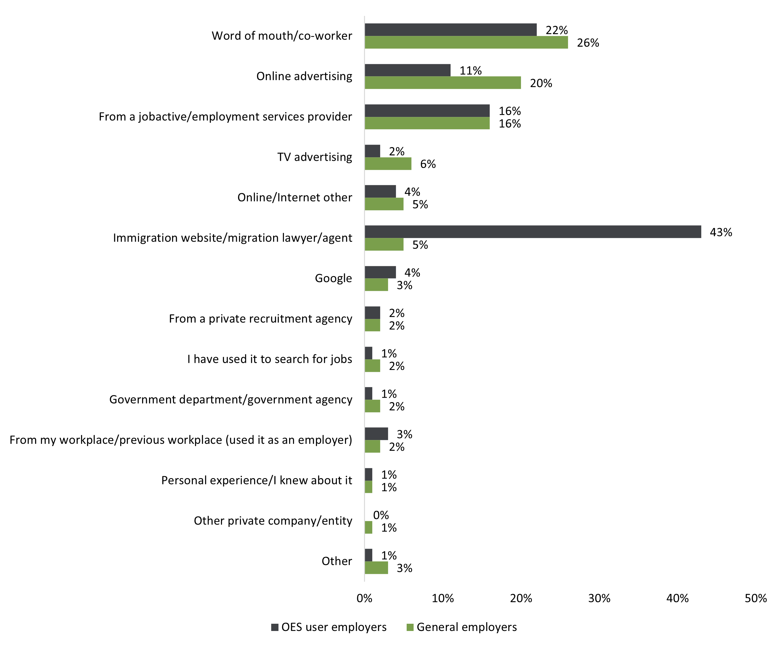
Source: OES Employer Survey, 2021.
Base: Aware of jobactive/JobSearch: general employers n=684; OES users n=1,272. ‘Don’t know’ / ‘no response’ figures are not displayed.
Note: Q. How did you hear about the jobactive/JobSearch website?

7.2 OES usage and reasons for use
Among OES users who had recruited candidates in the 2 years before the OES Employer Research, most (73%) had used OES as one of their recruitment platforms in the past year, but only 6% of general employers indicated that they had used OES (Figure 7.2). SEEK was the predominant recruitment platform for OES users, with 83% using it in the past year, followed by word of mouth (60%) and Indeed (53%). Word of mouth (63%) and SEEK (61%) roughly equally dominated the recruitment platforms for general employers’ past year recruitment, followed by Facebook (40%).
Figure 7.2 Recruitment platforms used in the past year
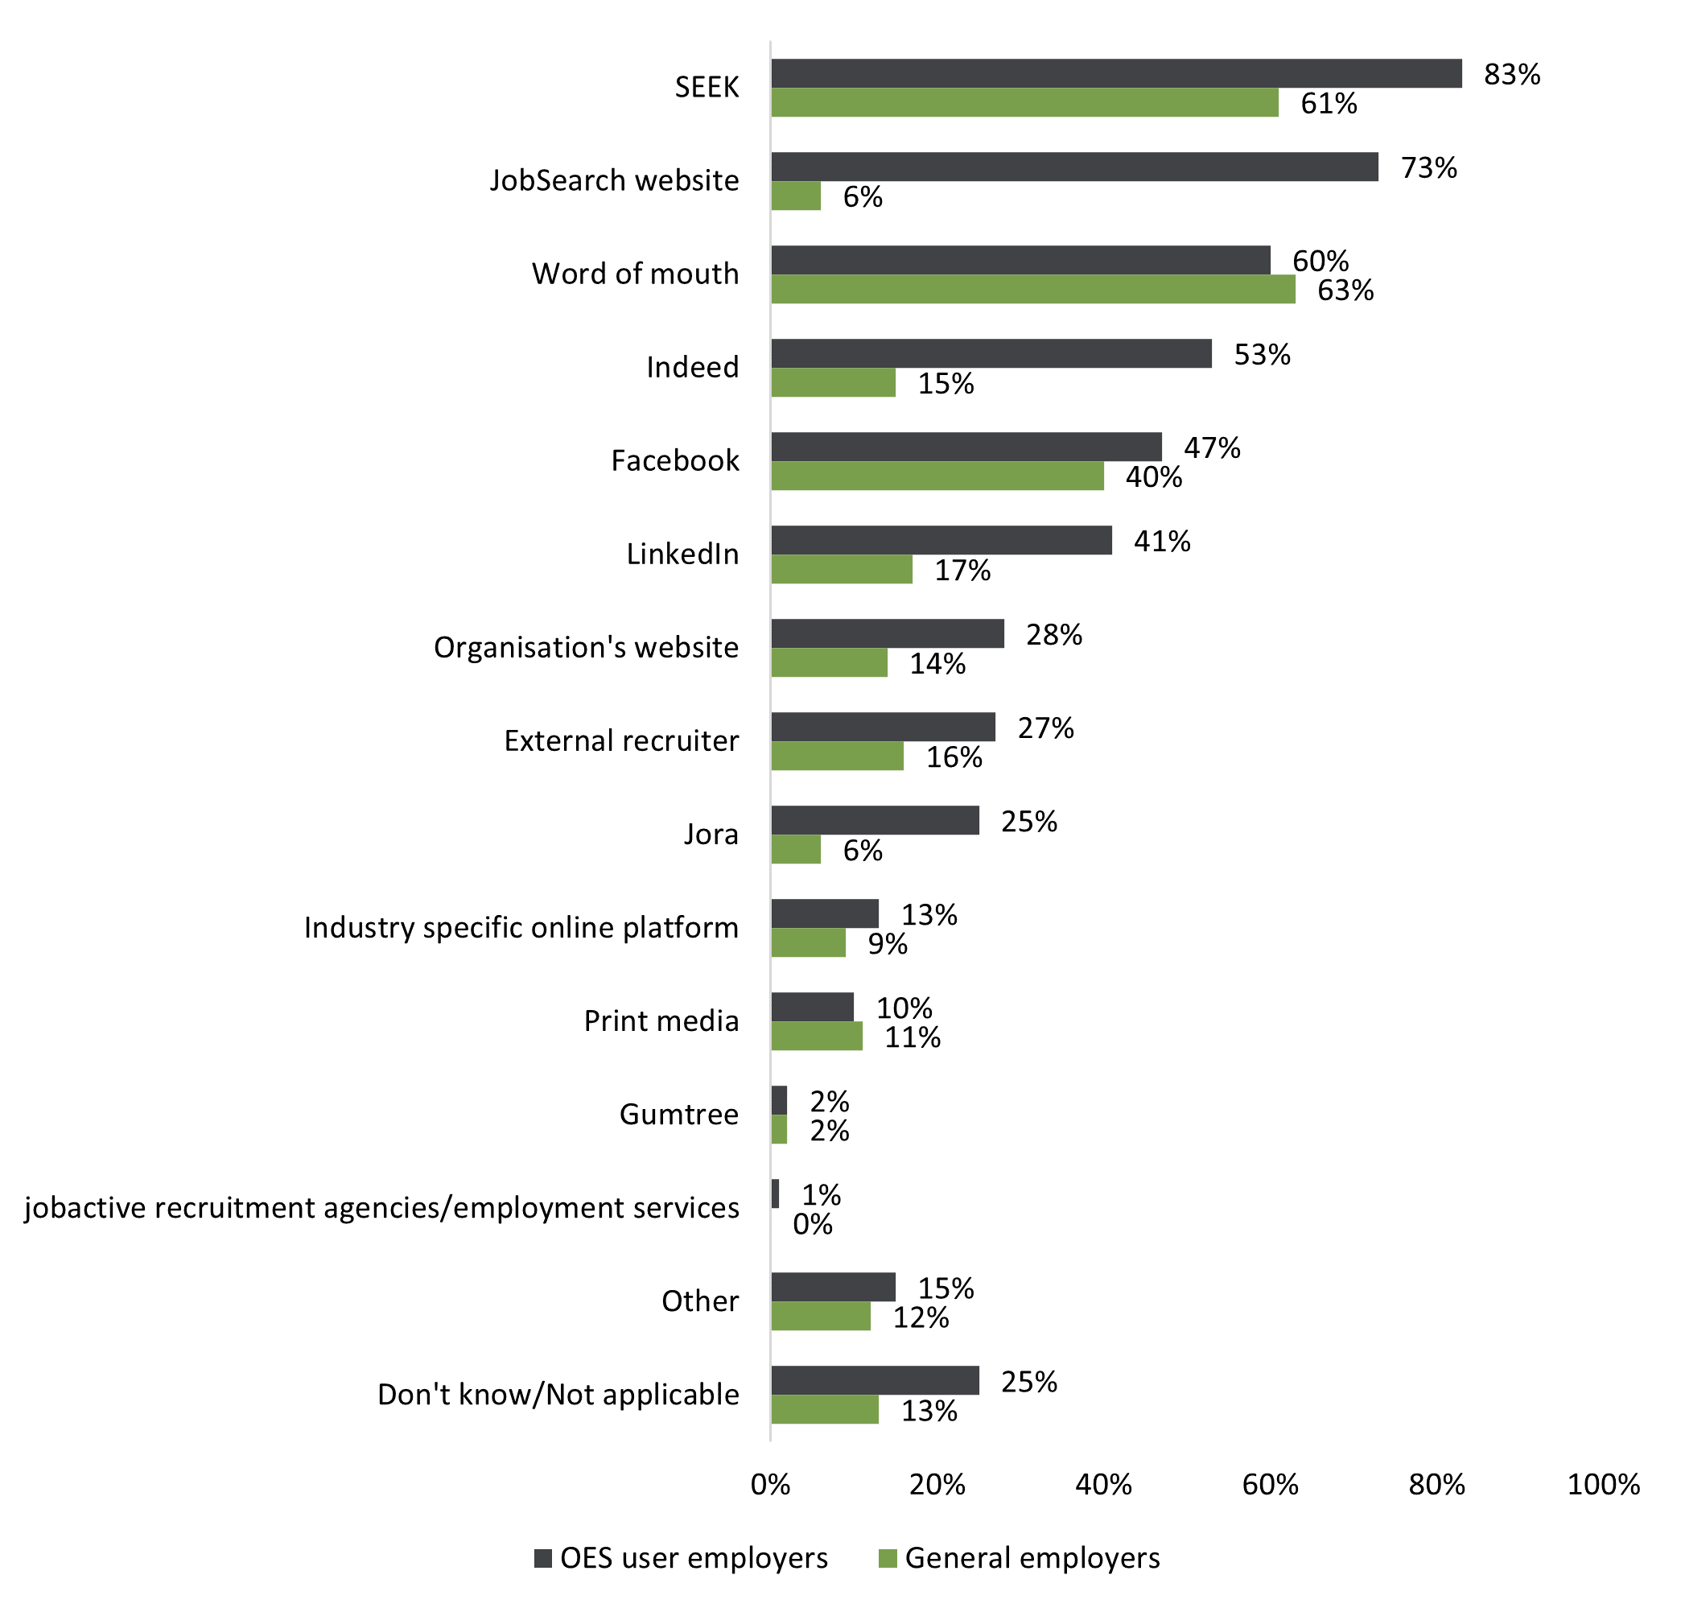
Source: OES Employer Survey, 2021.
Base: Have recruited in past 2 years, likely to recruit in next 2 years: general employers n=1,652; OES users n=1,257.
Note: Q. In the past year, when you have attempted to recruit staff, which methods or platforms have you used?
OES users in the OES Employer Research survey were asked to select from a list of reasons as to why they had chosen to place a job advertisement on the jobactive/JobSearch website, and 3 reasons stood out beyond all others (Figure 7.3):
- it was free to advertise (57%)
- legal obligations concerning labour market testing (44%)
- it provided an additional avenue to advertise beyond other platforms they used (28%).
Fifteen per cent of OES users used it for its quantity of candidates, and 14% for its diversity of candidates. Only 10% used it for the suitability of candidates.
Figure 7.3 Reasons for selecting the jobactive/JobSearch website to advertise a position – OES users
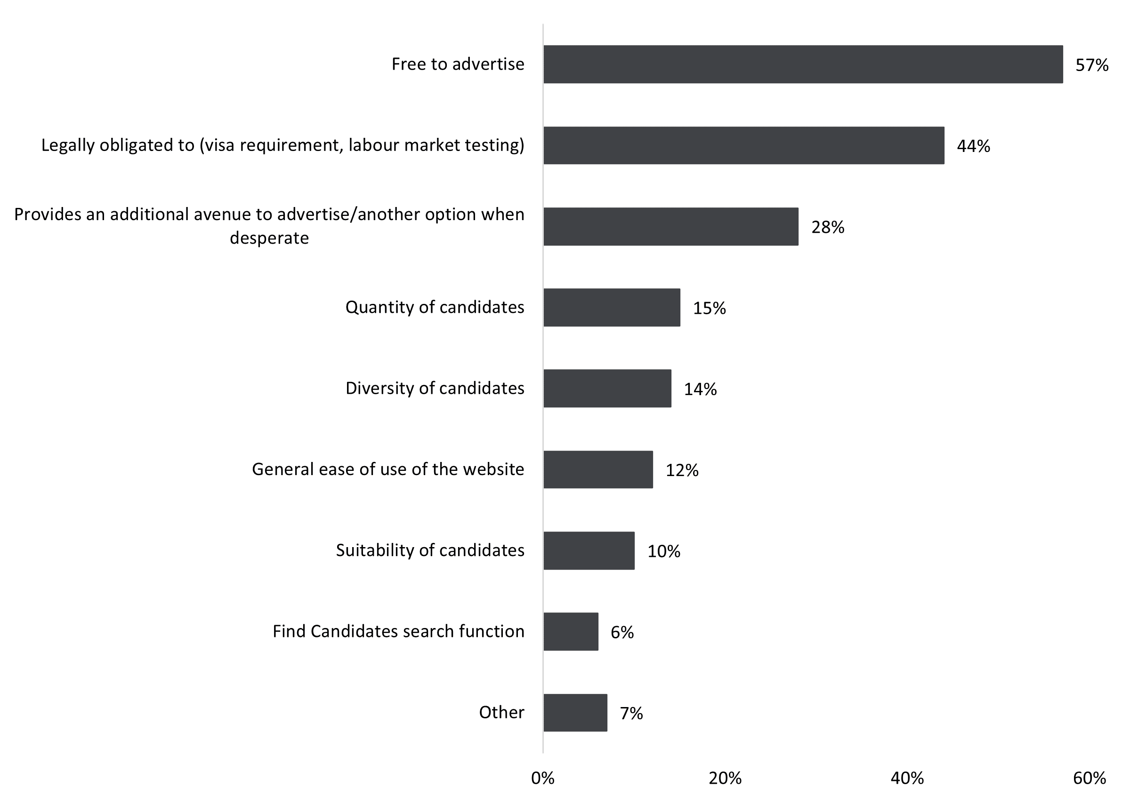
Source: OES Employer Survey, 2021.
Base: Have used the jobactive/JobSearch website, excludes those completing hard copy, n=1,215.
Note: Q. What are the key reasons that you have chosen or would choose to place a job advertisement on the jobactive/JobSearch website?
Some employers also liked the feature that allowed them to search and contact individual candidates.
Usually I’ll just go on there randomly and just go click on where it says the job and just click find candidates, and it’ll bring up a heap of profiles. And then you can just click on their profile and have a look at their qualifications. Then you’ve got the option of sending them a message through jobactive, or it gives you their phone number and their email address. (OES Employer Research, employer interview)

7.3 jobactive/JobSearch website usage barriers
When employers were asked about what they thought was the biggest barrier to using the jobactive/JobSearch website to recruit staff, around half (49%) of OES users mentioned the lack of quality/suitable candidates. This issue was also identified by many OES users during qualitative discussions around the difficulty in filtering out unsuitable applicants, combined with the lack of suitable candidates in the OES candidate pool:
There was one who was a vet nurse who was looking for some work. But most of them were that far from our industry and so it was just wasting my time really, that’s how it felt when I was going through the résumés everyday, this is a waste of time. (OES Employer Research, employer interview)
Yes because I did click on that and it came up with a couple of people but they weren’t suitable and it must work on a key word in their résumé and the first one had ‘pharmaceutical’ or something in there and she wasn’t AHPRA registered and she didn’t have a pharmacy degree. (OES Employer Research, employer interview)
I was looking at a couple of the ads or the roles that I’ve got live at the moment, and I was reviewing the applications that were received and you could clearly see people were just applying for any role, whether it was ’cos they were unemployed and they were applying for any role, so I think the filters need to be really specific. (OES Employer Research, employer interview)
I think whoever the applicant is, or whoever that person is applying for the job, they’re just ticking all the boxes saying they’re qualified … maybe if they develop something that makes them physically type something which deters them from just applying for every job so we don’t have to waste our time reading their résumé... (OES Employer Research, employer interview)
The issue I had with that is that it wasn’t very simple in that whilst there were filters I could’ve applied, that wasn’t really obvious when I filled out the job details. So I was just receiving jobs from people who worked in ice-cream parlours, and you know, with … you know, who would literally try and tick a box of putting job applications in I think. (OES Employer Research, employer interview)
A further 17% of OES users also cited the frustration of receiving job applications from people who were not really interested in the jobs themselves but had applied only to fulfil their job search requirements or other Services Australia requirements.
I did have one person respond to that saying that ‘hey mate I’ve got a quota to fill and that’s why I’ve applied for it.’ So yeah … but generally you don’t get any response, but if there was a way to filter out more of the inappropriate applications it would be good. (OES Employer Research, employer interview)
The prominent lack of suitable candidates was an issue commonly raised during the qualitative phase of the OES Employer Research both in relation to the jobactive/JobSearch site and more generally in relation to the current environment, which was seemingly lacking in talent pools to draw from. Finally, around 1 in 10 (9%) OES users mentioned that the site was glitchy or difficult to use.

7.4 Usage of the Find Candidates feature
Among those employers who had used OES for recruitment, 40% had used the Find Candidates feature on the jobactive/JobSearch website. Many OES users participating in the qualitative research reported that they had never even noticed the feature.
No, I didn’t see that at all, no. maybe that’s … maybe yeah obviously I wasn’t looking for it, didn’t stand out, no. (OES Employer Research, employer interview)
I don’t think, no I haven’t. I haven’t searched that. (OES Employer Research, employer interview)

7.5 OES user ratings of the website
Among employers who had used the jobactive/JobSearch website, a little over half (54%) said that the information on how to get help with any questions was either good or excellent; nearly 6 in 10 (59%) respondents said the ease of use was good or excellent (Figure 7.4). These ratings were consistent with findings from qualitative research:
I was really impressed with the job search; it was very easy to use. It was very similar to … to SEEK I suppose, but I was quite, yeah it was better than SEEK to be honest, because you can actually track all the new people that apply so, yeah I thought it was very good. I don’t think we’ll change our approach but do more of the same. (OES Employer Research, employer interview)
Figure 7.4 Ratings of the jobactive/JobSearch website by OES users
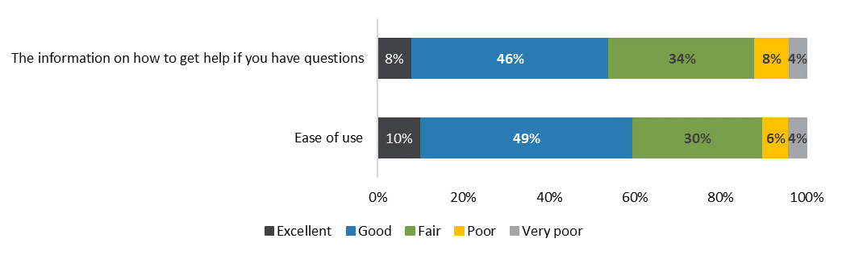
Source: OES Employer Survey, 2021.
Base: Have used jobactive/JobSearch website, excludes those completing hard copy survey, n=1,215.
Note: Q. Thinking about the jobactive/JobSearch website, how would you rate... Percentages exclude ‘don’t know’ and blank responses from the base.
However, overall satisfaction with using the jobactive/JobSearch website was lower: around a third (34%) were satisfied with the overall experience of using the website and a similar proportion (32%) were dissatisfied (Figure 7.5). The OES Employer Research survey showed that overall satisfaction was higher (55%) among respondents who had had prior success in hiring candidates via jobactive/JobSearch compared to those who had not (28%).
Figure 7.5 Satisfaction with overall jobactive/JobSearch website usage experience – OES users
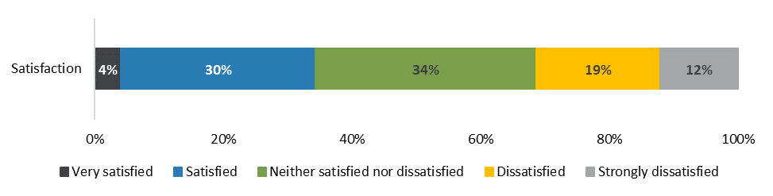
Source: OES Employer Survey, 2021.
Base: Have used the jobactive/JobSearch website, excludes those completing hard copy, n=1,215.
Note: Q. How satisfied are you with the overall experience of using the jobactive/JobSearch website? Percentages exclude ‘don’t know’ and blank responses from the base.
Qualitative research supported these results, in that employers who had hiring success with jobactive/JobSearch were more forgiving of the often arduous process of filtering through unsuitable candidates in order to find the single suitable one they eventually hired:
it doesn’t cost anything I suppose that’s a … and I suppose I get more variety even though I say there’s a lot more time wasters with résumés, you do get the opportunity to filter through a lot more, a broader area of résumés. So somewhere like SEEK or that you get minimal through, you know, in the initial timeframe Facebook’s the same, but yeah, JobSearch you do get a lot more, I suppose, a lot more applicants. (OES Employer Research, employer interview)

7.6 OES user segmentation
Based on both the quantitative and qualitative components of the OES Employer Research, OES users may be characterised into 4 segments:
- OES fans (about 43% of OES users): They were the most satisfied users, were the most likely to have hired staff from the jobactive/JobSearch site, and were primarily concerned with having a free-to-use platform, search functionality, and platform features that enabled them to manage applicants and manage their contact with them.
- Captive users (about 25%): They were the least satisfied users and used the jobactive/JobSearch site reluctantly (many for LMT purposes), were the least likely to have hired from it, and would most like to see enhancements to search functionality via applicant suitability screening.
- Reluctant users (about 19%): They were somewhat satisfied with the jobactive/JobSearch site, were looking for employees with specific credentials and traits, and required platform tools to help maximise their search efficiency and effectiveness.
- Opportunistic users (about 13%): They were somewhat satisfied users but the least likely to be familiar with the site’s features. They more frequently reported organisational growth and used many recruitment platforms, and their primary usage motivation was being incentivised to do so.
The segmentation may help inform policy thinking and platform design of future online services.

7.7 Recruitment platform features valued by employers
To identify employers’ needs in relation to which OES functions were regarded as most important, the OES Employer Research explored 7 key platform-related attributes as possible factors in influencing employers to use the jobactive/JobSearch website in the future. The attributes considered to be very important were very similar between the 2 employer groups across the board (Figure 7.6).
The 2 attributes that stood out most for both employer groups were:
- the ability to search for candidates, filtering by location, industry, occupation and skills – nominated as very important by nearly 7 in 10 respondents from both employer groups
- the ability to contact candidates directly – nominated as very important by around two-thirds of respondents from both groups.
The other 2 attributes considered very important by over half of both OES users and general employers were pre-screening of applicants for suitability, and the ability to manage applicants by shortlisting and rating them.
The 4 attributes considered very important by at least half of both OES users and general employers were also the key ones raised during the qualitative interviews:
… if you could do a profile search on someone – I’m not sure if that’s there, but it’s quick and easy for employers if it says ‘hey, there’s someone local who’s an admin officer’ or ‘can I do a profile search on someone?’ and an employer could just contact them directly. That’s a quick and easy tool; it might be easier for … employers, especially if they don’t do recruitment often, it might be a bit daunting for them to create a new account; advertise; check applicants. If they could just use a search tool, that would be easy and convenient. (OES Employer Research, employer interview)
… then give it a ranking based on the responses of the screening questions, would be fantastic. That would save a lot of time. (OES Employer Research, employer interview)
Figure 7.6 Importance of features in encouraging use of OES in the future (% very important)
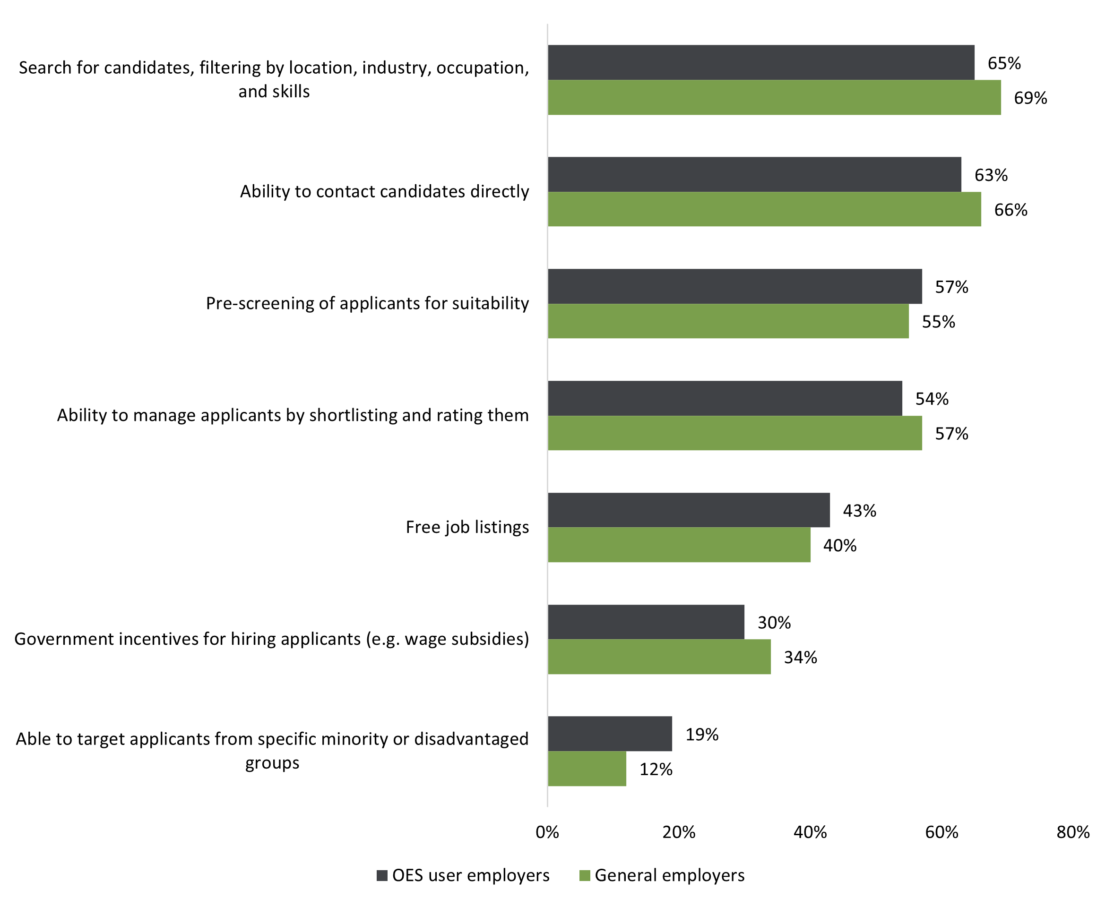
Source: OES Employer Survey, 2021.
Base: Likely to recruit staff in next 2 years, OES users n=1,184; general employers n=1,460.
Note: Q. How important would the following be in encouraging you to consider using the jobactive/JobSearch website.
[When asked about filters the respondent would like to see on JobSearch] … Like a radius filter, linked within say 30km, 20km, that they have working rights to work in Australia, that they are qualified for welders sort of thing, that they have a drivers licence, just better filters; just be able to put in everything that you need for that role and then it passes on people’s details. (OES Employer Research, employer interview)
If the answer was no to ‘do you have the relevant professional qualification’, otherwise I’ve actually got to go in, I’ve got to download the résumé, I’ve got to actually look at it, look at their professional qualifications list and see if they actually meet the minimum criteria and then rate them based on that. So screening questions would definitely save me a lot of time. (OES Employer Research, employer interview)

Chapter 8 Conclusion
This report has presented and discussed data analysis results and feedback from various stakeholders ranging from participants, providers and employers to internal stakeholders. The findings presented in previous chapters are synthesised in this chapter.

8.1 What worked well
Feedback from participants, providers and internal stakeholders revealed that OES was appropriate, effective and efficient in enabling job-ready and digitally capable participants to self-manage their job search online, thereby enabling employment services providers to focus their resources on supporting participants who needed additional assistance and support.
There was a general positive attitude towards OES among participants and jobactive providers. Providers agreed that online services were most appropriate for job seekers who were job ready and digitally capable. Most participants who were referred to OES preferred online services and were confident in self-managing their job search on an online platform. Feedback from OES participants on the JSS and Job Plan also indicated that the referral and onboarding processes were largely effective and efficient in identifying and engaging suitable job seekers in OES.
Most OES participants did not encounter issues meeting their MORs, and those who did were able to resolve these issues with assistance from the DSCC. A majority of participants found the OES dashboard most useful in helping them monitor and report their MORs; hence it is not surprising that, compared to other tools and features in OES, the dashboard was the most frequently and regularly used. Similarly, employers registered with OES mainly used the Find Candidates feature on the employer dashboard and seldom navigated beyond this feature to explore the jobactive/JobSearch website for other tools and resources.
The relatively low levels of opt-outs and transfers from OES to provider services indicated that online services worked well overall. OES participants’ attitude towards online services was also found to improve as they became aware of the features and tools available, with some indicating that OES helped them identify existing transferable skills and encouraged them to consider jobs in other industries.
Within 12 months from commencement, the vast majority of OES participants exited income support and/or employment services; and the vast majority of those exiting income support were found to be employed. Importantly, OES participants were found to be as likely to exit income support or employment services no matter whether they were in online services or serviced by a jobactive provider, suggesting that online services did not disadvantage job-ready job seekers in terms of achieving labour market outcomes compared with provider services. These findings were largely consistent with those from the OEST evaluation.
The evaluation also found that online services had lower cost per job seeker serviced than provider services under jobactive for equivalent job seekers. Together with the finding that job-ready job seekers were likely to achieve similar labour market outcomes whether they were in online services or provider services, this suggests that online services were more efficient than provider services in providing employment services for job-ready job seekers.

8.2 What did not work well
Similar to the OEST and NEST evaluations, this evaluation found that there is a lack of awareness and/or understanding among all research participants. This includes awareness of the opt-out option, the automatic transfer to a provider after 12 months in online services, the department helplines and of the broad range of OES functionality. There appeared to be confusion and fear among some jobactive providers that online services would eventually replace provider services.
Previous research undertaken by the department showed that awareness of government employment services was generally low among employers, and OES was no exception. Some employers who had used OES were disappointed about the lack of candidate screening and filtering features. There was also a common assumption that the calibre of candidates from a government website would most likely be low.
This evaluation also revealed an underutilisation of various tools and features in OES, and this is most likely due to the low awareness among OES participants of resources available. Most participants used OES solely for meeting and reporting their MORs and seldom ventured beyond the dashboard. This mirrored what employers said about their experience with OES: most had only used the Find Candidates feature on the employer dashboard. Also similar to employers’ experience, participants were frustrated with the lack of filtering on the jobactive/JobSearch website when searching for jobs. This is one of the reasons why participants favoured commercial job search sites over the jobactive/JobSearch site to look for jobs.
Despite the low awareness and underutilisation, a few participants who had used OES features like the online self-booking tool to participate in employment programs such as CTA found it to be useful; and, once informed about tools like Job Switch, many participants indicated that they were eager to give them a try. This indicates that more participants would have used the tools and resources in OES had they been aware of them.
While the evaluation found that online services worked well for most OES participants, OES participants with certain characteristics were more likely to opt out and/or less likely to achieve labour market outcomes. They included:
- those with lower digital literacy or access
- those with lower educational attainment
- those with mixed/poor English
- mature-aged participants
- those in more regional areas
- Aboriginal and/or Torres Strait Islander people
- people with disability.
This was consistent with concerns expressed by jobactive providers that some job seekers who did not meet the criteria for online services might have been misplaced into OES.

8.3 Limitations
There are some caveats to the above learnings, particularly regarding how the evaluation results may differ in different labour market conditions. The most significant impact on this evaluation was from the COVID-19 pandemic. To a lesser extent, the evaluation was also impacted by natural disasters such as bushfire and floods. One consequence was the suspension of MORs for job seekers impacted by the pandemic and natural disasters. It should also be noted that, despite the initial negative impact from the pandemic, the labour market over the evaluation period was relatively strong. Many job seekers would have had extensive experience in the labour market, so they would have found a job more quickly than their more disadvantaged counterparts. Results could be different under different labour market conditions.

Bibliography
Department of Education, Skills and Employment (2022). Online Employment Services Evaluation Strategy. Canberra: Australian Government. https://www.dewr.gov.au/employment-research-and-statistics/resources/online-employment-services-evaluation-strategy
Department of Education, Skills and Employment (2021). Online Employment Services Trial Evaluation Report. Canberra: Australian Government. https://www.dewr.gov.au/employment-research-and-statistics/resources/online-employment-services-trial-evaluation-report
Department of Education, Skills and Employment (2021). Online Job Seeker Classification Instrument Trial Evaluation Report. Canberra: Australian Government. https://www.dewr.gov.au/job-seeker-assessment-framework/resources/online-job-seeker-classification-instrument-trial-evaluation-report
Department of Education, Skills and Employment (2021). Transition to Work Final Evaluation Report. Canberra: Australian Government. https://www.dewr.gov.au/transition-work/resources/transition-work-final-evaluation-report
Department of Employment and Workplace Relations (2022). New Employment Services Trial Evaluation Phase 1 Report. Canberra: Australian Government. https://www.dewr.gov.au/employment-research-and-evaluations/resources/new-employment-services-trial-evaluation-phase-1-report
Department of Employment and Workplace Relations (2022). The Evaluation of jobactive Final Report. Canberra: Australian Government. https://www.dewr.gov.au/employment-research-and-evaluations/resources/evaluation-jobactive-final-report
Department of Jobs and Small Business (2018). I Want to Work. Canberra: Australian Government. https://www.dewr.gov.au/new-employment-services-model/resources/i-want-work
Gertler, PJ, Martinez, S, Premand, P, Rawlings, LB & Vermeersch, CMJ (2016). Impact Evaluation in Practice, second edition. Washington: Inter-American Development Bank and World Bank, 129–142. https://openknowledge.worldbank.org/bitstream/handle/10986/25030/9781464807794.pdf?sequence=2&isAllowed=y
Jobs and Skills Australia (2020). The Shape of Australia’s Post COVID-19 Workforce. Canberra: Australian Government. https://www.nationalskillscommission.gov.au/publications/shape-australias-post-covid-19-workforce

Appendices

Appendix A Policy detail – Targeted Compliance Framework
The TCF is a compliance framework that applies to participants in jobactive, ParentsNext, Disability Employment Services and NEST. The TCF consists of 3 ‘zones’: the Green Zone, the Warning Zone and the Penalty Zone.
Green Zone: All participants start in the Green Zone and, so long as they meet all their MORs, will remain in this zone.
Warning Zone: Participants enter the Warning Zone if they accrue a demerit. Each demerit has a lifespan of 6 active months. If a participant accrues 3 demerits or commits a ‘Fast-Track’ Mutual Obligation Failure (MOF), a provider will conduct a Capability Interview (CI) with them to determine whether their requirements are appropriate to their individual circumstances. If the participant is deemed capable, they continue in the Warning Zone; otherwise, their demerits will be reset to zero and they will return to the Green Zone and be required to address the issue identified by the CI.
Penalty Zone: If a participant accrues 5 demerits in 6 months or commits a ‘Fast-Track’ MOF while on 3 or more demerits, Services Australia will conduct a Capability Assessment with them to determine whether their requirements are appropriate to their individual circumstances. If the participant is deemed capable, they enter the Penalty Zone; otherwise they are returned to the Green Zone.
Once in the Penalty Zone if the participant continues to fail to meet their requirements, they will incur financial penalties where they do not have a reasonable excuse for non-compliance. Financial penalties are:
- loss of 50% of fortnightly payment after the first failure in the Penalty Zone
- loss of 100% of fortnightly payment after the second failure in the Penalty Zone
- payment cancellation and a 4-week post cancellation non-payment period after the third failure.
Figure A.1 provides a visual overview of the TCF model. More detail about the operation of the TCF in NEST regions may be viewed at https://www.dese.gov.au/uncategorised/resources/targeted-compliance-framework-mutual-obligation-failures-guideline.
The primary differences between the TCF and previous compliance frameworks are:
- Suspensions following a MOF are automated, removing the decision to suspend a payment from an employment services provider.
- Participants are able to know their state of compliance, through a colour-coding system and the ability to see their accrued demerits.
- Providers are able (with evidence) to recommend financial penalties. Under the TCF, financial penalties can only be applied in the Penalty Zone or when the participant has committed a work refusal failure or an unemployment failure.
- Providers can accept reasonable excuses from participants for a MOF, so that participants do not attract a demerit.
- CIs and CAs provide an additional safety net for new information to be considered if the outcome is that the requirements in a participant’s Job Plan are not suitable for the individual. If this is found to be the case, the participant is returned to the Green Zone and their demerits are set at zero, and their provider must negotiate a new, more appropriate Job Plan.
- The TCF aims for less reliance on the use of financial penalties as a mechanism of achieving behavioural change.
Figure A.1 Targeted Compliance Framework: visual representation
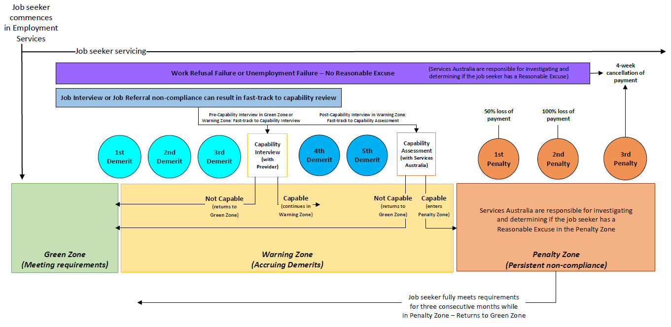
Source: Departmental guidelines.

Appendix B OES evaluation methodology

B.1. Key evaluation questions
The objective of the OES evaluation was to examine the appropriateness, effectiveness and efficiency of OES in supporting participants to self-manage their job search online, with investigation guided by the key evaluation questions as detailed in Table B.1.
Table B.1 Terms of reference and key evaluation questions
Term of reference |  | Key evaluation question
Appropriateness | KEQ1 | How well did OES meet the needs of the targeted cohort of job seekers?
Effectiveness | KEQ2 | How effective are OES core functionalities and enhancements in enabling participants to self-manage their job search and MORs, and improve their employability to find relevant and sustainable employment?
Effectiveness | KEQ3 | Are OES safeguards sufficient in ensuring that participants are in the right service and can effectively self-manage?
Effectiveness | KEQ4 | How effective is the DSCC in assisting participants to overcome barriers and remain engaged in OES?
Effectiveness | KEQ5 | What worked well and not so well in enhancing participant experience in and engagement with OES?
Efficiency | KEQ6 | Do the referral and onboarding processes ensure that job seekers get the most appropriate support to find employment?
Efficiency | KEQ7 | Has OES achieved value for money?

B.2. External factors
External factors impacting on the evaluation include:
- the COVID-19 pandemic, and the associated fluctuations impacting on the labour market and the number of job seekers on the jobactive caseload
- reduced ability for face-to face interaction (e.g., for qualitative interviewing or receiving assistance), and changing technology and access to digital services.

B.3. Data sources
The evaluation used a range of data sources and approaches including:
- administrative data analysis using data from the department’s ESS and RED from 1 May 2020 to 30 June 2022
- 2 main waves of quantitative (survey) and qualitative research with OES participants, including 4 rounds of intermediate small surveys with participants from June 2021 to May 2022
- qualitative research with internal and external stakeholders from June 2021 to May 2022, including jobactive providers, department helpline staff, the OES Evaluation Working Group members, Services Australia representatives and peak bodies
- a longitudinal study with 4 rounds of qualitative interviews with 8 OES participants
- a quantitative survey and qualitative interviews with employers conducted between September and October 2021
- findings from the PEES research undertaken between April and May 2021.
More detail on each of these data sources is contained in the following sections.
Figure B.1 outlines the evaluation approach visually by linking data sources with the evaluation terms of reference.
Figure B.1 The evaluation approach

B.4. Administrative data
The department’s administrative data collection, ESS, contains information about employment services received (e.g., placement type, referral date, commencement date and exit date), details about activities undertaken (e.g., creation of a JSS or a profile), details around contacts made to the department (e.g., enquiry data and enquiry type), and demographic details of participants.
RED data is constructed from Services Australia administrative data and is maintained by the department. The data covers unit record data on income support payments and periods of income support assistance (excluding Department of Veterans’ Affairs pensions).
This data allows for an analysis of the demographics of OES participants, the activities they undertake while receiving assistance, and whether they are on income support following assistance.
The administrative data included in the analysis is mostly for the period from 5 December 2020 to 30 June 2022. In most analyses, OES referrals before December 2020 were excluded, to discount the one-off COVID-19 referral phase, as this data is unsuitable for evaluation purposes due to the significant ‘noise’ in administrative data resulting from rapid changes to the application, assessment, referral and commencement processes of job seekers in employment services. Public health lockdowns from the onset of the COVID-19 pandemic in March 2020 contributed to substantial loss of employment, with hundreds of thousands of people losing much of their income virtually overnight. This created an influx of people claiming income support, mainly JobSeeker Payment and Youth Allowance (other). This in turn caused an influx of people being referred to the employment services caseload, which climbed from around 635,000 in February 2020 to 1,488,000 in September 2020. To accommodate the increased need for economic support and demands on the employment services caseload, changes were made to the JobSeeker Payment eligibility criteria, application process and rules.
Unless otherwise specified, the administrative data analyses are also limited to eligible participants who were referred to and commenced in OES up to 31 December 2021 and were on income support. These participants were observed up to 30 June 2022 to allow a reasonable amount of time to observe events such as opting out to a provider or exiting jobactive employment services or income support.

B.5. OES Participant Survey
Wallis was commissioned by the department to conduct quantitative research with OES participants at different points in time, aimed at monitoring OES participants’ awareness, usage and perceptions of OES overall, as well as of various particular features. This research was conducted through a series of surveys:
- Wave 1 survey conducted between July and August 2021
- interim surveys conducted between September 2021 and January 2022
- Wave 2 survey conducted between February and May 2022.
These surveys are referred to in this report as the OES Participant Survey Waves 1 and 2 and the OES Participant Interim Survey (Table B.2) – or collectively as the OES Participant Survey.
Participants were given the option to respond through either CATI or online surveying.
Table B.2 Breakdown of quantitative surveys with OES participants conducted by Wallis
Survey round | Description of the survey | Number of respondents
Wave 1 | A cross-sectional survey of OES participants between July and August 2021 | 4,229
Interim surveys | A monthly cross-sectional interim survey of OES participants from September 2021 to January 2022 | 1,002
Wave 2 | A cross-sectional survey of participants between February and May 2022 | 4,147
Source: OES Participant Survey, Waves 1 and 2; OES Participant Interim Survey.
Data collected in the OES Participant Survey were weighted before this evaluation to ensure that the results were as representative as possible of the entire OES population. Weighting was applied based on age, gender, educational attainment, Aboriginal and/or Torres Strait Islander status, and the OES status of the participant (e.g., commenced and current as at 30 June 2022, exited OES and employment services, or opted out of OES).

B.6. Employer research
To assess employer views and experiences with OES, the department commissioned Wallis Social Research to conduct research with employers in 2021, which included a quantitative survey and qualitative interviews. The employers participating in the research were drawn from 2 employer groups:
- a sample, provided by the department, of the employers who had registered on the OES platform from August 2020 to August 2021 (denoted as ‘OES users’ in the rest of this report)
- a general Australian employer sample sourced from a commercial sample pool supplied by Ilion, which is a provider of data and analytics products (denoted as ‘general employers’).

Quantitative survey
A multi-mode approach was adopted for the quantitative survey of employers, using CATI, an online survey and a paper-based questionnaire. The sample of employers supplied by the department were invited to complete either a CATI or the online survey, while the paper-based questionnaire was sent to all employers from the commercial sample pool. The survey was conducted between October and November 2021.
A total of 2,962 employers participated in the survey, with 1,087 from the OES user group and 1,875 from the general group (Table B.3). From the general group, 187 (10.0%) employers were also OES users. They were included in both groups for the results reported in this report.
Table B.3 Breakdown of employer survey responses
 | OES users | General employers | Total
Sample from the department | 1,087 | Nil | 1,087
Illion sample | 187* | 1,875 | 1,875
Total | 1,274 | 1,875 | 2,962
Source: OES Employer Survey.
Note: *187 employers were identified in the Illion sample as having used the jobactive/JobSearch website and were reported as part of both the OES users and general employer groups.

Qualitative research
A total of 45 in-depth interviews for the qualitative component of the employer research were conducted between August and September 2021, with 15 general employers and 30 OES users, by video calls using Microsoft Teams or telephone depth interviews of up to an hour.

B.7. Internal and external stakeholder research
Qualitative research was conducted with internal and external stakeholders from June 2021 to May 2022. The aim of this research was to assess the views of stakeholders on the appropriateness, effectiveness and efficiency of OES for participants. Stakeholders consulted in this research included:
- jobactive providers
- department helpline staff
- the OES Evaluation Working Group members
- Services Australia representatives
- peak bodies.

B.8. Longitudinal OES participant research
Wallis was commissioned by the department to undertake a longitudinal study with 8 OES participants. The aim of the longitudinal research was to monitor how factors such as participant awareness, engagement and perceptions of OES have changed over time. Four rounds of qualitative interviews were conducted with participants between September 2021 and June 2022.

B.9. Participant Experiences of Employment Services research
The department commissioned Wallis to conduct the PEES research, which collected information from participants in a range of employment services programs including OES. The purpose of the PEES research was to gain insights into participants’ experience with their employment services program, including awareness, engagement and satisfaction with the services provided.
The PEES research was undertaken between April and May 2021, including a quantitative and qualitative component (see below for more detail). While the PEES research explored a range of participant experiences with employment services including OES, NEST, Volunteer Online Employment Services Trial (VOEST) and jobactive, this report focuses only on PEES research findings relevant to OES.
The research provided some insights into participant experiences with service elements such as the onboarding process, activities and training undertaken, and job search and employment-related activities, including the use of the OES digital platform and other resources. The PEES research adopted both quantitative and qualitative approaches.

Quantitative survey
Research participants in the quantitative component of the PEES research had the option of completing the survey either online or by CATI. From the 10,227 program participants contacted for the survey, 5,288 successful responses were obtained, equivalent to a response rate of 52%. The numbers of survey respondents by program (including OES) are presented in Table B.4.

Table B.4 PEES Survey respondent breakdown by program
Sample group | Complete (n=)
jobactive | 1,042
jobactive comparison regions | 471
NEST Enhanced Services (provider servicing) | 1,059
NEST Digital Services | 1,068
OES comparison regions | 379
OES | 967
VOEST | 302
Total | 5,288
Source: PEES Survey, 2021.
Note: OES – participants using the mainstream digital platform on the jobactive/JobSearch website; OES comparison regions – participants using OES in non-NEST regions with key matching characteristics to those in NEST Digital Services; jobactive comparison regions – participants working with a jobactive provider in non-NEST regions with key matching characteristics to those in NEST Enhanced Services.

Qualitative research
The PEES qualitative research component involved 14 focus group and 34 in-depth discussions with OES, NEST, VOEST and jobactive participants using a combination of face-to-face and Microsoft Teams virtual meeting approaches.

Appendix C Detailed statistical tables and analysis

C.1. Job seeking
Table C.1 Reasons for using websites other than the jobactive/JobSearch website to search and apply for jobs (%)
 | All | Age |  |  |  |  | Education
 |  | <25 | 25–29 | 30–39 | 40–49 | 50+ | <Y12 | Y12 | Vocational | University
Other sites have jobs that are more suited to me | 56.5 | 61.3 | 51.8 | 56.6 | 55.1 | 54.5 | 35.2 | 55.7 | 58.6 | 63.1
It is easier to apply for jobs directly on other sites | 50.5 | 56.6 | 50.2 | 52.8 | 39.7 | 45.0 | 32.8 | 52.7 | 52.8 | 54.0
Other sites have better search capability | 48.2 | 50.5 | 53.8 | 50.3 | 42.5 | 37.2 | 27.6 | 44.3 | 52.7 | 54.6
I have already set up a profile on other sites | 43.8 | 37.1 | 50.5 | 43.1 | 48.6 | 44.4 | 42.0 | 41.7 | 42.0 | 47.0
Other sites are easier to navigate | 42.5 | 49.6 | 54.1 | 38.9 | 32.7 | 26.2 | 33.0 | 42.2 | 43.5 | 45.3
It is easier to keep track of job applications on other sites | 28.7 | 32.8 | 27.8 | 30.1 | 21.7 | 25.8 | 12.9 | 32.7 | 28.0 | 32.7
Other sites help to pre-fill questions on job applications | 23.6 | 25.9 | 31.8 | 17.5 | 16.8 | 23.1 | 11.0 | 26.9 | 23.1 | 26.5
Sample size (n) | 529 | 147 | 81 | 100 | 80 | 121 | 48 | 107 | 138 | 236
Source: OES Participant Survey, Wave 2.
Base: n=529, weighted results.
Note: Current OES participants at the time of the survey who reported using other sites more often than jobactive/JobSearch. Q. Why do you use other job search websites more often than government-provided online employment services (i.e., the jobactive/JobSearch website)?

Table C.2 Impacts of OES on job-seeking skills (% agree or strongly agree)
 | Made it easier to submit online job applications | Helped to adopt a persistent approach to job searching | Helped to understand the different ways to search and apply for jobs | Helped to be more open to look for work online | Helped to identify existing skills that could be useful for other jobs or industries
All OES participants | 56.0 | 53.6 | 52.8 | 51.6 | 41.7
OES status
Commenced and current | 57.2 | 55.8 | 54.4 | 52.9 | 42.5
Exited OES and employment services | 49.6 | 45.8 | 47.7 | 44.3 | 36.0
Transferred to provider after completing 12 months in OES | 71.9 | 67.6 | 61.9 | 70.4 | 55.3
Transferred to provider due to becoming ineligible | 57.0 | 52.9 | 51.8 | 48.8 | 43.8
Opted out to provider after commencement | 51.3 | 52.5 | 51.6 | 49.7 | 41.2
Age group
Under 25 years | 63.9 | 61.4 | 63.2 | 61.4 | 47.9
25 to 29 years | 49.9 | 51.8 | 46.5 | 46.1 | 36.4
30 to 39 years | 53.7 | 52.4 | 49.7 | 47.3 | 41.2
40 to 49 years | 52.6 | 45.7 | 47.0 | 48.1 | 40.4
50+ years | 52.8 | 47.1 | 47.9 | 46.3 | 36.6
Educational attainment
Under Year 12 | 58.0 | 53.4 | 54.2 | 52.9 | 46.7
Year 12 | 63.9 | 57.9 | 61.1 | 57.2 | 46.8
Vocational | 55.1 | 50.5 | 50.5 | 49.8 | 42.4
University | 49.1 | 52.7 | 47.2 | 47.9 | 34.6
Other cohorts
CALD background | 70.6 | 65.6 | 67.8 | 67.3 | 55.6
Aboriginal and/or Torres Strait Islander | 62.9 | 68.0 | 62.2 | 59.9 | 59.5
Disability | 54.8 | 51.5 | 43.0 | 49.2 | 38.0
Source: OES Participant Survey, Wave 1.
Base: n=4,203, weighted results.
Note: Excluded 26 respondents who opted out to provider before commencement. As the categories are not mutually exclusive, they do not add to 100%.

C.2. Outcomes
Table C.3 Cumulative outcome rates within 3 months from commencement
Demographic | All |  | Exit income support |  | Exit employment services |  | Income support reduction
Demographic | N | % | N | % | N | % | %
Overall | 88,597 | 100 | 38,477 | 43.4 | 27,628 | 31.2 | –41.2
Gender
Female | 37,424 | 42.2 | 16,617 | 44.4 | 12,155 | 32.5 | –41.5
Male | 51,173 | 57.8 | 21,860 | 42.7 | 15,473 | 30.2 | –41.0
Age group at commencement
Under 25 years | 30,719 | 34.7 | 12,384 | 40.3 | 9,942 | 32.4 | –38.8
25 to 29 years | 18,849 | 21.3 | 8,508 | 45.1 | 6,078 | 32.2 | –43.0
30 to 39 years | 17,690 | 20.0 | 8,095 | 45.8 | 5,564 | 31.5 | –42.2
40 to 49 years | 11,538 | 13.0 | 5,174 | 44.8 | 3,303 | 28.6 | –42.5
Over 50 years | 9,801 | 11.1 | 4,316 | 44.0 | 2,741 | 28.0 | –41.8
Education
Under Year 12 | 10,773 | 12.2 | 4,185 | 38.8 | 2,813 | 26.1 | –37.4
Year 12 | 24,077 | 27.2 | 9,329 | 38.7 | 7,103 | 29.5 | –36.4
University | 29,112 | 32.9 | 14,442 | 49.6 | 10,241 | 35.2 | –47.2
Vocational | 24,635 | 27.8 | 10,521 | 42.7 | 7,471 | 30.3 | –40.4
Remoteness
Major Cities | 68,221 | 77.0 | 29,565 | 43.3 | 21,230 | 31.1 | –41.1
Inner Regional | 14,243 | 16.1 | 6,082 | 42.7 | 4,349 | 30.5 | –40.5
Outer Regional | 6,133 | 6.9 | 2,830 | 46.1 | 2,049 | 33.4 | –43.7
Recent work experience
Not in the labour force | 20,406 | 23.0 | 8,481 | 41.6 | 6,905 | 33.8 | –41.0
Not working but looking for work | 2,945 | 3.3 | 1,019 | 34.6 | 736 | 25.0 | –35.3
Paid full-time work (30 hours+) | 46,120 | 52.1 | 21,432 | 46.5 | 14,584 | 31.6 | –44.4
Some work experience | 19,126 | 21.6 | 7,545 | 39.4 | 5,403 | 28.2 | –34.4
Previous jobactive experience within 2 years before the current POA start date
Without previous experience | 61,951 | 69.9 | 27,607 | 44.6 | 20,257 | 32.7 | –41.9
With previous digital experience | 9,555 | 10.8 | 4,508 | 47.2 | 3,128 | 32.7 | –44.4
With previous jobactive experience | 17,091 | 19.3 | 6,362 | 37.2 | 4,243 | 24.8 | –36.6
Other cohorts
CALD background | 14,001 | 15.8 | 6,254 | 44.7 | 4,230 | 30.2 | –41.1
Aboriginal and/or Torres Strait Islander | 2,078 | 2.3 | 810 | 39.0 | 548 | 26.4 | –38.9
Disability | 3,286 | 3.7 | 1,235 | 37.6 | 901 | 27.4 | –35.7
Without own transport | 23,931 | 27.0 | 9,213 | 38.5 | 6,746 | 28.2 | –37.9
With mixed/poor English | 1,562 | 1.8 | 650 | 41.6 | 441 | 28.2 | –38.2
Single parent | 1,822 | 2.1 | 732 | 40.2 | 468 | 25.7 | –39.2
Partnered parent | 3,259 | 3.7 | 1,789 | 54.9 | 1,201 | 36.9 | –42.9
Ex-offender | 2,620 | 3.0 | 1,036 | 39.5 | 681 | 26.0 | –38.8
Table C.4 Cumulative outcome rates within 6 months from commencement
Demographic | All |  | Exit income support |  | Exit employment services |  | Income support reduction
Demographic | N | % | N | % | N | % | %
Overall | 67,663 | 100 | 43,408 | 64.2 | 40,577 | 60 | –57.3
Gender
Female | 28,633 | 42.3 | 18,484 | 64.6 | 17,700 | 61.8 | –55.9
Male | 39,030 | 57.7 | 24,924 | 63.9 | 22,877 | 58.6 | –58.3
Age group at commencement
Under 25 years | 23,420 | 34.6 | 13,871 | 59.2 | 13,760 | 58.8 | –53.6
25 to 29 years | 14,198 | 21.0 | 9,350 | 65.9 | 8,640 | 60.9 | –59.6
30 to 39 years | 13,683 | 20.2 | 9,324 | 68.1 | 8,457 | 61.8 | –60.0
40 to 49 years | 8,875 | 13.1 | 5,931 | 66.8 | 5,287 | 59.6 | –58.6
Over 50 years | 7,487 | 11.1 | 4,932 | 65.9 | 4,433 | 59.2 | –58.0
Education
Under Year 12 | 7,946 | 11.7 | 4,805 | 60.5 | 4,312 | 54.3 | –54.5
Year 12 | 18,762 | 27.7 | 11,018 | 58.7 | 10,689 | 57.0 | –52.1
University | 21,963 | 32.5 | 15,414 | 70.2 | 14,241 | 64.8 | –63.3
Vocational | 18,992 | 28.1 | 12,171 | 64.1 | 11,335 | 59.7 | –56.6
Remoteness
Major Cities | 52,312 | 77.3 | 33,433 | 63.9 | 31,174 | 59.6 | –57.2
Inner Regional | 10,687 | 15.8 | 6,841 | 64.0 | 6,450 | 60.4 | –56.5
Outer Regional | 4,664 | 6.9 | 3,134 | 67.2 | 2,953 | 63.3 | –60.0
Recent work experience
Not in the labour force | 15,095 | 22.3 | 8,887 | 58.9 | 8,930 | 59.2 | –54.4
Not working but looking for work | 2,081 | 3.1 | 1,126 | 54.1 | 1,027 | 49.4 | –52.9
Paid full-time work (30 hours+) | 35,978 | 53.2 | 24,713 | 68.7 | 22,512 | 62.6 | –62.2
Some work experience | 14,509 | 21.4 | 8,682 | 59.8 | 8,108 | 55.9 | –48.8
Previous jobactive experience within 2 years before the current POA start date
Without previous experience | 48,787 | 72.1 | 31,499 | 64.6 | 29,849 | 61.2 | –57.4
With previous digital experience | 6,383 | 9.4 | 4,528 | 70.9 | 4,147 | 65.0 | –63.3
With previous jobactive experience | 12,493 | 18.5 | 7,381 | 59.1 | 6,581 | 52.7 | –54.0
Other cohorts
CALD background | 11,133 | 16.5 | 7,398 | 66.5 | 6,848 | 61.5 | –58.3
Aboriginal and/or Torres Strait Islander | 1,538 | 2.3 | 963 | 62.6 | 855 | 55.6 | –58.7
Disability | 2,424 | 3.6 | 1,418 | 58.5 | 1,375 | 56.7 | –52.3
Without own transport | 18,508 | 27.4 | 10,919 | 59.0 | 10,342 | 55.9 | –54.8
With mixed/poor English | 1,219 | 1.8 | 765 | 62.8 | 723 | 59.3 | –55.1
Single parent | 1,328 | 2.0 | 838 | 63.1 | 739 | 55.6 | –54.6
Partnered parent | 2,778 | 4.1 | 2,099 | 75.6 | 2,011 | 72.4 | –56.2
Ex-offender | 1,888 | 2.8 | 1,173 | 62.1 | 1,021 | 54.1 | –58.7

Table C.5 Cumulative outcome rates within 9 months from commencement
Demographic | All |  | Exit income support |  | Exit employment services |  | Income support reduction
Demographic | N | % | N | % | N | % | %
Overall | 49,284 | 100 | 36,075 | 73.2 | 36,028 | 73.1 | –63.8
Gender
Female | 21,087 | 42.8 | 15,528 | 73.6 | 15,835 | 75.1 | –61.9
Male | 28,197 | 57.2 | 20,547 | 72.9 | 20,193 | 71.6 | –65.2
Age group at commencement
Under 25 years | 17,473 | 35.5 | 11,965 | 68.5 | 12,492 | 71.5 | –60.7
25 to 29 years | 10,060 | 20.4 | 7,542 | 75.0 | 7,487 | 74.4 | –66.4
30 to 39 years | 9,976 | 20.2 | 7,722 | 77.4 | 7,540 | 75.6 | –66.2
40 to 49 years | 6,430 | 13.0 | 4,863 | 75.6 | 4,644 | 72.2 | –64.4
Over 50 years | 5,345 | 10.8 | 3,983 | 74.5 | 3,865 | 72.3 | –64.0
Education
Under Year 12 | 5,547 | 11.3 | 3,895 | 70.2 | 3,763 | 67.8 | –62.2
Year 12 | 13,560 | 27.5 | 9,150 | 67.5 | 9,424 | 69.5 | –58.6
University | 16,559 | 33.6 | 13,152 | 79.4 | 12,955 | 78.2 | –69.9
Vocational | 13,618 | 27.6 | 9,878 | 72.5 | 9,886 | 72.6 | –62.2
Remoteness
Major Cities | 38,112 | 77.3 | 27,860 | 73.1 | 27,717 | 72.7 | –63.9
Inner Regional | 7,706 | 15.6 | 5,616 | 72.9 | 5,672 | 73.6 | –62.8
Outer Regional | 3,466 | 7.0 | 2,599 | 75.0 | 2,639 | 76.1 | –65.5
Recent work experience
Not in the labour force | 11,579 | 23.5 | 8,004 | 69.1 | 8,448 | 73.0 | –62.5
Not working but looking for work | 1,363 | 2.8 | 863 | 63.3 | 846 | 62.1 | –60.4
Paid full-time work (30 hours+) | 26,299 | 53.4 | 20,381 | 77.5 | 19,880 | 75.6 | –68.4
Some work experience | 10,043 | 20.4 | 6,827 | 68.0 | 6,854 | 68.2 | –53.6
Previous jobactive experience within 2 years before the current POA start date
Without previous experience | 37,333 | 75.8 | 27,536 | 73.8 | 27,674 | 74.1 | –64.1
With previous digital experience | 3,557 | 7.2 | 2,826 | 79.4 | 2,785 | 78.3 | –68.4
With previous jobactive experience | 8,394 | 17.0 | 5,713 | 68.1 | 5,569 | 66.3 | –60.6
Other cohorts
CALD background | 8,239 | 16.7 | 6,246 | 75.8 | 6,168 | 74.9 | –65.1
Aboriginal and/or Torres Strait Islander | 1,075 | 2.2 | 776 | 72.2 | 775 | 72.1 | –65.1
Disability | 1,733 | 3.5 | 1,165 | 67.2 | 1,239 | 71.5 | –58.1
Without own transport | 13,608 | 27.6 | 9,336 | 68.6 | 9,387 | 69.0 | –62.3
With mixed/poor English | 831 | 1.7 | 587 | 70.6 | 598 | 72.0 | –61.3
Single parent | 889 | 1.8 | 646 | 72.7 | 625 | 70.3 | –61.6
Partnered parent | 2,288 | 4.6 | 1,901 | 83.1 | 1,898 | 83.0 | –60.1
Ex-offender | 1,271 | 2.6 | 940 | 74.0 | 870 | 68.5 | –68.0

Table C.6 Cumulative outcome rates within 12 months from commencement
Demographic | All |  | Exit income support |  | Exit employment services |  | Income support reduction
Demographic | N | % | N | % | N | % | %
Overall | 31,296 | 100 | 24,759 | 79.1 | 25,249 | 80.7 | –68.5
Gender
Female | 13,485 | 43.1 | 10,777 | 79.9 | 11,197 | 83.0 | –66.7
Male | 17,811 | 56.9 | 13,982 | 78.5 | 14,052 | 78.9 | –69.9
Age group at commencement
Under 25 years | 11,557 | 36.9 | 8,700 | 75.3 | 9,202 | 79.6 | –66.3
25 to 29 years | 6,310 | 20.2 | 5,093 | 80.7 | 5,140 | 81.5 | –70.8
30 to 39 years | 6,296 | 20.1 | 5,231 | 83.1 | 5,204 | 82.7 | –70.9
40 to 49 years | 3,957 | 12.6 | 3,214 | 81.2 | 3,179 | 80.3 | –68.3
Over 50 years | 3,176 | 10.1 | 2,521 | 79.4 | 2,524 | 79.5 | –67.4
Education
Under Year 12 | 3,319 | 10.6 | 2,485 | 74.9 | 2,466 | 74.3 | –66.3
Year 12 | 8,420 | 26.9 | 6,147 | 73.0 | 6,470 | 76.8 | –63.2
University | 11,086 | 35.4 | 9,478 | 85.5 | 9,532 | 86.0 | –74.8
Vocational | 8,471 | 27.1 | 6,649 | 78.5 | 6,781 | 80.0 | –66.5
Remoteness
Major Cities | 24,260 | 77.5 | 19,211 | 79.2 | 19,543 | 80.6 | –68.9
Inner Regional | 4,819 | 15.4 | 3,784 | 78.5 | 3,879 | 80.5 | –66.9
Outer Regional | 2,217 | 7.1 | 1,764 | 79.6 | 1,827 | 82.4 | –67.7
Recent work experience
Not in the labour force | 8,146 | 26.0 | 6,236 | 76.6 | 6,638 | 81.5 | –68.7
Not working but looking for work | 750 | 2.4 | 504 | 67.2 | 502 | 66.9 | –63.8
Paid full-time work (30 hours+) | 16,385 | 52.4 | 13,560 | 82.8 | 13,527 | 82.6 | –72.6
Some work experience | 6,015 | 19.2 | 4,459 | 74.1 | 4,582 | 76.2 | –57.8
Previous jobactive experience within 2 years before the current POA start date
Without previous experience | 24,870 | 79.5 | 19,891 | 80.0 | 20,321 | 81.7 | –69.1
With previous digital experience | 1,652 | 5.3 | 1,388 | 84.0 | 1,399 | 84.7 | –72.6
With previous jobactive experience | 4,774 | 15.3 | 3,480 | 72.9 | 3,529 | 73.9 | –64.2
Other cohorts
CALD background | 5,414 | 17.3 | 4,462 | 82.4 | 4,496 | 83.0 | –69.9
Aboriginal and/or Torres Strait | 626 | 2.0 | 476 | 76.0 | 491 | 78.4 | –68.2
Disability | 973 | 3.1 | 726 | 74.6 | 778 | 80.0 | –64.5
Without own transport | 8,686 | 27.8 | 6,498 | 74.8 | 6,706 | 77.2 | –67.4
With mixed/poor English | 506 | 1.6 | 390 | 77.1 | 399 | 78.9 | –67.6
Single parent | 548 | 1.8 | 436 | 79.6 | 439 | 80.1 | –67.6
Partnered parent | 1,576 | 5.0 | 1,396 | 88.6 | 1,406 | 89.2 | –63.2
Ex-offender | 734 | 2.3 | 565 | 77.0 | 551 | 75.1 | –71.3

Table C.7 Sustainability of exits by cohort
 |  | Return to income support within 12 months from exiting income support (%)
 | All OES participants | 12.5%
Gender | Female | 12.1%
Gender | Male | 12.8%
Age group | Under 25 years | 15.2%
Age group | 25 to 29 years | 12.4%
Age group | 30 to 39 years | 11.2%
Age group | 40 to 49 years | 10.7%
Age group | 50+ years | 10.4%
Educational attainment | Under Year 12 | 16.8%
Educational attainment | Year 12 | 15.2%
Educational attainment | University | 8.4%
Educational attainment | Vocational | 13.9%
Remoteness | Major cities | 11.9%
Remoteness | Inner regional | 14.1%
Remoteness | Outer regional | 15.9%
Recent work experience | Not in the labour force | 11.4%
Recent work experience | Not working but looking for work | 14.3%
Recent work experience | Paid full-time work (30 hours+) | 12.1%
Recent work experience | Some work experience | 14.4%
Previous jobactive experience | No previous experience | 11.3%
Previous jobactive experience | Previous digital experience | 16.3%
Previous jobactive experience | Previous provider-serviced experience | 20.5%
Other cohorts | CALD background | 8.0%
Other cohorts | Aboriginal and/or Torres Strait Islander | 20.4%
Other cohorts | With disability | 15.6%
Other cohorts | Without own transport | 13.8%
Other cohorts | Mixed/poor English proficiency | 10.4%
Other cohorts | Single parent | 11.4%
Other cohorts | Partnered parent | 7.2%
Other cohorts | Ex-offender | 21.7%

C.3. Difference-in-differences
To obtain a robust estimate of the effect of the OES on participants’ outcomes, we analysed 2 sources of administrative data – the inflow data and the monthly caseload data – using difference-in-differences (DiD). DiD is a quasi-experimental approach widely used to estimate the effect of a treatment on the treated group from observational data. Specifically, this approach is used to isolate differences in outcomes arising from the treatment from differences caused by other factors, typically changes in the broader environment over time. To this end, DiD estimates the treatment effect by comparing the outcomes of the treated group before and after the treatment to those of a group that would have been subject to the other changes but not the treatment.

Model specification
Formally, DiD is defined as follows:
$$y=β_{0}+β_{1}\left(Group\right)+β_{2}\left(Time\right)+β_{3}\left(Group×Time\right)+β_{4}\left(Covariates\right)+ε$$
$y$ presents the outcome of interest, which is assumed to be associated with:
- a group effect capturing differences between the treated group and the comparison group as denoted by $β_{1}\left(Group\right)$
- a time effect capturing changes in the broader environment over time as denoted by $β_{2}\left(Time\right)$
- a treatment effect, the main interest of the analysis, as denoted by $β_{3}\left(Group×Time\right)$
- the effect of other covariates as denoted by $β_{4}\left(Covariates\right)$.
In this study, we employed DiD in a linear regression framework.
Outcome. As both the inflow data and the monthly caseload data do not contain information on employment status, we followed previous evaluations such as that of the OEST and used exit from income support and exit from employment services as proxies for employment. Specifically, the analysis based on the inflow data examined exit from income support and exit from employment services within 12 months from commencement, whereas the analysis based on the monthly caseload data focused on exits in the following month.
Group. The treated group in our analysis included participants who were eligible for online servicing and, in the case before the introduction of OES, those who would have been deemed eligible for online servicing based on their JSCI score at commencement. On the other hand, the comparison group included participants who were not eligible – or would have been deemed not eligible – for online servicing.
Time. Given the focus of the analysis using the inflow data (i.e., outcome within 12 months from commencement), we defined the period of analysis after the introduction of OES as 5 December 2020 to 31 March 2021 to allow sufficient time (including a 91-day allowable break) for an outcome to be recorded. The study period before OES covered 5 December 2018 to 31 March 2019 to minimise the impact of seasonal effects on participants’ outcomes. To be included in the analysis, participants must have commenced their respective servicing within the study periods.
For consistency, the analysis based on the monthly caseload data examined the periods between December 2018 and March 2019 and between December 2020 and March 2021. In a similar vein, the analysis was limited to participants who had commenced their respective servicing and were not suspended by the end of the previous month.
Covariates. We included controls for personal characteristics shown to affect participants’ outcomes, including age, gender, Indigeneity, cultural and linguistic background, English language proficiency, disability status, parental status, level of education, recent work experience, previous convictions, and geographic location. The analysis based on the inflow data further took into consideration mode of transport, whereas duration of unemployment was added to the analysis using the monthly caseload data.

Parallel-trends assumption
To generate an accurate estimate of the treatment effect, the analysis needs to make the parallel-trends assumption; that is, the group effect has to be time invariant, and the time effect group invariant. In other words, the outcome for the treated group must track on a path parallel to that for the comparison group before the introduction of the treatment. Importantly, this common trend must prevail – or, at the very least, is expected to continue – post treatment. The difference between the groups would remain consistent if the treated group had not received the treatment. In this case, systematic deviations from this common trend show the effect of the treatment on the treated group.
The assumption can be validated by plotting the aggregated outcomes of the treated group against those of the comparison group over time. As Figure C.1 shows, the outcome rates for our treated and control groups seem to follow a common, parallel trend before the introduction of OES, including our period of analysis between December 2018 and March 2019.
Figure C.1 Exit rates from income support within 12 months from commencement for treated and comparison groups by month of referral
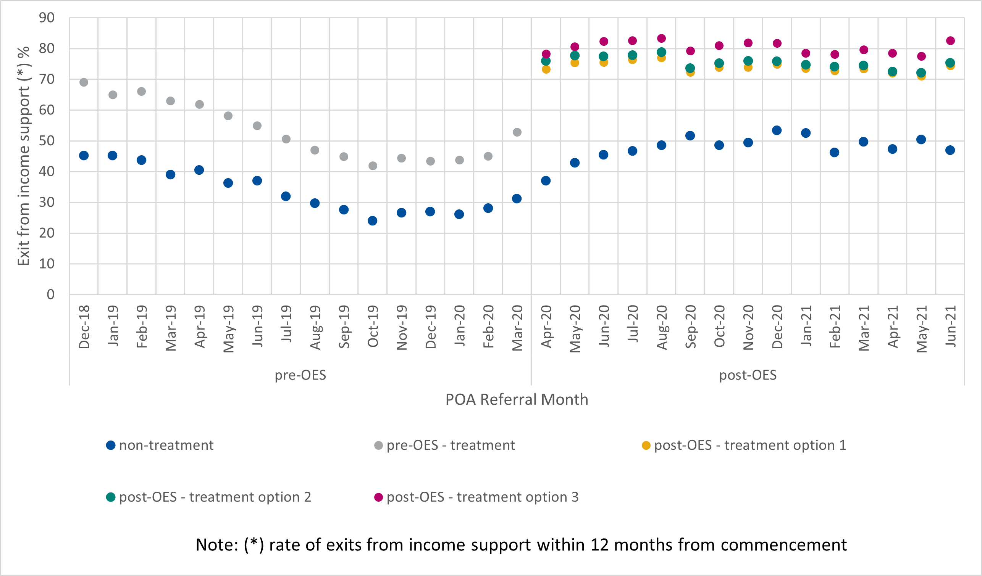

Figure C.2 Exit rates from jobactive employment services within 12 months from commencement for treated and comparison groups by month of referral
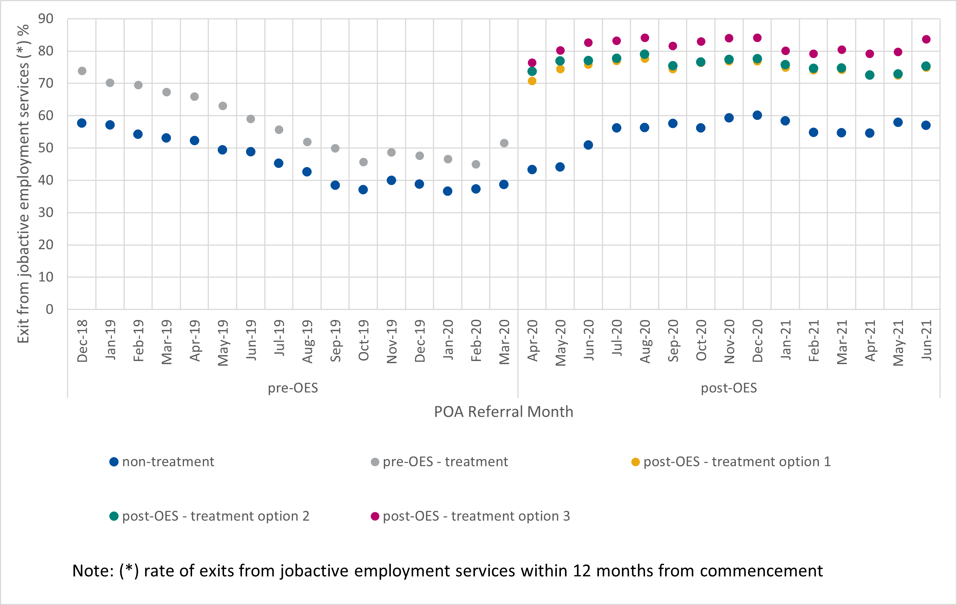

Sensitivity analysis
Our analysis thus far is subject to 2 caveats. First, the treated group before the introduction of OES is not fully compatible with the treated group after the introduction of OES. Specifically, the former included all participants who would have been deemed eligible for online servicing based on their JSCI score at commencement. On the other hand, the latter took into consideration whether participants actually participated in online servicing; participants who were eligible for online servicing but engaged with provider servicing instead were excluded from the analysis. Second, the treated group after the introduction of OES did not take into consideration whether participants remained in online servicing after commencement. In other words, it included participants who commenced in online servicing but later opted out or transferred to provider servicing due to changes in eligibility.
To test the robustness of our findings presented so far, we conducted 2 sensitivity analyses based on the inflow data. We first re-ran the analysis using all participants who were or would have been deemed eligible for online servicing as the treated groups both before and after the introduction of OES. Next, we limited the treated group after the introduction of OES to participants who took part wholly in online servicing before exiting employment services, income support, or OES after 12 months. Taken together, the results of the sensitivity analysis – as presented in Table C. – support our findings thus far that OES has little to no effect on participants’ outcomes in respect of exit from income support and exit from employment services.

Table C.8 Difference-in-differences estimation for the sensitivity analyses
Analysis | Exit from income support |  | Exit from jobactive employment services
Analysis | Estimate | Standard error | Estimate | Standard error
Main analysis | –0.003 | 0.011 | 0.009 | 0.011
Sensitivity analysis #1:  Participants who were or would have been deemed eligible for online servicing | –0.005 | 0.011 | 0.009 | 0.011
Sensitivity analysis #2:  Participants who took part wholly in online servicing before exiting employment services, income support, or OES after 12 months | 0.035* | 0.011 | 0.053* | 0.011
Note: *Indicates statistically significant effect at a significance level of 0.05 (p ≤ 0.05).

Appendix D Longitudinal insights

D.1. Tim
Tim is a high school graduate who moved to Australia with his family in 2014. He is currently 19 years old. Tim is using the jobactive/JobSearch website to log his MORs.
In his first interview Tim was waiting until he got his driver’s licence to apply for a carpentry apprenticeship. In the meantime, he was looking for work, though not through the jobactive/JobSearch website as he found it more difficult than other sites.
I find a little bit [more] difficult than SEEK and stuff … Cos in Jora and other stuff, they change it to this website; like, let's say, you’re trying to find this job. And they said like, this is something like, you can apply for it straight away or quickly apply for it.
In Tim’s first, second and third interview he was asked if he used any of the site functions like the career profile, JobTrainer etc. Each time his answer remained the same, showing no interest in using any of the functions provided on the site, including the job searching function, as he continued to believe that SEEK and Jora were more beneficial to his job search journey. The functions that were explained to Tim in his interview in the first round did not spark any interest over the next 2 rounds of interviewing.
In Tim’s third interview he remained unemployed but was still actively looking for work at both McDonalds and KFC, though he had not heard anything back. He was also doing a 3-week hospitality course because he felt he did not have much else to do with his time. The jobactive/JobSearch site still does not appeal to Tim because of the lack of jobs and the comparable ease of using other sites, and it was clear that this would not change between the third and final interviews coming up.
I guess they’re easy to use [other job sites]. I mean, I mostly use them every single year or day.
Well, I just guess there are more jobs that I want on Indeed than … than Job-thingy.

D.2. Amber
Amber48 has worked in tertiary education for many years as part of the professional staffing teams. She is a single mum and is university educated with a master’s degree.
Amber had minimal need for the jobactive/JobSearch website during her first round of interviews. She had previously used the site because she had been recently unemployed during COVID-19. She had experienced issues attempting to log her income each month to receive a parental assistance payment.
I did have some trouble working out where to go to report my income – which, as I said, I ended up on the phone with them, and that’s how they explained that I actually couldn’t, so I was looking for something that I couldn’t do.
Amber’s main frustration with this is that there was a lack of integration between Centrelink and the jobactive/JobSearch website, which caused her great confusion On one hand she has told Centrelink she is working, and on the other hand she was continuously getting reminders on the jobactive/JobSearch website to meet her MORs or risk having her payments stopped.
So every now and then I’ll get a text saying ‘you need to submit your job activities’.
At Amber’s second and third interview she was still working but had stopped receiving support payments and suddenly was no longer hearing from Centrelink about reporting her income. She then called them, and they confirmed she no longer had to report her income. She now no longer has any use for the jobactive/JobSearch site.
All of this put together led Amber to believe the system lacked integration with services like Centrelink, making her often confused about who she had to tell or not tell and what exactly she had to do to report requirements.
I think the fact that I was already working and it was telling me I had to apply for twenty jobs or have twenty interviews or whatever the timeframe was, I think that was part of that whole clunky system, because it’s almost like it didn’t acknowledge the fact that I was already working, and there was no way, even if I rang them, for them to put it into their system. It was still saying ‘you need to do this many interviews’ and ‘you’re behind’.

Appendix E Infographic summary of the OES Evaluation
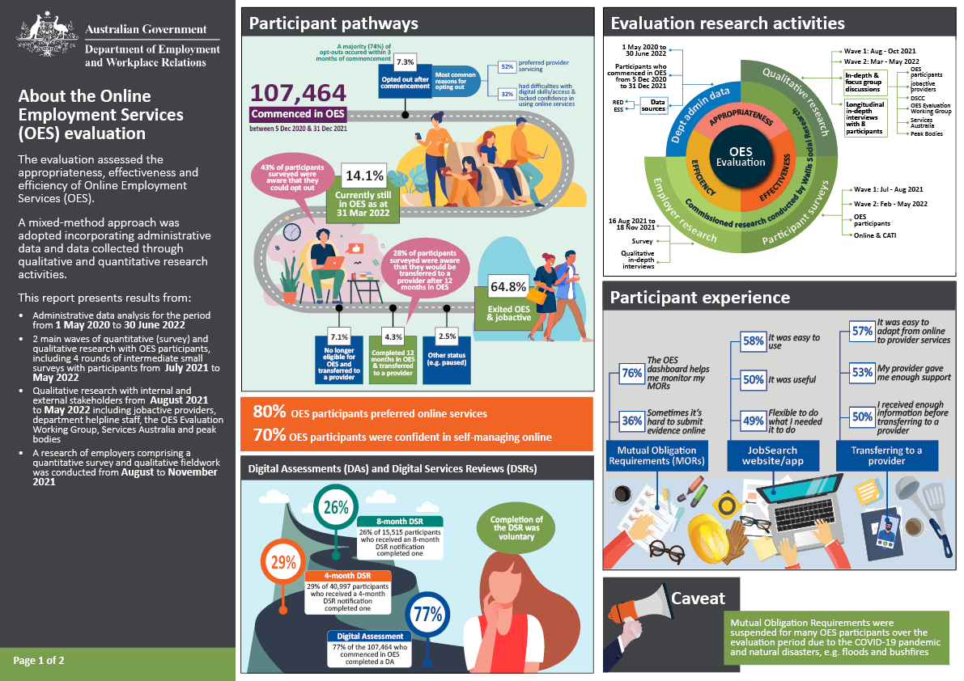
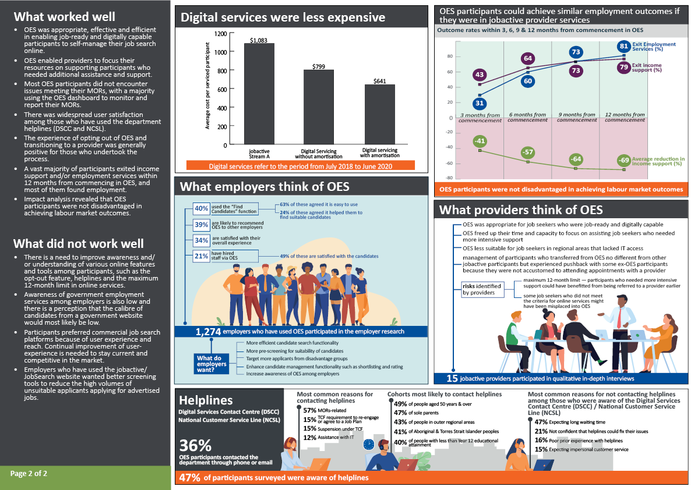

Difference-in-difference is a quasi-experimental approach to impact evaluation, used to estimate the treatment effect of a policy intervention by comparing the outcomes of the treated group before and after the treatment with that of a group that would have been subject to the other similar changes but not the treatment.
Notably, every OES participant who attempted a DA had completed it. This was consistent with the 100% completion rate from the NEST evaluation.
The NEST evaluation revealed a higher (51.7%) DSR4 completion rate compared to the 29.1% reported here. This difference is primarily due to the different time periods of analysis. The NEST rate was captured between 14 October 2020 and 31 March 2021, while the OES completion rate was captured between 5 December 2020 and 30 June 2022. When a comparable period of time was applied in a comparison study, the results showed similar DSR4 completion rates for NEST and OES.
The difficulty lies in the lack of a proper comparison group of job seekers who would be eligible for OES but had not participated in any employment services program.
Once an online service system is established and in operation, additional job seekers using the services incur little extra cost. This is in contrast with provider services. Providers need to employ more case managers or ask existing case managers to work longer hours to accommodate additional job seekers.
The Find Candidates feature is a search function on the employer dashboard on the jobactive/JobSearch website to help find job candidates among OES participants who have set their profiles to be visible to employers.
Previously Department of Education, Skills and Employment (DESE).
The scope of the Workforce Australia Employment Services evaluation is restricted to only provider and online services.
www.jobactive.gov.au
Completion of a DA was not compulsory.
It is worth noting that job seekers referred to OES generally had fewer barriers to employment and in undertaking online job search than provider-serviced participants, even if they fell into demographic groups that often pertain to higher levels of disadvantage in the labour market.
An evaluation of the Online JSCI Trial was conducted by Department of Education, Skills and Employment (2021) from July 2018 to March 2020 and the evaluation report is available on the department’s website.
Job Switch is an online tool that helps job seekers to explore and compare jobs that they might not have considered, based on their skills.
Participants could become ineligible because (1) their JSCI score exceeded the eligibility threshold or (2) they incurred 3 or more demerits.
Outcomes refers to proxies based on exit rates and reduced reliance on income support.
Source: Jobs and Skills Australia (2020), The shape of Australia’s post COVID-19 workforce.
Source: ABS, Labour Force, Australia, September 2022, seasonally adjusted. ABS data releases after this reference date may lead to small revisions in the data presented. It should be noted that unemployment numbers cannot be directly compared with the number of job seekers receiving employment assistance, as there are a number of definitional and methodological differences.
Job seekers refers to all individuals who applied for income support.
Job seekers with indeterminate eligibility were job seekers who did not have an active JSCI score, or had an active JSCI score greater than the OES threshold, or were manually transferred out by DESE staff due to indeterminate or ambiguous eligibility.
OES Participant Survey, Wave 1. Weighted results. N=1,645 participants who were currently in OES at the time of the survey and recalled completing a JSS.
PEES Survey, 2021. Weighted results. N=975 OES participants. Q. To what extent do you agree with the following statements: A The registration process was straightforward and easy to follow.
Participants with pure OES experience comprised (1) those who commenced in OES and were still in OES during the period of analysis, (2) those who exited OES and employment services, and (3) those who were transferred to a provider after completing 12 months in OES.
These percentages of opt-outs were derived from administrative data.
These figures were estimated from PEES Survey data. About 3% of OES participants reported no internet. A rating of 0–5 on a scale of 0–10 was defined as unreliable for this analysis. As the reliability rating was subjective, this measure should be interpreted as indicative.
Wave 2 of the OES Participant Survey found that 73.7% of participants had MORs. This explains why some participants had not used the OES dashboard.
Participants can share their profile by selecting to make it visible publicly for employers to find when searching for candidates, by clicking the ‘Share your profile’ button or by providing a unique link to potential employers that allow them to access the profile.
Valid exemption reasons include not being in a position to return immediately to the workforce because of being pregnant within 3 months of the expected due date; having been identified as requiring referral to more appropriate services; or having an exemption from Mutual Obligation Requirements (for reasons such as a medical or personal crisis situation).
These participants might have created the profile while in OEST, while receiving assistance from a provider, or while being assisted in other employment services programs.
This analysis period has been chosen as contact data for the OES population of interest is only available up to 6 December 2021.
Multiple detailed contact reasons could be selected for a single contact, and as such, the proportions may sum to more than 100%. For example, a participant contact may be recorded as related to ‘assistance with IT’ and ‘website – jobactive.gov.au’.
Only a small proportion (5.4%) of contacts made by OES participants to the department helplines were to opt out.
Participants who were in employment, study or training were exempted from DSRs.
DEWR policy guidelines.
Notably, every OES participant who attempted a DA had completed it, this was consistent with the 100% completion rate from the NEST evaluation.
The DSCC conducted outbound call research with participants who had received a DSR notification.
The NEST evaluation revealed a higher (51.7%) DSR4 completion rate compared to the 29.1% reported here. This difference is primarily due to the different time periods of analysis. The NEST rate was captured between 14 October 2020 and 31 March 2021, while the OES completion rate was captured between 5 December 2020 and 30 June 2022. When a comparable period of time was applied in a comparison study, the results showed similar DSR4 completion rates for NEST and OES.
Most job seekers have Annual Activity Requirements which differ according to age and circumstances; for example, after 12 months on income support, most job seekers can satisfy their MORs if they undertake at least 30 hours per fortnight of approved voluntary work, paid work or any combination of these activities.
The 2 exit measures were used to complement each other as a proxy for employment. They are highly correlated, but not the same because some job seekers could have left employment services by transferring to a non-activity-tested income support payment such as Disability Support Pension, or exited employment services but remained on income support while fulfilling their MORs through part-time work or a combination of activities including part-time work.
Income support reliance, ranging from zero to 100%, is calculated as the proportion of income support amount actually received relative to the highest amount possible according to social security legislation. If an individual is receiving the highest amount possible, their income support reliance is 100%. Reduction in income support reliance at the n-th month is the difference between the income support reliance at commencement and at the n-th month.
An allowable break is the number of days for which a participant is allowed to exit employment services or income support and re-join services. The allowable break for employment services is 91 days. Allowable breaks for income support are 42 days if the participant has been on income support for less than 12 months and 91 days if the participant has been on income support for 12 months or more. For the purpose of evaluation, the allowable break of 91 days was applied for both employment services and income support.
Duration of unemployment was included only in analysis using the monthly caseload data. The analysis excluded mode of transport as this information was not available from the monthly caseload data.
Exits from income support and employment services within 3, 6 and 9 months from commencement were also examined for inflow data. The results, again, showed that online services as compared with provider services did not disadvantage job seekers.
While this estimate is statistically significant, given that the underlying size of the Aboriginal and/or Torres Strait Islander job seeker population was small (3,570), the number of job seekers affected would not be large (about 320).
See Transition to Work Evaluation Report; jobactive Evaluation Report.
Comparing cost per employment outcome only may not be sufficient to assess cost-effectiveness since employment outcomes achieved could be affected by labour market conditions and the composition of program participants.
Throughout this report, ‘online services’ is used to refer specifically to Online Employment Services. In the cost-effectiveness analysis the scope of the concept is broadened to all ‘online services measures’ (including OES) that made digital servicing possible.
These are Budget measures, or costed policies that the government decided to pursue, that funded the development and implementation of online services, starting with the first OEST measures (the Digital Employment Services Pilot, included in the Portfolio Additional Estimates Statements 2017–18) and continuing with all subsequent online services measures (OEST, OES, NEST Digital Services, NESM digital and DSCC). We included Budget allocations before OES commencement (such as Digital Employment Services – Pilot, and Online Employment Services Trial – Expansion) because the OES digital services platform was based on the earlier investments.
Including OEST, OES and NEST DS. Because investments in the digital platform include those allocated before the commencement of OES, the number of participants in digital servicing should include those before OES as well (such as participants serviced in OEST).
A participant was identified to be in online services if they commenced the services by accepting a Job Plan and were on income support at commencement.
By amortising the capital investment comprised in the cost of measures, we distribute its yearly cost over the several years when it is in use, to recognise that this cost component realises its economic benefits beyond the year of initial investment. This provides a more accurate distribution of the economic value of inputs by financial year, making the comparison of input/resources and outcomes/impact over specific time periods more accurate.
Treating the capital investment into the digital platform as an intangible asset valued at cost of measures, fully amortised over 5 years using the straight-line method (in equal parts over each useful year), with no anticipated salvage value.
See note under Figure 6.4 about jobactive Stream A, the comparator group.
See note under Figure 6.4 about jobactive Stream A, the comparator group.
Businesses were categorised into 3 sizes based on the number of their employees: small (fewer than 20 employees), medium sized (20 to 199 employees) and large (200 or more employees).
The Find Candidates feature was an enhanced function that enabled employers to search for suitable job candidates on the jobactive/JobSearch website. OES participants who set their profile to ‘public’ would be discoverable to employers who performed a Find Candidates search.
Labour market testing (LMT) is a requirement for employers who wish to sponsor a foreign worker. LMT employers are usually required to demonstrate that they are not able to find a suitable Australian citizen or permanent resident worker. LMT generally requires employers to advertise the positions on prominent websites.
Targeted Compliance Framework: Mutual Obligation Failures Guideline v1.1 effective from 10 September 2018.
Targeted Compliance Framework: Mutual Obligation Failures Guideline v1.1 effective from 10 September 2018, p. 17.
All names were changed to allow for qualitative participant anonymity.

