

Supplementary Guidance for the Skills Guarantee PCP Version 1.2

Guidance for Relevant Entities

Contents

Actions for Relevant Entities Summary 3

Introduction 4

Procurements in scope 4

📌 Actions for Relevant Entities 4

Construction procurement 4

ICT procurement 4

Exemptions 5

📌 Actions for Relevant Entities 5

Formal exemptions 5

Determining eligibility and reasonableness 5

ADMS notifications and reviewing a new Contract 6

Gender Equality Action Plan (GEAP) 7

📌 Actions for Relevant Entities 7

Construction targets 8

Construction target examples 9

ICT targets 10

ICT target examples 11

Skills Guarantee Model Clauses 12

📌 Actions for Relevant Entities 12

Privacy 12

Consent Requirements and Privacy Considerations 12

Collection of Personal Information 13

Using Skills Guarantee Model Clauses to Secure Consent 13

📌 Actions for Relevant Entities 13

Contract variations 13

ADMS reporting for Contract variations 14

Panel or Standing Offer arrangements 14

📌 Actions for Relevant Entities 14

📌 Checklist for Relevant Entities 15

Contract variation examples 16

Submission Assessment 18

Reporting and compliance 18

📌 Actions for Relevant Entities 18

Frequently Asked Questions 19

Do PCP thresholds apply to projects as a whole or individual procurements? 19

Does the PCP apply to Sub-contractors? 19

How do I calculate the estimated individual value of a procurement to determine whether my procurement is subject to the PCP? 19

Does the PCP apply to a procurement where the estimated individual value is less than $10 million but the successful Submission is over $10 million? 19

Does the PCP apply to a procurement where the estimated individual value is over $10 million but the successful Submission is less than $10 million? 19

What is an Apprentice? 20

What is a Learning Worker? 20

How are Apprentice or Learning Worker Off-Site Labour Hours treated to calculate meeting the targets under the PCP? 20

How are part-time hours treated under the PCP? 21

Can more than one Apprentice or Learning Worker contribute to the Labour Hour targets? 21

How will Suppliers report on PCP targets? 21

Will a Suppliers performance be publicly available? 21

How will compliance be monitored under the PCP? 21

Are there financial penalties for non-compliance with PCP targets? 21

Will mitigating factors be considered when assessing a Supplier's compliance with the Skills Guarantee? 21

Further resources 22

# Actions for Relevant Entities Summary

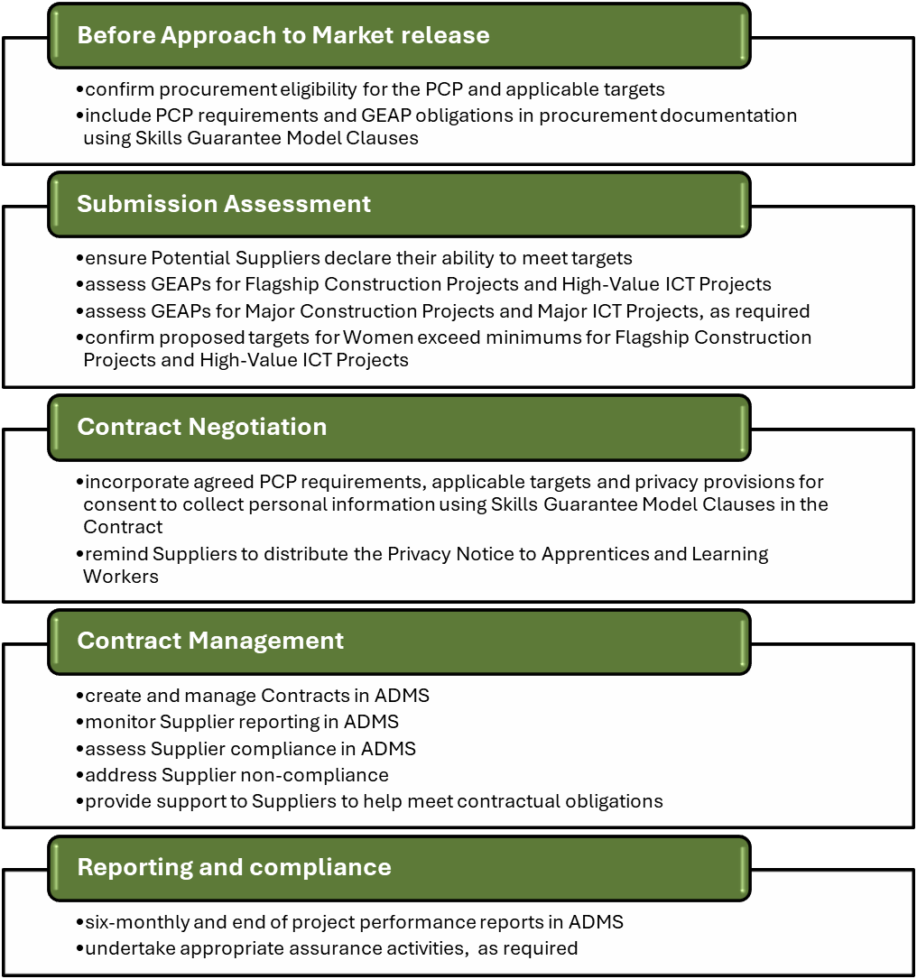

# Introduction

The **Australian Skills Guarantee (Skills Guarantee)** sets national targets for the participation of **Apprentices, Learning Workers and Women** on eligible Australian Government-funded major projects. These targets apply to **building and construction, maintenance services (Construction)**, and **information and communications technology (ICT)** procurements with an estimated individual value of **$10 million or more.**

This **supplementary guidance** supports **Relevant Entities** in understanding and implementing the **Skills Guarantee Procurement Connected Policy (PCP) Version 1.2**. It should be read alongside the PCP and provides practical advice on determining project eligibility, incorporating model clauses, meeting reporting requirements, and supporting compliance.

# Procurements in scope

## 📌 Actions for Relevant Entities

To determine whether a procurement falls within scope, Relevant Entities must ensure that the procurement:

* meets the definition of an Eligible Project
* meets the financial threshold
* uses an eligible United Nations Standard Products and Services Code (UNSPSC) subset code, and
* satisfies all other eligibility criteria.

## Construction procurement

Major Construction Project: Procurement with an estimated individual value of $10 million or more (GST inclusive) using a UNSPSC subset code listed in Appendix C of the PCP.

Flagship Construction Project: Procurement with an estimated individual value of $100 million or more (GST inclusive) using a UNSPSC subset code listed in Appendix C of the PCP.

## ICT procurement

Major ICT Project: Procurement with an estimated individual value of $10 million or more (GST inclusive) using a UNSPSC subset code listed in Appendix D of the PCP.

High-Value ICT Project: Procurement with an estimated individual value of $50 million or more (GST inclusive) using a UNSPSC subset code listed in Appendix D of the PCP.

**Table 1 – Overview of procurements in scope of the PCP**

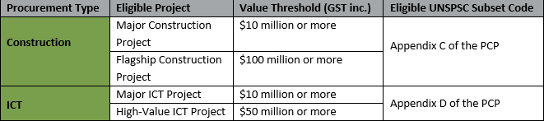

# Exemptions

## 📌 Actions for Relevant Entities

Before releasing procurement documentation and during the Submission assessment process, Relevant Entities must determine whether the procurement is:

* eligible under the PCP
* exempt from the PCP requirements.

## Formal exemptions

Some procurements may be formally exempt under **Section 2.4** of the PCP, including applying paragraph 2.6 of the Commonwealth Procurement Rules (CPRs) and when the Eligible Project is delivered wholly overseas. In such cases:

* PCP requirements must be excluded from procurement documentation
* Targets will not be considered during the Submission assessment.

## Determining eligibility and reasonableness

If an ICT procurement meets the eligibility criteria, Relevant Entities must assess whether it is reasonable to apply the targets. This assessment should consider the nature of the services being procured.

Examples where targets may not be reasonable for eligible ICT procurements:

* Highly specialised services requiring experienced personnel, with limited scope for Apprentices or Learning Workers.
* Procurement of pre-developed software requiring minimal Labour Hours.
* Extensions of software licensing arrangements with no delivery component.

If it is determined that applying targets is not reasonable, the procurement should be marked as not reportable in the Apprenticeship Data Management System (ADMS) Project Reporting Section, with documented justification of the rationale for not applying. Records must be maintained to support this decision.

## ADMS notifications and reviewing a new Contract

When ADMS identifies a new Contract that meets the PCP eligibility criteria, it will notify the Relevant Entity. The Relevant Entity must:

* log in to ADMS,
* review the Contract

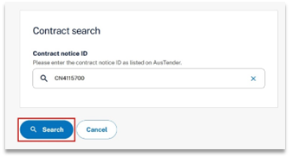

* record whether the Contract is reportable under the PCP, noting this does not require action in ADMS if the new Contract is exempt under Section 2.4 of the PCP, as outlined above.

If the procurement is reportable, this must be confirmed in ADMS when creating the project record and Relevant Entities will need to ensure the correct PCP version has been applied to the project.

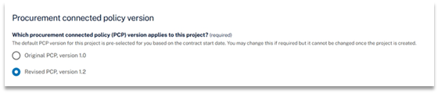

[Additional reporting guidance is available on GovTEAMS – Australian Skills Guarantee Operational Resources and Stakeholder Engagement Community](https://govteams.sharepoint.com/sites/australianskillsguaranteeoperationalresourcesandstakeholderengag/SitePages/Home.aspx).

# Gender Equality Action Plan (GEAP)

GEAPs are **mandatory** for Potential Suppliers to submit with their Submission for:

* Flagship Construction Projects (≥ $100 million), and
* High-Value ICT Projects (≥ $50 million).

GEAPs are **voluntary** and Potential Suppliers are **encouraged** to submit with their Submission for:

* Major Construction Projects (≥ $10 million), and
* Major ICT Projects (≥ $10 million).

GEAPs outline how Potential Suppliers will meet and sustain targets for Women, including:

* recruitment and retention strategies that will be put in place or continue to operate to ensure the targets for Women are achieved and sustained,
* workplace culture improvements,
* commitments to safe, respectful, and equitable environments.

GEAPs may include:

* Organisation-wide policies
* procurement-specific actions
* how the Supplier aims to drive both short and long-term outcomes
* how the Supplier’s broader policies will apply to the specific project.

A GEAP template for Potential Suppliers is available in the Supplementary Guidance for Suppliers for PCP Version 1.2 on the [DEWR website](https://www.dewr.gov.au/resources/australian-skills-guarantee).

## 📌 Actions for Relevant Entities

* ensure GEAPs are submitted by Potential Suppliers, where required
* assess whether the GEAP aligns with the project type and its applicable targets
* approve the Supplier’s GEAP
* remind the Supplier to share the GEAP with any Sub-contractors.
* monitor Supplier compliance and performance against gender equality targets outlined in their GEAP throughout the project lifecycle.
* encourage Suppliers to pursue both short and long-term outcomes
* recognise that cultural change takes time and sustained effort.

# Construction targets

**Table 2 – PCP requirements for Construction procurements**

|  |  |  |  |  |  |
| --- | --- | --- | --- | --- | --- |
| **Project Type** | **Value Threshold** | **Overarching Apprentice Target** | **Overarching Apprentice Targets for Women** | **Trade-Specific Apprentice Target for Women** | **Gender Equality Action Plan** |
| **Major Construction Project** | $10 million or more | Minimum 10% of all estimated Labour Hours by Apprentices | Minimum 7%* of Apprentice Labour Hours undertaken by Women | Minimum 5%* of Trade Apprentice Labour Hours undertaken by Women | Voluntary with Submission |
| **Flagship Construction Project** | $100 million or more | Minimum 10% of all Labour Hours | Must meet targets for Women for Major Construction Projects and set and meet more ambitious targets for Women | Must meet targets for Women for Major Construction Projects and set and meet more ambitious targets for Women | Mandatory with Submission |

*Targets for Women in listed in Table 2 are for 1 July 2025 to 30 June 2026 and increase one percentage point every financial year until 2030 as outlined in Table 3 below.

Targets for Women are based on the project’s Contract start date and increase each financial year for multi-year projects; **Table 3** below provides more information on the increases.

##### Table 3 - Annual increases of Targets for Women working on Construction projects

| **Targets apply** | **Overarching Apprentice Target for Women** | **Trade-specific Apprentice Target for Women** |
| --- | --- | --- |
| 1 July 2024 to 30 June 2025 | 6% | 4% |
| 1 July 2025 to 30 June 2026 | 7% | 5% |
| 1 July 2026 to 30 June 2027 | 8% | 6% |
| 1 July 2027 to 30 June 2028 | 9% | 7% |
| 1 July 2028 to 30 June 2029 | 10% | 8% |
| 1 July 2029 to 30 June 2030 | 11% | 9% |
| 1 July 2030 onwards | 12% | 10% |

## Construction target examples

Overarching Apprentice Target

* *Chapman & Louey Construction* has estimated that their **Major Construction Project** will require 8,000 Labour Hours.
* The Overarching Apprentice Target is calculated using the 8,000 estimated Labour Hours.
* 800 Labour Hours must be undertaken by Apprentices (10% of the Major Construction Project’s total estimated Labour Hours).
* All reported Apprentice Labour Hours are counted towards the 10% target in the reporting system.

Overarching Apprentice Target for Women

* *Chapman & Louey Construction’s* **Major Construction Project** has a Contract start date of 1 August 2025 and an end date of 30 June 2026.
* The project is subject to the 2025–26 financial year targets, requiring 7% of Apprentice Labour Hours to be undertaken by Women.
* If 800 Apprentice Labour Hours are reported, then 56 Labour Hours must be undertaken by Women Apprentices (7% of 800).

Trade-specific Apprentice Target for Women

* *Chapman & Louey Construction* estimates that 600 Labour Hours will be worked by Trade Apprentices.
* The 2025–26 financial year target requires 5% of Trade Apprentice Labour Hours to be undertaken by Women.
* 30 Labour Hours must be undertaken by Women Trade Apprentices (5% of 600).

# ICT targets

**Table 4 – PCP requirements for ICT procurements**

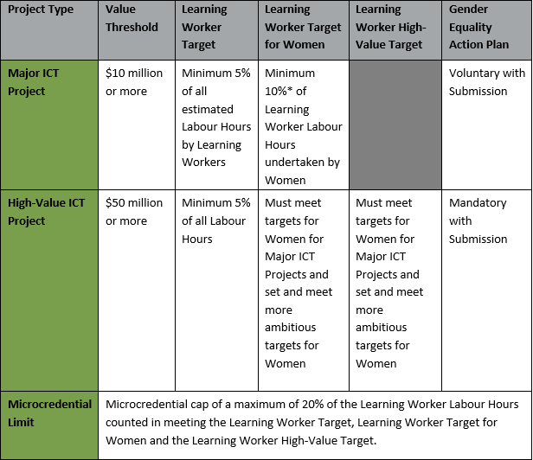

**\*** Targets for Women listed in Table 4 are for 1 October 2025 to 30 June 2026 and increase 2 percentage points every financial year until 2030.

##### Table 5 - Annual increases of Targets for Women working on ICT projects

| **Targets apply** | **Learning Worker Target for Women** |
| --- | --- |
| 1 October 2025 to 30 June 2026 | 10% |
| 1 July 2026 to 30 June 2027 | 12% |
| 1 July 2027 to 30 June 2028 | 14% |
| 1 July 2028 to 30 June 2029 | 16% |
| 1 July 2029 to 30 June 2030 | 18% |
| 1 July 2030 onwards | 20% |

Targets for Women are based on the project’s Contract start date and increase each financial year for multi-year projects.

## ICT target examples

Learning Worker Target

* *Brown & Smith ICT* has estimated that their **Major ICT Project** will require 3,000 Labour Hours.
* 150 Labour Hours need to be undertaken by Learning Workers (5% of the project’s total estimated Labour Hours).
* All reported Learning Worker Labour Hours are counted towards the 5% target in the Apprenticeship Data Management System (ADMS) online reporting system.

Microcredentials Limit for the Learning Worker Target

* a **maximum of 20% of the reported Learning Worker Labour Hours** may be attributed to Workers who are currently undertaking or have undertaken Microcredentials to meet the Learning Worker Target.
* For example, if 150 Learning Worker Labour Hours are reported, up to 30 hours may be from Microcredentials.
* the Microcredential limit for the Learning Worker Target is **assessed and calculated at the end of the Eligible Project** in ADMS, based on the reported (not estimated) Learning Worker Labour Hours.
* If more than 20% of the Learning Worker Labour Hours are from Microcredentials, ADMS will flag that the project has not met the target due to exceeding the limit and will prompt for the Supplier to provide an explanation.
* ADMS includes a progress bar showing Microcredential hour usage when viewing or assessing project reports to show how many Microcredential Labour Hours have been used against the limit.

Learning Worker Targets for Women

* *Brown & Smith ICT’s* **Major ICT Project** has a Contract start date of 1 November 2025 and has a Contract end date of 16 May 2026.
* The project is subject to the target for Women for the 2025–26 financial year, requiring 10% of Learning Worker Labour Hours to be undertaken by Women.
* The number of Labour Hours required to meet the target for Women is based on the reported Learning Worker Labour Hours.
* For example, if *Brown and Smith ICT* reports 170 Learning Worker Labour Hours, then 17 Labour Hours must be undertaken by Learning Workers who are Women (10% of the project’s total 170 Learning Worker Labour Hours).
* All reported Learning Worker Labour Hours for Women are counted towards the target for the financial year in ADMS.

Microcredentials Limit for the Learning Worker Target for Women

* a **maximum of 20%** of the reported Learning Worker Labour Hours for Women may be attributed to Microcredentials to meet the Learning Worker Target for Women.
* the Microcredential limit for the Learning Worker Target for Women **is assessed and calculated each financial year during the Eligible Project** in ADMS.
* For example, if 17 Labour Hours are reported for Women, the Microcredential limit would be 20% of the 17 = 3.4 hours.
* If more than 20% of the Women Learning Worker Labour Hours are from Microcredentials, ADMS will flag that the project has not met the target due to exceeding the limit and will prompt for the Supplier to provide an explanation.
* ADMS includes a progress bar showing Microcredential hour usage for the financial year when viewing or assessing project reports to show how many Microcredential Labour Hours have been used against the limit.
* Targets for Women are determined based on a project’s Contract start and will increase each financial year that the project continues.

# Skills Guarantee Model Clauses

The Skills Guarantee Model Clauses are designed to help non-Corporate Commonwealth Entities and prescribed corporate Commonwealth entities listed in Section 30 of the *Public Governance, Performance and Accountability Rule 2014* (PGPA) meet both:

* Mandatory requirements, and
* Optional provisions outlined in the PCP.

The Skills Guarantee Model Clauses are the mechanism to give effect to the PCP by applying to:

* Approach to Market (ATM) documentation
* Panel and Standing Offer documentation, and
* Contracts where the procurement has been determined as an Eligible Project for the PCP.

## 📌 Actions for Relevant Entities

For further guidance, refer to the [**Guidance for Using Model Clauses for Commonwealth Contracting Agencies Version 1.4**,](https://govteams.sharepoint.com/:w:/r/sites/australianskillsguaranteeoperationalresourcesandstakeholderengag/Shared%20Documents/Guidance%20for%20using%20the%20model%20clauses%20for%20Commonwealth%20Contracting%20Agencies%20Version%201.4.docx?d=w1d6ca305682c45d3a5b594b6017adcaa&csf=1&web=1&e=aCOlao) available on **GovTEAMS**.

# Privacy

## Consent Requirements and Privacy Considerations

Contracts within scope of PCP must include either:

* relevant Australian Skills Guarantee Model Clauses, or
* equivalent terms and conditions that secure the necessary consents.

These consents enable the Department of Employment and Workplace Relations (DEWR) to:

* collect,
* use, and
* store personal information of Apprentices and Learning Workers for verification and administration purposes.

## Collection of Personal Information

The collection of personal information supports DEWR in verifying reported data through ADMS. This includes confirming that individuals are:

* real and identifiable,
* actively engaged in their roles, and
* undertaking a recognised trade or qualification, where applicable.

Suppliers must distribute the [Australian Skills Guarantee Privacy Notice](https://www.dewr.gov.au/australian-skills-guarantee/resources/australian-skills-guarantee-privacy-notice) to Apprentices and Learning Workers working on Eligible Projects. This notice explains how DEWR will handle personal information under the PCP.

## Using Skills Guarantee Model Clauses to Secure Consent

The Skills Guarantee Model Clauses contain provisions which require the Supplier to obtain all necessary consents from its Apprentices and Learning Workers for the handling of their personal information as set out in the Australian Skills Guarantee Privacy Notice.

## 📌 Actions for Relevant Entities

* include suitable terms and conditions to obtain consent from Apprentices and Learning Workers are prescribed allowing DEWR to collect, use, and disclose personal information to comply with the Privacy Act 1988 and other relevant laws ATM, Contract, or panel/Standing Offer documentation
* ensure any modifications still meet PCP requirements
* be aware that changes may affect DEWR’s ability to manage personal information effectively
* remind Suppliers to distribute the [Australian Skills Guarantee Privacy Notice](https://www.dewr.gov.au/australian-skills-guarantee/resources/australian-skills-guarantee-privacy-notice) to Apprentices and Learning Workers, that is available on the DEWR website.

# Contract variations

Relevant Entities should consider **Section 3.2** of the PCP when a Contract Variation causes a procurement to become an Eligible Project under the PCP from changes to an existing Contract.

The PCP requirements should have already been applied to a procurement if the original estimated procurement value is $10 million (GST inclusive) or more.

Relevant Entities must ensure Contract Variations are reported in ADMS as soon as practicable. As Contract variations may not be published in AusTender in a timely way, it is important for Relevant Entities to confirm any new Eligible Projects in ADMS, including procurements where the PCP requirements were not applied and noting the reasons why.

If PCP Version 1 applies to the existing Contract, Relevant Entities may negotiate with the Supplier to apply the ICT targets outlined in Version 1.2 of the PCP to the varied Contract. However, the updated policy provisions, including the definitions of Learning Worker, High-Value ICT Project, and Microcredential could be included and applied with a Contract variation from 1 October 2025. Any negotiated targets aligned with the Version 1.2 ICT targets will be treated in the same manner as negotiated ICT targets under Version 1.

## ADMS reporting for Contract variations

ADMS will notify the Relevant Entity when an existing Contract is varied, including Contracts previously below the Skills Guarantee $10 million threshold. The Relevant Entity should log in to ADMS and review these Contracts for ongoing or new Skills Guarantee eligibility.

If the Contract was previously below $10 million and a variation means it now meets Skills Guarantee eligibility, you should follow the steps for creating a new project detailed above at the ADMS notifications and reviewing a new Contract section on Pg 6.

If there is a Contract variation to an existing Contract, which had previously been assessed for Skills Guarantee reporting, you will need to confirm the project’s reporting status, including for projects previously not reportable.

Please refer to the additional reporting guidance is available on [GovTEAMS – Australian Skills Guarantee Operational Resources and Stakeholder Engagement Community](https://govteams.sharepoint.com/sites/australianskillsguaranteeoperationalresourcesandstakeholderengag/SitePages/Home.aspx).

## Panel or Standing Offer arrangements

Lead agencies for existing panel or Standing Offer arrangements may vary the standard Contract terms of their deed of Standing Offer, indicating that the PCP requirements will apply to Eligible Projects procured from that panel or Standing Offer arrangement.

The assessment and reporting for the PCP requirements will occur when a new Contract is created for an Eligible Project under a panel or Standing Offer arrangement, or where a Contract under that panel or Standing Offer arrangement is varied making it an Eligible Project.

Relevant Entities will take the same approach to negotiating the inclusion of PCP requirements in a Contract variation for an Eligible Project under a panel or Standing Offer arrangement, as for Contract variations for Eligible Projects not under a panel or Standing Offer arrangement.

## 📌 Actions for Relevant Entities

Relevant Entities should negotiate the application of the PCP with Suppliers considering:

* if the Contract variation presents an opportunity to enhance the participation of Apprentices, Learning Workers, and Women in delivering the remainder of the Contract, supporting the PCP intent
* sufficient time remaining on the Contract to ensure Apprentices or Learning Workers receive an adequate training experience
* sufficient work to be completed within Australia
* remaining Contract deliverables requiring Labour Hours
* sufficient work available that align with the Apprentice or Learning Worker pathways
* a change in the type of Eligible Project creates an opportunity to negotiate higher targets for Women and the provision of a GEAP
* if the provision of a GEAP is agreed, ensure the Supplier provides a GEAP before their next quarterly report and include in the next six-monthly reporting in ADMS or earlier
* update the targets and Labour Hours remaining in the Contract
* if PCP Version 1 applies to an existing Contract, negotiating to adopt the ICT targets from PCP Version 1.2 with the Supplier and any negotiated targets based on Version 1.2 will be treated the same as those under Version 1 and updated policy provisions, such as Learning Worker or Microcredentials, should not be applied until the PCP Version 1.2 takes effect on 1 October 2025.
* exercise discretion to apply PCP requirements where a Contract is varied for reasons including, but not limited to:
  + - insufficient time to offer Apprentices or Learning Workers a meaningful training experience, e.g., there is only one month remaining on the Contract
    - the majority of the remaining Contract deliverables are scheduled to be completed overseas.
    - the majority of the remaining Contract deliverables do not require Labour Hours
    - there are no suitable pathways for Apprentices or Learning Workers in the remaining scope of work to be delivered.
    - document the reasons and maintain appropriate records where PCP requirements are not included as part of the Contract variation.

## 📌 Checklist for Relevant Entities

When a Contract is varied, consider the following actions:

1. **Risk Management**

☐ Update the **Procurement Risk Plan** to reflect any new or altered risks.

1. **Systems and Records**

☐ Update **ADMS** including any changes to supplier contact details and reporting status.

* Guidance on accessing and using ADMS is available on the Australian Skills Guarantee [GovTeams SharePoint](https://govteams.sharepoint.com/sites/australianskillsguaranteeoperationalresourcesandstakeholderengag/SitePages/Home.aspx).

☐ Ensure **Records Management** of:

* + - The updated Contract.
    - Supporting documentation and decisions related to the variation.

1. **Reporting Obligations**

☐ Report the Contract variation on **AusTender** within **42 days**, if the updated contract value is **$10,000 or more**.

1. **Privacy Compliance**

☐ Send the **Privacy Notice** to the Supplier, if required under the variation.

1. **GEAP Requirements**

☐ Request a **GEAP** from the Supplier if the procurement has changed classification:

* + - From a **Major Construction Project** to a **Flagship Construction Project**, or
    - From a **Major ICT Project** to a **High-Value ICT Project**.

☐ Provide a copy of the GEAP to **DEWR** as part of your **six-monthly reporting**.

## Contract variation examples

##### Scenario 1 (a) – Supplier agrees to include PCP requirements

|  |
| --- |
| The *Department of Example Scenarios* has contracted *Construction Company A* to deliver construction services.  The Contract start date is 30 September 2024 and the Contract end date is 30 September 2026. The Contract has an estimated value of $9,800,000. The UNSPSC code listed for the Approach to Market and subsequent Contract notice on AusTender is *UNSPSC 72100000 – Building construction and support and maintenance and repair services*.  In April 2026, the department identifies that more work is required to achieve the objective of the procurement and seeks to vary the Contract. The Contract variation will extend the Contract to end on 30 October 2026 and will result in the estimated procurement value increasing to $10,500,000.  As the UNSPSC is captured by the PCP Version 1.2 and the procurement has met the estimated individual value of $10 million and above (GST inclusive), the procurement meets the requirements of an Eligible Project, and the department seeks to include the PCP requirements for the remainder of the Contract term. Before negotiating with *Construction Company A*, the department assesses that:  there is sufficient time to provide relevant Apprentices with an adequate training experience  there is sufficient work to be completed in Australia  the remaining Contract deliverables require Labour Hours  there is sufficient work to be completed in areas which have an Apprentice pathway.  *Construction Company A* **agrees** to include PCP Version 1.2 requirements as part of the Contract variation which takes effect on 1 May 2026.  As the Overarching Apprentice Target does not change between financial years, *Construction Company A* will be required to ensure a minimum of 10% of all Labour Hours spent on the remainder of the Contract are undertaken by Apprentices.  As the Contract variation takes effect on 1 May 2026, *Construction Company A* will initially be required to ensure that 7% of Apprentice Labour Hours are undertaken by Women in Apprenticeships, and 5% of Trade Apprentice Labour Hours are undertaken by Women in Trade Apprenticeships. On 1 July 2026, these targets will increase to 8% and 6% respectively (see **Table 3** above) for the remaining period of the Contract.  The estimated Labour Hours and associated targets are included in the Contract.  The department’s contract manager for this Contract will need to create a project in the ADMS to commence reporting on this project. |

##### Scenario 1 (b) – Supplier does not agree to include PCP requirements

|  |
| --- |
| In the above example, if *Construction Company A* did not agree to include PCP requirements as part of the Contract variation, the *Department of Example Scenarios* would document the reasons why the PCP was not included and would maintain appropriate records.  The department’s contract manager for this Contract would need to record this project as ‘not reporting’ in the ADMS. |

##### Scenario 2 –PCP requirements not considered appropriate

|  |
| --- |
| The *Department of Procurements* has contracted *Construction Company B* under a Construction procurement.  The Contract start date is 15 October 2024 and the Contract end date is 15 October 2025. The Contract has an estimated value of $9,995,000. The UNSPSC listed for the Approach to Market and subsequent Contract notice on AusTender is *UNSPSC 72101500 – Building support services*.  In September 2025, the department identifies that the Contract will need to be extended to finalise the work and seeks to vary the Contract. The Contract variation will extend the Contract to end on 30 October 2025 and will result in the estimated procurement value increasing to $10,200,000.  As the UNSPSC is captured by the PCP Version 1.2 and the procurement has met the estimated individual value of $10 million and above (GST inclusive), the procurement meets the requirements of an Eligible Project, and the department assesses whether to include the PCP Version 1.2 requirements for the remainder of the Contract term. As the Contract variation does not allow enough time to provide Apprentices with an adequate training experience, the department decides not to include PCP Version 1.2 requirements.  The *Department of Procurements* documents the reasons why PCP requirements were not included and maintains appropriate records.  The record for this Contract in the ADMS will need to be reviewed, with the project continuing to be marked as ‘Not reporting’. |

# Submission Assessment

If the PCP is applied to the ATM documentation, Potential Suppliers must declare in their Submission whether they can comply with the PCP requirements. Relevant Entities are responsible for ensuring this declaration has been included in the Submission. While the PCP does not prescribe a specific format for this declaration, Relevant Entities should outline the requirement to include a declaration clearly in the relevant ATM clauses.

It is a matter for Relevant Entities to determine how to evaluate the PCP requirements during the Submission assessment process. Regardless of how the PCP requirements are framed, Relevant Entities must ensure that the assessment process includes consideration of the PCP requirements, as outlined in the PCP, **Section 5.** However, if an exemption is identified during the Submission assessment, such as the Potential Supplier proposes to deliver the entire procurement overseas, Relevant Entities are not required to consider the PCP requirements.

When assessing Submissions, Relevant Entities should check that the Potential Supplier’s GEAP refers to the correct Eligible Project type and identifies the appropriate Skills Guarantee targets that will apply to the procurement.

Relevant Entities should consider the past performance and reporting under the PCP of Potential Suppliers in the evaluation of the Submission. Supplier performance data for all completed Skills Guarantee projects will be available to all Relevant Entities.

Please also refer the [Assessing Submissions Guidance on GovTEAMS](https://govteams.sharepoint.com/:w:/r/sites/australianskillsguaranteeoperationalresourcesandstakeholderengag/Shared%20Documents/Assessing%20Submissions%20Guidance%20for%20Commonwealth%20Contracting%20Agencies%20Version%201.2.docx?d=wb6cead12f4ae46ae8d32a22fd28fcfa9&csf=1&web=1&e=cysdJA) for further information and a checklist.

# Reporting and compliance

Suppliers must submit their quarterly reports to Relevant Entities on their progress against targets in ADMS.

Sub-contractors may also be asked by their Supplier to record the hours worked by Apprentices and Learning Workers in ADMS.

## 📌 Actions for Relevant Entities

Relevant Entities are required to:

* monitor Supplier reporting and address Supplier non-compliance (where necessary) over the life of the Contract
* undertake appropriate assurance activities, as required
* complete compliance assessments for each quarterly reporting period in ADMS (this data will be sent through to DEWR every six months.
* assess the Supplier’s performance against targets for Women in ADMS at the end of each financial year
* provide an end of project report to DEWR in ADMS at the end of each Contract.

Please refer to the further [reporting guidance on GovTEAMS](https://govteams.sharepoint.com/sites/australianskillsguaranteeoperationalresourcesandstakeholderengag/SitePages/Home.aspx) for more information.

# Frequently Asked Questions

### Eligible Projects

### Do PCP thresholds apply to projects as a whole or individual procurements?

* The PCP financial thresholds apply to each individual procurement.

### Does the PCP apply to Sub-contractors?

* The PCP applies to the Contract between the Relevant Entity and the lead contractor (the Supplier).
* This means that while it does not apply to Sub-contractors directly, Suppliers are expected to report on all Labour Hours on the Eligible Project. However, Suppliers and Relevant Entities can enable Sub-contractors to report Labour Hours directly into ADMS. If Relevant Entities or Suppliers intend to permit Sub-contractors to submit data for a project, they will need to enable Sub-contractor access when the project is created in ADMS.
* Suppliers will need to ensure Sub-contractors have access to ADMS and provide accurate and timely reporting against the targets to the Supplier, to enable the Supplier to meet their reporting obligations to the Relevant Entity.

### How do I calculate the estimated individual value of a procurement to determine whether my procurement is subject to the PCP?

* A Relevant Entity will need to determine the ‘estimated individual value’ of the procurement.
* This should include options, extensions, renewals or other mechanisms that may be executed over the life of the Contract, in line with **Section 9.2** of the Commonwealth Procurement Rules (CPRs) definition of ‘expected value of a procurement’.
* For example, where the initial Contract for a procurement has a value of $9 million but includes an option to extend the Contract, worth an additional $1.5 million, the estimated individual value of the procurement would be $10.5 million. Therefore, this procurement would meet the $10 million threshold for Major Construction Projects and Major ICT Projects.

### Does the PCP apply to a procurement where the estimated individual value is less than $10 million but the successful Submission is $10 million or more?

* The PCP applies to eligible procurements with an estimated individual value of $10 million or more (including options, extensions, renewals or other mechanisms that may be executed over the life of the Contract).
* Where a procurements estimated individual value is less than $10 million, Relevant Entities are not required to include Skills Guarantee requirements in the Approach to Market.
* However, if the successful Contract value is $10 million or more, the Relevant Entities can negotiate with the successful Supplier to include the PCP requirements in the Contract.

### Does the PCP apply to a procurement where the estimated individual value is $10 million or more but the successful Submission is less than $10 million?

* If the procurements estimated individual value is $10 million or more, PCP requirements must be included in the Approach to Market.
* As the requirements are in the Approach to Market, the final Contract should also contain PCP requirements, even if the successful Contract value is under $10 million.

### Apprentices and Learning Workers

### What is an Apprentice?

* An Apprentice (also known as a *trainee or Australian* Apprentice) as a person who is:
  + employed under a Training Contract that has been registered with, and validated by, their State/Territory Training Authority
  + undertaking paid work and structured training which comprises both on and off the job training
  + undertaking a negotiated training program that involves obtaining a nationally recognised qualification, and
  + either directly employed by the Supplier or Sub-contractors or indirectly employed through a Group Training Organisation to work on an Eligible Project.

### What is a Learning Worker?

* A Learning Worker is:
  + a person who, while employed on a Major ICT Project or High-Value ICT Project, is an Apprentice or an ICT Cadet, or
  + a Worker who, while employed on a Major ICT Project or High-Value ICT Project, is currently undertaking Accredited VET and/or Higher Education relevant to the employment and skills needs of the employer while employed on the relevant Eligible Project, or
  + a Worker who, while employed on a Major ICT Project or High-Value ICT Project, is currently undertaking or successfully completes a Microcredential relevant to the employment and skills needs of the employer while employed on the relevant Eligible Project.

### PCP targets

### How are Apprentice or Learning Worker Off-Site Labour Hours treated to calculate meeting the targets under the PCP?

* Off-Site refers to Labour Hours undertaken not at the physical location/s of the Eligible Project to deliver inputs for the Eligible Project, or to undertake Apprentice or Learning Worker education and training contributing to their qualification and the Eligible Project.
* Labour Hours worked Off-Site to deliver inputs for an Eligible Project to count towards meeting the target could be, for example, the hours worked by a cabinet maker to manufacture cabinets for use on an Eligible Project.
* Hours spent Off-Site for formal Apprentice or Learning Worker training and education, including hours spent at a Registered Training Organisation or university, can be counted towards the PCP targets. However, these hours can only be counted once towards the Eligible Project. For example, if an Apprentice spends 10 hours in training, the total claimed hours must not exceed the actual hours spent Off-Site. If these hours are split between multiple projects, the sum of the reported Labour Hours must not be greater than the total hours the Apprentice or Learning Worker has worked Off-Site. For example, if the apprentice did 10 hours of training and 5 hours are allocated to Project A and 5 hours to Project B, that’s allowable. You would not be able to claim more than 10 hours in total across all projects.

### How are part-time hours treated under the PCP?

* All Labour Hours, including part-time Labour Hours, that an Apprentice or Learning Worker has worked on an Eligible Project will count towards PCP targets.

### Can more than one Apprentice or Learning Worker contribute to the Labour Hour targets?

* It does not matter how many different employees contribute to the targets, as the targets are based on Labour Hours, rather than head count. Suppliers will be asked to provide the total Labour Hours worked on the Eligible Project in ADMS, rather than the number of employees that are working on the Eligible Project.

### Reporting and compliance

### How will Suppliers report on PCP targets?

* Suppliers must submit quarterly reports in ADMS to Relevant Entities.
* Further guidance on this process is available on the Apprenticeships.gov.au website: [Australian Skills Guarantee reporting for suppliers and subcontractors | Australian Apprenticeships](https://www.apprenticeships.gov.au/about-apprenticeships/using-apprenticeships-data-management-system/ASG-suppliers-subcontractors).

### Will a Suppliers performance be publicly available?

* Suppliers' performance history with the PCP will be available for Relevant Entities to view after an Eligible Project has been completed. Supplier reports will not be shared publicly.

### How will compliance be monitored under the PCP?

* Relevant Entities are required to monitor Supplier performance based on their quarterly reporting. When required, Relevant Entities will need to address non-compliance with Suppliers in accordance with the streams of non-compliance detailed in the PCP.
* It is expected that Relevant Entities will utilise their own procurement processes and contract management mechanisms to discuss performance with Suppliers.

### Are there financial penalties for non-compliance with PCP targets?

* No, there is no requirement for financial penalties to be imposed under the PCP. However, this does not preclude Relevant Entities from imposing financial penalties for non-compliance where these have been agreed under the relevant Contract.

### Will mitigating factors be considered when assessing a Supplier's compliance with the Skills Guarantee?

* Yes, where performance is below expectations, mitigating factors should be considered by Relevant Entities. There are fields in ADMS for Suppliers to provide reasons for non-compliance.
* For example, if the Eligible Project is being delivered in a regional or remote area, and the supplier has not met PCP targets despite demonstrating reasonable efforts to do so, suppliers could indicate this as a mitigating factor in reporting. Relevant Entities should consider these factors when determining the appropriate compliance action to undertake, noting that suppliers are expected to continue working with Sub-contractors in regional and remote areas who may have limited access to apprentices as per **Section 4.1.4** of the PCP.

# Further resources

* Australian Government Contract Management Guide, Sections 2.12-2.13 – <https://www.finance.gov.au/sites/default/files/2023-07/australian-government-contract-management-guide-july-2023.pdf>
* Australian Government Procurement BuyRight, Contract Variations – <https://www.finance.gov.au/government/procurement/buyright/contract-variations>.
* WGEA Action Planning Tool – <https://www.wgea.gov.au/take-action/action-planning-tool>
* WGEA Employer guidance on developing policies and strategies for the six Gender Equality Indicators – <https://www.wgea.gov.au/take-action/policy-and-strategy-guidance>
* WGEA Policy and strategy guidance: Gender composition of the workforce – <https://www.wgea.gov.au/sites/default/files/documents/Policy-and-strategy-guidance-gender-composition-of-the-workforce.pdf>
* WGEA Policy and strategy guidance: Sexual harassment, harassment on the grounds of sex or discrimination – <https://www.wgea.gov.au/sites/default/files/documents/6-Policy-and-strategy-guidance-Sexual-harassment-harassment-on-the-ground-of-sex-and-discrimination.pdf>
* WGEA Gender Pay Gap Analysis Guide – <https://www.wgea.gov.au/take-action/gender-pay-gap/employer-gender-pay-gap-analysis-guide>
* WGEA Gender equitable recruitment and promotion guide - <https://www.wgea.gov.au/tools/recruitment-and-promotion-guide>
* Prime Minister and Cabinet (PM&C), Office for Women - [Working for Women: A Strategy for Gender Equality](https://genderequality.gov.au/sites/default/files/2024-03/working-for-women-a-strategy-for-gender-equality.pdf) - <https://genderequality.gov.au/sites/default/files/2024-03/working-for-women-a-strategy-for-gender-equality.pdf>