

Rapid evaluation of a COVID-era apprentice wage subsidy program

The Boosting Apprenticeship Commencements (BAC) and Completing Apprenticeship Commencements (CAC) programs

August 2024

© Commonwealth of Australia 2024

ISBN: 978-1-923278-03-5

This publication is available for your use under a [Creative Commons Attribution 3.0 Australia](mailto:DigitalDelivery@treasury.gov.au) licence, with the exception of the Commonwealth Coat of Arms, the Treasury logo, photographs, images, signatures and where otherwise stated. The full licence terms are available from [http://creativecommons.org/licenses/by/3.0/au/legalcode](https://www.w3.org/TR/WCAG20/).

Creative Commons attribution licence 3.0 icon. 

Use of Treasury material under a [Creative Commons Attribution 3.0 Australia](mailto:CreativeServices@treasury.gov.au) licence requires you to attribute the work (but not in any way that suggests that the Treasury endorses you or your use of the work).

**Treasury material used ‘as supplied’**

Provided you have not modified or transformed Treasury material in any way including, for example, by changing the Treasury text; calculating percentage changes; graphing or charting data; or deriving new statistics from published Treasury statistics — then Treasury prefers the following attribution:

*Source: The Australian Government the Treasury*.

**Derivative** **material**

If you have modified or transformed Treasury material, or derived new material from those of the Treasury in any way, then Treasury prefers the following attribution:

*Based on The Australian Government the Treasury data*.

**Use of the Coat of Arms**

The terms under which the Coat of Arms can be used are set out on the Department of the Prime Minister and Cabinet website (see <https://www.pmc.gov.au/honours-and-symbols/commonwealth-coat-arms>).

**Other uses**

Enquiries regarding this licence and any other use of this document are welcome at:

Manager  
Media Unit  
The Treasury  
Langton Crescent   
Parkes ACT 2600  
Email: [media@treasury.gov.au](http://creativecommons.org/licenses/by/3.0/au/deed.en)

# Acknowledgements

This rapid evaluation of the Boosting Apprenticeship Commencements (BAC) and Completing Apprenticeship Commencements (CAC) programs was prepared by the Department of the Treasury for the Strategic Review of the Australian Apprenticeship Incentive System led by the Honourable Justice Iain Ross AO and Ms Lisa Paul AO PSM.

The evaluation team comprised: Peter Bowers, Ethan Slaven and Harry Greenwell from the Australian Centre for Evaluation (ACE) and Will Mackey from the Data and Structural Analysis Branch (DASA). Staff in Treasury’s Data and Structural Analysis Branch were responsible for the quality assurance of the econometric modelling used in this report.

This evaluation was undertaken in partnership with the Department of Employment and Workplace Relations (DEWR). We thank DEWR’s Apprenticeships and Foundation Skills Division for the provision of data and sharing their insights into the Australian Apprenticeship Incentive System.

We thank participants at a seminar of the Tax and Transfer Policy Institute at the Australian National University for their feedback on our data, methods and results. A special thanks to Professor Robert Breunig for facilitating the TTPI seminar.

Lastly, we acknowledge the following organisations that engaged in our interviews and provided valuable insights into the operation of the BAC and CAC programs: Group Training Organisations and one of their peak bodies, Australian Apprenticeship Support Services providers and their peak body, state regulators and TAFE Directors Australia.

The views expressed in this evaluation report do not necessarily reflect those of the Australian Government.

# Contents

Acknowledgements ii

Contents iii

Executive summary 1

Background and policy context 3

The BAC and CAC programs 3

Objectives of the BAC and CAC programs 3

Timeline: key policy events and apprentice commencements 3

Structure of this report 4

Evaluation overview 5

Evaluation questions 5

Methods 5

Data 6

Terminology 6

BAC’s effects on commencements 7

Econometric model 7

Results 7

Discussion of causality and generalisability 10

BAC’s effects on completions 11

Australian Apprenticeship cancellation and retention rates 11

Econometric modelling of individual-level cancellations 13

Apprentice characteristics 15

Non-priority occupations experienced the strongest growth 15

A small number of occupations dominated commencements 15

Effects on key demographic cohorts 16

Employer characteristics 19

Commencements grew particularly strongly for small and medium businesses 19

Increase in employers hiring an apprentice for the first time 19

Cost effectiveness 21

Method 21

Results 22

Discussion of cost effectiveness 22

Sharp practice in non-trades occupations 24

Sharp practice largely an issue with non-trades existing workers 24

Eligibility criteria updated swiftly to address sharp practice 25

Some RTOs and third-party brokers drove sharp practice 26

Service providers, under pressure, struggled to mitigate sharp practice 27

Discussion and conclusion 28

Findings 28

Lessons for the design of future policies 28

Appendix A: Commencements—further modelling results 33

Effects by occupation 33

Effects by jurisdiction 34

Appendix B: Technical note on econometric modelling 37

Data 37

Econometric model of apprenticeship commencements 37

Econometric model of individual-level cancellations 40

Appendix C: Australian Apprentice and employer characteristics—additional results 41

Further demographic analysis of BAC Australian Apprentices 41

Change in commencements by industry 43

Appendix D: Progressed commencements 44

Descriptive statistics of progressed commencements 44

Econometric modelling of progressed commencements 44

Appendix E: Review of previous evaluations of apprentice wage subsidy programs 47

References 49

# Executive summary

**Program background:** The Boosting Apprenticeship Commencements (BAC) program was introduced in October 2020 to support businesses to take on Australian Apprentices during the COVID-19 pandemic. The BAC program provided a 50 per cent wage subsidy over 12 months from the date of commencement up to a maximum of $7,000 per eligible apprentice or trainee (Australian Apprentice) per quarter. This wage subsidy was applied for employers of Australian Apprentices engaged between 5 October 2020 and 30 June 2022. The Completing Apprenticeships Commencements (CAC) program was announced as part of the 2021-22 Mid-Year Economic and Fiscal Outlook and provided a tapered wage subsidy of 10 per cent for the period 12-24 months from the date of commencement, and 5 per cent for the period 24-36 months from the date of commencement.

This rapid evaluation of the BAC and CAC programs was prepared by the Department of the Treasury for the Strategic Review of the Australian Apprenticeship Incentive System led by the Honourable Justice Iain Ross AO and Ms Lisa Paul AO PSM. The evaluation sought to answer 8 key questions related to the programs’ impact on commencements and completions, the characteristics of the apprentices and employers that took part in the program, and the cost effectiveness of the programs. The evaluation was undertaken between April and July 2024.

**Evaluation approach:** This evaluation took a mixed-methods approach. The evaluation team analysed administrative data, built a time-series event study model of quarterly commencements, and built a probit model of an individual’s likelihood of continuing their training. A time-series event study model of quarterly ‘progressed commencements’ was used to take into account the effects of cancellations (included in appendices). This analysis was supported by a review of the existing literature on wage subsidies for apprenticeships, and interviews with selected stakeholders.

**Effects on Australian Apprenticeship commencements:** Overall, the BAC program had a large positive effect on apprenticeship and traineeship (Australian Apprenticeship) commencements. There were about 191,000 (between 160,000-220,000) additional commencements during the 7 calendar quarters that the BAC program was open to entrants, compared to what modelling suggests would have been expected without BAC. This was an increase of about 70 per cent on the level of commencements that modelling suggests would have occurred in the absence of the BAC.

The increase in commencements was especially pronounced amongst non-trade occupations (114,000) but was also observed in trade occupations (77,000). Since a majority of priority occupations are trade occupations, the increase in commencements were also greater in non-priority occupations than priority occupations. The program also led to increased commencements among the key cohorts of women, First Nations people, culturally diverse people, people with a disability, and people over the age of 21. Additional commencements were higher in the first and last quarters of the BAC program. These patterns were broadly consistent across states.

**Effects on completion rates:** It is too soon to measure completion rates for the entire training program of the BAC/CAC Australian Apprentices, but cancellation rates at 18 months provide a proxy measure. Cancellation rateswere higher for *non-trade* commencements (7% increase) during BAC, but slightly lower for trade commencements (0.7% decrease).

**Evidence of ‘sharp practice’:** A likely explanation for the elevated cancellation rates in non-trade apprenticeships was that many of these commencements may have been opportunistic, motivated more by the 50% wage subsidy than by a genuine commitment from the employer and Australian Apprentice to pursue an Australian Apprenticeship. Interview participants reported that there was substantial ‘sharp practice’ where businesses converted existing workers to Australian Apprenticeships for the purpose of receiving the wage subsidy. Some of the observed sharp practice went far enough for some stakeholders to describe it at as ‘rorting’. In response to these practices, the eligibility criteria were tightened for non-trade existing workers within the first few weeks of the program.

**Costs and cost effectiveness**: While the program achieved its intended outcome of increasing commencements, it did so at a significant cost. As of 31 March 2024, over $7.5 billion in BAC and CAC wage subsidies had been paid. The full cost of these interventions is currently unknown as CAC payments will continue beyond June 2025. This represents a cost of approximately $40,000 per additional commencement, and a forecast cost of approximately $80,000 per additional completion.

**Limitations**: The evaluation teams’ estimates of the effects of the program on commencements and cancellation rates are based on econometric modelling that attempts to estimate what would have happened in the absence of the BAC and CAC programs. Inevitably, this modelling will not have captured all factors that influence the commencement or retention decisions of employers and Australian Apprentices. However, we are confident that the model gives a good approximation, and the remaining ‘bias’ in our estimates is small.

Another key caveat relates to the generalisability of the results. The BAC and CAC programs were implemented during a time of distinct uncertainty and tight labour market conditions, which may have acted to amplify or reduce the impact of these interventions. This means estimates of the effects might not be accurate in the context of a weaker labour market.

**Lessons for the design of future policies:** There are several lessons from the BAC and CAC programs that may be valuable for the design of future policies. The BAC program was implemented under tight timeframes during a time of distinct economic uncertainty, and so many of these lessons would not have been apparent at the time the BAC program was first designed and implemented. Given this context, it is particularly important that future policymakers learn from the BAC experience.

* **Lesson 1:** If incentive payments are increased substantially, anticipate the risk of sharp practice—behaviour that might be technically within the rules but either unethical or inconsistent with the program’s goals—and design eligibility criteria accordingly.
* **Lesson 2:** Recognise the risk of ‘growing pains’ for Service Providers, Registered Training Organisations (RTOs) and Regulators from a rapid, substantial increase in incentive payments.
* **Lesson 3:** Consider targeting incentives at specific occupations if doing so would help support the policy goals of the incentive program.
* **Lesson 4:** Incentive payments are likely to be more effective if they are regular and front-loaded in the early years of an Australian Apprentice’s training.
* **Lesson 5:** Even in times of crisis, rapid, targeted consultations can be valuable for finding an effective program design.
* **Lesson 6:** Be careful with placing a ‘cap’ on participation as caps are logistically difficult to administer and can cause a rush of businesses trying to secure capped places.
* **Lesson 7:** Clarify the program’s objectives as much as possible from the beginning, and use these objectives to help guide program design and implementation, external communication, and evaluation.

# Background and policy context

## The BAC and CAC programs

The Boosting Apprenticeship Commencements (BAC) program, and the accompanying Completing Apprenticeship Commencements (CAC) program, were time-limited interventions that aimed to support businesses to take on new Australian Apprentices during the COVID-19 pandemic. The BAC program was announced on 4 October 2020, and was subject to several extensions and variations thereafter, including the addition of the CAC program that was announced in the 2021-22 Mid-Year Economic and Fiscal Outlook. Ultimately, the programs were open to people who commenced as an Australian Apprentice between 5 October 2020 and 30 June 2022.

These programs are detailed in the DEWR’s [Australian Apprenticeships Incentives Program Guidelines](https://www.dewr.gov.au/skills-support-individuals/resources/australian-apprenticeships-incentives-program-guidelines) (DEWR 2023a, pp62-69).

The BAC program provided a wage subsidy for the first year of an Australian Apprenticeship, covering:

* 50 per cent of an Australian Apprentice’s gross wage for the 12-month period from the date of commencement; up to a maximum of $7,000 per eligible Australian Apprentice per quarter (which equates to $28,000 for the 12-month period)

The CAC program provided a tapered wage subsidy over the second and third year of the Australian Apprenticeship (only for those eligible for BAC in the first year):

* 10 per cent of an Australian Apprentice’s gross wage for the period from 12 to 24 months from the date of commencement; up to a maximum of $1,500 per quarter (which equates to $6,000 for the 12-month period)
* 5 per cent of an Australian Apprentice’s gross wage for the period from 24 to 36 months from the date of commencement; up to a maximum of $750 per quarter (which equates to $3,000 for the 12-month period)

## Objectives of the BAC and CAC programs

The objectives of the BAC and CAC programs were to:

1. encourage employers to take on an Australian Apprentice during the economic recovery from the COVID-19 pandemic and retain them through to a second and third year of training
2. support the Government’s response to the COVID-19 pandemic
3. contribute to the development of a highly skilled and relevant Australian workforce that supports economic sustainability and competitiveness.

## Timeline: key policy events and apprentice commencements

The following chart shows the quarterly number of commencements from 2015 to 2023. Up until the end of 2019 there was a relatively consistent seasonal pattern in the number of commencements. The first confirmed case of COVID-19 in Australia was announced on 25 January 2020, and a nationwide lockdown commenced in late-March 2020. Commencements for the first 3 quarters of 2020, prior to the introduction of the BAC program, were lower than commencements in corresponding quarters for 2015-2019. This was likely due to falling business confidence lowering employer demand for Australian Apprentices.

Over the period that the BAC program was open to entrants (5 October 2020 to 30 June 2022), there was a sustained increase in the number of commencements relative to the preceding period. Once the BAC program closed to new entrants, headline commencement numbers returned to similar levels to the pre-BAC period.

Eligibility for BAC payments continued until 30 June 2023 (that is, 12 months from 30 June 2022), with eligibility for CAC payments continuing until June 2025 (that is, 36 months from 30 June 2022).

Figure 1: Key policy events and number of apprenticeship commencements by quarter

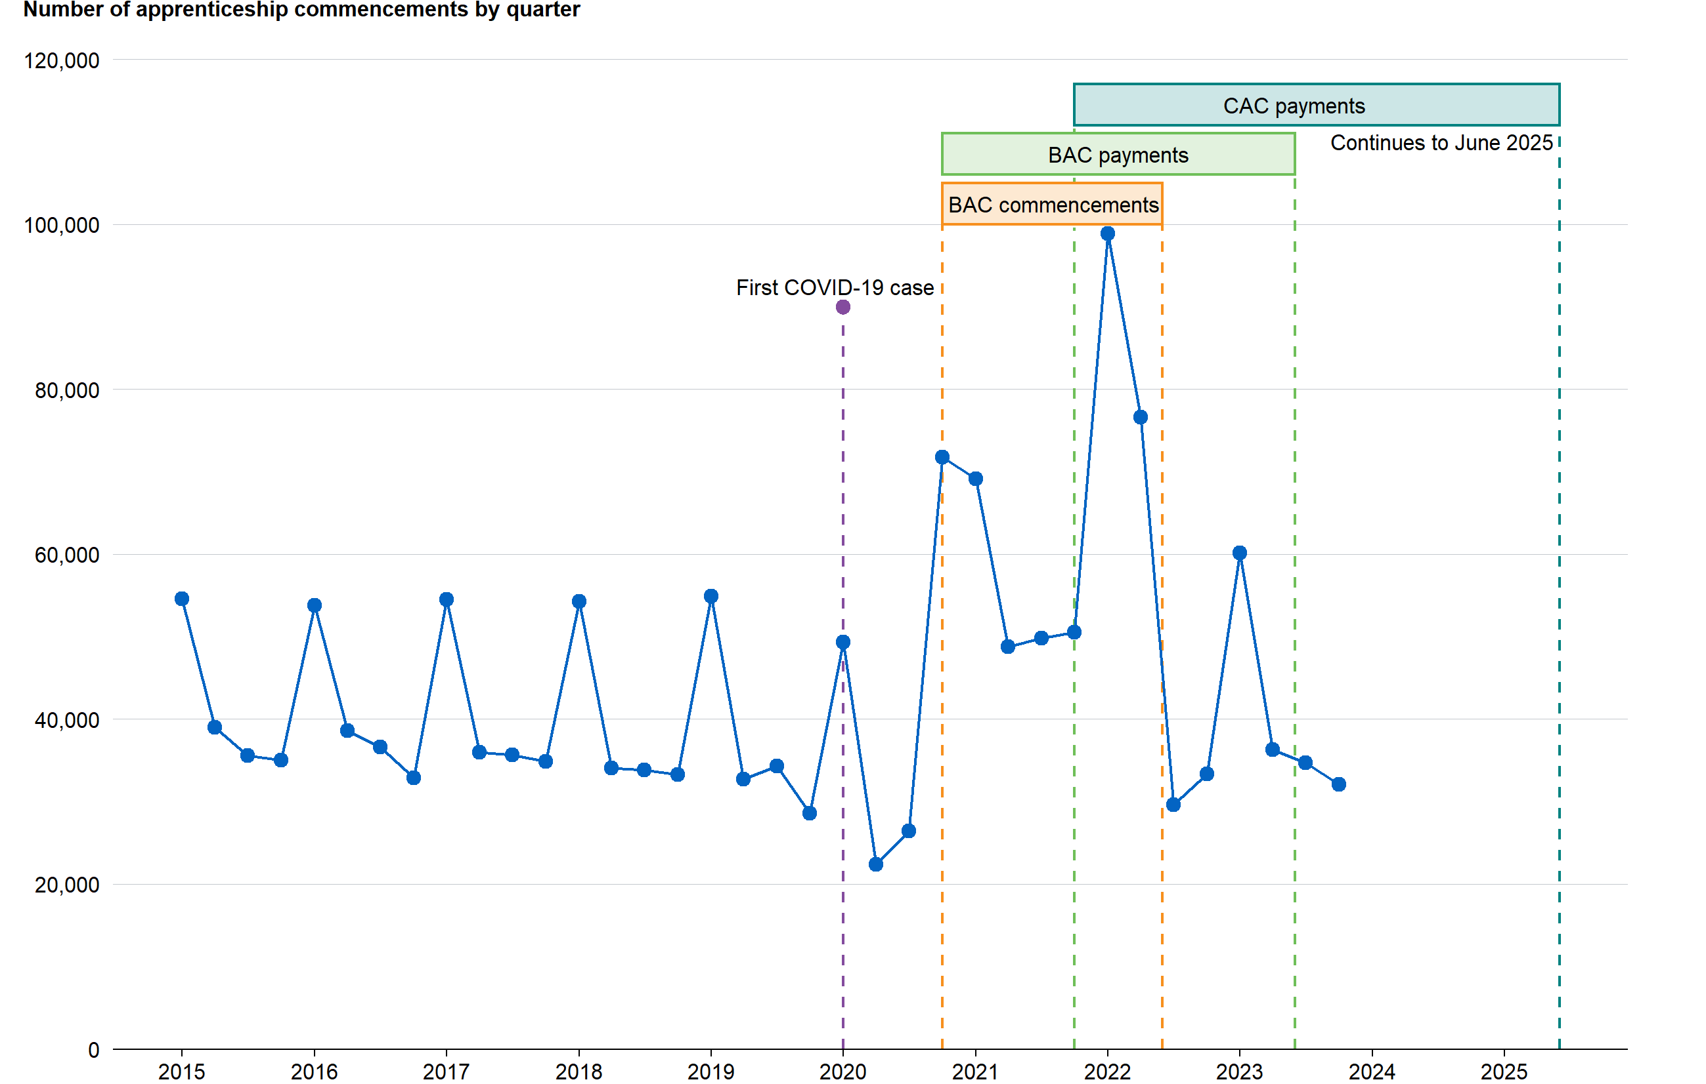

Source: DEWR admin data 2015-2023.

## Structure of this report

The remainder of this report is structured as follows. The first section outlines the evaluation questions, methods and data used. The next two sections report the evaluation team’s findings on the of the BAC program on apprenticeship commencements and completions.

The two subsequent sections examine the characteristics of apprentices and employers that took part in the program. This is followed by a discussion of the BAC program’s cost effectiveness. The penultimate section describes the ‘sharp practices’ that occurred in non-trade occupations. To conclude, we discuss the implications of this evaluation for the design of similar policies in future.

# Evaluation overview

This rapid evaluation was prepared by the Australian Centre for Evaluation in the Australian Treasury. The evaluation was undertaken between April and July 2024, as an input to the [*Strategic Review of the Australian Apprenticeships Incentive System*](https://www.dewr.gov.au/australian-apprenticeships/strategic-review-australian-apprenticeship-incentive-system) (DEWR 2024a). This section summarises our evaluation approach, specifically the evaluation questions, and the data and methods used to answer them.

## Evaluation questions

This evaluation sought to answer the following questions, relating to the BAC program’s first objective (to encourage employers to take on and retain Australian Apprentices) and third objective (to contribute to a highly skilled workforce).

### Apprentice commencements and completions

1. Did BAC achieve its intended objective of increasing commencements? Did CAC achieve its intended objective increasing retention and completion rates?
2. Did BAC stimulate commencements in occupations identified as experiencing skills shortages (priority occupations)?
3. What impact, if any, did the BAC and CAC schemes have on retention and completion rates?

### Apprentice and employer characteristics

1. Did the characteristics of BAC/CAC Australian Apprentices differ from past cohorts of Australian Apprentices?
2. Did the characteristics of employers who employed BAC/CAC Australian Apprentices differ from past cohorts of employers?
3. What proportion of employers of BAC/CAC Australian Apprentices were employing an Australian Apprentice for the first time (or the first time after a break)? Did these employers continue to employ Australian Apprentices after the BAC and CAC closed to entrants?

### Cost effectiveness

1. What was the cost per additional commencement and additional completion?
2. To the extent possible, comment on the cost effectiveness of the program in achieving their intended objectives?

## Methods

This evaluation took a mixed-methods approach. The evaluation team analysed administrative data, built a time-series event study econometric model of quarterly commencements, and built a probit econometric model of an individual’s likelihood of continuing their training. In the Appendix D, we also include results for a time-series event study model of quarterly ‘progressed commencements’ to take into account the effects of cancellations.

We also reviewed the existing literature on wage subsidies for Australian Apprenticeships (see Appendix E), reviewed mentions of the BAC program in submissions to the Strategic Review of the Australian Apprenticeship Incentive System, and interviewed selected stakeholders.

The stakeholders we interviewed included Group Training Organisations and one of their peak bodies, Australian Apprenticeship Support Services providers and their peak body, state regulators, TAFE Directors Australia, and the federal Department of Employment and Workplace Relations (DEWR).

## Data

Most of the analysis in this evaluation used administrative data from DEWR. This data covers every Australian Apprenticeship from 2006-2023.

The econometric modelling was supplemented with data from the Australian Bureau of Statistics’ [*Labour Force Survey*](https://www.abs.gov.au/statistics/labour/employment-and-unemployment/labour-force-australia-detailed/latest-release)*,* Jobs and Skills Australia’s [Internet Vacancy Index (IVI)](https://www.jobsandskills.gov.au/data/internet-vacancy-index), and the [*NAB Monthly Business Survey*](https://business.nab.com.au/nab-monthly-business-survey-february-2024/) (ABS 2024; JSA 2024; NAB 2024). See the section ‘BAC’s effects on commencements’ for more details.

The cost effectiveness section also used data from the *Department of Employment and Workplace Relations* on government spending on apprenticeships.

For analysis of priority occupations the evaluation team used priority occupations from the [Australian Apprenticeships Priority List](https://www.dewr.gov.au/australian-apprenticeships/apprenticeship-support#toc-australian-apprenticeship-priority-list) (DEWR 2024b), which replaced the [National Skills Needs List](https://www.dewr.gov.au/skills-support-individuals/resources/appendix-b-list-nsnl-qualifications) (DEWR 2023b).

## Terminology

This report follows DEWR’s terminology of using the phrase ‘Australian Apprenticeships’ to refer to both apprenticeships and traineeships.

For ease of reference, throughout this report, the phrase ‘the BAC program’ refers to both the *Boosting Apprenticeship Commencements (BAC)* and the *Completing Apprenticeship Commencements (CAC)* programs unless explicitly stated otherwise. Employers of Australian Apprentices who were eligible for the BAC wage subsidy in their first year of training, were also eligible for the CAC subsidies in their second and third year (and no one was eligible for CAC who was not also eligible for BAC), so the programs effectively formed part of the same package.

To avoid confusion, the department responsible for the BAC program is referred to as the ‘Department of Employment and Workplace Relations (DEWR)’, though we acknowledge that for part of the period the BAC program existed, Australian Apprenticeships were managed at the federal level by the ‘Department of Education, Skills and Employment (DESE).’

# BAC’s effects on commencements

To understand the effect of the BAC program on commencements, the evaluation team sought to develop a ‘counterfactual’, that is, an estimate of what commencements would have been without the program. In this section we explain the econometric model of the counterfactual that was developed, and the consequent results.

## Econometric model

A time series event study model was used to assess the effect of the BAC program on commencements. See Appendix B for the technical details of the model, but in broad terms, the model draws on historical data from 2006 to 2019. It then seeks to model the key drivers of commencements, namely:

* Seasonality (there are always higher commencements in the first quarter of the year),
* Policy changes in mid-2012, and
* Several variables reflecting economic and labour market conditions

The underlying theory supporting the choice of these economic variables is that commencements depend on employer demand. When a business is going well then it is more likely to need additional staff, and more willing to make an investment to train an Australian Apprentice. The specific economic and labour market variables used in the model are:

* Hours actually worked by occupation and state
* Unemployment rates by occupation and state
* Vacancy levels by occupation and state
* Business confidence

At the end of this chapter, the sub-section titled ‘Discussion of causality’ discusses how well these variables capture the main drivers of apprenticeship commencements.

## Results

### **Substantial** **increase in commencements, particularly for non-trades**

Over its 7-quarters, the BAC program resulted in a 70% increase in commencements compared to the modelled counterfactual of what would have occurred in the absence of the program (Figures 2 and 3). This represents 191,000 additional commencements (95% confidence interval of 154,000 to 222,000). (Note that this confidence interval is not symmetric around the point estimate due to the use of bootstrapping – see the technical Appendix B for an explanation and further details.)

The effect was particularly strong for non-trades, where there were 267,000 commencements during the BAC period. This represented an increase of 114,000, or 75%, compared to what would have been expected in the absence of the program (95% confidence interval of 94,000 to 131,000).[1]

Figure 2: Comparison of commencements and forecasted commencements without BAC, by quarter

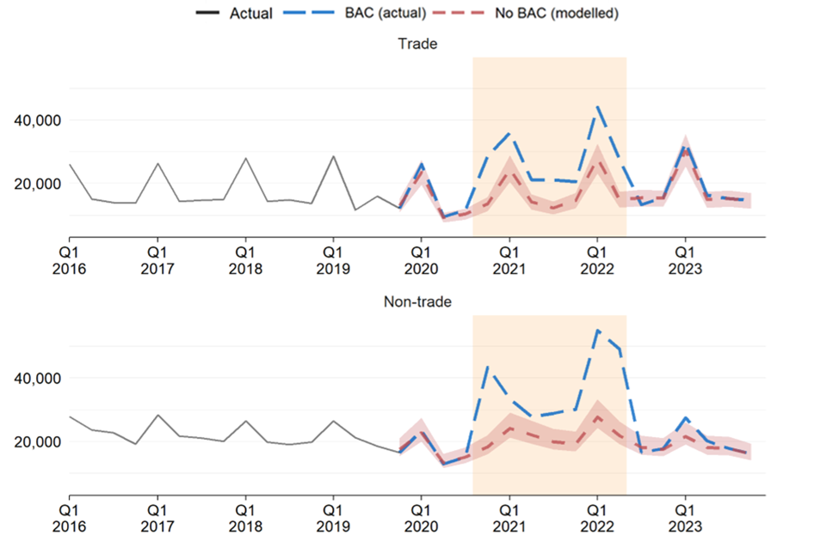

Source: Treasury modelling, see Appendix B for details.

Figure 3: Effect of BAC on the number of commencements by trade and non-trade

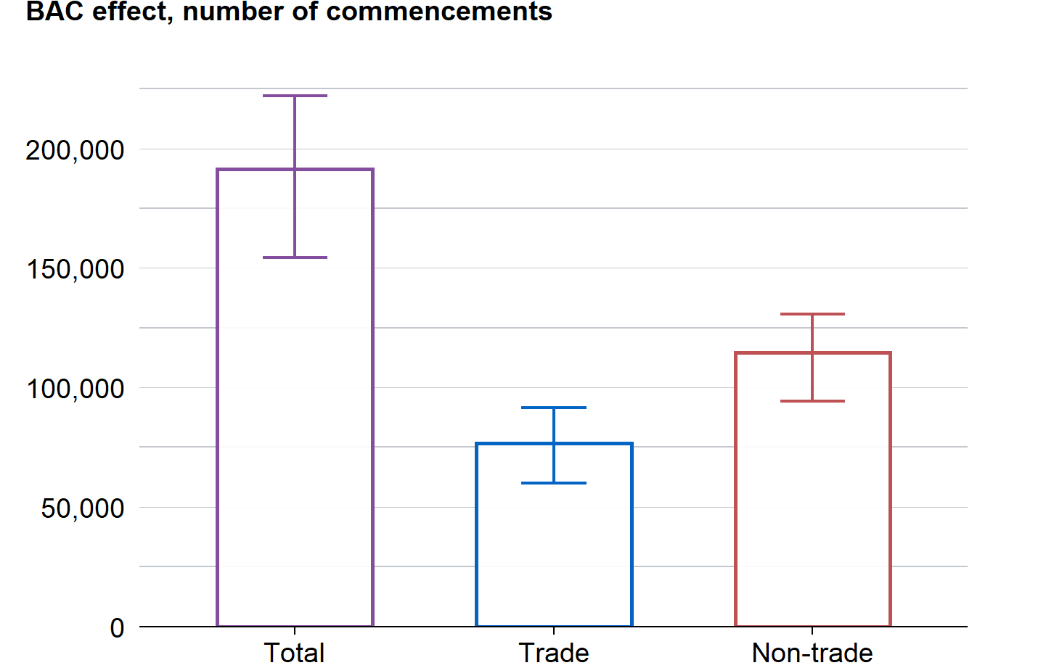

Source: Treasury modelling, see Appendix B for details.

Note: This chart shows the estimated increase in commencements due to BAC. Overall, commencements increased by about 191,000: an increase of 114,000 in non-trades, and 77,000 in trades. Error bars represent the 95% confidence interval.

For trades, by contrast, there were 199,000 commencements during the BAC period, an increase of about 77,000, or 63% compared to what would have been expected in the absence of the program (95% confidence interval of 60,000 to 92,000).

### **Strong effects across duration of the program**

The BAC program resulted in a significant increase in commencements in all quarters, but particularly in the first and final quarters of the program.

For trades, commencements increased by around 100 per cent for the first and final quarters of BAC, compared to the number of commencements expected without BAC. Between these quarters, commencements were lower but still around 50 percent higher than modelling suggests would be expected without the BAC.

For non-trades, the effect was even stronger. In the first and final quarters of the BAC, non-trade commencements were almost 150 per cent higher and 135% higher, respectively, than would have been expected without BAC. Between these periods, quarterly effects ranged from 30 per cent to 100%.

For the first quarter, this was partly due to the program initially having a funding cap of 100,000 places, which resulted in employers rushing to commence new Australian Apprenticeships before all places were used up. For the final quarters, this was partly due to a “pull-forward effect” where employers sought to commence Australian Apprentices before the program closed to new entrants.

Figure 4: BAC quarterly effects on apprenticeship commencements, with seasonal and economic controls

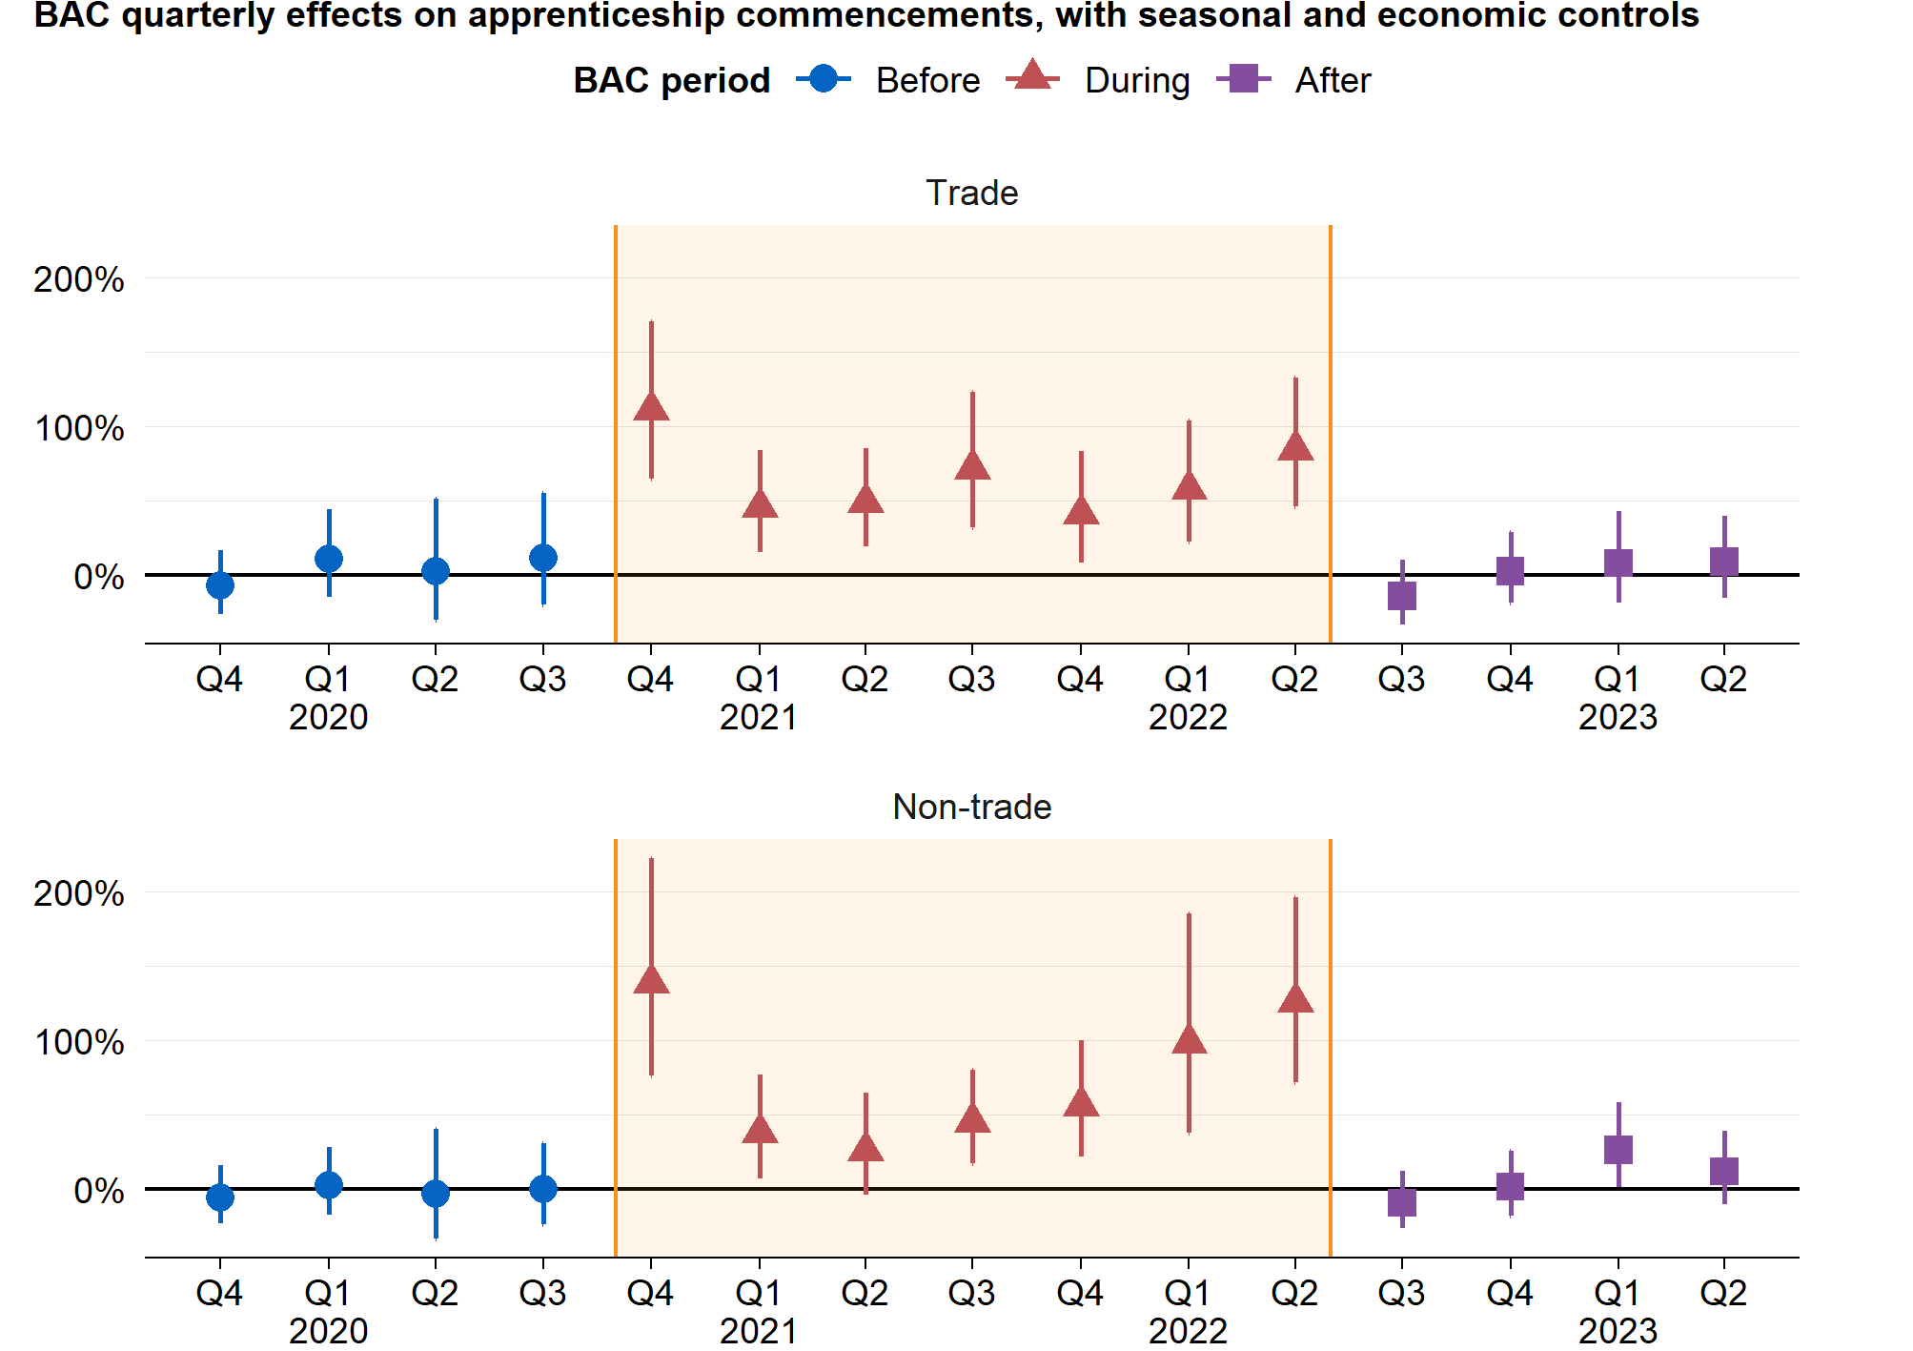

Source: Treasury modelling, see Appendix B for details.

Note: The point is the model estimate, and the line represents the 99 per cent confidence interval derived from the model.

### **Other results**

The evaluation team also looked at variation in the impacts of BAC across the states and territories, and across different occupation types as summarised below – for details, see Appendix A.

Overall, results in individual states were broadly consistent with the national aggregate findings in terms of effects being sizeable and statistically significant, and greater for non-trades. However, there were some possible differences that are discussed in Appendix A.

The effect of BAC on commencement was consistently positive across all *trade* occupations. For example, the three trade occupations with the largest number of commencements – carpenters, electricians and automotive electricians – saw an average effect over the BAC period of about 40%.

For the *non-trade* occupations, the effects were larger and more varied. For the three largest non-trade occupations, the BAC program caused commencements to more than double (that is, increase by more than 100%). Australian Apprenticeships amongst office managers grew more than six-fold.

## Discussion of causality and generalisability

### **Discussion of causality**

In the econometric modelling above and throughout this report, the evaluation teams have attempted to identify the causal impact of the BAC program by creating a counterfactual. That is, an estimate of what commencements would have been in the absence of the BAC program. These estimates were then compared with actual commencements to find the additional commencements *caused* by the program.

The accuracy of the estimates – and the causal claims – depends on how well the econometric model captured the key drivers of commencements.

It is not possible to be certain this model has captured *all* potentially relevant factors. For example, in the period immediately prior to BAC (Quarter 2 and Quarter 3 2020), Victoria had significantly fewer commencements than predicted by the model, which may indicate that the model is not completely capturing the effect of extended lockdowns in that state.

However, drawing on previous research undertaken by DEWR, we can be confident the model captures most of the important drivers (see Appendix B for details). The evaluation team is therefore confident that the model gives a good approximation, and the remaining bias in our estimates is likely to be small.

### **Discussion of generalisability**

Another key consideration in interpreting these results, and all results in this report, is their generalisability (or ‘external validity’). The BAC and CAC programs were broad-based interventions implemented during the height of the COVID-19 pandemic. This was a time of distinct uncertainty and, subsequently, of tight labour market conditions.

This may have acted to amplify the impact of these interventions, as labour demand was strong, and employers likely sought workers through alternative means. Consequently, the results in this paper reflect the impact of the BAC and CAC programs *during a tight labour market*. This study did not try to assess whether a similar intervention in different labour market conditions (such as a period of low labour demand) would generate similar impacts on commencement and retention rates.

# BAC’s effects on completions

This section analyses the reported completions and cancellations for BAC Australian Apprenticeships compared to previous cohorts.

One difficulty with analysing completions is that few BAC commencements could be expected to have had enough time to record a completion. For Australian Apprenticeships in trade occupations, most complete within 3-4 years, and in non-trades within 1-2 years. However, the admin data used for this evaluation only goes to 1.5 years after the end of the period where commencements were eligible for BAC (BAC closed to new entrants June 2022, and admin data goes to December 2023). Further, an Australian Apprenticeship may be suspended for a period and resumed later, and there is typically a time lag between a suspension, completion, or cancellation event occurring, and the employer reporting that event and it appearing in the data.

To get around these issues, in the following sections each BAC Australian Apprenticeship has been grouped into quarterly ‘commencing cohorts’, and categorised as having either ‘progressed’ or ‘cancelled’ at the 18-month mark. For example, there could be 15,000 apprenticeships in the Quarter 1 2014 commencing cohort, 9,000 of which progressed after 6 quarters and the remainder – 6,000 – cancelled. The definitions of the ‘commencing cohort’, ‘progressed commencements’ and ‘cancelled commencements’ are provided in the Box below.

|  |
| --- |
| **Key terms for understanding cancellations**  * ‘**Commencing cohort**’ refers to the Australian Apprenticeships that commenced in a given quarter * ‘**Progressed commencements**’ refers to the number of Australian Apprenticeships in a commencing cohort that had either reported a completion or had not cancelled (that is, remained in-training) 6 quarters after commencement * ‘**Retention rate**’ refers to the share of a *commencing cohort* that were *progressed commencements* at the 18-month mark * ‘**Cancelled commencements**’ refers to the number of Australian Apprenticeships in a *commencing cohort* that had reported a cancellation 18 months after commencement * ‘**Cancellation rate**’ refers to the share of a *commencing cohort* that were *cancelled commencements* at the 18-month mark. The *retention rate* plus the *cancellation rate* equal 100% |

## Australian Apprenticeship cancellation and retention rates

BAC cancellation rates were 7% higher than their historical levels for non-trades, but 0.7% lower for trades. For non-trades, at 6 quarters after commencement, cancellation rates for all-but-one of the BAC cohorts were higher than previous cohorts (Figure 5). For trade commencements, the cancellation rates for BAC cohorts were within the historical range, with between 25-30 per cent of apprenticeships cancelled 6 quarters (18 months) after commencement.

Figure 5: Cancellation rate by commencement cohort

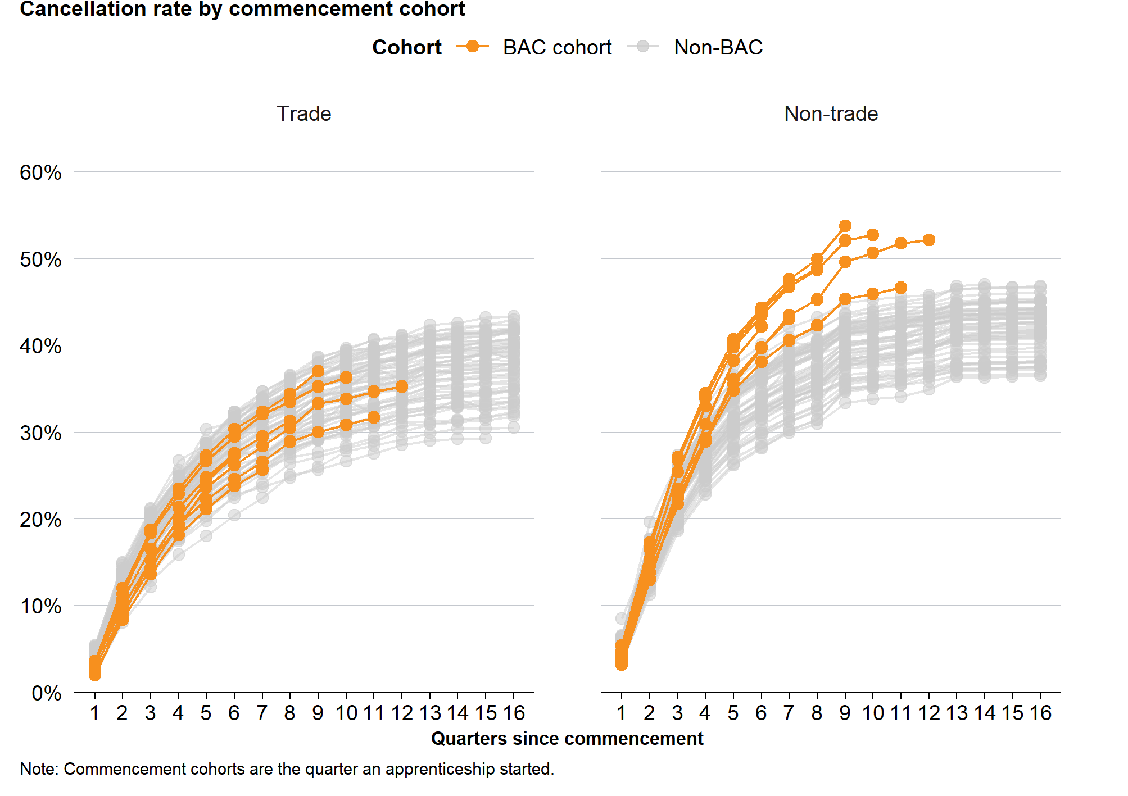

Source: DEWR administrative data 2006-2023.

Note: Commencement cohorts are the quarter an apprentice started.

Figure 6: 18-month retention rate by commencement cohort

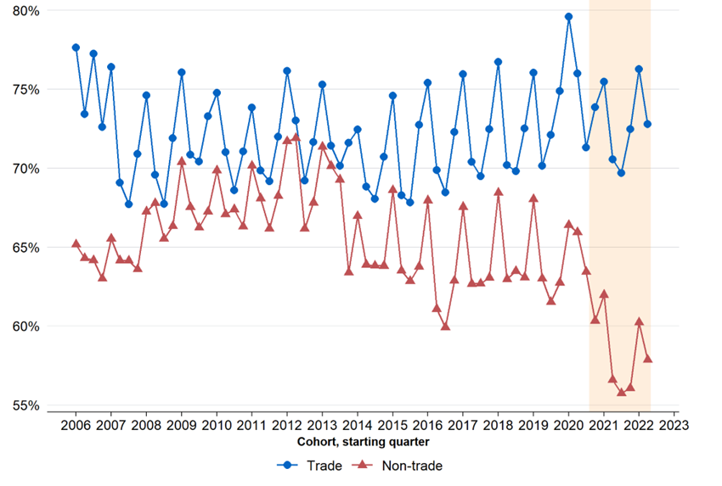

Source: Treasury modelling, see Appendix B for details.

Note: The vertical axis is truncated at 55% to make it easier to see changes in the retention rate.

The flip-side of the cancellation rate is the retention rate. Retention rates are defined as the share of commencements that have *not reported* cancelling their Australian Apprenticeship contract at the 6-quarter (18-month) mark. There can often be a time lag between when an Australian Apprenticeship is cancelled and when this cancellation is recorded on the Training Contract, so the actual retention rate may be lower than the rate as defined (based on reporting).

The retention rates showed a similar pattern to the completion rates, as expected (Figure 6). During the BAC program (shaded orange), the trade retention rate remained in-line with historic levels. By contrast, the retention rate for *non-trade* apprentices declined to historically low levels.

For a discussion of some of the potential drivers of low retention rates (and high cancellation rates) during the program, see the discussion of ‘sharp practice’ further below.

Appendix D includes further analysis on the numberof ‘progressed commencements’, which is defined as the number of commencing apprentices who continue or complete their apprenticeship within 6 quarters (18 months). This analysis differs from the above because it focuses on a *number*, rather than a *rate.*

## Econometric modelling of individual-level cancellations

### **Model and data**

An econometric model was used to analyse how cancellation rates differed between different states, and across different occupations. The model estimated how cancellation rates differed for individuals who commenced during the BAC program compared to previous cohorts. The model predicted the likelihood that an individual apprenticeship was cancelled 18 months after commencement, controlling for compositional changes in commencements and changes in economic conditions.

The approach used an individual-level probit model, which was ran on the 4 million individual apprenticeship commencements in the data set between 2006 and 2023. See Appendix D for technical details.

### **Results**

At the national level, the cancellation rate for trades was slightly lower, while for non-trades it was substantially higher. This is consistent with the descriptive statistics shown in the previous sections but has the advantage of controlling for compositional changes in commencements, and changes in labour market conditions.

Trade commencements during the BAC program were 0.7 percentage points less likely to be cancelled within the first 18 months. Non-trade BAC commencements, however, were about 7 percentage points more likely to be cancelled. This is a material shift when compared to the previous 6-quarter cancellation rate of 30-40 per cent for non-trades. These results were consistent across all states and territories (Figure 7).

Occupations with higher BAC commencements tended to also have higher cancellation rates (Figure 7). In particular, the following occupations all had high commencements during BAC, and also had some of the highest cancellation rates: Office and Practice Managers; Chief Executive, General Managers and Legislators; General Clerks; and Logistics Clerks. However, some occupations that did not experience a large increase in commencements due to the BAC program also had high cancellation rates, for example Truck Drivers and Storepersons.

Figure 7: Effect of BAC on cancellation rate by jurisdiction and occupation

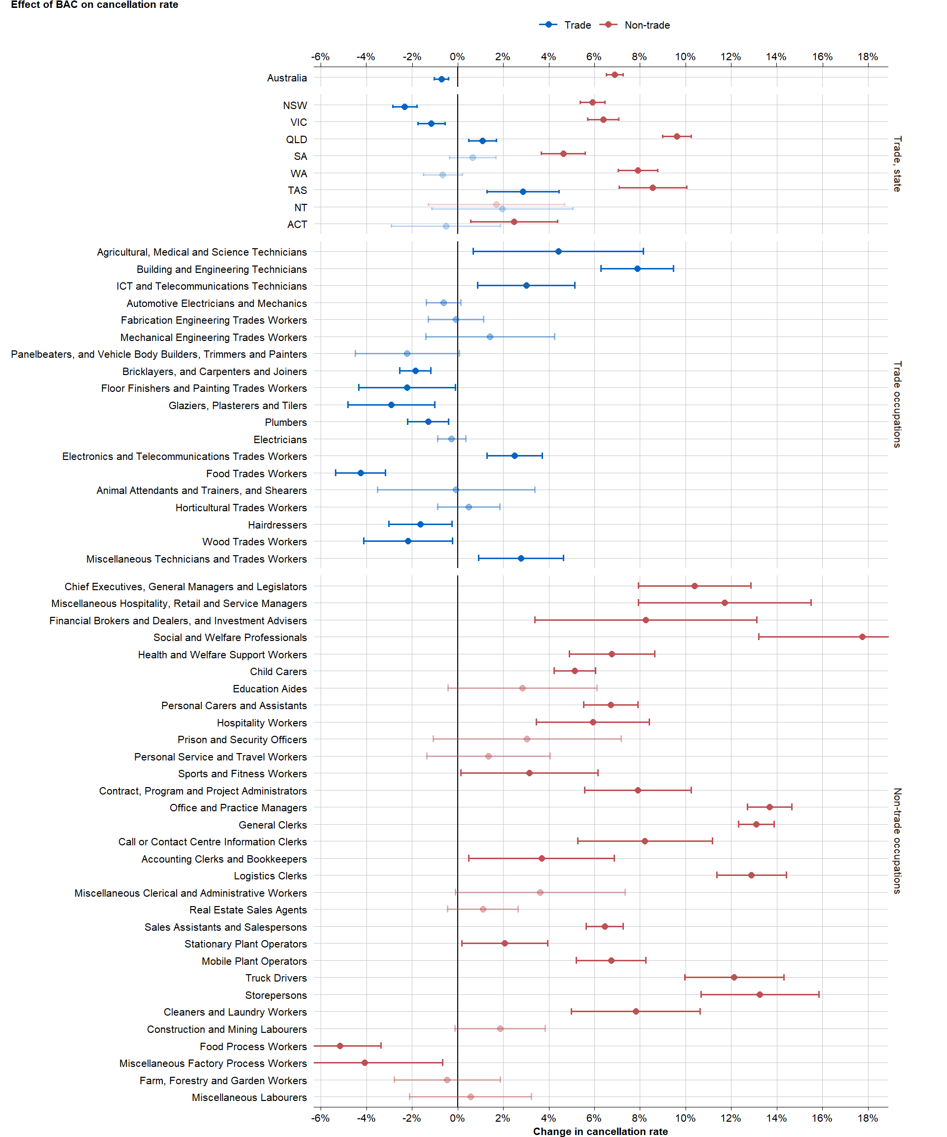

Source: Treasury modelling, see Appendix B for details.

# Apprentice characteristics

This section outlines the characteristics of commencing apprentices in three aspects:

* The share of BAC apprentices in priority occupations
* Which occupations saw the strongest growth in apprenticeships during the BAC period
* The demographic characteristics of BAC apprenticeship commencements

## Non-priority occupations experienced the strongest growth

Priority occupations refer to apprenticeships in occupations on the [Australian Apprenticeships Priority List](https://www.dewr.gov.au/australian-apprenticeships/apprenticeship-support#toc-australian-apprenticeship-priority-list), and previously the [National Skills Needs List](https://www.dewr.gov.au/skills-support-individuals/resources/appendix-b-list-nsnl-qualifications) (DEWR 2024b; DEWR 2023b).

The share of commencements in priority occupations fell slightly during the BAC period (Figure 8). Priority occupations are predominantly trades-based so these results are consistent with our earlier finding that the BAC program had a greater impact in increasing non-trade commencements than trade commencements.

Figure 8: Proportion of apprenticeship commencements in priority occupations quarterly

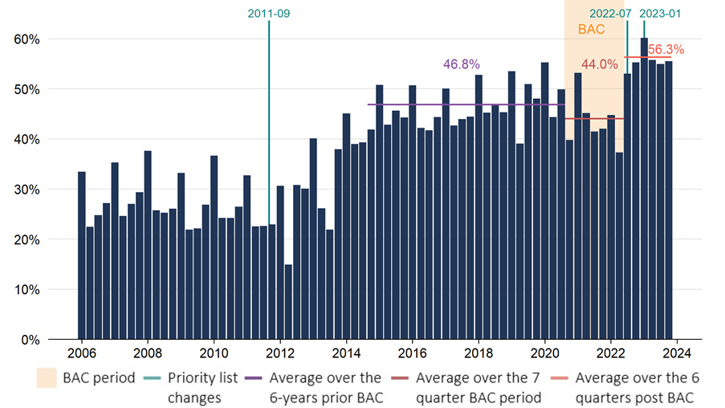

Source: DEWR administrative data 2006-2023.

## A small number of occupations dominated commencements

The occupations with the largest increases in commencement numbers under the BAC program were: office administration (General Clerk and Office Manager), carpenters, logistics-related workers (Production Clerk), and hospitality workers. Of the 40 occupations that saw the largest increase in the number of commencements under the BAC program, only 12 were in priority occupations.

In this section the evaluation team looked at the difference between the calendar years 2019 (pre-BAC) and 2021 (during BAC). Full calendar years were analysed rather than the exact BAC period (5 October 2020 to 30 June 2022) to avoid seasonality effects. However, this comparison does not distinguish between changes attributable to BAC and those attributable to the pandemic.

Figure 9: Top 40 occupations with largest increase in apprenticeship commencements between 2019 and 2021

Source: DEWR administrative data 2006-2023.

## Effects on key demographic cohorts

This section explores the demographic characteristics of BAC Australian Apprentices to better understand whether the program supported key demographics of interest. Three calendar years are compared: 2019 (pre-BAC), 2021 (during BAC) and 2023 (post-BAC). As above, full calendar years are analysed rather than the exact BAC period to avoid seasonality effects. This comparison does not distinguish between demographic changes attributable to BAC and those attributable to the pandemic or other trends at the time, so results cannot be interpreted as the causal effect of the BAC program.

### BAC increased the number of commencements for all key demographic cohorts

The BAC program was associated with an increase in the *number* of apprenticeship commencements in each of the following demographic cohorts:

* Gender
* Age
* People with a disability
* People from culturally and linguistically diverse backgrounds
* First Nations people

The *share* of commencements was similar to pre-BAC levels for gender, people with a disability, and people from culturally and linguistically diverse backgrounds (See Appendix C for more details on these cohorts). This section discusses the two groups for which the share of BAC commencements differed from pre-BAC levels: age and First Nations people.

#### **Age**

BAC commencements were more likely to be aged 21 years or older than previously (Figure 10). During interviews, stakeholders mentioned that employers often prefer ‘older’ apprentices because they are seen as having more life skills and being more reliable. However, older Australian Apprentices must receive a higher wage by law.

There are three factors that may explain the increase in apprenticeships aged 21 or older. First, the BAC wage subsidy reduced the additional cost of an older apprenticeship. Second, in non-trade occupations, the BAC program led to a substantial increase in workers undertaking an apprenticeship with their existing employer. (In some cases, this may have reflected ‘sharp practice’, as discussed in a later section of this report.)

Finally, the increase in older apprenticeships may have been partly due to broader impacts of the pandemic, rather than the BAC program. Specifically, the pandemic led to substantial disruption in the labour market that may have caused older workers to look for further qualifications.

Figure 10: Share of apprentice commencements by age group in 2019, 2021 and 2023

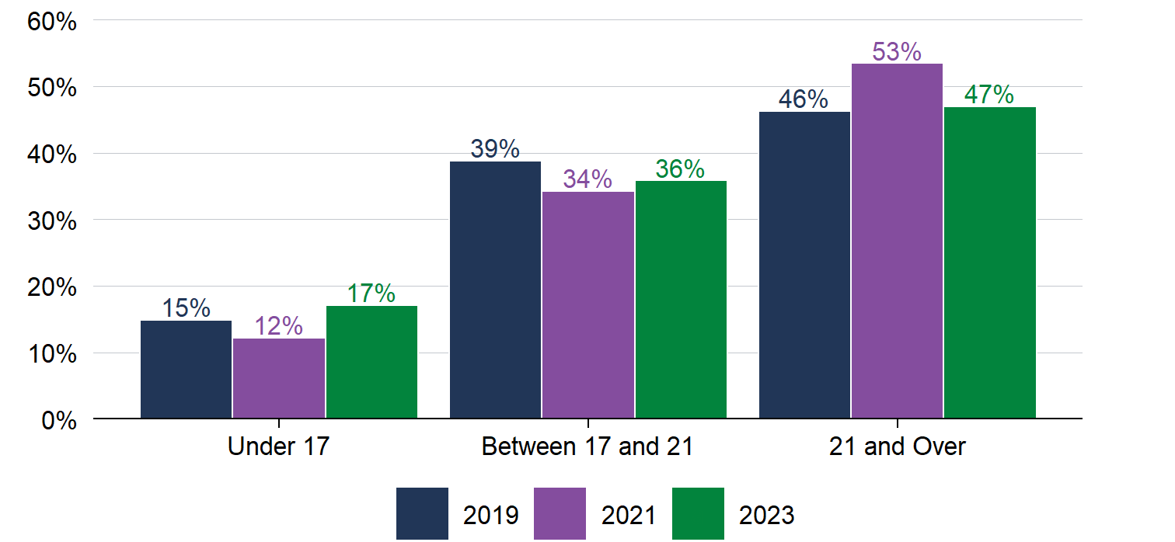

Source: DEWR administrative data 2006-2023.

#### **First Nations people**

While the BAC program was associated with a large increase in the *number* of First Nations people undertaking an Australian Apprenticeship, it was also associated with a lower *share* of commencements being First Nations people than either before or after the BAC program (Figure 11). This lower share of First Nations commencements during the BAC program mainly occurred within the non-trade occupations (Figure 12).

Examining the possible explanations for this was beyond the scope of this evaluation. However, a potential explanation, proposed by one interviewed stakeholder, is that Australian Apprenticeship commencements may become more representative of the population as the number of people commencing an Australian Apprenticeship increases. The share of Australian Apprenticeship commencements that were First Nations people prior to BAC was approximately 8% while the share of the overall population is approximately 3%. Another possible explanation is that the change was due to other factors related to the pandemic, rather than the BAC program itself.

Figure 11: Share of apprenticeship commencements that are First Nations people

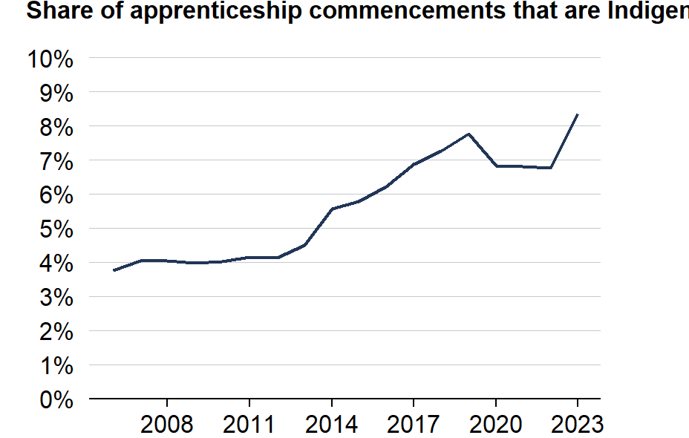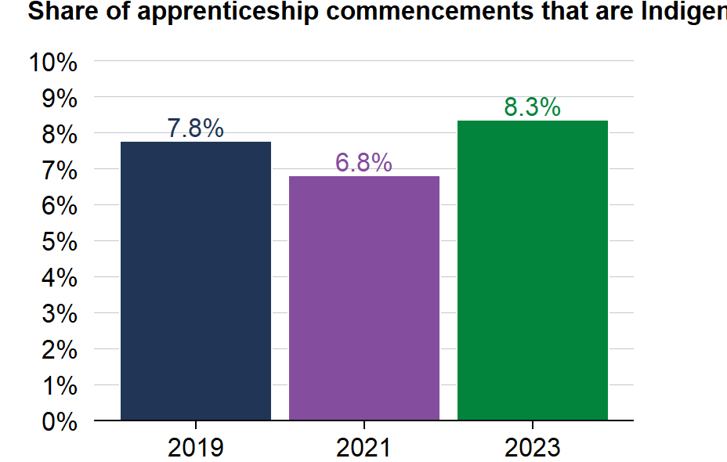

Source: DEWR administrative data 2006-2023.

Figure 12: Share of apprenticeship commencements that are First Nations people by Trade and Non-trade

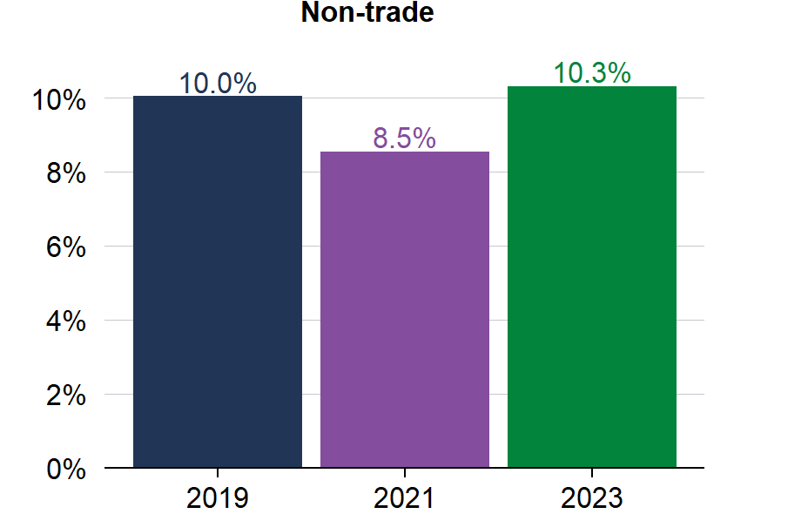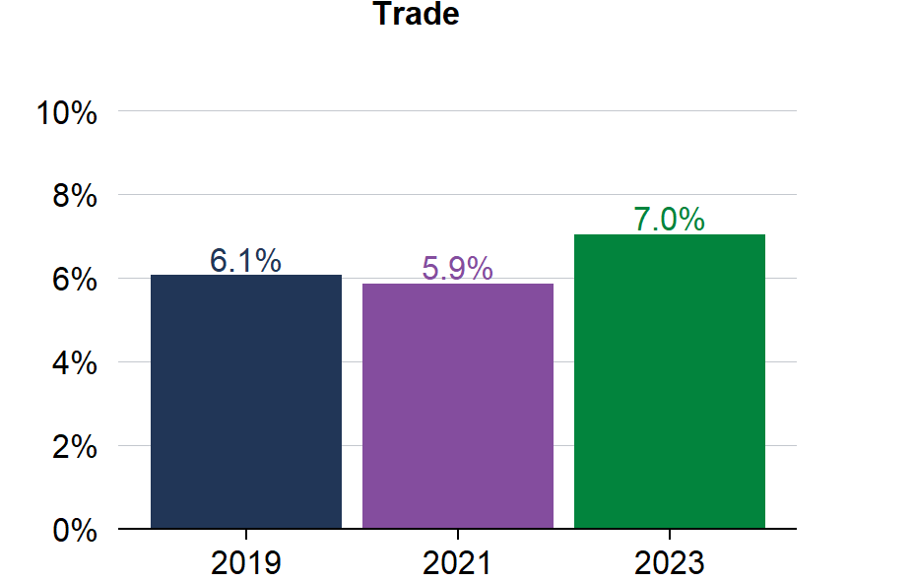

Source: DEWR administrative data 2006-2023.

# Employer characteristics

## Commencements grew particularly strongly for small and medium businesses

Over the BAC period, the average number of apprenticeship commencements per quarter grew by 98% for small businesses (0-19 employees) and 95% for medium businesses (20-199 employees), significantly larger than 29% for large employers (over 200 employees) (Figure 13). This resulted in small businesses eclipsing large businesses for having the largest number of commencements per quarter.

This was partly be driven by the fact that the program eligibility criteria were updated within the first few weeks to only allow a maximum of 30 existing worker commencements in non-trade occupations per employer (see our later discussion of ‘sharp practice’).

Figure 13: Effect of BAC on commencements by employer size

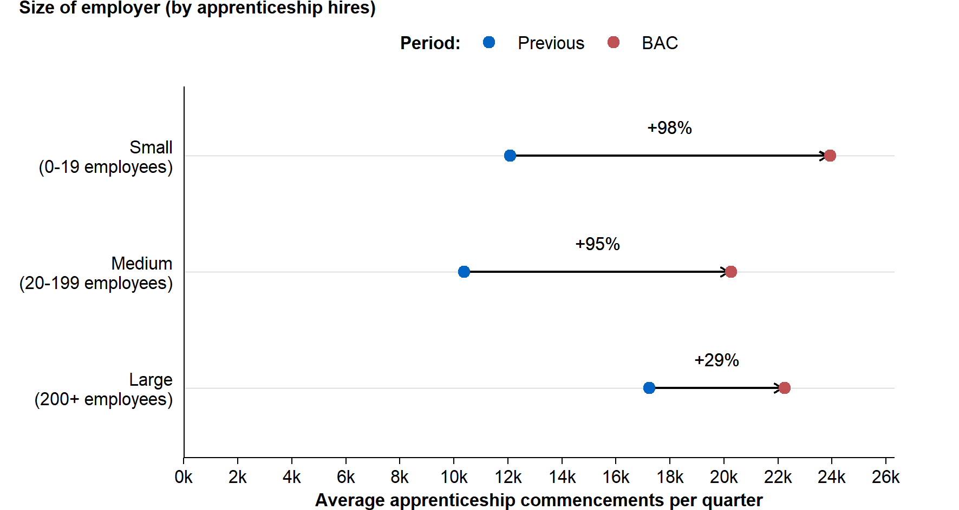

Source: DEWR administrative data 2006-2023.

Note: ‘BAC’ period refers to Quarter 4 2020 to Quarter 2 2022. ‘Previous’ period refers to Quarter 4 2017 to Quarter 2 2019.

## Increase in employers hiring an apprentice for the first time

The number of employers hiring an Australian Apprentice for the first-time rose during the BAC period. This rise was driven by small, new employers – those who had not commenced an Australian Apprentice in the previous 12 months. The number of new employers remained above-trend during the whole BAC period, reaching a peak in the final months, indicating that the BAC continued to attract new employers through to the end of the BAC period (Figure 14).

There was also a significant rise in existing employers – those who had commenced an Australian Apprentice in the previous 12 months – in the final months of the program. This includes both employers who regularly hire Australian Apprentices, and employers that were new to hiring Australian Apprentices at the beginning of the program and that brought on more Australian Apprentices towards the end of the program.

Of those that took on an Australian Apprentice for the first time during the BAC period (that is, ‘New employers’ in the chart below), some continued to hire apprentices afterward (red), while others did not (blue). The split between these groups was broadly similar to non-BAC periods.

Figure 14: Number of employers by prior and future status

Source: DEWR administrative data 2006-2023.

Note: Each quarter the number of employers who hired an apprentice in that quarter is counted. They are sorted into their past and future hiring behaviour in the following way: i) ‘New employers’ are employers who had not hired an apprentice in the past 12 months, then ‘Existing employers’ are those who had, ii) ‘Hired apprentice after’ means the apprentice hired another apprentice in the next 12 months, whereas ‘Do not hire apprentices after’ means they did not.

# Cost effectiveness

## Method

While the BAC program was successful in increasing commencements, it did so at a cost of over $7.5 billion (through to 31 March 2024).

The evaluation team calculated the overall cost of each ‘additional’ commencement and completion by dividing the overall cost of the program by the number of ‘additional’ commencements or completions.[2] For commencements, we used the ‘additional’ commencements numbers from the modelling described in the commencements section.

For completions, we had to take into account the fact our econometric modelling was of cancellations at the 18-month mark, not the end of the Australian Apprenticeship. The evaluation team took a conservative approach of using the completion rate for the most recent cohort for which the NCVER report completion rates, and then adjusting it using the 18-month cancellation rate from the modelling. For example, for trades the most recent reported completion rate from the NCVER was 53.4%, so this figure was increased by 0.7% to assume 54.1% of trades commencements under BAC completed their training.

Figure 15: Government funding per ‘additional’ apprentice commencement and completion (AUD)

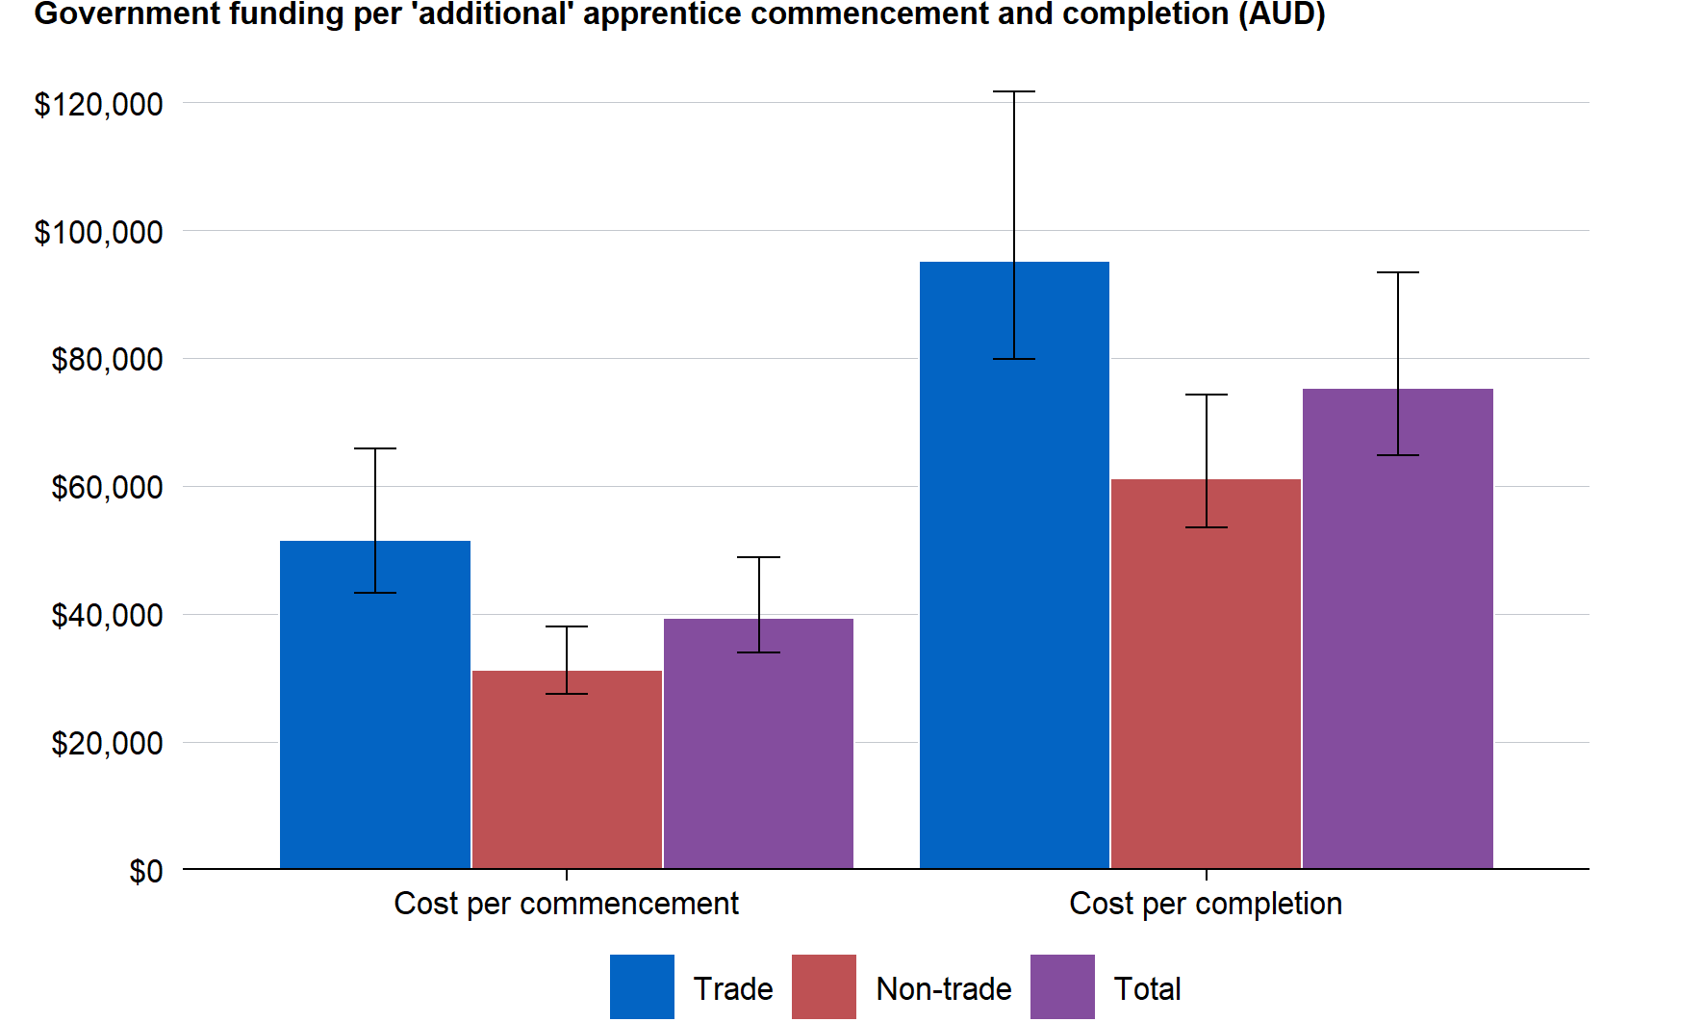

Source: DEWR administrative data 2006-2023 and DEWR internal expense data

## Results

The analysis found that the BAC program cost approximately $40,000 per additional commencement ranging from $30,000 to $50,000, and the cost of an additional Australian Apprentice completion was approximately $80,000 ranging from $60,000 to $90,000 (Figure 15).[3]

While this tells us the cost of an ‘additional’ commencement, another relevant data point is the cost to the government per Australian Apprentice in-training. The analysis calculated that the BAC and CAC programs resulted in this cost increasing by a factor of 5 compared to the pre-BAC period (Figure 16)[4].

Figure 16: Federal government funding of Australian Apprentices per person in-training (AUD)

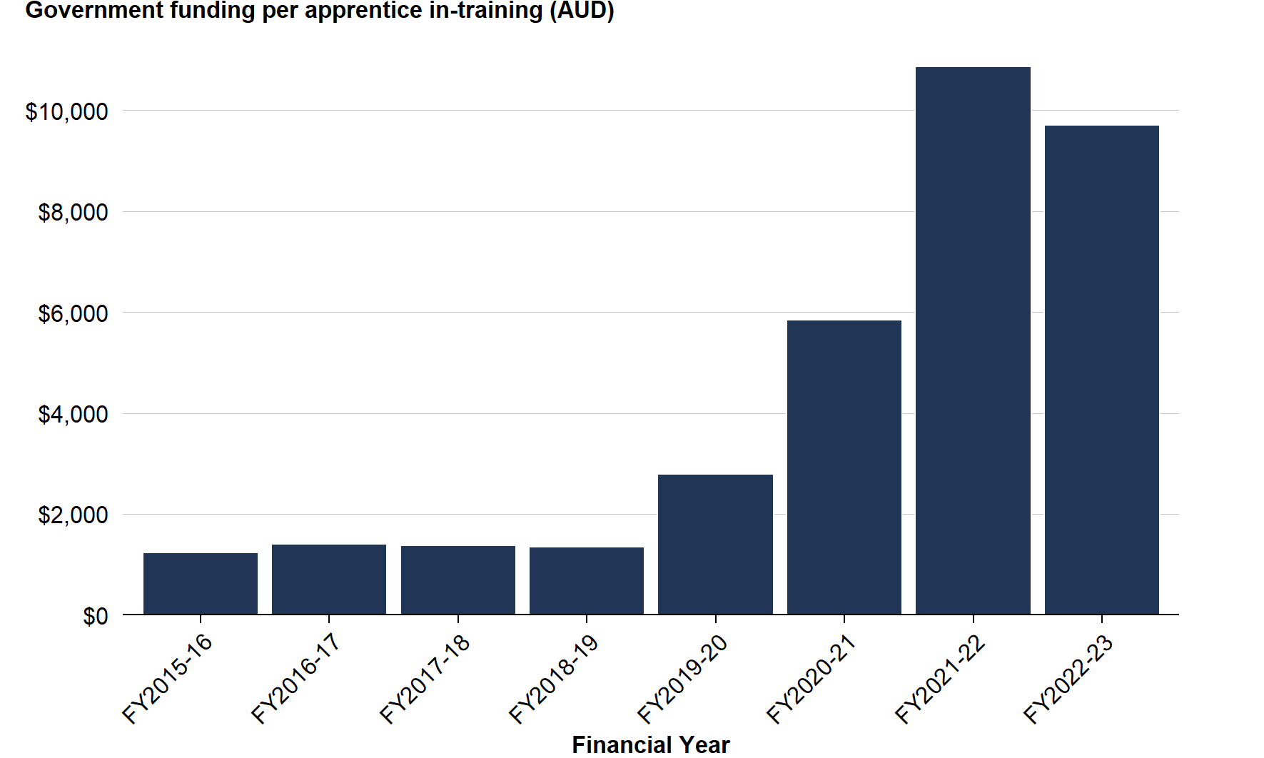

Source: DEWR administrative data 2006-2023 and DEWR internal expense data.

## Discussion of cost effectiveness

BAC achieved its goal of increasing commencements and increasing the number of employers taking on an Australian Apprentice for the first time. However, it did so at a cost of approximately $40,000 per additional commencement and approximately $80,000 per additional completion.

Whether such costs are justified depend on a range of factors. This includes the value of an individual receiving training to the Australian economy and the personal long-term skill benefits of training to the individual. These questions in turn depend on what the BAC Australian Apprentice would have done if they had not taken part in the program. Giving a quantitative answer to these questions would require a formal cost-benefit analysis, which was beyond the scope of this evaluation.

It could be argued, however, that the BAC and CAC programs were greater value for money for trades occupations than for non-trade occupations, for several reasons:

* An Australian Apprenticeship is not generally required in many non-trades occupations—such as retail or hospitality—to be job-ready or to satisfying the licensing requirements needed to practice in the profession. Yet these non-trade occupations were much more responsive to the BAC and CAC programs.
* Completion rates for non-trades occupations were lower than their usual low rates. This was not the case for trades.
* A high share of commencements in non-trades were in occupations that were not priority occupations.
* As discussed in the following section, there was evidence of potential ‘sharp practice’ in non-trade occupations.

# Sharp practice in non-trades occupations

During interviews, some stakeholders reported there was substantial ‘sharp practice’, generally involving existing workers in non-trade occupations. Multiple stakeholders went to the extent of describing this as ‘rorting’.

The sharp practice usually involved businesses transferring existing workers onto an Australian Apprenticeship for the primary purpose of receiving the wage subsidy, rather than pursuing a training opportunity. In some cases, workers were informed of the arrangement but not necessarily consulted on whether they were interested in commencing training. For example, in an accounting firm, all-but-one of its employees commenced an Australian Apprenticeship in work, health and safety. While it may have been appropriate, during a pandemic, for one or two staff to undertake such training, it seems unlikely that this training was required across the firm.

In many cases, this problematic behaviour did not breach relevant program guidelines or constitute fraudulent activity. Accordingly, we refer to this as ‘sharp practice’, as distinct from non-compliant behaviour.

Stakeholders also described behaviour that went beyond sharp practice and constituted a breach of the Training Contract and relevant state or territory legislation. Such breaches would technically warrant regulatory action by the relevant State Training Authority (STA), however over the BAC period many STAs were too overwhelmed for all potential breaches to be fully investigated. A common breach of the Training Contract was failing to release workers to attend training (with payment for time spent training). In extreme cases, existing workers were not informed they were being commenced in a qualification.

The remainder of this section summarises selected stakeholders’ observations. The next subsection explains why issues with sharp practice were particularly evident for existing workers in non-trade occupations. It then describes the changes to eligibility criteria in the first few weeks of the program that helped mitigate these sharp practices. In the final two subsections we describe the role of certain RTOs and third-party brokers in driving the sharp practice, and then why under pressure service providers struggled to mitigate the issues.

This summary should not be seen as attributable to any particular stakeholder as it represents our interpretation and synthesis of interviews with selected stakeholders, complemented by our own research and analysis.

## Sharp practice largely an issue with non-trades existing workers

Stakeholders reported the issues with sharp practice were particularly an issue with existing workers in non-trade occupations. This is likely a contributing reason to why cancellation rates for non-trades Australian Apprentices were higher under the BAC program than their usual rates, which was not the case for trades occupations. However, cancellations may also have increased due to other factors like the tight labour market (Nelms 2017, pp28-30).

To illustrate the dynamic described, the chart below shows how the share of commencements that were existing workers was elevated during the BAC program (Figure 17). This was particularly evident for non-trades during the early stages of the program, and resulted in an increase in the share of non-trade cancellations that were existing workers.

Figure 17: Share of commencements and cancellations that are existing workers, by trade and non-trade

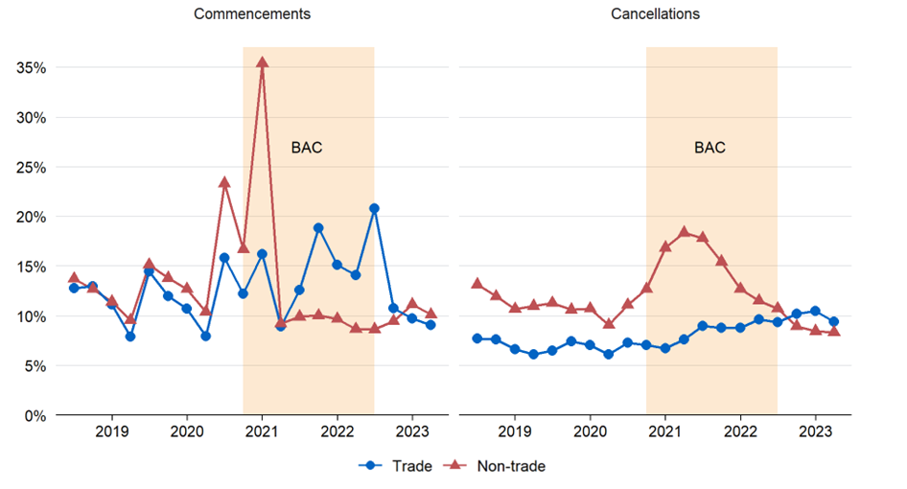

Source: NCVER data 2024.

One of the likely reasons for the particularly large spike in commencements in the quarter BAC was announced was, at that time, the program was capped at 100,000 places. This cap was later removed as part of the 2021-22 Budget. While the cap was intended to limit the overall financial commitment, it inadvertently benefited employers with existing workers that could more rapidly commence in an Australian Apprenticeship, relative to employers that had not yet identified a suitable Australian Apprentice.

There are a few reasons sharp practices related to existing workers was predominantly seen in relation to non-trades rather than trades occupations:

* Trades training is usually undertaken in-person at a TAFE or other training provider, which requires an employee to be paid to attend classes off-site often for one-day per week. This meant shifting existing workers onto a trades Australian Apprenticeship—but keeping their job roles and responsibilities the same—would be difficult or impossible. By contrast, there is greater flexibility in how non-trades training is delivered (for example, remotely or on-line rather than in-person).
* In non-trades occupations like hospitality and office administration (both of which experienced large increases in commencements), there was a greater likelihood of an existing worker being available to commence a qualification than was the case for trades-based industries like, for example, carpentry and plumbing.
* The bulk of trades training is delivered by state-government funded TAFEs, whereas a significant share of non-trades training is delivered by for-profit RTOs. The latter may have had a stronger incentive to participate in sharp practices.

## Eligibility criteria updated swiftly to address sharp practice

Within days of BAC’s launch, the Department of Employment and Workplace Relations (DEWR) became aware of the sharp practice issues outlined above due to market intelligence suggesting high numbers of existing worker sign ups. The eligibility criteria were tightened 3 weeks after launch (the program launched 5 October 2020, criteria were tightened 28 October). The policy changes were:

* For non-trades occupations, existing workers would only be eligible if they were being transferred from a less secure to more secure form of employment (that is, from casual to part-time, or from part-time to full-time)
* Employers could only access the BAC for up to 30 existing workers commencing in a non-trade Australian Apprenticeships.

Most stakeholders agreed that these changes limited the frequency of sharp practice, though there was some disagreement on the extent of their impact. Some believed the changes ended sharp practice entirely, others said it substantially curtailed it but did not limit it entirely, while others believed the changes had only a small effect on decreasing sharp practice. This final group argued that existing workers should have been excluded from program eligibility entirely.

Stakeholders pointed to a few ways that sharp practice was still possible after the changes.

First, training contracts were sometimes back-dated to start prior to the new eligibility criteria. The launch of BAC resulted in such an increase in demand for signing up to an Australian Apprenticeship that the service providers that are responsible for setting up training contracts were overwhelmed with demand. This was used as justification for backdating—for example, if a business had reached out to a service provider prior to the new eligibility criteria but was not signed up because the service provider was at capacity and sign-ups were delayed. Backdating of Training Contracts is typically a matter that is regulated by State Training Authorities, with DEWR’s eligibility determination made on the commencement date as approved by the State Training Authority. So, this factor would have been more relevant in some states than others.

Second, businesses with more than one Australian Business Number (ABN) could shift non-trades workers over to a different ABN. This meant the employees became a ‘new worker’ and so restrictions on ‘existing workers’ did not apply.

Finally, casual and part-time staff who had been employed for less than 12 months were considered to be ‘new workers’. Consequently, restrictions on the eligibility of ‘existing workers’ to the BAC program did not apply to them.[5] Some stakeholders suggested it could be worth modifying this definition since a casual/part-time employee who has been at a company for 11 months would probably be better considered an existing employee.

## Some RTOs and third-party brokers drove sharp practice

Interviewed stakeholders reported that sharp practice was enabled and driven by some Registered Training Organisations (RTOs) and third-party brokers seeking a financial benefit from the program. These organisations would advertise to employers that they could assist the employer get a 50% wage subsidy in exchange for some proportion of the wage subsidy amount. For example, some said their fee was the first BAC quarterly payment (that is, a maximum of $7,000 per employee), and that the business would receive all payments thereafter. Stakeholders reported that many of the RTOs involved in these practices were similar to those involved in fraudulent or sharp practices targeting international students.

The third-party brokers played the same role as the RTOs but in completing administrative functions around claiming payments, but linked employers up with an RTO to deliver training (rather than delivering the training themselves). Interestingly, some stakeholders commented that these third-party brokers had not previously existed in the vocational education system in Australia but emerged following the launch of the BAC program when there was opportunity to benefit from the large quantity of funding available.

In some cases, employers may not have *intentionally* engaged in sharp practice, but were misled by the RTOs and third-party brokers. For example, interview participants suggested that some RTOs and third-party brokers did not properly inform businesses about their responsibilities under the Training Contract—including the need to monitor and support the Australian Apprentice’s development, release them from work to complete the study components of their training, and pay employees for time spent studying. In some cases, such businesses were later investigated by regulators for whether they were fulfilling their responsibilities under the Training Contract. This resulted in some employers having an overall negative experience of taking part in the Australian Apprenticeships systems and being less likely to engage again in future because they were investigated for not fulfilling obligations of which they were unaware.

## Service providers, under pressure, struggled to mitigate sharp practice

In order for an employee to undertake an Australian Apprenticeship, they must enter a Training Contract. DEWR contracts primary responsibility for conducting Training Contract sign-ups to Australian Apprenticeship Support Services providers (‘service providers’).

Some stakeholders argued that the problems outlined above were exacerbated because not all service providers were diligent in their duties. For example, service providers could have probed whether the individual was a good fit for the training they were being signed up to. This provides an indication of whether the sign up was being undertaken for the primary purpose of accessing the wage subsidy, rather than skill development. In some cases, service providers could also have more clearly explained to businesses their obligations as employers of an Australian Apprentice (for example, to pay Australian Apprentices for the off-the-job study components of their training).

Some of these issues are understandable. Service providers were experiencing staffing and resourcing pressures similar to other businesses during the early stages of the COVID-19 pandemic. These pressures were exacerbated by the sudden and significant increase in demand for sign-up activities (typically undertaken in person) due to the BAC program It is not unexpected that there was an overall decrease in the level of rigour around sign-ups during this period.

On the other hand, government pays service providers a set fee per trainee they sign up. Some stakeholders argued that this means service providers have a financial incentive to sign up as many trainees as possible without applying the due diligence expected of them, and this became a particular issue with the higher levels of sharp practice under the BAC program.

# Discussion and conclusion

## Findings

Overall, the BAC program had a large positive effect on Australian Apprenticeship commencements. There were about 191,000 (between 160,000-220,000) additional commencements during the 7 calendar quarters that the BAC program was open to entrants, compared to what modelling suggests would have been expected without BAC. This represents an increase of about 70 per cent on the level of commencements that would likely have occurred in the absence of the BAC.

The increase in commencements was especially pronounced in non-trade occupations (114,000) but was also observed in trade occupations (77,000). Additional commencements were higher in the first and last quarters of the BAC program. These patterns were broadly consistent across states.

Cancellation rateswere higher for *non-trade* commencements (7% increase) during BAC, but slightly lower for trade commencements (0.7% decrease). Cancellation rates were particularly high for occupations that experienced a strong growth in commencements due to the BAC program.

During interviews, some stakeholders reported there was substantial sharp practice in non-trade occupations where businesses converted existing workers to Australian Apprenticeships for the purpose of receiving the wage subsidy rather than for the purpose of training. This was likely one of the key drivers of the higher cancellation rates for non-trade occupations as employees who were not actually interested in training cancelled their training once their employers had received the wage subsidy.

While the program was successful in boosting both commencement and completions, it did so at a substantial cost of approximately $40,000 per additional commencement and approximately $80,000 per additional completion.

## Lessons for the design of future policies

In this section, we summarise lessons from the BAC program for the design of similar apprenticeship incentives in future. These lessons are distilled from our quantitative analysis, interviews with selected stakeholders, and desktop research.

The BAC program was implemented under tight timeframes during a time of distinct economic uncertainty, and so many of these lessons would not have been apparent at the time the BAC program was first designed and implemented. This provides a particularly valuable opportunity for future policymakers to learn from the BAC experience.

### Lesson 1: Eligibility criteria for apprenticeship incentives should anticipate the risk of sharp practice

The substantial increase in funding for apprenticeships provided through the BAC program created incentives for ‘sharp practice’. This was particularly evident for existing workers in non-trades occupations. That is, some firms transferred existing workers onto an Australian Apprenticeship for the purpose of receiving the wage subsidy, rather than to pursue training.

The eligibility criteria for existing workers were tightened within the first few weeks of the BAC program’s launch. The change reduced the prevalence of sharp practice. In future, eligibility criteria for existing workers to access apprenticeship incentives should build on this experience.

### Lesson 2: Recognise the risks associated with a rapid, substantial increase in funding

A further lesson is just to recognise the risks arising from the sheer size of the BAC program. Annual government payments to employers with an Australian Apprenticeship increased by approximately ten-fold from pre-COVID to the height of the BAC program ($360 million for FY2018-19 to $3.8 billion in FY2021-22).

Had the subsidy been smaller, there would have been less incentive for a minority of RTOs and third-party brokers to encourage sharp practice, or for businesses to engage in it. Similarly, there would have been less risk that service providers, regulators and training providers were overwhelmed by the surge in demand.

Future apprenticeship incentive programs should consider these potential ‘growing pains’ and adapt the program design and implementation accordingly. For example, if possible, it may help if the incentive program starts small, and then is expanded over time. This could be achieved by initially restricting the program for the highest priority occupations and then later expanding to eligibility. Alternatively, it could mean introducing a smaller subsidy initially, and then gradually increasing the subsidy over time. Another approach would be to provide sufficient funding—and time—to other parts of the training system that are likely to come under pressure due to increased commencements.

Here are further details on the ‘growing pains’ that resulted from the BAC program’s surge in apprenticeship commencements.

* **Service Providers** – All Australian Apprenticeships are underpinned by an approved Training Contract. DEWR’s contracted Australian Apprenticeship Support Services providers are responsible for conducting sign-up meetings and progressing the Training Contract to the relevant state or territory regulator for approval. Due to the significant increase in commencements, Australian Apprenticeship Support Services providers reported delays in conducting sign-ups and processing claims for payment.
* **Registered Training Organisations (RTOs)** – An Australian Apprenticeship consists of on-the-job training, and off-the-job training at a TAFE or private Registered Training Organisation (RTO). BAC contributed to a significant increase in commencements over a period where the off-the-job training system was already struggling to meet demand. This was due to a number of factors including: Fee Free training programs increasing demand; teacher shortages; and stricter limits on class sizes due to social distancing regulations. This meant some Australian Apprentices experienced longer than usual delays in commencing the classroom component of their training, and so they were being paid a discounted training wage without receiving off-the-job training. This also created issues for employers, who were unable to claim payments until the Australian Apprentice commenced formal training.
* **Regulators** – The vocational education sector is regulated at both the federal level (for example, determining if an RTO can be registered), and at the state level (for example, State Training Authorities responsible for approving the Training Contract and monitoring the delivery of training). BAC caused a sudden increase in in-training numbers, putting pressure on regulators’ ability monitor the system.

### Lesson 3: Consider targeting incentives at specific occupations if doing so would help support the policy goals of the incentive program

The BAC program was a broad-based incentive program that provided the same incentives regardless of industry or occupation. Multiple stakeholders we interviewed mentioned that it may be worth considering targeting future incentive programs at, for example, areas of the economy where Australian Apprenticeships are necessary to meet licensing requirements for that occupation. For example, a program could be restricted to just trades or priority occupations, or a larger subsidy provided to these occupations.

Depending on the policy goals of the incentive program, there are a several reasons why a more targeted approach may be worth considering. First, an Australian Apprenticeship pathway is not required to enter the workforce in all fields. For example, in the trades, Australian Apprenticeships are necessary to gain the skills required to fulfil the role and, in addition, to satisfy licensing requirements necessary to participate in the workforce. However, in other industries like hospitality and office administration, a qualification may in some cases be valuable but are not essential to be job-ready or to satisfy the licensing requirements needed to participate in the workforce. It is arguable that apprenticeship incentives supporting these industries carry a less clear economic benefit.

Second, cancellation rates for non-trades, but not trades, were significantly higher under the BAC program than is usually observed. A cancellation may not always represent a ‘bad’ outcome, as many of these Australian Apprentices will still have gained some job-relevant skills. In addition, a cancellation decision may reflect an individual’s preference to pursue a different career path. Nevertheless, the significantly higher cancellation rates suggest government funding may not have been as cost-effective for these qualifications. In particular, the unusually high cancellation rates in non-trade occupations suggest these Australian Apprentices may not have seen value in continuing their training through to completion.

Third, as described earlier, there were issues with sharp practice in non-trade occupations, which were far less pronounced in trade occupations.

Finally, as described earlier, Australian Apprentices who commenced during the BAC program were less likely to be in priority occupations than those that commenced prior to the BAC program.

### Lesson 4: Regular, front-loaded incentive payments can be beneficial

Some stakeholders noted that employers appreciated the *timing* of BAC program payments—in addition to the much larger payment size. The payment structure differed from the usual apprenticeship employer payments in two ways.

First, BAC/CAC payments were almost entirely front-loaded in the first year of the apprenticeship. The program provided a wage subsidy of 50% in the first year, 10% in the second year, and 5% in the third year. This approach reflects an Australian Apprentice’s productivity over time: they are likely to be least productive in their first year, and then gradually become more productive thereafter. One stakeholder pointed out that a business has a strong incentive to keep on a third- or fourth-year apprentice because at that point they are making the business money.

Second, BAC payments were made quarterly, which is more regular than employer apprenticeship payments either before or after the BAC program. For example, the typical employer incentive available for an electrical apprenticeship commenced anytime in FY2015-2019 was a single payment of $1,500 at six months, and $2,500 at completion.

DEWR has sought to leverage this lesson in the design of the Australian Apprenticeships Incentive System. There is, however, an additional administrative burden for businesses in submitting forms in order to receive a payment. This should also be considered in determining whether more regular payments would overall be beneficial to businesses, potentially through further consultations with employers.

### Lesson 5: Even in times of crisis, rapid, targeted consultations can still be valuable

Some stakeholders we spoke to stated they foresaw the issues with sharp practice when the eligibility criteria were first announced. If it had been possible to consult these stakeholders and incorporate their feedback into the design of the program, it is possible that hundreds of millions of dollars could have been saved.

Of course, in the context of a global pandemic and the consequent emergency time pressures, conducting a consultations process was especially challenging. Instead, an agile policy development process was adopted (that is, launch the program quickly and then modify it as issues emerge), which proved effective at mitigating at least some issues. Nonetheless, even in a time of crisis, a small number of targeted consultations would have been valuable.

Any consultation plan must, however, also take into account the need for confidentiality around the announcement of significant government programs. For example, in implementing the *Australian Apprenticeship Wage Subsidy (AAWS)* program in 2019, evidence emerged of employers delaying taking on an apprentice on the expectation that more generous incentives may be on the horizon (Deloitte 2022a).

### Lesson 6: Be careful with placing a ‘cap’ on participation

When the program was first announced, there was a cap of 100,000 places. Following strong uptake over the first few months of the Program, the cap was removed in March 2021. While the cap was intended to limit the overall financial commitment, it inadvertently created several issues that should be considered when designing future public policies.

First, the cap created a rush of businesses trying to get their employees onto the program before the limit was reached. Some stakeholders said this encouraged some unusual behaviour, such as businesses signing up more apprentices than they had the capacity to supervise simply for the purposes of securing one of the capped places.

Second, caps are logistically difficult to administer. A typical sign-up process can take up to 8 weeks as it includes: identification of a suitable employer and apprentice, a sign-up meeting, the Training Contract being approved by the relevant State Training Authority, and eligibility for apprenticeship incentives being finally determined. BAC were allocated on the basis of the sign-up date. Employers were required to complete an additional registration process to give effect to this (where failure to register would prevent the employer meeting eligibility criteria). However, this process did not fully resolve concerns about employers missing out, or uncertainty about exactly when the cap would be reached.

Third, employers’ sense of urgency generated criticism of other actors in the system. These criticisms related to the timeliness of sign-ups managed by Australian Apprenticeship Support Services providers, delays in Training Contract approvals from State Training Authorities, and the availability of training through TAFEs/RTOs. These actors responded to the pressure in different ways. For example, some service providers and State Training Authorities conceded that they applied less rigour to the sign-up and Training Contract approval processes during this period. Interviewed stakeholders also reported that RTOs enrolled apprentices in coursework that did not have training places available for 6-12 months. Finally, one service provider indicated that they chose not to hire more staff because they expected the cap would be reached quickly, at which point demand would decrease. This left them ill-placed when the cap was removed.

### Lesson 7: Clarify the program’s objective from the beginning, and use these to help guide program design, implementation, communication and evaluation

A final lesson for future policymakers is to clarify the program’s objectives as much as possible from the beginning, and use these objectives to help guide program design and implementation.

The BAC program had 3 objectives:

A. Encourage employers to take on an Australian Apprentice during the economic recovery from the COVID-19 pandemic and retain them through to a second and third year of training

B. Support the Government’s response to the COVID-19 pandemic

C. Contribute to the development of a highly skilled and relevant Australian workforce that supports economic sustainability and competitiveness.

Despite this, our interviews with stakeholders revealed a range of different perspectives on the purpose of the BAC program. Some believed it was intended to support skill-building during economic recovery, others that it was also intended to maintain employment during economic uncertainty, and still others saw it as supporting industries particularly hard hit by the pandemic.

For future programs, it may be helpful to specify how the program is expected to contribute to a skilled workforce (for example, by addressing gaps in priority occupations, or by addressing a general fall in the number of apprenticeships). Similarly, if a similar program is introduced during another crisis situation (comparable to the pandemic), it would help to set out how the program would support the government's crisis response. This additional detail should help with program design, as well as communication with stakeholders about the program's intent, and subsequent evaluation.

# Appendix A: Commencements—further modelling results

This appendix provides further results on apprenticeship commencements. It provides disaggregated estimates of the effect of the BAC program on commencements by occupation type, and by jurisdiction.

## Effects by occupation

The effect of the BAC program on commencements was fairly consistent across trade occupations, however it varied more widely for non-trades (Figure 18). Occupations were analysed using the 97 ANZSCO (Australia and New Zealand Standard Classification of Occupations) Minor Groups. For example, ‘Automotive Electricians and Mechanics’ is an ANZSCO Minor Group that belongs to the ‘Technicians and Trades Workers’ ANZSCO Major Group. The following results should be treated with some caution given the smaller sample sizes for individual occupations, and the potential for random variation in the data.

### Trade occupations

Commencement effects were consistently positive across all trade occupations:[6]

* The three largest trade occupations – carpenters, electricians and automotive electricians – saw average commencements over the BAC period of around 40% more than would have been expected without BAC. Hairdressers’ commencements increased by 39% and wood trades workers had similar effects with a 53% increase.
* By comparison, plumbers (increase of 30%), mechanical engineers (increase of 25%), and panel beaters (increase of 34%) had somewhat subdued effects.
* Food trades workers – which includes chefs, cooks, bakers and butchers – had commencements that were 60% higher than would have been expected without the BAC.

### Non-trade occupations

Effects for non-trade occupations were even greater than trades, with some occupations having particularly extreme growth in commencements: [7]

* The three non-trade Australian Apprenticeships with the largest number of commencements all had strong increases due to the BAC program: general clerks (150% increase), salespersons (123% increase), and hospitality workers (110% increase).
* Office managers had commencement growth far exceeding other occupations, with commencements 588% higher during the BAC period than would have been expected without the program.
* Child carers had a smaller effect (12% increase) that was not statistically significant. Discussions with stakeholders suggested this may have been due to changes in licensing requirements prior to the BAC period, already elevating these Australian Apprenticeship numbers to high levels.

Some non-trade occupations were significantly lower than the counterfactual without the BAC program. We do not interpret this as the BAC program ‘backfiring’ by discouraging new commencements. Instead, this reflects other factors influencing commencements that were not captured in our model. For instance, personal service and travel workers occupations were greatly affected by border closures during the BAC period and saw a significant decrease of 39% in commencements despite the BAC. Many travel agents had to find alternative employment, so employers were not taking new apprentices.

Figure 18: BAC's effect on the percentage change in commencements by occupation, trade and non-trade

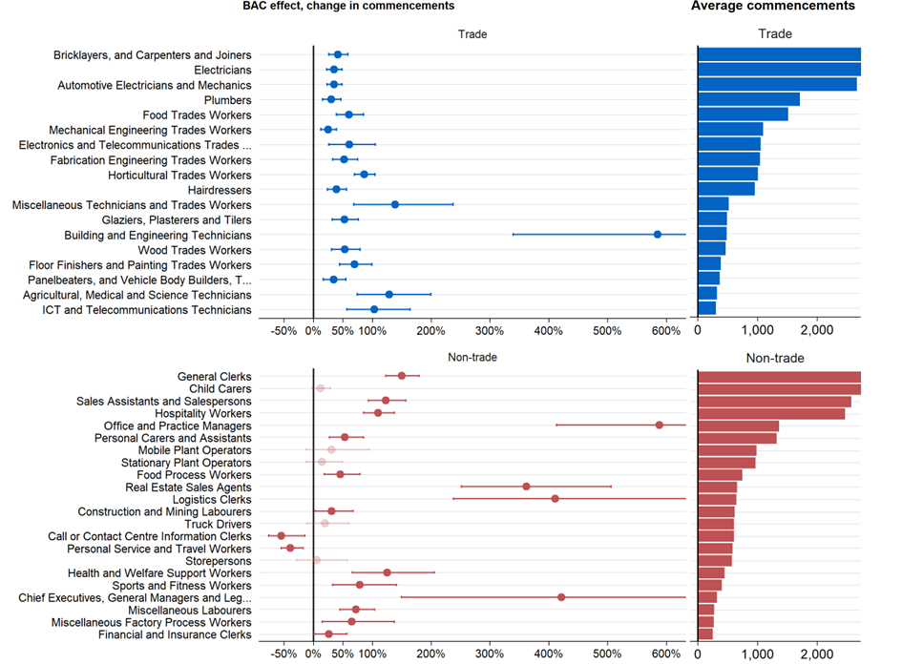

Source: Treasury modelling, see Appendix B for details.

## Effects by jurisdiction

Overall, the effect of the BAC program on commencements in individual states was broadly consistent with the national aggregate findings in terms of effects being sizeable and statistically significant, and greater for non-trades. There were, however, some apparent differences to the aggregate findings at the state level. Again, the following results should be treated with some caution given the smaller sample sizes for some jurisdictions.[8]

* Trade commencements in New South Wales (NSW) saw a muted effect during the middle periods of the BAC program. Non-trade commencements in NSW saw consistently higher growth than the national average during the BAC period.
* In the period immediately prior to the introduction of the BAC program, Victoria had significantly fewer commencements than expected. This indicates that the model is not completely capturing the effect of extended lockdowns in that state in Quarter 2 and Quarter 3 2020. This suggests the extended lockdowns in Victoria may actually bias our estimates downwards and so the true effects of BAC in Victoria in later periods may actually be larger than estimated.
* Non-trade commencements in South Australia were particularly high in the last two quarters of the BAC period, being 200-230 per cent higher than expected without BAC.

These results were estimated by repeating the model outlined in the ‘BAC’s effects on commencements’ section at the state trade/non-trade level.

### Western Australia as a quasi ‘control group’ for not experiencing COVID-19

A state of interest is Western Australia (WA), which was less affected by COVID-19 infections and restrictions, yet had the same access to the BAC and CAC programs as other jurisdictions.

Like the rest of Australia, economic activity in WA was interrupted by national restrictions in March 2020. But it saw strong and *relatively* consistent growth in hours worked in trade and non-trade occupations in the subsequent periods. However, WA was still affected by global supply constraints, state and international border closures, and by uncertainty that surrounded the COVID-19 pandemic.

BAC commencement effects in WA were consistent with the national average. Both trade and non-trade commencements were about 100 per cent higher than expected in the first quarter of BAC, then subsided (but were still positive and statistically significant) in the middle 5 quarters, before rising again at the end of the BAC period in 2022.

These WA results, combined with the relatively consistent patterns across the states, indicate that the positive effect the BAC program had on commencements was not a ‘COVID effect’ due to an individual state’s responses to the COVID-19 pandemic.

Figure 19: Comparison of commencements and forecasted commencements without BAC by state

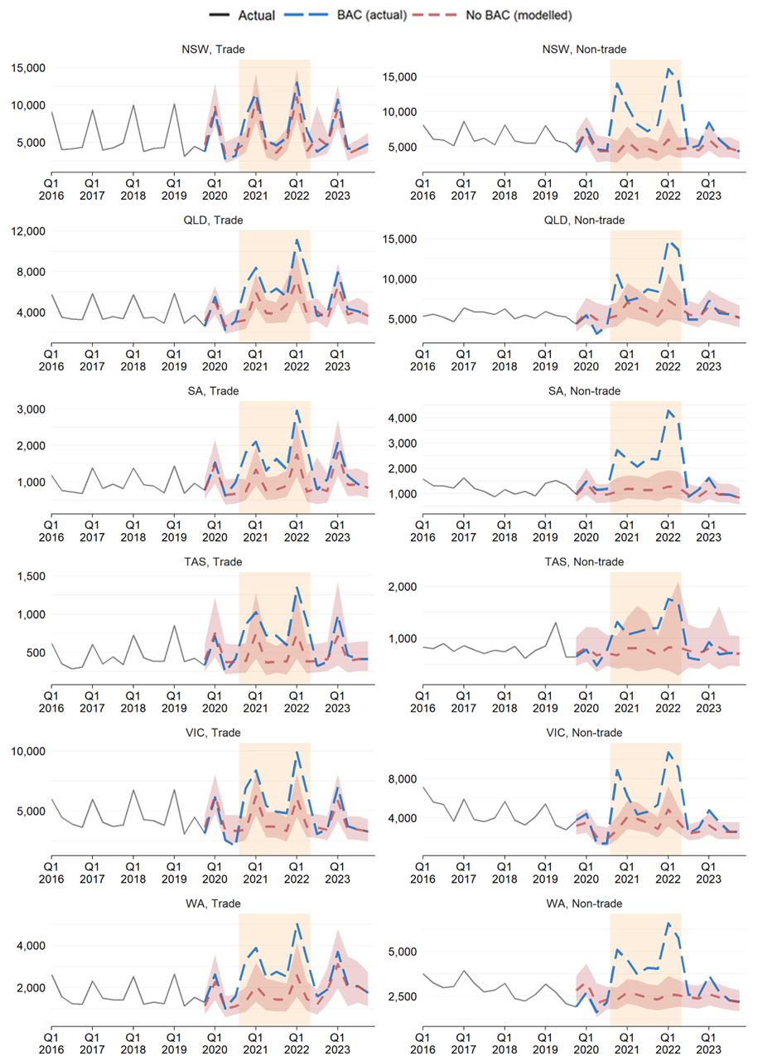

Source: Treasury modelling, see Appendix B for details.

# Appendix B: Technical note on econometric modelling

## Data

Most of the analysis in this evaluation used administrative data from the Department of Employment and Workplace Relations (DEWR). This data covers every Australian Apprenticeship from 2006-2023.

The econometric modelling was supplemented with data from the Australian Bureau of Statistics’ [*Labour Force Survey*](https://www.abs.gov.au/statistics/labour/employment-and-unemployment/labour-force-australia-detailed/latest-release)*,* Jobs and Skills Australia’s [Internet Vacancy Index (IVI)](https://www.jobsandskills.gov.au/data/internet-vacancy-index), and the [*NAB Monthly Business Survey*](https://business.nab.com.au/nab-monthly-business-survey-february-2024/) (ABS 2024; JSA 2024; NAB 2024). See the ‘Econometric model’ sub-section of the‘BAC’s effects on commencements’ section for more details on how this data is used.

The ‘Cost effectiveness’ section also used data from the Department of Employment and Workplace Relations on government spending on apprenticeships.

For analysis of priority occupations we used the [Australian Apprenticeships Priority List](https://www.dewr.gov.au/australian-apprenticeships/apprenticeship-support#toc-australian-apprenticeship-priority-list) (DEWR 2024b), which replaced the [National Skills Needs List](https://www.dewr.gov.au/skills-support-individuals/resources/appendix-b-list-nsnl-qualifications) (DEWR 2023b).

## Econometric model of apprenticeship commencements

A time series event study model was used to assess the effect of the BAC program on commencements. In broad terms, the model draws on historical data from 2006 to 2019. It then seeks to model the key drivers of commencements, namely:

* seasonality (there are always higher commencements in the first quarter of the year),
* policy changes in mid-2012, and
* several variables reflecting economic and labour market conditions.

The underlying theory supporting the choice of these economic variables is that commencements depend on employer demand. This, in turn, depends on economic and labour market conditions that affect business performance. When these conditions are strong and a business is going well, it is more likely to need additional staff, and more willing to make an investment to train an Australian Apprentice. The specific economic and labour market variables used in the model are:

* Hours actually worked by occupation and state
* Unemployment rates by occupation and state
* Vacancy levels by occupation and state
* Business confidence

### Model

For each quarter $q$ at event time $t$ ( $t=0$ at BAC introduction):

$$y_{tq} =α +\sum_{j≥-4}^{10}{δ_{j} I[t=j]}+βT_{tq} + \sum_{i=1}^{4}{γ_{i} I[q=i]} +ω X_{tq} +ε_{tq}$$

where:

* $y_{tq}$ is log apprenticeship commencements at time 𝑡.
* $δ_{j}$ are the coefficients of interest that give the effect of a quarter being during BAC (or just before or just after BAC), on commencements. Note that $I[t=j]$*is* a set of BAC variables for the 4 quarters before BAC, 7 quarters during BAC, and 4 quarters after BAC.
* $T_{tq}$ is a vector of time variables, including a linear time trend with a break at Quarter 2 2012 to reflect structural changes in non-trade commencements due to a policy change. Time dummy variables are also added for Quarter 2 2012, Quarter 2 2013 and Quarter 3 2013 to reflect sudden and temporary spikes in non-trade commencements.
* $I[q=i]$ is a set of variables to control for quarterly seasonal effects.
* $X_{tq}$ is a set of time-varying economic and labour market control variables detailed immediately below.

### State and occupation estimation

We also include commencements modelling results at the state and occupation level. These are calculated by running the model above on data that is specific to the state (for state results), or specific to the occupation (for occupation-level results).

### Data

The time-varying economic and labour market control variables are:

* **Hours actually worked** by occupation (ANZSCO unit) and state are sourced from Table *EQ08,* [*ABS LFS Detailed*](https://www.abs.gov.au/statistics/labour/employment-and-unemployment/labour-force-australia-detailed/latest-release) (ABS, 2024).
* **Unemployment rates** by occupation (ANZSCO major) and state are sourced from Table *UQB3,* [*ABS LFS Detailed*](https://www.abs.gov.au/statistics/labour/employment-and-unemployment/labour-force-australia-detailed/latest-release) (ABS, 2024).
* **Vacancy levels** by occupation (ANZSCO unit) and state are sourced from Jobs and Skills Australia’s [Internet Vacancy Index (IVI)](https://www.jobsandskills.gov.au/data/internet-vacancy-index), Table *ANZSCO4 Occupations, States and Territories* (JSA, 2024). JSA’s Internet Vacancy Index (IVI), largely made up of SEEK job ad data, is used as a measure of labour demand. The series contains job ad data by ANZSCO unit (4-digit) level and state which is aggregated up to the relevant occupation and geography level used in each model.
* **Business confidence** by industry (ANZSIC division) is sourced from the [NAB Monthly Business Survey](https://business.nab.com.au/nab-monthly-business-survey-february-2024/) which is provided to Treasury (NAB, 2024).

### Calculation of confidence intervals

For our econometric modelling, confidence intervals were calculated using bootstrapping. This approach to calculating confidence intervals avoids making restrictive assumptions about the distribution of the estimator for the parameter of interest. Note that this can result in confidence intervals not being symmetric around the point estimate because the distribution of the estimator is also allowed to not be symmetric.

### Discussion of causality

DEWR has conducted extensive research, including a literature review, of the factors driving Australian Apprenticeship commencements. The key factors are summarised in the table below.

Many of the identified factors are captured in the econometric model. For example, ‘Industry of occupation growing and positive outlook’ is captured by the hours worked by industry data included.

Many other factors are structural and only change slowly over time – this includes employer-side factors (for example, licensing requirements, or productivity of an apprentice) and apprentice-side factors (for example, sex, or socio-economic status). Since the BAC period was relatively short (less than 2 years) and there were no known dramatic changes in these factors during the BAC period, we did not attempt to add them to the econometric model.

This rationale for the econometric model also applies to the modelling of ‘cancellations’ immediately below, as well as the modelling of ‘progressed commencements’ discussed in Appendix D.

### **Summary of the drivers of apprenticeship commencements (prepared by DEWR)**

|  |  |  |
| --- | --- | --- |
| ****Employer vs Apprentice-side**** | ****Category**** | ****Factor**** |
| **Employer-side factors affecting the supply of apprenticeship places** | **Industry/occupation specific factors affecting employers**  (Nelms et al. 2017; Karmel 2017; Deloitte Access Economics 2020; Nechvoglod *et al*. 2009) | * Industry or occupation growing and positive outlook. * Occupation is licensed requiring an apprenticeship. * Desire to ‘give back to industry’. * Productivity of apprentice compared to apprentice wages deemed good. * Perceived benefit of future qualified worker to the business * Historical industry/employer experience with apprentices |
|  | **Other factors affecting employers**  (Deloitte Access Economics 2012; Deloitte Access Economics 2021) | * Incentive for trade apprentices (moderately effective) * Incentive for non-trade apprentices (highly effective) * Incentives timed to coincide with peak apprentice hiring period. * Incentive for existing worker apprentices (highly effective in non-trades, potentially subject to sharp practice) * Incentives to engage businesses new to apprenticeships (very low effectiveness) * Incentive for businesses already with apprentices to hire more (highly effective) |
| **Apprentice-side factors affecting the demand for apprenticeship places** | **Individual-level factors intrinsic to potential apprentices**  (Nelms et al. 2017; Karmel 2017; Deloitte Access Economics 2020; Dickie *et al*. 2011; Powers 2021) | * Interested in the occupation * Lower academic ability or left school before completing Year 12 * From an English-speaking background or First Nations * Likes ‘working with their hands’ or ‘outdoors’ * Male, younger * Likes idea of own business / independence (especially for trades) |
|  | **Environmental factors affecting potential apprentices**  (Nelms et al. 2017; Karmel 2017; Deloitte Access Economics 2021; Dickie *et al*. 2011; Powers 2021) | * Positive general views of apprenticeship occupations * Lower socio-economic status * Went to a government school * Non-metropolitan environment * Trade occupations in higher proportion in local community * Wage disparity compared to other workers deemed a ‘fair trade’ * Apprentice incentives (moderately effective) |

## Econometric model of individual-level cancellations

The model for individual-level cancellations estimated the probability of cancellation (interpreted as the cancellation rate) using a probit model. It also drew on historical data from 2006 to 2019.

### Model

The cancellation of an individual apprenticeship, $c_{i}$ , is described with a probit model:

$$c_{i}=Φ (α+δ{\text{BAC}}_{t}×{\text{trade}}_{o}+\sum_{j=1}^{4}{γ_{j} I\left[q=j\right]}+ωX_{i}+βE_{t,o,s}+ε_{i})$$

where, for commencing cohort $t$ in occupation $o$ and state $s$:

* $c_{i}$ is the probability of cancellation for an individual
* ${BAC}_{t}$: indicates whether the Australian Apprenticeship was commenced during the BAC period.
* ${trade}_{o}$:  indicates whether the Australian Apprenticeship was in a trade or non-trade occupation.
* $X_{i}$: a set of time-invariant demographic variables: sex, age (and age squared), Indigenous status, born in Australia, English spoken at home, and self-assessed disability status; as well as apprentice-level industry fixed effects.
* $E_{t,o,s}$:  are time-variant labour market variables, including unemployment rate by major occupation and state and job vacancy rate by detailed occupation level and state. These variables are entered both at the time of commencement and 4 quarters later to allow for economic conditions later in the apprenticeship to affect cancellation behaviour.
* $I[q=i]$ is a set of variables to control for quarterly seasonal effects in cancellation rates.

### Data

First, we calculated the 6-quarter cancellation rate for all commencements between Quarter 1 2006 and Quarter 2 2022. We then added this data to the commencements dataset used for the commencements modelling (and outlined above). Apprentice demographic characteristics are also added.

Labour market variables are added four quarters after the commencement date to allow for labour market conditions after commencement to affect the cancellation rate.

# Appendix C: Australian Apprentice and employer characteristics—additional results

This appendix provides further comparison of the demographic characteristics of Australian Apprentices who commenced prior to, and during, the BAC program. It also looks at changes in commencements by industry.

Three calendar years are compared: 2019 (pre-BAC), 2021 (during BAC) and 2023 (post-BAC). Full calendar years are analysed rather than the exact BAC period to avoid seasonality effects. This comparison does not distinguish between demographic changes attributable to BAC and those attributable to the pandemic or other trends at the time, so results cannot be interpreted as the causal effect of the BAC program.

## Further demographic analysis of BAC Australian Apprentices

The share of **female commencements** appeared to increase between 2019 (pre-BAC) and 2021 (during BAC) (Figure 20). However, there was already a modest upwards trend in the share of female commencements that continued until 2023. Consequently, it is unclear whether there was just a continuation of an underlying trend that was unaffected by BAC (and the pandemic).

Figure 20: Share of apprenticeship commencements that are female

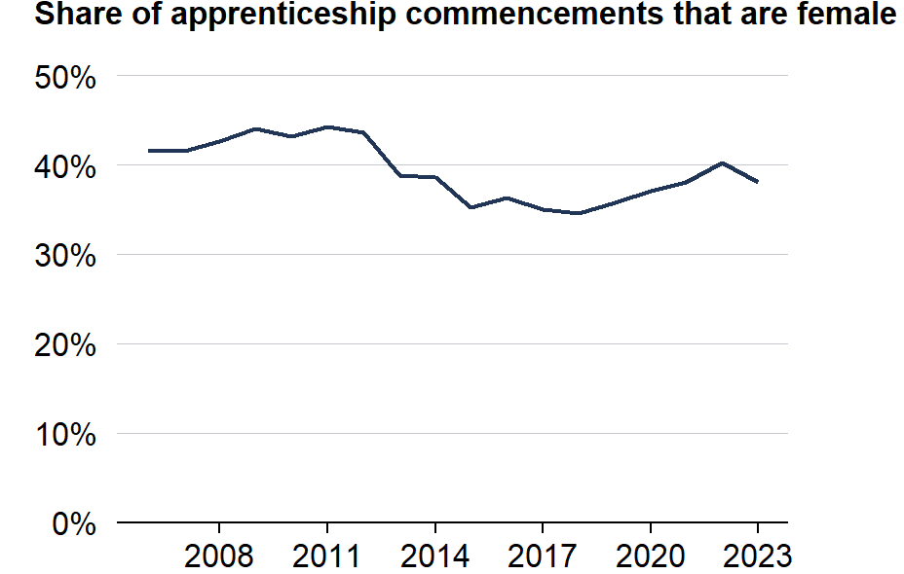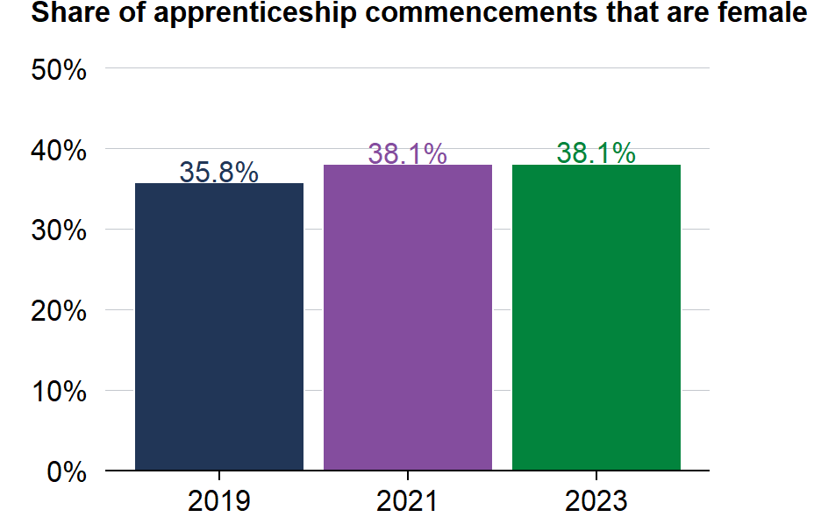

Source: DEWR administrative data 2006-2023.

The share of Australian Apprenticeship commencements that were **living with a disability** grew fairly steadily from 2006 to 2017 (Figure 21). The share of commencements stabilised for the next 4 years but then continued to increase in 2022. These changes do not neatly coincide with the timing of the BAC program or the pandemic so it is unclear to what extent they can be attributed to the BAC.

The share of Australian Apprenticeship commencements that had a **non-English language spoken at home** has declined in most years since its peak in 2016 (Figure 22). This decline was arrested in 2020 and 2021, before continuing subsequently. It is possible that the BAC (or pandemic-related effects) interrupted this decline, or it may be that the various fluctuations were due to other factors.

The share of Australian Apprenticeship commencements who were **born in a non-English speaking country** experienced a spike during the BAC/pandemic period (2021-22), and then a decline subsequently (Figure 23). Given the coincidence in timing, it is possible the increased share was due to some combination of the BAC and pandemic-related factors.

Figure 21: Share of apprenticeship commencements with a disability

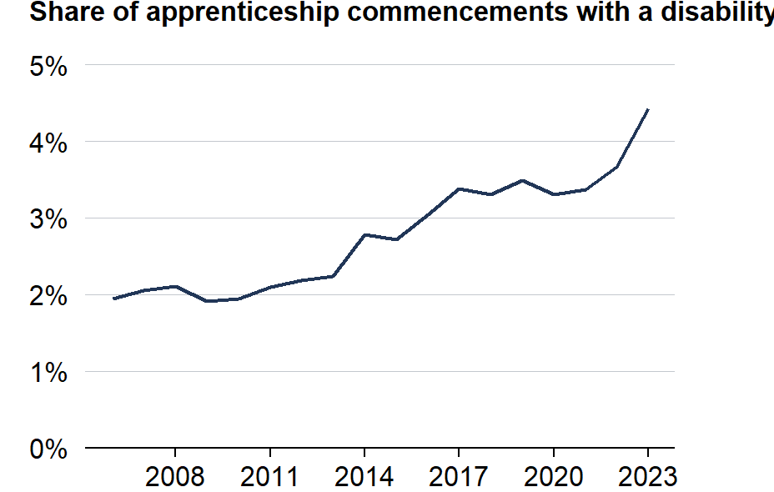

Source: DEWR administrative data 2006-2023.

Figure 22: Share of apprenticeship commencements with a non-English language spoken at home

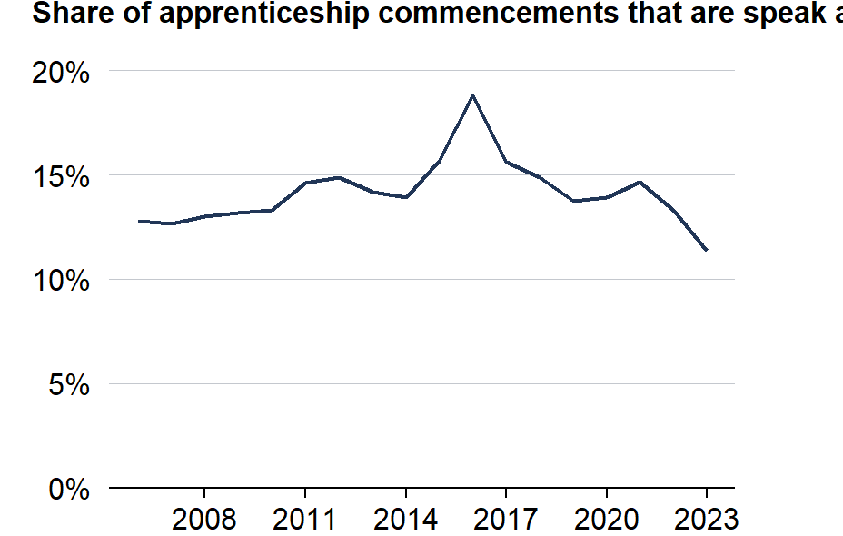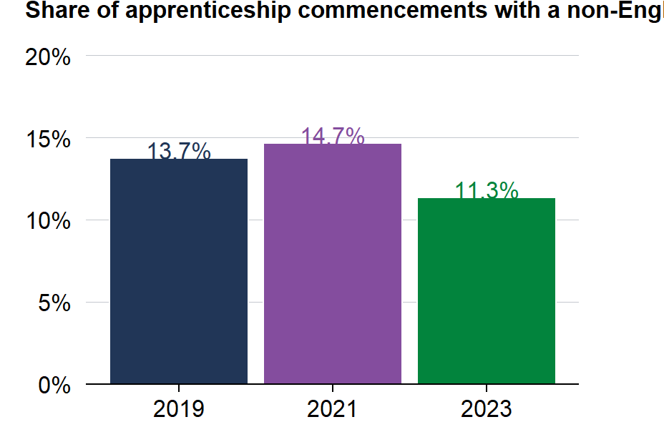

Source: DEWR administrative data 2006-2023.

Figure 23: Share of apprenticeship commencements who were born in a non-English speaking country

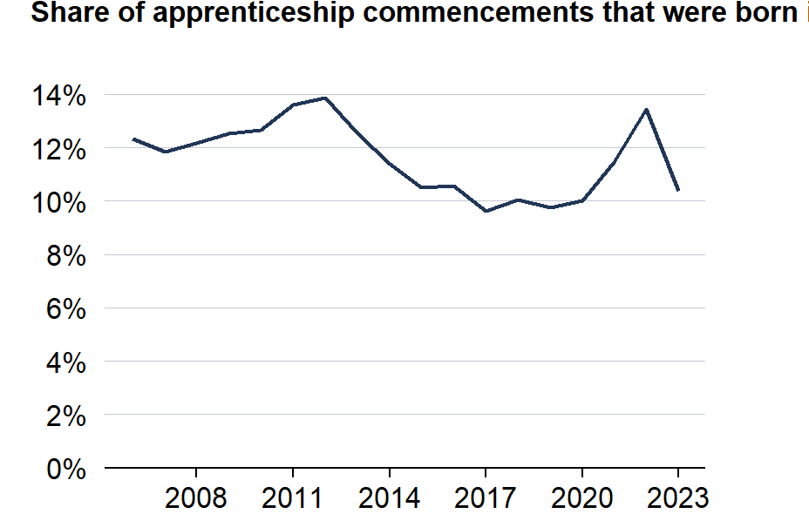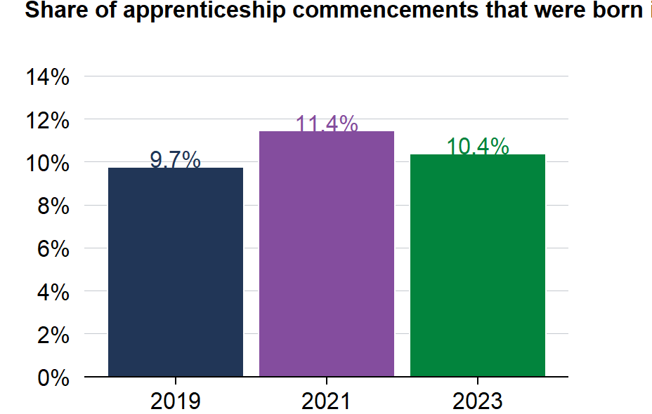

Source: DEWR administrative data 2006-2023.

Note: Non-English-speaking country is defined according to the countries not listed under the ABS standard classification of main English-speaking countries (United Kingdom, Ireland, United States of America, Canada, New Zealand, South Africa and Australia).

## Change in commencements by industry

Commencements in the BAC period grew across all industries (ANZSIC division) compared to the previous period.[9]

The Employers in *Construction* – the largest employer industry – commenced 66% more Australian Apprentices during the BAC period, increasing from about 8,000 per quarter to 13,000 per quarter during BAC (Figure 24). Employers in the next largest industries during the BAC period—*Accommodation and Food Services* and *Administrative and Support Services—*had increases of 92% and 37% respectively. These increases may be due to the BAC program but may also be due to pandemic-related factors.

Figure 24: Change in average apprenticeship commencements by industry per quarter

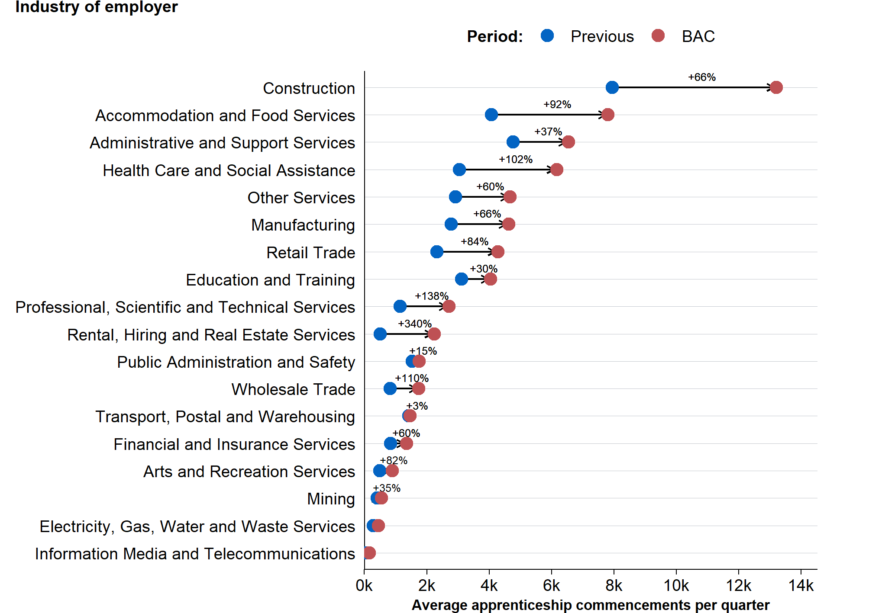

Source: DEWR administrative data 2006-2023.

Note:‘BAC’ period refers to Quarter 4 2020 to Quarter 2 2022. ‘Previous’ period refers to Quarter 4 2017 to Quarter 2 2019.

# Appendix D: Progressed commencements

While the discussion of completions in the body of the report focused on the retention *rate*, another important measure is the *number* of commencements that progress through their training without cancelling. We refer to this as ‘progressed commencements’ and define it as the number of commencing apprentices from a given quarter who have completed or are continuing their apprenticeship after 6 quarters (18 months). That is, the number of commencements who have not yet cancelled at the 6-quarter mark.

## Descriptive statistics of progressed commencements

While the total number of non-trade commencements during the BAC period were higher than trade commencements, the total number of *progressed commencements* were about the same across trades and non-trades (Figure 25). This is due to the fact apprentices who commenced a non-trade apprenticeship during the program were more likely to cancel.

Figure 25: Number of progressed commencements, by commencing quarter

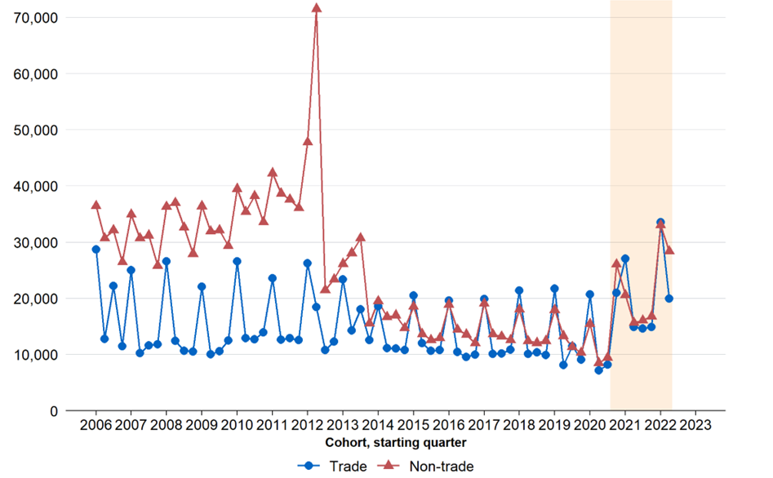

Source: DEWR administrative data 2006-2023.

## Econometric modelling of progressed commencements

### Econometric model

We model ‘progressed commencements’ using a similar time-series model to that used to model commencement numbers (see Appendix B).

This model has the same structure and variables as the commencements model. However, it adds labour market variables for 2-quarters and 5-quarters ahead to allow for changes in conditions, after commencement, that might affect cancellation behaviour. The dependent variable is the log of progressed commencements.

A ‘continuing rate’ variation of the model is also explored. This version adds the (log) number of commencements in a cohort to the model, turning its interpretation into ‘number of continuing apprenticeships for a given number of commencements’ (that is, the retention rate).

### Results

Figure 26 shows the number of progressed commencements in a particular quarter under both the BAC (actual) and non-BAC (counterfactual) scenarios.

As with the commencements modelling, both trade and non-trade *progressed* commencements were materially higher during the BAC period than would have been expected without the BAC program. However, unlike the commencements modelling, the results for trades and non-trades are more similar. This is due to the higher cancellation rates for trades.

Figure 26: Additional progressed commencements, by quarter of commencement

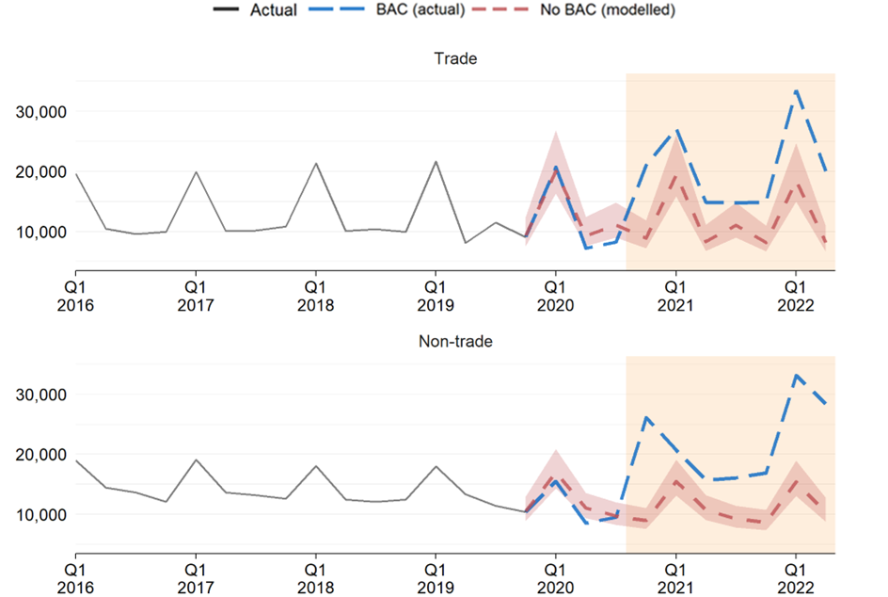

Source: Treasury modelling, see Appendix B for details.  
Note: These charts show number of commencements for a particular quarter who, 18 months later, had not cancelled their apprenticeship.

This model provides a proxy answer to the question of whether more commencing apprentices will complete their qualification. However, there are some inherent issues with this approach to keep in mind:

1. This model has a similar structure and variables as the commencements model however it differs in two ways: it estimates *progressed* commencements, rather than *total* commencements, and so it includes 2- and 5-quarter-ahead labour market variables. Consequently, the results from the two models are not directly comparable.
2. The model does not account for compositional change in commencement demographics. For example, the model does not adjust for the older age of BAC commencements.
3. The model does not account for compositional change in apprenticeship type (occupation, industry). For example, the model does not adjust for the shift towards non-trade occupations during BAC.
4. The model does not factor in changes in the number of people commencing apprenticeships in each quarter.

The compositional and commencement effects (point 2-4 above) are addressed by the individual-level probit model reported in the cancellations section.

# Appendix E: Review of previous evaluations of apprentice wage subsidy programs

This appendix summarises the findings from 4 previous evaluations of Australian apprentice wage subsidy programs.

|  |  |  |
| --- | --- | --- |
| Program | Program details | Key findings from previous evaluations |
| **Australian Apprenticeship Incentives Program (AAIP)** | **Program:** Payments made to employers, typically $1500 at commencement and $2500 at completion.  **Eligibility:** All apprentices and trainees.  **Timing:** Commenced in 1998. | **Deloitte Access Economics (2020) report found:**   * Commencements declined over the decade (from a peak of 330,000 in 2010-11 to around 155,000 in 2018-19), largely due to the withdrawal of incentives for existing workers in occupations not on the National Skills Needs List in 2012-13. * The drivers of commencements over 2010-2020 appeared to be specific to individual occupations and specific state and territory economic and policy changes. * Trade-based apprenticeship commencements had not grown with population and employment growth as they were largely stable over 2013/14-2018/19. * The implicit training subsidies arising from the AAIP were much higher for non-trade-based traineeships than trade-based apprenticeships because non-trade-based traineeships were of a much shorter duration. * Evidence of the effect of incentives on completion rates was mixed. |
| **Australian Apprenticeship Wage Subsidy (AAWS)** | **Program:** The wage subsidy was calibrated to 75% of the award wage in the first year, 50% in the second year and 25% for the third year (and no subsidy in the fourth year). For regional employers.  **Eligibility:** Only apprentices in occupations aligned to the National Skills Needs List (NSNL) were eligible.  **Timing:** Introduced as a trial measure in two phases over 2019.  **Cost:** Overall, $120 million in wage subsidies allocated and supported 2,715 new apprenticeships in 2,715 employers. | **Deloitte Access Economics (2022a) report found:**   * These 2,715 rural and regional apprenticeship commencements represented 13% of all rural and regional apprenticeship commencements in skills need occupations in 2019. * Total rural and regional apprentice commencements increased by 1.3% (523) over 2019. From 2015 to 2018, the number of commencements fluctuated around 41,000 but overall declined by 0.3% on average year-on-year. * Total participation by rural and regional employers increased by 2.0% (760) over 2019, after average year-on-year declines of 0.6% from 2015 to 2018. |
| **Supporting Apprentices and Trainees (SAT)**  The SAT wage subsidy was introduced as part of the Australian Government’s response to the COVID-19 pandemic. | **Program:** This wage subsidy was valued at 50% of apprentice wages to a maximum of $7,000 per quarter per apprentice. It supported small and medium sized employers retain existing apprentices and trainees, and re-hire apprentices displaced during the pandemic.  **Eligibility and timing:** For apprentices employed between 1 January 2020 and 31 March 2021.  **Cost:** Overall, $1.9 billion in wage subsidies was provided to nearly 75,000 employers supporting over 150,000 apprentices. | **Deloitte Access Economics (2022b) report found:**   * The number of employers participating in apprenticeships increased over 2020 (by 4%) and 2021 (by 16%), after year-on-year declines in the previous five years * Total apprentice volumes and continuing apprentice volumes increased over 2020 (by 4%) and 2021 (by 20%). This was driven by higher apprentice retention rates overall and for SAT apprentices. |
| **Wage subsidies provided through the Employment Pathway Fund (EPF)** | **Program:** Wage subsidies as an incentive to encourage employers to employ disadvantaged job seekers on an ongoing basis.  The paper uses DEWR and Centrelink administrative data to examine short term outcomes achieved by job seekers who received wage subsidy assistance through Job Services Australia (JSA) Stream services. | **DEWR (2012) evaluation found:**   * Approximately one quarter of Job Services Australia wage subsidy job seekers got a job that they would not have if not for the wage subsidy. * While around 15% of wage subsidy placements went to job seekers who would have found a job anyway, the money was used to provide the job seekers with better conditions. |

# References

ABS (Australian Bureau of Statistics) (2024) [*Labour Force Survey*](https://www.abs.gov.au/statistics/labour/employment-and-unemployment/labour-force-australia-detailed/latest-release), ABS, accessed 8 May 2024.

Deloitte Access Economics (2012) [*Econometric analysis of the Australian Apprenticeships Incentives Program*](https://www.voced.edu.au/content/ngv%3A64341), report to the Australian Government Department of Education, Employment and Workplace Relations.

Deloitte Access Economics (2020) *Australian Apprenticeship Incentices Review*, report to the National Skills Commission, Deloitte Access Economics.

Deloitte Access Economics (2021) *Apprentice Elasticity Review*, report to the Department of Education, Skills and Employment, Deloitte Access Economics.

Deloitte Access Economics (2022a) *Australian Apprenticeship Wage Subsidy (AAWS) Evaluation*, report to the Department of Employment and Workplace Relations.

Deloitte Access Economics (2022b) *Supporting Apprentices and Trainees (SAT) Evaluation*, report to the Department of Employment and Workplace Relations.

DEWR (Department of Employment and Workplace Relations) (2012) [*Employment Pathway Fund Evaluation Chapter 2: Wage Subsidies*](https://www.dewr.gov.au/employment-services-evaluations/resources/employment-pathway-fund-evaluation-chapter-2-wage-subsidies), DEWR, accessed 7 May 2022.

DEWR (Department of Employment and Workplace Relations) (2023a) [*Australian Apprenticeships Incentives Program Guidelines*](https://www.dewr.gov.au/skills-support-individuals/resources/australian-apprenticeships-incentives-program-guidelines), DEWR, accessed 20 May 2024.

DEWR (Department of Employment and Workplace Relations) (2023b) [*National Skills Needs List*](https://www.dewr.gov.au/skills-support-individuals/resources/appendix-b-list-nsnl-qualifications), ABS, accessed 13 May 2024.

DEWR (Department of Employment and Workplace Relations) (2024a) [*Strategic Review of the Australian Apprenticeship Incentive System*](https://www.dewr.gov.au/australian-apprenticeships/strategic-review-australian-apprenticeship-incentive-system), DEWR, accessed 8 May 2024.

DEWR (Department of Employment and Workplace Relations) (2024b) [*Australian Apprenticeship Priority List*](https://www.dewr.gov.au/australian-apprenticeships/apprenticeship-support#toc-australian-apprenticeship-priority-list), DEWR, accessed 13 May 2024.

Dickie M, McDonald R & Pedic F (2011), [*A fair deal: apprentices and their employers in NSW*](https://www.voced.edu.au/content/ngv%3A48917), New South Wales Board of Vocational Education and Training Integrated Research Report, Sydney.

JSA (Jobs and Skills Australia) (2024) [*Internet Vacancy Index*](https://www.jobsandskills.gov.au/data/internet-vacancy-index), JSA, accessed 8 May 2024.

Karmel T, [*Factors affecting apprenticeships and traineeships*](https://austreasury.sharepoint.com/sites/eval-function/eva/Apprenticeships%20review%20(BAC,%20CAC)/armel%20T,%20Factors%20affecting%20apprenticeships%20and%20traineeships,%20research%20commissioned%20by%20the%20Fair), research commissioned by the Fair Work Commission, Research Report 3/2017, Part II, February.

NAB (National Australia Bank) (2024) [*NAB Monthly Business Survey*](https://business.nab.com.au/nab-monthly-business-survey-february-2024/), NAB, accessed 8 May 2024.

NCVER (National Centre for Vocational Education Research) (2024) [*DataBuilder*](https://www.ncver.edu.au/research-and-statistics/data/databuilder), NCVER, accessed 16 July 2024.

Nechvoglod L, Karmel T and Saunders J (2009) [*The cost of training apprentices*](https://ncver.edu.au/research-and-statistics/publications/all-publications/the-cost-of-training-apprentices), NCVER, accessed 23 April 2024.

Nelms L, Yuen K, Pung A, Farooqui S & Walsh J (2017), [*Factors affecting apprenticeships and traineeships*](https://www.fwc.gov.au/documents/sites/wagereview2017/research/apprenticetrainee.pdf), Fair Work Commission, Research Report 3/2017, Part I, February.

Powers T (2020) [*Factors Lifting Apprenticeship Retention expectations (FLARe)*](https://www.voced.edu.au/content/ngv%3A88599#!), Monash University, accessed 23 April 2024.

Treasury (2023) [*Independent Evaluation of the JobKeeper Payment*](https://treasury.gov.au/publication/p2023-455038), Treasury, accessed 17 July 2024.

1. We define trades Australian Apprenticeships as those relating to ANZCO Major Group 3: Technicians and Trades Workers. Non-trades Australian Apprenticeships refer to all other ANZCO Major Groups.
2. These ‘cost effectiveness’ values represent how much government spending is required for an additional commencement or completion, and so can be used to, for example, compare the costs of increasing completions using a BAC style wage subsidy to the costs of increasing completions using alternative policy measures (for example, employee wage subsidies, apprentice mentoring programs, etc). This evaluation has not sought to identify such other policy measures and their costs.
3. Ranges refer to 95% confidence intervals. These were calculated using bootstrapping, which means the confidence interval is not always symmetric around the point estimate. See Appendix B for details.
4. ‘Federal government funding of Australian Apprentices per person in-training’ calculated by taking the total federal government expenditure in the Australian Apprenticeships Incentives Program (AAIP) for each financial year and dividing by the number of Australian Apprenticeships in-training in the middle of the financial year (31 December). Note this AAIP funding is largely employer subsidies. For example, in the year prior to BAC it was 99.0% employer subsidies, 0.3% subsidies for apprentices, and 0.8% for a mentoring and tutorial program.
5. For the purposes of determining eligibility for apprenticeship incentives, including the BAC program, an ‘existing worker’ was defined as a person who had been employed for 3 months full-time, or 12-months casual or part-time. (This is the way full-time equivalence is calculated for these employees.) Therefore, casual and part-time staff who had joined, for example 11 months ago, were not subject to the revised eligibility criteria for existing workers.
6. Occupations discussed in this section refer to the following ANZSCO minor codes: carpenters (331), electricians (341), automotive electricians (321), hairdressers (391), wood trades workers (394), plumbers (334), mechanical engineers (323), panel beaters (324), food trades workers (351).
7. Occupations discussed in this section refer to the following ANZSCO minor codes: clerks (531), salespersons (621), hospitality workers (431), personal carers (423), child carers (421), office managers (512), food process workers (831), personal service and travel workers (451).
8. Results are not reported for the Australian Capital Territory or the Northern Territory due to small sample sizes.
9. The ‘BAC period’ refers to the 7 quarters between Quarter 4 2020 to Quarter 2 2022. The ‘previous period’ refers to the 7 quarters between Quarter 4 2017 to Quarter 2 2019.