

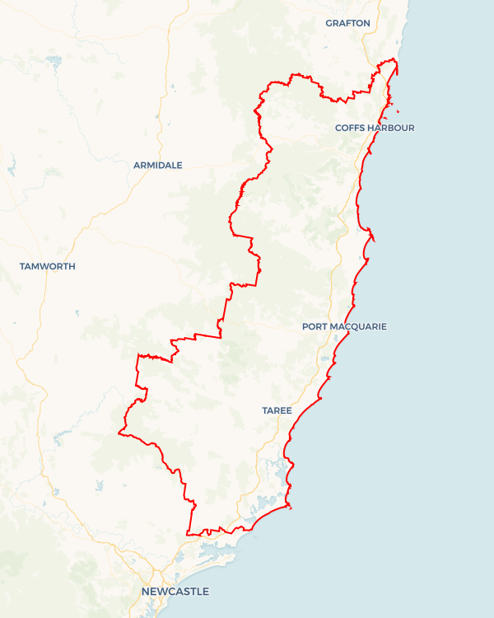Local Jobs Plan

Mid North Coast ****Employment Region**** | NSW | ****January 2023****

Workforce Australia Local Jobs (Local Jobs) is a program that supports tailored approaches to accelerate   
reskilling, upskilling and employment pathways in response to current and emerging local workforce needs.

## Local Jobs elements

### Local Jobs Plan

The Local Jobs Plan sets out the skills and employment challenges and priorities of the region, and associated strategies that will drive the design and implementation of activities to be implemented to address these challenges.

### Employment Facilitators

Employment Facilitators and Support Officers support the delivery of the program by bringing together key stakeholders including businesses, employment services providers, higher education and training organisations.

### Local Jobs and Skills Taskforce

Each Employment Region has its own Taskforce. Representatives include local stakeholders who have demonstrated experience in upskilling, reskilling, and an ability to represent, connect and collaborate with others in the region to meet labour market needs.

### Local Recovery and National Priority Funds

The Local Recovery Fund supports projects that meet the priorities identified in the Local Jobs Plan. The National Priority Fund provides funding for innovative local solutions to address structural barriers to employment.

Explore labour market insights for the  
[Mid North Coast](https://www.jobsandskills.gov.au/work/employment-region-dashboards-and-profiles/monthly-labour-market-dashboards) Employment Region

## Local labour market challenges in the region

* There are known issues in securing adequately skilled workers in growth and demand sectors with accessible entry level work. For example: aged care, disability, tourism, construction, and manufacturing. Prior to   
  COVID-19, there was industry reliance on migrant and backpacker labour to fill roles, with the region still observing labour market shortages across these sectors.
* The region holds structurally high unemployment in specific locations including Nambucca, Kempsey, and Taree.
* There are high levels of disengagement among young people with this cohort experiencing ongoing difficulties in securing long term employment.
* The region has a high level of unemployment among Indigenous Australians and mature aged individuals with these cohorts facing unique labour market disadvantages.
* Housing availability and affordability make it challenging to attract and retain workers in the region with a rising rate of homelessness being experienced among individuals in the region.
* Transport is an ongoing issue within the region with individuals limited by poor or no available transport options particularly in towns outside the main centres.
* The region has had significant impacts from natural disasters since 2019, including drought, bushfires and flooding with the region still recovering.

## Local jobs and skills priorities and strategies in the region

### Priority 1 – Disengaged youth

#### What are our challenges and opportunities?

#### The Mid North Coast Employment Region is characterised by significant youth unemployment and comparatively higher levels of youth disengagement.

#### How are we responding?

* Leveraging locally available youth services, programs and initiatives to effectively inform and contribute to the streamlined design of training and employment pathways to address local labour market needs.
* Building awareness of the long-term career opportunities available within the region.
* Designing and delivering industry-specific programs and projects to support young people to engage with and develop the required capabilities to take up apprenticeship and traineeship opportunities including entrepreneurship.
* Engaging with business, industry and government to develop best-practice strategies to engage and retain youth.
* Building collaborative employment and training solutions that align to growth industries such as health care and social assistance, retail, hospitality, construction, manufacturing, accommodation and tourism services.

### Priority 2 – Mature aged participants

#### What are our challenges and opportunities?

#### The Mid North Coast Employment Region has an ageing population that is reflected in a high number of mature aged participants. This cohort experiences unique labour market disadvantages.

#### How are we responding?

* Working with businesses to create streamlined access to employment opportunities for mature aged participants.
* Working with Employment Service Providers including the Career Transition Assistance program to provide access to training and up-skilling for participants to enter and/or re-enter the labour market.
* Building labour market awareness around mature aged participants while working to unpack the perceived issues of hiring this cohort within the local labour market. This includes the promotion of best practice strategies.
* Identifying industries of opportunity such as the health care sector, aged and disability care and accommodation and tourism sectors that value the life experiences and skill sets of this cohort.

### Priority 3 – Employment participation for Indigenous Australians

#### What are our challenges and opportunities?

#### Increase the inclusion of Indigenous Australian participants within the local labour market and support equitable access to training and employment pathways.

#### How are we responding?

* Working collaboratively with community, Aboriginal Assemblies, Local Aboriginal Lands Councils and Indigenous organisations to create meaningful employment opportunities in areas that have significance for Indigenous Australians.
* Facilitating the development and delivery of business bespoke training and recruitment pathways that draw on the full range of available programs and services supporting Indigenous Australians.
* Building awareness and promoting the benefits of workforce diversity and the range of available resources (i.e., government and community) which are available to businesses to support the recruitment and retention of Indigenous Australians.
* Utilising existing working groups and industry groups to minimise duplication but provide workforce development and industry activation for Indigenous Australians.
* Leveraging existing funding and initiatives across the region including the Smart and Skilled Funding and Indigenous Skills and Employment Program.
* Ensuring that all projects submitted to the Local Recovery Fund or similar through the Taskforce consider issues of access and prioritisation for Indigenous Australians.

### Priority 4 – Support Culturally and Linguistically Diverse (CALD) participants to be work ready

#### What are our challenges and opportunities? The CALD cohort face additional challenges in securing work due to low language, literacy or numeracy skills, and/or barriers to the recognition of overseas skills and qualifications.

#### How are we responding?

* Working with Employment Service Providers, government and training organisations to create education, training and employment opportunities for this cohort, including use of the Skills for Education and Employment program and the Adult Migrant English program.
* Facilitating the development and delivery of bespoke training and recruitment pathways including entrepreneurship avenues, drawing on the Self-Employment Assistance program and the local Entrepreneurship Facilitator.
* Working with business and local industry particularly in the Coffs Harbour area where there are higher cohort numbers.
* Building awareness and promoting the benefits of workforce diversity and the range of available resources (i.e., government and not-for-profit) which are available to businesses to support the recruitment and retention of culturally and linguistically diverse individuals.
* Addressing labour market demand in industries such as agriculture, food services, manufacturing and meat processing that have seen success in the take up of entry level roles by culturally and linguistically diverse individuals.
* Leveraging existing programs and groups within the region to provide holistic support to assist individuals to successfully enter sustainable and long-term careers.

## Want to know more?

* Contact: Sonny Neale Mid North Coast Employment Facilitator: [MidNorthCoastNSW.AGEF@dewr.gov.au](mailto:MidNorthCoastNSW.AGEF@dewr.gov.au)
* Visit: [Local Jobs](https://www.dewr.gov.au/local-jobs) or [Workforce Australia](https://www.workforceaustralia.gov.au/)