

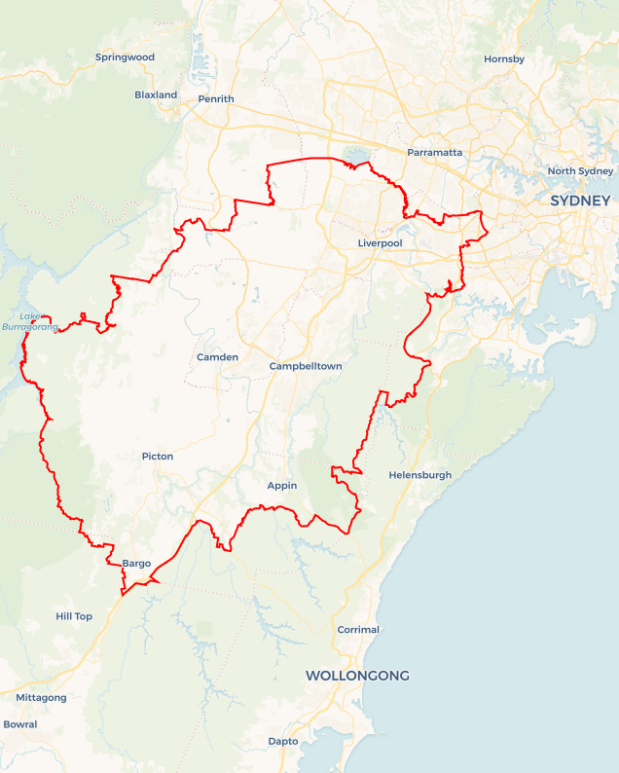Local Jobs Plan

Sydney South West ****Employment Region**** | NSW | March 2025

Workforce Australia Local Jobs (Local Jobs) is a program that supports tailored approaches to accelerate   
reskilling, upskilling and employment pathways in response to current and emerging local workforce needs.

## Local Jobs elements

### Local Jobs Plan

The Local Jobs Plan sets out the skills and employment challenges and priorities of the region, and associated strategies that will drive the design and implementation of activities to be implemented to address these challenges.

### Job Coordinators

Job Coordinators and Support Officers support the delivery of the program by bringing together key stakeholders including businesses, employment services providers, higher education and training organisations.

### Local Jobs and Skills Taskforce

Each Employment Region has its own Taskforce. Representatives include local stakeholders who have demonstrated experience in upskilling, reskilling, and an ability to represent, connect and collaborate with others in the region to meet labour market needs.

### Program Funds

The Employment Region’s Local Initiatives Fund enables targeted local investments that support local labour market functioning. Further, from 2025/26, a central grants-based fund will respond to local needs and help progress broader employment service reform objectives.

Explore labour market insights for   
[Sydney South West](https://www.jobsandskills.gov.au/data/employment-region-dashboards-and-profiles/monthly-labour-market-dashboards) Employment Region

## Local labour market challenges in the region

* High levels of unmet demand for entry level workers in growth employment areas such as construction, hospitality, retail, warehousing and logistics and aged and disability care.
* Known and predicted skills gaps in high value sectors with projected growth, including construction (especially engineering and project management), advanced manufacturing, scientific and technical services, health care and tertiary education.
* Young people, migrants, refugees and other individuals in the region may face barriers to employment related to limited qualifications, generational unemployment, language challenges and difficulty having overseas qualifications recognised. Additionally, those from low-income backgrounds may encounter systemic inequalities and discrimination.
* Fragmented awareness and delivery mechanisms for the range of available skills training and employment support options designed to aid economic recovery resulting in potentially diminished access and benefit for locals and businesses.
* Transport related barriers including a lack of transport options aligning to the demands of shift work and a high volume of people without a driver's licence and/or without suitable transport.
* The requirement for pre-employment checks in various sectors to qualify for roles.

## Local jobs and skills priorities and strategies in the region

### Priority 1 – Skills shortages and priority industries

#### What are our challenges and opportunities?

#### The region has a strong labour market demand in health care and social assistance, retail trade, hospitality, construction and education and training. Knowledge of and access to the range of available training options and pathways to reskill or upskill for available local jobs is not always sufficiently clear and coherent to optimise outcomes for individuals and businesses. There is opportunity to meet the needs of businesses by engaging people into pathways to develop skills and attributes required to ensure sustainable employment.

#### How are we responding?

### Coordinating a range of training options – including full qualifications, short courses and/or micro-credentialing – directly linked to current labour demand, to provide individuals with a single, streamlined pathway to upskilling and reskilling options and information.

### Developing and implementing overarching industry-specific recruitment models in areas of regional skills shortages – such as health care and social assistance – to expedite and increase connection and collaboration, as tailored to individual business needs.

### Supporting local individuals and businesses to build entrepreneurial capability and innovate, positioning individuals to respond to new and emerging economic opportunities in the region.

### Sourcing programs that encompass development of soft skills and business-specific training to prepare and support individuals into sustainable employment.

### Priority 2 – Infrastructure Projects

#### What are our challenges and opportunities?

As the region’s infrastructure expands with numerous infrastructure projects currently underway or planned, there is a growing demand for skilled and unskilled workers to support continued economic development. This includes construction of the Western Sydney Airport and development of the surrounding Aerotropolis precinct as part of the Western Sydney City Deal, in addition to the Sydney Metro Corporate Plan and net zero initiatives. There is opportunity to effectively address the skills shortage in current and future infrastructure projects and meet the recruitment needs of employers during the construction and operational phases.

#### How are we responding?

* Collaborating with project stakeholders to creating employment pathways to infrastructure projects.
* Providing solutions that support access to opportunities and reduce current, known barriers including transport. We are organising buses and driving lessons.
* Supporting employers to diversify their workforce by connecting them with individuals from a range of backgrounds – including culturally and linguistically diverse (CALD) individuals, First Nations peoples and women and youth – and leveraging traineeship and apprenticeship pathways.
* Building business capability by supporting businesses to confidently employ and retain individuals, ensuring education on the importance of strong post-placement supports and collaboration with local Workforce Australia Employment Service Providers (providers).

### Priority 3 – Migrants and Refugees

#### What are our challenges and opportunities?

#### As a major migrant and refugee settlement area, the region has a significant migrant, refugee and CALD population who require specialised, tailored assistance to facilitate a smooth transition into the local workforce. The local government areas of Fairfield and Liverpool have some of the highest concentrations of refugee resettlement nationally. There is opportunity to facilitate pathways that assist migrants and refugees to build the required skills and vocational language literacy, positioning individuals to move into available employment opportunities and/or supporting transition into trained professions.

#### How are we responding?

* Designing and delivering an employer-specific promotional campaign that highlights the benefits of workforce diversity and the range of available government and community resources to support the recruitment and retention of migrants and refugees, including the mature age cohort.
* Developing a register of potential collaboration opportunities with businesses and industries in high growth areas in the context of workforce diversity goals.
* Connecting individuals with available information and supports, including Self-Employment Assistance Information for CALD communities and the Skills for Education and Employment (SEE) Program.
* Facilitating the development and delivery of business bespoke training and recruitment pathways that draw on the full range of available programs and services supporting migrants and refugees.

### Priority 4 – Youth Unemployment

#### What are our challenges and opportunities?

The region faces significant youth unemployment, as combined with relatively high levels of youth disengagement from education and employment. There is opportunity to develop and implement local strategies to support youth to connect with education and training pathways linked to available jobs.

**How are we responding?**

* Developing a consolidated view of locally-available youth services, programs and initiatives to effectively inform the streamlined design of potential education, training and employment pathways that address local needs.
* Designing and delivering industry-specific preparatory programs to support young people to engage with and develop required capability, positioning individuals for employment or apprenticeship and traineeship opportunities in growth areas.
* Creating skills and career development pathways aligned with skills shortage areas and employment growth opportunities, including collaboration with apprenticeship providers to foster long term, sustainable employment outcomes.

### Priority 5 – First Nations and Closing the Gap

#### What are our challenges and opportunities?

The region faces a high incidence of unemployment of First Nations peoples, being disproportionately higher than the NSW and national unemployment rates. Opportunities exist to support greater inclusion of participants within the local labour market and provide more equitable access to skilling and employment pathways.

**How are we responding?**

* Developing a consolidated view of locally-available First Nations services, programs and Closing the Gap initiatives to effectively inform the streamlined design of potential education, training and employment pathways that address local needs.
* Designing and delivering industry-specific preparatory programs that support First Nations people to engage with and develop required capability and connecting with pathway programs, opportunities in growth areas and apprenticeships and traineeships.
* Connecting First Nations peoples with available information and supports, including the Skills for Education and Employment (SEE) Program: SEE First Nations.
* Supporting entrepreneurship by identifying opportunities and creating skills development pathways aligned with growth economies.

## Want to know more?

* Contact: Natalie Whitton, Sydney South West Job Coordinator: [Natalie.whitton@localjobsprogram.org.au](mailto:Natalie.whitton@localjobsprogram.org.au)
* Visit: [Local Jobs](https://www.dewr.gov.au/local-jobs) or [Workforce Australia](https://www.workforceaustralia.gov.au/)