

MANAGING

**WORKERS**

**COMPENSATION**

IN THE

COMMONWEALTH

# CHAIR’S FOREWORD



Helping people remain healthy and safe at work is good for workers, employers and the community.There are significant mutual benefits associated with preventing injuries and supporting workers to return to work as quickly as possible where a workplace injury or disease does occur.

That’s why I am pleased to share some of the successful initiatives recently trialled by member public service agencies of the Deputy Secretaries’ Working Group on Managing Workers Compensation in the Commonwealth (the working group).

The working group recently oversaw a number of projects aimed at improving injury prevention, early intervention, and rehabilitation and return to work outcomes. Member agencies designed and adopted solutions that suited their local circumstances by promoting organisational attitudinal and behavioural change. The enthusiasm with which the projects were embraced was very encouraging and the outcomes are equally as promising. I also expect the agencies involved will continue to benefit from improved workers compensation outcomes for some time into the future.

One of the most important lessons from the projects is about the value of non-legislative approaches to policy. While there is often a focus on legislative reform, the success of the projects shows that by changing internal practices employers can foster healthy workplaces, prevent injuries and illness, provide early assistance and support for injured and ill employees to help them recover as quickly as possible, and support their early return to work so that where possible, they can recover at work.

I strongly encourage Australian Pubic Service leaders to read this booklet and reflect on some of the practical and tested ways they can create healthy workplaces for staff and reduce workers compensation claims.



**Sandra Parker**

*Chair — Deputy Secretaries’ Working Group on Managing*

*Workers Compensation in the Commonwealth*

*Deputy Secretary, Workplace Relations and Economy*

*Strategy, Department of Employment*

# Overview

## Deputy Secretaries’ Working Group on Managing Workers Compensation in the Commonwealth

**The Deputy Secretaries’ Working Group on Managing Workers Compensation in the Commonwealth was established as a sub-committee of the Secretaries’ Board in 2014 to identify and promote ways that Australian Public Service (APS) agencies could improve their performance in injury prevention, early intervention, and rehabilitation and return to work. The ultimate aim was to reduce workers compensation premiums across the APS by improving work health and safety and rehabilitation outcomes for injured employees.**

Membership of the working group includes deputy secretaries (or equivalents) from the following

APS agencies:

* Australian Public Service Commission
* Australian Taxation Office
* Comcare
* Department of Agriculture and Water Resources
* Department of Employment
* Department of the Environment and Energy
* Department of Health
* Department of Human Services
* Department of Immigration and Border Protection
* Department of the Prime Minister and Cabinet
* Department of Social Services
* Department of Veterans Affairs.

## Pilot initiatives

Working group members commenced trialling a number of targeted pilots in 2014 aimed at improving

performance in injury prevention and return to work outcomes. The pilots covered the following initiatives:

* mandatory training on work health and safety (WHS) and early intervention
* better performance from rehabilitation providers
* excellence in case management
* identifying and remedying psychological hotspots
* identifying suitable duties for return to work
* early intervention
* re-examining long tail claims.

The Australian Public Service Commission (APSC) completed an evaluation of the pilots in June 2016

after they had been running for 12–18 months. The APSC concluded that while the pilot activities were not particularly unique, they achieved positive outcomes for the agencies involved. The findings showed that increasing the focus on injury prevention, rehabilitation processes and return to work has a measurable return on investment. Comcare data also showed that while the working group member agencies only represented 40 per cent of the total Comcare premium pool, together they accounted for 72 percent of the overall reduction in Comcare premiums from 2015–16 to 2016–17. Accordingly, the APSC recommended that initiatives like these pilots be adopted more broadly across the APS.

The aim of this booklet is to provide other APS agencies with information about the approach and early outcomes of a number of the pilot initiatives, and promote some simple yet effective measures that can be implemented to improve workers compensation performance and reduce premiums.

# COMCARE: Mandatory early intervention training for managers

## Background

**There was a significant increase in the costs of the Comcare scheme and an increase in APS workers compensation premiums over recent years. Equally, Comcare’s own workers compensation premiums continue to rise steadily.**

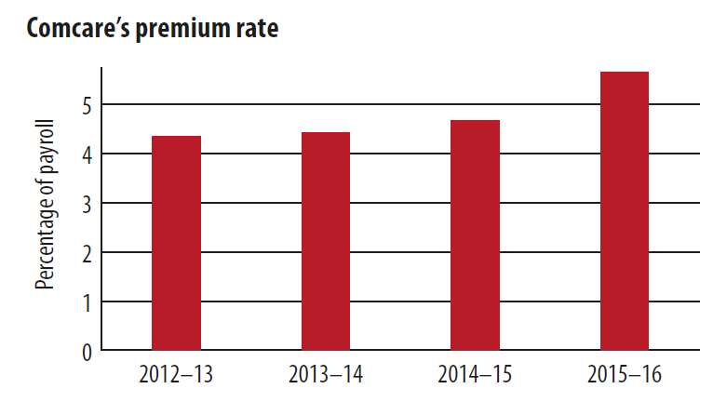

Whilst most agencies offer work health and safety training, it is not always mandatory and does not necessarily place sufficient emphasis on early intervention. The project anticipated that mandatory early intervention training would improve prevention, early detection and reporting of injuries and positively impact premiums.

## The project

Comcare developed the *Early Intervention for Managers* training program with input from key internal subject matter experts. As a first step, a test workshop was conducted with feedback being used to refine content before rolling out four pilot sessions. The feedback from the pilot sessions was encouraging, prompting Comcare to make the training mandatory for all of its managers. Key aims of the training included:

* building capacity of managers to identify the need for early intervention and respond in accordance with Comcare guidelines
* strengthening understanding of the need for managers and Rehabilitation Case Managers/People Team to work together to develop and implement solutions for supporting staff through injury and illness
* positively influencing rehabilitation outcomes through the understanding of effective implementation and local management of early intervention strategies
* positively influencing workplace culture, attendance and wellbeing through Comcare-wide use of early intervention strategies.

Over 2015–16, 72 percent of all Comcare managers completed the mandatory training. Development of the training course also aligned with the release of a new Early Intervention Program which formed part of the course content.

## Resourcing considerations

One additional staff member was engaged short term to assist with the project management and initial development of the training course. Ongoing training will be delivered by Comcare’s Learning and Development Team using existing resources.

## The outcome

Over the project evaluation period (April 2015– March 2016), Comcare experienced a significant

60 per cent reduction in the number of claims received and an 80 per cent reduction in the number of claims accepted in comparison to 2013–14. Comcare attributes this result in part to the renewed focus on early intervention and injury prevention.

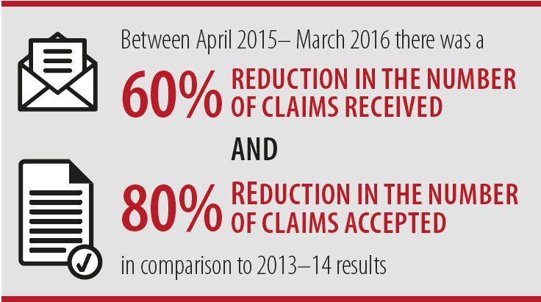

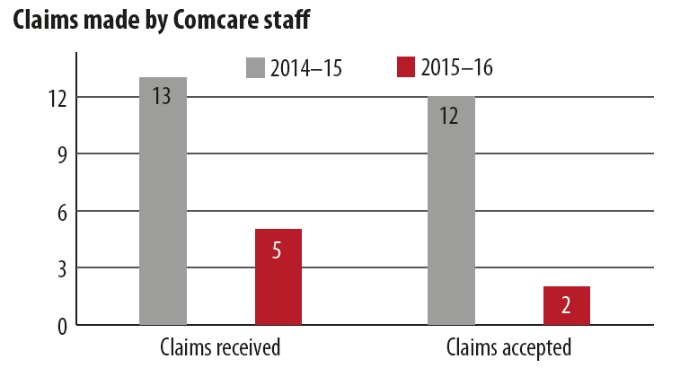

## Associated benefits

The training resulted in a positive reporting culture, which enabled Comcare to shift towards injury and illness prevention through early identification, instead of reactive methods such as through the workers compensation process for established injuries and illness. The training also improved staff capability by providing the following learning outcomes:

* identify the benefits of early intervention to both the individual and the organisation
* identify the warning signs of injury and illness
* explain the responsibilities of managers in relation to incident and injury reporting
* list the key messages for managers in responding to warning signs and reports of injury or illness
* describe a number of early intervention strategies that may be used to support staff through working
* collaboratively with the People Team
* demonstrate the ability to apply risk management principles to early intervention decision making.

The training course has also been altered to be delivered externally by Comcare’s Learning and

Development Team to other APS agencies so they may benefit from the program.

5

2

# Department of Employment: Actively managing long tail workers compensation claims

## Background

**In this pilot project, the Department of Employment reviewed its open workers compensation claims and began managing them actively.**

Two internal WHS staff reviewed all of the department’s 74 open claims, some dating back decades. The case managers undertook the review in addition to their usual work. Long tail claims reviews can be complex and some claimants were resistant to engaging with the review. The skills and experience of WHS personnel in building relationships were vital to the project’s success.

## The project

All cases were prioritised by expected future claims liability. The reviewers started by looking at ‘low cost claims’, which were often still open only due to administrative oversight. Within 12 months, 22 of these cases were closed. When a review was announced, some claimants with very low estimated claim costs (e.g. payment for one doctor’s visit per year) voluntarily exited the scheme rather than engage with a review.

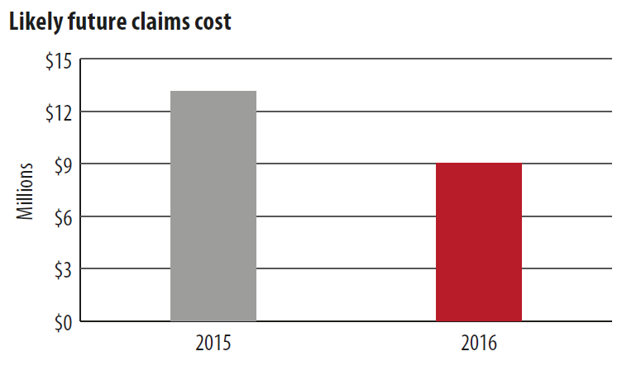

The circumstances of the remaining cases were investigated by examining case histories. The department placed claimants at the centre of the review, even if they were no longer employed by the department. Case managers used experience to predict where intervention was likely to lead to a good outcome and reviewed those cases first. WHS staff conducted case reviews in batches, writing to claimants to inform them of the process.

Where claimants responded, their cases were referred for an initial needs assessment by a Comcare approved workplace rehabilitation provider. Claimants who did not respond initially were more likely to resist the review process, often viewing it as cost-cutting only. The department persevered by arranging independent medical examiners to review claimants’ ability to undertake rehabilitation.

Rehabilitation took many forms, but included occupational therapy, training in new technology and short courses to help claimants develop their confidence in returning to work. Getting the right fit with a rehabilitation provider was vital as some external providers with competing KPIs were occasionally reluctant to take the necessary time to rehabilitate psychological injuries.

## Associated benefits

During the trial, rehabilitation costs per claimant spiked, which raised Comcare’s interest. Comcare also decided to review ongoing liability for a number of the cases and found that some claimants were no longer suffering their original condition. Comcare ceased these claims. In addition to the savings in decreased future liability, case and claims managers became more proactive in seeking the best outcomes for claimants, the department and Comcare.

## Lessons learned

1. Agencies undertaking case reviews of long tail claims would benefit by using dedicated staff as long tail reviews are labour-intensive and require patience.
2. Regular reviews prevent cases from ‘falling through the cracks’ and improve caseload management.
3. Case managers need to be aware that sometimes the gains made in rehabilitating psychological injuries will be very small—though very significant to the claimant.

## The outcomes

Progress to date includes closing 34 claims, 10 claimants returning to work, and expected future claims liabilities decreasing from $32 million in 2014 to $24 million in 2016.

# Department Of Employment: Effective use of rehabilitation providers project

## Background

**It is widely accepted that both employees and employers benefit from the quick recovery and return to work (RTW) of injured employees. For this reason, it is concerning that Comcare data shows the median incapacity period for accepted injury claims of premium payers has increased by 1.6 weeks over the last five years.**

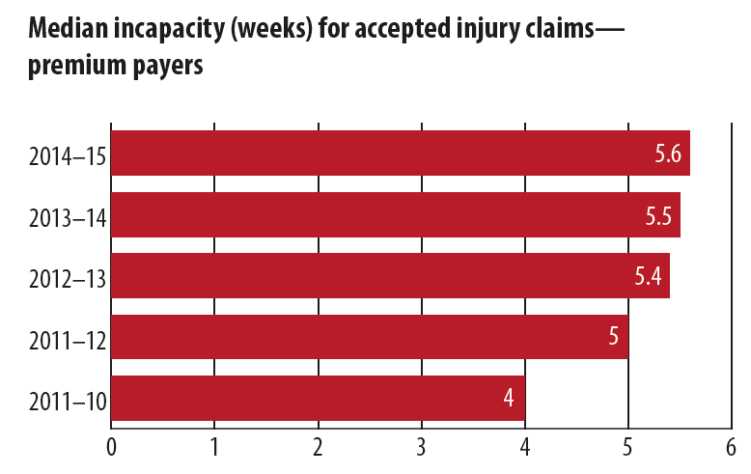

Where a workplace injury occurs and rehabilitation is required, an Approved Rehabilitation Provider (ARP) is engaged to work with the injured employee and relevant agency (usually represented by a rehabilitation case manager) to rehabilitate the employee and, where possible, return them to work as soon as possible. The expectation of the pilot project was that the recovery and return to work timeframes for injured workers could be improved by APS agencies working more closely with rehabilitation providers.

## The project

In this pilot the department developed a standard Service Level Agreement (SLA) to support better performance monitoring by case managers of ARPs. The SLA clearly outlines ARP responsibilities, accountabilities and key performance indicators (KPIs) and must be agreed to by the ARP before each engagement. The SLA stipulates that rehabilitation services will be subject to an evaluation process to inform future referrals. This is particularly important to assist the department to better evaluate the performance of the ARPs.

Departmental case managers were trained in how to best manage rehabilitation providers. For example, where

employee or employer needs were not being met or the ARP was not meeting SLA requirements, case managers were encouraged to communicate performance feedback with the ARP consultant directly and escalate concerns with the principal for immediate resolution where required. Where appropriate, case managers were also supported to manage the RTW process themselves rather than continuing to engage the services of an ARP.

## Resourcing considerations

The project was delivered using the existing resources of the HR section of the department. Case managers were provided with additional training on how to actively monitor the actions and outcomes of ARPs as part of their regular responsibilities. While the revised approach requires additional attention when engaging an ARP, over time the refined practices should ease pressures on case managers.

## The outcome

Early indications of the pilot suggest that improved governance arrangements will reduce incapacity timeframes and result in future cost savings. For example, where case managers deemed it appropriate, to remove the ARP and oversee the claimant’s return to work themselves, the department saved approximately $2,000–$3,000 per claim.

Additionally, as a direct result of the pilot, the department has now fully adopted the SLA to support improved accountability and performance of ARPs. The more active approach to managing ARP referrals is also consistent with obligations under the *Public Governance, Performance and Accountability Act 2013* to ensure the department is getting value for money.

## Associated benefits

This new approach has the added benefit of making managers and employees feel an increased sense of control in the rehabilitation process by effectively engaging them in the RTW process. The project has also resulted in the following benefits:

* a broader choice of potential rehabilitation providers following re-evaluation of the market
* case managers being more proactive in managing the activities, suitability and outcomes of rehabilitation providers
* quicker resolution of issues as case managers promptly share client experiences and feedback with rehabilitation providers
* greater feeling of control for injured employees and their managers through improved understanding of service expectations and stronger engagement in the quality assurance process.

# Department of Employment: Promoting psychologically healthy workplaces

## Background

**The number of accepted psychological injuries for APS employees is a concern for APS leaders.**

**Comcare data indicates that the incidence of accepted mental stress claims is significantly higher for premium payers than it is for self-insured licensees.**

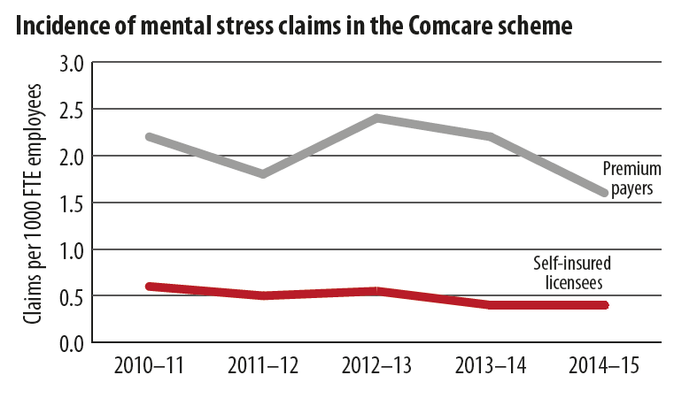

There is good evidence to suggest that the best strategy to reduce the incidence of psychological injury is to improve the psychosocial environment or psychosocial safety climate of a workplace. Evidence also suggests improving the psychological environment of a workplace is likely to result in lower rates of unscheduled absences.

## The project

The aim of this project was to improve the psychological health and wellbeing of employees and lower the risk of psychological injury by identifying areas of the department that would benefit from an increased level of support. Using 2015 APS Census results, the People Branch identified six branches within the department with poorer employee perceptions of the incidence and management of bullying and harassment. The People Branch then took a hands-on approach to working with relevant areas through the following actions:

1. Contacting Branch Managers to ensure an action plan was in place to address areas of concern.

2. Working closely with Branch Managers to establish a better understanding of the nature of the issue.

3. Conducting information sessions for managers and staff about:

• bullying and harassment

• having difficult performance related conversations

• code of conduct awareness; and

• working effectively in the APS.

A main focus of these information sessions was to encourage people to talk to their manager, the People Branch or an Equity and Diversity Officer early to lower the risk of psychological injury occurring.

4. Developing tip sheets designed to inform managers of ways to identify early warning signs for psychological injuries.

5. Holding follow-up sessions with managers on the importance of promoting a positive workplace culture.

## Resourcing considerations

While no additional resources were allocated, the project required a shift of effort and absorbed resources

equivalent to one fulltime senior HR officer.

## The outcome

Improved psychosocial safety climate is a leading indicator for workers compensation performance i.e. it reduces the risk of incidence of future mental stress claims. For this reason, the success of the project was measured against whether there had been any improvement in employee perceptions regarding how the department prioritises and manages employee psychological health wellbeing.

Data from the 2016 APS Census indicates that, for the branches involved in the trial, employee perceptions in relation to how the department manages and prioritises psychological health have improved. In particular, compared to 2015, levels of employee agreement with the following statements show encouraging results:

* ‘Information about workplace psychological wellbeing is always brought to my attention by my immediate supervisor’ – up 10 per cent on average
* ‘In my agency, employees are encouraged to become involved in psychological health matters’–up 8 per cent on average
* ‘SES act quickly to correct problems or issues that affect psychological health’ – up 7 per cent on average.

The census data also saw a decrease in the number of employees who believe they have either been the subject of or have witnessed bullying or harassment over the past 12 months. Compared to 2015, on average, 9 per cent fewer employees considered they had witnessed bullying or harassment in the workplace and 4 per cent fewer believed they had been subjected to bullying or harassment in the workplace.

## Other initiatives — supporting psychologically healthy workplaces

To support the success of the project, and as part of an ongoing commitment to improving the psychological health of employees, the department has also implemented the following initiatives:

* exploring behavioural economics approaches to improving psychological wellbeing
* establishing a panel of Employee Assistance Program (EAP) providers rather than using a single provider (this gives a broader range of service options and makes it easier for staff in regional areas to access help)
* providing new starters with pre-identified psychological issues with better information about

support services during the recruitment process

* trialling a positive attendance pilot aimed at empowering managers with early intervention strategies and reducing unscheduled absences.

# Department of Health: Acting fast and intervening early

## Background

**When choosing its pilot project, the Department of Health realised that 45 per cent of its claims were for body stress (musculoskeletal injuries). They also found that their average claims cost was $51,000, more than double the Commonwealth average of $24,000 for comparable injuries.**

## The project

The department identified work areas with a high incidence of injuries and/or high computer use. The pilot team selected the data entry, finance and payroll areas for intervention.

Participants were pre-surveyed on their pain symptoms and ergonomic equipment was provided to employees based on their results. The equipment rolled out for three months and included ergonomic mice and keyboards, sit/stand desks and dual screens. Participants were surveyed on pain again afterwards.

The pilot team next took advantage of an organisational restructure to streamline other ergonomic functions. It found the coordination of workstation assessments (WSAs) and ordering ergonomic equipment used six full-time equivalent (FTE) staff in administration units across the department. On average:

* WSAs were taking up to 3 weeks from request to provision
* ergonomic equipment was taking 5–7 weeks to arrive.

The WHS team centralised WSAs and equipment funding from each branch in the department to replace the WHS functions of the disbanded business admin units. The pilot team centralised the ergonomic equipment purchasing with standard suppliers, including a single national State Office supplier. It created a limited catalogue of approved ergonomic equipment for all complaint types. Stock is kept in the property store at all times for immediate deployment.

The WHS team replaced the six FTE admin staff with a full-time occupational therapist and a full-time exercise physiologist. These specialist staff were selected for their expertise and ability to find efficiencies in managing a large WSA program. They set up a single email address for WSA requests. The Ergo App, designed by the Department of Health and developed by the Department of Employment, later replaced this process.

The app coordinates input from the requesting staff member, assessor and the property team and manages the WSA process in real time. Employees can use it to request an assessment and attach supporting documentation like doctors’ certificates. As the assessor inputs information from a WSA, the app generates an immediate report, which is issued to the employee on the spot. The app also sends alerts to the property team when specialist equipment is needed. Use of the Ergo App has saved one hour per assessment. The pilot has greatly improved the turnaround times for WSAs and equipment. Where before the process could take up to

10 weeks from request to delivery of equipment, this has been reduced to five days.

The two person team conducted 900 WSAs between October 2015 and June 2016. To drive further efficiency,

the team has also:

* developed a ‘how to set up your desk’ video for the department’s intranet; and
* started group WSAs for up to 60 staff per week, where the WHS staff assist employees to set up dummy desks and write down settings, which the employees then take and apply at their desks.

## The outcomes

The WHS team is now central to all key WHS infrastructure changes. The team is consulted first prior to rolling out new IT equipment and furniture.

It has demonstrated increased benefits for staff in the department through early intervention. Work areas have embraced the new processes which in turn has saved them time, resources and money.

The department has created an environment where staff understand the equal value of prevention, rehabilitation and return to work.

## Associated benefits

The department also changed its approach to early intervention during the pilot. By intervening early in circumstances that would cause a claim, or when intervention on non-work injuries could lead to a mutually beneficial return on investment, the department has lowered its accepted claim rate dramatically:

* 2014 – 37 claims
* 2015 – 19 claims
* 2016 – 10 claims.

Taking on 72 early intervention cases in 2015–16 cost the department $50,000 but saved an estimated $19 million in Comcare costs.

# Department of Health: Excellence in case management

## Background

**When the pilot projects were designed, the Department of Health acknowledged it had a high premium and looked at the capabilities of its Rehabilitation Case Managers (RCMs) as one area for improvement.**

**The department has a workforce of approximately 5,500 staff with six RCMs, so having a high level of capability was critical to case management success.**

## The project

The department set about developing a recruitment framework, a capability gap analysis tool and a training program that could be used by any agency.

It engaged Communicorp to complete a capability and confidence gap analysis of their case managers and design a program to address their needs.

The department invested $80,000 on a comprehensive training plan. This included going back to basics, so as not to overlook the obvious. Other agencies were invited to attend some of the training sessions. Training included:

* SRC Act in a day
* Case Management Essentials
* CIS training
* WHS Act in a day
* Workplace Psychological Health Essentials
* Work Orientated Treatment Foundations for best practice work-focussed treatment of psychological injuries
* Managing Staff with Mental Health Concerns and Complex Personalities
* Fitness for Duty Workshop
* Invalidity training
* AAT proceedings
* Preparation of influential Employer Statements.

## The outcomes

This training was highly regarded and proved very successful for all participants. The biggest outcome from the training was all the RCMs being trained to write influential employer statements. These statements accompany Comcare claims, and set out the circumstances of the claim, any witness information and other relevant matters.

The training has also resulted in better resourcing for the claims process. Previously all statements were prepared by a legal expert in the WHS team. Now, RCMs have learned to gather the evidence and prepare the statement with minimal involvement of a lawyer, and witnesses can engage in the process with confidence and clarity.

Following the training, Comcare’s acceptance of claims from Department of Health employees has dropped by 95 per cent. Where claims are accepted, the thorough nature of the statements means that Comcare can reach decisions more quickly and accurately. Overall, the return on investment was significant. Not only did the Department of Health realise a 21 per cent reduction in its workers’ compensation premium, compared to a 7 per cent APS average, but the confidence and capability of case managers also improved considerably.

## Lessons learned

The department is committed to supporting capability development across the APS. It has developed an RCM role description for the APSC’s Integrated Leadership System (commonly known as the ILS), and created a document for use across the APS. The idea was to show the RCM role inside a universal capability framework, to generate greater understanding of its function. The department has shared the resource across the APS, receiving very positive feedback, in particular with smaller agencies with minimal HR resourcing.

The RCM framework is now available to all agencies. This includes a role description to be used during recruitment and performance assessments. As a result of this project, the RCM ILS means RCMs receive consistent feedback on their work performance and capability is growing across the APS.

## Resourcing considerations

The final capability improvement the department undertook was introducing systematic support for all case management staff. As case management can be stressful and emotionally taxing, the department engaged an organisational psychologist to debrief the team individually once a month. Staff can use the session to just download all the facts of the preceding month, to work through issues around them.

This costs about $15,000 annually for the eight people in the WHS team. Case managers all find the mandatory debriefings to be of great value. The department is committed to maintaining its capability by retaining and nurturing their staff.

# Department of Human Services: *Project Focus*: Long term claims review

The Department of Human Services’ *Project Focus* pilot began in September 2014. An intensive casemanagement model was used to manage long tailworkers compensation claims with two aims:

* facilitate recovery and return to work where possible
* reduce the department’s financial liability.

‘Long tail’ claims were defined as those open for more than two years. The claimants often have multiple barriers to return to work, complex and varied physical and/or psychological issues, and a long history of treatment and rehabilitation interventions with mixed success.

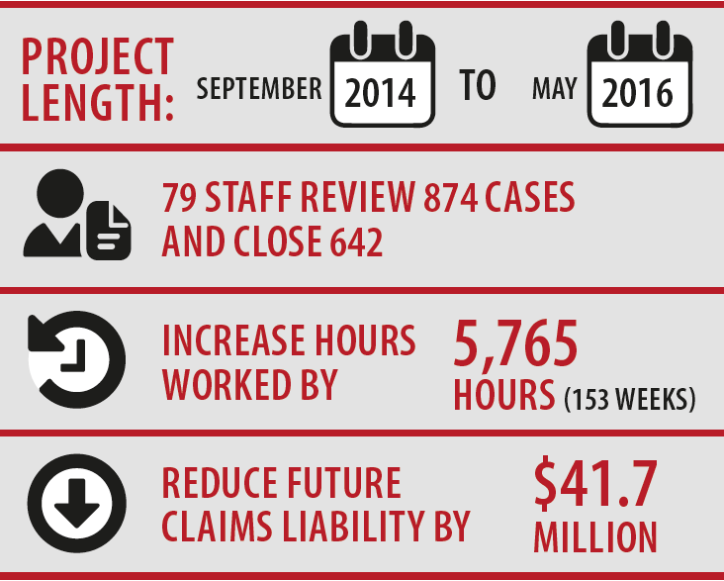

## The project

With the closure of CRS Australia, DHS had a unique opportunity to redeploy 79 experienced allied health professionals into the pilot project. The team used a multi-disciplinary approach and all of their available skills to handle case reviews. This was critical to delivering comprehensive rehabilitation and reducing liability.

**The project ran in two stages**

Stage One reviewed all open claims with injury dates between 2010–2012 to maximise the impact of return to work outcomes and because recent claims experience influences premium calculations.

Stage Two reviewed all open claims with a pre-2010 injury date. Initial case reviews followed the same pattern:

* a comprehensive handover from the previous rehabilitation case manager
* consultation with all case stakeholders
* a review of treatment efficacy and evidence based interventions
* a review of Comcare’s CIS information.

The project staff developed action plans, and prioritised claims where significant cost reductions were achievable or a return to work was possible with further rehabilitation and support. To maintain intensity, cases were reviewed fortnightly to monitor progress towards rehabilitation goals.

The ‘intensive case management model’ used active re-engagement of the injured worker through:

* regular face to face contact wherever possible for support, education and planning
* exploring other communication methods including email, telephone, talking points, fact sheets and video conferences
* frequent communication to clarify expectations, explore concerns, promote transparency and trust, identify achievable opportunities, and develop genuine commitment to the return to work process.

The team used psychosocial risk assessments to identify and address risks that would prevent a return to work. These included non-work related issues like co-morbid medical conditions or lifestyle, relationship to the department or reasons for entrenchment in the workers compensation system.

## The outcomes

The pilot team regularly liaised with Comcare, the workplace rehabilitation provider and others to ensure that current treatments were effective. They also maintained a link between treatments and interventions, and measured these against goals in the workplace or at home.

Development of a strong collaborative approach was fundamental to achieving successful rehabilitation case management outcomes. Starting from the perspective of *‘how can we work together?*, the team spent considerable time building and maintaining relationships with key stakeholders and the employee. Line managers were coached to develop supportive, positive and sustainable return to work environments.

At the end of the project, the department had reduced likely future costs for long tail claims by an estimated $41.7 million (comparing likely future costs in October 2014 and December 2015). This was a significant return on investment.

## Lessons learned

1. A multidisciplinary team approach can help identify new actions and opportunities to resolve long tail claims.
2. Periodic review of long tail cases, including invalidity retirement cases, can identify case management gaps and options to improve rehabilitation and liability outcomes.
3. Actively monitoring Workplace Rehabilitation Provider performance against service standards and endorsed action plans is critical to timely, appropriate and cost-effective return to work.

# Department of Prime Minister and Cabinet: Promoting psychologically healthy workplaces

## Background

Following machinery of government changes in 2013, the Department of the Prime Minister and Cabinet became the rehabilitation authority for an additional 300 workers compensation claims, 147 of which had likely future liabilities. Psychological injury was the causal mechanism for 29 per cent of the department’s active rehabilitation matters.

Prior to 2013, the department was managing only 19 cases and had no dedicated work health and safety (WHS) section. The existing system for managing workers compensation cases was inherently unable to respond to the increased caseload and complexity, the dispersed workforce and new risk profile. In response, the department transformed its operational framework for managing risks to its people.

## The project

Psychological risk was confirmed as a priority for targeted intervention and the psychological safety pilot was developed to identify and respond to at-risk work areas. Work areas at psychological risk were identified based on Executive feedback, analysis of injury mechanisms, prevalence of psychological conditions and APS census results.

Two categories of work areas were considered for the trial. Firstly, candidate work areas were selected for voluntary participation, where workers were performing risky work. To address this, a risk assessment and package of recommended controls was developed and implemented.

The second category included work areas where there appeared to be more at-risk workers. This intervention included: targeted training and workshops; coaching for managers; fact sheets; individual well-checks led by psychologists; directions to attend independent medical assessments, return to work and not to attend work; increased non-compensational case management; referral of matters for assessment for conduct investigation; increased evidence-based employer statements; and active and frequent case conferencing.

## The outcomes

The psychological safety pilot was part of a broader transformation project. This included transforming the department’s operational framework. As indicated in the table below, results are encouraging and the broader project has had a positive impact on future liabilities and claim numbers. Additionally, as a direct result of the psychological safety project, two workers returned to pre-injury hours and substantive roles. Anecdotally, the trial has also prevented the lodgement of a number of additional psychological claims.

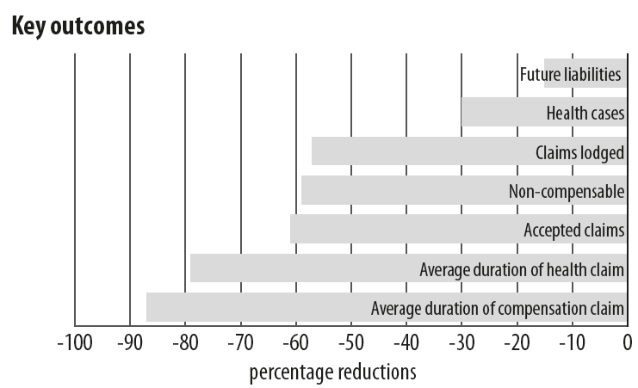

## Lessons learned

1. The department now has a balanced approach to managing safety (compassionate and compliance focused) and sustained, consistent, transparent, proportionate and responsive service delivery.

Achieving this required a full redesign of the department’s operational framework and rehabilitation management system—controlling psychological risk is merely one component of this system.

2. No case management initiative will be successful and produce measurable, sustained benefits if the operational framework is inherently unable to support delivery.

3. Start with the data—scope and understand a problem’s contributory factors and how success will be defined and measured. The work area accountable for delivery needs authority to act and capability across all required elements (people, processes, tools, technology, data and information management).

# Department of Social Services: Early intervention for musculoskeletal injuries

## Background

A trial project by the Department of Social Services (DSS) focused on the effectiveness of early intervention for musculoskeletal injuries by improving the department’s administrative response to injuries. The projects aims

were to:

* provide best practice training for new case management staff
* create cultural change in the organisation through education and training for managers
* increase awareness of activities of the Work Health and Safety (WHS) section within DSS
* incorporate sound case management processes and practices as business as usual.

## The project

A small team of three ran the pilot that used three approaches to meet the project aims.

1. The team developed a suite of templates and information guides for use by case managers.

The templates and guides allowed for a consistent approach to case management. They were designed to help case managers gather all of the facts about an injury and a potential claim at the very beginning of the process. When put into practice, the answers in the template supported the preparation of a workers compensation claim and/or allowed targeted early intervention.

2. The team created information packs for managers and employees explaining Comcare and DSS paperwork and procedures.

The information packs included explanatory documents, listed all the forms and information needed for participation in rehabilitation and case-management, and described their purpose. Comcare needs access to all relevant information and evidence about an injury to determine a claim. Since the pilot it has been able to make determinations earlier than previously because the templates allowed relevant facts and information to be gathered and provided.

3. Managers at the Executive and Senior Executive level were educated in how to respond to injuries and complete Comcare forms.

The reference document *A manager’s guide to prevention,* *early intervention and injury management responsibilities* was developed and disseminated. It provided relevant information, definitions and WHS team contact details. The pilot team approached all branches in the department and provided targeted support to some areas through group, branch or team-level information sessions.

In addition, branches were encouraged to look at their census results and respond to any concerns raised by staff. When early intervention was utilised, case managers informed Group Managers of the claimant’s progress throughout the intervention. When a compensation claim was submitted, Group Managers were responsible for meeting a KPI to ‘respond to a request for a factual management statement’ within five days.

## The outcome

Training has increased case manager confidence, and they are now more likely to initiate case conferences or take other actions to progress stalled claims processes.

Staff have become more sophisticated in their approach to managing claims, and have strengthened relationships with injured employees, their managers and Comcare claims managers. All injured employees have been provided with reasonable adjustments and suitable duties.

Early intervention is now a standard response to injuries, and the WHS team are now more likely to divert people into intervention, rather than immediately opening a compensation claim. The department funds early intervention through a corporate allocation, not line area budgets.

When the project began, senior department management took it seriously and established the five day KPI and funded a new Rehabilitation Management System. Both of these actions have had positive results. The department attributes the success of the early intervention pilot to these claims outcomes:

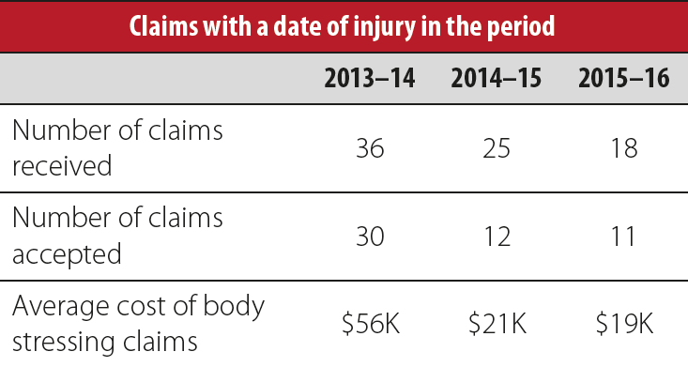

**Claims with a date of injury in the period**

The Department of Employment gratefully acknowledges the following agencies for the information provided in this booklet:

* Comcare
* The Department of Health
* The Department of Human Services
* The Department of the Prime Minister and Cabinet
* The Department of Social Services.

For more information on the Deputy Secretaries’ Working Group on Managing Workers Compensation in the Commonwealth or this pilot project contact:

Tim Johnson

Director, Non-legislative Reforms Section

Department of Employment

Phone: 02 6121 6802

Email: timothy.johnson@employment.gov.au.