


National Foundation
Skills Strategy

A Strong and Sustainable Australian Adult Foundation Skills Sector

2025–2035
We acknowledge the Traditional Owners and Custodians of Country throughout Australia and acknowledge their continuing connection to land, water, and community. We pay our respects to the people, the cultures and the elders past and present. We acknowledge First Nations custodianship of 65,000 years of knowledge, skills and learning systems.
© Commonwealth of Australia 2024

The material in this document is licensed under a Creative Commons Attribution—
4.0 International license, with the exception of:
- the Commonwealth Coat of Arms
- this department’s logo
- the Skills and Workforce Ministerial Council logo
- any third party material
- any material protected by a trade mark, and
- any images and/or photographs.
More information on this CC BY license is set out at the creative commons website: http://www.creativecommons.org
Enquiries about this license and any use of this document can be sent to: copyright@dewr.gov.au.
Use of all or part of this document must include the following attribution:
© Commonwealth of Australia 2024
The document must be attributed as the National Foundation Skills Strategy 2025–2035.

Contents
Skills and Workforce Ministerial Council Foreword 4
Introduction and context 5
What are foundation skills? 5
The challenge 5
Foundation skills delivery 7
Strong foundations 8
What stakeholders have told us 11
Vision 2035 12
National Focus Areas 12
Our Ambitions 13
First Nations Foundation Skills 13
The Path Forward 16
A Strong and Sustainable Australian Adult Foundation Skills Sector – Timeline 17

Skills and Workforce Ministerial Council Foreword
The National Skills Agreement is a 5-year agreement between the Australian and state and territory governments that reflects a commitment to ensure that no Australian is left behind or held back as the economy transitions and adapts to structural change. The Agreement includes agreed reforms, one of which is to improve foundation skills training capacity, quality and accessibility.
As part of this reform, the Australian and state and territory governments agreed to work together to develop a National Foundation Skills Strategy (the Strategy) to address issues of critical importance to the future of Australia and the wellbeing of individual Australians. This Strategy sets a shared direction for all governments for adult foundation skills nationally over the next decade and reflects our shared commitment to build foundation skills levels among Australian adults.
The Strategy is designed to enhance the lives of people who struggle every day to read and write, do maths or use computers – key foundation skills. We know that building these skills can improve people’s lives, creating new ways of engaging in communities and workplaces. Importantly, it can lead to opportunities for further education and training – helping to build the skilled workforce of the future and drive our state, territory and national economies.
This Strategy is about putting learners at the centre of our efforts: ensuring that policies and programs are designed to deliver the skills that learners want and need to enable them to build their careers and enrich their communities. This includes tailored support for specific cohorts, including Culturally and Linguistically Diverse people, people with disability, and First Nations people. Aligned with the National Agreement on Closing the Gap, we know that for First Nations people better outcomes are achieved when we work in partnership to design and deliver foundation skills training tailored to local circumstances and needs.
The Strategy outlines agreed areas of national focus against which the Australian and state and territory governments will align their priorities and actions. Through this Strategy, we want to ensure people understand the benefits of improved literacy and numeracy, we want to connect with those who need training but are not receiving it, and we want to empower people to seek support where they may have previously experienced embarrassment. We have also given a special focus to building up those who work tirelessly, day in and day out, to make sure that people are given the best start in their learning journey – the teachers, trainers and volunteers across our foundation skills workforce.
The Strategy acknowledges there are key pieces of research, data and evidence that we need to build before a more detailed and wide-ranging suite of actions can be designed and implemented. Building our understanding of the foundation skills workforce, and how we ensure the training is right for learners, are important building blocks. A detailed action plan will be progressively developed to underpin this Strategy and drive improvements across the sector.
Together, the Strategy and our action plan represent how we will take collaborative action to strengthen the adult foundation skills sector in Australia over the next ten years. Together, our vision is that:
‘By 2035, all adult learners in Australia are supported to access quality foundation skills training to develop the foundation skills they need to participate confidently and fully in work, education and training, and the broader community’
Skills and Workforce Ministerial Council, December 2024

Introduction and context

What are foundation skills?
Foundation skills are the core skills or competencies that underpin workforce participation, productivity, and social inclusion. They include:
Language, literacy, numeracy and digital (LLND) skills – listening, speaking, reading, writing, numeracy (the use of mathematical ideas) and digital literacy.
Employability skills – a set of non-technical skills, knowledge and understandings that underpin successful participation in work, such as initiative and innovation, planning and organising, problem solving and teamwork.
These are core ’learning to learn‘ skills, which give people access to an education system, providing opportunities to develop careers and engage in lifelong learning.

The challenge
According to the OECD Programme for the International Assessment of Adult Competencies (PIAAC), one in five working-age Australian adults has low literacy and/or numeracy skills.

That’s around 3 million adults across Australia.
‘Most of my working life, I have lived with the fear that one day someone will ask me to write or spell a word and I will not be able to do it and feel so ashamed of myself. I had to stop helping out at the school that my children attended because the year one children wanted me to write on the bottom of their drawings that it was a picture of a Ballerina or an Astronaut or a firefighter or something that I could not spell.’ – Adult learner
For First Nations people, the rates of English LLND skills are even lower. It is estimated that 40% of First Nations adults have minimal English literacy, and that figure can be as high as 70% in remote communities, noting that their level of literacy may be different in their first language.

People with low foundation skills may face difficulties in participating in social
and community life, employment, and education and training.

Research shows that having low foundation skills increases a person’s vulnerability in many areas. These include financial disadvantage, social isolation, lack of employment opportunities, impacts on health and wellbeing, being unable to access services, and being unable to understand and action important government and legal documentation.
Employers say low literacy and numeracy levels affect businesses. The Australian Industry Group’s workforce and skills survey in 2024 found that 88% of companies are affected by low literacy and numeracy skill levels, with more than one in five (21%) ‘highly impacted’. The impacts of low skill levels include poor completion of workplace documents, time wastage, staff lacking in confidence and unwilling to take on new work, and teamwork and communication problems.
Improving literacy and numeracy increases a person’s likelihood of earning more. An increase in literacy or numeracy can lead to a 10% increase in wages.
And in the long run, an increase in adult literacy also increases GDP. A 1% increase in literacy translates into a 3% increase in GDP per head. The association between labour productivity and literacy is equally strong.
‘Everyday skills are necessary when working in any industry. The agricultural industry for example has specific safety requirements, requires problem solving for many tasks and depends on competence in key basic numeracy and literacy skills. Ability to read gauges when operating large machinery, to determine flock numbers, dosage of animal husbandry, application of seeding, fertilizer and the list goes on. Without adequate base skills, employees will be limited in career growth, in employment prospects and in remuneration options. With many working in isolated and solo tasks, safety may be compromised.’ – Employer

Foundation skills delivery
The delivery of foundation skills training is diverse, reflecting the varying needs of individuals. Accredited and non-accredited courses provide a range of options to suit individual needs, and are overseen by a range of state, territory and Australian Government governance bodies that also provide funding for many of these courses.
There are multiple ways that learners can gain and improve their foundation skills through training, including through accredited or non-accredited training. Depending on the needs of learners, the training could be purely focussed on building foundation skills, or foundation skills could form a component of a broader vocational education and training (VET) or Adult and Community Education (ACE) course. Foundation skills are also delivered by many types of training organisations, including Registered Training Organisations (RTOs), secondary schools, and community organisations.
Non-accredited foundation skills training is also delivered through a range of providers, including the ACE sector. Training in the ACE sector may include basic adult education programs, aimed at adults with limited formal education or language skills, drop-in sessions at libraries and volunteer tutor programs.
There is limited data on the extent of foundation skills training delivered across Australia. In 2023, 58,740 people studied units from the Foundation Skills Training Package (FSK), however this Training Package represents only a portion of the foundation skills training occurring in nationally accredited courses. National data on non-accredited adult basic education programs delivered by ACE providers is not collected.

Strong foundations
All Australian governments currently commit significant resources to a range of policies, initiatives and programs with the aim of supporting adults to develop their foundation skills. The graphic below illustrates the starting point for the Strategy, showing the key initiatives currently in place across Australia. The Strategy will build on this work being undertaken both nationally and across states and territories, through a shared commitment to increasing foundation skill levels among Australian adults. From this starting point, an action plan will be collaboratively developed that supports flexibility in approach and implementation. The Strategy will frame how the Australian Government and state and territory governments will work together on identified issues of critical importance to the future of Australia and the wellbeing of individual Australians, to set the direction for building foundation
skills nationally.


Commonwealth
Programs including Skills for Education and Employment (SEE): SEE offers free foundation skills training for all Australians aged 15 years and over, and left school, seeking to improve their reading, writing, maths, English language and digital skills. SEE includes a dedicated stream for whole-of-community training delivery for First Nations people.
Funding for Reading Writing Hotline: Australia’s national telephone referral and advisory service for adults seeking help with literacy and numeracy.
Foundation Skills Study and participation in the OECD Programme for the International Assessment of Adult Competencies (PIAAC): to improve the evidence base for foundation skill levels of Australian adults.


New South Wales
Smart and Skilled Program: offers an entitlement to eligible learners for no fee training in selected foundation skills qualifications and courses on the NSW Skills List along with part qualifications and units of competency.
Adult and Community Education (ACE) Strategy: plan to deliver crucial training and education in LLND to equip disadvantaged learners and support them to access further learning, and employment opportunities.
ACE Program: delivers tailored and flexible education to provide equitable access to
lifelong learning opportunities which includes but is not limited to non-accredited foundation skills training.


Victoria
Adult, Community and Further Education Board: with statutory roles and functions under the Education and Training Reform Act 2006 (Vic) including provision of non-accredited foundation skills training.
Skills First Literacy and Numeracy Support program: designed for learners requiring literacy and numeracy skills to support the achievement of vocational competence and increasing the level of proficiency in literacy and numeracy of Victorians undertaking VET.


Queensland
Skills Investment: investment in industry informed foundation skills training to gain meaningful and sustainable employment. Training suits individual needs and career stages such as full foundation skills qualifications or units of competency. Training delivery can be stand-alone prior to or concurrent with a vocational qualification, or integrated.
Skilling Queenslanders for Work (SQW): funds training and support for unemployed
or underemployed people with a focus on attainment of or pathway to a Certificate III qualification. Funding is also available to deliver stand-alone foundation skills and lower-level
vocational qualifications.
Diverse Queensland Workforce Program (DQW): assists work ready migrants, refugees, and international students by funding not-for-profit organisations one-stop-shops or hubs offering client-centred training and employment services.


Western Australia
Foundation Skills Policy Review: progressing recommendations from the Review to ensure foundation skills of Western Australians are well-suited to the needs of individuals, industry,
the community and economy.
Read Write Now (RWN): a non-accredited, volunteer-based program established in 1977, providing one-to-one tuition for adults wishing to develop their literacy and numeracy skills in
an informal environment.
The Participation Program – Work Readiness stream: provides support including assistance for language and literacy to unemployed or under-employed people who are ready to work but are seeking relevant skills and experience to access meaningful work.


South Australia
Upfront Assessment of Need (UAN): a prescribed pre-enrolment process that every funded RTO must use to determine the course suitability, learning and wellbeing needs, and foundation skills gaps of each student.
Flexible delivery of foundation skills bridging units: students who are recommended foundation skills bridging units can access the training flexibly. This can be one-on-one or in small groups and South Australia funds this service over and above the subsidy for delivery of FSK.
Adult Community Education (ACE): training delivery in easy to access, community-based settings which may comprise non-accredited training, accredited training, and micro-credentials. ACE grants fund a projects-based approach to deliver free of charge foundation skills training.


Tasmania
26TEN Tasmania: long-term strategy for adult literacy and numeracy 2016-2025 in Tasmania. It sets a framework for action by the whole state – business, community groups, government, education and training providers, and individuals, who want to live in a state where all adults have the reading, writing, numeracy and communication skills they need for work and life.
Lifting Literacy Community Framework: sets out a community-wide framework aimed at any Tasmanian organisation that wants to help lift literacy rates in Tasmania. As part of this, the Tasmanian Government is implementing a plan to improve literacy outcomes across the early years, school years and adult learners demographic segments.


Australian Capital Territory
Skilled to Succeed: outlines the ACT Government’s priorities and plans for harnessing the ambition that thrives in the ACT community. There are 4 key priorities with Priority 1 encompassing foundation skills training.
ACT ACE Grants Program: funding for not-for-profit organisations to support pathways for Canberrans experiencing barriers to further education, training and employment through informal and customisable foundation skills learning in supportive and familiar environments.
Foundation Skills at CIT: tailors foundation skills programs for individual teaching departments, depending on the needs of the learner cohort. Fee-free foundation skills delivery to eligible learners through Fee-Free TAFE.


Northern Territory
The Supplementary recurrent assistance (SRA): is allocated to public vocational education providers, based on their First Nations student numbers, to focus provider effort in priority areas including improving First Nations literacy and numeracy.
The Indigenous Tutorial Assistance Scheme (ITAS): provides resources for one-on-one support for language, literacy and numeracy skills for First Nations learners.
The Equity Training program: funds projects for key equity groups that are focused on re-engaging or engaging Territorians in employment or further training programs. Projects can include literacy and numeracy support.

What stakeholders have told us
Stakeholders have identified a range of issues that need to be addressed to enable Australians to have the opportunity to develop the foundation skills they need to participate fully in employment, further education and training, and the community. These relate to ensuring access for individuals to training, ensuring the availability of qualified and experienced teachers, and ensuring underpinning sector architecture is as effective as possible and reflects contemporary conditions.
Access to support and training
People may not know where to go to ask for help. A suitable course may not be available locally, and online study is not always an option or an effective way for some people to learn. Transport, work, family arrangements and other issues may also make it difficult for people to attend face-to-face courses. People may feel embarrassed or ashamed and find it challenging to acknowledge they struggle with literacy or numeracy, deterring them from seeking support.
Tailored support
A one-size-fits all approach does not meet the needs of all learners. Training is most successful when it is engaging, relevant to individual circumstances, complemented by wrap-around support, and available where, and when, it is needed.
First Nations learners
First Nations people and communities need to have access to culturally appropriate courses and support programs, particularly in rural and remote locations. This includes courses delivered in First Nations languages. Foundation skills training and support for First Nations learners need to be designed in partnership with First Nations-led organisations to meet local requirements and circumstances.
Workforce
Shortages of qualified and experienced teachers are at a critical point, including for the First Nations workforce. This will affect the capacity of governments and providers to deliver more training, particularly in rural and remote areas.
Limited data availability
The evidence base is limited in scope and ad hoc in nature. Governments and stakeholders need access to a more robust evidence base to inform policy development and direct funding where it will have the most impact.
Foundation skills sector architecture
Key mechanisms and governance arrangements underpinning the foundation skills sector need to operate as effectively as possible. These include:
- delivery of foundation skills in vocational education and training qualifications
- long-term governance arrangements
- contemporary frameworks for teaching and assessment
- engagement with stakeholders and First Nations partners.

‘A few years ago, I decided to get some help not just in my mental health but also to finally work on my reading and writing. I found it hard to find someone that would tutor an adult and the lack of direction on where to get help and lack of advertising made this challenging. I would start to get help then it would all become too hard again. This would definitely put some people off seeking help and sticking with it.’ – Adult learner

Vision 2035
The Strategy, along with a detailed action plan, will guide the way Australian governments will seek
to strengthen the adult foundation skills sector in Australia. Together, our vision is that:

By 2035, all adult learners in Australia are supported to access quality foundation skills training to develop the foundation skills they need to participate confidently and fully in work, education and training, and the broader community
First Nations people will be supported by ensuring the design and delivery of foundation skills training is developed in genuine partnership. The National Skills Agreement includes a commitment to develop a nationally networked First Nations VET policy partnership to ensure active engagement with First Nations people, organisations and communities on national VET policies and programs.
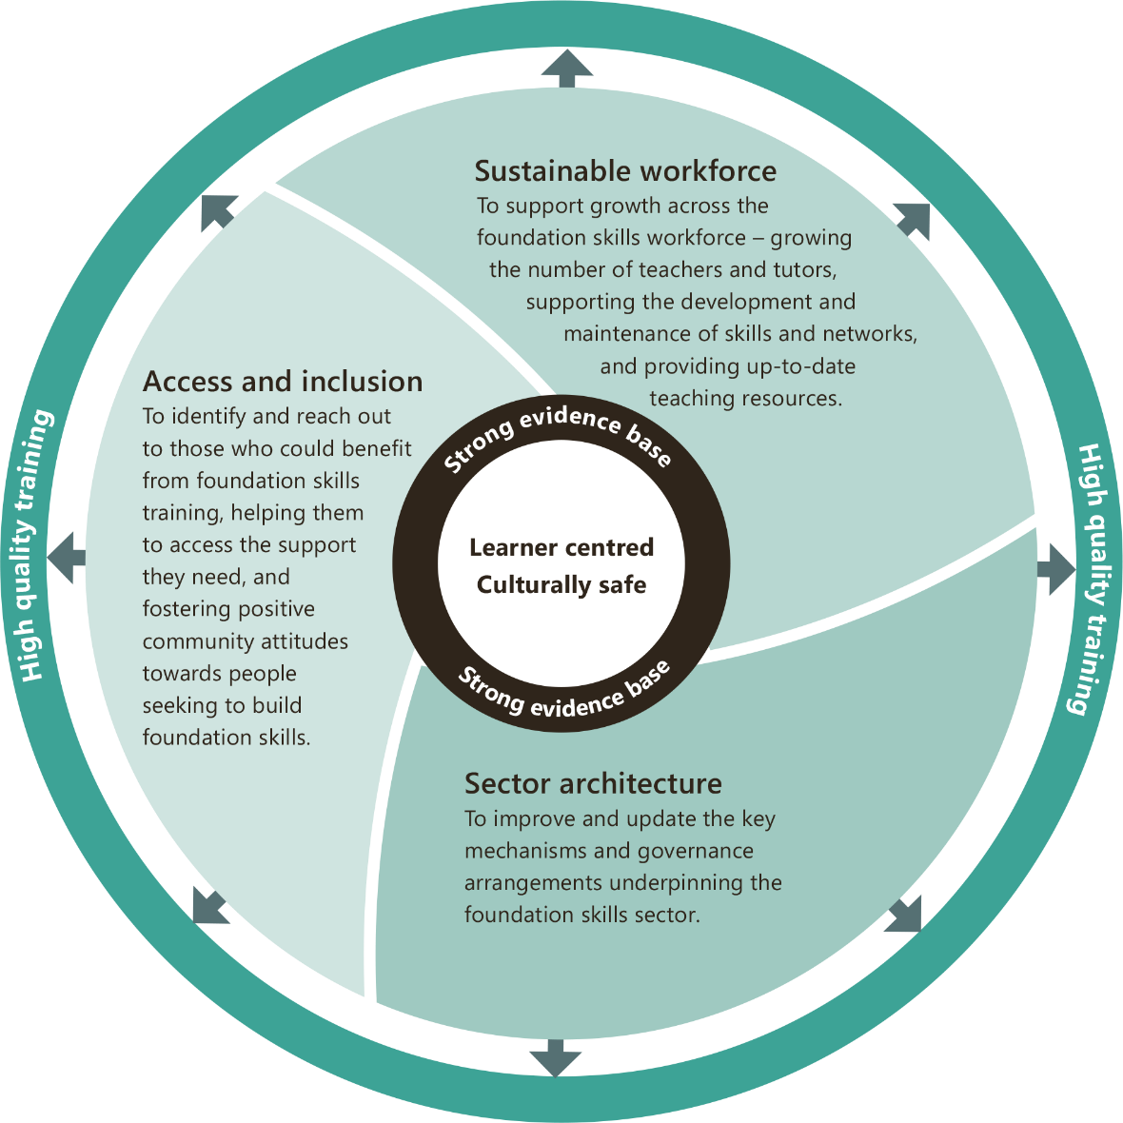
National Focus Areas
This diagram is of four concentric circles. The middle circle is divided into three sections and each section is a different colour. These sections each represent one of the three National Focus Areas, which are ‘Access and Inclusion’, ‘Sustainable Workforce’ and ‘Sector Architecture’. Each section has a brief description of what that National Focus Area entails.
These are:
- Access and Inclusion. To identify and reach out to those who could benefit from foundation skills training, helping them to access the support they need, and fostering positive community attitudes towards people seeking to build foundation skills.
- Sustainable Workforce. To identify and reach out to those who could benefit from foundation skills training, helping them to access the support they need, and fostering positive community attitudes towards people seeking to build foundation skills.
- Sector Architecture. To improve and update the key mechanisms and governance arrangements underpinning the foundation skills sector.
At the centre of the sections that comprise the largest middle circle, are two concentric circles. The outer circle is labelled ‘Strong evidence base’ and the inner circle is labelled ‘learner centred’ and ‘culturally safe’. This represents the values at the core of the National Focus Areas (learner centred and culturally safe), and that all National Focus Areas share an emphasis on a strong and robust evidence base. The most outer circle, surrounding the three National Focus Area sections, is labelled ‘High quality training’. There is white space between the largest middle circle and the outer circle, which has arrows pointing outwards from the National Focus Areas in the largest middle circle to the most outer circle. This represents that all National Focus Areas share an emphasis on creating a high-quality foundation skills training experience, which is learner centred and culturally safe, and is underpinned by a strong evidence base.

Our Ambitions

Within the National Focus Areas our ambitions are:

Access and inclusion
- Empowered learners, ready to work, study and engage in their communities
- Connected services and accessible training (‘no wrong door’)
- Tailored support, including for First Nations learners
- Increased community awareness and reduced feelings of shame and embarrassment

Sustainable workforce
- A sustainable workforce
- A skilled workforce
- Strong teacher networks and ongoing professional development
- Contemporary teaching products, tools and resources

Sector architecture
- Effective governance arrangements
- Effective and up-to-date core skills frameworks
- Meaningful qualifications and training
- Mechanisms to ensure effective ongoing engagement with the sector and partnerships with First Nations organisations
‘Due to his inability to read, he was unemployed and lamented the fact of not being able to earn money by having a job. After 8 months of tutoring my student became confident enough that he applied for a job at Woolworths and then started working.’ - Literacy tutor
All national focus areas share a cross-cutting emphasis on accurate and comprehensive data collection and analysis, and a high-quality experience for learners. Ensuring there is a strong and robust evidence base available to, and shared by, governments and stakeholders is key to ensuring improvements can be made for the benefit of foundation skills learners.

First Nations Foundation Skills
The National Skills Agreement provides for a step-change in the approach of Australian governments to delivering on Closing the Gap commitments for skills, with dedicated investment and concrete action to ensure that the design and delivery of skills and training programs to First Nations students is in full and genuine partnership.
Forming and establishing foundational partnerships with First Nations people and organisations in the skills sector is key to delivering successful Closing the Gap outcomes under the National Skills Agreement. The National Skills Agreement includes dedicated investment to progress specific policy initiatives aligned to the four Priority Reforms in the National Agreement on Closing the Gap. Aligning programs and actions with the four Priority Reforms enables activities to complement each other, increasing their ability to support better outcomes for First Nations students.
In addressing the foundation skills needs of First Nations people, it is important to recognise and build on the strengths of learners, including that many First Nations people speak multiple languages and are skilled communicators. Our aim is that those who wish to improve their LLND skills can access the services they need in a culturally safe environment, and that a variety of delivery models is available and supported to meet community and learner complex needs.
Ensuring tailored training and availability of wrap-around support is also important to address the range of training and non-training barriers to participation. It is also vital that we support First Nations-led organisations, including Aboriginal Community Controlled Registered Training Organisations (ACCRTOs) and foundation skills training specialists, working in partnership, to deliver foundation skills training.
All Australian governments are working with First Nations people, their communities, organisations and businesses to implement the National Agreement on Closing the Gap at the national, state and territory, and local levels. The Closing the Gap Priority Reforms are embedded in the National Skills Agreement, and the Australian Government is working in partnership with states and territories and the Coalition of Peaks to progress a package of reforms to:
establish partnerships with First Nations organisations in VET to provide genuine engagement and agency in policy making (Priority Reform 1: Formal partnerships and shared decision making)
expand investment in the capability, sustainability and growth of the Aboriginal Community-Controlled (ACC) and First Nations Owned (FNO) training sector (Priority Reform 2: Building the community-controlled sector)
grow the First Nations VET workforce and boost cultural capability of mainstream RTOs
(Priority Reform 3: Transforming government organisations)
boost data and evaluation capability in the First Nations VET sector (Priority Reform 4: Shared access to data and information at a regional level).
The action plan for this Strategy will provide an opportunity to develop adult foundation skills-focussed activities that are complementary to these measures and that link the National Focus Areas of the Strategy and ambitions to the Closing the Gap Priority Reforms and National Targets. It will also align and build on other initiatives in place, including the commitment of the VET Workforce Blueprint to develop localised and bespoke First Nations strategies to build the First Nations VET workforce, developed from the ground up in partnership with First Nations peoples.

The National Focus Areas link to Closing the Gap national socio-economic targets.
Target 7 – Youth are engaged in employment or education
Improved provision of LLND support for First Nations learners supports youth (ages 15-24) who have left school and have low LLND skills to engage in employment, education or training.
Target 8 – Strong economic participation and development of people and their communities
Improved provision of LLND support for First Nations learners supports First Nations learners
(aged 25-64) to participate economically through improved access to further education or training, and better employment opportunities.
The action plan will be developed in line with the Closing the Gap Priority Reforms,
with a dedicated stream of actions to support foundation skills for First Nations adults.

The Path Forward
The Strategy will be delivered through an action plan to be agreed and funded through decisions of the Skills and Workforce Ministerial Council in 2025. Funding of $53 million over five years is available under the National Skills Agreement to support activities.
In 2025, governments will engage with key national, state and territory stakeholders, and partner with First Nations organisations and communities to develop initiatives and actions to operationalise the vision and national focus areas of the Strategy.
The action plan will set out a range of actions to be taken at national, state and territory, and local levels under the Strategy. These will be flexible to ensure that the actions identified address local requirements and circumstances.
Actions will align with the national focus areas and contribute to achievement of the vision supporting activities to strengthen the foundation skills sector and improve the foundation skills of Australian adults.
A range of nationally focussed actions, to set up the ongoing work of the Strategy, will be implemented from early 2025 and led by the Australian Government. These initial actions will include work on communication activities to promote opportunities for foundation skills training and encourage people to seek support, establishing nationally agreed high-level principles for foundation skills assessment, a foundation skills workforce analysis, and updating components of the national foundation skills
sector architecture.
The effectiveness of the Strategy and the action plan will be measured against the Indicators and Outcomes Framework developed by states and territories and the Australian Government to deliver on the National Skills Agreement. Actions under the Strategy will be regularly reviewed, with flexibility to update and adjust.
Activities that support First Nations people will be an important part of the action plan, with a dedicated stream to support foundation skills training for First Nations people. Actions will be developed in partnership with First Nations organisations and communities and align with the Closing the Gap Priority Reforms in order to effect real change and improved outcomes.

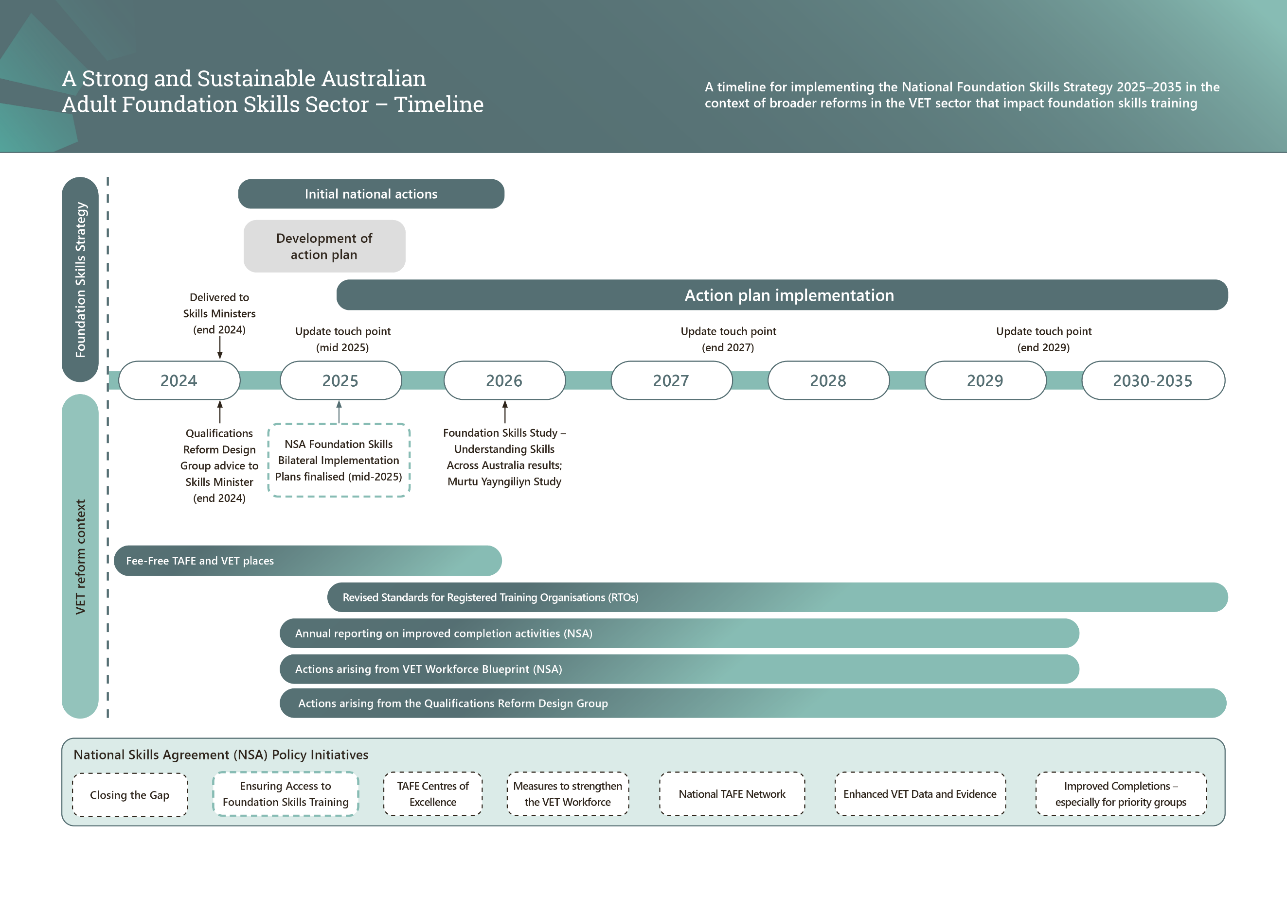
A Strong and Sustainable Australian Adult Foundation Skills Sector – Timeline
This full page, landscape formatted diagram sets out the implementation of the National Foundation Skills Strategy 2025-2035, in the context of broader reforms in the Vocational Education and Training (VET) sector.
The diagram has a vertical axis that lists a Foundation Skills Strategy section, and a VET Reform Context section on the left-hand side of the page. Horizontally across the middle of the diagram are single boxes labelled each year from 2024 to 2029, and then a single box for the five-year period 2030-2035. These boxes divide the page into two sections: Foundation Skills Strategy and VET Reform Context.
The Foundation Skills Strategy section timeline includes the following milestones:
- 2024: Delivered to Skills Ministers (end 2024)
- 2025: Update touch point (mid 2025)
- 2027: Update touch point (end 2027)
- 2029: Update touch point (end 2029)
The VET Reform context timeline includes the following milestones:
- 2024: Qualifications Reform Design Group advice to Skills Ministers (end 2024)
- 2025: NSA Foundation Skills Bilateral Implementation Plans finalised (mid-2025)
- 2026: Foundation Skills Study - Understanding Skills Across Australia results; Murtu Yayngiliyn Study
- 2024-2026: Fee-Free TAFE and VET places
- 2025- 2030-2035: Revised Standards for Registered Training Organisations (RTOs)
- 2025-2029: Annual reporting on improved completion activities (NSA)
- 2025-2029: Actions arising from VET Workforce Blueprint (NSA)
- 2025-2030-2035: Actions arising from the Qualifications Reform Design Group
Along the bottom of the page, horizontally, is a box with each of the National Skills Agreement (NSA) Policy Initiatives listed in individual boxes within the box. These include:
- Closing the Gap
- Ensuring Access to Foundation Skills (coloured, drawing the link to the NSA Foundation Skills Bilateral Implementation Plans box in the VET Reform context timeline)
- TAFE Centres of Excellence
- Measures to strengthen the VET Workforce
- National TAFE Network
- Enhance VET Data and Evidence
- Improved Completions – especially for priority groups

OECD (2017), Building Skills for All in Australia: Policy Insights from the Survey of Adult Skills – data from 2011-12.
Commonwealth of Australia (2022), Don’t take it as read – Inquiry into adult literacy and its importance. Note: all pull-out quotes included in this strategy are from public submissions to the Inquiry into adult literacy and its importance (2022).
See for example Uncovering Adult Literacy and Numeracy Needs in Australia: A Comprehensive National Study (prepared by Social Equity Works for the Reading Writing Hotline, 2023) and Helping Clients Fill in Forms Report (a partnership research project between the Reading Writing Hotline and NSW Council of Social Service, conducted by Social Equity Works, 2020).
Australian Industry Group (2024), Counting the cost: Addressing the impact of low levels of literacy and numeracy in the workplace.
Productivity Commission (2014), Literacy and Numeracy Skills and Labour Market Outcomes in Australia.
Schwerdt, G., Wiederhold, S., and Murray, T.S. (2020), Literacy and Growth: New Evidence from PIAAC Available at: https://kops.unikonstanz.de/entities/publication/9a17fe6a-7d61-4127-b479-04bb61e58c72.
Adult Learning Australia (2022), Australian adult community education environmental scan 2022.
NCVER (2024), Total VET students and courses 2023, NCVER, Adelaide. Figure includes students enrolled in FSK units within FSK and non-FSK qualifications, excluding students undertaking FSK units not delivered as part of a nationally recognised program.
Adult Learning Australia (2022), Australian adult community education environmental scan 2022.
Commonwealth of Australia (2024), VET Workforce Blueprint. Available at: https://www.dewr.gov.au/vet-workforce-blueprint/resources/vet-workforce-blueprint.

