


Guide to RTO Data Provision Requirements

  CC BY 4.0 AU
With the exception of the Commonwealth Coat of Arms, the Department’s logo, any material protected by a trade mark and where otherwise noted all material presented in this document is provided under a Creative Commons Attribution 4.0 International (https://creativecommons.org/licenses/by/4.0/) licence.
The details of the relevant licence conditions are available on the Creative Commons website (accessible using the links provided) as is the full legal code for the CC BY 4.0 International (https://creativecommons.org/licenses/by/4.0/legalcode)
The document must be attributed as the Guide to RTO Data Provision Requirements.
Version | Amendment details | Author | Approved/Endorsed by | Date
0.1 | Initial publishing version | Chris Keppel | Bronwyn Todd  (Director - VET Data Streamlining Legislation and Policy) | 10/7/2026

Contents
Guide to RTO Data Provision Requirements 1
Section 1 Overview of this guide 5
Intent of this guide 5
Section 2 Overview of the VET data environment 6
The role of VET data 6
Legislative framework 6
Section 3 Phased transition to new reporting environment 7
When RTOs transition to reporting against the VET Information Standard 7
Nationally recognised school training 8
Section 4 Requirement to maintain an appropriate VET data system 9
VET Data Systems 9
Section 5 Obligation to provide reportable data 10
Overview of the obligation 10
Minimum quarterly reporting obligations 12
Reporting frequency 13
Section 6 Reporting pathways 14
The Direct Pathway 14
The Indirect Pathway 14
The Reporting pathways in practice 15
Section 7 Providing privacy notices to students 16
Providing privacy notices to students 16
Section 8 End of quarter declarations 18
Standard end of quarter declaration requirements 18
No activity declarations 18
Nil activity reports 19
Section 9 Exemptions from data reporting requirements 20
Exemptions from providing reportable data 20
Scope of exemptions 20
Obligations when exempted 20
USI Exemptions 21
Section 10 Failing to report and inaccurate or incomplete data reporting 23
Inaccurate or incomplete data notifications 23
Failure to report 23
Section 11 Other reporting obligations to the regulator 24
ASQA powers to require information under the DPRs 24
Requirement to advise ASQA of changes in circumstances 25
Annual reporting in relation to quality indicators 25
Section 12 Reporting on cessation of registration 26
Section 13 Further resources 27
Commonwealth legislation and instruments 27
State or Territory legislation and guidelines 27
Appendix 1 Glossary 29

Note: Call out boxes with additional information appear throughout this guide. These boxes provide the following information:
References to other documents | 

Additional context/out-of-scope notes | 

Section 1
Overview of this guide

Intent of this guide
This guide provides information for Registered Training Organisations (RTOs) to understand the changes to Data Provision Requirements (DPRs) being implemented from 2026 through the National Vocational Education and Training Regulator (Data Provision Requirements) Amendment (Data Streamlining) Instrument 2026 (DPRs amendments).
This guide does not replace the DPRs amendments but provides further information to help RTOs understand these changes.  Common terms in this guide are defined in the glossary. These terms are shown in bold the first time they appear. | 
- Other essential changes to the VET data landscape being introduced at the same time as the DPRs amendments are:
  - The introduction of the VET Information Standard to replace the AVETMISS for VET providers data standard – outlining the national framework for the collection and reporting of information on VET provider activity in Australia.
  - The implementation of the National VET Data System (known as the Student Training Activity Reporting System (STARS)) – to enable the validation and submission of data through student management systems without the need to extract NAT files.
RTOs may transition to VET Information Standard reporting up until the end of 2028 but must be transitioned to comply with the DPRs from 1 January 2029. Until an RTO transitions, they should continue to refer to the National VET Data Policy: https://www.dewr.gov.au/vet-activity-data/national-vet-data-policy and to the AVETMISS pages: https://www.ncver.edu.au/rto-hub/what-is-avetmiss on the National Centre for Vocational Education Research (NCVER) website. | 
- This guide provides links to external resources to further assist RTOs in understanding the changes introduced by the DPRs amendments.
- This guide includes examples to explain how the DPRs amendments will work in practice.
- This guide (and other supporting information on the department website) will be updated progressively.

Section 2
Overview of the VET data environment

The role of VET data
- VET data is an essential national asset. It provides the core evidence base to understand learner pathways, RTO performance, workforce capability, industry needs and training outcomes.
- VET data enables governments, RTOs and employers to make informed decisions, respond to emerging challenges and direct investment where it will have the greatest impact.
- Data from national VET statistical collections and surveys contributes to the publication of reports and data products that illustrate how the national VET sector operates.

Legislative framework
- Under the National Vocational Education and Training Regulator Act 2011 (NVETR Act) RTOs are subject to requirements to provide data on VET activity in accordance with the DPRs made under subsection 187(1)
- The DPRs are the legal framework that defines the rules, requirements and obligations that RTOs must meet to legally submit their VET activity data to the NCVER.
- The DPRs form part of the VET Quality Framework under the NVETR Act and compliance with the DPRs form part of the conditions of registration of RTOs under section 22.
- Data collection, use and disclosure are embedded in the VET Quality Framework to ensure effective regulatory oversight by the National VET Regulator (ASQA).
RTOs registered in Victoria by the Victorian Registration Qualifications Authority (VRQA) or Western Australia by the Western Australian Training Accreditation Council (WA TAC) are subject to equivalent obligations that apply under state law. More information is available on their websites:  VRQA - https://www2.vrqa.vic.gov.au/  WA TAC - https://www.wa.gov.au/organisation/training-accreditation-council | 

Section 3
Phased transition to new
reporting environment

When RTOs transition to reporting against the VET Information Standard
There is a phased approach for RTOs to transition from AVETMISS to VET Information Standard submission of reportable data.
This transition information does not apply to the reporting of national recognised schools training (VET in Schools) data. See further the subsection on this issue below. | 
Different transition days for reporting in line with the DPRs amendments apply depending on:
- When an RTO was first registered, and
- Whether an RTO has an arrangement with a State or Territory Training Authority (STA)

Transition arrangements depend on the type of RTO:
Fee-for-service RTOs, and RTOs who do not provide government funded training:
- If registered before 1 January 2028 and they have no arrangements with an STA, an RTO may transition to reporting using the VET Information when their Student Management System (SMS) Provider is able to support VET Information Standard reporting arrangements. They must transition by 1 January 2029.
- If registered on or after 1 January 2028 and they have no arrangements with an STA, an RTO must report using the VET Information Standard from the date they are registered and must have an SMS that supports VET Information Standard reporting arrangements.
RTOs providing government funded training or a mix of government funded training and fee-for-service training:
- Will report against AVETMISS until a transition date advised by their STA regardless of registration date.
  - In circumstances where an RTO is newly registered and their STA has already commenced transitioning RTOs to reporting against the VET Information Standard, they may not need to submit AVETMISS data. This will be advised by the STA in these circumstances.
- where an RTO has been reporting against AVETMISS, this advice will outline the date that VET Information Standard data reporting must commence.
All RTOs will be required to report against the VET Information Standard from 1 January 2029 for all ongoing and new VET Activity from that date.
This means that the final AVETMISS VET Provider Collection submission (other than nationally recognised school training) will be submitted no later than 28 February 2029.
These arrangements are summarised below:
RTO Type | What you must report | When the VET Information Standard starts*
RTO registered before 1 Jan  2028 with no STA arrangement | AVETMISS until your  chosen transition date | Any date you choose  up to 1 Jan 2029
RTO registered on or after 1 Jan  2028 with no STA arrangement | VET Information  Standard only | From the day you  are registered
RTO with an STA arrangement | AVETMISS until STA  specified transition date  VET Information Standard only  if newly registered and the STA has already commenced transitioning RTOs. | On the date advised  by your STA
*Your SMS must support VET Information Standard reporting arrangements prior to this date

Nationally recognised school training
At commencement on 1 October 2026, the amendments to the DPRs do not change the way in which national recognised schools training (VET in Schools) data is reported to boards of study even after an RTO has otherwise transitioned to reporting using the VET Information Standard.
VET in Schools data may in future be incorporated into the VET Information Standard. Updates will be provided through the department website, NCVER website and STA websites to advise RTOs when VET Information Standard reporting arrangements apply to VET in Schools data. | 
VET in Schools data will continue to be collected in line with Part B of the National VET Data Policy and in accordance with the specifications outlined in AVETMISS.
VET in Schools providers should continue to discuss their reporting requirements and obligations with their STA. | 

Section 4
Requirement to maintain an appropriate VET data system

VET Data Systems
- Under the DPRs amendments, all RTOs are required to have and maintain a VET Data System with the digital functionality required to support:
  - data submission requirements for the VET Information Standard and,
  - the ability to transmit the data to the National VET Data System (otherwise known as the Student Training Activity Reporting System (STARS)).
- RTOs must have their VET Data System in place to be ready to transition to reporting data under the VET Information Standard.
- A VET data system must be able to collect and store all reportable data in a digital form and be capable of providing this data as required through the:
  - direct reporting pathway, or
  - indirect reporting pathway
- Section 6 of this guide explains reporting pathways, including which pathways applies to each RTO.
- A compliant VET Data System for the VET Information Standard is a SMS either:
  - contractually managed with an independent SMS supplier, or
  - managed by an RTO in-house.
For RTOs developing their own in-house approach to connect to the National VET Data System, technical resources are available through the VDS Developer Portal. Registration is through the VET Information Standard website: https://vetinformationstandard.ncver.edu.au/the-developer-Portal  RTOs should contact their SMS supplier to understand when they will be able to support VET Information Standard reporting arrangements. | 

Section 5
Obligation to provide reportable data

Overview of the obligation
RTOs that have transitioned to reporting using the VET Information Standard are subject to ongoing obligations to provide reportable data.
To understand how to meet reporting obligations under the VET Information Standard, RTOs should consider if data is available, relevant and therefore, reportable. This section explains these terms and when they apply.
RTOs may have additional contractual reporting requirements that are specifically required by their STA. RTOs should refer to their STA for more information on these requirements. | 
The VET Information Standard describes the data specifications required for meeting reporting obligations under the DPRs amendments. The VET Information Standard is available through the VET Information Standard website.
For RTOs which have not yet transitioned to VET Information Standard reporting, further information on the reporting specifications that continue to apply for AVETMISS can be found in the National VET Data Policy https://www.dewr.gov.au/vet-activity-data/national-vet-data-policy and the AVETMISS pages: https://www.ncver.edu.au/rto-hub/what-is-avetmiss on the NCVER website. | 
To comply with the DPRs amendments, RTO’s submitted datasets will need to include all reportable data outlined in the VET Information Standard for:
- Each VET Student that was enrolled by the RTO, and
- Each VET Course that the RTO provides to those students, whether by the RTO directly or on behalf of the RTO by another party.
Data is considered reportable when:
- it is VET Information Standard described data that is currently available to the RTO, and
- the data is relevant to the RTOs obligations under the currently in force version of the VET Information Standard.
The VET Information Standard website provides further information on versions of the VET Information Standard. | 

Data is considered available to an RTO as soon as the data is produced by or collected by the RTO or its:
- contractors (including the contractors’ employees)
- subcontractors (including the subcontractors’ employees)
- employees
- volunteers, or
- third parties delivering assessment or training on behalf of the RTO
Data is considered relevant if it is:
- specified in the VET Information Standard as a requirement for the jurisdiction(s) the RTO is operating in, and
- obtained by the RTO in a quarter after it became required in the VET Information Standard.
RTOs should note that versions of the VET Information Standard may be published on the VET Information website that describe data elements that will become mandatory in future. These versions are published to give RTOs visibility and understanding of future reporting obligations. | 
The flowchart below shows when data is reportable by an RTO because it is both relevant and available:
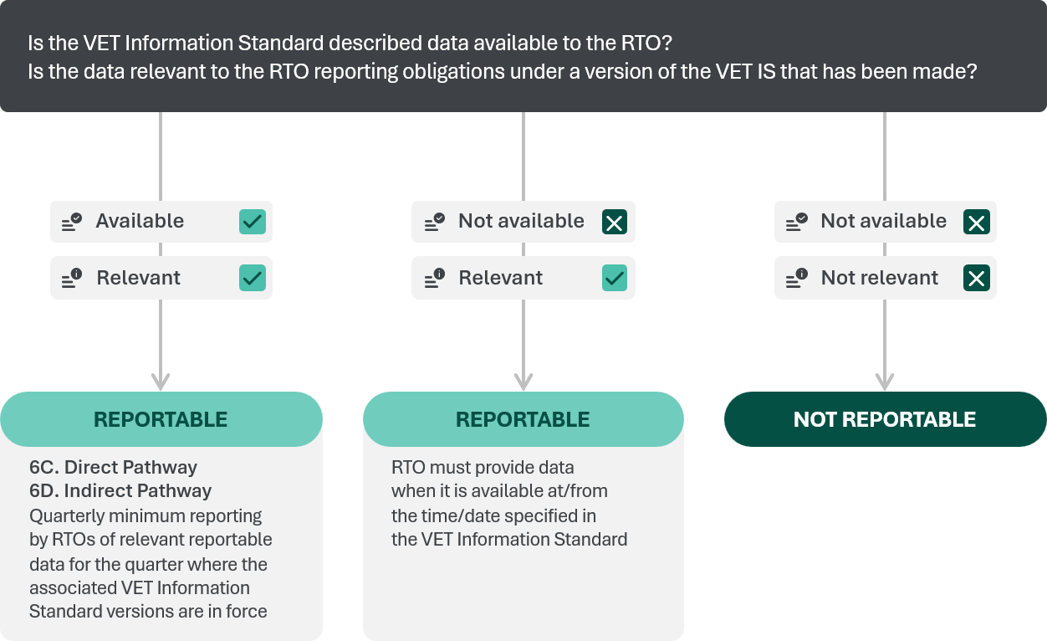

Minimum quarterly reporting obligations
RTOs must report complete, accurate and validated data within one month of the end of the quarter during which it becomes available.
- Quarters are defined by calendar year.
This means that submission timeframes are as follows:
QUARTER 1  1 January –  31 March  RTO quarter 1 submission due  by 30 April | QUARTER 2  1 April –  30 June  RTO quarter 2 submission due by 31 July | QUARTER 3  1 July –  30 September  RTO quarter 3 submission due by 31 October | QUARTER 4  1 October –  31 December  RTO quarter 4 submission due by 31 January
The requirement to report quarterly is a minimum reporting obligation. The option is available to RTOs to submit reportable data at any time. This means RTOs may submit data several times in a reporting period.
- RTOs with an arrangement with an STA may also be required to report more frequently than quarterly under those arrangements.
Where exemptions apply to an RTO from reporting particular data, they will be required to provide aggregate data within the relevant quarterly reporting period (see further section 9).

Reporting frequency
RTOs can choose to meet minimum quarterly reporting obligations by providing reportable data either:
- Progressively as data becomes available during the quarter (‘as you go’ submission), and
- As a single batch within one month of the relevant quarter ending (‘end of quarter’ submission).
The diagram below shows both of these options.
- The ‘as you go submission’ allows an RTO to choose a time that suits their administrative needs to validate and submit data without waiting for a specific time window.
- The ‘end of quarter’ submission allows RTOs to provide all data for the quarter in a single batched report.

VET Activity Data Submission Timeframe
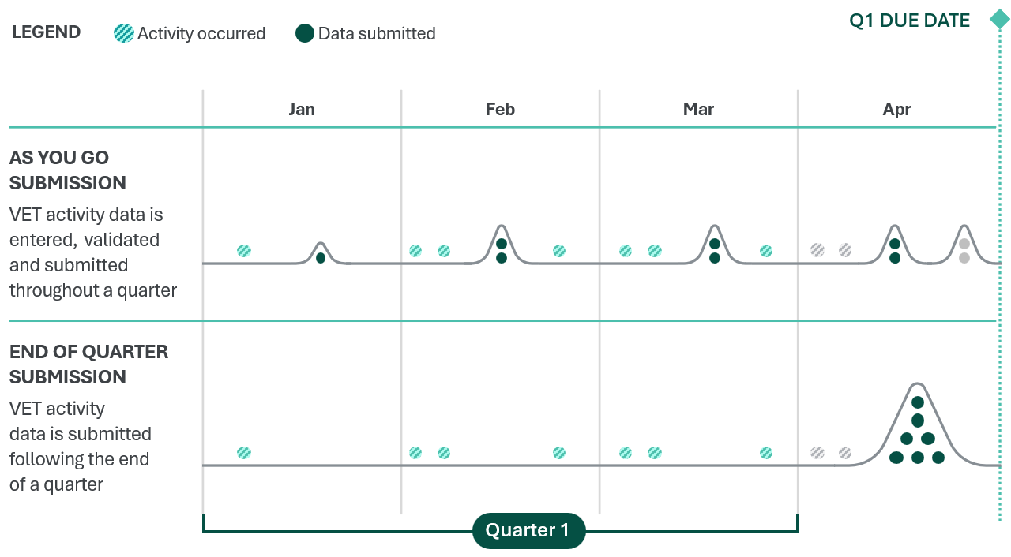

Section 6
Reporting pathways
After an RTO has transitioned to VET Information Standard reporting requirements, they will be subject to requirements to report under either the ‘direct’ or ‘indirect’ reporting pathway depending on:
- the type of training they are delivering (fee-for-service training, non-government funded training or government funded training)
- any contractual arrangements they may have with one or more STAs.
Both pathways are equally acceptable reporting pathways for the purposes of the DPRs amendments and RTOs will be required to follow the requirements outlined by:
- any regulator in the jurisdiction where they operate and/or
- Any STA if the RTO has any government funded activity in the jurisdiction.

The Direct Pathway
The direct pathway is where RTOs submit VET Information Standard compliant data directly to NCVER via their SMS:
- through the National VET Data System (STARS)
- in a format satisfying requirements set out in the VET Information Standard, and
- within the relevant quarterly reporting period.
The direct pathway applies to:
- RTOs without an arrangement with an STA (RTOs delivering only fee-for-service training, and RTOs who do not provide government funded training)
- RTOs with an arrangement with a STA that specifies use of the ‘direct pathway’ (currently the Australian Capital Territory, New South Wales, the Northern Territory and South Australia).
Queries regarding data validations, corrections and submissions can be made at any time with NCVER through this pathway.

The Indirect Pathway
The indirect pathway is where RTOs submit VET Information Standard compliant data:
- through an STA’s VET data system via their SMS
- in a format satisfying the requirements set out in the VET Information Standard, and
- within the quarterly reporting period.
The indirect pathway applies to RTOs with an arrangement with an STA which specifies use of the ‘indirect pathway’ (currently Queensland, Tasmania, Victoria and Western Australia).
Where applicable the indirect pathway will be specified by the relevant STA in arrangements with the RTO.
The STAs will collect and transmit that data to NCVER via the National VET Data System (STARS) on the RTO’s behalf.
Queries regarding data validations, corrections and submissions can be made at any time with the relevant STA when reporting through this pathway.

The Reporting pathways in practice
A high-level summary of the reporting pathways is outlined below.
- For both reporting pathways RTOs will deliver training to students and enter the activity into their student management system (SMS).
- For the direct pathway this process shows that an RTO’s SMS will provide national reportable data directly to NCVER to meet reporting requirements.
- For the indirect pathway this process will be facilitated by the RTO’s SMS providing the data to an STA which will then send that national reportable data on to NCVER on behalf of RTOs operating in their jurisdiction.
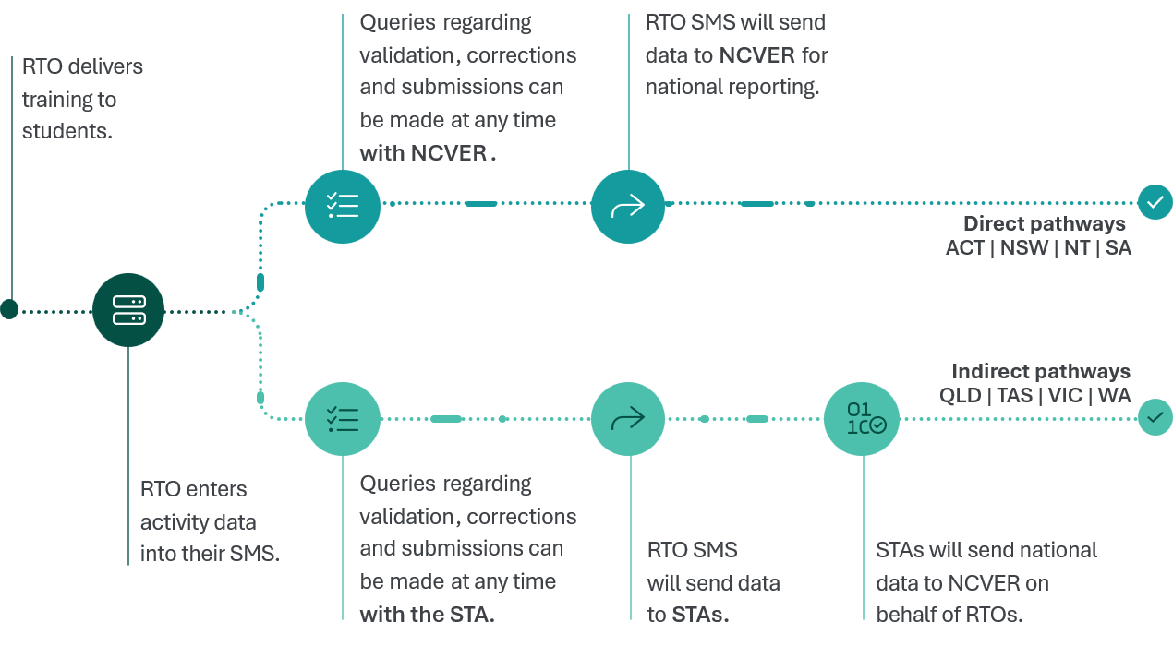

Section 7
Providing privacy notices to students

Providing privacy notices to students
- Commonwealth and state and territory legislation impose obligations requiring protection of the privacy of personal information obtained from students.
- In circumstances where an RTO collects personal information about an individual, they will be required to provide that individual with a privacy notice which at a minimum includes the information outlined in schedule 1 of the DPRs.
  - Reportable data under the DPRs includes personal information about individuals, so this will at a minimum include any time an RTO enrols a VET student.
- Privacy notices must be provided no later than the time the individual enrols in all or part of a VET course an RTO provides.
A sample enrolment form including minimum mandatory content requirements for a privacy notice is available on the NCVER website. | 
There are minimum requirements for the content of a privacy notice outlining:
- Why personal information is collected
- How it is used
- How it is handled by NCVER and other bodies, and
- How an RTO may be contacted to enable a student to:
  - request access to their personal information
  - correct their personal information
  - make a complaint about how their personal information has been handled
  - ask a question about the privacy notice.
The minimum mandatory content requirements for a privacy notice when reporting against VET Information Standard are outlined in Schedule 1 of the DPRs instrument at https://www.legislation.gov.au/F2020L01517/asmade/versions
The minimum content requirements for privacy notice for a provider reporting against AVETMISS are outlined in the National VET Data Policy: https://www.dewr.gov.au/vet-activity-data/national-vet-data-policy  The minimum content for a privacy notice for an RTO which has transitioned to reporting against VET Information Standard includes additional information about how personal information may be used by VET data system operators to meet contractual requirements and ensure VET data systems are operating correctly. | 
Where students are concerned about the handling of their personal information they should contact RTOs in the first instance. Where they are not satisfied after 30 days with any response received from an RTO they may contact the Office of the Australian Information Commissioner to make a privacy complaint.

Section 8
End of quarter declarations
Each quarter an RTO’s authorised representative will be required to provide a declaration on data submissions for that quarter.
This declaration will either:
- Meet standard declaration requirements to provide a declaration and an understanding and acknowledgement regarding the submission
- Provide a no activity declaration, or
- Provide a nil activity report.
This quarterly reporting obligation in the DPRs amendments differs from existing arrangements for AVETMISS which require this declaration to be provided annually. | 

Standard end of quarter declaration requirements
- Where an RTO has submitted data with an activity date in a quarter (by enrolling new students or delivering courses) they will be required to meet the standard end of quarter declaration requirements.
- The RTO’s authorised representative will declare that to the best of their knowledge:
  - The information provided for the reporting period is complete and accurate.
  - Any corrections or updates for prior reporting periods, that have been made within the current reporting period are complete and accurate.
- The RTO’s authorised representative will also be confirming that they understand and acknowledge that data submission is subject to the data collection, use and disclosure provisions outlined in the Terms and Conditions which are hyperlinked in the declaration.
- A no activity declaration or a nil activity report will appear as an additional field in the end of quarter declaration if applicable.

No activity declarations
- There may be times when an RTO provides training to students during a quarter, but this training does not result in a new student registration, commencement, completion, deferral or cancellation of a VET course (referred to as a “change of status”).
- In this circumstance, an RTO will confirm in their end of quarter declaration that they do not need to submit a nil activity report for the period.
The VET Information Standard website has further guidance on student enrolment status changes. | 

Nil activity reports
- RTOs are required to provide a nil activity report to NCVER if in a quarterly period they have neither:
  - enrolled new VET students
  - provided VET courses.
- This nil activity report is provided through end of quarter declarations which must be made through the National VET Data System or other means agreed by NCVER.
- RTOs will be prompted to consider whether they need to submit a nil activity report for the period in circumstances where they have not submitted any data.
Declaration scenarios
The three declaration scenarios are shown in the diagram below:
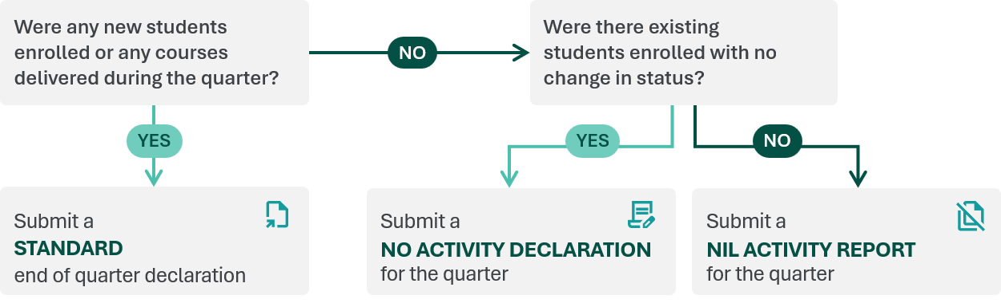

Section 9
Exemptions from data reporting requirements

Exemptions from providing reportable data
RTOs may be exempted by ASQA from the requirement to provide certain reportable data, subject to meeting the requirements of the VET Data Provisions Exemptions Policy.
- Similar processes for exemptions under this policy apply for RTOs registered in Victoria by the VRQA and Western Australia by the WA TAC.
The requirements for prospective VET exemptions are outlined in the standalone VET Data Provision Exemptions Policy  For previously granted VET exemptions material is provided in Part B of the National VET Data Policy (sections 5.1 to 5.15): https://www.dewr.gov.au/vet-activity-data/national-vet-data-policy | 

Scope of exemptions
An RTO may be granted an exemption from requirements to submit VET Information Standard compliant data for training relating to:
- national security, border protection or policing matters; or
- emergency or safety community services
The criteria for seeking this exemption are outlined in the current version of the VET Data Exemptions Policy.
Details of the exemption will be specified to the RTO in a written notice which will include details of the:
- type of training and associated data that is covered by the exemption
- period the exemption applies for (or that the end of this period will be advised to the RTO by ASQA at a later time), and
- conditions (if any) the exemption is subject to.

Obligations when exempted
RTOs granted a reporting exemption under the DPRs are required to report aggregate data on exempt activity quarterly in line with the submission timeframes that apply to VET Information Standard data.
RTOs that have a reporting exemption should note that aggregate data for a reporting period is considered to be available to them from on the last day of a quarter. This means that all data is submitted in one batch at the end of the quarter, rather than progressively. | 
The VET Data Provision Exemptions Policy outlines the:
- aggregate data which will need to be reported,
- format it is to be reported in, and
- the conditions of reporting,
- in circumstances where a reporting exemption has been granted
RTOs granted an exemption will also be required to comply with any obligations outlined in the VET Data Provision Exemptions Policy, notice of exemption decision from their VET regulator, and other requirements outlined in the DPRs.
Further information on VET data exemptions can be found in the VET Data Provision Exemptions Policy on the department website. | 

USI Exemptions
- Exemptions for Unique Student Identifiers (USIs) are managed under the Student Identifiers legislative framework.
- Under the Student Identifiers legislation, RTOs can only issue a VET qualification or VET statement of attainment to a student who has a USI, unless either the RTO or the student has been granted an exemption from the USI requirement by the Student Identifiers Registrar or the Minister.
- The Student Identifiers legislation does authorise RTOs who have been granted a reporting exemption in accordance with the DPRs and Exemptions Policy to issue VET qualification or VET statement of attainment to an individual who has not been assigned a USI.
- Students who don’t have a USI will not, however, be able to obtain a VET Transcript in relation to the exempt training.
These arrangements provide for the existing exemption which applies for RTOs reporting against AVETMISS to also apply for RTOs reporting against the VET Information Standard. | 

Further information on the operation of USI reporting exemptions can be found on the Unique Student Identifier website: https://www.usi.gov.au/providers/provider-support/reporting-requirements-and-exemptions | 

Section 10
Failing to report and inaccurate or incomplete data reporting

Inaccurate or incomplete data notifications
If an RTO provides inaccurate or incomplete reportable data, that data is considered to have not been submitted.
Inaccurate or incomplete data is not considered to meet the DPRs. RTOs must correct and provide any data identified as inaccurate or incomplete to meet their obligations.
RTOs reporting using the VET Information Standard only need to resubmit data that was identified as inaccurate of incomplete. This differs from requirements under AVETMISS which require RTOs to resubmit all submitted data files for the reporting period. | 

Failure to report
RTOs that do not meet their data submission requirements (including failures to update inaccurate or incomplete data) may be considered to have breached a condition of their registration.
ASQA responds to non-compliance in a proportionate way where monitoring activities identify that a provider does not meet the requirements of the legislation and/or the Standards.
Further information on ASQAs approach to compliance can be found at: https://www.asqa.gov.au/about-us/how-we-regulate/our-approach | 
Non-compliance may result in regulatory action being taken against the RTO by a VET regulator.

Section 11
Other reporting obligations
to the regulator

ASQA powers to require information under the DPRs
To facilitate undertaking its regulatory functions in managing the registration or renewal of registration of an RTO, ASQA may write to request certain information from:
- an RTO at any stage, or
- from an applicant for registration or renewal of registration.
The information ASQA can request from an RTO or an applicant is outlined in section 8 of the DPRs and includes but is not limited to information on:
- Business registration information
- Contact details
- Information to assess compliance with Fit and Proper Person Requirements and Financial Viability Risk Assessment Requirements
- Information on proposed, current and ceased training including through contractual arrangements and delivery overseas
- Details on applications under other legislative frameworks.
The DPRs amendments largely maintains the existing information that needs to be provided to ASQA on request under the existing DPRs.  Changes introduced through the DPRs amendments (that apply both for RTOs reporting against AVETMISS and those reporting against VET Information Standard including new RTOs applying for registration) include:  - Broadening the categories of persons involved in the governing of an RTO (to beyond just expressly executive officers and high managerial agents) who ASQA can ask for the names and involvement in registrations under other educational frameworks.  - Narrowing the scope of information that can be requested on training packages, VET qualifications, VET accredited courses, modules or units of competency that the NVR registered training organisation or applicant delivers or intends to deliver to:  - National codes and titles of the above, and  - Evidence to demonstrate that each trainer and assessor meets credential and competency requirements under the Standards for NVR RTOs. | 
RTOs and applicants are subject to a requirement to provide the requested information as specified and within the requested timeframe. A failure to comply with a request may adversely impact ASQA’s assessment of a registration or renewal application.
VRQA and WA TAC have equivalent powers to request information from RTOs registered by them. RTOs in those jurisdictions should refer to the relevant regulator website to find out more about these obligations. | 

Requirement to advise ASQA of changes in circumstances
Where information has been requested by ASQA from an RTO in accordance with the DPRs, RTOs are required to advise ASQA and provide updated details when circumstances change for this information as soon as possible after the change.
RTOs are also required to notify ASQA of any changes resulting in non-compliance with Financial Viability Risk Assessment Requirements and Fit and Proper Person Requirements.
RTOs should also note their ongoing obligation under the National Vocational Education and Training Regulator (Compliance Standards for NVR Registered Training Organisations and Fit and Proper Person Requirements) Instrument 2025 to notify ASQA of material changes that would significantly affect their ability to comply with their obligations under the NVETR Act framework.

Annual reporting in relation to quality indicators
- RTOs are subject to requirements to provide an annual summary report to ASQA by 30 June each year outlining its performance during the previous calendar year.
- This quality indicators report is based on student and employer feedback collected by the RTO using the quality indicators agreed by Skills Ministers.
Further information on quality indicators requirements for:  - ASQA registered RTOs can be found at: https://www.asqa.gov.au/for-providers/provider-obligations/data-collection-provision/quality-indicator-annual-summary  - VRQA registered RTOs can be found at: https://www2.vrqa.vic.gov.au/stay-compliant#quality-indicator-data-reporting  - WA TAC registered RTOs can be found https://www.wa.gov.au/organisation/training-accreditation-council/rto-reporting-requirements | 

Section 12
Reporting on cessation of registration
- If an RTO’s registration is cancelled or withdrawn, they will be required to provide all outstanding reportable data that was available immediately before the cancellation or withdrawal takes effect.
- Under both the direct and indirect reporting pathways RTOs must provide this reportable data:
  - in a format that satisfies the requirements set out in VET Information Standard
  - through their approved reporting pathway
- If any data is found to be inaccurate or incomplete, an RTO must provide correct and complete data within 30 days of the registration cessation or withdrawal.
Equivalent obligations apply to RTOs registered in Victoria or Western Australia when their registration is cancelled or withdrawn.  RTOs registered by VRQA or WA TAC should refer to their websites for further information on their reporting obligations in these circumstances. | 

Section 13
Further resources
Key legislative and regulatory documents outlining applicable data obligations for RTOs can be found at the following links:

Commonwealth legislation and instruments
Australian Privacy Principles
www.oaic.gov.au/agencies-and-organisations/guides/app-quick-reference-tool
National Vocational Education and Training Regulator Act 2011
https://www.legislation.gov.au/Series/C2011A00012
National Vocational Education and Training Regulator
(Data Provision Requirements) Instrument 2020
www.legislation.gov.au/Series/F2020L01517
Privacy Act 1988
www.legislation.gov.au/Series/C2004A03712
Student Identifiers Act 2014
www.legislation.gov.au/Series/C2014A00036
Student Identifiers Regulation 2014
www.legislation.gov.au/Series/F2014L01204
Student Identifiers (VET Exemptions) Instrument 2021
www.legislation.gov.au/Series/F2021L01365
VET Data Provision Exemptions Policy
https://www.dewr.gov.au/vet-activity-data/resources/vet-data-provision-exemptions-policy
VET Information Standard
https://vetinformationstandard.ncver.edu.au/

State or Territory legislation and guidelines
AQTF Essential Conditions and Standards for Continuing Registration (Vic)
https://www2.vrqa.vic.gov.au/standards-and-guidelines-registered-training-organisations
Education and Training Reform Act 2006 (Vic)
www.legislation.vic.gov.au/in-force/acts/education-and-training-reform-act-2006/080
Victorian Registration and Qualifications Authority Guidelines for VET Providers
https://www2.vrqa.vic.gov.au/standards-and-guidelines-registered-training-organisations
Vocational Education and Training Act 1996 (WA)
www.legislation.wa.gov.au/legislation/statutes.nsf/law_a858.html
Vocational Education and Training (General) Regulations 2009 (WA)
www.legislation.wa.gov.au/legislation/statutes.nsf/law_s41125.html

Appendix 1
Glossary
TERM | DEFINITION
ASQA | The Australian Skills Quality Authority is the National VET Regulator under the National Vocational Education and Training Regulator Act 2011.
Australian Vocational Education and Training Management Information Statistical Standard (AVETMISS) | The national data standard applying to RTOs that:  - have not transitioned to reporting against the VET Information Standard  - are continuing to report nationally recognised schools training for the VET in Schools collection.  AVETMISS also continues to be used for the purpose of the Apprenticeship and Trainee collection and the National VET Funding Collection.  AVETMISS is authorised by the Ministers responsible for Skills and administered by NCVER.  AVETMISS specifications include the:  - AVETMISS VET Provider Collection specifications for the National VET Provider and National VET in Schools collections.  - AVETMISS Apprentice and Trainee Collection specifications for the Apprentice and Trainee Collection.  - AVETMISS VET Funding for the National VET Funding Collection.
Data Provision Requirements (DPRs) | The National Vocational Education and Training Regulator (Data Provision Requirements) Instrument 2020 (Commonwealth) and documents referenced in this Instrument such as the VET Information Standard and the Data Provision Exemptions Policy which outline reportable data.
DPRs Amendments | The National Vocational Education and Training Regulator (Data Provision Requirements) Amendment (Data Streamlining) Instrument 2026 which outlines amendments to the Data Provision Requirements concerning the implementation of the VET Information Standard and the changes outlined in this guide.
National Centre for Vocational Education Research (NCVER) | National Centre for Vocational Education Research is the National VET Data Custodian and is responsible for the collection and quality assurance of the VET Information Standard data provided by RTOs.
Nationally recognised schools training | Training that is delivered as part of a school curriculum and that leads to a VET qualification or VET statement of attainment.
National VET Data Policy | The document endorsed by Skills Ministers and outlining in part B the National VET Provider Collection Data Requirements that apply to RTOs reporting under AVETMISS.
National VET Data System (NVDS) | The National VET Data System (otherwise referred to as the Student Training Activity Reporting System (STARS)) is a VET data system operated and maintained by the Commonwealth or NCVER under legal authority.
National VET Regulator Registered Training Organisations (NVR RTO) | A training organisation registered to deliver Nationally Registered Training by the Australian Skills Quality Authority.
NVETR Act | The National Vocational Education and Training Regulator Act 2011 which establishes the Australian Skills Quality Authority as a VET regulator and the framework for the regulation of NVR RTOs.
Privacy Notice | Describes how an entity handles personal information collected from the student that may be used together with training activity information. The Privacy Notice lists the ways information about the student is collected and why, and how it is used and shared.  The minimum mandatory content for inclusion in a Privacy Notice for an RTO that has VET Information Standard reporting arrangements is included in Schedule 1 of the National Vocational Education and Training Regulator (Data Provision Requirements) Instrument 2020 (Commonwealth
Quarter | A period of 3 months beginning 1 January, 1 April, 1 July or 1 October used for determining reporting requirements.
Registered Training Organisation (RTO) | A training organisation that is registered to deliver VET Courses with one of the following VET Regulators:  - The Australian Skills Quality Authority (ASQA)  - Western Australia Training Accreditation Council (WA TAC) or the  - Victorian Registration and Qualifications Authority (VRQA).
Reportable data | The data required to be collected and reported in accordance with the specifications set out in the VET Information Standard or Exemptions Policy (as applicable).
State or Territory Training Authority (STA) | The local authority responsible for administering vocational education and training in each state or territory.
Transition day | The day from which an NVR RTO will be required to collect and report reportable data in accordance with VET Information Standard requirements. This day will depend on:  - the type of training the RTO delivers (whether fee-for-service or government funded)  - whether the RTO has an arrangement with an STA.  - when the RTO was first registered.
Unique Student Identifier (USI) | A student identifier assigned to an individual by the Student Identifiers Registrar under the Student Identifiers Act 2014.
VET accredited course | - if ASQA has delegated to a body the function of accrediting a course —a course accredited by the body under the delegation; or  - in any other case—a course accredited by ASQA.
VET Course | - the units of competency of a training package that is endorsed by the Ministerial Council; or  - the units of competency or modules of a VET accredited course; or  - the units of competency or modules of a course accredited by VRQA or WA TAC
VET Data Provision Exemptions Policy | The document agreed by Skills Ministers that sets out the requirements for being granted an exemption from certain requirements under the Data Provision Requirements.
VET Data System | A computer system that is used to collect, store and manage information collected in accordance with the DPRs or any equivalent requirements in a non-referring State.
VET in Schools | An alternative common name for nationally recognised schools training, data on which is compiled by NCVER in the VET in Schools collection.
VET Information Standard (VET IS) | The national framework agreed by Skills Ministers for the collection and reporting of information on VET Activity in Australia that replaces AVETMISS for VET providers who have transitioned to reporting under this new data standard.
VET Qualification | VET Qualification has the same meaning as in the NVETR Act:  a testamur, relating to a VET course, given to a person confirming that the person has achieved learning outcomes and competencies that satisfy the requirements of a qualification.
VET regulator | Has the meaning given by the NVETR Act and includes ASQA, VRQA and WA TAC.
VET statement of attainment | VET Statement of Attainment has the same meaning as in the NVETR Act:  in relation to units of competency or modules of a VET course, a statement given to a person confirming that the person has satisfied the requirements of units of competency or modules specified in the statement.
VRQA | the Victorian Registration and Qualifications Authority responsible for regulating RTOs registered under the Education and Training Reform Act 2006 (Vic) and associated regulatory requirements.
WA TAC | The Western Australian Training Accreditation Council responsible for regulating RTOs registered under the Vocational Education and Training Act 1996 (WA) and associated regulatory requirements.
WA TAC | The Western Australian Training Accreditation Council responsible for regulating RTOs registered under the Vocational Education and Training Act 1996 (WA) and associated regulatory requirements.

