YOUR GUIDING COALITION

Creating your network map

Your guiding coalition

While a single person or small team can typically manage returner programs, some key individuals will play a significant role in laying the foundations of your program.
It may be useful to draw on a reference group to provide advice and support through the design and implementation of the program.

CORE PROJECT TEAM
PROGRAM MANAGER
The program manager will be responsible for designing, implementing and coordinating the returner program.
PROGRAM SPONSOR
Sponsorship and prioritisation of senior leaders will be critical for program success. The program sponsor will serve as the primary contact for your returner and will take responsibility for resolving issues if and when they arise.
LINE MANAGERS/SUPERVISORS
Line managers/supervisors will support you to identify current and future gaps in skills and help you to administer the returner program. Line managers/supervisors will also be the day to day contact for the returner. They will help you to evaluate and adjust the program over time.

INFLUENCERS AND ADVISORS
ALLIES
Allies are individuals in your business who have returned from a career break, balance work and caring responsibilities, or run parent/carer networks. These individuals will provide you with valuable insights and personal experience.
RECRUITMENT
Your recruitment function will help you to develop tailored recruitment approaches to target returners.
LEARNING AND DEVELOPMENT
Your learning and development function will support the development of tailored training and skilling programs for returners.
CONNECTORS
Connectors may take the form of recruiters, community members or partners who will support you to connect with returners in your community.
ADVOCATES
Advocates are ‘influencers’ within your business who can help to build internal support and energy for the returner program.

Creating your network map

Senior leaders are not the only individuals in your business who can guide and create energy around your supported returner program. There are influencers within the business and community who can have a disproportionate effect on the energy levels of others.
The ‘influencers’ within your network may not be immediately obvious. The ‘Networked Approach’ below, will help you to unearth the diverse types of relationships that exists in your business and the broader community.

THE NETWORKED APPROACH
The ‘snowball approach’ is a simple survey technique to help you understand networks and patterns of influence within your business and community. It is an anonymous email survey (for example, through Survey Monkey or other survey tools) with questions such as:
  - Who do you go to for information when you have trouble at work?
  - Whose advice do you trust and respect?
  - Who do you look up to?
  - Who and where do you turn to for information within the community?
Ask employees to nominate three to five people. Names that are repeated are the individuals within your business or community who are your ‘influencers.’

NARROW THE POOL
To deepen the analysis and further select appropriate individuals and groups, consider the following questions about the ‘influencers’ you have identified:
  - Who has more capacity to support you? Why?
  - Do you think this person will support the returner program? Why?
  - Who in this group has the most influencing power? Why?
  - Is one of these people likely to be negatively affected by the program or oppose it?
  - How similar is this individual to others in your group?
  - Do you trust the information you receive from this individual?
  - Who in the group adds a unique perspective?
  - Whose expertise and insights will be essential for the success of the program?

EXAMPLE OF A NETWORK MAP

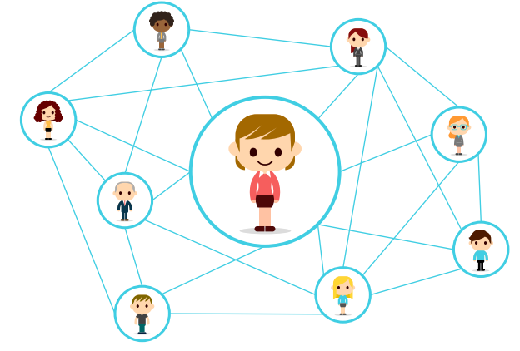MOBILISING YOUR NETWORK
Once you have identified your influence leaders, there are a number of ways to mobilise them throughout the program.
  - Invite them to be part of your reference group, providing advice at a particular stage or throughout the project.
  - Factor them into the supportive ecosystem that you create around the returner. Invite them to be buddies, mentors, allies or advocates for the program.
  - Ask them to be early adopters, and pilot returner programs in their team or area.
  - Test assumptions and ideas with this group. Give them early access to information and ask them for information as the program is implemented.

