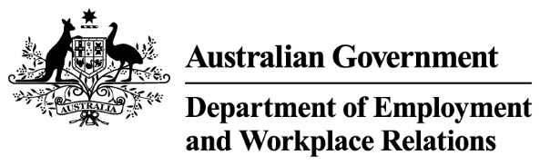

Protecting your information
This fact sheet contains advice about steps you should take to protect your personal information when lodging a Fair Entitlements Guarantee (FEG) claim and when expecting advice from the Department of Employment and Workplace Relations (the department) about the assessment of your claim.
Signing-up for FEG Online Services
When signing-up for FEG Online Services:
- set a strong password or pass-phrase that is different to the passwords you use for personal email and social media accounts
- Passwords must comply with the following rules:
- Have a minimum of fourteen (14) characters
- Must not contain the User ID, Given Name or Surname
- It must not be one of the last twenty (20) passwords used
- Users can not change their password for forty-eight hours immediately following their last change of password
- Contain characters from three of the following four categories:
- English uppercase characters (A-Z)
- English lowercase characters (a-z)
- Numeric (0-9)
- Non-alphanumeric (eg: !exclamation mark, $, #, or %).

- keep your login ID and password secure.
Lodging a FEG claim
When lodging a FEG claim:
- only use a support person who you trust if you need assistance to complete and lodge your claim. Always review the responses they enter into the FEG claim form on your behalf
- reject offers of help to complete your FEG claim from people you do not know, or who you have had limited contact with, e.g. social media contacts or former work colleagues
- contact the FEG Hotline on 1300 135 040 if you experience technical difficulties or need support to understand a question in the FEG claim form
- keep your claim form, identity documents, banking and taxation details secure.

Email correspondence about your FEG claim
Email correspondence with the department about your FEG claim will only occur with an email address ending in: @dewr.gov.au (e.g. FEG@dewr.gov.au).
If you receive email correspondence about your FEG claim that looks fake or suspicious:
- do not select and open hyperlinks, internet addresses, and email attachments
- do not reply to the email
- report it by calling the FEG Hotline on 1300 135 040, Mon - Fri, 9 am - 5 pm (AEST/ADST).
Phone calls about your FEG claim
If you call the FEG Hotline to ask about your claim, a FEG representative will ask for your name, date of birth and the name of your former employer to retrieve your claim record and to avoid disclosing your personal information to someone other than you or your nominated alternative contact.
If a FEG representative calls you to discuss your claim, they will:
- only call during business hours
- say who they are and that they are calling from the Department of Employment and Workplace Relations or the Fair Entitlements Guarantee
- not ask you for other personal information over the phone.
If a FEG representative requires further information from you to assess your claim, they may call to inform you that additional information is needed and send you a request in writing, via email or post.
If you receive a call or a text message claiming to be from FEG or the department and you are concerned that it may be fake, or have concerns about the information being requested, terminate the call and contact a FEG representative by calling the FEG Hotline on 1300 135 040, Monday - Friday, 9 am - 5 pm (AEST/ADST). Please do not reply to the text message or click into any links embedded in the message.
Further information
For more information about how to identify and protect yourself from scams, visit:
www.scamwatch.gov.au.
For more information about how to protect yourself and your personal information online, visit: www.staysmartonline.gov.au.

