


Complaints service
  - 1 May 2025 – 31 October 2025

Acknowledgement of Country
The Department of Employment and Workplace Relations acknowledges the traditional owners and custodians of Country throughout Australia and their continuing connection to land, waters and community. We pay our respects to them and their cultures, and Elders past, present and emerging. We extend that respect to the First Nations peoples who have so generously shared their wisdom, time, knowledge and lived experience with us in developing this service.
With the exception of the Commonwealth Coat of Arms, the Department’s logo, any material protected by a trade mark and where otherwise noted all material presented in this document is provided under a Creative Commons Attribution 4.0 International https://creativecommons.org/licenses/by/4.0/) licence.
The details of the relevant licence conditions are available on the Creative Commons website (accessible using the links provided) as is the full legal code for the CC BY 4.0 International (https://creativecommons.org/licenses/by/4.0/legalcode)
The document must be attributed as the Complaints service report.

Contact us
For enquiries about the licence and use of this report, email the Complaints Resolution Branch at complaintsfeedback@dewr.gov.au
If you would like to make a complaint or obtain further information about the complaints service, contact us:
- online via https://www.dewr.gov.au/complaints
- by phone at 1800 805 260 (toll free from landlines; mobile charges may apply)
- in writing at: The NCSL Manager
Department of Employment and Workplace Relations
GPO Box 9828
Canberra ACT 2601

Reader’s guide
This report provides information on complaints about employment services and pre-employment services received by the Department of Employment and Workplace Relations (the department) between 1 May 2025 and 31 October 2025. We also make comparisons throughout this report to the previous report covering the period from 31 October 2024 to 30 April 2025.
This report only relates to programs managed by the department. Complaints relating to other programs, including Inclusive Employment Australia managed by the Department of Social Service and the Remote Australia Employment Service managed by the National Indigenous Australians Agency, are not included in this report as they are the responsibility of another agency.

Part 1: Chief Complaints Officer
This part contains a letter from the Chief Complaints Officer introducing this report and explaining the performance of the complaints service over the 6 months to 31 October 2025.
Part 2: Complaints service overview
This part provides an overview of the complaints service. It includes our purpose and aim, how we are organised within the department, and who we answer to. It also provides information about the complaints handling process.
Part 3: Complaints received
This part provides information about the complaints we received about employment and pre-employment services, including demographic information about the people who made a complaint.
Part 4: Outcomes and themes in complaints
This part explores the different ways that complaints were addressed and the key themes in complaints received about employment and pre-employment services.
Part 5: What’s next
This part summarises what we do with the complaints we receive, and what we intend to do next.
Part 6: Appendices
This part includes some background information about the data used in this report, as well as a glossary of key terms.

Contents
Acknowledgement of Country 2
Contact us 3
Reader’s guide 4
Key statistics 7
Changes between this and last report 8
Chief Complaints Officer 9
Complaints service overview 10
Our aim 10
Our principles 10
Our structure 10
Our complaints process 11
How complaints are received 12
How complaints are recorded 13
Complaint reviews 14
Review of a decision taken 14
Complaints received 15
Who made a complaint? 15
Gender 16
Cohorts 17
Age group 18
Time in employment services 19
Program 20
All complaints 21
Complaints by program 24
Workforce Australia Services 24
Workforce Australia Online 26
Transition to Work 28
Parent Pathways 30
Other complaints 32
Outcomes and themes in complaints 34
Complaint outcomes 34
Complaint supported 35
Complaint unsupported 36
Information provided 36
Complaint withdrawn 37
Themes in complaints 38
Service satisfaction 39
Mutual obligations and compliance 40
Behaviour 41
Funding 42
Transfers, referrals and eligibility 42
System satisfaction 43
Complaints process 43
Referred to another organisation 44
Privacy 44
What’s next 45
Appendices 46
Appendix A: Data used in this report 46
Appendix B: Glossary of key terms 47
Abbreviations and acronyms 47
Glossary 47
Appendix C: 12 months of complaints data 52

Key statistics
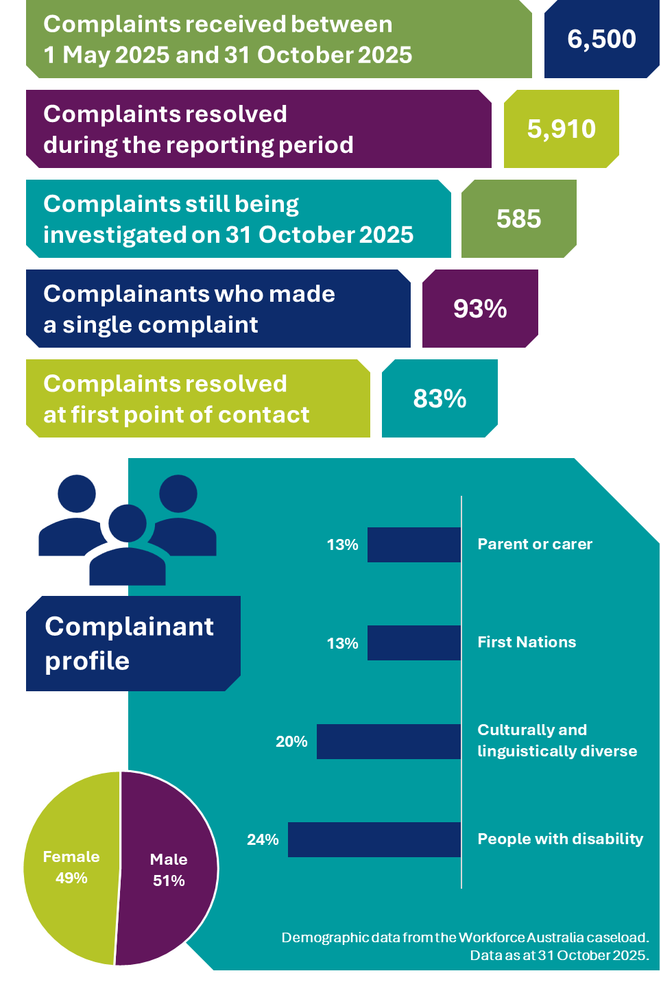
- An infographic presenting key statistics from the complaints service, including:
- 6,500 complaints received between 1 May 2025 and 31 October 2025
- 5,910 complaints resolved during the reporting period
- 585 complaints still being investigated on 31 October 2025
- 93% of complainants made a single complaint
- 83% of complaints resolved at the first point of contact.
- The infographic provides a profile of complainants, with demographic data taken from the Workforce Australia caseload as at 31 October 2025. Complainant demographics include:
- 49% female and 51% male
- 13% parent or carer
- 13% First Nations
- 20% culturally and linguistically diverse
- 24% people with disability.

Changes between this and last report
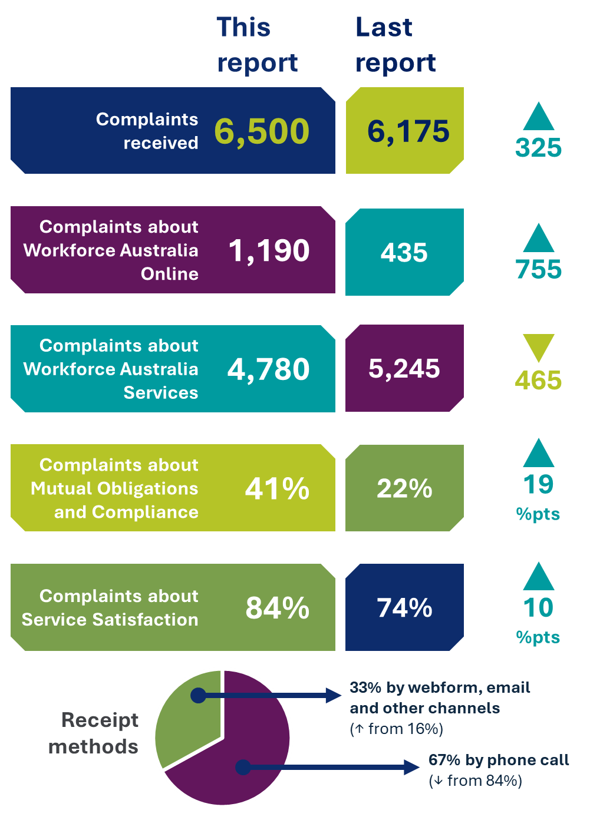
We recognise that this report and the last report cover consecutive 6-month periods and that seasonal differences may affect the volume and type of complaints we receive. We feel it is important to show the most substantial changes between the previous and current reports to support reader usability.
- An infographic presenting the most substantial changes between this report and the last report. Changes include:
- Complaints received increased from 6,175 to 6,500 (up 325)
- Complaints about Workforce Australia Online increased from 425 to 1,190 (up 755)
- Complaints about Workforce Australia Services decreased from 5,245 to 4,780 (down 465)
- Complaints about Mutual Obligations and Compliance increased from 22% to 41% (up 19 percentage points)
- Complaints about Service Satisfaction increased from 74% to 84% (up 10 percentage points)
- Complaints received by phone call decreased from 84% of all complaints to 67%
- Complaints received by webform, email and other channels increased from 16% of all complaints to 33%.

Chief Complaints Officer
I am pleased to present the latest report on the complaints service for employment and pre-employment services in Australia. Since its inception in late 2024, the complaints service has continued to evolve, guided by data analysis and engagement with stakeholders. The Commonwealth Ombudsman also published 2 reports in 2025. Among other things, these reports contained with recommendations and suggestions for the complaints service: Automation in the Targeted Compliance Framework and Fairness in the Targeted Compliance Framework: when decisions are made beyond your control. These reports are being carefully considered in our work to continuously improve the service.
A core aim of the complaints service is to be accessible, which means making sure that individuals experiencing a vulnerability or those who belong to historically disadvantaged groups can easily make a complaint and have their voice heard. Over the past 6 months, the service has continued to have strong engagement from people with disability, culturally and linguistically diverse individuals, First Nations peoples, and parents and carers. The information we receive via complaints from these groups helps to inform improvements to accessibility, ultimately enhancing the operation of the service.
To further enhance the operation of the service, we will commence work to consider and consult on performance measures for the service, drawing on guidance from the Commonwealth Ombudsman’s Better Practice Complaint Handling Guide. While every effort is taken to resolve complaints at the first point of contact – often on the same day – sometimes complaints require more detailed investigation, follow-up or review. The complaints service seeks to balance prompt and effective resolution of complaints with procedural fairness and the need to ensure that outcomes are appropriate. And of course, if complainants are not satisfied with the outcome, they are able to ask for a review. The complaints service aims to minimise delays, while ensuring complaints are managed professionally and impartially.
We welcome ongoing feedback to help us assess and improve our performance against the complaints service operational principles.
Looking ahead, we will continue to use complaints as one of our key sources of intelligence to support improvements across the employment services system, and to the complaints service itself.
Lisa Schofield
L Schofield
Chief Complaints Officer

Complaints service overview

Our aim
We aim to deliver a complaints service that is accessible and considers the needs of complainants, including those who experience a vulnerability, and that handles complaints impartially, confidentially and with empathy.

Our principles
We are committed to deliver a complaints service that is:
- Fair – focused on achieving fair outcomes for each complaint. We’ll handle each complaint fairly, confidentially, and with respect for all parties involved.
- Accessible – easy for you to make a complaint. You can make a complaint online, by email, over the phone or by letter.
- Efficient – prompt in addressing your complaint and communicating proactively with you. We’ll let you know if we need more time or if there is a delay.
- Transparent – open and honest with you about your complaint. We’ll keep you informed at each stage of the complaints process and explain the outcome of your complaint, including any findings that we make.

Our structure
The complaints service is part of the department’s Employment and Workforce Group, which is responsible for employment and pre-employment services.
The complaints service is overseen by the Chief Complaints Officer – a senior departmental official who is independent of program delivery.
The service has staff in the National Customer Service Line (NCSL) who receive, assess and action complaints that can be resolved at the first point of contact with the department.
Complaints that are unable to be resolved at first contact are referred to the complaints management team, reporting to the Chief Complaints Officer. These complaints require further investigation and include more serious, sensitive or complex complaints.

Our complaints process
We consider a complaint to be when a person tells us they are dissatisfied with something about employment or pre-employment services and they would like, or are entitled to, a response. Complaints can be simple – about a single issue – or can be more complex and raise multiple issues at the same time.
When we receive a complaint, we work to understand what happened and if something different should have happened. Our complaints process has several key steps (see Figure 1 below).
1
Receiving a complaint: We receive most complaints by phone call to our NCSL, however we also receive complaints through our online complaints form, by email and post, and from Members of Parliament on behalf of constituents.
2
Assessing the complaint: When we receive a complaint, we assess it to make sure that we are the right people to respond. If someone else should respond, we help the complainant get in contact with them. If we are the right people to respond, we assign a complaints officer to address the complaint, where we can’t provide a solution at the first point of contact.
3
Helping to find a solution early: If we can, we try to address a complaint at the first point of contact or as soon as possible after we gather information to understand an issue. Sometimes we can help address an issue early by providing more information to a complainant about a process or policy, or by facilitating a transfer to a new provider.
4
Investigating the complaint: If we can’t find a solution early, we investigate the complaint. We may need to ask for more information from the complainant, another party to the complaint like a provider, or another team in the department. More complex or sensitive complaints may take longer to investigate to ensure we can get the outcome right.
5
Communicating the outcome: We tell the complainant and other parties to a complaint about the outcome in writing. We also provide information about a complainant’s right to request a review of the handling of the complaint if they aren’t satisfied with the outcome.
Figure 1: Our complaints process
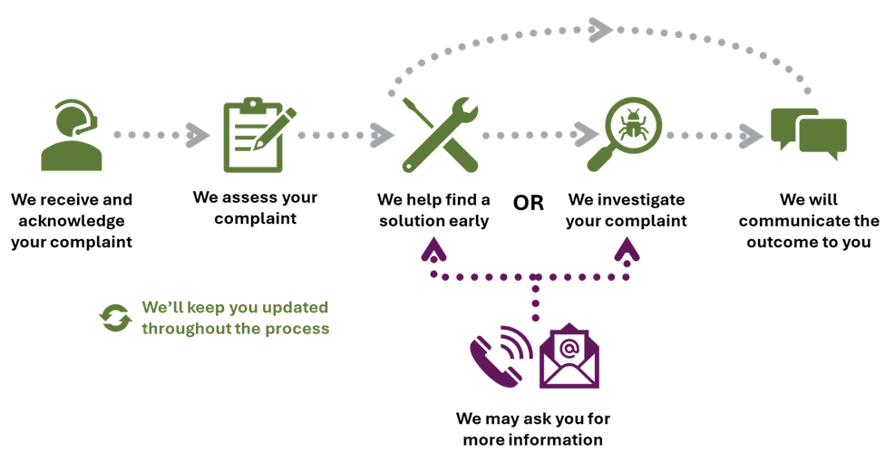

How complaints are received
About two-thirds of the complaints received were by phone call. Receiving complaints by phone means complaints often can be addressed at the first point of contact, while a complainant is still on the call.
The rest of the complaints received were by the following channels:
- 22% were received through our webform
- 10% were received by email
- 1% were received from another agency or a Member of Parliament on behalf of a constituent
- <1% were received by mail
- <1% were received from other sources.
Compared to the previous 6 months, we received fewer complaints by phone call and more through our complaints webform and by email.
Figure 2: Complaint receipt methods
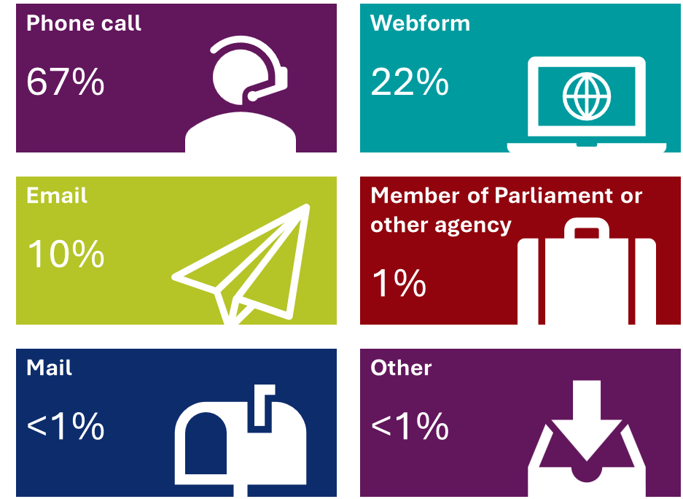

How complaints are recorded
When we receive a complaint, we capture information in our system to help us understand what might need to change or what could be done better to address the complaint.
As we work to address a complaint, we keep track of:
- details about the complaint, including:
  - who made it and who else was involved
  - what it was about
  - when and where any issue happened
  - why the complainant is dissatisfied.
- what outcome the complainant is seeking
- each time we contact someone about the complaint
- what actions we took because of the complaint.
We use this information, which we call complaints data, to understand who is best placed to address a complaint.
We also use complaints data to understand what about the employment services system people aren’t satisfied with and who we need to inform.
Where a provider is found to be in breach of their contractual responsibilities, the department will take action in accordance with the Deed and Guidelines.
Making anonymous and confidential complaints
Sometimes, you may not want to share your identity with the complaints service. If you would like to make a complaint without telling us who you are, this is an anonymous complaint.
If you make a complaint and tell us who you are, but you ask us not to share your identity with anyone else – like your provider – this is a confidential complaint. If you make a confidential complaint, we will do our best to protect your identity if we have to request information from someone else.
It is important to note that if you make an anonymous or confidential complaint, we may not be able to investigate fully. This is because we are unable to ask other parties for information or evidence without identifying you.
A note on complaints data
To protect individuals' privacy, the numbers presented in this report have been rounded to the nearest 5 and proportions have been rounded to the nearest whole number. This may result in non-additivity for some totals. Zeros are actual zeros.
Appendix A: Data used in this report provides more information about the data confidentiality procedures used in this report and our data revisions policy.

Complaint reviews
Once a complaint has been resolved and all parties are informed of the outcome, if the complainant is not satisfied, they can ask for a review of the way the complaint was handled.
The review process for complainants is outlined in the box below:
If you are not satisfied with the outcome of your complaint or how we handled it:
You can ask us for an explanation or a review. You can do this in writing by replying to the outcome email or letter we send you, or over the phone by calling the NCSL on 1800 805 260.
- If you ask for an explanation, we will contact you to provide more information about the outcome of your complaint.
- If you ask for a review, we will assess your request and may contact you to ask for more information.
If we can review the complaint:
- We will let you know that your complaint is under review.
- We will look at how we handled the complaint, as well as the facts, the law, and the policy involved in the outcome.
- Following our review, we may uphold the original outcome or change the outcome in part or in full. We will notify you of the review outcome in writing (or by phone if you prefer).
If we can’t review the complaint:
- We will notify you in writing (or by phone if you prefer) and explain why we can’t review your complaint.
If you are still not satisfied:
- You can request a further review by the Commonwealth Ombudsman: www.ombudsman.gov.au/complaints

Review of a decision taken
Some decisions relating to employment services are regulated by social security law. The complaints service cannot review these decisions. If a complainant was affected by a decision made under the social security law, we will help them contact Services Australia to request a formal review by an Authorised Review Officer.
If the complainant is unsatisfied with the outcome of a formal review, they can appeal the decision to the Administrative Review Tribunal.

Complaints received

Who made a complaint?
Most people who made a complaint (99%) were participants in an employment or pre-employment services program. This has increased slightly compared to the previous 6 months. Among the remaining complaints, a small number were made by people who chose to remain anonymous (1%), employers (<1%) and other individuals (<1%), including members of the public and representatives from community organisations.
Because most of the complaints we received were from employment services participants, we can compare the characteristics of the group of complainants who told us their Job Seeker ID (the complainant caseload) to the characteristics of the Workforce Australia caseload to see if there are any similarities or differences between people who made a complaint and people participating in employment services.
Examining complaints by characteristics, like gender or age group, can indicate whether some groups of people experienced more issues with employment services than others.
Comparing the Workforce Australia and complainant caseloads
It is important to note in this section that the Workforce Australia caseload is made up of people in the Workforce Australia Services, Workforce Australia Online and Transition to Work programs at the end of the reporting period in October 2025 (point in time). The complainant caseload, however, is made up of complainants who lodged a complaint during the 6-month reporting period.
This means that the two groups are not directly comparable, because a person may have made a complaint in June and no longer be a participant in employment services in October when the Workforce Australia caseload was measured.
Where there has been a change that is greater than 1 percentage point compared to the previous 6 months, this is shown in the figures in this section.

Gender
The Workforce Australia caseload and complainant caseload had similar proportions of individuals by gender, as shown in Figure 3 below.
Compared to the previous 6 months, there has been a small increase in the proportion of female complainants and a small decrease in the proportion of male complainants. The proportion of male and female individuals on the Workforce Australia caseload has remained the same.
Figure 3: Comparison of caseloads by gender
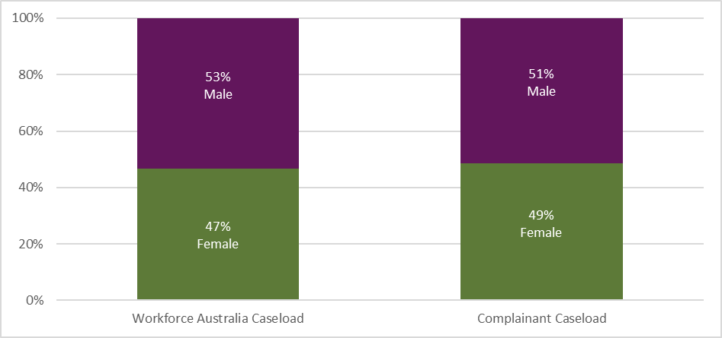

Cohorts
Figure 4 below shows the proportion of individuals on the Workforce Australia caseload who belonged to a specific cohort, compared with the proportion of complainants who belonged to those same cohorts. Individuals can belong to multiple cohorts, so these proportions may not add to 100%.
People with disability made up a smaller proportion of complainants. Compared to the previous 6 months, however, the proportion of complainants who were people with disability decreased.
People who identified as culturally and linguistically diverse made up a larger proportion of complainants. Compared to the previous 6 months, the proportion of complainants from culturally and linguistically diverse backgrounds stayed about the same.
All cohorts made up similar proportions compared with their proportions of the Workforce Australia caseload.
Figure 4: Comparison of caseloads by cohort proportion
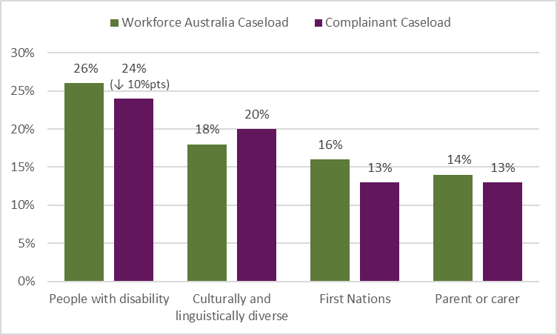Note: Cohorts are not mutually exclusive; an individual may belong to multiple cohorts.
16%
14%

Age group
Figure 5 below shows the proportion of individuals on the Workforce Australia caseload compared with the proportion of complainants by gender and age group.
In general, the proportions of each age group of complainants and individuals on the Workforce Australia caseload were similar.
People under the age of 25 years made up a slightly smaller proportion of complainants, compared with their proportions of the Workforce Australia caseload.
Figure 5: Comparison of caseloads by gender and age-group proportion
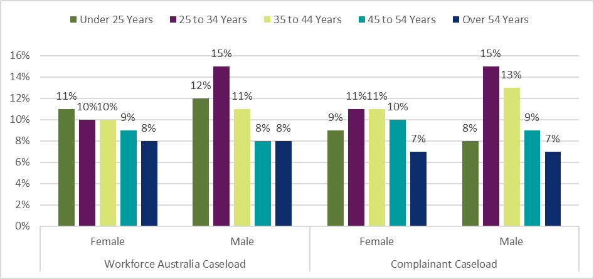Note: In the previous report, caseload and complainant groups were mislabeled in this figure. The gender and age proportions for each group presented were correct.

Time in employment services
Figure 6 below compares the proportion of individuals on the Workforce Australia caseload with the proportion of complainants by the amount of time they have been in employment services.
People who were in employment services for less than 12 months made up a smaller proportion of complainants, compared with their proportion of the Workforce Australia caseload. However, compared to the previous 6 months, the proportion of complainants in this group increased.
People who were in employment services for 12 months or more made up a larger proportion of complainants, compared with their proportion of the Workforce Australia caseload.
The proportion of complainants who were in employment services for 24 to 59 months and those who were in employment services for 60 months or more has fallen compared to the previous 6 months.
Figure 6: Comparison of caseloads by time-in-service proportion
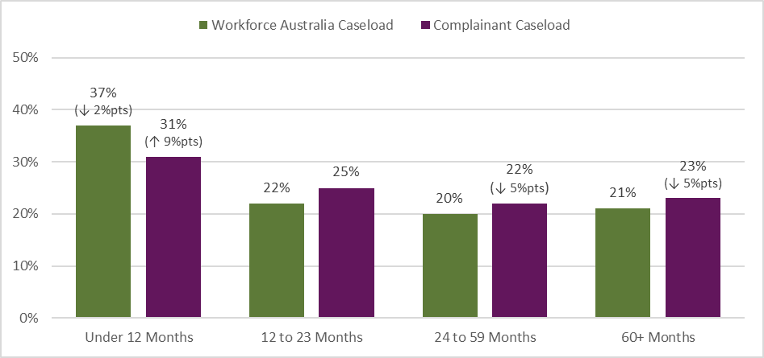

Program
Figure 7 below compares the proportion of individuals on the Workforce Australia caseload – which comprises the Workforce Australia Services, Workforce Australia Online and Transition to Work programs – with the proportion of complainants participating in each program.
People participating in Workforce Australia Services made up a larger proportion of complainants, compared with their proportion of the Workforce Australia caseload. Compared to the previous 6 months, however, the proportion of complainants in Workforce Australia Services has decreased.
People participating in Workforce Australia Online and Transition to Work made up smaller proportions of complainants, compared with their proportion of the Workforce Australia caseload. Compared to the previous 6 months, however, the proportion of complainants in Workforce Australia Online has increased.
To give a sense of scale for the proportion of individuals in a particular program who made a complaint over the past 6 months, one complainant engaged with the service for about every 115 participants in Workforce Australia Services. In Workforce Australia Online this was one complainant per 185 participants in Workforce Australia Online, and in Transition to Work, this was one complainant per 577 participants.
Figure 7: Comparison of caseloads by program proportion
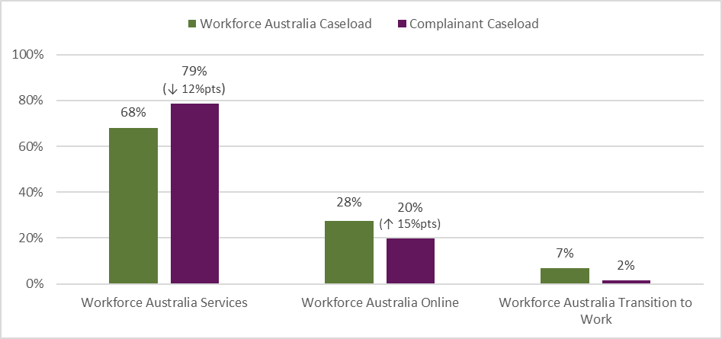

All complaints
Workforce Australia is the Australian Government’s primary employment service. Workforce Australia has a range of services available to help all Australians, not just people on income support, to find, keep, change jobs or create their own job.
Individuals who are on income support and have mutual obligations, are referred to an appropriate employment service depending on their individual needs. These include:
- Workforce Australia Services: individuals who require additional support will be connected to a provider who will tailor the support needed
- Workforce Australia Online: supports eligible individuals to access online tools and resources based on their own personal needs
- Transition to Work: helps young people aged 15–24 into work (including apprenticeships and training) or education.
Parents or carers of young children who are not working can volunteer to participate in Parent Pathways. Parent Pathways is a voluntary service that provides personalised assistance and financial support to eligible parents and carers of children up to the age of 6 years.
The complaints service also handles complaints for other Workforce Australia-branded programs, such as Career Transition Assistance, Self-Employment Assistance and Work for the Dole, and stand-alone DEWR programs like the Reconnection, Employment and Learning Program and Skills for Education and Employment. Complaints relating to these programs managed by the department are reported in the other complaints section below.
To give a sense of scale for the number of complaints received over the past 6 months, for every 108 individuals on the Workforce Australia caseload at the end of October 2025, we received about one complaint. Compared to the period from 31 October 2024 to 30 April 2025, this number has decreased from about one complaint for every 111 individuals on the Workforce Australia Caseload at the end of April 2025.
Counting ‘complaints’ or ‘complainants’
In the previous section, ‘Who made a complaint?’, we compared numbers of complainants – individual people who made a complaint to the department – to the number of people on the Workforce Australia caseload.
For the rest of this report, we consider complaints – the number of individual cases lodged with the department. Each complainant may lodge more than one complaint.
Table 1: All complaints received 1 May 25 – 31 Oct 25
All programs | Number of complaints | Change from previous 6 months
Complaints received | 6,500 | ↑ 325
Complaints resolved | 5,910 | ↑ 225
Complaints open at end of reporting period | 585 | ↑ 95
Most participants who made a complaint submitted a single complaint, however less than 1 in 10 complainants submitted multiple complaints. Compared to the previous 6 months, the number of participants submitting more than one complaint stayed about the same.
Figure 8: Number of complaints received by month – all programs
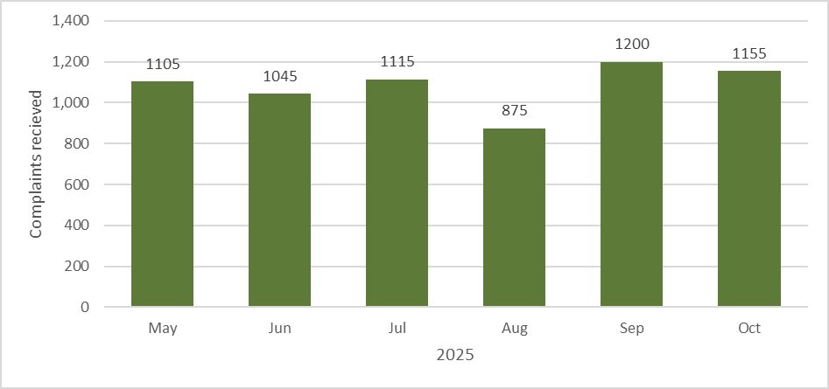
When we can address a complaint at the first point of contact, we will. We may address a complaint at the first point of contact by helping a person to transfer to a different employment services provider, or by providing a more detailed explanation of employment services policy and programs. Compared to the previous 6 months, the number of complaints addressed at the first point of contact has increased from more than 3 in 4 complaints to almost 5 in every 6 complaints.
Complaints that are not resolved at the first point of contact are referred to a specialist team of complaints officers who will further investigate the complaint. If we need to contact someone else to help us understand why a complaint has been made, like a provider or another team in the department, we will ask them for information. When we receive a response, we follow up with the complainant to address the complaint. Our complaints officers are trained to handle complaints that are more complex in nature, contain serious allegations of misconduct, or involve a minor.
Complainants are kept informed of the progress of their complaint throughout the complaint handling process.
Table 2: How we handled all complaints 1 May 25 – 31 Oct 25
Category | Proportion of complaints | Change from previous 6 months
Addressed at first point of contact | 83% | ↑ 7 percentage points
More information required to resolve | 14% | ↓ 5 percentage points
Serious, sensitive or complex | 3% | ↓ 2 percentage points

Complaints by program

Workforce Australia Services
Individuals on income support with mutual obligation requirements may be connected to a Workforce Australia Services provider who tailors support to help get them job-ready, and find suitable, secure employment.
Providers guide individuals to manage their participation in the program, including helping them understand how to use the Points Based Activation System to meet their points target and job search requirement each reporting period. Providers can also offer:
- advice based on an individual’s situation and plans for the future
- help accessing study or training opportunities
- help to develop the skills to prepare for, find and keep a job, or to run a business
- access to a range of activities, workshops and work experience opportunities
- help accessing financial support.
In some locations there are specialist providers to deliver personalised services to cohorts including culturally and linguistically diverse, First Nations people, ex-offenders, and refugees.
The overall proportion of complaints was higher for Workforce Australia Services than other programs, comprising about 74% of all complaints received since May 2025. This is likely due to the larger caseload of participants as well as the nature of the program, where individuals must interact with a provider regularly, creating more touchpoints for potential dissatisfaction than other programs that have less intensive support, fewer requirements, or that are self-managed or voluntary.
Compared to the previous 6 months, however, there was a decrease of 11 percentage points in the number of complaints received relating to the program.
For every 100 participants in Workforce Australia Services at the end of October 2025, we received about one complaint relating to the program. This represents about one complaint for every 147 people on the Workforce Australia caseload.
Table 3: Complaints received about Workforce Australia Services 1 May 25 – 31 Oct 25
Workforce Australia Services | Number of complaints | Change from previous 6 months
Complaints received | 4,780 | ↓ 465
Complaints resolved | 4,345 | ↓ 500
Complaints open at end of reporting period | 435 | ↑ 35
Table 4: Top 5 themes in complaints about Workforce Australia Services 1 May 25 – 31 Oct 25
Theme | Proportion of complaints | Change from previous 6 months
Service satisfaction | 91% | ↑ 12 percentage points
Mutual obligations and compliance | 43% | ↑ 20 percentage points
Behaviour | 32% | ↑ 11 percentage points
Funding | 14% | ↑ 4 percentage points
Transfers, referrals and eligibility | 9% | ↑ 1 percentage point
While there was an overall decrease in complaints relating to Workforce Australia Services, the proportion of complaints in the top 5 themes has increased.
Figure 9: Number of complaints received by month – Workforce Australia Services
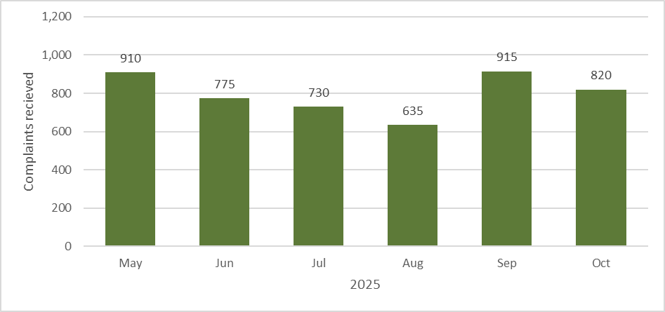

Workforce Australia Online
Individuals who are assessed as being more job-ready are referred to Workforce Australia Online to access tools, information and training to help them manage their mutual obligations and move into secure employment.
Everyone accessing Workforce Australia Online is supported by dedicated staff from the department’s Digital Services Contact Centre (DSCC). The DSCC helps guide participants with:
- information and technical support for all users of the service
- assistance to tailor their points target and manage their mutual obligation requirements to better reflect their personal circumstances
- access to education and training and other supports
- access to the Digital Employment Fund, to get certain items to find and start a job, or to move for a new job.
Importantly, individuals using online servicing can choose to move to a provider for additional support at any time and for any reason.
Complaints relating to Workforce Australia Online represent about 18% of all complaints received. This is an increase of 11 percentage points from the previous 6 months.
For every 160 participants in Workforce Australia Online at the end of October 2025, we received about one complaint relating to the program. This represents about one complaint for every 589 people on the Workforce Australia caseload.
Table 5: Complaints received about Workforce Australia Online 1 May 25 – 31 Oct 25
Workforce Australia Online | Number of complaints | Change from previous 6 months
Complaints received | 1,190 | ↑ 755
Complaints resolved | 1,075 | ↑ 675
Complaints open at end of reporting period | 115 | ↑ 80

Table 6: Top 5 themes in complaints about Workforce Australia Online 1 May 25 – 31 Oct 25
Theme | Proportion of complaints | Change from previous 6 months
Service satisfaction | 80% | ↑ 38 percentage points
Mutual obligations and compliance | 51% | ↑ 24 percentage points
System satisfaction | 13% | ↓ 3 percentage points
Transfers, referrals and eligibility | 10% | ↓ 4 percentage points
Referred to another organisation | 7% | Not previously reported
While there was an overall increase in complaints relating to Workforce Australia Online, there was a larger proportional increase in complaints in the top 2 themes.
Figure 10: Number of complaints received by month – Workforce Australia Online
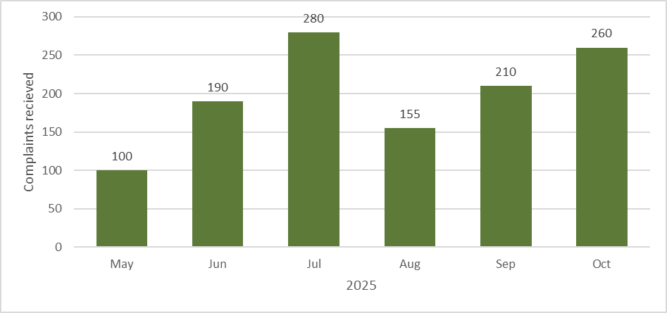

Transition to Work
Transition to Work helps young people aged 15–24 into work (including apprenticeships and training) or education. Transition to Work participants receive intensive, pre-employment support to develop practical skills to get a job, connect with education or training, find local job opportunities and connect with relevant local community services.
Complaints relating to Transition to Work represent just over 1% of all complaints received. This is about the same compared to the previous 6 months.
For every 640 participants in Transition to Work at the end of October 2025, we received about one complaint relating to the program. This represents about one complaint for every 9,339 people on the Workforce Australia caseload.
Table 7: Complaints received about Transition to Work 1 May 25 – 31 Oct 25
Transition to Work | Number of complaints | Change from previous 6 months
Complaints received | 75 | ↓ 20
Complaints resolved | 70 | ↓ 20
Complaints open at end of reporting period | 5 | No change
Table 8: Top 5 themes in complaints about Transition to Work 1 May 25 – 31 Oct 25
Theme | Proportion of complaints | Change from previous 6 months
Service satisfaction | 91% | ↑ 7 percentage points
Behaviour | 32% | ↑ 11 percentage points
Funding | 27% | ↑ 16 percentage points
Mutual obligations and compliance | 25% | ↑ 14 percentage points
Other organisation | 18% | Not previously reported
Note: Due to the small number of complaints relating to Transition to Work, a change in the number of complaints in a theme will have a larger effect on the proportion of that theme compared to a program receiving more complaints.
Figure 11: Number of complaints received by month – Transition to Work
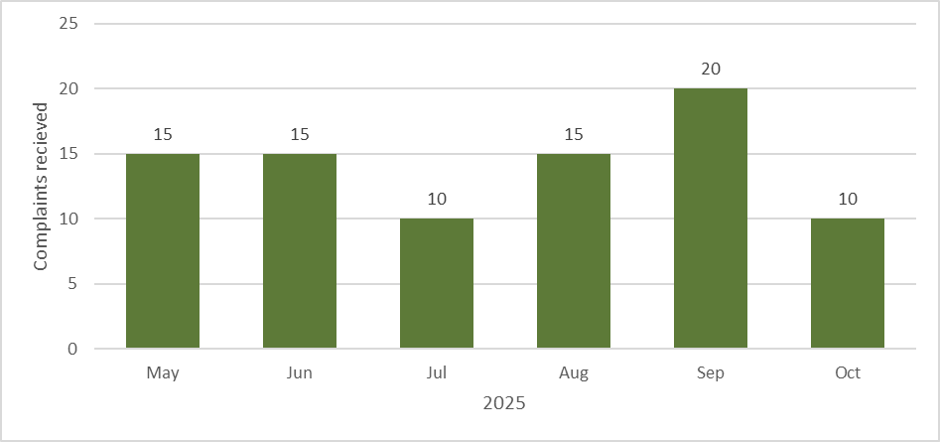

Parent Pathways
Parent Pathways is a voluntary service that provides personalised assistance and financial support to eligible parents and carers of children up to the age of 6 years.
Parent Pathways is about parents and carers and their individual needs. With the help of a qualified mentor, participants can receive flexible support to assist with any study or work goals.
Complaints relating to Parent Pathways represent less than 1% of all complaints received. This is about the same compared to the previous 6 months.
For every 515 participants in Parent Pathways at the end of October 2025, we received about one complaint relating to the service. This represents about one complaint for every 15,564 people on the Workforce Australia caseload.
Table 9: Complaints received about Parent Pathways 1 May 25 – 31 Oct 25
Parent Pathways | Number of complaints | Change from previous 6 months
Complaints received | 45 | ↓ 10
Complaints resolved | 45 | No change
Complaints open at end of reporting period | 0 | ↓ 10
Table 10: Top 3 themes in complaints about Parent Pathways 1 May 25 – 31 Oct 25
Theme | Proportion of complaints | Change from previous 6 months
Service satisfaction | 81% | ↑ 8 percentage points
Funding | 58% | ↑ 13 percentage points
Transfers, referrals and eligibility | 21% | Not previously reported
Note: Due to the small number of complaints relating to Parent Pathways, a change in the number of complaints in a theme will have a larger effect on the proportion of that theme compared to a program receiving more complaints.
Figure 12: Number of complaints received by month – Parent Pathways
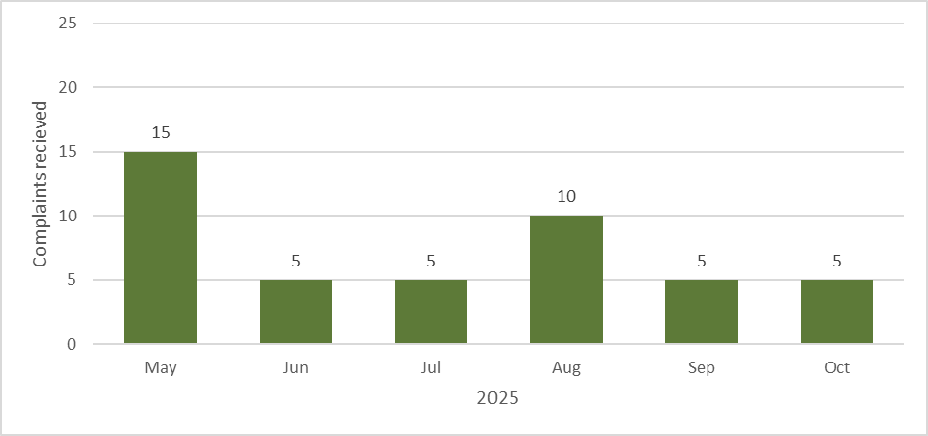

Other complaints
We track complaints separately for several smaller programs, including Career Transition Assistance, Self-Employment Assistance and Work for the Dole. These programs are Workforce Australia branded programs but have policy settings that mean participants may have a different experience of employment services. We also receive complaints for stand-alone programs managed by the department, like Skills for Education and Employment, Norfolk Island Employment Support Program, and the Reconnection, Employment and Learning Program. Due to the small number of complaints about these programs, they are reported together in this section.
Complaints about the Workforce Australia website, smartphone app, and other things related to employment services but not connected to a specific program are also reported in this section as other complaints.
Other complaints represent about one complaint for every 1,773 people on the Workforce Australia caseload at the end of October 2025.
Table 11: Other complaints received 1 May 25 – 31 Oct 25
Other complaints | Number of complaints | Change from previous 6 months
Complaints received | 395 | ↑ 50
Complaints resolved | 365 | ↑ 50
Complaints open at end of reporting period | 30 | No change
Table 12: Top 5 themes in other complaints 1 May 25 – 31 Oct 25
Theme | Proportion of complaints | Change from previous 6 months
Service satisfaction | 69% | ↑ 16 percentage points
Mutual obligations and compliance | 24% | ↑ 8 percentage points
Behaviour | 18% | ↑ 4 percentage points
Transfers, referrals and eligibility | 16% | ↑ 4 percentage points
System satisfaction | 11% | ↓ 3 percentage points
Note: Due to the small number of other complaints, an increase or decrease in the number of complaints in a theme will have a larger effect on the proportion of that theme compared to a program receiving more complaints.
Figure 13: Number of complaints received by month – other complaints
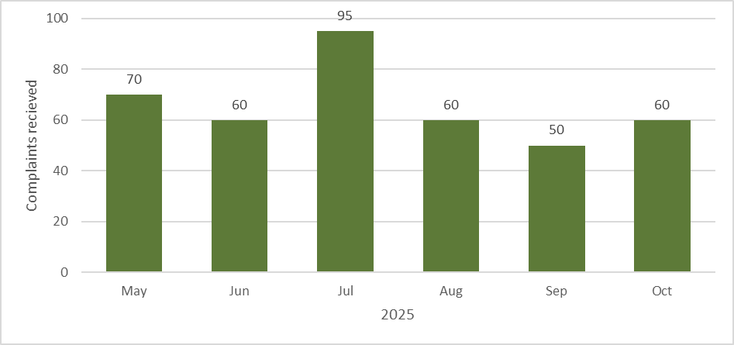

Outcomes and themes in complaints

Complaint outcomes
Complaint outcomes explain how a complaint was resolved for the complainant, including whether evidence was provided to support a complaint or not. The department uses outcomes data as one way to identify and address systemic issues raised through complaints.
An outcome is recorded when a complaint is resolved in our complaint system. As noted in the ‘Our complaints process’ section, a single complaint can raise multiple issues. Because of this, more than one outcome may be captured. Outcomes are reported as proportions because a single complaint case can have more than one outcome recorded.
Outcomes that can be assigned are:
- supported – when action is taken to change something for a complainant, including where evidence is provided or found supporting a complaint.
- unsupported – when evidence is not provided or found supporting a complaint at the time, noting that action may still be taken in response to the content of the complaint.
- information provided – when the complainant is given more information to help them understand employment services policy or program settings, addressing the complaint.
- complaint withdrawn – when the complainant asks us to stop progressing a complaint.
In employment and pre-employment services, if a participant feels like they are not getting the right help from their current provider, they can choose to transfer to a new provider. When a participant is supported by the complaints service to transfer to a new provider, this is recorded as a complaint because it represents dissatisfaction with their current servicing arrangement. It should be noted that a participant transferring to a new provider cannot be assumed to mean their original provider was doing something wrong, but that the service was not the right fit for that individual.
Complaints that are resolved without requiring a response from a provider are handled by the complaints service directly.
When a complaint about the department is received, this is independently investigated by the complaints service. If the complaint is supported, the department may take a range of actions, which could include providing feedback to the appropriate area in the department about the issues raised and opportunities for improvement.
Table 13: Complaint outcomes by proportion of resolved complaints 1 May 25 – 31 Oct 25
Complaint outcome | Proportion of complaints | Change from previous 6 months
Supported | 57% | ↓ 3 percentage points
Unsupported | 24% | ↑ 2 percentage points
Information provided | 25% | ↑ 2 percentage points
Complaint Withdrawn | 1% | No change
Interpreting data on complaint outcomes
The proportions reported in this section may add up to more than 100%. This is because complaints can be assigned multiple outcomes, which means a single complaint may be counted in more than one outcome category.
For example, a person might call the NCSL to make a complaint. During the call, they say they believe their mutual obligation requirements aren’t tailored to their circumstances. They also mention dissatisfaction with the response they received when they contacted their provider to discuss their concern.
The complaints officer handling the complaint might assign an ‘information provided’ outcome if they explain mutual obligation policy to help the complainant understand their requirements, and a ‘supported’ outcome if the provider apologises for the complainant’s earlier unsatisfactory experience. In this example, the single complaint would be counted in 2 separate outcome categories.
It is important to note, when comparing outcomes data in this report to the previous 6 months, that complaints received prior to 1 March 2025 were not required to have outcomes applied.

Complaint supported
A complaint with a supported outcome means there was some evidence to support an issue that was raised, or there was something for the department or a provider to change or fix. About 4 in 7 resolved complaints had a supported outcome. Compared to the previous 6 months, this has decreased.
When a complaint requires input or action from a provider, this is sent to the provider to consider and respond to. The provider is asked to inform the department about any actions they take to address the complaint. When the complainant is notified of the outcome of their complaint, the provider is informed that the complaint has been resolved.
Almost 2 in 3 supported outcomes related to a transfer to another provider, an opt-out from a service, or referral to a more appropriate service. This means that a complainant was unsatisfied with the service they were receiving or not receiving the appropriate service, and the complaints service helped them to find a different provider, exit from a service, or find a more appropriate service.
About 1 in 80 supported outcomes related to a decision made by a provider that did not comply with the Deed or Guidelines of the relevant service. In these cases, the decision was changed or a recommendation made to vary the decision, such as approving a payment or activity. These decisions are also referred to the relevant part of the department for further consideration and action where necessary. If a decision was made under the social security law, the complainant is assisted to contact Services Australia to request a formal review.

Complaint unsupported
A complaint with an unsupported outcome means evidence was not provided or available to support an issue that was raised, a transfer or opt-out could not be actioned at that time, or the complainant could not be contacted for more information after they made the complaint. About one quarter of resolved complaints had an unsupported outcome. Compared to the previous 6 months, this has increased.
About one third of unsupported outcomes related to a transfer or opt-out request that could not be actioned. This could be because a complainant wanted to transfer to a program or service that they were not eligible for, or they requested a transfer to a provider that was too far away or who had a full caseload at the time. Compared to the previous 6 months, this has decreased.
About 4 in 9 unsupported outcomes were recorded because the complainant could not be contacted again after making their complaint.
If we need more information to resolve your complaint
We will make several attempts over several days to contact you using your preferred contact method.
If we cannot contact you, we will resolve the complaint as unsupported for the time being.
If this happens, you are welcome to get back in contact with us to give us more information. We will raise a new complaint and add the new information you provide.
If we can resolve your complaint without needing more information from you, we will.

Information provided
A complaint with an information provided outcome means the complaint was resolved by providing more detailed information to a complainant about policy or program settings, including their mutual obligation requirements. About a quarter of resolved complaints had an information provided outcome. Compared to the previous 6 months, this has increased.
When a complaint is resolved with an information provided outcome, this means that a complainant had a concern about employment services, but things were working the way they were designed to.
Data about information provided outcomes are shared with teams in the department who are responsible for relevant policies and programs, who use it to identify where improvements can be made to the way employment services programs are communicated and explained.

Complaint withdrawn
A complaint with a complaint withdrawn outcome means the complainant asked us to stop investigating their complaint. About one in one hundred resolved complaints had a complaint withdrawn outcome. Compared to the previous 6 months, this has remained the same.
Complainants may ask for their complaint to be withdrawn for a range of reasons and are not required to provide a reason why. Complainants are allowed to make anonymous complaints, and the complaints service can also progress some complaints confidentially, though this may limit what we can do to fully investigate and respond to a complaint.

Themes in complaints
When a complaint is entered into the complaints system, topics are used to identify the main issues raised and who needs to be informed to help address the complaint. Topics are updated over time to capture complaints about new programs and emerging issues.
Topics are grouped together to create themes, which give an idea of what aspects of the employment services system are generating concern. The themes presented in this section are the most common concerns complainants have raised with the service.
Interpreting data on complaint themes
The proportions reported in this section may add up to more than 100%. This is because complaints can be assigned multiple topics, which means a single complaint may be included in more than one theme.
Interpreting the link between topics and outcomes
There is no direct link in our complaints system between individual topics and an individual outcome. Outcomes relate to a complaint case as a whole, not to individual topics or the themes used to group them. When interpreting the outcomes by theme tables in this section, it is important to remember that complaints can have multiple themes and multiple outcomes.
Table 14: Complaint themes by proportion 1 May 25 – 31 Oct 25
Complaint theme | Proportion of all complaints | Change from previous 6 months
Service satisfaction | 84% | ↑ 10 percentage points
Mutual obligations and compliance | 41% | ↑ 19 percentage points
Behaviour | 25% | ↑ 5 percentage points
Funding | 12% | ↑ 2 percentage point
Transfers, referrals and eligibility | 9% | ↓ 1 percentage point
System satisfaction | 8% | ↑ 4 percentage points
Referred to another organisation | 7% | ↑ 4 percentage points
Complaints process | 1% | ↓ 3 percentage points
Privacy | 1% | No change

Service satisfaction
Around 5 in 6 complaints related to a person’s level of satisfaction with a service delivered by an employment services provider, the department, or another organisation or individual. Compared to the previous 6 months, this proportion has increased.
Just over half of complaints included a service satisfaction concern about an employment services provider staff member. This proportion has increased from just over two fifths in the previous 6 months, reflecting more than 1,000 additional complaints. Because most participants in employment services are matched with a Workforce Australia Services provider, it makes sense that when a person has a complaint about employment services it involves a provider staff member. In many cases, the provider staff member is enacting their company or departmental policy, so it is important to recognise that the volume of complaints may not reflect poor performance by individuals.
About 1 in 50 complaints included a service satisfaction concern about a department staff member. While this proportion has doubled compared to the previous 6 months, this reflects only 35 additional complaints.
The most frequent concerns in complaints about service satisfaction included:
- difficulty participants had getting in contact with a provider or the department
- providers not honouring their obligations to participants
- the suitability of jobs that providers referred participants to, or the lack of referrals to jobs.
Table 15: Outcomes by theme 1 May 25 – 31 Oct 25 – Service satisfaction
Theme | Outcome | Proportion of complaints in theme | Proportion of all complaints
Service satisfaction  5,455 complaints | Supported | 59% | 52%
Service satisfaction  5,455 complaints | Unsupported | 21% | 18%
Service satisfaction  5,455 complaints | Information provided | 19% | 17%
Service satisfaction  5,455 complaints | Complaint Withdrawn | 1% | <1%

Mutual obligations and compliance
Just over 2 in 5 complaints related to a person’s mutual obligation requirements or compliance actions resulting from a suspected failure to meet an obligation. Compared to the previous 6 months, this proportion has increased by 19 percentage points.
Just over 1 in 4 complaints related to mutual obligation requirements, such as appointments, job searches and other activities. Compared to the previous 6 months, this proportion has increased by 13 percentage points. These complaints may be because a person had concerns about the appropriateness of their mutual obligation requirements, such as the scheduling of appointments they had to attend, the number of jobs they had to apply for in a reporting period, or the requirement to enrol in and complete training to improve their job readiness.
Just under 1 in 4 complaints related to potential or actual compliance actions. These complaints included concerns about possible payment suspensions (for example, a notification that a payment may be suspended if mutual obligations are not met), re-engagement requirements, or Targeted Compliance Framework decisions. Compared to the previous 6 months, this proportion has increased by 13 percentage points. These complaints may be because a person felt their income support payment should not be paused, or they had a good reason for failing to meet a requirement that was not properly considered.
About 3 in 100 complaints related to a points target, which is the number of points an employment services participant with mutual obligation requirements must earn to meet their requirements in each reporting period. Compared to the previous 6 months, this proportion has increased by one percentage point. These complaints may be because a person thought their points target was not tailored to their circumstances.
Table 16: Outcomes by theme 1 May 25 – 31 Oct 25 – Mutual obligations and compliance
Theme | Outcome | Proportion of complaints in theme | Proportion of all complaints
Mutual obligations and compliance  2,645 complaints | Supported | 50% | 21%
Mutual obligations and compliance  2,645 complaints | Unsupported | 23% | 10%
Mutual obligations and compliance  2,645 complaints | Information provided | 27% | 11%
Mutual obligations and compliance  2,645 complaints | Complaint Withdrawn | 1% | <1%

Behaviour
One quarter of complaints included concerns about the behaviour of another person, such as an employment services provider staff member, department staff member, employer, or job seeker. Compared to the previous 6 months, this proportion has increased by 5 percentage points. About 9 in 10 of these complaints included concerns about unprofessional behaviour by a provider staff member, which has increased by 19 percentage points compared with the previous 6 months.
About 3 in 100 complaints included an allegation of suspected serious misconduct, such as bullying, harassment, discrimination, violence, or sexual misconduct. Compared to the previous 6 months, this proportion has increased by one percentage point. All complaints, especially those involving suspected serious misconduct, are taken seriously by the department.
As noted above, where providers are found to be in breach of their contractual responsibilities, such as by failing to maintain a safe environment for participants, the department will take action in accordance with the Deed and Guidelines.
Table 17: Outcomes by theme 1 May 25 – 31 Oct 25 – Behaviour
Theme | Outcome | Proportion of complaints in theme | Proportion of all complaints
Behaviour  1,640 complaints | Supported | 61% | 17%
Behaviour  1,640 complaints | Unsupported | 20% | 5%
Behaviour  1,640 complaints | Information provided | 17% | <1%
Behaviour  1,640 complaints | Complaint Withdrawn | 1% | <1%

Funding
About 3 in 25 complaints included concerns about funding provided through employment services. Compared to the previously 6 months, this proportion has increased by 2 percentage points. Most of these complaints related to the Employment Fund, which providers and the DSCC can access to purchase a wide range of relevant goods and services to help people find and retain a job.
Most complaints received about funding were about a funding request being declined or delayed by a provider, or what goods and services the funds could be used to purchase. This is consistent with the previous 6 months.
Table 18: Outcomes by theme 1 May 25 – 31 Oct 25 – Funding
Theme | Outcome | Proportion of complaints in theme | Proportion of all complaints
Funding  770 complaints | Supported | 50% | 6%
Funding  770 complaints | Unsupported | 18% | <1%
Funding  770 complaints | Information provided | 31% | <1%
Funding  770 complaints | Complaint Withdrawn | 1% | <1%

Transfers, referrals and eligibility
About 1 in 11 complaints received were about transfers between employment services providers, referrals to different employment services programs, and eligibility for enrolment in a program. Compared to the previous 6 months, this proportion has decreased by one percentage point.
Among complaints about transfers, most were about the process of transferring to a new provider, or a decision about whether a transfer could be actioned. This is consistent with the previous 6 months.
Table 19: Outcomes by theme 1 May 25 – 31 Oct 25 – Transfers, referrals and eligibility
Theme | Outcome | Proportion of complaints in theme | Proportion of all complaints
Transfers, referrals and eligibility  610 complaints | Supported | 50% | <1%
Transfers, referrals and eligibility  610 complaints | Unsupported | 29% | <1%
Transfers, referrals and eligibility  610 complaints | Information provided | 20% | <1%
Transfers, referrals and eligibility  610 complaints | Complaint Withdrawn | 1% | <1%

System satisfaction
About 2 in 25 complaints received were about the Workforce Australia website, smartphone app, or another system used to deliver employment services. Compared to the previous 6 months, this proportion has increased by 4 percentage points. These complaints included concerns about notifications sent by providers and by the department.
Most system satisfaction complaints were about notifications, and these concerns were mostly about notifications not being received, or about the amount of time provided to take an action in a notification. This is consistent with the previous 6 months.
Table 20: Outcomes by theme 1 May 25 – 31 Oct 25 – System satisfaction
Theme | Outcome | Proportion of complaints in theme | Proportion of all complaints
System satisfaction  500 complaints | Supported | 43% | <1%
System satisfaction  500 complaints | Unsupported | 25% | <1%
System satisfaction  500 complaints | Information provided | 30% | <1%
System satisfaction  500 complaints | Complaint Withdrawn | 1% | <1%

Complaints process
About 1 in 100 complaints received were about the complaints process itself. Compared to the previous 6 months, this proportion has decreased by 3 percentage points. This includes complaints about the time taken to resolve a complaint.
Just under half of these complaints were about how the department handled a complaint. This information is used to continuously improve the complaints service.
Table 21: Outcomes by theme 1 May 25 – 31 Oct 25 – Complaints process
Theme | Outcome | Proportion of complaints in theme | Proportion of all complaints
Complaints process  75 complaints | Supported | 41% | <1%
Complaints process  75 complaints | Unsupported | 25% | <1%
Complaints process  75 complaints | Information provided | 34% | <1%
Complaints process  75 complaints | Complaint Withdrawn | 1% | <1%

Referred to another organisation
About 7 in 100 complaints received were more appropriately handled by another organisation. Compared to the previous 6 months, this proportion has increased by 4 percentage points. Complainants are provided information on how to get in contact with the appropriate organisation when a complaint is made about something they have responsibility for.
Most of these complaints were about changes in personal circumstances, including cases where a person needed to be assessed by Services Australia to determine their eligibility for a program or make changes to their mutual obligation requirements. This is consistent with the previous 6 months.
Table 22: Outcomes by theme 1 May 25 – 31 Oct 25 – Referred to another organisation
Theme | Outcome | Proportion of complaints in theme | Proportion of all complaints
Referred to another organisation  475 complaints | Supported | 39% | <1%
Referred to another organisation  475 complaints | Unsupported | 27% | <1%
Referred to another organisation  475 complaints | Information provided | 34% | <1%
Referred to another organisation  475 complaints | Complaint Withdrawn | <1% | <1%

Privacy
About 1 in 100 complaints received were about privacy concerns, including alleged privacy breaches. Compared to the previous 6 months, this proportion has not changed.
Table 23: Outcomes by theme – Privacy 1 May 25 – 31 Oct 25
Theme | Outcome | Proportion of complaints in theme | Proportion of all complaints
Privacy  60 complaints | Supported | 49% | <1%
Privacy  60 complaints | Unsupported | 22% | <1%
Privacy  60 complaints | Information provided | 28% | <1%
Privacy  60 complaints | Complaint Withdrawn | 1% | <1%

What’s next
To continue delivering a user-centred complaint service, we must ensure that all complaints are addressed efficiently without compromising the quality of investigations. Since the establishment of the service in October 2024, we have been monitoring how long it takes to handle and resolve different kinds of complaints. In the months ahead, we will be consulting on performance measures. It is our intention that these performance measures will be incorporated in future reporting.
The first full year of complaints data also provides good insights regarding key areas of focus for improving employment services. The complaints service will continue to identify and monitor issues as they emerge, ensuring that these insights are shared promptly when the data gives any early indication things may not be working as they should. The issue of service satisfaction remains a strong theme in this report, and in the next 6 months, we will work to understand what provider and department staff are doing – or not doing – that may be contributing to service satisfaction complaints.
While there has been a slight increase in complaints since the last report, this represents less than one per cent of participants on the Workforce Australia caseload raising an issue with the department. Further, in recognition of the ‘no wrong door’ approach taken by the complaints service, communications will be enhanced to the public and job seekers over the next 6 months to help improve awareness about the different ways a complaint can be lodged with the department and how the complaints process works. We will also be working in partnership with Services Australia to more effectively communicate the roles and responsibilities of each agency.
Complaints insights are being shared with policy, program, mutual obligations and compliance, and assurance teams in the department. Along with other departmental intelligence sources, complaints data supports potential issues to be identified earlier and in a more systematic way. We are working to incorporate complaints data in other departmental information platforms to provide a more holistic understanding of the day-to-day and strategic operation of the employment services system.
In our next complaints report, progress against these activities will be shared to give confidence to the public and job seekers regarding the operations of the complaints service and to provide transparency in how complaints data is being used to improve the function of our employment and pre-employment services.
If you have a complaint, compliment or feedback, we encourage you to contact us.
We will use what you tell us to address any issues you may have experienced, and to continue to refine what we do, delivering a complaints service for all Australians who engage with employment services.

Appendices

Appendix A: Data used in this report
Data revisions policy
Data are sourced from several departmental systems. Data can be dynamic and there can be delays in transmission of information from the department's employment service providers.
Data are considered to be provisional and may be revised in future publications. Data used in this report were extracted from the system on the dates below:
- Complaint case data was last updated on 31 October 2025.
- Complaint topics data was last updated on 31 October 2025.
- Complaint outcome data was last updated on 31 October 2025.
- Workforce Australia caseload data as at 31 October 2025.
Confidentiality
Data used in this report are treated for confidentiality to uphold the department’s legal obligation to keep personal information protected. The department’s privacy policy and additional information about our commitment to protecting the personal information we hold can be accessed at: https://www.dewr.gov.au/using-site/privacy-notice
To protect the privacy of individuals, all numbers are rounded to the nearest 5. Proportions are calculated using rounded numbers. This may result in non-additivity for some totals. Zero cells are actual zeros.

Appendix B: Glossary of key terms

Abbreviations and acronyms
Term | Definition
App | Application
DSCC | Digital Services Contact Centre
NCSL | National Customer Service Line

Glossary
Term | Definition
Activity | Courses, training, work experience and other programs that help participants in employment services build skills and prepare for work.
Administrative Review Tribunal | An independent body that can review decisions about a Centrelink payment, allowance or benefit that a person affected by the decision doesn’t agree with, if it has first been reviewed by a Centrelink Authorised Review Officer.
Advocacy group | An organisation that works to influence public opinion and policies on specific issues.
Anonymity | The situation in which someone's name is not given or known.
Career Transition Assistance | An employment services program designed to help people 45 years and over to improve their confidence and skills to become more competitive in the local labour market.
Caseload | The total number of individuals enrolled in an employment services program.
Cohort | A group of individuals who share a common characteristic (such as ‘gender’ or ‘age group’).
Commonwealth Ombudsman | The Ombudsman can investigate complaints about actions and decisions of Australian Government agencies to see if they are wrong, unjust, unlawful, discriminatory or just plain unfair. The Ombudsman also seeks remedies for those affected by administrative deficiency and acts to improve public administration generally.
Commonwealth Ombudsman’s Better Practice Complaint Handling Guide | A resource shared by the Commonwealth Ombudsman to help the public service ensure it has effective and customer-focused complaint handling systems. Read the Better Practice Complaint Handling Guide.
Complainant | A person who makes a complaint for themselves or a business.
Complaint outcome | Explains how a complaint was resolved for a complainant, including whether evidence was provided to support a complaint or not.
Complaint receipt methods | How complaints are received by the department, including by telephone, webform, email and letter.
Complaint themes | Patterns or similarities across complaints that highlight the underlying issues people are dissatisfied with.
Complaint Withdrawn | A complaint outcome that means the complainant asked us to stop progressing their complaint.
Complaints process | The steps involved in receiving, assessing, investigating and resolving complaints.
Compliance | In relation to a person, compliance refers to the processes used by the department to check if people receiving income support are meeting their obligations and to encourage them to take action if they are not.  In relation to a provider, compliance refers to whether a provider is meeting requirements under a Deed and Guidelines.
Data confidentiality procedures | Steps taken to protect data from unauthorised access and disclosure, including by protecting personal and private information.
Deed | A Deed is a contractual arrangement between the department and a provider organisation to offer an employment or pre-employment service.
Demerit | A record of an employment services participant’s failure to meet their mutual obligations without a valid reason.
Digital Services Contact Centre | The department’s contact centre that provides support to individuals participating in the Workforce Australia Online program.
Employment Fund | The Employment Fund is a flexible pool of funds available to Workforce Australia Employment Services providers (providers) and staff in the DSCC to offer support tailored to the needs of each person, employer, and the local labour market.
Employment Services Program | A set of measures designed to assist individuals to find and maintain work, and that helps employers to connect with job candidates.
Employment services provider (Provider) | An organisation that has a contract to help individuals find and maintain work by offering job searching assistance, skills development, and support to meet mutual obligation requirements.
Guidelines | Guidelines specify detailed provider obligations to deliver employment and pre-employment services, and support providers to meet their Deed obligations.
Income Support Payment | A regular payment from the government, administered by Centrelink, to help individuals with living costs while looking for work, or when they are unable to fully support themselves.
Job search | The number of job searches (applications) a participant is required to complaint to meet their job search requirement each reporting period.
Job seeker | A person who is actively seeking work and may be receiving an income support payment while doing so.
jobactive | An employment services program that ended in July 2022 and was replaced with Workforce Australia employment services.
Job-ready | When a person has the necessary skills, qualifications, and mindset to effectively perform in a job or industry.
Literacy | A person’s level of ability to read, write, speak and listen.
Minor | A person under the age of 18 years old.
Mutual Obligations Requirements | Tasks and activities that people receiving income support payments must undertake to help them become job-ready or find employment.
National Customer Service Line | The department’s contact centre whose primary responsibility is to provide a point of contact to help people with their employment services enquiries.
No Wrong Door | A principle where any point of contact with the department is acceptable, and individuals are assisted to access the service they need.
Notifications | Messages sent to participants by email, SMS, online platforms or letter.
Parent Pathways | A voluntary pre-employment service that provides personalised assistance and financial support to eligible parents and carers of children up to the age of 6 years, assisting with personal, study or work goals.
Parents Advisory Group | A group of stakeholders including representatives with relevant lived experiences who contribute to continuous improvement of the Parent Pathways service by providing feedback to ensure parents’ needs are met.
ParentsNext | An employment services program for parents and carers of young children that was discontinued in October 2024 and replaced by Parent Pathways.
Payment on Hold | When an income support payment is temporarily held while a participant in an employment services program fixes their missed mutual obligation requirements.
Peak Body | A representative, non-government organisation that acts as a voice for a specific industry.
Points Based Activation System | A system that gives choice and flexibility in how a person meets their mutual obligation requirements, allowing people to complete tasks and activities to earn the points needed to meet an individual tailored points target.
Points target | The set number of points a participant is required to earn and report to meet their points requirement each reporting period.
Privacy breach | Unauthorised access to or disclosure of personal or sensitive information.
Provisional | For the present time but likely to change; temporary.
Re-engagement requirement | A condition that a participant in employment services must engage with their provider within 5 business days if points target or an appointment with the provider is missed, to continue receiving income support payments.
Reporting period | The number of days a participant in employment services has to meet and report their mutual obligation requirements in return for income support.
Resolved | A complaint is resolved when an outcome has been provided to the complainant and the case is finalised in our complaints system.
Self-Employment Assistance | A program designed to help individuals start, develop, and grow a small or micro-business.
Skills for Education and Employment | An employment services program that delivers free language, literacy, numeracy and digital skills training to eligible Australians.
Social Security Law | The Social Security Act 1991 and the Social Security (Administration) Act 1999 govern entitlement to and administration of employment services programs and income support payments.
Stakeholder | An individual, group, peak body or organisation that is affected by the actions, decisions or performance of government program or policy.
Target of a complaint | The person or organisation that a complaint has been made about.
Time-In-Service | The total length of time an individual has been enrolled in an employment or pre-employment services program.
Timeliness benchmark | A performance target that defines how long a process or task should take to be completed.
Transition to Work | An intensive pre-employment and employment service that helps people aged 15–24 into work (including apprenticeships and training) or education.
User-centred design | An approach to designing products, services or systems that prioritises the needs, wants and limitations of the people that will use them.
Vulnerability | A non-vocational circumstance (such as homelessness or domestic violence) that may mean a person needs additional support.
Webform | A digital form on the department's website for complainants to submit a complaint online.
Work for the Dole | An employment services program that offers individuals in Workforce Australia Services work-like experience that builds their skills, while contributing to their local community.
Workforce Australia Online | An employment service program for those determined to be more job-ready and who have the capability to self-manage their mutual obligation requirements online.
Workforce Australia Services | An employment service program that helps individuals to find and maintain secure work by connecting them with a provider who offers a range of support.

Appendix C: 12 months of complaints data
With the publication of this report, we now have 12 months of complaints data available. The graphs below show monthly variations in complaints received, complaint themes and complaint outcomes over the first year of operation of the complaints service.
Figure 14 below shows the number of complaints received each full calendar month since the launch of the service. This figure shows a dip in complaints around the December–January holiday period.
Figure 14: Complaints received by month from November 2024 to October 2025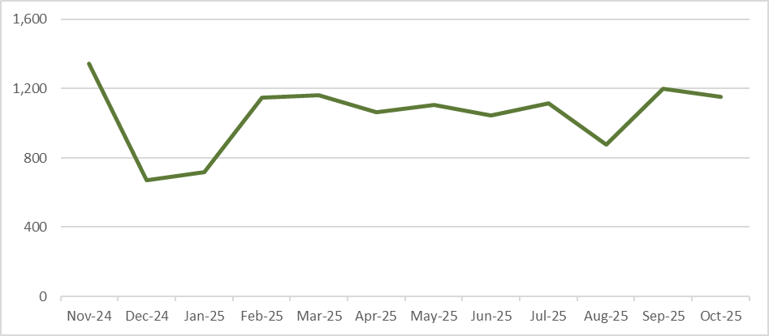
Figure 15 below shows the Top 5 complaint themes each full calendar month since the launch of the service. Service satisfaction complaints have remained the most common in each month.
Complaints can be assigned multiple topics, so a single complaint may be counted in more than one theme at a time. This means that the total number of themes in any single month may not sum to the total number of complaints received in that month.
Figure 15: Top 5 complaint themes by month from November 2024 to October 2025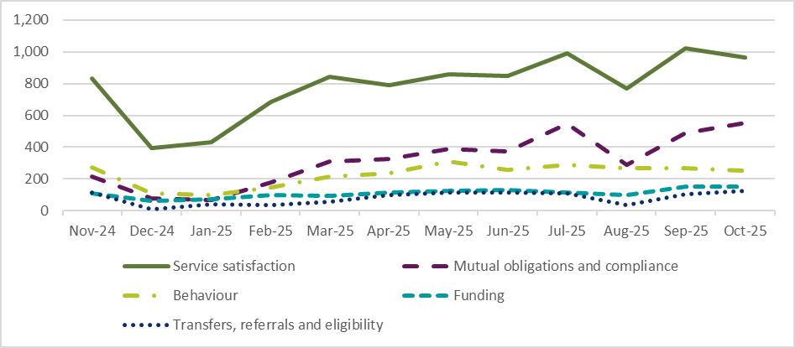

Figure 16 below shows the number of outcomes applied to resolved complaints each full calendar month since the launch of the service.
Complaints can be assigned multiple outcomes, so a single complaint may be counted in more than one outcome category at a time. This means that the total number of outcomes in any single month may not sum to the total number of complaints resolved in that month.
Figure 16: Complaint outcomes by month from November 2024 to October 2025
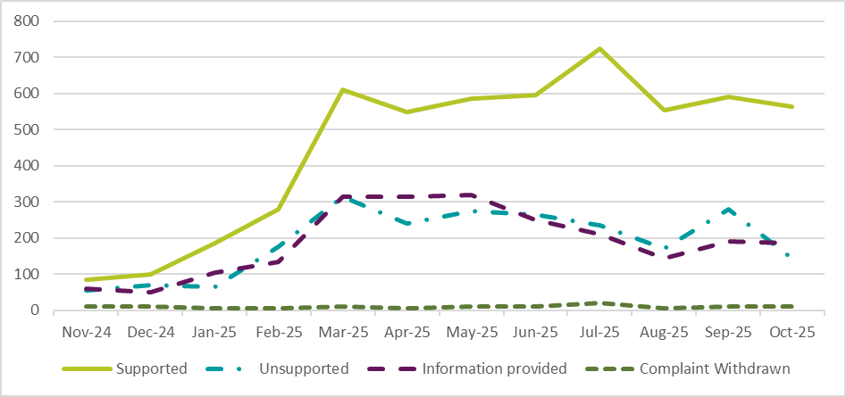Note: Prior to 1 March 2025, outcomes are not available for all resolved complaints. Outcomes were progressively implemented following the establishment of the complaints service on 31 October 2024.

Inclusive Employment Australia replaced Disability Employment Services from 1 November 2025.
Remote Australia Employment Service replaced the Community Development Program on 1 November 2025.
To protect the privacy of individuals, the number and proportion of individuals on the Workforce Australia and complainant caseloads who identify as neither male nor female is withheld.
Changes in caseload proportions between the previous report and this report are indicated by up and down arrows.
Changes in caseload proportions between the previous report and this report are indicated by up and down arrows.
Changes in caseload proportions between the previous report and this report are indicated by up and down arrows.
Changes in caseload proportions between the previous report and this report are indicated by up and down arrows.
Some people on income support with mutual obligations may be referred to Inclusive Employment Australia or the Remote Australia Employment Service, depending on their circumstances.
This includes a small number of complaints received in the previous reporting period.
The proportions reported in this table may add up to more than 100%. This is because complaints can be assigned multiple topics, which means a single complaint may be included in more than one theme.
The proportions reported in this table may add up to more than 100%. This is because complaints can be assigned multiple topics, which means a single complaint may be included in more than one theme.
The proportions reported in this table may add up to more than 100%. This is because complaints can be assigned multiple topics, which means a single complaint may be included in more than one theme.
Due to the small number of complaints relating to Parent Pathways, themes are not reported where they could be identifying.
The proportions reported in this table may add up to more than 100%. This is because complaints can be assigned multiple topics, which means a single complaint may be included in more than one theme.

