
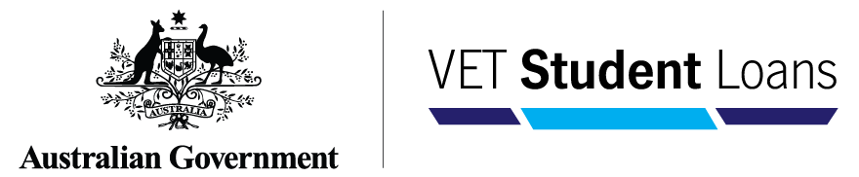

VSL course caps indexed amounts
Maximum loan amounts for VSL courses are indexed annually on 1 January in line with the
VET Student Loans (Courses and Loan Caps) Determination 2016.
The maximum loan amounts for 2026 have been finalised. These will apply to all units of study (new and continuing VSL students) with a census day of 1 January 2026 or later.
When you adjust your tuition fees for 2026, including increasing fees to reflect the indexed amounts, you must publish the new tuition fee schedule on your website.
You must ensure that tuition fees charged to students align with fees prescribed in the issued Statements of Covered Fees and Fee Notices. The tuition fees must not exceed the maximum tuition fees specified in a student’s eCAF application for a VET Student Loan. Any changes to a continuing student’s VET Student Loan amount must be discussed and agreed with the student and new Statements and Notices issued as required.
Table 1: VET Student Loans (Course and Loan Caps) Determination 2016 – Loan amounts indexed for 2025 and 2026
 | 2025 ($) | 2026 ($)
Band 1 (Part 1, Schedule 1) | 6,278 | 6,428
Band 2 (Part 2, Schedule 1) | 12,557 | 12,858
Band 3 (Part 3, Schedule 1) | 18,838 | 19,290
Specific (Schedule 2) | 94,207 | 96,467
The 2026 maximum loan amounts indexation has been applied in line with the consumer price index (All groups CPI, index numbers, weighted average) for the relevant December quarters, which is available at the Consumer Price Index, Australia, June Quarter 2025 | Australian Bureau of Statistics.

9 September 2025

