

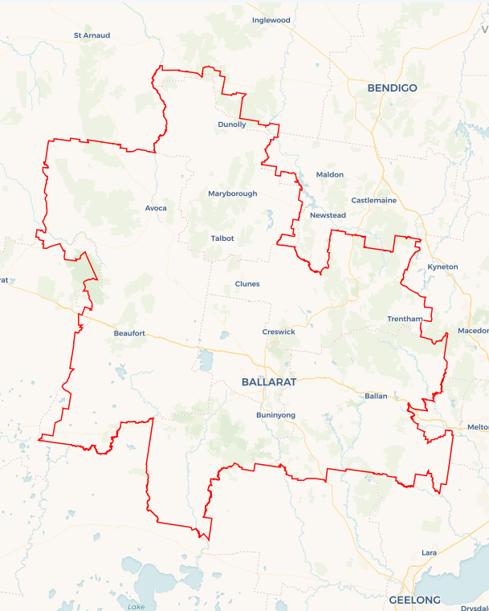Local Jobs Plan

Ballarat Employment Region | VIC | January 2023

Workforce Australia Local Jobs (Local Jobs) is a program that supports tailored approaches to accelerate   
reskilling, upskilling and employment pathways in response to current and emerging local workforce needs.

## Local Jobs elements

### Local Jobs Plan

The Local Jobs Plan sets out the skills and employment challenges and priorities of the region, and associated strategies that will drive the design and implementation of activities to be implemented to address these challenges.

### Employment Facilitators

Employment Facilitators and Support Officers support the delivery of the program by bringing together key stakeholders including businesses, employment services providers, higher education, and training organisations.

### Local Jobs and Skills Taskforce

Each Employment Region has its own Taskforce. Representatives include local stakeholders who have demonstrated experience in upskilling, reskilling, and an ability to represent, connect and collaborate with others in the region to meet labour market needs.

### Local Recovery and National Priority Funds

The Local Recovery Fund supports projects that meet the priorities identified in the Local Jobs Plan. The National Priority Fund provides funding for innovative local solutions to address structural barriers to employment.

Explore labour market insights for the  
[Ballarat](http://www.jobsandskills.gov.au/work/monthly-labour-market-dashboards) Employment Region

## Local labour market challenges in the region

* **Mature age** **-** Mature age participants may face specific challenges to gaining employment due to their age and the changed labour market. Barriers may include age discrimination, difficulty accessing training and difficulty arranging flexible work opportunities.
* **Youth****-** For many young people the transition from school to work was disrupted by the COVID-19 pandemic. These young people may face multiple barriers to entering the workforce including a lack of access to career guidance, limited work experience and part-time job opportunities, and the casualisation of available positions.
* **Aboriginal and Torres Strait Islander peoples -** Indigenous Australians tend to have higher unemployment rates than non-Indigenous Australians in the Ballarat region. Reasons for lower employment rates may be due to lower levels of education, skills and training, job retention, health and discrimination.
* **Transport -** Participants located in smaller local government areas, including Golden Plains, Hepburn, Moorabool, and Pyrenees Shire have limited access to public transport which can be a barrier getting to and from the workplace. Participants in these locations also have limited access to driver licence initiatives.
* **Females -** Women may face additional barriers finding suitable and sustainable employment due to the availability and cost of childcare, caring responsibilities, work-life balance, pay inequality, lower wages in female dominated industries and lack of flexible working arrangements.
* **People with disability -** Working-aged people living with a disability are unemployed longer and may experience several unique barriers and challenges, including discriminatory attitudes during recruitment, a lack of understanding of the supports available, difficulties negotiating reasonable adjustments in the workplace and flexible working arrangements, and limited access to transport.

## Local jobs and skills priorities and strategies in the region

### Priority 1 – Maximise the benefits of existing Australian, Victorian, and local government programs, to create pathways into major industries

### What are our challenges and opportunities?

It can be difficult for participants and employers to navigate the programs and pathways available to upskill and reskill participants to meet the demand for major industries.

### How are we responding?

* Maximising the extent to which local positions are filled by local participants to meet the needs of major infrastructure projects.
* Promoting existing programs to enhance local employment and training opportunities.
* Collaborating with Workforce Australia Employment Services Providers to connect participants to suitable services to better prepare them for employment.
* Engaging with organisations to identify and link participants to suitable local vacancies to promote sustainable employment outcomes.

### Priority 2 – Maximise the extent to which local participants are skilled to meet the needs of major projects, including large infrastructure projects and redevelopment works, to generate opportunities for skill development aligned to local employer and industry needs

### What are our challenges and opportunities?

Participants are oftenunder skilled to meet local employer demands in industries such as manufacturing, retail trade, accommodation and food services, aged care, information and communications technology, and administration and support.

### How are we responding?

* Co-designing programs in partnership with Workforce Australia Employment Services Providers and employers to promote sustainable employment outcomes for participants.
* Engaging with organisations to identify and link participants to suitable local vacancies to promote sustainable employment outcomes.
* Collaborating with local Indigenous organisations to develop strategies to improve engagement in training and employment opportunities.
* Targeting opportunities aligned to Strategic and Economic Development Plans such as capital work projects with local councils.
* Promoting transferable skills across all industries, with a focus on sectors with critical workforce shortages.
* Developing new and innovative ways for businesses and participants to connect and removing barriers to sustainable employment.

### Priority 3 – Broker opportunities for youth skill development and employment, including apprenticeships and traineeships

### What are our challenges and opportunities?

Young people in the Ballarat region may have limited qualifications and work history, as well as a limited knowledge of career pathways into employment. There are also high levels of unmet demand for entry-level workers in growth employment areas such as hospitality and tourism, business, construction, manufacturing and aged and disability care.

### How are we responding?

* Collaborating with Workforce Australia Employment Services Providers, Transition to Work Providers and the Australian Apprenticeships Service Network to promote apprenticeship and traineeship pathways as sustainable employment outcomes for participants.
* Maximising the extent to which local entry level positions are filled by youth participants.
* Engaging with large-scale infrastructure and development projects to identify and link participants to suitable local vacancies to promote sustainable employment outcomes.

### Priority 4 – Engage with, support, and skill disadvantaged mature aged, Aboriginal and Torres Strait Islander and female participants

### What are our challenges and opportunities?

### Mature aged, Aboriginal and Torres Strait Islander and female participants may experience disadvantage gaining employment due to the location of jobs, employer discrimination and structural changes in the labour market. There is an opportunity to boost employment and training in priority areas in collaboration with existing local organisations, including to support ongoing Closing the Gap targets.

### How are we responding?

* Collaborating with Workforce Australia Employment Services Providers to better prepare participants for employment and address barriers.
* Maximising the extent to which local positions are filled by local participants, to meet the needs of major infrastructure projects.
* Engaging with local Indigenous organisations to develop strategies to improve engagement in training and employment opportunities.
* Promoting existing programs to enhance local employment and training opportunities.
* Engaging with organisations to identify and link participants to suitable local vacancies to promote sustainable employment outcomes.

## Want to know more?

* Contact: Margi Cousins, Ballarat Employment Facilitator: [margi.cousins@ballaratemploymentfacilitator.com.au](mailto:margi.cousins@ballaratemploymentfacilitator.com.au)
* Visit: [Local Jobs](https://www.dewr.gov.au/local-jobs) or [Workforce Australia](https://www.workforceaustralia.gov.au/)