

**Local Jobs Plan**

**Fitzroy Employment Region**

**Queensland**

April 2022

Contents

The Local Jobs Program 3

Key employment and training priorities 3

Employment Region Overview 4

Key challenges in the Fitzroy region 9

Local Stakeholders and Opportunities 11

Attachment A: Key Priorities 15

Attachment B: Labour Market Data Dashboard – April 2022 17

The Department of Education, Skills and Employment acknowledges the traditional owners and custodians of country throughout Australia and their continuing connection to land, waters, and community. We pay our respects to them and their cultures, and Elders past, present and emerging. We acknowledge and respect the many traditional owner groups and custodians of country within the Fitzroy Employment region and we acknowledge the Darumbal People on whose land this Local Jobs Plan was written.

# The Local Jobs Program

As part of supporting Australia’s economic recovery from the COVID-19 pandemic, the Australian Government’s Local Jobs Program (LJP) brings together expertise, resources, and access to funding at the local level to accelerate reskilling, upskilling and employment pathways in 51 Employment Regions.

Recognising the importance of local knowledge in getting people back into jobs quickly, the LJP includes the following key elements in each region:

* a local Employment Facilitator
* a Local Jobs and Skills Taskforce
* a Local Jobs Plan
* a Local Recovery Fund to support small scale activities
* access to the National Priority Funding Pool.

The Taskforces, each chaired by the respective region’s Employment Facilitator, develop, and update a Local Jobs Plan for their region that identifies key employment and training priorities and provides a framework for driving employment outcomes in the context of the local labour market.

This Local Jobs Plan for the Fitzroy Employment Region identifies the key LJP priorities with a focus on creating employment opportunities, actively upskilling or reskilling local job seekers and meeting local employer demands.

# Key employment and training priorities

1. Collaborate, co-ordinate and utilise current programs and funding to identify, upskill, and place appropriate job seekers within the Fitzroy ER into industries experiencing on-going labour shortages, namely:
   1. Agriculture, Forestry and Fishing
   2. Mining
   3. Health Care and Social Assistance
   4. Manufacturing
   5. Construction
   6. Tourism & Hospitality
2. Increase the number of young job seekers aged between 15 and 24 to undertake apprenticeships and traineeships to fill current and emerging employment opportunities across the region by improving their employability and suitability for vacancies.
3. Leveraging new and existing programs through collaboration and communication to increase employment pathway opportunities through training and upskilling for:
   1. Indigenous job seekers
   2. Mature Aged job seekers
   3. Job seekers with a Disability
   4. Long-Term Unemployed (12 months and above).

A full description of these key priorities, the strategies to address them and a list of key stakeholders can be found at Attachment A.

# Employment Region Overview

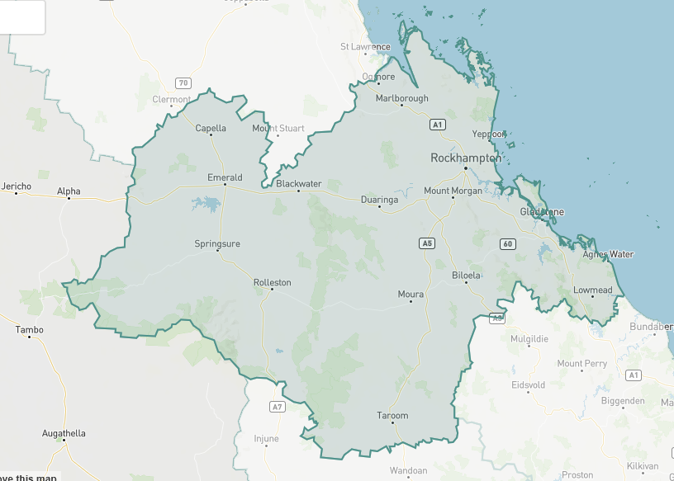

Situated between the Mackay ER in the north and Darling Downs, Wide Bay and Sunshine Coast ER’s in the south, the Fitzroy ER has a total land area of 117,588.0 km², an average daily temperature range of 14.9°C to 28.2°C and an average annual rainfall of 711mm.

Fitzroy has six Local Government Areas (LGAs): Rockhampton, Gladstone, Livingstone, Central Highlands, Banana, and Woorabinda. The largest cities/towns in each area being

Rockhampton, Gladstone, Yeppoon, Emerald, Biloela and Woorabinda.

Population distribution and median age

On 30 June 2020, according to the ABS, the Fitzroy ER had an estimated population of 228,264 persons. Rockhampton had the largest population of 81,999, followed by Gladstone with 63,861 persons. However, Livingstone Shire had the fastest growth over the previous five years with the average annual growth rate of 1.1%.

**Figure1: Estimated resident population by LGA, Fitzroy Employment Region and Queensland**

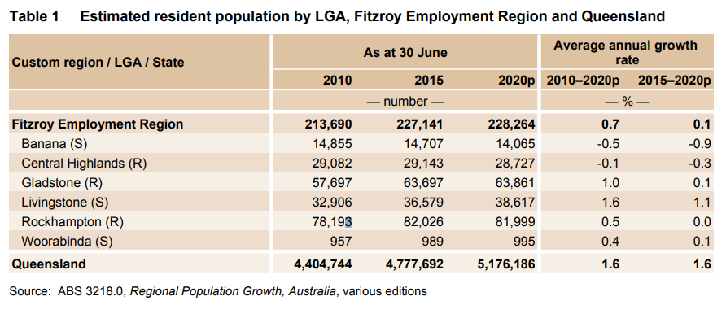

On 30 June 2019, the median age in the ER was 36.8 years, which represents an increase of 1.8 years from ten years earlier and is below the Queensland average of 37.4 years.

**Figure 2: Median age by LGA, Fitzroy Employment Region and Queensland**

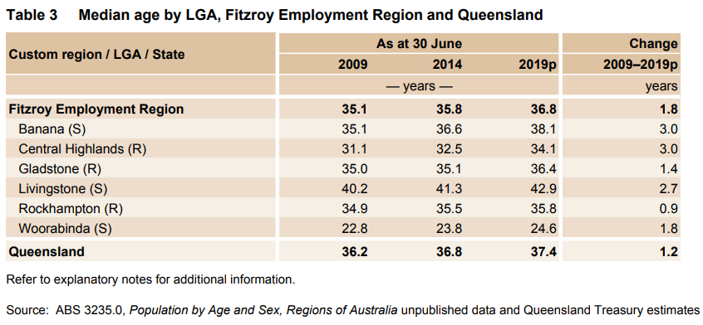

Source: ABS 3235.0, Population by Age and Sex, *Regions of Australia* unpublished data and Queensland Treasury estimates.

**Schooling completion rates**

An understanding of education levels in each LGA is critical for assessing the effectiveness and feasibility of any proposed training and development strategies. The percentage of students with the highest level of schooling of year 11 or 12 is 49.9%. Gladstone had the largest percentage at 52.7%. This indicates that high school completion rates in the ER are still lower than the Queensland average of 58.9%. As a result, any training strategies may need to focus on foundation skills to ensure that participants can successfully compete their training, particularly any non-school qualifications.

**Figure 3: Highest level of schooling completed by LGA, Fitzroy Employment Region and Queensland, 2016**

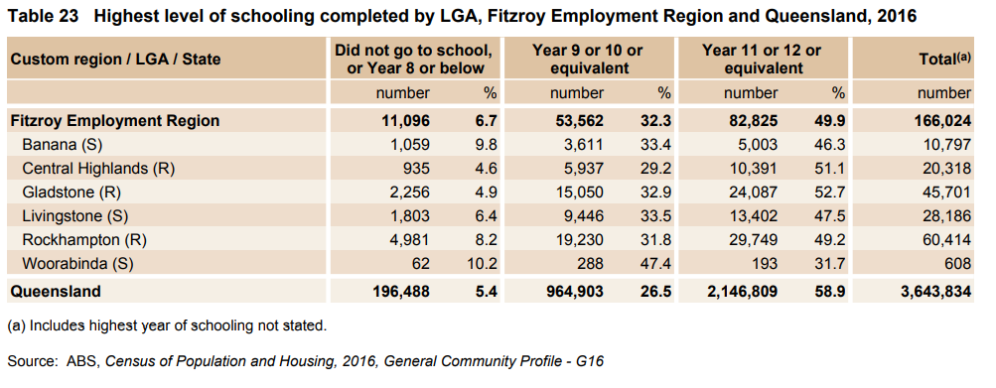Many entry level jobs across the region now require a minimum Certificate qualification and it is hoped the number of people with a non-school qualification will increase over the coming years.

Labour market characteristics

The Fitzroy ER contains four Statistical Area 3 regions (SA3) according to the ABS, which all have different labour market characteristics; Rockhampton, Gladstone, Central Highlands and Biloela.

**Rockhampton SA3 region - Labour market overview**

Rockhampton is known as the gateway to the west and the beef capital of Australia. The Beef industry is one of the main industries in the Rockhampton region. There are two beef processing plants or meat-works located in Rockhampton, which are operated by Teys Australia and JBS Swift.

The largest employing industries in the area (by number of people) are Health Care and Social Assistance; Construction; Retail Trade; Education and Training; and Tourism and Hospitality. Rockhampton has the largest population of the three regions and is the retail and support hub for the ER, with the largest road, train, and air hubs, shopping centres and hospitals in the region.

The Stanwell Power Plant is a major employer in the Rockhampton region, employing 717 full time equivalent direct employees. The Queensland Government also recently granted approval for the development of a hydrogen plant at Stanwell.

Rockhampton is also a part of the Regional Manufacturing Hubs program established in 2018, specialising in rail manufacturing and technology, advanced technologies for metal production and food product innovation.

The Rockhampton region also includes the Capricorn Coast which consists of Yeppoon, Emu Park, Byfield Forest and Shoalwater Bay. The main industries are Tourism and Hospitality, Construction, Retail Trade, Manufacturing and Agriculture. The area is known for its pineapples and other tropical fruits, as well as being a gateway to the Southern Great Barrier Reef.

**Gladstone SA3 region - Labour market overview**

Gladstone has a large natural deep harbour which permits the import and export of goods and commodities. The Gladstone Port Authority reports that last year the largest imported commodity was bauxite, with coal being the largest export.

Gladstone is part of Queensland’s Industry and Manufacturing Hub Programs, specialising in biofuels, hydrogen and renewable energy.

Queensland Alumina Ltd, owned by Rio Tinto and Rusal, is the largest alumina processing plant in the southern hemisphere with the capability to produce 3.95 tons of alumina each year.

Other manufacturing companies in Gladstone include Cement Australia, NRG Gladstone Power Station and the Boyne Smelters where alumina is smelted into aluminum. The unemployment rate in Gladstone has been higher than the state average since the conclusion of the construction of the liquefied natural gas projects in 2015.

**Central Highlands SA3 region - Labour market overview**  
The main industries in the Central Highlands region are the Resource sector, predominately located in the Bowen and Galilee Basin and Agriculture. The Agricultural industry includes beef, grains, macadamias, cotton, grapes, melons, and citrus. Another industry the Central Highlands relies on is, Tourism, with many popular tourist attractions in the region such as Carnarvon Gorge, the Sapphire Gemfields and the Australian Coal Mining Museum, which attracts tourists from all over Australia exploring the past, present and future of the Australian coal mining industry.

**Biloela SA3 region - Labour market overview**

Beef, Agriculture, Energy and Mining are the largest employing industries in the Biloela area.

Beef is supported by the operation of Teys Australia located on the outskirts of Biloela. Teys is actively involved in resettlement of refugees to stabilize the workforce.

Agriculture has always been a big part of Biloela and the Callide Valley and continues to be one of the main industries in the region. With both irrigation and dryland farming there is a vast range of produce grown in the area, such as lucerne, cotton, sorghum, wheat, legumes and herbs.

There are two coal mines located in the Callide Valley which supply coal to the Callide Power Station.

Major employing industries

As of February 2022, the largest employing industries in the Fitzroy ER collectively account for over 50% of all employment in the Fitzroy ER. These include Health Care and Social Assistance, Construction, Agriculture, Forestry and Fishing, Mining and Retail Trade. Public Administration and Safety, Manufacturing, and Accommodation and Food Services are all around half the size of the largest employing industry, Health Care and Social Assistance, at just over 6% each.

**Figure 4: Share of employment by industry in Fitzroy ER, February 2022**

|  |  |  |
| --- | --- | --- |
| **Share of Employment by Industry, February 2022, Fitzroy** | | |
|  |
| **Industry** | **Fitzroy** | **Queensland** |  |
| Health Care and Social Assistance | 13.20% | 15.10% |  |
| Construction | 10.70% | 8.80% |  |
| Mining | 9.50% | 2.90% |  |
| Agriculture, Forestry and Fishing | 8.60% | 2.60% |  |
| Retail Trade | 8.40% | 9.70% |  |
| Public Administration and Safety | 6.90% | 6.20% |  |
| Education and Training | 6.80% | 8.40% |  |
| Accommodation and Food Services | 6.60% | 7.80% |  |
| Manufacturing | 5.60% | 7.20% |  |
| Other Services | 5.30% | 4.20% |  |
| Administrative and Support Services | 4.80% | 3.10% |  |
| Transport, Postal and Warehousing | 4.60% | 5.10% |  |
| Professional, Scientific and Technical Services | 3.20% | 7.80% |  |
| Wholesale Trade | 2.20% | 2.70% |  |
| Electricity, Gas, Water and Waste Services | 1.20% | 1.20% |  |
| Rental, Hiring and Real Estate Services | 1.10% | 2.10% |  |
| Arts and Recreation Services | 0.80% | 1.50% |  |
| Information Media and Telecommunications | 0.50% | 1% |  |
| Financial and Insurance Services | 0.10% | 2.70% |  |
| Source: ABS Labour Force, Detailed, February 2022, four-quarter averages. |  |  |  |
| Caution: These data can be subject to significant statistical variability and should be interpreted with care. For more information see the download file available from the Data Downloads page. | | |  |

# 

# Key challenges in the Fitzroy region

**COVID-19 pandemic**

Like the rest of Australia, the Fitzroy ER was initially affected in March 2020 by COVID-19 and the required lockdowns and restrictions. Businesses whose main industry were Retail, Services Sector, Hospitality, Entertainment, and Community Support were forced to either lay off workers or cut their hours. Many employers across the region supported their staff with the use of JobKeeper payments where possible, and for as long as possible.

Investment by both Commonwealth and State governments in infrastructure projects in the region such as the Rockhampton Ring Road, Rookwood Weir and upgrades to the Shoalwater Bay Defence Training Area have supported employment.

However, not all industries have recovered from COVID-19 restrictions and are finding it hard to attract employees, such as the Agricultural industry, who have historically relied on backpackers for the harvesting of some crops.

The Tourism and Hospitality industry which has been directly affected by the pandemic is also experiencing staff shortages. Labour supply from international students and other overseas visitors has dried up due to pandemic travel restrictions, which has impacted staffing in this largely casual workforce. Restrictions and lockdowns have hit this industry hard with restaurants and cafés in some cases having to change the hours they operate or even close.

The staff shortages in the Health, Aged and Community Care sector have been exacerbated by the pandemic, specifically in times of outbreak, pushing nursing and personal care workers to exhaustion as they cover multiple shifts to cope with other staff in isolation.

The recent Rockhampton Jobs Fair showed that vaccination rates were on ongoing issue. Over 300 job seekers attended the day in March 2022 perusing over 1,200 jobs from employers that were currently employing. More than a third of these jobs were in the Health, Aged and Community Care sector. The main feedback from ESP’s as to the reason more didn’t attend was the large amount of job seekers that were not fully vaccinated, a mandate on the venue.

According to <https://www.health.gov.au/resources/publications/covid-19-vaccination-geographic-vaccination-rates-sa4-19-april-2022> the Australian Government’s SA4 Covid-19 Geographic Vaccination Rates, as at 19 April 2022 for Central Queensland (SA4), over 91% of people were double vaccinated in the region. This falls to 56.8% of people receiving their booster shot, which is essential to be fully vaccinated, and mandatory to work in the Health and Education sectors.

**Schooling completion and non-school qualification rates**

An understanding of education levels in each LGA is critical for assessing the effectiveness and feasibility of any proposed training and development strategies. According to the Australian Bureau of Statistics, Census of Population and Housing, 2016, General Community Profile, the percentage of students in the region with the highest level of schooling of year 11 or 12 is 49.9%. Gladstone had the largest percentage at 52.7%. Woorabinda had the lowest completion rate at 31.7%. This indicates that high school completion rates in the ER are still lower than the Queensland average of 58.9%.

Non-school qualifications describe the highest non-school qualification (e.g. bachelor degree, diploma) completed as stated in the 2016 Census of Population and Housing. This information is based on persons aged 15 years and over. In the Fitzroy ER, 55% of persons have completed a non-school qualification, compared to the Queensland state average of 59.1%. The Livingstone LGA had the largest percentage of people with a non-school qualification at 57.5%.

Individuals without Year 12 is a reliable indicator of disadvantage in people aged 15 years and over whose highest level of education is Year 11 or lower (includes Certificate I and II). Low levels of language, literacy and numeracy, as well as limited digital literacy, impacts training and education engagement and completion rates.

Internet access is also patchy across the Fitzroy ER. Although internet access is good in Rockhampton and Gladstone, outside the major population areas, access can be poor, making it difficult for job seekers to access online services including training.

**Long Term Unemployed (12months+)**

The continued growth of the Long-Term Unemployed cohort in the Fitzroy ER is of particular concern in the Region. LJP caseload data as of 31 March 2022 states that 76.7% of all participants in JobActive, Transition to Work (TTW) and ParentsNext have been registered with Employment Services for over 12 months. The de-casualisation of employment in the Fitzroy ER as well as focusing on unskilled, entry level employment opportunities will go a long way to help address this issue.

**Youth unemployment**

According to the Queensland Government Statisticians Office, the youth unemployment rate in the Fitzroy ER was 7.5% in March 2022 down from 10.3% in March 2021. While this is significantly less than the Queensland rate of 10.2% Pin March 2022, this cohort of youth are the most disadvantaged, with multiple barriers to employment including housing, low levels of literacy and numeracy, mental health and transport issues, and still represent a large proportion of the caseload – 20.5%. Youth in the Fitzroy ER are more likely to be employed in insecure casual employment within Retail 21.3% and Accommodation and Food Services 20.7% with a combined 42% of youth aged 15-24 employed in these industries.

**Homelessness**

There were 929 people who were experiencing homelessness in the Central Queensland Region according the to 2016 Census. Of these 126 were young people, accounting for roughly 14% of the total homeless population. Of those young people, 42% identified as Aboriginal and Torres Strait Islander or both.

Housing availability and affordability is an issue across the Fitzroy ER. The Residential Tenants Authority (RTA) advised that the average weekly price for a 3-bedroom house rental in the December 2021 quarter by LGA was: Rockhampton $370, Gladstone $330, the Central Highlands $320, Banana $380 and Livingstone LGA the most expensive to rent at $400. According to the Real Estate Institute of Queensland, Rockhampton recorded one of the lowest rental vacancy rates for the state in the December 2021 quarter at 0.4%. Gladstone was a little higher at 1.2%, but both were well below the average QLD rate of 1.8%. With rental vacancy rates so low and prices so high, it is no surprise that those on government assistance are driven to outlying areas with cheaper rent such as Mt Morgan (40kms from Rockhampton) which is $250 a week on average for a 3-bedroom house. Transport to employment opportunities then becomes an issue, with little to no public transport available.

**Limited access to transport**

The geographical makeup of the Fitzroy ER is a challenge within itself. Population centres are quite dispersed throughout the region, often requiring an overnight stay to visit another major town/city. This can prevent local job seekers from undertaking education and accessing employment opportunities. Public transport in the region is restricted and, in some areas, not available at all. Routes and timetables in the region are limited and often incompatible with the location and shift times of available employment opportunities. This is especially prevalent in manufacturing and processing roles as well as tourism, hospitality and retail where shifts often finish late with no public transport available at those times.

A current snapshot of the Fitzroy ER Labour Market can be found at Attachment B.

# Local Stakeholders and Opportunities

There are six local government councils in the Fitzroy ER: Rockhampton Regional Council, Livingstone Shire Council, Gladstone Regional Council, Central Highlands Regional Council, Banana Shire Council and Woorabinda Aboriginal Shire Council.

Significant stakeholder groups within Fitzroy include Advance Rockhampton, Capricorn Enterprise, Central Highlands Development Corporation, Construction Skills Queensland, Gladstone Area Ports and Development Limited, Queensland Agriculture Workforce Network, Regional Development Australia, Central and Western Queensland Region, State Government Departments such as the Department of Employment, Small Business and Training (DESBT), the Department of Regional Development, Manufacturing and Water, the Department of Seniors, Disability Services and Aboriginal and Torres Strait Islander Partnerships and the Department of Premier and Cabinet. Given the existing local partnerships, the Fitzroy Local Jobs Team is regularly collaborating with Local and State Government Departments and other stakeholders to develop local approaches to employment in the region. Industry specific taskforce meetings are being held utilising the experience of specific stakeholders being brought in as guests/specialists in the industry, to present data and answer questions about how we can better service that industry.

There are seven Australian Government employment programs delivered by 11 employment services providers (ESP’s) in the region. JobActive will finish on 30 June 2022 and is now being transitioned into the new Workforce Australia model which will commence on 1 July 2022. Three providers will deliver Workforce Australia services in the region: Community Solutions, MAX Employment and MRAEL. Other employment services in the region include ParentsNext, Transition to Work (TtW), New Enterprise Incentive Scheme (NEIS), Career Transition Assistance (CTA), Employability Skills Training (EST), Time to Work Employment Services (TWES) and the Entrepreneurship Facilitator.

All ESPs have a physical presence throughout the region, with either full-time, part-time or outreach hours to support job seekers and program participants. Most ESPs have physical offices staffed full-time in Rockhampton and Gladstone, apart from the Entrepreneurship Facilitator who travels regularly throughout the ER. Outside Rockhampton, physical locations are in key regional towns namely Emerald, Biloela, Yeppoon, Agnes Water and Mount Morgan. All ESPs service the discrete Aboriginal community of Woorabinda, on an outreach basis.

Other Australian Government programs include Disability Employment Services (DES), Disability Management Service (DMS), Employment Support Service (ESS), National Disability Insurance Scheme (NDIS) and Australian Apprenticeship Support Network (AASN).

A number of labour hire and private recruitment companies also operate within the Fitzroy ER.

Education providers include Central Queensland University (4 campuses in the region) and Registered Training Organisations (RTO)’s such as TAFE Queensland, Designer Life, Axiom College, Occupational Skills Centre Australia, Narbil Training, DTE Training and Safety, Civil Safety among many more. RTOs are primarily located within populated areas such as Rockhampton and Gladstone which makes it difficult to get education/training in the smaller town centres if you don’t have access to transport or the ability to attend courses within the Gladstone and Rockhampton areas.

**Employment Service Provider (ESP) caseload composition, March 2022**

Fitzroy ER has a significantly high number of job seekers who identify as Indigenous – 3,385 (26.9%), mature-aged – 3,035 (24.1%) and people with disability – 3,521 (28%) according to the Fitzroy ER, LJP Caseload Data (31 March 2022) in Figure 5.

Indigenous people face a number of barriers to employment. The location of jobs, employer discrimination and lack of work experience impact on Indigenous people’s chance of finding employment. Additional barriers include health/mental health issues and low levels of literacy and numeracy due to low school, further education or training completion rates. Caring responsibilities can further limit participation. Concepts to start to address these barriers would include life skills training contextualised to the cohort (i.e. a classroom environment doesn’t always work), cultural training for employers and ongoing holistic mentoring for not only the job seeker but their family.

Barriers job seekers with disability face include inaccessible workplaces, misinformed attitudes towards disability (i.e. people with disability are costly to employ and are less productive than people without disability), employers’ lack of understanding and confidence to talk about disability and its impact on those who currently work, and who might work, in their organisations. Employers may also have concerns around potential risks, including superannuation implications, Workcover costs and exclusions. Some of these barriers are real and some are perceived, but it is clear that a lot more education needs to be done to change mindsets as people with disability have significant potential that can be brought to the workforce in a wide range of industries and positions.

The mature age cohort represents almost a quarter of the caseload in Fitzroy and have their own specific barriers to gaining employment. Age discrimination occurs regularly with younger staff being cheaper to employ and, in some cases, the mature aged are perceived to be set in their ways and not willing to learn. Other barriers include lack of digital literacy, low levels of literacy and numeracy, care-giving responsibilities, inflexibility of employment arrangements, physical illness, injury and disability among others. Employers may overlook a mature aged candidate, even though those over 55 are often found to more reliable and loyal workers.

The culturally and linguistically diverse (CALD) and refugee cohorts reflected in the caseload are indicative of the low number of CALD people in the region, although the meat processing plants in Rockhampton and Biloela have historically employed significant numbers of migrant labour. It is hoped that the recent lightening of restrictions including international travel will bring back more CALD people to the region.

**Figure 5: Fitzroy ER, LJP Caseload Data (30 April 2022)**

|  |  |  |
| --- | --- | --- |
| Employment Service Provider cohort (inc. Online Employment Services (OES), New Employment Services Trial (NEST), Transition to Work (TTW) & ParentsNext) | Number of job seekers | Percentage of JobActive caseload |
| Indigenous | 3,326 | 26.8% |
| Culturally and Linguistically Diverse (CALD) | 367 | 3.0% |
| Person with a disability (PWD) | 3,424 | 27.6% |
| Refugee | 35 | 0.3% |
| Youth (15-24 years) | 2,496 | 20.1% |
| Mature Age (50+) | 3,026 | 24.4% |
| Parents | 3,492 | 28.1% |
| + 12 months4 | 9,459 | 76.2% |
| Total caseload | 12,406 |  |

**Source:** Fitzroy LJP Data – Provided by DESE not publicly released, April 2022.   
**Data disclaimer:** Data is regularly changing and should be only considered as an indication of characteristics at the time of publication. Data is expected to change and should be reviewed and referenced no less than every quarterly reporting period.

(1) The Employment Region and Local Government Areas (LGA) are mapped using the participants residential address, with a small number of participants with an Employment Region or LGA of 'Not Stated', these are addresses either not able to be mapped to an Employment Region/LGA, or their address is not recorded. These may differ slightly from caseload figures that use provider address.

(2) Caseload participants in TTW, PN, and JA by Local Government Areas (LGA). Note that LGA boundaries may extend beyond the Employment Region.

(3) A participant can have multiple characteristics; therefore, the sum of participant characteristics will not equal the total caseload.

(4) Participants who have been registered with Employment Services for 12 months or longer.

**Existing local projects and strategies**

Across the Fitzroy ER there are a number of projects in planning and implementation phases that present significant opportunity for employment. The projects are funded by Local Councils, State and Federal Governments, and through all three levels of government in a Regional Deal, which aims to improve the productivity and livability of the Fitzroy region by stimulating economic growth, improving social outcomes, and supporting local leadership.

Projects are typically promoted through Local Council strategic implementation plans, Regional Development Australia project reports or Queensland State Government economic recovery plans. Project reports are generally published and reported via LGAs or Local Council jurisdictions and Regional Development Australia committees.

Links to major projects in the region can be found below:

* <https://www.csq.org.au/major-projects-explorer/explore-by-project/>
* <https://www.rockhamptonregion.qld.gov.au/CouncilServices/Works-and-Projects/Major-Projects>
* <https://www.gladstone.qld.gov.au/major-projects>
* <https://www.chrc.qld.gov.au/building-planning-projects/council-projects/>
* <https://www.livingstone.qld.gov.au/living-here/my-community/council-projects>

The LJP aims to identify, upskill, and create pathways into these local projects by maximising and leveraging new and existing programs and funding to satisfy opportunities or gaps in the labour market. The Employment Facilitator and Taskforce will be leveraging existing networks to tailor local approaches to these projects, to accelerate the upskilling of job seekers, and move them into employment as quickly as possible.

# Attachment A: Key Priorities

|  |  |
| --- | --- |
| ***Priority One:*** Collaborate, co-ordinate and utilise current programs and funding to identify, upskill, and place appropriate job seekers within the Fitzroy ER into industries experiencing on-going labour shortages, namely: a. Agriculture, Forestry and Fishing, b. Mining, c. Health Care and Social Assistance, d. Manufacturing, e. Construction f. Tourism and Hospitality. | |
| **Strategies** | **Stakeholders** |
| * Encourage collaboration and communication between stakeholders to identify suitable job seekers in the region who possess the right attributes and a desire to work in the industries. * Create, promote, and enhance training and development pathways for suitable job seekers to gain employment in the listed sectors. * Consult with industry representatives, employers, and associations to develop and refine appropriate strategies to assist in upskilling and recruitment, ensuring job seekers are skilled to meet the needs of major projects in the region. * Liaise with industry, employers, and other stakeholders, to effectively create Local Recovery Fund activities that address the staff shortages in the region. | Employers  Employment Services Providers  State and Local Government  Registered Training Organisations  Peak Bodies and Advocacy Groups  Industry Representatives |

|  |  |
| --- | --- |
| ***Priority Two:*** Increase the number of young job seekers aged between 15 and 24 who are suitable to undertake apprenticeships and traineeships to fill current and emerging employment opportunities across the region by improving their employability and suitability for vacancies. | |
| **Strategies** | **Stakeholders** |
| * Engage with employers and other local stakeholders to determine the needs and skilling shortages of the youth cohort. * Develop a regular communication tool to communicate what financial incentives are available to employers and how to utilise them. * Increase apprenticeships, wage subsidies and training program uptake to increase local job seeker engagement. | Employers  Employment Services Providers  Employment Skills Training (EST) providers  State and Local Government  Apprenticeship and Traineeship Networks  Registered Training Organisations  Peak Bodies and Advocacy Groups  Indigenous Employment Specialists  Disability Employment Specialists  Traditional Owner Groups |

|  |  |
| --- | --- |
| ***Priority Three:*** Leveraging new and existing programs through collaboration and communication to increase employment pathway opportunities through training and upskilling for:  a. Indigenous job seekers  b. Mature aged job seekers  c. Job seekers with disability  d. Long-Term Unemployed (12 months and above). | |
| **Strategies** | **Stakeholders** |
| * Engaging with employers and other local stakeholders in order to communicate the makeup of the current job seeker cohorts looking for work, to create tailored training and employment programs to the caseload. * Develop engagement and training plans to provide employment pathways into growth industries. * Support job seeker engagement by supporting local apprenticeships/traineeships, the utilisation of wage subsidies and communication of available training programs * Encourage self-employment by education of available programs such as New Enterprise Incentive Scheme (NEIS) and the Entrepreneurship Facilitator. | Employers  Employment Services Providers  State and Local Government  Registered Training Organisations  Peak Bodies and Advocacy Groups  Indigenous Employment Specialists  Disability Employment Specialists  Traditional Owner Groups |

Attachment B: Labour Market Data Dashboard – **April** 2022

This Labour Market Data Dashboard was published in April 2022 and provides a summary of the key indicators for the Fitzroy labour market.
 
The dashboard combines a range of data for each of the 51 Employment Regions, to provide an overview of local labour market conditions. Dashboards are also available for each state and territory, and at the national level. The data used include the Labour Force Survey, Employment Services Caseload, Internet Vacancy Index and Small Area Labour Markets.

