

**Local Jobs Plan**

**Kalgoorlie**

**Western Australia**

**May 2022**

Contents

The Local Jobs Program 3

Key employment and training priorities 3

Employment Region overview 4

Key challenges in the Kalgoorlie Employment Region 5-8

Local stakeholders and opportunities 8-9

Attachment A - Key employment and training priorities: strategies and stakeholders 10-11

Attachment B – Labour Market Data Dashboard (April 2022) 12

***The Department of Education, Skills and Employment acknowledges the traditional owners and custodians of the lands where we work and travel through. We pay our respects to their people, cultures and their Elders past, present and emerging.***

# The Local Jobs Program

As part of supporting Australia’s economic recovery from the COVID-19 pandemic, the Australian Government’s Local Jobs Program (LJP) brings together expertise, resources and access to funding at the local level to accelerate reskilling, upskilling and employment pathways in 51 Employment Regions.

Recognising the importance of local knowledge in getting people back into jobs quickly, the LJP includes the following key elements in each region:

* a local Employment Facilitator
* a Local Jobs and Skills Taskforce
* a Local Jobs Plan
* a Local Recovery Fund to support small scale activities
* access to the National Priority Funding Pool.

The Taskforces, each chaired by the respective region’s Employment Facilitator, develop and update a Local Jobs Plan for their region that identifies key employment and training priorities and provides a framework for driving employment outcomes in the context of the local labour market.

The Local Jobs Plan for the Kalgoorlie Employment Region identifies the key LJP priorities with a focus on creating employment opportunities, actively upskilling or reskilling local job seekers and meeting local employer demands.

# Key employment and training priorities

1. Engage with industry to articulate the needs of employers and job seekers and inform the development of response strategies which maximise local job placements.

2. Ensure that local people are adequately skilled, prepared and supported for current and upcoming employment opportunities and projects, including addressing factors impacting on job readiness, such as lack of transport, lack of work experience, justice issues, and drug and alcohol challenges.

3. Leverage existing Australian and West Australian Government programs, to create pathways into local growth industries, particularly Mining/Resources, Hospitality and Health Care and Social Assistance, with a focus on youth and Aboriginal jobseekers.

4. Optimise communication and engagement with long term unemployed job seekers on education training and other entry pathways into key local industries.

A full description of these key priorities, the strategies to address these and a list of key stakeholders can be found at **Attachment A**

# Employment Region overview

The Kalgoorlie Employment Region is located within the Eastern Goldfields region of Western Australia and is situated about 590 kilometres east - northeast of Perth. The area is also referred to as Kalgoorlie- Boulder, as the surrounding urban area includes the historic townsite of Boulder. The Kalgoorlie region is made up of one local government authority, the City of Kalgoorlie-Boulder.

With a population of around 29,000 residents and covering over 95,500 square kilometres, The City of Kalgoorlie - Boulder is the largest urban centre in the Goldfields region and the fifth largest in Western Australia.

It is worth noting that the Kalgoorlie employment region is defined as the geographical area of the town of Kalgoorlie-Boulder only and does not cover the area serviced by the Community Development Program (CDP), which is administered by the National Indigenous Australian Agency (NIAA). Refer to the boundary map below.

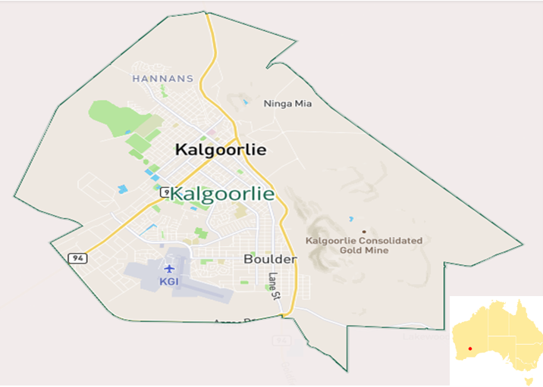

The city was established in 1893 during the Western Australian gold rush. It replaced Coolgardie as the largest settlement in the Eastern Goldfields. Kalgoorlie is the destination of the Goldfields Water Supply Scheme and the Golden Pipeline Heritage Trail. The nearby Fimiston Open Pit (Super Pit) mine was Australia's largest open-cut gold mine for many years. Owned by Northern Star Resources Limited, the life of the mine will be extended to 2034 with major expansions commencing in 2023.

Mining is the largest employer within the Employment Region, accounting for 19,000 jobs as at February 2022 (Source: National Skills Commission). According to REMPLAN, the 11,000 mining jobs in Goldfields-Esperance constitute 14% of all 80,000 jobs in the Western Australia mining sector (Source: REMPLAN economic data, Western Australia – Goldfields-Esperance 2022).

The region has limited public transport infrastructure, making access to private vehicles and drivers’ licences highly desirable. A “C” Class Manual drivers’ licence is an essential requirement for employment in the many of the mining industries.

There are five secondary schools in the region: Eastern Goldfields College, John Paul College, Fairbridge College, Kalgoorlie-Boulder Community High School and Goldfields Baptist College. Kalgoorlie is also home to Central Regional TAFE’s Kalgoorlie campus and Curtin University’s Schools of Mines.

# *Kalgoorlie lies on the traditional lands of the Wongatha/Wangkatha people**.*

# Key challenges and opportunities in the Kalgoorlie Employment Region

Industry:

The continued demands of the local mining and resources sector have seen an ongoing need for staff across a range of other industries, such as Hospitality and Accommodation Services, Health Care and Social Assistance, Retail and Child Care. Employers operating in non-resource related industries find it challenging to attract and retain staff, who are drawn to the generous remuneration offered by the gold, nickel and lithium mining sectors and the allied resources industries. Some local industries have also experienced a loss of their workforce to other higher wage locations such as the Pilbara, or to larger centres offering broader lifestyle and career options, such as Perth. There is a degree of seasonal transience of job seekers between the city and the traditional lands outside the region, which also impacts the available local workforce.

The absorption of the available workforce into the mining industry, has also impacted the supplier chain in the Transport, Construction, Logistics, Warehousing and Manufacturing industries, which support the resources sector.

Attracting and retaining staff within the local hospitality and accommodation service industry, has been very challenging, several cafes and restaurants are unable to operate at full capacity, or on weekends and public holidays and some have ceased to operate. Chefs are particularly difficult to find, as are kitchen and housekeeping staff. Some employers are targeting mature aged chef apprentices and offering higher than normal hourly rates, to attract and retain staff. Hotel/motel chains are utilising a FIFO model of employment and providing accommodation for their workers on site, as they are unable to recruit sufficient staff numbers locally.

Relative wages and working conditions favour mining over lower wage industries, with the mining industry leveraging local hospitality and accommodation businesses to source workers during times of shortage. This means repeated efforts to attract new workers are required, with small and medium employers struggling to meet recruitment and retention costs.

The Goldfields DAMA (Designated Area Migration Agreement) is a five-year labour agreement between the Commonwealth Government, the City of Kalgoorlie-Boulder and the Shires of Coolgardie, Dundas, Esperance, Leonora, Menzies, and Ravensthorpe.

It aims to attract skilled migrants to work and live in the Goldfields DAMA Region, allowing Goldfields employers to sponsor skilled overseas workers in specified industries, that are currently experiencing critical skill and labour shortages.

The **Goldfields Migrant Employment Project (GMEP)** **funded through the Regional Economic Development grants program in 2019,** assists new migrants and refugees in Perth to connect with employment opportunities in Kalgoorlie and the wider communities of the Goldfields. There has however, been some reluctance from the partners of skilled migrants to relocate to the region.

Pressures created by skills shortages in the Health Care and Social Assistance sector across WA continue to impact local economies. This is by far the biggest growth and employing industry in the State and there is an urgent need to focus on identifying and skilling up this workforce, as the demands in the sector continue to grow. Significant resources are being dedicated to support the aged and disability sectors with the WA Department of Training and Workforce Development (DTWD) funding the NDIS Job Matching Service Program until June 2023. The aim of the program is to assist Disability Support Organisations with workforce planning and to connect them with existing services such as the Jobs and Skills Centre, Central Regional TAFE, and employment and Apprenticeship/Traineeship service providers.

The Boosting the Local Care Workforce (BLCW) Program is delivered by Ernst & Young, with the First Peoples Disability Network (Australia), and the Community Services Industry Alliance. The BLCW Program is funded by the Department of Social Services and aims to develop the capacity of disability and aged care service providers to operate effectively and expand their workforce. A Regional Workforce Advisory Group has been established in Kalgoorlie-Boulder.

Employment:

As at May 2021, the WA – Outback (North and South) had an unemployment rate of 3%, compared with 3.4% for Western Australia.[1]. It should be noted however that the regional unemployment rate dropped 5.1% between March 2020 and March 2022.

The regional participation rate increased by 4% to 73.2% from March 2020 to February 2022, in comparison to the current WA participation rate which increased 1.5% to 69.7% in the same period.

While most job ready job seekers can secure employment with relative ease and leverage the available job opportunities, the long-term unemployed caseload continues to increase steadily. These job seekers encounter a range of vocational and non-vocational barriers to employment, most notably relating to lack of skills and work experience, intergenerational unemployment, homelessness and justice issues.

Barriers such as a lack of transport, difficulties in obtaining/retaining a driver’s licence, lack of ID documentation, inability to obtain police clearances and poor employability skills, have had a marked impact on the job readiness of some people in Kalgoorlie.

Drug and Alcohol clearances are a mandatory prerequisite for most positions across Kalgoorlie, especially in the resources sector. Ongoing onsite testing and low employer tolerance for positive results, means that job seekers with drug and alcohol issues, face a major barrier to securing and/or retaining employment within this industry. The relatively high rate of drug and alcohol barriers in the region, mean that a significant proportion of local job seekers are unable to access many of the job opportunities which the region has to offer. It is noted that many industries, including the mining/resource sector, now have mandatory COVID-19 vaccination pre-employment requirements.

Aboriginal people represent over 50 per cent of the local employment service provider caseloads, and yet are the most disadvantaged and underrepresented group within the local labour market.

Further investigation is needed as to the extent of these issues amongst the pool of unemployed people in Kalgoorlie, with a focus on developing strategies in consultation with industry, to address these barriers. Developing soft skills and teamwork, building resilience and motivation, and providing on the job mentoring support and wrap around services, have been identified as crucial to building employment pathways for the most disadvantaged job seekers in Kalgoorlie.

Partnerships:

The Goldfields region is part of the Cashless Debit Card initiative administered by the Department of Social Services. The objective of the Cashless Debit Card (CDC) is to ensure that welfare payments are spent in responsible and meaningful ways and not on products and activities that contribute to social harm.

To further support this initiative, a Jobs Fund and Job Ready initiative was announced in the 2021-22 Federal Budget. The aim of the initiative is to create employment opportunities for CDC participants, and to uplift and upskill them to be job ready.

The aims and objectives of the Department of Education, Skills, and Employment’s (DESE) Local Jobs Program aligns closely with those of the Jobs Fund and Job Ready initiative. The Cashless Debit Card Service’sEmployment Support Hub in Kalgoorlie is one of four Hubs established in the Goldfields region. Other Hubs have been established in the Local Shires of Coolgardie, Laverton and Leonora.

An additional challenge for the region, is the general lack of affordable long and short-term accommodation options to house incoming workers and their families. Kalgoorlie has a substantial non-resident (FIFO) workforce which further impacts on the availability of residential property stock for workers seeking to move to the region permanently.

The Goldfields Esperance Development Commission’s report on Housing and Land Summary reported a vacancy rate of 2.1% with the region’s rental market further tightening during the second half of 2021. Weekly rents jumped by 18.2 percent over the year, reaching an average of $416 in the final half of 2021. Stakeholders continue to indicate that the limited availability of affordable rental properties is having an adverse effect on the ability to attract and retain workers.

The City of Kalgoorlie Boulder, together with the Kalgoorlie Chamber of Commerce and Industry have been driving a long-term liveability plan to promote Kalgoorlie as a lifestyle destination and encourage new employees and their families to move to Kalgoorlie permanently to help build the local population. The Department of Training and Workforce Development’s (DTWD) Skills Summit identified this as a priority with a recommendation to promote the benefits of living in the region and the diverse range of employment opportunities available to grow the working population. The lead agency for addressing this priority will be the Goldfields-Esperance Development Commission.

# Local stakeholders and opportunities

The Goldfields- Esperance Development Commission (GEDC), Regional Development Australia Goldfields Esperance (RDA), City of Kalgoorlie- Boulder and the Kalgoorlie Boulder Chamber of Commerce and Industry are several of the major stakeholders in the region.

The region has access to a range of Australian Government programs including jobactive, ParentsNext, Transition to Work (TtW), New Enterprise Incentive Scheme (NEIS), Career Transition Assistance (CTA), Employability Skills Training (EST), Skills for Education and Employment (SEE), Australian Apprenticeship Support Network (AASN), Vocational Training and Employment Centre (VTEC), The Time to Work Employment Service (TWES) and Disability Employment Services (DES). As of 1 July 2022 these programs with be delivered under the new Workforce Australia suite of services.

Other government agencies within the region include the National Indigenous Australian Agency, Services Australia and the Jobs and Skills Centre (Kalgoorlie).

The Kalgoorlie Region has a diverse economy, with the largest employing industries as of February 2022 being Mining (15.5%, down 5% since February 2020), Public Administration and Safety (11%, down 9%) and Construction (10.9%, up 11%).

The gold mining industry, including the secondary industries which support the resources sector, are by far the largest and most profitable primary industry which drives the Kalgoorlie economy.

Kalgoorlie Consolidated Gold Mines (KCGM), Northern Star, Ashanti Gold, Carey Mining, Downer, Goldfields St Ives, Linkforce, Mondadelphous, Ora Banda and Yonga Djena are just some of the large resource employers operating in the region, who have ongoing vacancies.

Many provide differing career pathways and support, via work placements and traineeships. Subsequent supply chain and supporting businesses such as engineering, mechanical workshops, parts suppliers and maintenance industries, are useful steppingstones into the resources sectors.

The first of thirty-nine new Caterpillar 793F trucks have arrived at Northern Star’s KCGM Operation. The Caterpillar 793F’s will replace the existing fleet that has been operating in the Fimiston Open Pit (Super Pit) for over 20 years. Trainee positions for CAT 793 and 777 Haul Truck Operators are available with trainees enrolled in the Certificate III in Surface Extraction**,** completed over a 24-month period.

The City of Kalgoorlie Boulder is spearheading a raft of future projects with will present a variety of long-term job opportunities, including the proposed Hilton DoubleTree Hotel, $7 million dollar Golf Course resort development, residential apartment development (80 units), $15 million refurbishment of the CBD, airport and depot projects and various roadworks. The City itself has a range of administrative roles available.

A large new Coles store recently opened in Kalgoorlie and together with Woolworths, Bunnings and KMART, offers a variety of retail employment pathways specifically targeted at Aboriginal people. A range of facility maintenance, cleaning and security roles are also available through employers such as Compass and Delron/Ventia.

Additionally, two new childcare centres are being built in the region, which will also require significant local staffing resources.

In August 2020, the City of Kalgoorlie-Boulder signed a sublease for its strategic industrial land with Lynas Corporation Limited for their new Rare Earth Processing Facility in Kalgoorlie-Boulder. The project is expected to create up to 260 jobs during construction and over 130 ongoing residential jobs in Kalgoorlie. Other new developments approved by the City of Kalgoorlie-Boulder include an Aldi store.

In its 2022/2023 Budget, the WA State government announced $19.1 million for the development of new residential land in two regional locations, including Kalgoorlie and $11 million for industrial development at Lot 350 in Kalgoorlie.

The Regional Economic Development Grants (RED Grants) program is a $28.8 million over five years State Government initiative that invests in local projects to stimulate economic growth and development in regional Western Australia. The Goldfields-Esperance Development Commission (GEDC) received 21 RED Grant applications across the 2020-21 round. Applicants were seeking more than $3.3 million in funding to support projects to the total value of $7.9 million.

New housing options are being opened in Kalgoorlie-Boulder with the construction of 31 new residential lots in GreenView at the Karlkurla residential estate. Civil works will commence in the coming months to deliver lots, ranging in size from 544sqm to 888sqm. Approximately 20 local workers will be based onsite to prepare earthworks, drainage, electrical and retaining work. Lots were released for sale late 2021.

# Attachment A: Key employment and training priorities: strategies and stakeholders

**Priority One: Engage with industry to articulate the needs of employers and job seekers and inform the development of strategies which maximise local job placements.**

**Strategies**

* Conduct analysis to map out local industry needs and understand skills gaps, leveraging the outcomes of the DESE Kalgoorlie Roundtable conducted in March 2021.
* Identify non-negotiable pre-employment requirements as well as flexibilities available in key industries of need.

**Stakeholders**

Employment Facilitator, Local Jobs and Skills Taskforce, key employers, Kalgoorlie Boulder Chamber of Commerce and Industry, City of Kalgoorlie Boulder, Goldfields Esperance Development Commission, Regional Development Australia Goldfields Esperance and industry representatives and peak bodies

**Priority Two: Ensure that local people are adequately skilled, prepared and supported for current and upcoming employment opportunities and projects, including addressing factors impacting on job readiness, such as lack of transport, lack of work experience, justice issues, and drug and alcohol challenges.**

**Strategies**

* Map out the scope of the challenges facing the local workforce and identify areas of opportunity
* Broker solutions utilising the Local Recovery Fund and other existing programs, to develop projects that will address specific barriers and train and prepare job seekers to meet labour requirements of local employers and industries.

**Stakeholders**

Employment services providers, community support services, Employment Facilitator and Local Jobs and Skills Taskforce, Kalgoorlie Boulder Chamber of Commerce and Industry, City of Kalgoorlie Boulder, Goldfields Esperance Development Commission, Regional Development Australia Goldfields Esperance

**Priority Three: Leverage existing Australian and WA Government programs, to create pathways into local growth industries, particularly Mining/Resources, Hospitality and Health Care and Social Assistance, with a focus on youth and Indigenous jobseekers.**

**Strategies**

* Connect local employment services providers with key representatives of the Mining/Resources, Hospitality, Health Care and Social Assistance industries to develop and promote specific career paths and build aspiration to work within these industries
* Identify transferable skills across industries to open alternate pathways
* Engage youth and Indigenous support services in workforce development appropriate and specific to these cohorts

**Stakeholders**

jobactive, Transition to Work and ParentsNext providers, Department of Education (state), high schools, Central Regional TAFE, Chamber of Minerals and Energy, Kalgoorlie Boulder Chamber of Commerce and Industry, Australian Hoteliers Association, Aged and Community Services Australia, WA Department of Training and Workforce Development, Goldfields Esperance Development Commission, Regional Development Australia Goldfields Esperance, Building Local Care Workforce Advisory Group, Wirrpanda Foundation (VTEC), National Indigenous Australians Agency, Aboriginal employers and community organisations

**Priority Four: Optimise communication and engagement with long term unemployed job seekers on education, training and other entry pathways into key local industries.**

**Strategies**

* Leverage existing promotional opportunities at events such as Jobs Fairs, expos and employer run industry days and develop new promotional initiatives as guided by the Local Jobs Plan.
* Deliver regular workshops and information sessions to job seekers on current opportunities and support services available.

**Stakeholders**

DESE, Services Australia, Employment Facilitator, Local Jobs and Skills Taskforce, employment services providers, Jobs and Skills Centre, WA Department of Training and Workforce Development, Central Regional TAFE, Kalgoorlie Boulder Chamber of Commerce and Industry, City of Kalgoorlie Boulder, Goldfields Esperance Development Commission, Regional Development Australia Goldfields Esperance

# Attachment B – Labour Market Data Dashboard (April 2022)

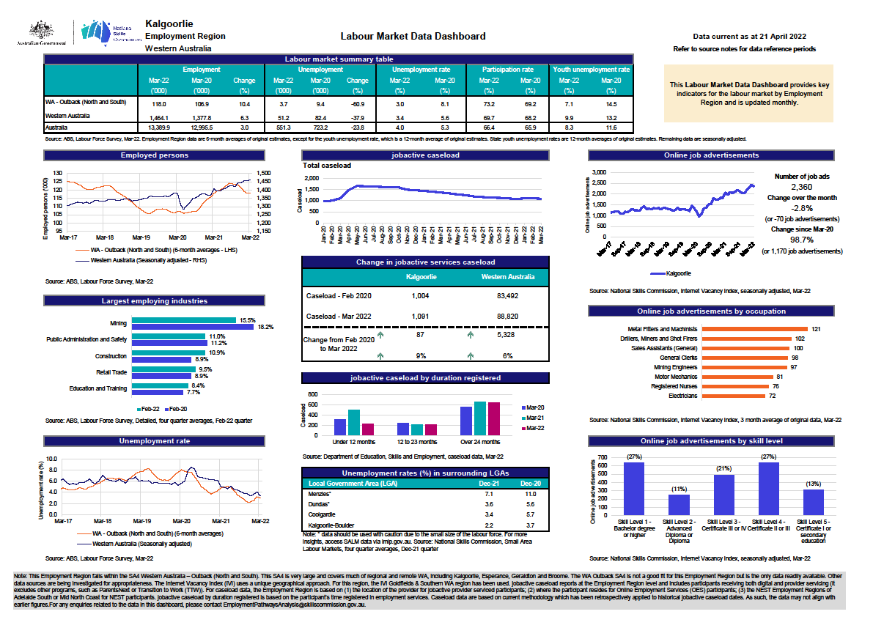

1. Note: The Kalgoorlie Region falls within the SA4 Western Australia – Outback (North and South). This SA4 is very large and covers much of regional and remote WA, including Kalgoorlie, Esperance, Geraldton and Broome. While the WA Outback SA4 is not a good fit for this Employment Region it is the only data readily available at present.