


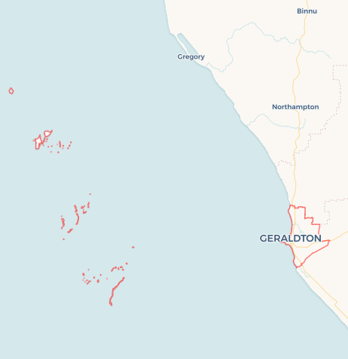
Local Jobs Plan
  - Geraldton Employment Region | WA | August 2026
Workforce Australia Local Jobs (Local Jobs) is a program that creates partnerships between business
and communities to meet local workforce needs, thereby improving employment outcomes.
Local Jobs operates in all 51 Employment Regions in Australia.

Local Jobs Overview

Local Jobs Plan
Each Employment Region has a Local Jobs Plan which outlines the labour market challenges in the region and the strategies to address these challenges.

Job Coordinators
Each Employment Region has a dedicated Job Coordinator who leverages existing resources, supports local labour markets through structural adjustments and retrenchments, and creates opportunities for collaboration between business and communities.

Local Jobs and Skills Taskforce
Each Employment Region has its own taskforce that meets regularly with the Job Coordinator to develop an understanding of challenges in the region and implement solutions. The taskforce is comprised of representatives from the region.

Local Jobs, Local People Grant
The Local Jobs, Local People grant funds activities that help people into ongoing employment or training. Activities must support local labour market needs.
Explore labour market insights for the
Geraldton Employment Region

Local labour market challenges

- Geraldton faces high youth disengagement from education and employment. Many young people leave the region due to perceived limited access to tertiary education, a lack of structured career pathways, and the absence of culturally safe, youth-focused employment programs. Improved access to transport, education and culturally responsive career pathways can support greater participation and success for First Nations young people.
- Employers in Geraldton report ongoing difficulty finding workers with the right qualifications and experience, particularly in trades, health care, and hospitality. Training providers are present but often misaligned with current industry needs, creating a persistent gap between available skills and job requirement.
- First Nations people in Geraldton continue to experience employment disparities. Challenges include limited access to culturally safe environments, underrepresentation in skilled and leadership roles in recruitment and workplaces.
- The region’s reliance on seasonal industries like agriculture, fishing, and tourism results in high levels of casual and insecure work. This leads to income instability, limited career progression, and underemployment, particularly affecting women and young people.
- Geraldton struggles to attract and retain skilled professionals in sectors such as health, education, and technical trades. Contributing factors include housing shortages, limited lifestyle amenities, and professional isolation from networks and training opportunities.
- Transport remains a major barrier to workforce participation, especially for young people, First Nations communities, and people with disabilities. Issues include limited public transport, high vehicle costs, and poor road infrastructure in remote areas.
- Geraldton’s economy is heavily reliant on a few keys sectors such as agriculture, mining support, and logistics, which are vulnerable to market fluctuations, climate change, and automation. This lack of diversification limits economic resilience and adaptability.
- Digital access and literacy are uneven across the region, affecting participation in remote work, online education, and digital services. Challenges include unstable internet coverage, low digital literacy among disadvantaged groups, and limited access to devices and support.

Local priorities

Priority 1 – Increased First Nations economic participation

What are our challenges?
There is an opportunity to strengthen First Nations representation in skilled, professional and leadership roles across the region, building on the knowledge, capability and contribution of First Nations peoples. This is compounded by the limited availability of culturally safe workplace environments, which can hinder recruitment, retention, and career progression for First Nations individuals. Without culturally responsive support, First Nations people may face barriers to entering and advancing within the workforce.

How are we responding?
- Working closely with Aboriginal Community-Controlled Organisations to provide culturally safe training to employers and include them on decision making processes.
- Promoting programs and initiatives to increase the employability of First Nations people.
- Working with training organisations to understand future demand for skilled labour and build pathways for the First Nations people to participate in a culturally safe environment to meet these demands.
- Continue strengthening connections with community organisations, support services and programs that can assist First Nations participants to achieve their employment and career aspirations.

Priority 2 – Industry and job exposure for skilled labour

What are our challenges?
The region is currently experiencing a noticeable gap between the skills held by the local workforce and those required for existing and future job opportunities. This issue is made worse by the movement of skilled workers to metropolitan areas like Perth, where career progression and opportunities are more abundant. At the same time, limited collaboration between employers and education providers has created a disconnect that continues to widen the gap.

How are we responding?
- Working closely with local education organisations like the Central Regional TAFE and group training organisations to understand current offerings and promote these to fill the skill gaps through Workforce Australia Employment Services Providers.
- Holding a round table with educational organisations and local employers to discuss current and future skills requirements and build pathways so participants can get real world experience and build on employment skills.
- Promoting vocational pathways and apprenticeships for local youth such as organising in school programs like a career taster for students to create opportunity into trades and give them work experience.
- Hosting meetings with local training organisations to enhance the support offered and uncover training solutions.

Priority 3 – Employee and employer support

What are our challenges?
Local businesses are facing difficulties attracting and retaining skilled workers, resulting in workforce shortages and increased pressure on existing employees. This can lead to understaffing, burnout, and reduced business capacity. The challenge is further compounded by many businesses unable to offer full-time employment, limiting job security and career progression opportunities. Strengthening collaboration, targeted upskilling and inclusive hiring practise can help address these challenges.

How are we responding?
- Working closely with industry peak bodies to get an overview of current struggles to develop programs to support businesses.
- Promoting government programs and grant opportunities to support new employees and give them an opportunity to develop in the workforce while easing financial burden for the businesses.
- Using current labour market trends to support the direction development needs to take to fill the skills gap.
- Recognising and celebrating employers who demonstrate leadership in inclusive employment and workforce development.
- Strengthening employer and educational relationships to create pathways so job seekers can gain meaningful work experience.

Priority 4 – Use of existing programs and incentives

What are our challenges?
A key challenge in workforce development is the low level of awareness among stakeholders—including employers, service providers, and job seekers—about the range of programs and grants available to support career change, career development, and workforce growth. As a result, these opportunities are often underutilised.

How are we responding?
- Utilising social media channels to promote opportunities to relevant stakeholders.
- Organising and promoting information sessions on grant opportunities for employers and providers to create opportunities for job seekers.
- Using events to promote pathways for jobseekers to find employment and to fill current or future skills gaps.
- Working closely with all relevant stakeholders.
- Supporting the delivery of financial education and planning, including guidance on how entering the workforce may alter government assistance.

Want to know more?
- Contact Madi Signa, Geraldton Job Coordinator at Madi.Signa@dewr.gov.au
- Visit Local Jobs or Workforce Australia

