

Local Jobs Plan

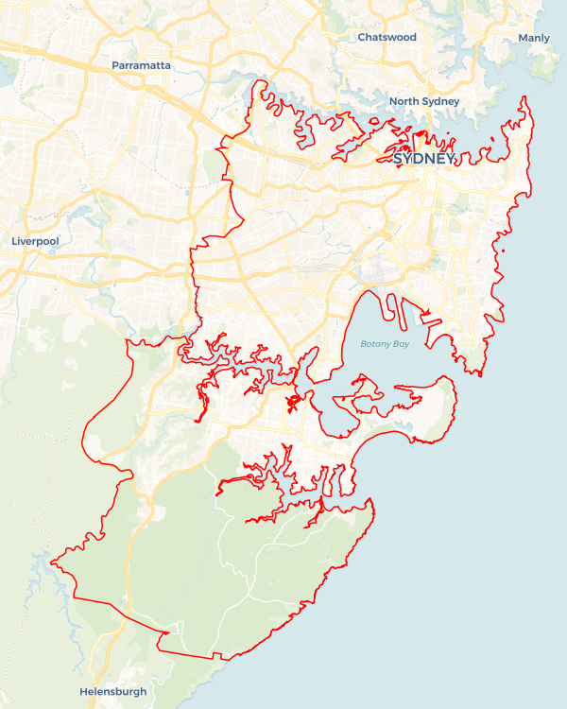

Explore labour market insights for the   
[Sydney East Metro](https://www.jobsandskills.gov.au/data/employment-region-dashboards-and-profiles/monthly-labour-market-dashboards)  Employment Region

Explore labour market insights for   
[[Employment Region Name](https://labourmarketinsights.gov.au/regions/employment-regions/)] Employment Region

Sydney East Metro ****Employment Region**** | NSW | ****September 2023****

Workforce Australia Local Jobs (Local Jobs) is a program that supports tailored approaches to accelerate   
reskilling, upskilling and employment pathways in response to current and emerging local workforce needs.

## Local Jobs elements

### Local Jobs Plan

The Local Jobs Plan sets out the skills and employment challenges and priorities of the region, and associated strategies that will drive the design and implementation of activities to be implemented to address these challenges.

### Employment Facilitators

Employment Facilitators and Support Officers support the delivery of the program by bringing together key stakeholders including businesses, employment services providers, and higher education and training organisations.

### Local Jobs and Skills Taskforce

Each Employment Region has its own Taskforce. Representatives include local stakeholders who have demonstrated experience in upskilling, reskilling, and an ability to represent, connect and collaborate with others in the region to meet labour market needs.

### Local Recovery and National Priority Funds

The Local Recovery Fund supports projects that meet the priorities identified in the Local Jobs Plan. The National Priority Fund provides funding for innovative local solutions to address structural barriers to employment.

## Local labour market challenges and opportunities in the region

* High demand for entry-level workers in hospitality and tourism, healthcare and social assistance, construction and infrastructure, and retail.
* Projected growth in high-value sectors, including manufacturing, wholesale trade, aged, disability and childcare, accommodation and food services, information, and communications technology (ICT) administration and support, and aviation resulting in current and predicted skills gaps.

* Limited awareness of available skills training and employment support options designed to support economic recovery resulting in missed opportunities to access and benefit individuals and businesses.
* Ongoing risks for disadvantaged cohorts, including Indigenous people, people from culturally and linguistically diverse (CALD) backgrounds and disengaged young people within the region. These include limited social support, stereotyping, sense of displacement, as well as stress and recovery from trauma or discrimination.

## Local jobs and skills priorities and strategies in the region

### Priority 1 – Employment pathways

#### What are our challenges and opportunities?

Long-term unemployed participants often lack the skills required to enter or re-enter the workforce. These skills are often interpersonal skills, emotional intelligence, job-specific skills, job preparation skills (I.e., interviews and resume-writing), digital literacy and confidence. The Sydney East Metro Employment Region has a strong labour market demand in Healthcare and social assistance, construction and infrastructure, retail, and hospitality and tourism. The Sydney East Metro Employment Region will focus on building training pathways to employment that develop the skills required to prepare for entry-level roles in these   
in-demand industries.

#### How are we responding?

* We are collaborating with industry stakeholders across the region to coordinate and link training and employment opportunities in the various sectors to prepare individuals for employment and match them with appropriate job opportunities. We also endeavour to raise awareness of the many career pathways available in the industry while engaging directly with businesses in the Sydney East Metro Employment Region.
* We continue to work with local organisations to coordinate a range of training options from full qualifications, short courses, and employer-specific bespoke and micro-credentials linked to current labour demand in the region to provide people with upskilling and reskilling opportunities.
* Our Taskforce works to identify industry-specific recruitment models in areas across the region relating to skills shortages and job vacancies. These models are tailored to individual business needs and enable collaboration with employment services and training providers across the Sydney East Metro Employment Region.
* We look to support individuals and businesses to build entrepreneurial capability through Sydney East Metro network connections in response to new and emerging economic opportunities across all sectors identified.

### Priority 2 – Healthcare and Social Assistance

#### What are our challenges and opportunities?

Across all 51 employment regions nationally, we face the challenge of workforce shortages in the care sectors. Statistics estimate 1.2 million people will require care and assistance with daily living over the next 40 years, from basic to higher levels of care with complex medical conditions. The Sydney East Metro Employment Region will focus on supporting local businesses to fill their in-demand vacancies with suitable candidates.

#### How are we responding?

* We are coordinating a range of options from full qualification, short course, and employer-specific bespoke and micro-credential training linked to current labour demand in the region to provide people with upskilling and reskilling opportunities.
* We are implementing programs such as recruitment drives and employment pathways that will bring significant, ongoing change to workforce attraction and retention.
* Our Taskforce is developing and implementing industry-specific recruitment models in areas of regional skills shortages (e.g., healthcare, and social assistance) that enhance business and individual connections. These will be tailored to business needs and enable collaboration across the industry.
* We host a regular Working Group for industry stakeholders to support the sector through sharing ideas on initiatives to drive workforce attraction and retention in the care industries.

### Priority 3 – Construction and Infrastructure Workforce Targets

#### What are our challenges and opportunities?

Several small-scale projects in the region are underway and near commencement including St George Hospital Redevelopment, Randwick hospital redevelopments, Eastern Tunnelling Package, and Barangaroo nearing completion. These projects across the region continue to provide extensive employment opportunities through all phases of these projects. The Sydney East Metro Employment Region will focus on supporting Construction and Infrastructure businesses to fill in-demand vacancies and meet their workforce targets.

#### How are we responding?

* Our Taskforce regularly discusses current and pending infrastructure and development projects to identify recruitment needs, required skills and timelines.
* We are working with Workforce Australia Employment Services Providers to align identified skills in demand with the skills profiles of individual participants in the region.
* We will develop and deliver recruitment solutions informed through engagement with stakeholders across the region. These may include direct recruitment; short course upskilling to support skills transferability into the construction industry; and pre-employment programs comprising employability and   
  industry-specific skills training as preparation for entry-level opportunities, apprenticeships, and traineeships.
* A Construction and Infrastructure Working Group has been established to provide networking opportunities to increase awareness of activities and programs that support the industry.

### Priority 4 – Indigenous Employment

#### What are our challenges and opportunities?

#### Indigenous unemployment is disproportionately higher than the mainstream unemployment rate. This is due to Indigenous people having unique barriers to employment, including a limited access to relevant training and culturally safe workplaces. The Sydney East Metro Employment Region will focus on breaking down barriers to employment through developing appropriate training pathways with access to mentoring and opportunities for Indigenous people to meet with inclusive employers.

#### How are we responding?

* We are coordinating a range of options from full qualification, short course, employer bespoke and micro-credential training linked to current labour demand in the region to provide Indigenous people with opportunities to learn employability skills and apply for available job opportunities.
* We are undertaking stakeholder engagement in the development of industry-specific employment and training models relating to Indigenous people to better match them with suitable jobs.
* We are supporting Indigenous people to seek their desired career paths through training and job matching.
* We hold regular Working Group meetings to workshop ways to break down employment barriers for Indigenous people.

### Priority 5 – Youth

#### What are our challenges and opportunities?

In the current labour market, there are exceptionally high numbers of at-risk youth who are not engaging in education or employment. For this reason, the focus for the Sydney East Metro Employment Region is to support young people to engage in education and training pathways linked to job opportunities. Youth are at the core of all the industry priorities in the region and regular engagement in activities and opportunities will assist local stakeholders in transitioning young people into employment. Supporting youth at the inception phase of their careers will ensure their future success in the workforce. This contributes significantly to regional economic growth and development.

#### How are we responding?

* We are connecting youth services to vocational programs that support young people towards job-readiness and consequential economic opportunities.
* We are working with local stakeholders to design and deliver pre-employment programs to support disengaged young people develop the required skillset to take up an apprenticeship or traineeship in high growth industries.
* We are identifying opportunities and creating skills development pathways aligned with growth industries to support youth entrepreneurship.
* We are collaborating with local governments to support youth careers and employment expos, ensuring there are opportunities for young people to connect with industry stakeholders.
* We host regular Youth Working Group meetings to workshop ways to break down employment barriers for young people.

## Want to know more?

* Contact: Kelly Hayes, Sydney East Metro Employment Region Employment Facilitator: [Kelly.HayesSEM@localjobsfacilitator.com.au](mailto:Kelly.HayesSEM@localjobsfacilitator.com.au)
* Visit: [Local Jobs](https://www.dewr.gov.au/local-jobs) or [Workforce Australia](https://www.workforceaustralia.gov.au/)