

Information for businesses
  - Career Revive

What is the Career Revive program?

Career Revive provides businesses with tailored supports to better recruit and retain women returning to work following a career break.
Supports provided through the program include:
- review business policies, processes and performance environment
- co-design a tailored action plan
- design a supported returner program
- access support to implement the changes.
Participation in Career Revive may also complement a business’s compliance reporting of women in the workforce in accordance with the Workplace Gender Equality Act 2012.


How do businesses apply to participate in the Career Revive program?
The Department of Education, Skills and Employment runs an expression of interest process to select interested medium to large businesses to participate in Career Revive.
To be eligible to participate businesses need to:
- be medium to large (50+ employees)
- be looking to strengthen their business recruitment and retention practices for women
- have provided evidence of a strategy to improve diversity, equity or inclusion.

For information on how to apply for the next Career Revive intake go to: www.dese.gov.au/career-revive
The expression of interest process is run up to six months in advance of the commencement of the intake. This allows time for businesses to plan and allocate resources for their participation in the program.

What services will KPMG provide to businesses?
Businesses selected to participate in Career Revive receive expert advice from KPMG consultants who will:
- Review your business processes and policies benchmarked against industry best practice.
- Undertake culture diagnostics to determine strengths, challenges and development areas for HR, leaders and staff.
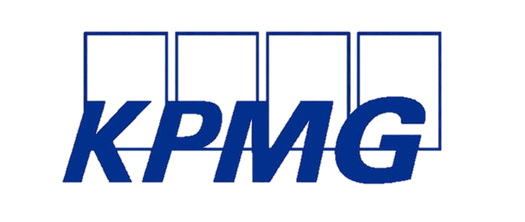
- Co-design an action plan which enables the HR team and leaders to tailor their actions to their organisational priorities.
- Provide mentorship and coaching.
- Facilitate capability workshops for leaders and individuals across the business.
- Provide access to toolkits and supports to aid ongoing maturation.
- Provide networking opportunities with other businesses and HR leaders committed to helping women to enter and thrive in the workplace.


What is expected from businesses?
To maximise engagement in the program, businesses will need to have capacity to participate in a range of activities including a culture survey, design workshops, KPMG site visit, co-designing an action plan, action learning groups and workshops.
Participating businesses will need to nominate an executive sponsor to drive ownership for the program and support implementation of actions. Therefore, businesses will need to ensure they have allocated sufficient resources to participate fully in Career Revive.

Based on previous intakes each business needs to allocate sufficient time for its HR team to get the most out of their participation in Career Revive. We estimate this to be approximately 1-2 hours each week for the next 10 to 12 months. The KPMG team will rely on your knowledge of your business and people when scheduling consultations and activities during the first 1-3 months of the program, which has been noted by previous intakes as requiring 2-4 hours each week. Some weeks will be more intensive than others as we progress through the stages of the program, but the time investment will be beneficial to your business to make the most of participating in the program.
We also recommend that your business identifies a group of key individuals from across your organisation to participate and work with the HR team and your nominated executive sponsor. This will help to champion the action plan strategies across your business and improves implementation of your returner program and achieving outcomes through the Career Revive program.


What businesses say about participating in the Career Revive program
This has been a great experience for Nexus. We’ve been able to diversify our hiring and be more aware of people with gaps in employment… this definitely flows on from the Career Revive program to increase participation in the workforce.
Erica Bramble, Human Resources Advisor, Nexus Primary Health
Career Revive has become a different way of badging our Inclusion and Acceptance program. It has started an inclusion and acceptance dialogue at OFO and helped our people think of new ways of doing things. Our proudest achievement is yet to come.
Candice Fennell, Head of Human Resources, OneFortyOne
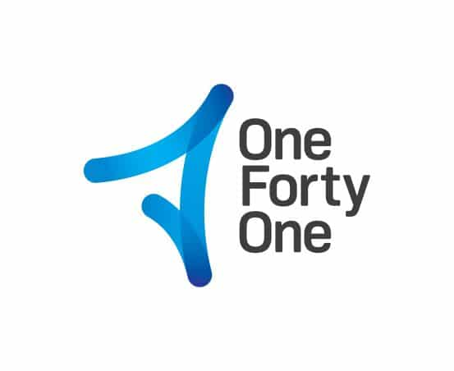

The Career Revive journey
1-3 months

4-12 months

Support over 12 months

