


Provider Transition Advice 2022
  - New and continuing Providers | 22 April

With the exception of the Commonwealth Coat of Arms, the Department’s logo, any material protected by a trade mark and where otherwise noted all material presented in this document is provided under a Creative Commons Attribution 4.0 Australia licence.
The details of the relevant licence conditions are available on the Creative Commons website (accessible using the links provided) as is the full legal code for the CC BY 4.0 AU licence.
The document must be attributed as the Provider Transition Advice 2022 – New and continuing providers webinar – web version.

Purpose
To provide:
- an overview of the Provider Transition Advice
- an opportunity for continuing and new providers to ask questions relating to the Advice.


Transition Objectives
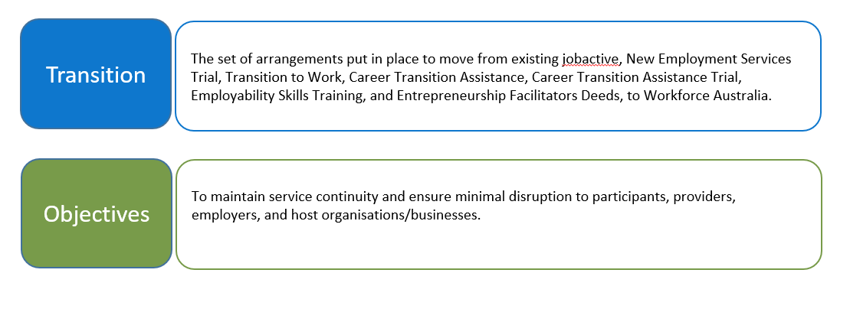

Transition Principles
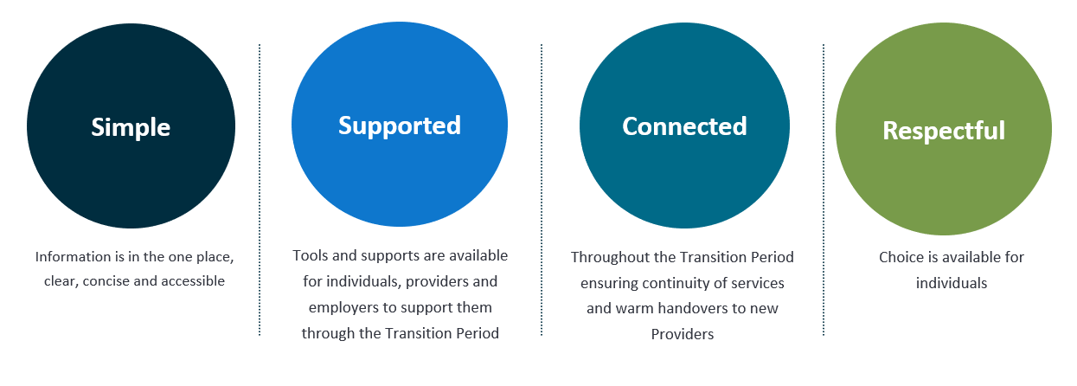

2022 Transition Timeline
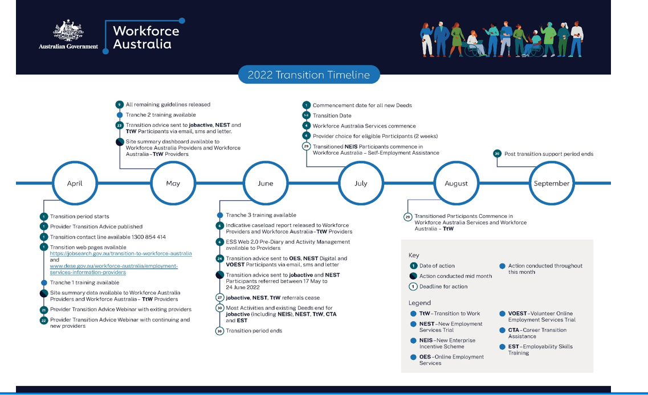

Servicing under current Deeds
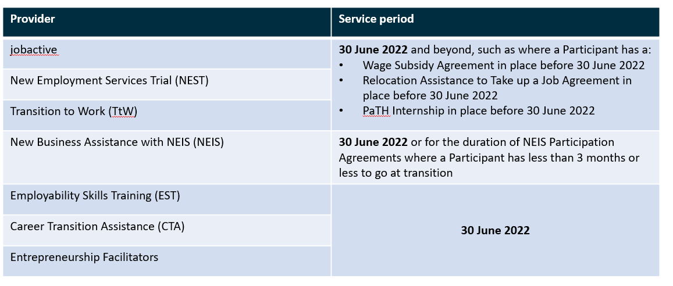

Managing Activities under current Deeds
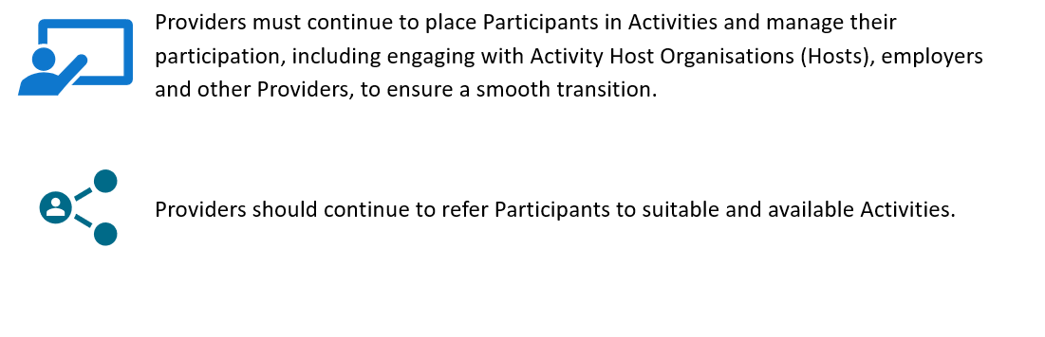

Activity end dates under current Deeds
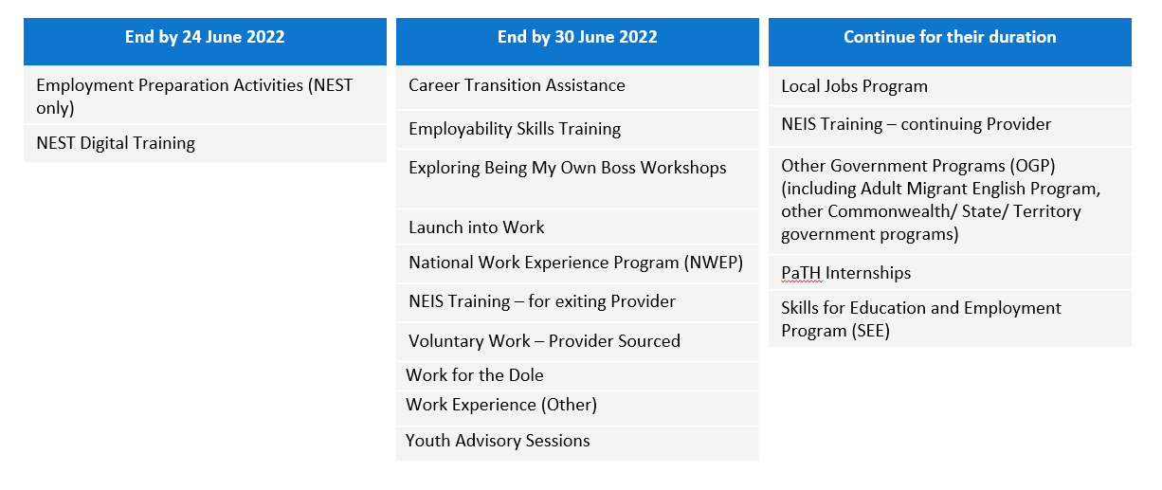

PaTH Internships under jobactive, NEST and TtW
For PaTH Internship Agreements that continue after 30 June 2022
Continuing Providers must:
- fulfill the PaTH Internship until it ends
- ensure the PaTH Internship Agreement is confirmed in ESS Web by 30 June 2022
- record and retain copies of any changes to the PaTH Internship Agreement offline.
Vacancies
Any unfilled vacancy invitations in ESS Web will cease after 30 June 2022. Continuing providers should ensure any vacancies they wish to fill are accepted and placement confirmed by 30 June 2022.

Wage Subsidy Agreements under jobactive, NEST and TtW
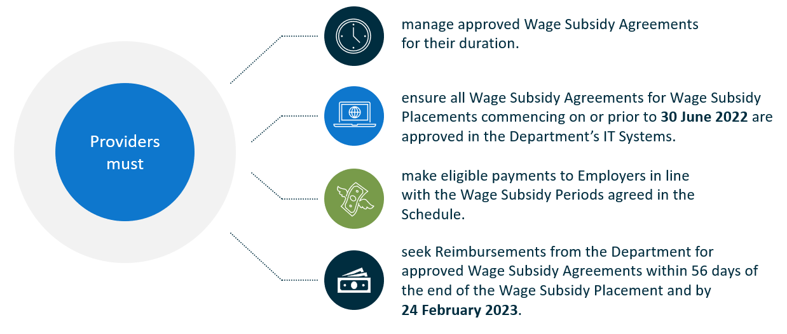

Relocation Assistance to Take Up a Job (RATTUAJ)
Continuing Providers must fulfil all Relocation Assistance to Take Up a Job Agreements for their duration.
By 30 June 2022, Continuing Providers must:
- enter and have approved all RATTUAJ Agreements in the Department’s IT Systems (ESS Web) for work that commences on or before 30 June 2022.
- finalise as far as possible all other outstanding RATTUAJ actions in the Department’s IT Systems (ESS Web) by 30 June 2022, including changing the status of any RATTUAJ Agreements that are not required to ‘Created in Error’.
Participants who enquire about RATTUAJ assistance prior to 1 July 2022 for work placements that commence on or after 1 July 2022 are to be encouraged to discuss their relocation needs with their new Provider from 4 July 2022.

Employment Fund
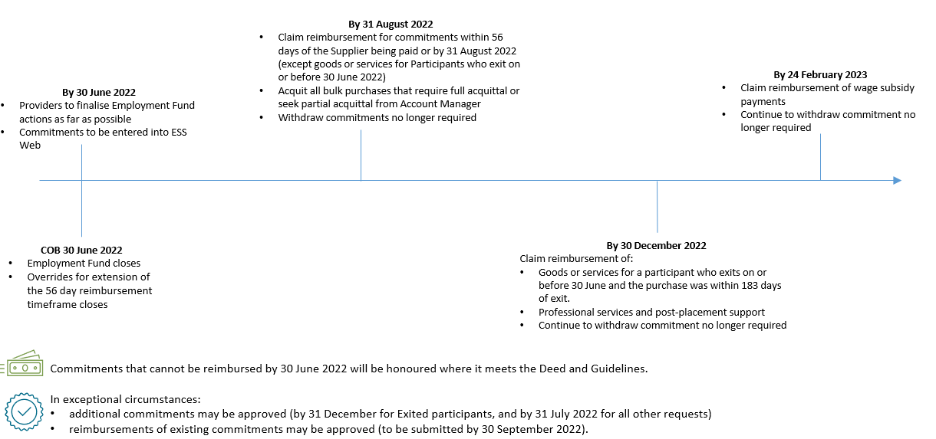

New Business Assistance with NEIS
Servicing
- NEIS Participants who have 3 months or less to go on 30 June 2022 will continue to receive NEIS Services with their current provider until the end of their NEIS Participant Agreement.
- NEIS Participants who have more than 3 months to go on 30 June 2022 and are with an exiting provider will be transitioned to a Self-Employment Assistance provider on the Transition Weekend (i.e. 1-3 July 2022).
- All transitioned NEIS Participants must be commenced by 29 July 2022.
Continuing providers
- May continue to commence eligible people into NEIS Assistance until Thursday 9 June 2022.
- Must advise eligible people who have not started NEIS Assistance by 9 June 2022 to connect with them again in July.

Entrepreneurship Facilitators
Servicing under current Deed
Entrepreneurship Facilitators must continue to provide the activities specified in their Work Plans for the duration of their current Deed unless advised otherwise by the Department.

Records management under current Deeds
Continuing providers exiting a region must:
- return all Participant Service Records (preferably electronically) to the Department unless they are eligible for destruction.
- notify Account Managers by 31 May 2022 of the volume and format of the records to be returned.
New Business Assistance with NEIS records
NEIS Providers who will continue to service NEIS Participants after 1 July 2022 must retain the relevant records and return within 28 business days of the last servicing date.

Signage under current Deeds
By 30 June 2022 continuing Providers must:
- remove and dispose of window stickers in a manner that ensures they are not able to be used again
- remove existing program branding and logos from all signage
- remove the existing branding and logo from all communication products.

Allocation of Participants

Transition for Participants
Pre-transition service | Post-transition service
OES/NEST Digital Employment Services Participants with less than 12 months in OES/NEST Digital Services. | Workforce Australia Online
OES/NEST Digital Employment Services Participant with 12 months or over in OES/NEST Digital Services and is in:  - employment  - work placement  - training  - another Activity. | Workforce Australia Online
All other OES/NEST Digital Employment Services Participants. | Workforce Australia Services
jobactive (all Streams) or NEST Enhanced Services Participant with recent earnings (see Note 1 below) and:  - is not tracking to an Employment Outcome  - is not in the Targeted Compliance Framework penalty zone  - is not a pre-release prisoner or restricted access participant  - does not have a:  - high JSCI score  - serious incident report or Managed Service Plan  - draft or approved wage subsidy agreement  - draft or approved PaTH Internship Agreement | Workforce Australia Online  (may choose Workforce Australia provider services)
- jobactive Stream C/NEST Enhanced Services Participants if eligible for TtW (see Note 2 below).  - TtW | Workforce Australia - TtW  (may choose Workforce Australia provider services)
All other jobactive and NEST Enhanced Services Participants. | Workforce Australia provider services
New Business Assistance with NEIS with more than 3 months remaining in NEIS Assistance | Workforce Australia – Self-Employment Assistance
Volunteer Online Employment Services Trial | Can register for Workforce Australia - Online

Early access to indicative caseload and IT System
Workforce Australia providers and Workforce Australia – TtW Providers
Site summary
- Site summary data has been released.
- In mid-May 2022, the Site Summary dashboard will be released in ESS Web 2.0.
Indicative caseload report
On 6 June 2022, the indicative caseload report will be available in ESS Web 2.0.
Pre-Diary
- From 6 June 2022, Providers can book Participants (in their indicative caseload) into Appointments from 4 July 2022.
Activity management
- From 6 June 2022, Providers will be able to create Activities in ESS Web 2.0 so that referrals can occur from Monday 4 July 2022. This will also be available to Workforce Australia – CTA and EST Providers.

Access to the Department’s IT Systems
System Outage
- The Department’s IT systems will not be available from 8:00 pm AEST on 30 June 2022 until the start of business on 4 July 2022.
Claims and payments
- Continuing Providers will retain access to ESS Web post 30 June 2022 to claim Fees, Outcome Payments and Reimbursements in accordance with the relevant Deed and Guidelines.

Commencing Workforce Australia Services and Workforce Australia – TtW
- Providers must:
- open all Sites by Friday 1 July 2022 and be ready to commence Services on Monday 4 July 2022
- Commence Transitioned Participants (except those who are Suspended) by Friday 26 August 2022
- source and set up Activities, Wage Subsidy Agreements and Relocation Assistance with Participants from 4 July 2022 to suit Participants needs in line with the relevant Deed and Guidelines.

Commencing Services under Workforce Australia – Self Employment Assistance
- Workforce Australia - Self-Employment Assistance Providers must be ready to commence operations from Friday 1 July 2022.
- The Self-Employment Assistance Provider must meet with and create a new Small Business Coaching Agreement with Transitioned Participants by Friday 29 July 2022.

Communication to Participants
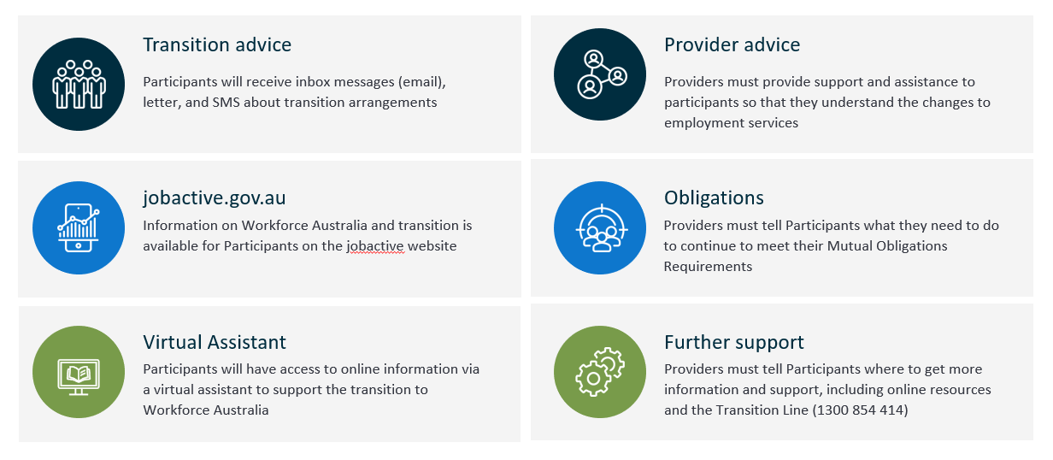

Communication to Employers
Providers must keep Employers informed about the changes to employment services and the new arrangements.
Providers should explain:
- changes in the delivery of employment services to the Participant and the new Provider’s contact details if applicable
- what support and assistance will continue to maintain the Participant’s employment, including the ongoing management of a Wage Subsidy or RATTUAJ Agreement
- where to get more information about transition arrangements, including by promoting transition information that is published on the Department’s websites.

Communication to Activity Host Organisations
Providers must keep Host Organisations informed about the changes to employment services and the new arrangements.
Providers should:
- discuss Activities that are not continuing with Hosts as early as possible
- encourage Hosts to run suitable Activities after Workforce Australia starts.

Workforce Australia training
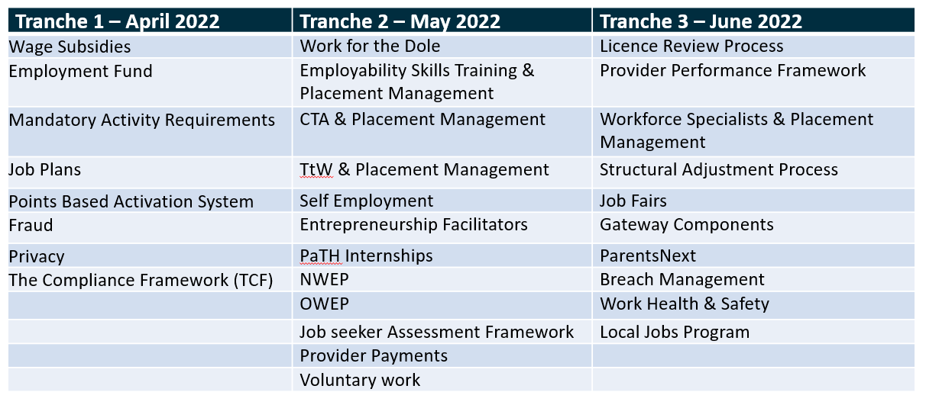

Process driven approach for Workforce Australia training
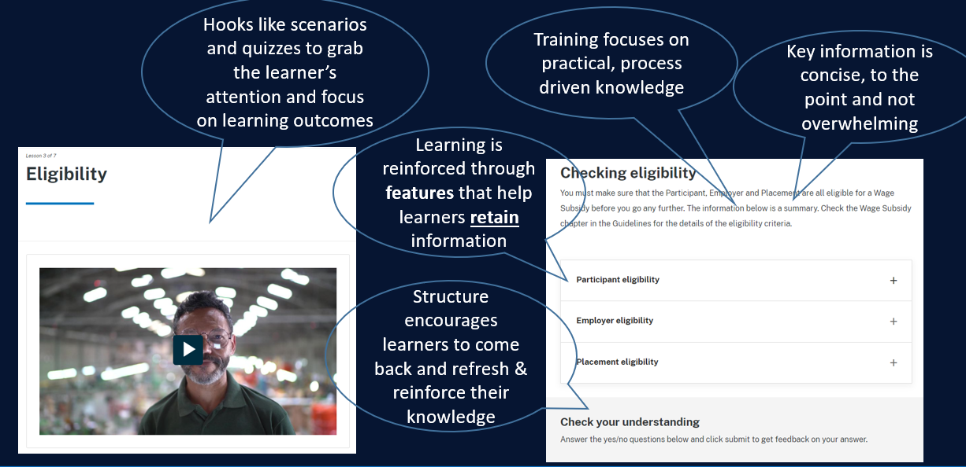

Branding and Signage
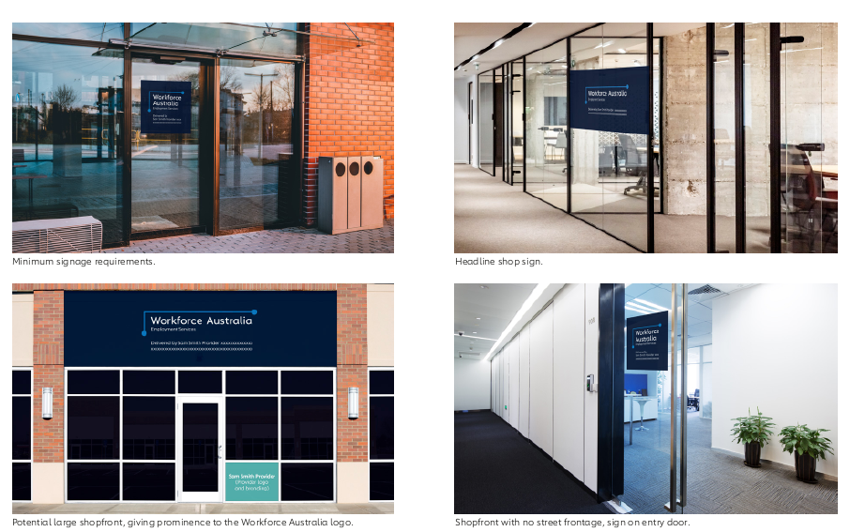

Contact your Account Manager for all enquiries
