

How do I access FEG Online Services
Online lodgement is the easy way to make a claim for assistance under the Fair Entitlements Guarantee (FEG). Lodging a claim online also ensures that we receive your claim as soon as it is submitted. This fact sheet provides a step-by-step guide to using FEG Online Services.

Features of FEG Online Services
FEG Online Services provides the following features:
- lodge your FEG claim online
- complete your tax file number declaration online
- provide your bank details
- upload supporting documentation
- check the status of your claim
- update your bank details
- update your tax file number
- update agent details
- update entitlement details
- update contact details
- access letters the department has sent you
- lodge a review of your FEG decision.
If you have already lodged a paper based claim form you can still register for FEG Online Services to monitor your claim and access letters sent by the department.

Section 1 – Registration and login
- To register go to FEG Online Services and click Register.
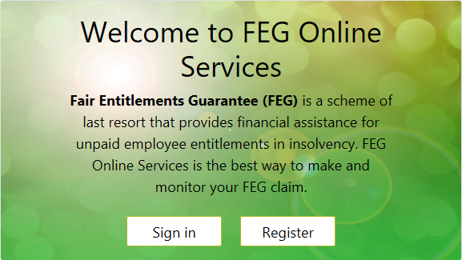
- Accurately complete all fields and then click Register. You must provide your legal first name, legal surname and date of birth for the purposes of registering for FEG Onlines Services. These details will flow through to any claim for FEG assistance you initiate.
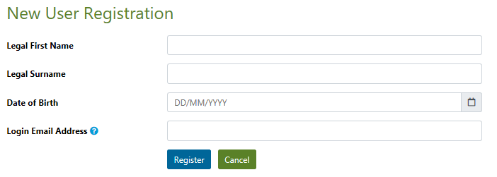
Note: Your registration email address is a unique identifier which your online services account is registered under. Once you have created an online services registration using a particular email address, no one else can use the same email address to register for FEG Online Services.
- Once your registration is successful a temporary password will be emailed to your nominated email address.
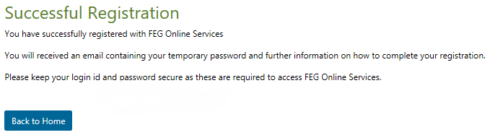
Note: This is not your application for Fair Entitlement Guarantee (FEG). To apply for FEG, use your email and password for FEG Online Services to sign in and make a claim.
- Return back to the Home page and select Sign In. Enter your email address and your temporary password and then click Sign in.
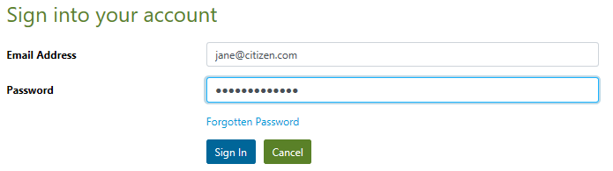
- After successful login you will be prompted to change your temporary password. Your new password must contain a minimum of nine characters and may consist of a combination of:
- 1 uppercase letter (A-Z)
- 1 lowercase letter (a-z)
- 1 numeric character (0–9)
Your password cannot be the same as any of your last 5 passwords.
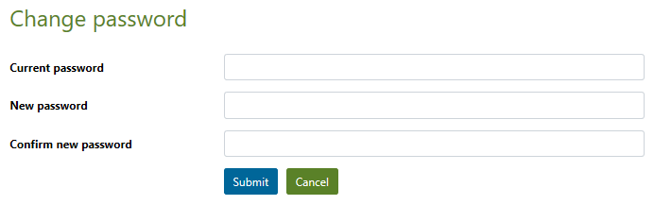
- Once you have successfully changed your password, you will receive a confirmation email and be taken to the FEG Online Services home page.
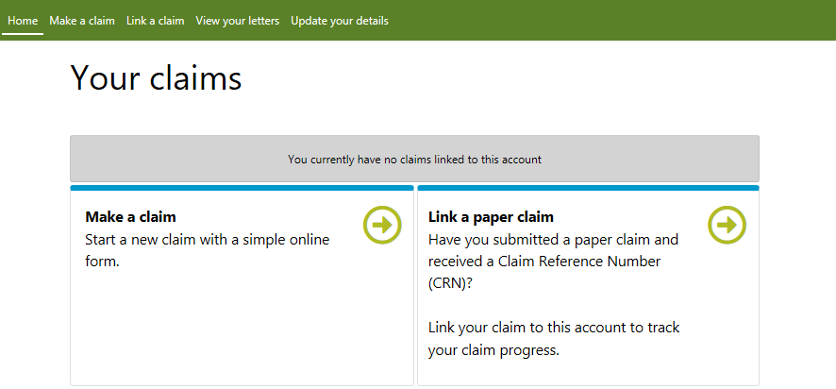
You are now ready to start completing your FEG claim form. If you are not ready to start completing your FEG claim form you may sign out and, using your email address and new password, return at another time to start this process.

Trouble shooting tips
- I try to login to FEG Online Services and a ‘the details entered don’t match those on our system’ or ‘the Username/Login Id or Password that you have entered is incorrect’ error message displays
Tip: When attemping to login for the first time, you must enter the email address you used to register for an online services account and the temporary password we emailed you following the registration process. Your password is case sensitive and the details must be an exact match.
- I can’t remember my password
Tip: Go to the FEG Online Services login page and click I have forgotten my password. You will then be prompted to enter your email address and your date of birth. We will then send you an email with a new temporary password which you will need to change the first time you attempt to login.
- My FEG Online Services account is locked
Tip: If you enter an incorrect password 5 times, your account will be locked. If you have a locked account, you will need to select I have forgotten my password and follow the steps outlined above.

Section 2 – How to lodge a FEG claim online
- Select Make a claim to start a new claim form
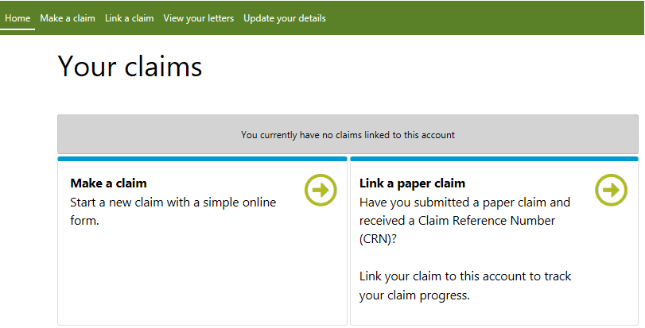
- Enter the ABN or ACN of your former employer and select Check. If you do not know the ABN or ACN select the tick box and enter in the legal or trading name of your former employer.
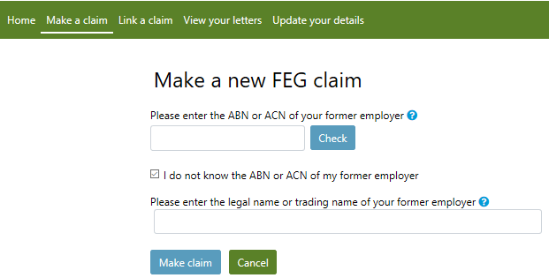
Note: your former employer’s ABN or ACN can usually be found on your payslip, employment contract, PAYG tax payment summary or can be found using the ABN Lookup tool.
You will not be made ineligible for FEG assistance if you are unable to accurately identify your employer’s legal name, but your claim may take longer to process.

- Once you have selected Make a claim you will be directed to the new claim form.
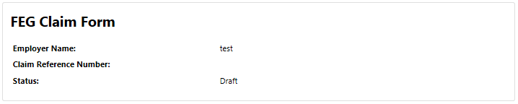
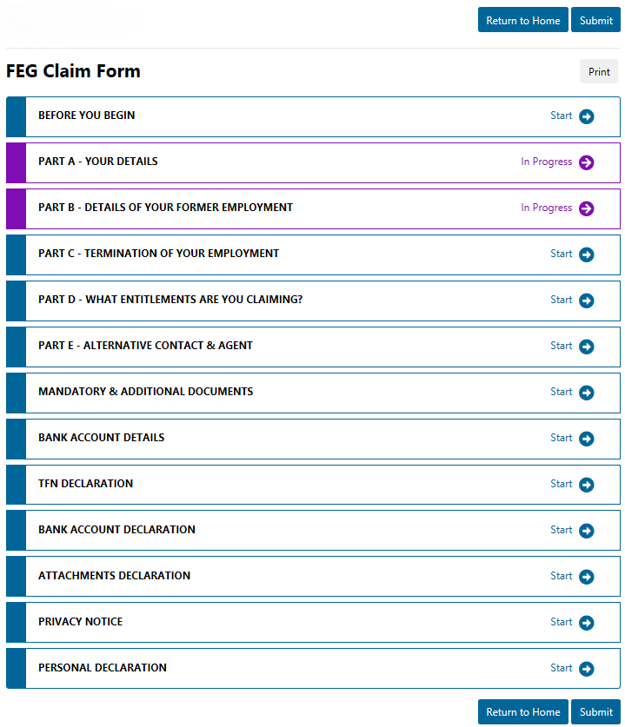
- The FEG Claim Form is set out in parts. Once you complete a part, you need to click Save and Continue to navigate to the next part. To navigate between parts click Save and Exit to return to the home screen, and select the part you wish to view or edit.
It is important that you answer all of the questions unless they are marked as Optional. You will not be able to submit a claim if all the mandatory fields have not been completed.
The question mark next to a question means there is help text available. Click on the question mark and the help text will appear on the right hand side of the screen.
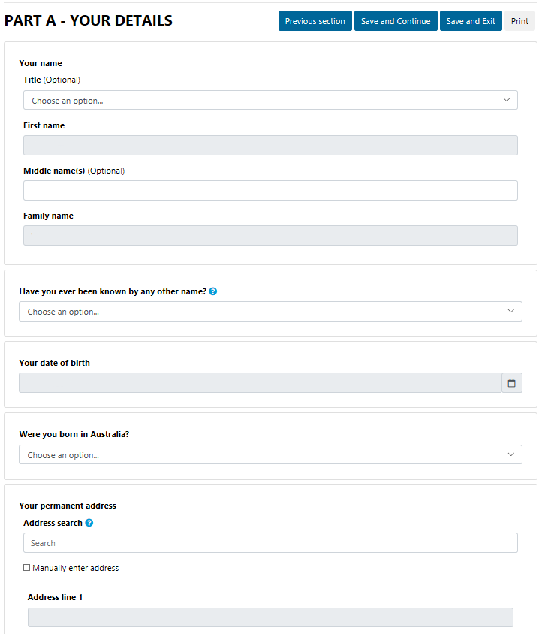

Important!
To be eligible for assistance under FEG you must be an Australian citizen or the holder of a permanent visa
(ie your current visa allows you to live in Australia indefinitely) or special category visa (ie your current visa allows you to stay and work in Australia as long as you remain a New Zealand citizen) at the time your employment ended.
Before assessment of your claim can commence, you must provide documentary evidence to support your claim that you were an Australian citizen or the holder of a permanent visa at the time your employment ended. If you do not provide this evidence your claim will not be effective and you will not be eligible for assistance under FEG.
Acceptable evidence of your citizenship or residency status includes a copy of at least one of the following categories of documents:
- Australian passport issued no later than the date of the end of your employment
- Full Australian Birth Certificate. Extracts of birth certificates are insufficient
- Australian Citizenship Certificate issued prior to the end of your employment. Including both sides if there is anything on the reverse side
- ImmiCard that is linked to an official online record of your permanent Australian visa, and which confirms that the visa was issued prior to the end of your employment
- Registration by Descent document
- Where appropriate, for the purpose of proving you hold a permanent visa, a copy of a passport that is linked to an official online record of your permanent Australian visa, and which confirms that the visa was issued prior to the end of your employment; or a copy of the visa label from your passport (passport details must be visible); or a copy of the Visa Grant Notice that includes the details of your passport you used to apply for that visa
- Where appropriate, for the purpose of proving you held a Special Category visa at the end of your employment, a current New Zealand passport that is linked to an official online record of your Special Category Visa, and which confirms that the visa was issued prior to the end of your employment, or a New Zealand passport that was current at the end of your employment or, if your passport had expired, the most recent expired New Zealand passport that you held at the time you entered Australia prior to working for the employer
- Confirmation of Identity and Citizenship for Aboriginal and Torres Strait Islander people where other documentation is not available. You should use the Confirmation of Identity and Citizenship form which is available on the department’s website.
- In circumstances where you are not able to provide any of the above categories of documents before the end of the legislated 12-month period for lodging your claim, a completed statutory declaration from you, verifying that you do not have and are unable to obtain such documents, and detailing the steps you propose to take to obtain a copy of the required document(s). You should use the Commonwealth statutory declaration form which is available on the website of the Attornney-General’s Department.
Please note: Your driver’s licence is not acceptable evidence of your citizenship or residency status.
Where the name on the document does not match the name that you are claiming under you will also need to provide proof of the change of name by providing one of either:
- Change of name certificate, or
- Marriage certificate.
Important: The department verifies the authenticity of the aforementioned mandatory documents that you provided by requesting confirmation of the document from the agency or organisation that issued the document.
- To upload documentary evidence (and any other supporting documentation you wish to provide) go to the Mandatory & Additional Documents tab. Click the greyed out field, select documents from your computer or drag and drop a document from your computer into this field. More than one file can be added at a time. A list of your uploaded attachments will be shown in this field after these steps have been completed.
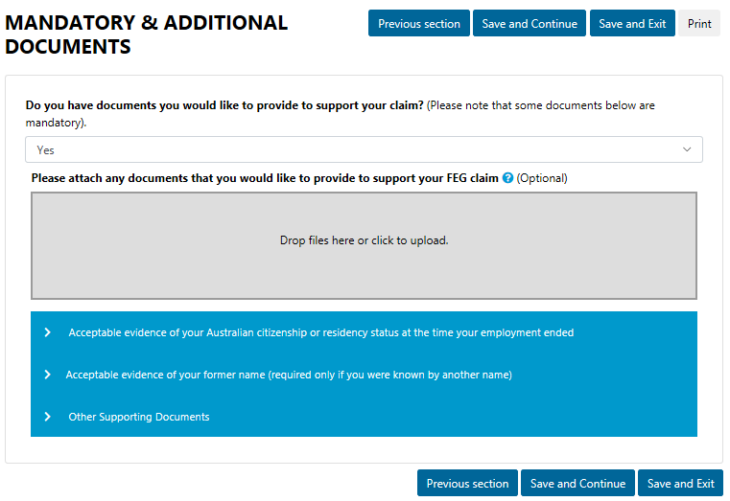
- Complete the bank account details form. You will be asked to verify these details later on as part of the Bank Account Declaration.
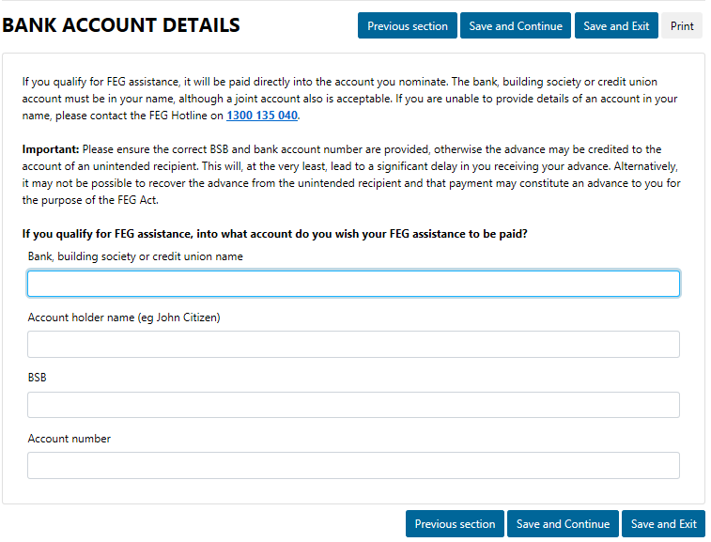
- We are authorised under the Taxation Administration Act 1953 to request your TFN. You are not required to provide your TFN.
If you receive a FEG assistance payment and have provided your TFN, it will be taxed in accordance with a variation given to the department by the Australian Taxation Office (ATO). We are required to withhold tax from your FEG assistance at the top rate of tax if you do not provide your TFN or claim an exemption from providing your TFN.
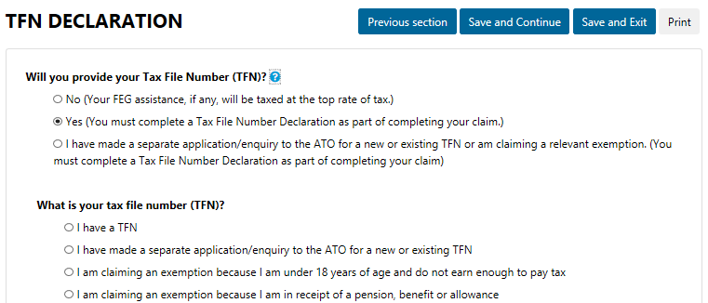
- The Attachments Declaration page asks you to confirm that you have attached copies of evidence to prove you were an Australian citizen or the holder of a permanent or special category visa at the time your employment ended. Select Yes if you have attached the documents and then click Continue. If you have not attached your documents you should do so before submitting your claim otherwise your claim will not be effective and you will not be eligible for assistance under FEG.
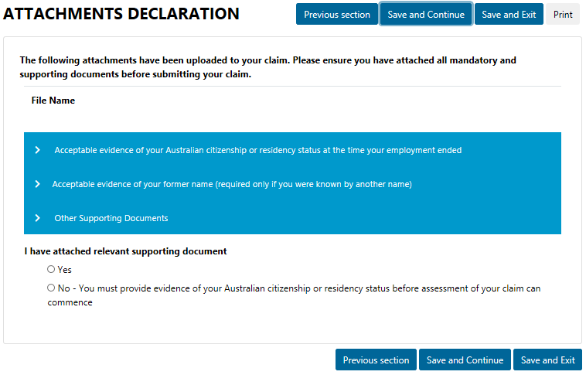
- The next step you must complete is to carefully read the Privacy Notice and Personal Declaration. Once you have read this information you must, declare you have read the privacy notice, agree to the personal declaration, and enter your name.
- After you have completed all parts of the FEG Claim Form and uploaded your attachments, you are ready to submit your claim. Before you submit your claim we strongly encourage you to review the information you have provided in your claim form to make sure it is correct.
- When you are ready to submit your claim click Save and Exit to return to the home screen.
If you have not completed all the mandatory questions in a part of your claim form, the system will display a status of Start or In Progress to indicate that you need to complete that part. To navigate back to these sections you can click on each part to return to complete the question(s).
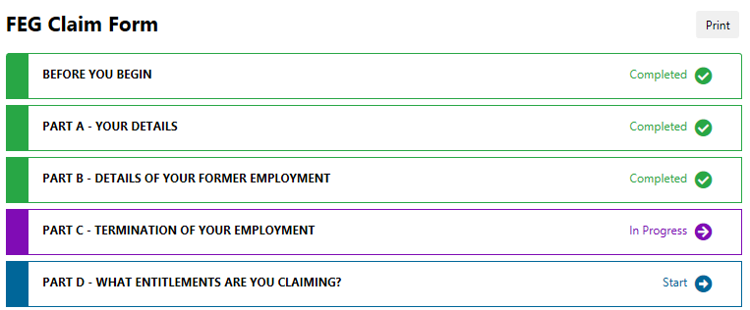
- To submit your claim click the Submit button.
- Once you have submitted your claim you will receive a confirmation message which will include your claim reference number. Please carefully record this information. Your claim reference number will also be emailed to you.

Trouble shooting tips
- When I try to submit my claim, I receive a message that a claim with the same details already exists in the system.
Tip: Before you are able to submit a claim the system will check that you have not already lodged a claim against the employer. If the system finds a matching claim, you will not be able to submit another claim and you will receive an error message.
Please contact the FEG Hotline on 1300 135 040, Mon - Fri, 9 am - 5 pm (AEST/ADST) or send an email to FEG@dewr.gov.au if you want to check if we have already received your claim.
- I didn’t receive an email confirmation after submitting my claim
Tip: You may not have received email confirmation because the email address you entered is incorrect or due to technical issues being experienced with the system. Please contact the FEG Hotline on 1300 135 040 or send an email to FEG@dewr.gov.au to confirm your claim has been submitted successfully.
- I can’t upload my attachments
Tip: Each individual file that you attach must be no more than 5MB. You can attach files up to a total of 20MB to your claim form. Not all file types are accepted for upload. Acceptable formats are doc, docx, txt, xls, pdf, jpg, gif, tif, tiff, xml or ppt. If the file that you are trying to upload is not one of these file types then you will not be able to submit it online. You can either save the file in one of our supported file types or send it via email to FEG@dewr.gov.au (or FEGreviews@dewr.gov.au if the attachments relate to a review you have lodged). Please make sure you also include your full name, date of birth and claim reference number in your email so we can process the additional information as quickly as possible.

Section 3 – How to track the progress of your FEG claim
Now that you have submitted your claim, you can track the status of your claim using FEG Online Services.
- First you will need to login to FEG Online Services. If you submitted your claim online your claim will automatically be linked to your FEG Online Services account. If you submitted a paper based claim form you will need to link your claim to your account.
- To link your claim to your account click Link a claim, enter your claim reference number (this can be found on your FEG Acknowledgement Letter), name and date of birth and then click Save.
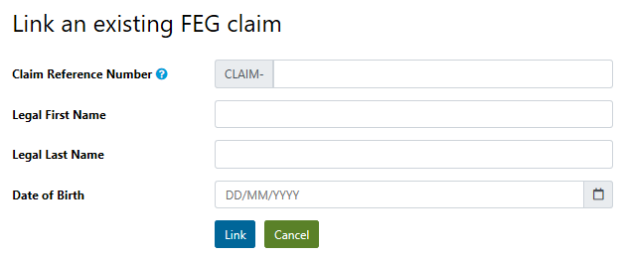
- Once you have successfully attached the claim to your account, the claim will be listed as an existing claim linked to your account. You can now check the status of your claim, view and add attachments, update your bank account details, agent details, entitlement details, contact details, submit your tax file number declaration online (if you haven’t done so already) and access letters we have sent you.
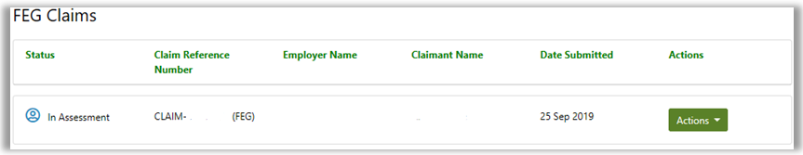
- To check the status of your claim click Actions and select Track Claim from the drop down. The claim status bar will now appear. This helps you check how your claim is progressing and includes useful information about what each stage involves.
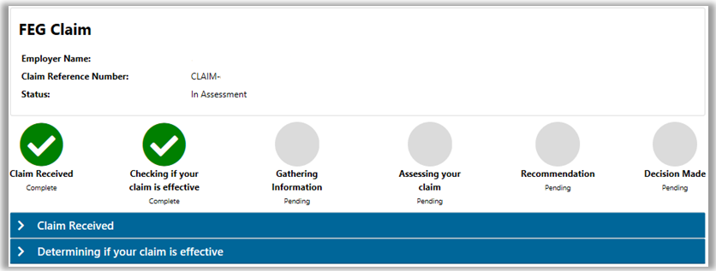

Trouble shooting tips
- My claim has not progressed to the next step since I last checked
Tip: We aim to process your claim as quickly as possible but the time it takes us to complete your claim is dependant on the demand for the scheme and the complexity of your claim. We aim to process a claim within 16 weeks of receiving an effective claim.
- I am unable to check the status of my claim on FEG Online Services
Tip: You will be able to track the status of your claim immediately after submission. If you are unable to link your claim to your account using your claim reference number please contact the FEG Hotline for further assistance on 1300 135 040.

Want more information?
You can contact the FEG Hotline if you want further information about using FEG Online Services:
- phone 1300 135 040
Mon - Fri, 9 am - 5 pm (AEST/ADST)
- email FEG@dewr.gov.au
If you speak a language other than English, call the Translating and Interpreting Service (TIS) on 13 14 50 for free help anytime. If you speak an Indigenous language, call the Aboriginal Interpreter Services on 1800 334 944.
Further information about FEG is also available on the FEG website.
The information contained in this fact sheet is of a general nature and explains, in summary form, the intended operation of the
Fair Entitlements Guarantee Act 2012 - it is not legal advice. Where necessary, you should seek your own independent legal advice relevant to your particular circumstances. The Commonwealth does not make any representation or warranty about the accuracy, reliability, currency or completeness of the information contained in this fact sheet and is not liable for any loss resulting from any
action taken or reliance made by you on the information contained in this factsheet.

