Australian Government
Department of Employment and Workplace Relations

Fair Entitlements Guarantee Logo


FEG IP Online Help Guide

Table of Contents

1 Login 5

1.1 Landing page 5

2 My Dashboard 6

2.1 Navigation pane 7

3 Manage Cases 8

3.1 Searching for a case 9

3.2 Status of a case 10

3.3 Reassign a case 10

3.4 Assign a new liaison 10

3.5 Remove a liaison 10

4 Manage Claims 11

4.1 Searching for a claim 11

5 Manage Tasks 13

5.1 Creating a task for a case 13

5.2 Creating a task for a claim 14

5.3 Selecting a task 14

5.4 Searching for a task 14

5.5 Status of task 16

5.6 Accessing questionnaires through tasks 16

5.7 Uploading a file to a task 16

5.8 Removing an uploaded file from a task 17

5.9 Assigning a task 17

5.10 Creating comments for a task 17

5.11 Deleting an IP created Task 18

5.12 Submitting a task 18

5.13 Requesting approval of a task 19

5.14 Approving and rejecting a task 19

5.15 Complete a task 20

6 Questionnaires 21

6.1 Accessing questionnaires 21

6.2 Editing the questionnaire 21

6.3 Viewing questionnaires 22

7 Verification Spreadsheet Task 23

7.1 Accessing the verification spreadsheet 23

7.2 Uploading a completed verification spreadsheet 24

7.3 Error and warning flags 24

7.4 Editing the verification spreadsheet 25

7.5 Submitting the verification spreadsheet 25

7.6 Opting out 25

8 Messaging 26

8.1 Creating a message 26

8.2 Selecting a message 26

8.3 Searching for a message 27

8.4 Status of a message 27

8.5 Uploading a file to a message 28

8.6 Removing an uploaded file from a message 28

8.7 Creating message text 28

8.8 Deleting a message 29

8.9 Submitting a message 29

8.10 Complete a message 30

9 Manage Correspondence 31

9.1 Searching for correspondence 31

10 Manage eCitizen Account 32

10.1 eCitizen website 32

11 User Account Management 33

Settings > Teams Search 33

Settings > User Search 33

11.1 Create users 34

11.2 Linking eCitizen accounts 35

11.3 Maintaining a user 35

11.4 Update user details 36

11.5 User permissions 36

System Administrator 36

Maintain Users 36

Maintain Teams 36

Action Tasks 36

Assign Tasks 36

Submit Task 37

Maintain Case Assignments 37

11.6 Create teams 37

11.7 Maintaining a team 38

11.8 Assign a user to a team 38

11.9 Assign a primary contact to a team 38

11.10 Update team details 38

11.11 Deactivate a team 39

11.12 Task workflow 39

12 Exportable Reports 40

12.1 Generating a report 40

13 Manage Verification Spreadsheet Templates 41

13.1 Creating a template 41

13.2 Creating mapping definitions 42

13.3 Finalising template setup 42

13.4 Managing templates 43

13.5 Searching for a template 43

14 Resource Centre 44

14.1 Searching documents 44

14.2 Viewing documents 44

14.3 Viewing links 44

1. Login

To log in, go to [FEG IP Online](https://extranet.employment.gov.au/FEGIPONLINE/). It is recommended the above link is bookmarked (ie: add to Favourites), or that insolvency practitioners (IPs) navigate to the Information for Insolvency Practitioner section of the page [Fair Entitlements Guarantee](https://www.dewr.gov.au/fair-entitlements-guarantee) to access FEG IP Online in future instances.

The landing page provides basic information about FEG, how the Department of Employment and Workplace Relations (department) and IPs interact in administering FEG claims, and contact details for the department.

* 1. Landing page

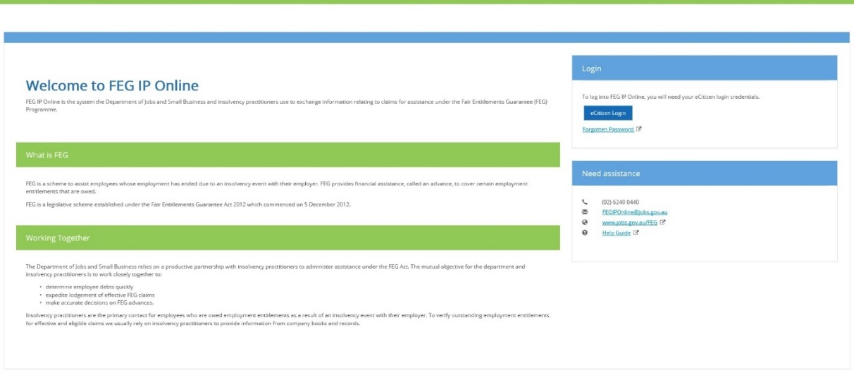

To log in you will need to create an eCitizen account. This can be initiated by the system administrator for your firm or the department. To request that the department initiate creation of your eCitizen account please email [FEGIPOnline@dewr.gov.au](mailto:FEGIPOnline@jobs.gov.au) or contact the FEG IP Hotline on (02) 5122 4444. Please note further information about account creation is available in the *User Account Management*section at chapter 11.

**Note:** the link contained in the initial account activation email sent from eCitizen should not be re-used as it is designed for one-time use only and expires after 72 hours.

To login to your account:

1. Click the **eCitizen Login** button under the *Login* heading.
2. On the *eCitizen Login* page enter your **username** and **password** and click **Login.**

**Note:** if you work across a number of offices (e.g. Sydney, Melbourne and Brisbane), and your eCitizen account is linked to more than one office, you have the option to select the office you wish to log into.

1. My Dashboard

Once you have successfully logged in you will be directed to *My Dashboard* page.

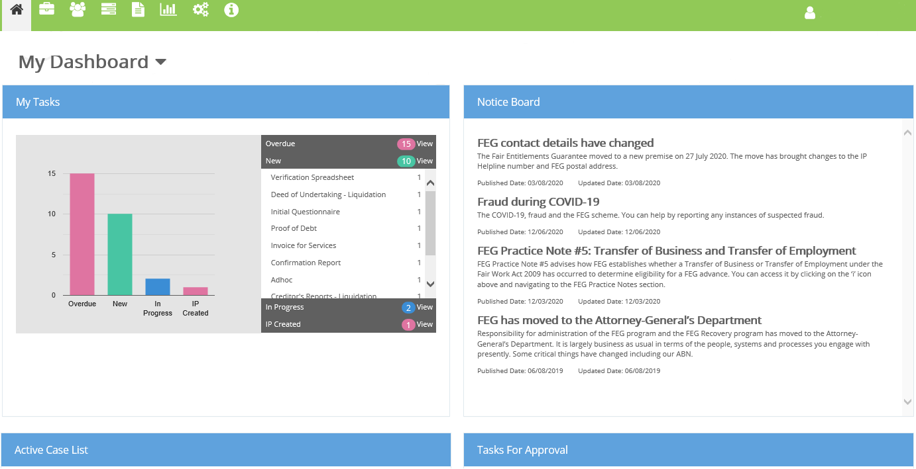

Using the drop-down options you can select to view *My Dashboard* or *Firm Dashboard***.**

*My Dashboard* displays the following:

* tasks assigned to you and your team
* tasks you have created
* messages you have created
* messages you have sent and received
* the stage these tasks are in (overdue, new, in progress, approved)
* all active cases assigned to you and your team
* tasks assigned for approval to you and other users with the same role permission
* notice board articles.

*Firm Dashboard*displays the following:

* tasks assigned to your firm
* the stage these tasks are in (overdue, new, in progress, approved)
* messages created by the firm
* messages the firm has sent and received
* all active cases assigned to you and your team
* tasks assigned for approval to you and other users with the same role permission
* notice board articles.

**Note:** all fields within the page are dynamic allowing you to drill into specifics.

The*Notice Board* contains communications that are typically short-form messages. Clicking on the heading directs the user to another tab containing the full message content.

* 1. Navigation pane

The navigation pane is displayed in the top left of the landing page.

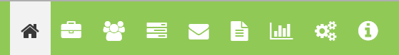

The navigation pane allows you to navigate directly to the following options:

|  |  |
| --- | --- |
| My dashboard icon | The home icon takes you to *My Dashboard* |
| Case Screen icon | The case icon takes you to *Manage Cases* |
| Manage claims icon | The claim icon takes you to *Manage Claims* |
| Task Screen icon | The task icon takes you to *Manage Tasks* |
| Message search icon | The messaging icon takes you to *Message Search* |
| Correspondence Screen icon | The correspondence icon takes you to *Manage Correspondence* |
| Reports Screen icon | The reports icon takes you to *Reports* |
| Setting Screen icon | The settings icon allows you to *Manage Teams, Manage Users, manage Task Workflow* and *Manage Templates* |
| Resource Centre icon | The resource centre icon takes you to the *Resource Centre*to view FEG related information and guides. |

1. Manage Cases

The *Case Search* page allows you to search cases assigned to your firm.

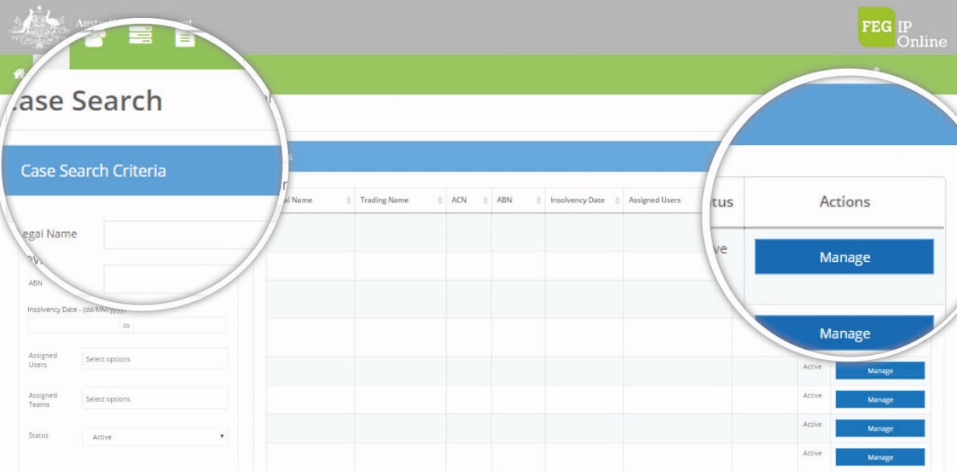

This function allows you to search by *Legal name*, *Trading name*, etc. as shown below.

**Note:** if a search returns no result, try leaving the *Status*field empty. You can use the *Reset* button to clear previous search parameters.

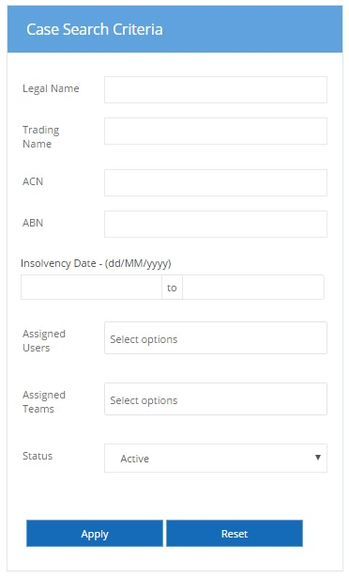

* 1. Searching for a case

To search for a case assigned to your firm:

1. Click the **Cases Icon** within the *Navigation Bar*
2. Enter the search criteria (e.g. company name, ABN etc.) within the *Search Criteria*
3. Select the *Case*from the *Search Results*by clicking the **Manage** button
4. Click the **Manage** button and you will be taken to the *Manage Case*page.

**Note:** you can only view cases the department has assigned to your firm.

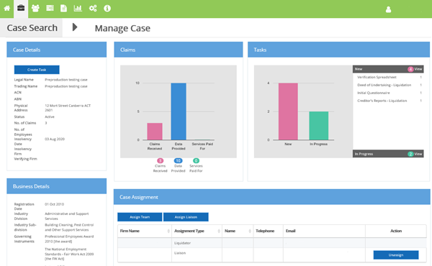

The *Manage Case*page displays the following**:**

* *Case Details* – provides case basic information such as the number of claims submitted, number of employees and the date of the insolvency event. Allows you to create a task for cases where you are assigned as the liaison.
* *Claims* – displays a graph of the number of claims submitted and the claim assessment stage the claim is in
* *Tasks* – displays a graph of all tasks for the case and the stage they are in
* *Total Payments Made* – displays a table including the amount that has been paid for each employment entitlement type
* *Case Assignment* – allows you to assign a new team or user to the case from your firm
* *Business Details* – provides basic information about the business
* *Claims By Stage* – shows a graph of how many claims are in each stage
* *Questionnaires* – displays a list of all questionnaires (ie: Initial Contact and Recovery) for the case, what stage they are in and the percentage completed for each
* *Case Attachments* – contains relevant attachments to the case.

**Note:** some fields within the page are dynamic allowing you to drill into specific details.

The Create Task button will display if you are assigned as the liaison for the case. The button will be greyed out do not have the relevant role permissions (System administrator or Action Tasks) assigned to your profile.

* 1. Status of a case

A task may be in the following status:

* *Active* – the case will be in this status when it has been created and applicable service provider details are entered. Cases are generally created on the receipt of the first claim
* *Recovery* – the task will move to this status when all claims have been processed
* *Closed* – the task will move to this status when all claims have been processed, no further claims are expected and no further action is required on the case by the FEG branch.
  1. Reassign a case

System administrators and **users with *Maintain Case Assignment* role permissions** can reassign a liaison in FEG IP Online when a case is in the status of *Active* or *Recovery*. To unassign and replace a liaison on an *Active or Recovery* case follow these steps:

* 1. Assign a new liaison

1. Select **Assign Liaison** in the *Case Assignment* panel. The pop-up box will give an option to assign the case to an individual user
2. Select **Set as Liaison**.
   1. Remove a liaison
3. Within the *Case Assignment* panel select **Unassign** next to the user you wish to remove
4. Select **Unassign**
5. Select **Case Search** to return to the tasks with the previously applied search criteria.

**Note:** if the user is the last remaining liaison on a case, the system will prevent the user from being unassigned. A new liaison must be added before the last remaining liaison can be unassigned from the case.

Please see *Unlinking/Deactivating users – FEG IP Online* in the Resource Centre for further details.

1. Manage Claims

The *Claim Search* page allows you to search through claims for a case.

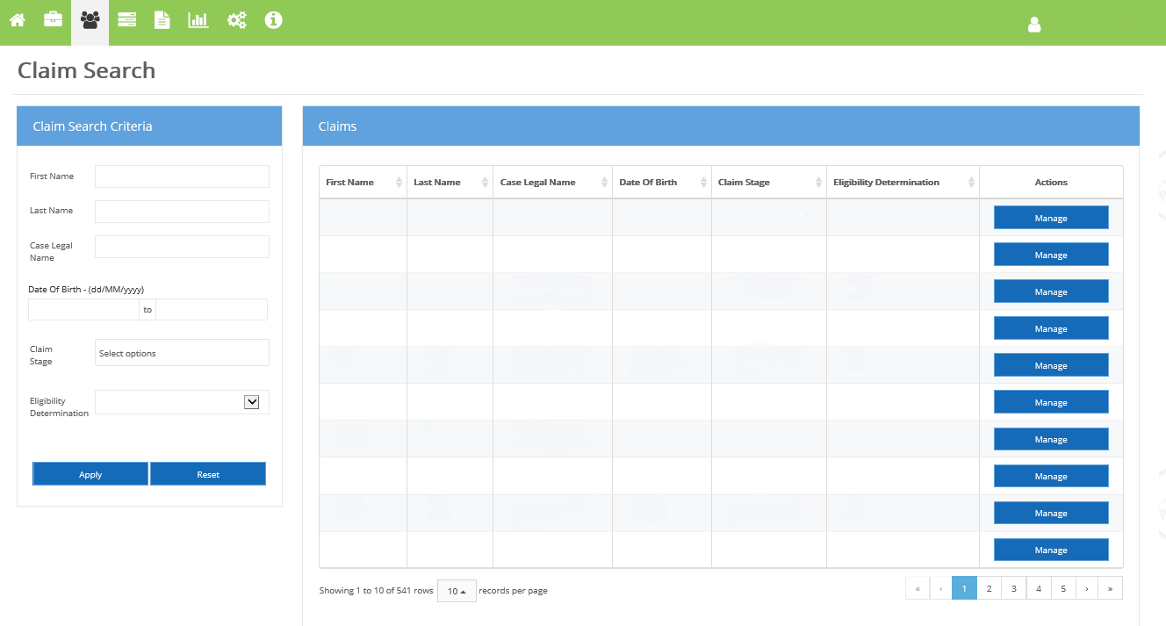

* 1. Searching for a claim

To search for a claim:

1. Click the **Claims** icon within the *Navigation Bar*
2. Enter the search criteria (e.g. claimant’s name) within the *Search Criteria*
3. Select the claimfrom the *Search Results*using the **Manage** button
4. Click the **Manage** button and you will be taken to the *Claim View* page.

**Note:** you can only view claims for cases that are assigned to your firm.

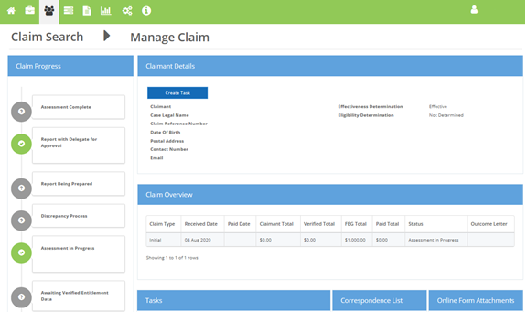

The *Manage Claim*page displays the following**:**

* *Claim Progress* – provides an overview of the progress of the claim
* *Claimant Details* – provides basic information about the claim such as whether the claim is effective, claim outcome details, and the claimant’s contact details. Allows you to create a task for a claimant where you are assigned to the case as the liaison.
* *Claim Overview* – provides a list of the decisions that have been made on the claim and any outcome letters that have been sent to the claimant by the department
* *Tasks* – shows any tasks that relate to the claim
* *Correspondence List* – displays correspondence sent to the claimant by the department
* *Online Form Attachments* – displays relevant attachments that the claimant has sent the department.

1. Manage Tasks

The *Task Search* page allows you to create and search tasks for cases assigned to your firm.

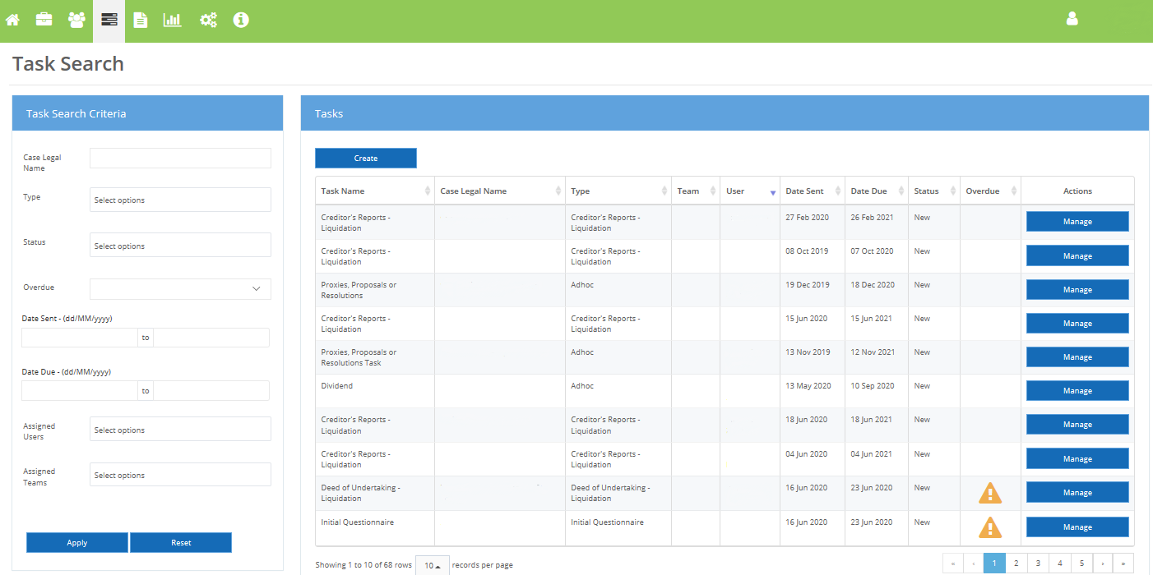

* 1. Creating a task for a case

System administrators and **users with the ‘*Action Tasks’* role permission** can create a task for a case where they are assigned as the case liaison. To create a task for a case:

1. Click the **Tasks Icon** within the *Navigation Bar*
2. Select the **Create** button in the *Tasks* panel
3. Complete the *Create Task* pop up box
   1. Select a *Type* from the drop-down
   2. Enter in a *Task Name*
   3. Select a *Case Legal Name* from the drop-down. The list will display all cases where the users is assigned as the liaison.
   4. Select a *Category* from the drop-down

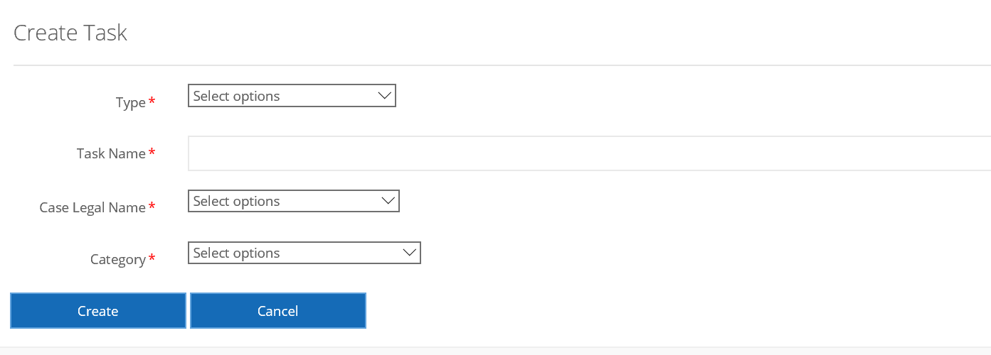

1. Select **Create**

**Note:** once the task has been created you can *Submit*, *Assign* or *Delete* the task.

* 1. Creating a task for a claim

System administrators and **users with the ‘*Action Tasks’* role permission** can create a task for a claimant associated with a case where they are assigned as the case liaison. To create a task for a claimant:

1. Click the **Tasks Icon** within the *Navigation Bar*
2. Enter the search criteria (e.g. claimant’s name) within the *Search Criteria*
3. Select the claimfrom the *Search Results*using the **Manage** button
4. Click the **Manage** button and you will be taken to the *Claim View* page.
5. Select the Create Task button
6. Complete the Create Task pop up box by
   1. Selecting a *Type* from the drop down
   2. Entering in a *Task Name*
   3. Selecting a *Category* from the drop down

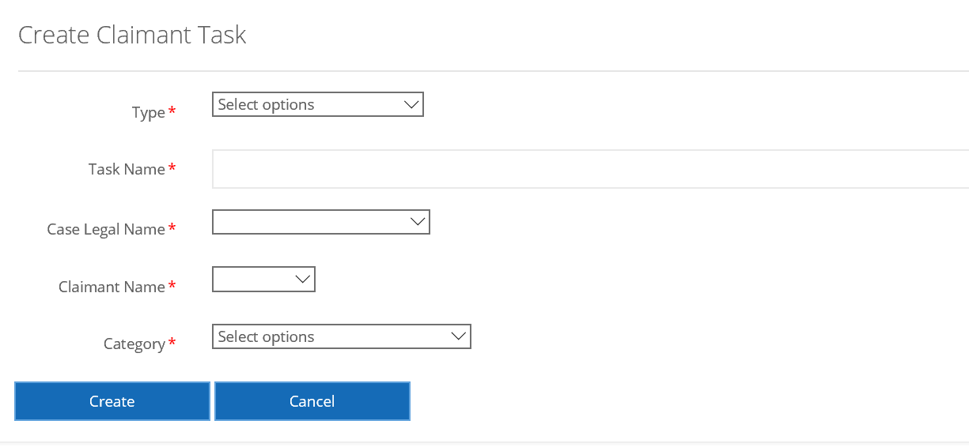

1. Select **Create**

**Note:** the Case Legal Name and the Claimant Name will auto populate. Once the task has been created you can *Submit*, *Assign* or *Delete* the task.

* 1. Selecting a task

You can select a task by:

* searching for a task through the *Task Search* page
* opening the task through the *My Tasks* panel on *My Dashboard***,** *Case* or *Claim*pages.
  1. Searching for a task

The search task function allows a user to search and filter tasks. To search for a task:

1. Click the **Tasks Icon** within the *Navigation Bar*
2. Enter the *Search Criteria*and select **Apply**
3. Select the task from the *Search Results*list using the **Manage** button.

**Note:** you can apply filters based on *Case Legal Name, Type, Status, Date Created (Date Range), Due Date (Date Range),* *Team,* and *User*.

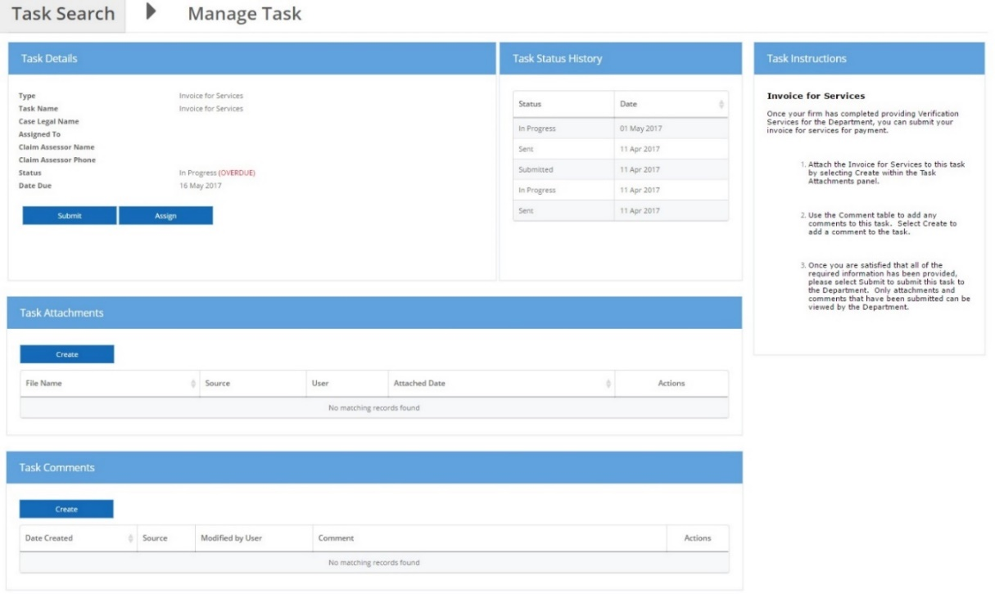

Once you select the *Manage* button in the *Actions* column, you will be taken to the *Manage Tasks* view. The *Manage Tasks* page displays the following task details:

* *Task Instructions* – please read these instructions as the department usually provides specific instructions for each task
* *Task Details* – displays details such as the types of task, status and who it is assigned to
* *Task Status History* – displays the history of the task
* *Task Attachments* – displays attachments that have been sent to you as well as attachments you have uploaded.
* *Discrepancy Data* – contains a Manage Data button and displays details of the case and claimant decision progress
* *Questionnaires* – displays details of the questionnaire (ie: Initial contact or Recovery) and the ability to edit or view the questionnaire.
* *Task Comments* – displays comments that have been sent to you as well as comments you have sent to the department.
* *Tasks Claimants* – displays the details of the claimant linked to the task (ie: claim reference number, claimant name and date of birth).

**Note:** you will only see the Questionnaire panel and the Discrepancy Data panel if the task type is a questionnaire or discrepancy report (case and claimant) respectively. Refer to the FEG Discrepancy process help guide in the IP Resource Centre to learn more about the discrepancy task types.

* 1. Status of task

A task may be in the following status:

* *IP Created* – the task will be in this status when it has been created but not submitted to the department.
* *New* – the task will be in this status when it is first assigned to you
* *In Progress* – the task will move to this status when you commence work by clicking **Work on Task** or when a task submitted for approval has been rejected

Picture of Work on Task icon

* *Submitted* – the task will move to this status when you submit the task to the department
* *Overdue* – the task will be in this status if you do not submit the task before the due date

Picture of Status InProgress (OVERDUE) icon

* *Completed* – the task will be in this status if no further action is required
* *Pending Approval* – the task will move to this status once you have clicked **Request Approval**
* *Approved* – the task will move to this status once approved to be submitted.
  1. Accessing questionnaires through tasks

Some tasks are questionnaire task types and in these instances the user will need to complete the questionnaire within FEG IP Online by following these steps:

1. Click the **Task Icon** within the *Navigation Bar*
2. Enter the *Search Criteria* and select **Apply**
3. Select the task from the *Search Results* list using the **Manage** button
4. Select **Work on Task** for new task to go to the questionnaire. For tasks in progress select **Edit**or **view** under the *Questionnaire*heading.

Refer to how to access, edit and view Questionnaires at chapter 6.

* 1. Uploading a file to a task

Some tasks require the user to complete and return documentation. To upload completed documentation:

1. Click the **Tasks Icon** within the *Navigation Bar*
2. Enter the *Search Criteria*and select **Apply**
3. Select the task from the *Search Results*list using the **Manage** button
4. Select **Create** under the *Task Attachments*heading
5. Drag and drop the appropriate file or select the *Upload File* button to choose a file manually
6. Once the attachment has successfully uploaded, select **Close.**

**Note**: you can upload multiple files to a task or documents can be dragged and dropped from the users’ desktop and local drives.

* 1. Removing an uploaded file from a task

If you wish to remove an uploaded file from a task:

1. Click the **Tasks Icon** within the *Navigation Bar*
2. Enter the *Search Criteria*and select **Apply**
3. Select the task from the *Search Results*list using the **Manage** button
4. Select the **Remove** button against the appropriate attachment under the *Task Attachments*heading
5. Select the **Remove** button to confirm you wish to remove the attachment.

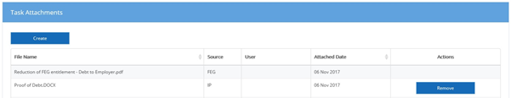

**Note:** once the task has been submitted to the department, attachments can no longer be removed.

* 1. Assigning a task

To assign tasks to a user, office or team for completion:

1. Click the **Tasks Icon** within the *Navigation Bar*
2. Enter the *Search Criteria*and select **Apply**
3. Select the task from the *Search Results*list using the **Manage** button
4. Select the **Assign** button under the *Task Details*heading. The pop-up box will give you the option to assign the task to an individual user or a team under *Assignment Type*
5. Once you have selected the *Assignment Type* and *User*, select **Assign.**
   1. Creating comments for a task

To add a comment to a task:

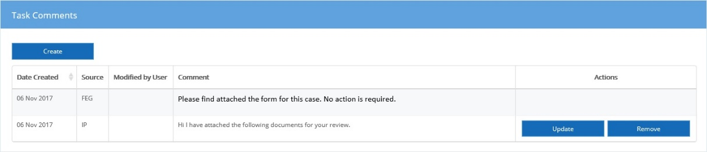

1. Click the **Tasks Icon** within the *Navigation Bar*
2. Enter the *Search Criteria*and select **Apply**
3. Select the task from the *Search Results*list using the **Manage** button
4. Select **Create** under the *Task Comments*heading
5. Type in the comment
6. Once you have finished the comment select **create.**

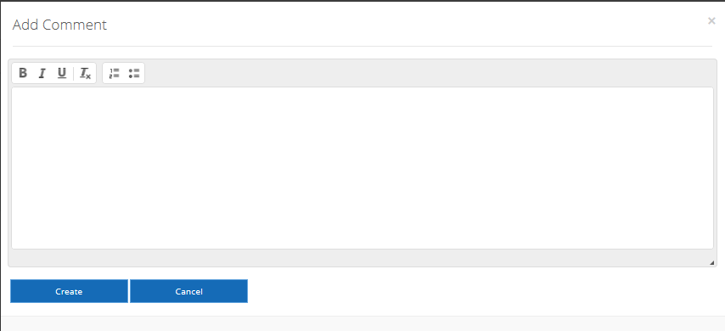

**Note:** you can *update* and *remove* a comment you have created by clicking on the applicable button. However, you can no longer change or remove a comment once the corresponding task has been submitted.

* 1. Deleting an IP created Task

If you wish to delete a task:

1. Click the **Tasks Icon** within the *Navigation Bar*
2. Enter the *Search Criteria*and select **Apply**
3. Select the task from the Search Resultslist using the **Manage** button
4. Select the **Delete** button against the appropriate attachment under the *Task Attachments*heading.

**\*** Please note a task cannot be deleted after it has been submitted to the department.

* 1. Submitting a task

To submit a task:

1. Click the **Task Icon** within the *Navigation Bar*
2. Enter the search criteriaand select **Apply**
3. Select the task from the *Search Results* list using the **Manage** button
4. Complete the task
5. Once the task is complete click **Submit** under the *Task Details* heading.

Task submit button is displayed

**Note:** to complete some tasks, you may need to upload a file, please refer to Uploading a file to a taskat **5.5**.

You can *Submit* an incomplete task if you require extra time to action the task or require further guidance or clarification. Use the comments field to provide details for the department to consider the request.

* 1. Requesting approval of a task

To request approval for a task:

1. Select **Work on Task**
2. Select **Request Approval**
3. Select who should be notified to approve the task and select **Request Approval**
4. The task status will change to **Pending Approval**.

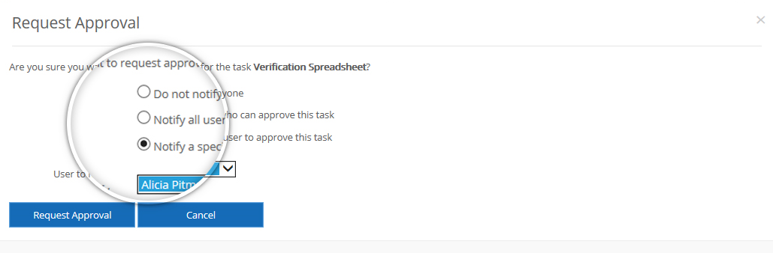

* 1. Approving and rejecting a task

Tasks pending approval will appear under the Notice Board panel in the *My Dashboard* and *Firm Dashboard* pages.

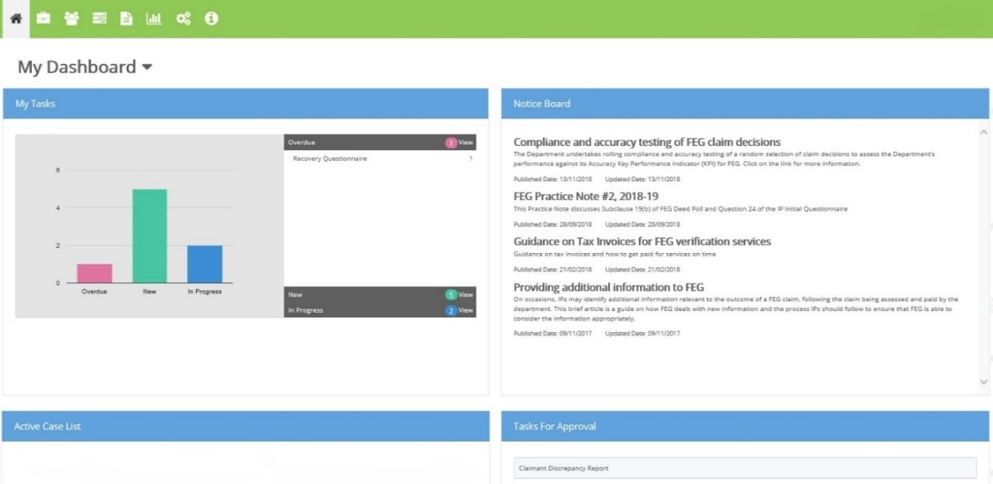

To approve or reject a task:

1. Click the **Tasks Icon** within the *Navigation Bar*
2. Enter the *Search Criteria*and select **Apply**
3. Select the task from the *Search Results*list using the **Manage** button
4. Enter any further comments or upload attachments prior to Rejecting or Approving the task
5. Select **Approve Task** or **Reject Task**
6. The task status will move to *Approved* in *My Tasks* on *My / Firm Dashboard.*

**Note:** rejecting a task will revert the status to *In Progress* and send an email notification to the assigned user. The user can make necessary changes and resubmit for approval.

**Important:** users including system administrators must be assigned the same role permissions as the task for approval, e.g. if the role assigned to a discrepancy report is *Approve Tasks* then this permission needs to be added to any user, in the *Manage Users* setting, who needs to approve this task. System administrators will therefore need *System Administrator* and *Approve Tasks* permissions.

If the user does not have the same permission as the task, the task will not appear in the *Tasks for Approval* panel on their dashboard. In addition, the user will not be able to approve the task.

* 1. Complete a task

The complete a task function allows a user to complete IP created tasks. To complete a task:

1. Click the **Tasks Icon** within the *Navigation Bar*
2. Enter the *Search Criteria*and select **Apply**
3. Select the task from the *Search Results*list using the **Manage** button
4. Select the **Complete** button under the *Task Details*heading.

**Note:** only IP created tasks can be completed. Once a task is completed it can no longer be used to send comments or attachments.

1. Questionnaires

There are two types of questionnaires: The Initial Contact, and Recovery. Completing the Recovery questionnaire is optional. The Initial Contact questionnaire should be completed by the due date.

* 1. Accessing questionnaires

Questionnaires are initially sent from the department to the firm as a task. Users are able to access the task through *My Dashboard*or the *Task Search*.Questionnaires can also be accessed through *Case Search***.**

The Questionnaire banner will display the following:

**Case: Status: Last Submitted By: Last Submitted Date:** (incl. Time)

* 1. Editing the questionnaire

To edit a questionnaire:

1. Click **Work on Task** for a newquestionnaire
2. Select **Edit** in the Questionnaire panel for *In Progress*questionnaire tasks
3. From the *Case* page users can click on the relevant questionnaire.

Within *Edit Mode* the following functions are available at the bottom of the page:

* *Prev* **–** allows user to move to the previous page of questions
* *Next* – allows user to move to the next page of questions
* *Print* – allows user to print out the questionnaire
* *Save Draft* – allows user to save the questionnaire in draft without submitting to the department
* *Save and Submit* – allows user to save the questionnaire and submit to the department
* *View Task* – if the task has not been submitted to the department the user will be able to go back to view to task and add attachments or comments.

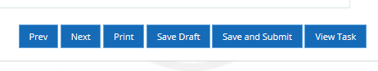

Once the user is in the questionnaire they can navigate through the questionnaire either by using the *Selection Bar* on the left hand side of the page, or clicking *Next* (and *Prev*).

**Note:** you must complete the mandatory questions before submitting either questionnaire. These include the ‘Agree’ checkbox at the Acknowledgements section, and Question 7 in the Initial Contact questionnaire.

* 1. Viewing questionnaires

To view a questionnaire:

1. Click **Work on Task** for a *New*questionnaire
2. Select **View** in the *Questionnaire* panel for *In Progress*questionnaire tasks
3. From the *Case* page users can click on the relevant questionnaire.

Within *View Mode* the following functions are available at the buttons at the bottom of the page.

* *Prev* – allows user to move to the previous page of questions
* Next – allows user to move to the next page of questions
* Edit – allows user to edit the questions
* *Print* – allows user to print out the questionnaire
* *Submit* – allows user to submit to the department
* *View Task* – if the task has not been submitted to the department the user will be able to go back to view to task and add attachments or comments.

The navigation bar is displayed

Once the user is in the questionnaire they can navigate through the questionnaire either by using the *Selection Bar* on the left hand side of the page, or by clicking *Next* (or *Prev*).

1. Verification Spreadsheet Task

FEG IP Online requires that you upload, rather than attach, the completed verification spreadsheet to the Verification Spreadsheet task.

**Note:** if you attempt to attach the verification spreadsheet to the verification task, instead of uploading the completed verification spreadsheet, you will receive the following error message and will not be able to submit the verification spreadsheet task.

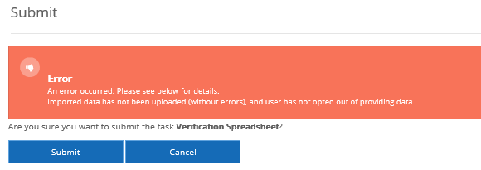

The *Data Import* page allows users to *Upload Data* or *Opt Out* of providing data. Click *Opt Out* if you are unable to provide verification services at all or by the due date.

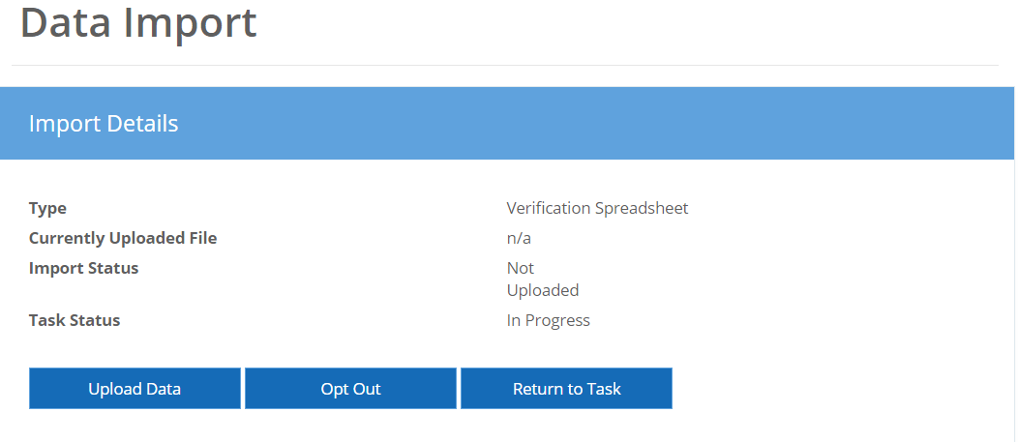

* 1. Accessing the verification spreadsheet

Verification spreadsheets are sent from the department to the firm as a task. Users are able to access the task through *My Dashboard*or the *Task Search*.Verification spreadsheets can also be accessed through *Case Search*.

**Note:** you can use the FEG supplied verification spreadsheet or your own spreadsheet used to verify employee data. Refer to chapter 12 for more details.

* 1. Uploading a completed verification spreadsheet

To edit a spreadsheet:

1. Click **Work on Task**
2. Select Upload Data in the *Data Import* page
3. Confirm the correct *Template* is displayed
4. Drag and Drop file or select Upload File and select the completed verification spreadsheet from the users’ desktop and local drives.

**Note:** if the FEG supplied verification spreadsheet is used the applicable template is ‘Default (Excel) [xlsx]’. This template appears in the drop down box unless your firm sets an IP firm alternative template as default.

A preview of the data will appear in the *Preview* panel of the *Data Import* page.

* 1. Error and warning flags

Errors and warning flags appear in the preview panel to draw a user’s attention to:

* missing data
* data that may require amending, or
* data that may require additional information before submitting the task.

A verification spreadsheet containing an error message cannot be submitted back to the department until all errors have been addressed or the applicable line entry is removed from the spreadsheet and the amended spreadsheet uploaded.

Warning flags should be addressed but do not prevent the user from submitting a verification task.

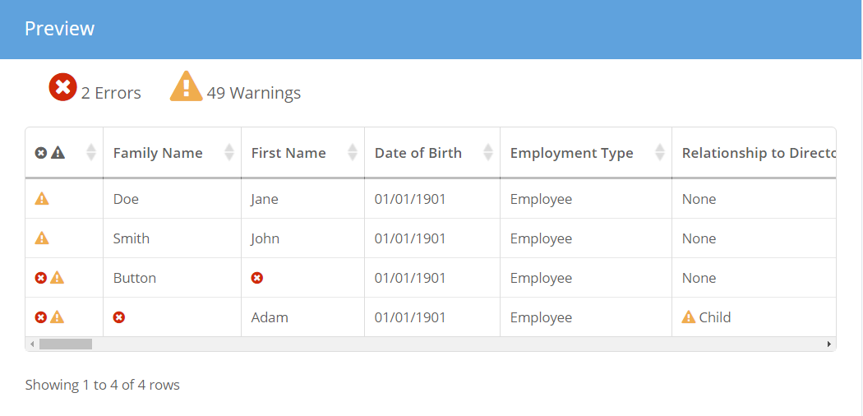

* 1. Editing the verification spreadsheet

Only one spreadsheet can be uploaded to a verification task. To make a change to the data that has been uploaded but not submitted, you will need to upload a new spreadsheet. The imported spreadsheet will replace any information that has previously been uploaded.

To upload a new or amended spreadsheet:

*(If you are returning to a task already in progress)*

1. Click the **Tasks Icon** within the *Navigation Bar*
2. Enter the *Search Criteria*and select **Apply**
3. Select the task from the *Search Results*list using the **Manage** button
4. Click **Manage Data** under the Data Import heading
5. Complete steps 6 & 7.

*(If you are already in the Data Import page)*

1. Select **Upload Data** in the *Data Import* page
2. Drag and Drop file or select Upload File and select the completed verification spreadsheet from the users’ desktop and local drives.
   1. Submitting the verification spreadsheet
3. Click **Return to Task** in the*Import Details*panel
4. Select **Create** under the *Task Comments*heading
5. Type in the comment
6. Once you have finished the comment select **Create**
7. Select **Submit** in the *Task Details* panel.

**Note:** please use the Task Comments to list the names of any workers you consider to be clearly ineligible for a FEG advance (this should not require a detailed assessment). The verification spreadsheet should only include employee entitlement data for former employees who are likely to be eligible for a FEG advance.

* 1. Opting out

If the firm is unable to provide verification services, you must select the **Opt Out** button. The **Opt Out** button allows the user to notify the department that the firm has elected not to provide verification services. The **Opt Out** button is also used to request an extension. This button is only available where you have not already uploaded a verification spreadsheet.

To remove data from the task:

1. Select **Delete Data** from the *Import Details* panel.

To Opt out of providing data or request an extension:

1. Click **Work on Task**
2. Click **Opt Out** from the *Import Details* panel
3. Select **Opt Out Reason**
4. Enter Additional Information if Other or Extension Required is selected
5. Select **Opt Out**
6. Select **Submit Task** from *Task Details* panel
7. Select Submit to confirm you wish to submit the Verification Spreadsheet task.

**Note:** you will not be able to opt out of a task if additional information is not supplied for opt out reason “Other” or “Extension Required”.

1. Messaging

The *Message Search* page allows you to create and search Messages for companies not currently reflected within the eFEG database. Messages could relate to an impending liquidation against which FEG claims are anticipated.

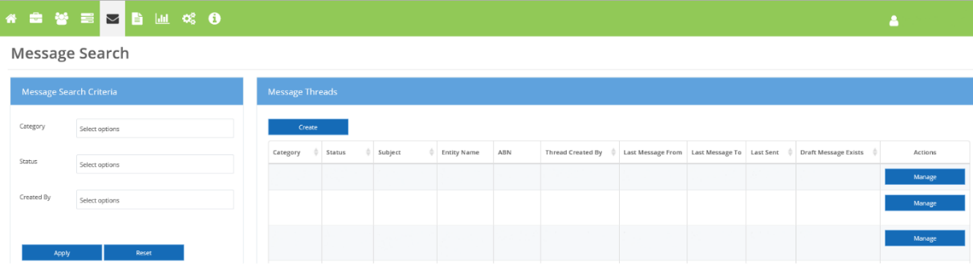

**Note:** users must use the creating a task function when providing information in relation to existing FEG claims or cases assigned to their firm.

* 1. Creating a message

All userscan create a Message for a non FEG related case. To create a Message for a non FEG case:

1. Click the **Messaging Icon** within the *Navigation Bar*
2. Select the **Create** button in the *Tasks* panel
3. Complete the *Create Task* pop up box by
   1. Selecting a *Message Category* from the drop down
   2. Enter an *Entity Name*
   3. Enter the *ABN*
   4. Enter a *Subject* heading

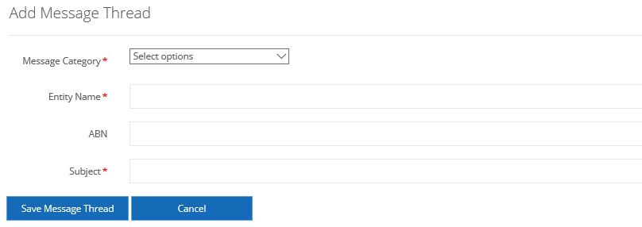

1. Select **Save Message Thread**

**Note:** once the Message has been created you can *Add a Message* or *Delete* the Message.

* 1. Selecting a message

You can select a message by:

* searching for a message through the *Message Search* page
* opening the message through the *My Messages* panel on *My Dashboard*.
  1. Searching for a message

The search messages function allows a user to search and filter messages. To search for a message:

1. Click the **Messaging Icon** within the *Navigation Bar*
2. Enter the *Search Criteria*and select **Apply**
3. Select the message from the *Search Results*list using the **Manage** button.

**Note:** you can apply filters based on *Category*, *Status*, and *Created By*.

Once you select the *Manage* button in the *Actions* column, you will be taken to the *Manage Message Thread* view. The *Manage Message Thread* page displays the following task details:

* *Message Thread Details* – displays details such as the message subject, entity name, category, status and who created the message
* *Messages* – displays Messages that you have sent to the department as well as message that have been sent to you
* *Attachments* – displays attachments that you have uploaded as well attachments that have been sent to you.

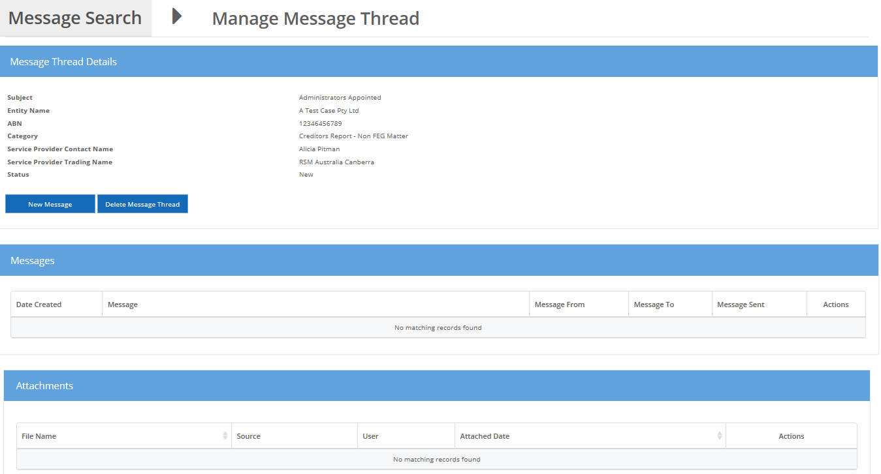

* 1. Status of a message

A message may be in the following status:

* *New* – the message will be in this status when you create a new message thread and it does not include message text
* *In Progress* – the task will move to this status when you commence work by clicking **New Message** and save message text
* *Submitted to Department* – the task will move to this status when you submit the task to the department
* *Sent by Department* – the task will move to this status when the department responds to the message
* *Completed* – the task will be in this status when you or the department have completed the message thread and no further action is required
  1. Uploading a file to a message

Files can be added to a message if the message thread contains message text. To upload a file:

1. Click the **Messaging Icon** within the *Navigation Bar*
2. Enter the *Search Criteria*and select **Apply**
3. Select the message from the *Search Results*list using the **Manage** button
4. Select **Create** under the *Attachments*heading
5. Drag and drop the appropriate file or select the *Upload File* button to choose a file manually
6. Once the attachment has successfully uploaded, select **Close.**

**Note**: you can upload multiple files to a message or documents can be dragged and dropped from the users’ desktop and local drives.

* 1. Removing an uploaded file from a message

If you wish to remove an uploaded file from a message:

1. Click the **Messaging Icon** within the *Navigation Bar*
2. Enter the *Search Criteria*and select **Apply**
3. Select the message from the *Search Results*list using the **Manage** button
4. Select the **Remove** button against the appropriate attachment under the *Attachments*heading.
5. Select the **Remove** button to confirm you wish to remove the attachment.

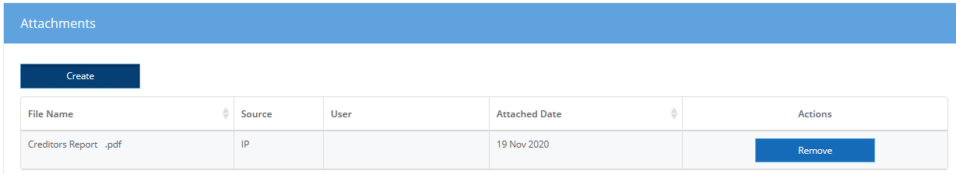

**Note:** once the message has been submitted to the department, attachments can no longer be removed.

* 1. Creating message text

To add text to a message:

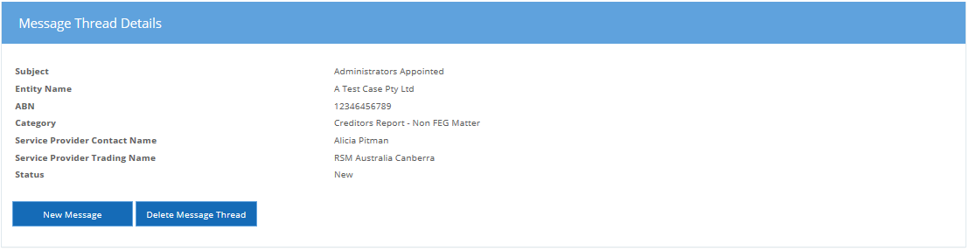

1. Click the **Messaging Icon** within the *Navigation Bar*
2. Enter the *Search Criteria*and select **Apply**
3. Select the message from the *Search Results*list using the **Manage** button
4. Select **New Message** under the *Message Thread Details*heading
5. Type in the message text
6. Once you have finished the comment select **Save.**

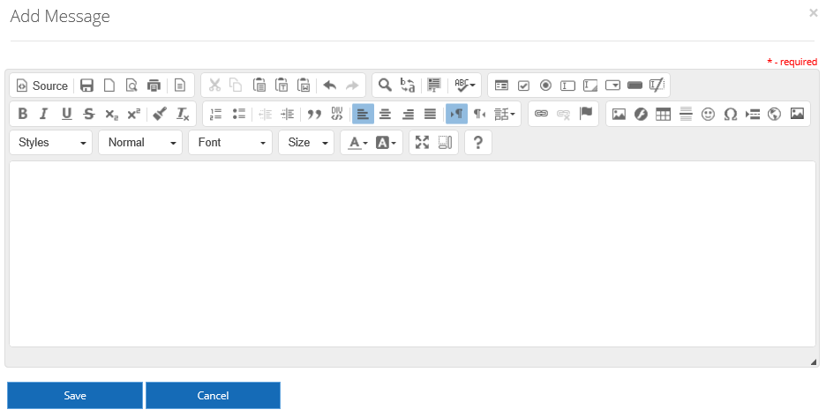

**Note:** you can view / *update* and *remove* a comment you have created by clicking on the applicable button. However, you can no longer change or remove a comment once the corresponding message has been submitted to the department.

* 1. Deleting a message

If you wish to delete a message:

1. Click the **Messaging Icon** within the *Navigation Bar*
2. Enter the *Search Criteria*and select **Apply**
3. Select the message from the *Search Results*list using the **Manage** button
4. Select the **Delete Message** button under the *Messages* heading.

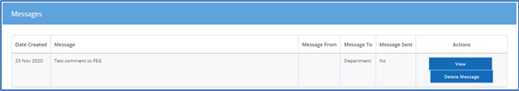

**Note:** a message cannot be deleted after it has been submitted to the department. The deletion of an unsent message will also remove any unsent attachments.

* 1. Submitting a message

To submit a message:

1. Click the **Message Icon** within the *Navigation Bar*
2. Enter the search criteriaand select **Apply**
3. Select the message from the *Search Results* list using the **Manage** button
4. Add message text and attachments
5. Once the message is complete click **Submit** under the *Message Thread Details* heading.

Task submit button is displayed

**Note:** to submit a message, the message thread must contain message text.

* 1. Complete a message

To complete a message:

1. Click the **Message Icon** within the *Navigation Bar*
2. Enter the *Search Criteria*and select **Apply**
3. Select the message from the *Search Results*list using the **Manage** button
4. Select the **Complete** button under the *Message Thread Details*heading.

**Note:** completing a message indicates no further action is required and the message can no longer be used to send comments or attachments. Only messages in the status of *Sent by the Department* can be completed.

1. Manage Correspondence

The *Correspondence Search* page allows the user to search for correspondence that has been sent to their firm or that relates to a claim or case assigned to their firm.

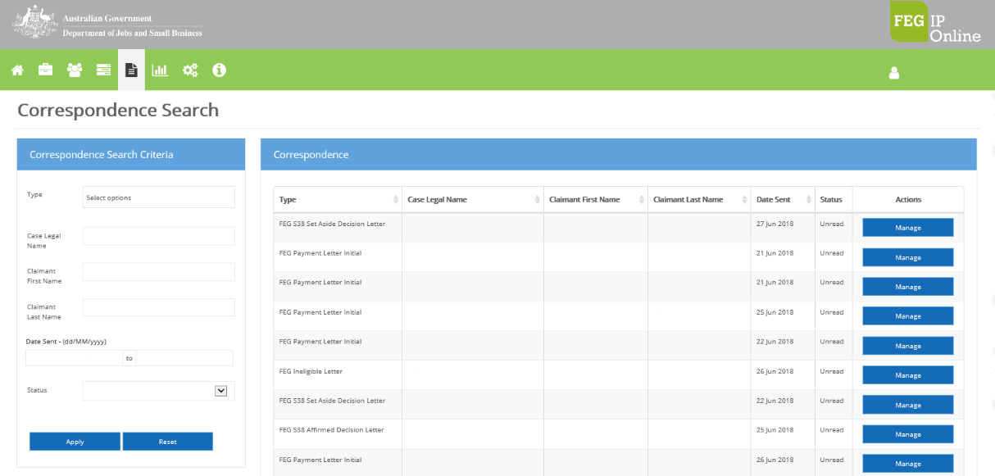

* 1. Searching for correspondence

To search correspondence:

1. Click the **Correspondence Icon** within the *Navigation Bar*
2. Enter the search criteria (e.g. name) into the *Search Criteria*box
3. Select the correspondence from the *Search Results*list.

**Note:** you can apply filters based on Case Legal Name, Date Created (date range), Due Date (date range), StatusandClaimant**.**

Click on the **Manage** button to view the correspondence and mark it as read.

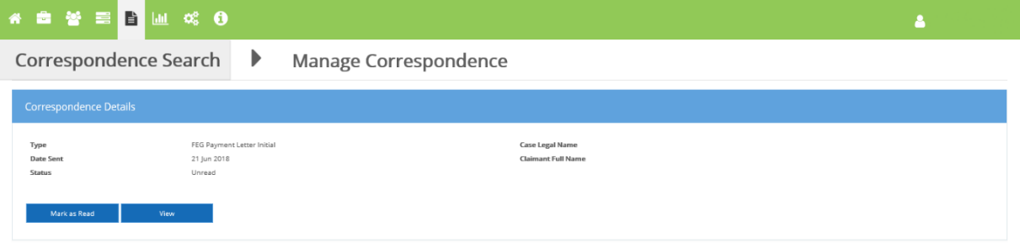

1. Manage eCitizen Account

Users are able to manage their eCitizen account by selecting their name at the top right hand side of FEG IP Online. The user will get the following options:

* *Manage eCitizen Account* **–** If the user selects this they will receive a warning that they are about to be redirected to the eCitizen website.

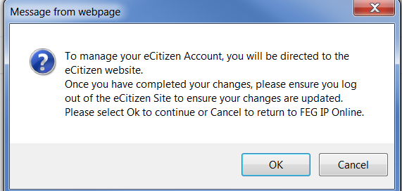

* *Log out* **–** If the user selects this they will be logged out of FEG IP Online.
  1. eCitizen website

If the user selects to be redirected to eCitizen website, they will be given the following options:

* *Change Password* – allows user to select this option to change their eCitizen account password, then will need to provide their *User ID*, *Current Password* and *New Password*
* *Manage Details* – allows user to update their *Name*, *Contact details* and *Username*
* *Manage Questions* – allows user to update their security questions.

**Note:** the*Forgotten Password*and*Forgotten User ID*can be accessed via the ‘eCitizen Login’ button on the login page of FEG IP Online. The facility allows a user to recover their *User ID*by entering their*Email address* and *Mobile**number*.

1. User Account Management

Liquidators and system administrators are responsible for managing user accounts linked to FEG IP Online for their firm. User roles should be reviewed and maintained on a regular basis - this is a key requirement to maintain integrity in access controls for IP firms to FEG information held in FEG IP Online.

Please see *Unlinking/Deactivating users – FEG IP Online* in the Resource Centre for further details.

System administrator functions are viewable in the *Settings* icon. Within *Settings*, thesystem administrator can *Manage Teams*or *Manage Users,* and manage*Task Workflows.*

Settings > Teams Search

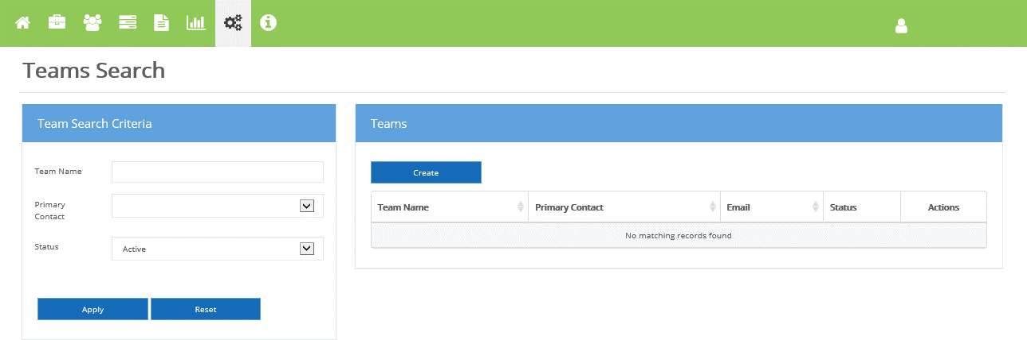

Settings > User Search

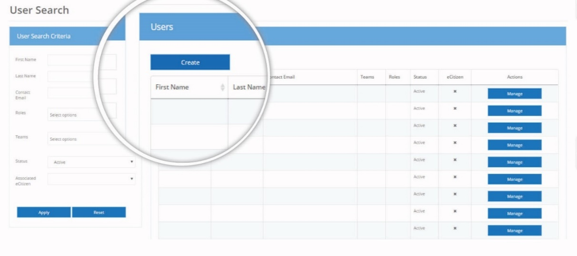

* 1. Create users

To create a new user:

1. Click **Settings** within the *Navigation Bar*
2. From the drop down listselect *Manage Users*
3. Within the User Management page select **Create**
4. Complete the User Details fields
5. Click **Create.**

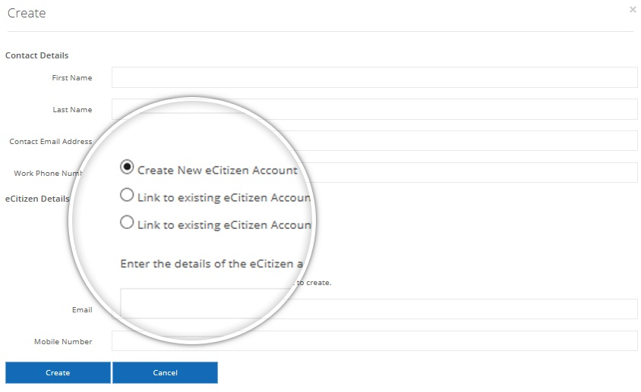

The system administrator has three options:

1. *Create New eCitizen Account* – select this option if the user does not have an eCitizen account.   
   You will need to provide the email address and mobile number of the user.
2. *Link to existing eCitizen Account* – select this option if the user already has an eCitizen account.   
   **Note:** you will need the details of the eCitizen account.
3. *Link to existing eCitizen Account later* – select this option if the user already has an eCitizen account but does not have the account details available.

After creating the user, the system administrator will need to assign permissions.

The user will receive an activation URL sent to the email address and an SMS PIN sent to the mobile number specified for each user, which expires after 72 hours.

* 1. Linking eCitizen accounts

To link an eCitizen account:

1. Click **Settings** within the *Navigation Bar*
2. From the drop down list select **Manage** **Users**
3. Within User Management enter the *Search Criteria*and select **Apply**
4. Select the user from the *Search Results*list using the **Manage** button
5. Within the *User Details* page select **Link eCitizen Account**
6. Enter in the *email address*and *mobile number*of the user and select **Link eCitizen Account.**

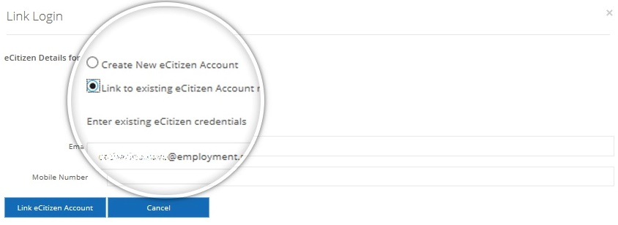

* 1. Maintaining a user

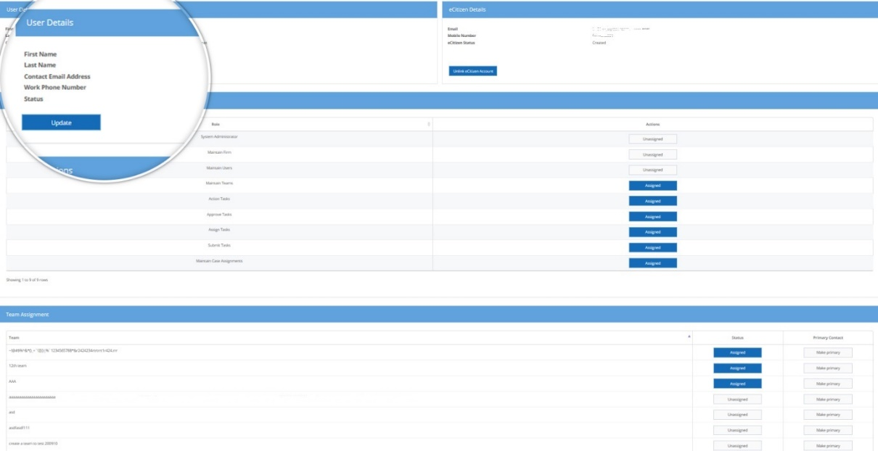

* 1. Update user details

The system administrator can update user details such as contact number, email or office within the *User Account*page as follows:

1. Click **Settings** within the *Navigation Bar*
2. From the *drop down list*select **Manage Users**
3. Enter the users details within the **User** **Search Criteria**
4. Select the user from the search list using the **Manage** button
5. Update the users details, and select **Update.**
   1. User permissions

System Administrator

The system administrator has permission to perform all these actions. The following role groups have the corresponding permissions listed below.

Maintain Users

* create new user accounts
* edit existing user accounts
* maintain eCitizen settings for user accounts
* assign users roles
* assign users to teams.

Maintain Teams

* create new teams
* edit existing teams
* assign users to teams.

Action Tasks

* create an IP created task
* delete an IP created task
* add attachments to a task
* add comments to a task
* remove an attachment from a task
* remove a comment from a task
* update a comment on a task
* complete an IP created task.

Assign Tasks

* assign tasks to a user or team
* add comments to a task
* remove comments from a task
* update comments on a task.

Submit Task

* submit tasks
* add comments to a task
* remove comments from a task
* update comments on a task.

Maintain Case Assignments

* add a liaison contact to a case
* remove a liaison contact from a case
* assign a team to a case
* remove a team from a case
* Assign a user’s permissions.

The system administrator can update a user’s permissions by:

1. Click **Settings** within the *Navigation Bar*
2. From the drop down list select **Manage** **Users**
3. Enter user’s name within the ***User Search Criteria*** box
4. Select the user from the search list using the **Manage** button
5. Click **Assign** next to the desired role type.

To unassign:

1. Click **System Settings** within the **Navigation Bar**
2. From the drop down list select **Manage Users**
3. Enter user’s name within the ***User Search Criteria*** box
4. Select the user from the search list using the **Manage** button
5. Click **Unassign** next to the unwanted role type.
   1. Create teams

To assist in managing workflows, you can create teams within your offices by:

1. Click **Settings** within the *Navigation Bar*
2. From the drop down listselect **Manage Teams**
3. Within the Team Management page, click **Create**
4. Complete the Team Details fields
5. Click **Create.**

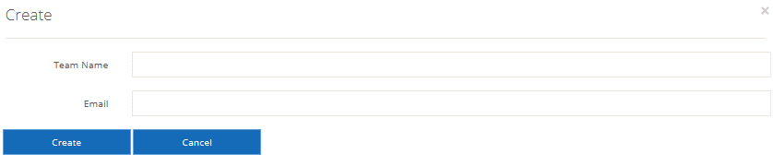

* 1. Maintaining a team

The system administrator is responsible for maintaining the teams within your firm.

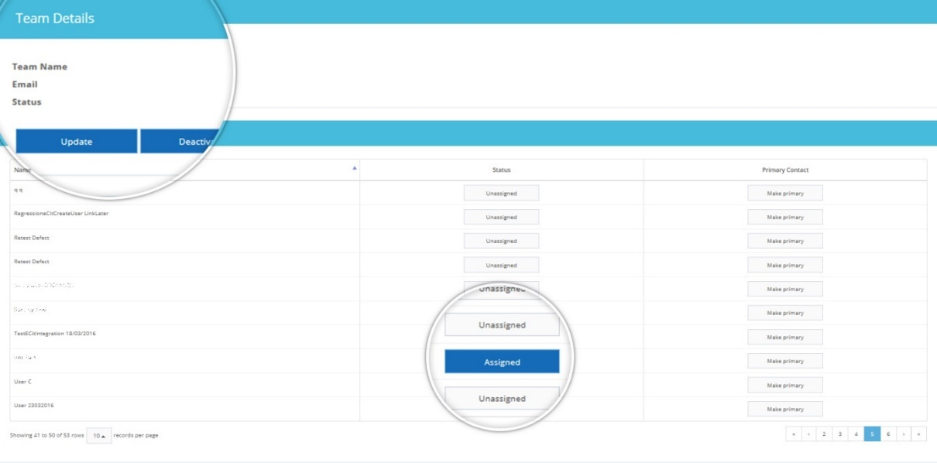

* 1. Assign a user to a team

A user can be assigned to a team to help prioritise and distribute tasks. To assign a user to a team:

1. Click **Settings** within the *Navigation Bar*
2. From the drop down listselect **Manage Teams**
3. Create a new team or select an existing Active team from the listand select **Manage**
4. Select the user from the *User Assignment*list by clicking **Unassigned**.
   1. Assign a primary contact to a team

To assign a user as the primary contact for a team:

1. Click **Settings** within the *Navigation Bar*
2. From the drop down listselect **Manage Teams**
3. Create a new team or select an existing Active team from the listand select **Manage**
4. Select the user from the *User Assignment*list by clicking **Make Primary**.
   1. Update team details

To update team details:

1. Click **Settings** within the *Navigation Bar*
2. From the drop down listselect **Manage** **Teams**
3. Enter the team’s name within the *Team Search Criteria*box
4. Select the Team from the search list using the **Manage** button
5. Update the Team details
6. Click **Update**.
   1. Deactivate a team

To deactivate a team:

1. Click **Settings** within the *Navigation Bar*
2. From the drop down listselect **Manage** **Teams**
3. Enter the Team’s name within the **Search Criteria** box
4. Select the Team from the search list using the **Manage** button
5. Select **Deactivate**
6. Select **Deactivate** to confirm you wish to deactivate the Team.

**Warning:** deactivating a team will unassign all users, tasks and cases that are assigned to that team.

* 1. Task workflow

The Manage Settings icon includes management of Task Workflow. This enables system administrators to manage workflow rules for tasks, including who has permission to approve specific tasks.

The *Task Workflow* page allows system administrators to assign an approver role to a Task Type.

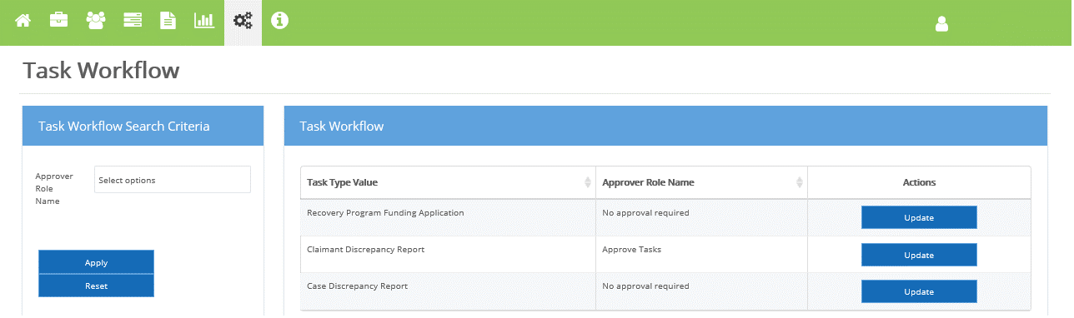

1. Click **Settings** within the Navigation Bar
2. From the drop down listselect **Task Workflow**
3. Enter the*Approver Role Name* within the **Search Criteria** box
4. Select the **Update** button to define the role the user must have in order to approve a particular task
5. Select the *New Approver Role* from the drop down, and select **Submit**.

**Note:** the *system administrator* role permission does not automatically include a permission to approve tasks. To be able to approve or reject a task they must also be assigned the *Approve Tasks*role permission for each applicable task type in *Manage Users.*

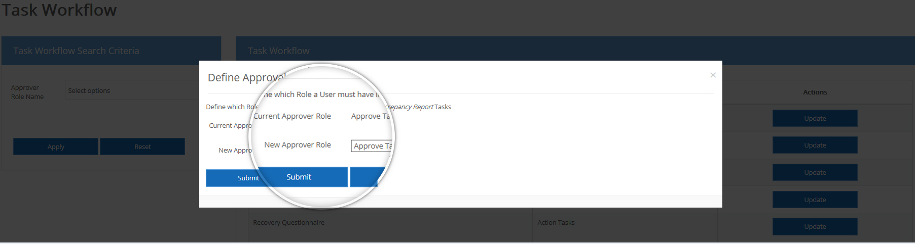

1. Exportable Reports

The *Reports* page allows you to select the report type and case to then generate reports against your firm.

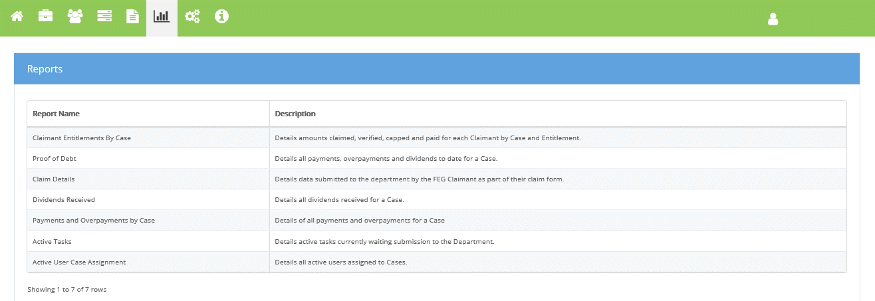

* 1. Generating a report

To generate a report:

1. Click the **Reports Icon** within the *Navigation Bar*

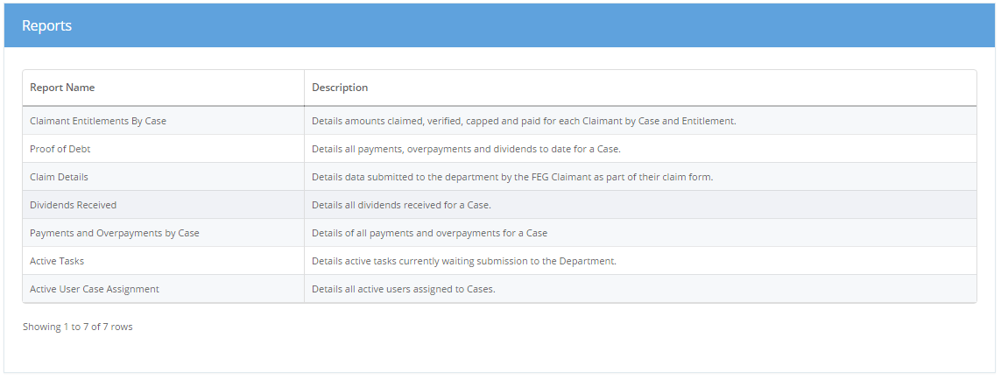

1. Click on the Report Name you would like to generate
2. Select **CaseId** where applicable
3. Click the **Generate** button.

**Note:** the Dividends Received Report will be empty where no dividends have been received. You can only generate a certain report one at a time – save and or close the current report before attempting to generate another of the same name (type).

1. Manage Verification Spreadsheet Templates

The *Import Template Search* page allows a system administrator to map a firm or case specific verification spreadsheet in FEG IP Online. This process will allow IP firms to use their own spreadsheet instead of using the FEG supplied verification spreadsheet.

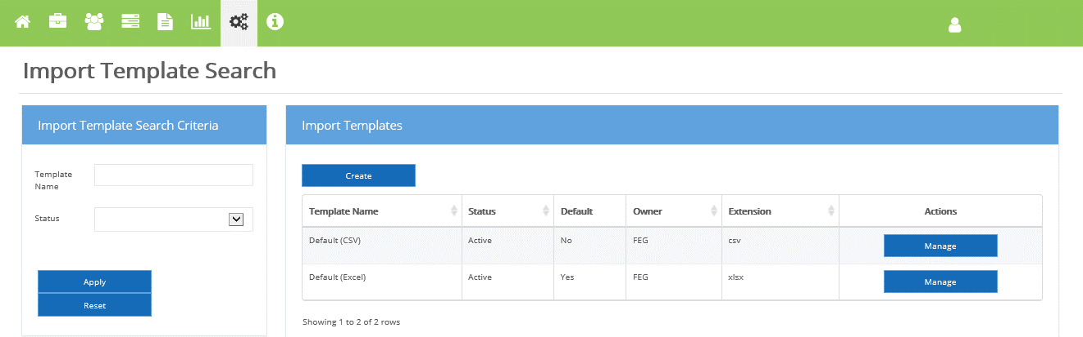

* 1. Creating a template

Before creating an alternative template to the FEG supplied verification spreadsheet, you must ensure it contains columns for all employee entitlement data required as part of providing verification services to FEG.

To create a template in FEG IP Online:

1. Click on the **Settings** within the *Navigation Bar* and select **Manage Templates**
2. Click on the **Create** button on the *Import Templates* page
3. Enter the *Template Name.* **Note:** there is a limit of 50 characters
4. Select the **File Type** of your template
5. Select if you want to create a blank template or copy from an existing template
6. Click **Create**.

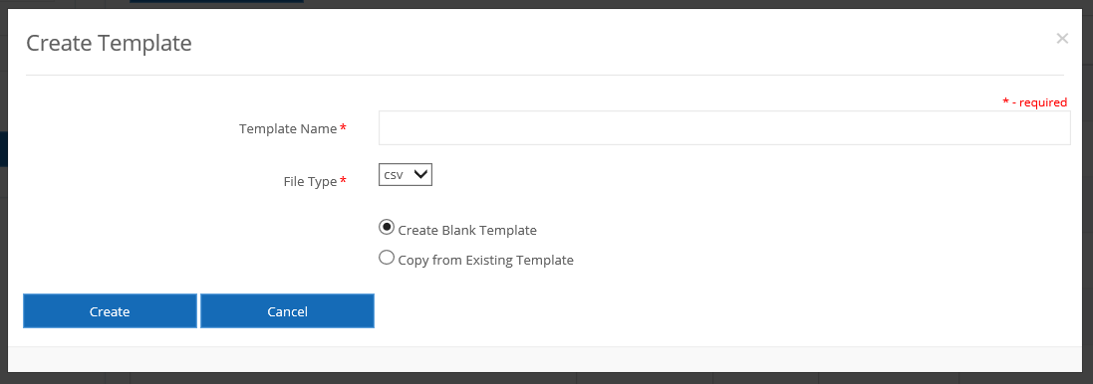

**Note:** once you select **Create**, you will be presented with the *Template Details* pagewhere you will be able to manage and map your spreadsheet to the template.

* 1. Creating mapping definitions

For the Upload Data process to work it is necessary to map the source column headings to FEG fields.

To map the new template to FEG fields:

1. Open your existing template
2. Copy and Paste your column headings from your spreadsheet into the *Source Column Heading* field on the *Mapping Definition* section of the *Template Details* page. For example, FEG Field: Surname = Source Column Heading: Last Name; and FEG Field: Date of Birth = Source Column Heading: DOB
3. Click **Save Mapping**.

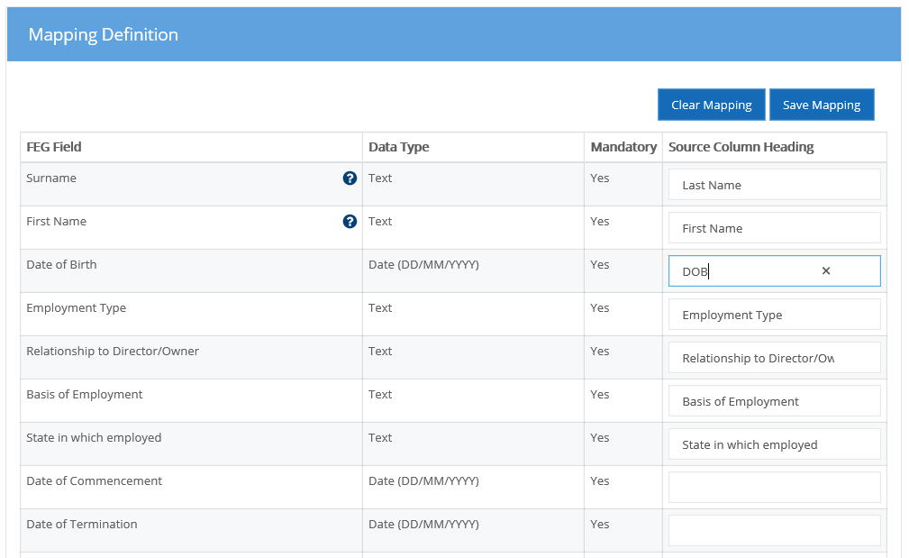

**Note:** where your column heading matches the FEG column, for example ‘Surname’, please make sure this is copied into the Source Column heading from your own spreadsheet. It is possible to copy over from the FEG Field column in FEG IP Online, however, you must make sure it’s an exact match to the column heading in the selected spreadsheet.

* 1. Finalising template setup

1. Click on **Activate**
2. Click on **Set Default**.

**Note:** only the FEG .xlsx spreadsheet and one IP spreadsheet can be set as a default template. Users have the ability to swap which template is set as default to make selection easier.

* 1. Managing templates

System administrators have the ability to Update, Deactivate or Activate any template.

Managing a template allows you to:

* **Update** its name, header row number, lookup data import file type
* **Activate** or **Deactivate** the templates
* Set a template as your **Default**
* Map your own spreadsheet column headings to your template.

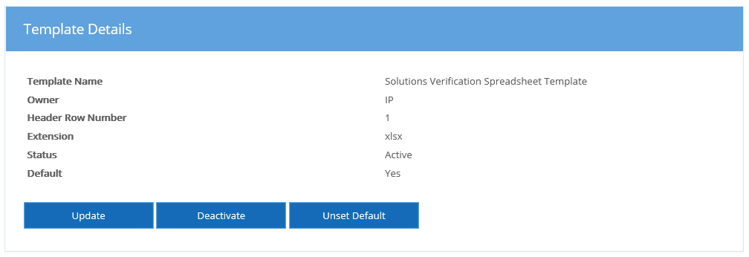

**Note:** you will need to **Update** the header row number when the source column heading is not located in row 1 of the verified spreadsheet.

* 1. Searching for a template

You can search for a template by:

* Template Name (also a fuzzy search)
* Status, or
* A combination of both.

1. Resource Centre

The resource centre page allows you to select and view FEG related information such as Practice Notes, Fact Sheets, and a list of FEG contacts, etc.

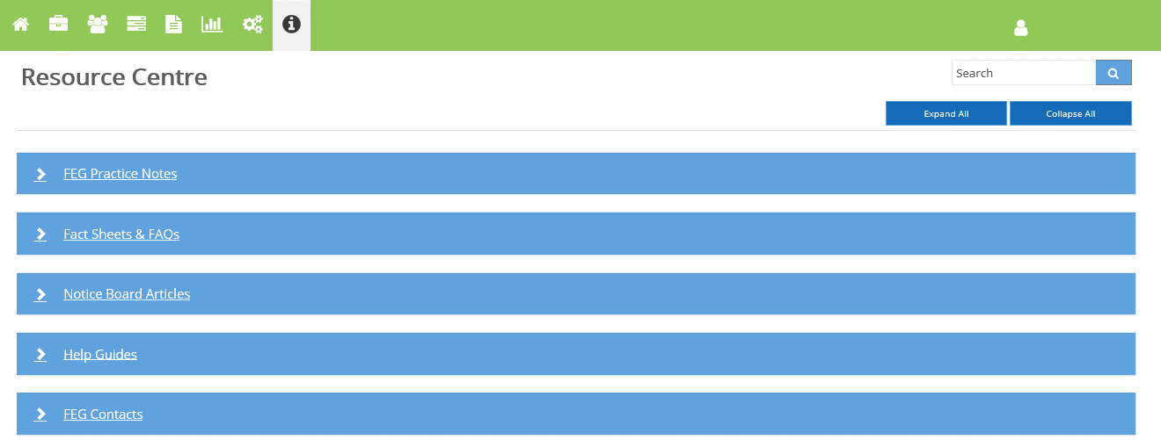

**Note:** the resource centre displays a list of categories. Each category contains one or more files. The files will either open up as a document or open a new tab in the explorer bar.

* 1. Searching documents

A user can conduct a search across the whole resource centre or within a specific category. To search for a document:

1. Enter the keyword(s) in the search field
2. Select the search button or press the enter key.

The page will expand the categories containing files that match the search parameter.

* 1. Viewing documents

1. Click on file name.
   1. Viewing links
2. Click on file name
3. Click on **Set Default.**