Appendix D to the Report of the Migrant Workers’ Taskforce
Department of Jobs and Small Business
Fair Work Ombudsman

The information needs of vulnerable temporary migrant workers about workplace laws
June 2018
Prepared by:
Multicultural Marketing and Management
Australian Government Department of Jobs and Small Business
Fair Work Ombudsman

©Department of Jobs and Small Business and Fair Work Ombudsman 2018
ISBN
978-1-76051-626-0 [PDF]
978-1-76051-627-7 [DOCX]
The material in this document is licensed under a Creative Commons Attribution – 4.0 International licence, with the exception of:
- any third party material;
- any material protected by a trade mark; and
- any images and/or photographs.
More information on this CC BY licence is set out at the creative commons website: www.creativecommons.org. Enquiries about this licence and any use of this document can be sent to: copyright@jobs.gov.au .
Report prepared by:
Multicultural Marketing and Management, the Department of Jobs and Small Business, and the Fair Work Ombudsman
The information and advice expressed in this report is made to the best of the authors’ knowledge and beliefs based upon the information available at the time of preparation.
We would like to thank the migrant workers and stakeholders who participated in this project for sharing their time, insights and expertise.

Table of Contents
©Department of Jobs and Small Business and Fair Work Ombudsman 2018 2
Table of Contents 3
List of Figures 5
Abbreviations, acronyms and definitions 6
1. Executive Summary 7
Background 7
Summary of Findings 8
Awareness of Australian workplace laws and conditions 8
Information needs 8
Best channels and formats for communicating with migrant workers 10
Views on existing government communications products 10
Recommendations 12
Recommendation 1 12
Recommendation 2 14
Recommendation 3 16
Recommendation 4 19
2. Introduction 20
Background 20
Research objectives 20
About Multicultural Marketing and Management (MMM) 21
3. Methodology 22
Study design and methods 23
Sample size calculation 24
Timeline of fieldwork 25
Recruitment strategy 25
Barriers to participation 26
Limitations 26
4. Findings 28
Research objective 1: Determine the extent to which migrant workers are aware of where they can go to get help with workplace matters consistent with Australian law 28
Migrant workers' awareness of workplace laws 28
Views on current information needs 35
Awareness of the Fair Work Ombudsman 39
Misconceptions and perceptions 41
Research objective 2: Identify which channels and formats best suit migrant workers in Australia and what types of content they need most 47
Information sources used by migrant workers are diverse 47
Research objective 3: Obtain migrant workers’ feedback on existing communications material provided by government agencies 53
General views on government information products was positive 53
Government information products should be widely promoted and distributed 56
Feedback on existing government information products 57
Appendix 1 – Survey respondent characteristics 66
Appendix 2 – Example of visa grant notice and fact sheet 74

List of Figures
Figure 1: Target population 23
Figure 2: Receipt of information about working in Australia by visa type 28
Figure 3: What information about working in Australia did you receive before you came to Australia? 29
Figure 4: Information about how much to be paid by visa type 30
Figure 5: Information about other workplace laws and conditions by visa type 31
Figure 6: Type of information they were looking for 33
Figure 7: Reasons for not seeking information about Australian workplace laws 34
Figure 8: Workplace information needs by visa type 34
Figure 9: Workplace information needs 36
Figure 10: Awareness of the FWO by visa type 38
Figure 11: Knowledge of the role of the FWO by visa type 39
Figure 12: Knowledge of the responsibility of the FWO 39
Figure 13: Workplace information source by self-rated English proficiency 42
Figure 14: Source of other information from government services 47
Figure 15: Most common time to seek out workplace information when in Australia 48
Figure 16: The best way to provide information – top responses 49
Figure 17: The best time to receive information about workplace laws and conditions in Australia 50
Figure 18: Ease of comprehension of the FWO in-language web page 56
Figure 19: Helpfulness of the FWO in-language web page 57
Figure 20: Recall of the visa grant notice by visa type 59
Figure 21: Ease of comprehension of the visa grant notice 60
Figure 22: Helpfulness of the visa grant notice 60
Figure 23: Visa type 65
Figure 24: Native language 65
Figure 25: Work status 66
Figure 26: Age 67
Figure 27: Visa category by age 67
Figure 28: Gender 68
Figure 29: Citizenship jurisdiction 68
Figure 30: Location 69
Figure 31: Length of stay in Australia 69
Figure 32: Length of time in current job 70
Figure 33: Time visa was granted 70
Figure 34: Highest level of education completed 70
Figure 35: Work status before coming to Australia 71
Figure 36: Electronic devices used to search for information 71
Figure 37: Self-rated English language proficiency 71
Figure 38: Industry/occupation currently working 72

Abbreviations, acronyms and definitions
ATO – Australian Taxation Office.
DIBP – The former Department of Immigration and Border Protection, now Department of Home Affairs.
FWO – Fair Work Ombudsman. The FWO helps employees, employers, contractors and the community to understand and comply with Australia's workplace laws. It provides information and advice, investigates workplace complaints, and enforces Commonwealth workplace laws.
Hospitality industry – Survey participants were asked which industry/occupation they work in. ‘Hospitality (lodging, food serving, bartender, etc.)’, ‘Fast food restaurant (food is ordered at a counter)’ and ‘Restaurant (food is ordered from a waiter/waitress)’ were offered as separate options. In this report, these three options have been combined into one category called Hospitality.
Migrant workers – For the purposes of this research project, the term ‘migrant workers’ refers to temporary migrants with a work right, who hold one of the four types of visa covered by the research (does not include New Zealand citizens).
MMM – Multicultural Marketing and Management, the researchers who conducted the online survey, focus groups and interviews.
MWT – Migrant Workers’ Taskforce, established by the Australian Government to address migrant worker exploitation.
Research objective 1: Determine the extent to which migrant workers are aware of where they can go to get help with workplace matters consistent with Australian law.
Research objective 2: Identify which channels and formats best suit migrant workers in Australia and what types of content they need most.
Research objective 3: Obtain migrant workers’ feedback on existing communications material provided by government agencies.
Visa categories covered in this research:
WHMs – Working Holiday Makers (Working Holiday visa subclass 417 and Work and Holiday visa subclass 462) are visitors on extended holiday, up to 12 months, although they can apply for a second-year WHM visa provided three months of specified work (in regional or Northern Australia) has been completed. WHM’s can do any kind of work during their stay in Australia, but are limited to a maximum period of six months’ work with any one employer, unless given permission by the Department of Home Affairs to work longer. If the employer has several locations, the worker may work up to 12 months for the employer as long as they work no more than six months at a single location.
Graduate visa – Temporary graduates (visa subclass 485) are international students who have recently graduated from an Australian educational institution. The 485 visa lets them stay in Australia for up to four years, depending on their qualifications.
Student visa – International students (visa subclass 500, 572, 573, 574) who have been accepted to study full time at a recognised educational institution in Australia; they may stay up to five years.
457 visa – Temporary Work (skilled) (visa subclass 457) enabled an employer to sponsor someone for this visa if they could not find an Australian citizen or permanent resident to do the skilled work. The 457 visa was abolished and replaced with the new Temporary Skill Shortage (TSS) visa in March 2018. As the research was conducted in 2017, there were no TSS visa holders included in the research.

1. Executive Summary
The research into the Information Needs of Vulnerable Temporary Migrant Workers about Workplace Laws focuses on how best to inform migrant workers about their rights and obligations in regards to workplace laws in Australia. Despite the plethora of communication activities undertaken by government agencies, there has, up until now, been little evidence about the usefulness of the information for migrant workers and what information channels work best for them. The research sought input directly from 2186 migrant workers from 39 countries and regions, and was conducted in 12 languages (including English for the quantitative component).
The research provides evidence for government agencies on three main issues; migrant workers' knowledge of how to access assistance regarding workplace information, which channels can best reach those workers, and how to improve the information provided to them.

Background
The research project is an action item of the Migrant Workers’ Taskforce (MWT) following a stocktake of current government communication activities. The MWT, chaired by Professor Allan Fels AO with Dr David Cousins AM as Deputy Chair, was established by the Australian Government in October 2016 to address migrant worker exploitation, and to identify proposals for improvements in law, law enforcement and investigation, and other practical measures to more quickly identify and rectify any cases of migrant worker exploitation.
This research project was conducted by Multicultural Marketing and Management (MMM) in mid to late 2017 and was managed and sponsored by the Department of Jobs and Small Business with sponsorship and support from the Fair Work Ombudsman (FWO). The Department of Home Affairs, the Department of Education and Training, and the Australian Taxation Office (ATO) also participated in the project.
The total population relevant to the scope of the report was 653,800 as at 30 June 2017. This is the total number of people in Australia who were the primary holder of an International Student visa (subclasses 500 and 570–576), working holiday (WHM) visa (subclasses 417 and 462), Temporary Graduate visa (subclass 485), or Temporary Work (skilled) visa (subclass 457). The survey sample was designed on the basis of this population as at 31 December 2016, which was 564,500. An overview of the characteristics of survey participants is at Appendix 1.
A mixture of quantitative and qualitative methods were used in the research. These included an online survey and three forms of qualitative research: focus group discussions, group evaluation exercises and semi-structured in-depth interviews. The researchers also interviewed 11 key stakeholders in the education, migration and employment areas.
MMM’s extensive research panel of multicultural research participants, use of community organisations and online advertising were some of the methods used for the recruitment of participants for both the quantitative and qualitative data used in the report. Rigorous safeguards to ensure confidentiality were implemented to address any potential concerns about consequences of participation.

Summary of Findings
Migrant workers’ information needs relating to workplace laws and conditions are diverse. They depend on the reason for travel to Australia and the stage of the migrant’s journey. What is clear from the research is that more can be done to promote the current products and services; and there are a number of different touchpoints government agencies can use to deliver the information which needs to be clear, concise and consistent.
Migrant workers’ understanding of their workplace conditions and obligations is relatively low and there are some misconceptions about different elements of the system. These can be addressed with accurate, consistent and timely messaging.

Awareness of Australian workplace laws and conditions
In general, the migrant workers who participated in the research did not have a good knowledge of workplace rights and laws. Many survey participants (80 per cent) did not recall receiving any information about working in Australia before coming to Australia. Among those that did recall receiving information (a higher proportion of WHMs and international students), most indicated that the information related to the number of hours they could work (as part of their visa conditions), how to get a tax file number, how much to be paid, or how to find a job. Three of these are not workplace laws/conditions but are more practical concerns about work or visa conditions.
A majority of survey respondents (61 per cent) did however remember receiving the Department of Home Affairs visa grant notice and fact sheet. The research found that the grant notice was remembered as it provided advice about the success or not of gaining a visa. The participants indicated that at the time of receiving the notice, they were likely to be focusing on other related issues and therefore could not recall the workplace information contained in the fact sheet. These findings show that at the point of receiving the grant notice the migrant workers are typically not engaging with workplace issues however the research also found that the participants thought the information was useful so could be provided separately to the notice and at a different time.
Awareness of the FWO was low, with 21 per cent of respondents indicating they had heard of the FWO. This was explored further in the qualitative research component: of those who were aware of the FWO, its investigative and support roles were best known followed by the FWO’s role in educating employees about workplace laws and conditions.

Information needs
Once migrant workers arrived in Australia their interest in seeking information on how much they should be getting paid increased, but only to 32 per cent of survey participants. Those seeking information on other workplace conditions was lower at 18 per cent.
When considering migrant workers’ current information needs, 29 per cent of respondents thought that they needed more information about workplace laws and conditions. This was predominantly the case for international students (37 per cent) and WHMs (33 per cent), while only 13 per cent of the 457 visa holder participants felt they had a need for more information. This was likely to be because the 457 visa holders were sponsored by an employer (with specific rules regarding their employment), so already had their employment organised.
Among survey respondents who did not seek any information, 69 per cent indicated that this was because they did not have a need, they believed their employer was doing the right thing, or because they were happy in their job. The majority of participants in the qualitative research also reported low levels of knowledge about minimum wages and working hours and a mixed interest in knowledge of workplace rights, with some participants stating that information about workplace rights was of no use, or not relevant to them (as they felt they had a good job) so they were not motivated to know more.
However, this should not be seen as an indication that there is no need for government agencies to ensure that their products are accessible and high quality. A quarter of the participants who answered the survey question indicated that they did not seek information because they were fearful of getting into trouble, or did not want to get their employer into trouble. As well, many participants believed that work opportunities are rare, and they did not want to ask questions about their entitlements as they were worried they might lose their job, be given fewer shifts, or jeopardise working relationships by stepping outside their cultural standards. The qualitative research supported these findings with some migrant workers becoming increasingly interested and keen to know more as the discussions progressed.
For those participants who sought out information once they arrived in Australia, their needs were varied; with a slightly larger proportion seeking information on how to find work, how much they should be paid and the number of hours they could work.
This finding was reinforced when migrant workers were asked what information they would currently find most useful, with no clear ‘winner’ emerging from the survey options put to the participants and the discussion group participants providing a diverse list of topics. Most survey respondents nominated minimum pay rates and where to find answers to questions about pay, conditions and deductions as useful. In addition, focus group participants were also interested in knowing more about taxation and superannuation.
This diversity of needs is also obvious when examined by visa type, for example, WHMs were significantly more interested in knowing more about minimum wages and how much they should be paid, and less interested in the difference between an employee and a contractor. By contrast, graduates were more interested in the distinction between an employee and a contractor, but were less interested in seeking information about seasonal work. Migrant workers on 457 visas were the least interested in knowing more information about workplace rights, but the topics they did want more information on were primarily employer deductions from pay, and how many hours they could work.
The qualitative work revealed some misconceptions held by migrant workers. Many of the participants believed that certain workplace laws and entitlements are not applicable to them as non-residents or as holders of a specific visa. This impression appeared to extend to government services as well. Further, a number of participants seemed to share the impression that they would only be able to interact with government agencies in English, despite the fact that agencies — particularly the FWO — provide a large volume of translated content and in-language contact options.

Best channels and formats for communicating with migrant workers
In-language and in English social media sites and family and friends in Australia were the main sources of workplace information for survey respondents. This was also true for those in the discussion groups. In most cases this involved community social media groups rather than official government accounts. After arriving in Australia, the educational services provided by the universities and colleges were also identified as a useful and popular source of information for international students.
The researchers asked about migrant workers’ use of the FWO website and the VEVO website or smartphone application. While the number of respondents who sourced information from the FWO and the VEVO system was small, both were ranked the highest in terms of usefulness prior to arriving in Australia. Once in Australia, the FWO website continued to be viewed as very useful while the usefulness of the VEVO system was not considered as high as previously.
The importance of high quality government online information was reflected with more than 81 per cent of respondents indicating that when looking for information from a government source they would search online first.
The migrant workers said that the best time to receive information was when they were looking or applying for a job, when they started a new job, when their visa was granted or when they arrived in Australia – providing evidence for the need for information to be provided at a number of different communication points.
The qualitative research discussion groups explored this issue further with participants advising that emails are a useful source of information as they can be referred to later, and that written information is also useful so it can be machine translated to assist in their understanding.

Views on existing government communications products
From a practical perspective, the research sought feedback on existing communications material developed by a number of Australian government agencies. Overall, the feedback was that the participants valued the government products and that some were considered best practice. However, the participants felt that these products were not widely known or promoted.
Participants provided feedback on a range of printed materials, videos, website material, Facebook pages and the myVEVO app. The feedback was wide ranging and included a number of specific suggestions for improvement, including ensuring translated materials considered linguistic differences and that search engine optimisation be prioritised (to ensure government websites are high in search engine results). As well, some participants found the content to be challenging and for this reason indicated that they preferred translated materials.
Participants found the FWO videos very useful and were keen for them to be actively promoted. The Guide to Starting a New Job was also well received by many of the participants, particularly its step-by-step design and its short, simple messages. The official Department of Home Affairs and FWO Facebook pages were also praised, specifically the Department of Home Affairs’ ‘Tip Tuesdays’.
Participants found the FWO in language web pages easy to understand, comprehensive and helpful. However, some improvements were suggested in relation to specific content in some languages.
Feedback on the visa grant notice and fact sheet provided by the Department of Home Affairs was not as positive, with many respondents finding the fact sheet hard to understand and only moderately helpful. Participants therefore suggested consideration be given to other options and times for distribution. The preference was for this information to be sent via email when the visa is granted and when they are entering Australia, and with web links for browsing or downloading important information.
Overall, participants thought that the Government could reach out to them more and provide these resources at multiple contact points, including train stations, immigration customs areas, libraries, universities, employers, hostels and in-language social media groups. It was suggested that this may help to stress to migrant workers the importance of knowing about their workplace rights and Australian workplace laws.

Recommendations

Recommendation 1
Improve the delivery and accessibility of information to ensure the right messages are provided at the right time. Use personal email addresses and mobile phone numbers to provide relevant, accessible and timely information at different times.
The Department of Home Affairs to enhance and maximise the capture, and use, of contact details (including email addresses and mobile phone numbers) from temporary migrants during the visa application process and update the details if they change, to enable better targeting of educative and communications activities. The Department of Home Affairs, Department of Education and Training, ATO, and FWO work together to ensure the contact details of migrant workers are accurate and can be cross-matched and shared with each other for targeting education and communication purposes.
The collection of current personal email addresses and mobile phone numbers for all migrants would enable agencies to communicate directly with migrant workers at various points during their stay and reduce any filtering that may occur through migration and education agents.
Currently, people provide email addresses and mobile phone numbers during the visa application process, however some of the email addresses become obsolete as they belong to migration agents (either in Australia or overseas) who helped lodge the application, or the email addresses are not valid or maintained. Mobile phone numbers provided at this point are frequently overseas numbers and not used during the migrant worker’s time in Australia, often people change mobile numbers once arriving in Australia but do not provide these to agencies.
The Department of Education and Training requires education providers to collect personal email addresses and/or mobile phone numbers from international students as part of the educational institution enrolment process. This information is entered into a central system owned and maintained by the Department of Education and Training. The ATO also collects similar information from migrant workers during the tax file number application process.
It is recommended that the Department of Home Affairs enhance strategies to maximise the capture of client contact details. Further, all agencies (including the Department of Home Affairs, the Department of Education and Training, the ATO and FWO) should work together to improve the collection of current and relevant contact details of all migrant workers in Australia that are updated on a regular basis, while minimising erroneous or extraneous data.
Develop alternative ways to provide the information in the visa grant notice and fact sheet to increase the likelihood of the visa holders engaging with the information.
Many of the participants in the research advised that they did not read the fact sheet material attached to the grant notice, as the main focus at this time is on the success of their visa application. However, the research also found that once they read the information, many participants found it useful.
To address this, the information should be provided at a number of different times and in different formats. There are a number of touch points available that could be used to disseminate different aspects of the information. These touch points include, but are not limited to, after the visa grant notice is sent, when the visa holder arrives in Australia or when they apply for a tax file number from the ATO. While the research found that the timing of the visa grant notice is not currently working well, continuing to use one of the early touchpoints is important to dispel early the myth that migrant workers do not have the same workplace rights as Australian workers.
As well, alternative ways of delivering the information need to be developed. The participants advised that they were receptive to receiving the information in many different ways, including via in-language videos, online advertising on YouTube, Facebook and in-language websites, traditional advertising on radio and billboards, blogs, and via apps. Using personal email addresses and mobile phone numbers means links to up-to-date information can be provided and kept by the migrant worker for use at a later date.
Another option is to develop a very short (maximum 2 minutes) compulsory video and quiz on the most important workplace rights messages. This quiz could be included as part of the online visa application.
Use behavioural approaches and nudges to encourage migrant workers to act if they believe they are not receiving their correct workplace entitlements.
It is recommended that government agencies apply behavioural economics approaches to encourage migrant workers to act if they believe they are not receiving their correct workplace entitlements. The research found there are a number of behavioural barriers that may be stopping migrant workers from addressing issues related to workplace compliance. For instance, participants indicated that due to timing of communications, they were likely to be focusing on other related issues and therefore could not recall the workplace information contained in the grant notice, or due to fear of ramifications, participants did not seek out information.
Behavioural economics approaches such as make it Easy, Attractive, Social and Timely (the EAST Framework), could be applied to encourage migrant workers to take action if they are not receiving their correct workplace entitlements. Consideration can be given to the best time to deliver the behavioural interventions to ensure that they have the desired impact. There is a range of trigger point opportunities available for government to communicate with migrant workers. For example: a nudge with information about the FWO could alert a migrant worker to the FWO services; a WHM could receive a message within three months of arriving in Australia about specified work requirements; all visa holders could receive additional information when applying for a tax file number; or at the end of semester when a student visa holder does not leave the country, government could assume the student is staying and working, and use this opportunity to provide additional information.
The effectiveness of behavioural interventions can be tested, either through the use of a randomised controlled trial or through an alternative evaluation method, to ensure they have the required impact of increasing the knowledge of migrant workers about their workplace rights and how to access assistance. Following a successful evaluation these interventions can then be rolled out to scale.

Recommendation 2
Enhance the promotion of products and services already available from government agencies, including; prioritise the use of social media, ensure migrant workers know about FWO’s in-language information and videos, and improve the internet search ranking of government information.
Agencies need to improve the ranking of official government translated information through search engine optimisation (SEO).
The research found that the government sites are not featuring highly in Google or other search engines when people are searching for information on Australian workplace laws and conditions, particularly if the person is searching in a language other than English. Improving in-language SEO by ensuring metadata is translated will help ensure government websites are highly ranked in in-language search results.
It is also recommended that agencies use SEO to assist migrant workers with finding the relevant translated information by considering additional metadata for each of these pages.
Agencies need to focus on ensuring that information is ranked highly in search results; this work could include researching and trialling techniques based on the different needs and countries of origin of the migrant workers.
Expand the range of in-language social media channels (e.g. WeChat) and specifically target visa holders by enhancing in-language posts across government channels and those of partner organisations.
The evidence is clear from the research that migrant workers mainly use both English and in-language social media channels to source information. Using these channels to disseminate information needs to become one of the main and ongoing communications tools agencies use.
The FWO has undertaken several successful communication campaigns which included in-language social media content aimed at promoting migrant worker tools and resources, including the in-language videos and the translated anonymous report tool.
The FWO, the Departments of Home Affairs, Education and Training and the ATO need to increase their in-language communication activities, or engage with partner organisations, to promote and advertise the top high-level messages, as well as the tools and resources available to migrant workers. In recognition of the primary information sources identified through this research (family/friends, community groups, etc.), consideration should be given, where possible, to distributing these messages through partner organisations who are in direct contact with migrant workers. This also includes staying abreast of the current social media sites for different nationalities, for example, WeChat is currently very popular among migrants from some Asian countries. Other in-language media forums include Hojubada (Korean, Melbourne), Hojunara (Korean, Sydney), Ozyoyo (Chinese), YeeYi (Chinese), and Nichigo Press (Japanese).
All agencies are to enhance promotion of the FWO’s in-language information and resources across government websites and through community networks, consular networks, social media and in-language media forums.
The research found that while the quality of the FWO information was considered high, awareness of the FWO is low among migrant workers, with 79 per cent of survey respondents not having heard of the FWO previously. Participants indicated that they would trust government bodies and information on their websites more than other ‘private’ websites, if they are faced with workplace issues. The participants also indicated that they would like information that explains their entitlements and any implications of lodging a complaint.
It is recommended that the FWO continue to promote the translated information and assistance that is available. This should also include information about the role of the FWO, how migrant workers can ask for assistance from the FWO, information about the complaints procedure, the anonymous report function, as well as details about how the information provided will be used. This is to reassure migrant workers that they should not lose their job as a result of asking for information or assistance from the FWO.
To raise more awareness of the FWO, it is recommended that FWO contact information and resources be distributed through a variety of channels both onshore and offshore. This could include, but is not limited to, embassies and consulates, backpacker hostels and all education institutions.
All government agencies need to promote the FWO and specifically their in-language tools. This is particularly true for the Department of Home Affairs as it is usually the first point of contact for migrant workers.
The high-level short message (see recommendation 3) that ‘the FWO has in-language information on workplace rights’ should be communicated at every available avenue and touch point. A QR code could be linked to the FWO website for migrant workers to store and use later.
The Department of Education and Training needs to ensure all education providers are providing international students with regular information on workplace rights and obligations and the services of the FWO and support other stakeholders, such as education attachés, to provide this information.
The educational services provided by the universities and colleges are a popular source of information for international students when seeking information about pay rates and work place conditions.
However, more could be done to ensure that all education institutions, including the private smaller language and vocational colleges, are providing regular information on Australian workplace rights and obligations. Further, departmental support for education attachés in the embassies and consulates to provide this information to international students should be enhanced.
The National Code of Practice of Education and Training to Overseas Students 2018 already requires that information on workplace rights and obligations be provided to all international students, however it not clear if this is monitored and if all institutions (particularly the smaller private language and vocational colleges) provide information or if it is provided on a regular ongoing basis.

Recommendation 3
Improve government information products so they are translated, simple, clear and consistent and therefore useful for migrant workers and, if needed, can be translated by machine translation software tools.
Enhance reliability and understanding of information by all agencies providing translated, simple, clear and consistent information across government websites and products.
The research provides clear evidence that there is not one best source, format, channel, or time for migrant workers to receive information on Australian workplace laws and conditions. Therefore, government agencies need to use a range of methods to promote information.
Participants across both the survey and focus groups also indicated that they prefer translated information and would like more information about a range of topics including: pay rates; how many hours they can work; leave entitlements; taxation; superannuation; who to contact if they are being treating unfairly at work; and the differences between employees and contractors.
Given the language barriers it is therefore imperative that the information provided (including current information) is consistent across each of the agencies, that clear statements are included, and that where possible, the information is translated to ensure it is useful to the migrant workers.
The migrant workers reported that often they compare the content and layout of the English and translated information, to test the information’s authenticity. To ensure that the translated material is considered legitimate, both the English and translated information needs to be in the same format and structure.
As well, the feedback indicated that some translated material did not pick up the nuancing required for some languages and cultures, for example, there can be linguistic differences for the same language depending upon the geographic location of where the language is spoken. Translated material needs an independent translator check before publishing; this includes using translators and checkers from different countries but for the same language and also potentially different ages to account for generational differences.
For information that cannot be translated, it is recommended that agencies simplify English content to ensure that migrant workers can use automatic translation tools to understand the content. It is particularly relevant for important complex information that is hard for a person to understand if their first language is not English. This will reduce the risk of incorrect translation issues and will also assist migrant workers to understand and engage with the English content.
Agencies are to work together to develop and prioritise key short messages that are easy to understand and apply, are relevant and can be communicated to migrant workers at different communication points.
Agencies are to develop short, pointed, high-level messages about workplace rights and entitlements that are used at various touchpoints, including but not limited to:
- Workers in Australia – including visa holders with permission to work – have the same workplace rights as Australian citizens.
- No one can take your passport.
- The Fair Work Ombudsman has in-language information about workplace rights.
The research demonstrates that migrant workers have diverse information needs depending on the type of visa they are on, and the time in their migration journey. There needs to be different messages for different visa holders and at different touch points, for example a WHM may require a reminder about the second year visa requirements (and the importance of doing specified work), this information will be more useful two to three months after they have arrived in Australia.
A further finding shows that many migrant workers do not seek information about their workplace rights in Australia because they do not believe they have the same rights as Australian workers; so an early short pointed message can easily dispel this myth.
Include a ‘Language Help’ icon on the Department of Home Affairs website and enhance the prominence of the icon on the ATO website.
It is a widespread practice for websites to include a ‘Language Help’ icon and a list or drop-down menu of languages available. Non-English speakers will often go straight there for information. Once translated information is developed, it is recommended that the Department of Home Affairs add a ‘Language Help’ icon to direct migrant workers to the information.
It is recommended that any list of translated information available is provided in English first and then followed by the relevant in-language translation.
For the ATO, the link to ‘Language Help’ needs to be more prominently displayed on the ATO home page and other pages.
Simplify online user pathways and webpage addresses on the Department of Home Affairs, the ATO and the FWO websites so the information is easy to find and addresses are shorter and easier to type, remember and find online.
On the main page of the Department of Home Affairs website there is a text box for ‘Individuals and Travellers’. Adding ‘Temporary migrant workers’ to the list would allow temporary migrant workers to click on the link to get a text sitemap of all pages relevant to their needs. In addition, create a simpler URL such as www.homeaffairs.gov.au/temp-migrant-workers, which should go to a text sitemap that is linked to all Department of Home Affairs information for temporary migrant workers, to pages of translated information, and to web pages at other agencies such as the FWO and the ATO. Temporary migrant workers are not familiar with Australian agencies, so this would point them in the right direction.
The research found that migrant workers were keen for more information on superannuation and tax information. At present, the ATO website does not explain that migrant workers can claim back some tax deductions and superannuation contributions made on their behalf by the employer. While the ATO does have generic information for all tax payers, there is no clear guidance specifically for migrant workers.
The ATO website should provide clear information on their webpages specifically for migrant workers that is easily accessible from the main ATO webpage to assist migrant workers to apply for a tax file number, to understand their rights and obligations in relation to taxation and the process for claiming tax and superannuation back when they leave Australia.
On the FWO website, the top of the ‘Young workers & students’ page should include a sentence that explains ‘International students should see the 'Visa holders & migrants' page.’ In addition, simplify the navigation to ‘Visa holders and migrant workers – workplace rights and entitlements’, an important information web page for temporary migrant workers.
Add information about workplace rights and entitlements to relevant ATO correspondence, including, but not limited to, the tax file number letter and the tax return notice of assessment.
The research indicated that the correspondence from the ATO when providing a tax file number is an underutilised touch point for migrant workers and would be a good channel for communicating information about work rights in Australia to migrant workers.
This is considered appropriate as the application for a tax file number is an expression of the intention to work in Australia so the provision of a few key messages at this stage would be beneficial for migrant workers.
Develop and promote a platform, or enhance the Department of Home Affairs’ myVEVO app, to provide migrants with a single ‘go-to’ place with workplace information.
There is a lot of information available for migrant workers, but due to the different responsibilities of government agencies it is located across several different websites. From the migrant worker’s perspective, this can be unhelpful and confusing. A one-stop platform for information that is specific to their visa type would make it easier for migrant workers to access the information when they need it most and know that the information is correct for their circumstances. Incorporating user-centred design principles will ensure that the focus is on assisting migrant workers to have the best information to inform their decisions while in Australia, and reduce their vulnerability to exploitation.
The myVEVO app and website would make the ideal platform to develop a place where all migrants could access information about their visa and other important information specific to their visa, such as workplace and tax information. Awareness of the myVEVO app was low among participants in the survey and the evaluation sessions, however after using the app some participants indicted that the app was very intuitive and easy to navigate, while others advised that the app lacked functionality and could be expanded to include additional functionality and more detailed information about workplace rights and entitlements. The research also found that most of the participants preferred to use their smartphones to look for information, so enhancing the myVEVO app to support migrant workers’ need for workplace information would mean that this information would be more accessible to them than searching the various websites.
Noting that the myVEVO app and website were not designed for this purpose, the platforms already include some information on workplace rights, and could potentially include more detail or provide in-app links to the other government agencies, particularly the FWO and the ATO. Developing a new platform for this purpose would not be viable given the expense.
The development of a single channel for communicating with migrant workers will need to include efforts to promote the platform to migrant workers, given that the myVEVO app already exists and there is not much awareness of it currently. The app could be promoted via, for example, encouraging all visa holders via email and or text message, promoting the app via a QR code at touch points, such as, on billboards, at airports, embassies, consulates and hostels, and advertisements on social media sites. A postcard could also be developed and distributed with a high-level message about the benefits of using myVEVO and showing the QR code. Behavioural economics approaches and nudges could also be explored to test the impact of different messages to encourage people to use the app.

Recommendation 4
Work with industry and community stakeholders to educate employers, particularly employers from non-English speaking backgrounds and small businesses to address misconceptions about the rights and entitlements of migrant workers in Australian workplaces, such as Australian workplace laws and conditions do not cover migrant workers.
Relevant agencies to enhance their work with industry and community stakeholders to raise capability and awareness among employers that ‘Migrant workers and visa holders have the same workplace rights as all other workers in Australia’.
The research found that many migrant workers seek information and advice about their workplace rights and entitlements directly from their employer. It is also clear that language is a barrier for understanding Australia’s workplace relations rules, so therefore it is imperative to ensure that clear and concise information is provided to employers who do not speak English as a first language and small businesses who do not have human resources expertise. The VEVO website used by employers could also be a useful place to educate employers.

2. Introduction
This research project, sponsored for the MWT by Department of Jobs and Small Business and the FWO, and conducted by MMM, aims to identify the information needs of migrant workers in Australia with respect to workplace laws. Advice was sought from migrant workers about the most effective communication channels and their views about current communications materials. Other participating agencies included the Department of Home Affairs, the Department of Education and Training, and the ATO.
This study aims to help the government agencies involved by identifying: the extent to which migrant workers are aware of where they can go to get help with workplace matters; which media sources, or distribution strategies, can best reach those workers; and how to improve both the content and ‘cut through’ of the information provided to migrant workers. Adopting recommendations based on findings from the research will assist with better accessibility of information and subsequently improve the understanding of workplace laws by migrant workers.

Background
The MWT identified four areas of action as its initial focus, one of which was better communication with visa holders about workplace laws. The MWT commissioned this research as part of this area of action. Given the numerous high-profile cases of exploitation of temporary migrant workers in Australia, it is important for the government to understand how best to inform migrant workers of their rights in the workplace and where they can seek assistance if they have concerns.

Research objectives
The project has three research objectives:
- Determine the extent to which migrant workers are aware of where they can go to get help with workplace matters consistent with Australian law
- Identify which channels and formats best suit migrant workers in Australia and what types of content they need most
- Obtain migrant workers’ feedback on existing communications material provided by government agencies.
Research objective 1 sought quantitative and qualitative evidence on the degree of awareness migrant workers have with respect to how they can access information about various aspects of workplace laws in Australia, and whether there are differences in this knowledge between visa types, languages spoken, age, gender or other characteristics.
The findings provide an understanding of migrant workers’ awareness of where to go for information on workplace laws and how to seek further assistance.
Research objective 2 explores migrant workers’ knowledge of various platforms available when seeking information about workplace laws. It also explores which channels, formats, content, and modes of communication work best when communicating information about workplace laws to them, including identifying any barriers in accessing or understanding the information and educational materials available. Under this objective, the researchers also investigated when migrant workers want and need information – for example, in their home country before they leave, immediately on arrival in Australia, or at a later stage.
Research objective 3 sought feedback from migrant workers on the effectiveness of specific existing information and education materials developed by the FWO, Department of Home Affairs and the ATO. This included content from websites, social media platforms, mobile apps, printed materials, and video content.

About Multicultural Marketing and Management (MMM)
Following a limited tender process using the Research and Evaluation Services Panel managed by the Department of Jobs and Small Business, the company MMM was awarded the contract to undertake the research. MMM, established in 1993, is a multicultural expert in Australia, with over 20 years’ experience in assisting Australian Government departments in quantitative and qualitative research, data collection and data analysis with culturally and linguistically diverse people.
MMM employs experienced bilingual researchers to conduct research in over 70 languages. Researchers are members of the Australian Market and Social Research Society (AMSRS). They comply with AMSRS’s Code of Professional Behaviour and Privacy Principles for researchers, and Australian Marketing Institute Code of Professional Conduct. MMM also comply with the values and principles of ethical research, including respect for human beings, research merit and integrity, and justice and beneficence, as stated in the National Statement on Ethical Conduct in Research Involving Humans, issued by the National Health and Medical Research Council.

3. Methodology
The population of interest was temporary migrant workers, which for the purposes of this project, refers to people in Australia who are the primary holder of a temporary visa with the right to engage in paid work. ‘Illegal’ workers, or those working without a visa, are out of scope, as are permanent residents or new citizens from a culturally and linguistically diverse background. The specific visa types within the scope of this project include:
- International students (visa subclasses 500, 572, 573 and 574)
- Temporary graduate (visa subclass 485)
- Temporary Work (Skilled) (visa subclass 457)
- Working Holiday Makers (visa subclasses 417 and 462).

Only those people who had been in paid work during their time in Australia, or those who intended to look for work soon were included. Those with no intention to work in Australia were excluded (for example, international students who wish to focus solely on their studies or WHMs who wish to travel).

The research was conducted in the following languages:
- Mandarin Chinese
- Cantonese Chinese
- Korean
- Hindi
- Arabic
- French
- German
- Italian
- Japanese
- Spanish
- Vietnamese.

These languages were informed by FWO data on the incidence of enquiries and complaints in the respective visa categories, as well as data available on the Department of Home Affairs website, the Department of Education and Training, and Census data about the main nationalities and languages of temporary visa holders.
Participants in the qualitative research were recruited on the basis of being a native speaker of one of these 11 languages. The survey was available in each of the 11 languages, as well as English, and was available to in-scope migrant workers (subject to the condition that they are able to complete the survey in one of the languages). Screening quotas were set for some citizenship jurisdictions, meaning there was a maximum number of responses allowed from residents of some major source jurisdictions.
For Chinese people the research included both Mandarin and Cantonese. Mandarin is the official language of China and Taiwan. Cantonese is widely used in southern China, Hong Kong and among some Chinese in Vietnam, Singapore, Malaysia, and Cambodia. For people from India, Hindi languages are widely spoken in the north, and English is spoken widely nationwide. Therefore, Indian participants were offered a choice to have discussions in English or Hindi.

Study design and methods
A mixed research method was used, comprising of a survey, focus group discussions, group evaluation exercises, semi-structured in-depth interviews, and interviews with key stakeholders. This approach allowed for the collection of both qualitative data to provide a deeper understanding of participants' experiences and quantitative data to provide statistical insights.
Online survey: 2010 survey results were obtained with caps placed on certain locations and visa types to ensure a diversity of respondents.
Focus groups: Eleven focus groups were conducted (one in each of the target languages). Each group included 7–9 participants (n=92). The focus groups were made up of participants from all of the visa categories and the discussions ran for approximately 90 minutes.
The focus group discussion was designed to ascertain the target audience's understanding, knowledge, attitudes, feelings, beliefs, experiences and insights. The groups were held in Sydney, Melbourne and Perth.
Group evaluations: Eleven group evaluations were conducted with participants selected similarly to those in the focus groups (by visa type and language group) in Sydney, Melbourne, Brisbane and the Gold Coast. The sessions were two-and-a-half hours in length.
The evaluation sessions were designed to seek information from participants about their views of communication materials produced by Government agencies, including the FWO and the Department of Home Affairs. The testing included seeking feedback on language, translation, format and design, as well as ease of accessibility.
Semi-structured in-depth interviews: One-hour, one-on-one, in-depth interviews were conducted with 21 participants. The aim was to obtain detailed qualitative feedback from migrant workers. One-on-one in-depth interviews allowed interviewees to speak freely without fear, shame or embarrassment in front of others.
The analysis of the survey, semi-structured in-depth interviews, group evaluations and focus groups was convergent. Initially analysis took place independently for each strand. As results emerged from the different strands, they were compared and validated with the results of other strands of the research.
External stakeholders’ interviews: Eleven interviews were conducted with external stakeholders. The interviewees were from organisations that provide welfare and advocacy support to international students and migrant workers or are representatives from industries that employ large numbers of migrant workers. Information from these interviews provided valuable insights into the perceptions of these stakeholders on the extent to which migrant workers know their workplace rights and where to access further information. In addition, these stakeholders provided insights into specific knowledge deficits and how improvements in imparting information to migrant workers could be made.

Sample size calculation
The in-scope migrant population, according to the Department of Home Affairs, in Australia as of 31 December 2016 was 564,500 – this is the population figure used to design the sample. The in-scope migrant population is the number of people on temporary visas with work rights, it is not an indicator of the number of migrants working. The proportion of temporary graduates or WHMs participating in the labour market at any one time is not known, however there is data on international students. Therefore, the target population (see Figure 1 below) was adjusted down for the proportion of international students who undertake paid work while in Australia, using data from the Department of Education and Training.
Figure 1: Target population
Type of visa | Number of people  (2016 figures)
International students (visa subclass 500)  (Adjusted – based on Department of Education and Training data showing that around 54 per cent of higher education and 83 per cent of VET students engage in paid work during their stay in Australia) | 259,100
Temporary graduate (subclass 485) visa holders | 28,600
Working Holiday Makers (visa subclasses 417 and 462) | 148,500
Temporary Work (skilled) visa holders (subclass 457) | 81,300
ADJUSTED TOTAL | 517,500

Only primary visa holders were recruited to participate in the research (i.e., not partners or children). Given the inherent challenges in sampling from such a widespread, diverse, and often hard-to-reach group, the study used quota sampling. This method ensured the sample drew from all categories in the target population. In order to be able to make accurate estimates about small sub-populations of interest, quotas were set for visa category, citizenship jurisdiction and geographic location.
With an estimated (adjusted) population of approximately 517,500, the survey sample of 2010 gives a confidence level of 95 per cent and a confidence interval of 2.18 per cent. This means the researchers are 95 per cent confident that when, for example 47 per cent of the sample chooses an answer, the true percentage of the population that would have picked that answer, had the group's entire population been interviewed, is 47 per cent plus-or-minus 2.18 per cent. This confidence interval applies to questions answered by the entire survey sample of 2010, where a question has been answered by fewer respondents, the confidence interval will be higher. For this reason, throughout the report, where relevant, the number of respondents to a question is provided so that readers are able to adjust confidence levels accordingly. Further, to ensure the robustness of analysis and anonymity of survey participants, any cross tabulations using occupations or countries of origin with results less than 20, are not reported. An overview of the demographics of survey respondents is at Appendix 1.

Timeline of fieldwork
An interdepartmental workshop was conducted on 31 May 2017. This facilitated MMM’s understanding of the issues facing migrant workers, the expectations of frontline staff and managers from the FWO, Department of Home Affairs, Department of Education and Training, and the ATO about common issues they discuss with migrant workers and the resources they use in their communications with migrant workers. This helped ensure that the research instruments met the objectives of the research.
Ethics approval to conduct the research was sought and obtained from the Bellberry Human Research Ethics Committee in August 2017. Bellberry reviewed and approved this study in accordance with the National Statement on Ethical Conduct in Human Research (2007). This Statement has been developed to protect the interests of people who agree to participate in human research studies.
Pilot fieldwork commenced on 8 September 2017. Qualitative fieldwork for the main research ran from 17 October 2017 to 24 November 2017. The quantitative fieldwork (survey) commenced on 4 November 2017 and closed on 31 December 2017.

Recruitment strategy
The research used the following methods to recruit participants to the research:
- MMM's research panel of several thousand multicultural research participants, refreshed on an ongoing basis through projects the company undertakes
- MMM’s bilingual consultants’ network
- community organisations
- online advertising, including in-language social media and in-language forums
- snowballing (a recruitment method in which participants are asked to refer people they know to participate in the research).
In the recruitment advertisements and email notices (in English or in-language) the aim and area of the research was briefly stated. Potential candidates were then asked to contact MMM via email or SMS with their visa type number, language and industry they work in. Candidates were further screened by phone or email before invitations or survey links were provided.
Participation was by invitation only. Participants for the qualitative research were emailed the information sheet and consent form in their language. Respondents for the survey were provided with a link to the information sheet and consent form in English and in their language. Participants were recruited to participate in one component of the research, such as the survey only or a focus group only.
A small incentive was offered to encourage participation. This was approved by the ethics committee. For the focus group discussions (90 minutes) a $70 cash incentive was provided. Group evaluation (2.5hours) participants were compensated with $100 and participants for in-depth interviews (1 hour) were given $40. Web survey respondents were sent a $5 Woolworths e-gift card following completion of the survey. These small reimbursements are consistent with research recruitment standards as compensation for the time and effort of assisting with the study. There was no incentive provided to the stakeholder organisations.

Barriers to participation
The researchers considered that the largest barrier to participant recruitment was fear of the consequences of participation, such as disclosing behaviour that may be in breach of their visa conditions. All possible measures, including rigorous safeguards and confidentiality, were undertaken to address this issue. Nevertheless, for some groups the projected sample size was challenging to achieve. In particular, some 457 visa holders dropped out of the qualitative research after receiving the project information sheet and consent form. In other cases, there were also ‘no-shows’ who cited reasons of urgent work commitments. These people were contacted to participate in the survey with many of them completing it.

Limitations
The main limitation of this research is the representativeness of the survey sample. As the contact details of all migrant workers in Australia were unavailable, a database from which people could be randomly selected to create a fully random sample was not possible. However the sample size was relatively large, with participants recruited primarily through a variety of methods including in-language online advertising, in-language social media, MMM’s multicultural research panel and networks, community organisations, advertising and snowballing. This may have led to over-representation of some groups of migrant workers in certain cities, and under-representation of others. Attempts to mitigate this risk were done by the application of quotas throughout the recruitment phase.
The survey was completed by more participants from Melbourne (39 per cent of total respondents) than Sydney (22 per cent). While data does not exist on the geographic location of the migrant worker population as a whole, Department of Home Affairs data showed that there are more 457 visa holders and international students living in Sydney than Melbourne. This is not in itself a problem for the survey findings as workplace laws are consistent across the country.
Steps were taken to ensure participants could only fill out the survey once. However, the possibility of one respondent completing multiple surveys cannot be ruled out. The $5 Woolworths gift card was not considered a large enough incentive for participants to have taken the survey multiple times. The researchers monitored for multiple responses from the same IP (internet protocol) address and on occasions where this occurred, compared them to ensure the responses significantly differed.
The aim of this research is practical in nature, rather than academic. The findings and recommendations will enable government agencies such as the FWO and the Department of Home Affairs to enhance or improve their efforts to inform migrant workers about workplace laws, rights and entitlements in Australia. As such, the researchers consider that the limitations of the survey results stemming from any possible sample bias do not reduce the robustness of the findings or impede the aims of the research project.

4. Findings

Research objective 1: Determine the extent to which migrant workers are aware of where they can go to get help with workplace matters consistent with Australian law

Migrant workers' awareness of workplace laws

Awareness of workplace information among migrants is low
Most survey respondents did not receive, or cannot remember receiving, information before coming to Australia and many have not sought any further information since arriving. Participants from the qualitative components of the research self-assessed their knowledge of workplace laws and conditions as low.
The research found that overall women were somewhat more likely to have looked for information on workplace laws compared to men. This difference was relatively small — for example, 23 per cent of women said they had received information about working in Australia before they arrived, compared with 19 per cent of men. These minor differences in results by gender did not lead to any findings or recommendations.
It is also important to note that there is a consistent pattern in the analysis with 457 visa holder respondents in the survey being the least likely to say they had received information prior to arrival or needing and seeking out information. In the qualitative research they reported that they did not actively seek information themselves but rather relied on the details of employment contracts provided by their employers for information or directly from the human resource departments of the organisations they were employed by. In many cases, this occurred following arrival in Australia. This is not necessarily a problem as they may be getting better tailored information from their employer.
There are a number of reasons for the apparent lack of engagement with information which are associated with the specific 457 visa conditions. Under the 457 visa program, migrant worker sponsors (employers) are required to meet reporting and compliance arrangements to ensure that all workplace laws and conditions are applied to the migrant worker. In addition, 457 visa holders came to Australia to take up a full-time job with a salary above the Temporary Skilled Migration Income Threshold, thereby ensuring a reasonable means of financial support. These provisions are likely to explain why 457 visa holders tend not to engage with information sources like the visa grant notice and fact sheet, or seek information on workplace issues after their arrival in Australia.

Before coming to Australia visa holders received information about working in Australia but few remember it
All of the visa holders in the research would have been sent a fact sheet with the visa grant notification, outlining key information about working in Australia. The fact sheets are different depending on the visa type and an example of the fact sheet for an international student is at Appendix 2. Despite this, almost 80 per cent of survey respondents reported that they either did not receive, or do not remember receiving, information about workplace rights before arriving in Australia. When looking at participants by visa type, 90 per cent of 457 visa holders did not receive, or remember receiving, information about workplace rights before coming to Australia, compared with 66 per cent of WHMs.
Figure 2: Receipt of information about working in Australia by visa type
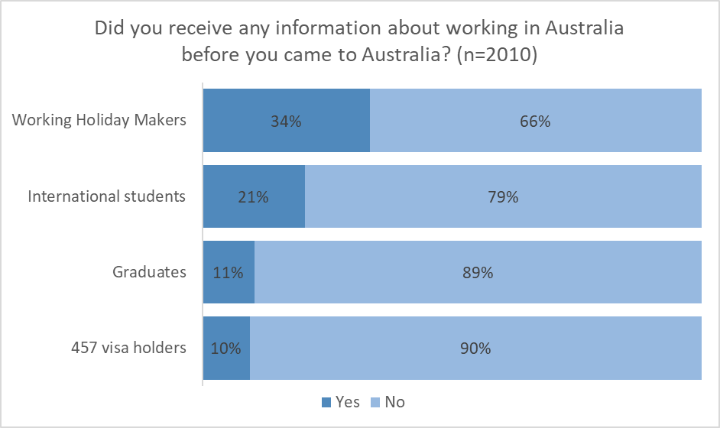

Migrant workers from China (12 per cent), India (13 per cent) and Japan (14 per cent) were least likely to have received, or remember receiving, information prior to arriving in Australia. Migrant workers from Germany (41 per cent), France (34 per cent) and Italy (33 per cent) were most likely to say they had received such information.
When considering the jobs and industries that migrant workers are in employed in, those working in real estate (5 per cent), travel and tourism (6 per cent), and petrol stations (7 per cent) were least likely to have received, or remember receiving, information prior to arriving in Australia. Respondents working in farming (46 per cent), courier/delivery/taxi services (including Uber and Deliveroo) (45 per cent) and childcare (including au pairs) (37 per cent) were most likely to have received, or remembered receiving, information.
Among the 21 per cent of survey respondents who had received information prior to arriving in Australia, the most common type of information they had received was information related to how many hours a fortnight their visa entitled them to work, how to get a tax file number, and how to find work. Only 15 per cent of respondents who had received information before coming to Australia had received information about how to get help if they had concerns at work.
Figure 3: What information about working in Australia did you receive before you came to Australia?
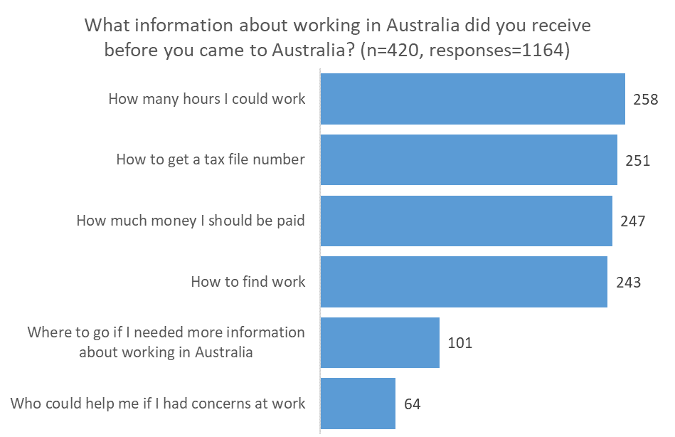

When broken down by visa type, WHMs in the survey most often reported receiving information on how to find work. Temporary graduates and students reported receiving information about how many hours per fortnight they could work (most, if not all, temporary graduates would likely have entered Australia on a student visa). Those on 457 visas reported receiving information about how much money they should be paid and how to get a tax file number.
Findings from the in-depth interviews and focus groups explored this further and indicated that for many participants, prior to arriving in Australia other practicalities were considered more important. At this time, participants were focused on understanding enrolment and study requirements, finding accommodation, exchange rates or the work rights associated with their visa. Many felt that the work conditions in Australia were as good, if not better, than at home and did not feel a need for information. Aside from at times seeking general information about hours of work and hourly wage rates, many participants were prepared to seek specific information as the need arose.
I only had a look at my visa status, I didn't pay attention to the visa grant fact sheet.
Cantonese, graduate, male

I was just glad that I was granted a visa, so I didn't pay much attention. And at the time, I didn't even think about getting a job so I did not read too much into my letter.
Vietnamese, graduate, male

Since arriving in Australia one third of participants sought information on how much they should be paid
Once migrant workers arrived in Australia, 32 per cent (641) of respondents reported that they had sought out information on how much they should be getting paid. WHMs (41 per cent) and international students (38 per cent) were most likely to report seeking information on how much they should be paid compared with 457 visa holders (14 per cent), and a much higher proportion of women (42 per cent) sought out the information compared with men (24 per cent).
Figure 4: Information about how much to be paid by visa type
Since arriving in Australia have you sought out information on how much you should be getting paid? | Number | Yes | No
Working Holiday Makers | 571 | (232) 41% | (339) 59%
Graduates | 209 | (43) 21% | (166) 79%
International students | 801 | (307) 38% | (494) 62%
457 visa holders | 429 | (59) 14% | (370) 86%
Total | 2010 | (641) 32% | (1369) 68%

Respondents from Hong Kong (47 per cent), Italy (42 per cent) and China (38 per cent) were most likely to seek out information on pay rates while migrant workers from India (17 per cent) and Japan (26 per cent) were least likely to seek out this information. As with the place of origin, the type of work or industry the migrant worker was engaged in appears to have some bearing on whether information is sought about pay rates. Those working in hospitality (56 per cent) were most likely to report seeking this information, while those working in petrol stations and real estate (both 9 per cent), automotive industry (11 per cent) or call centres (14 per cent) were least likely to seek out information about pay rates. In terms of age, a large proportion of respondents (77 per cent) were in the 18–34 age bracket. The youngest age bracket of 18–24 were most likely to search for information on pay (39 per cent).
I want to know how much should I be paid if I worked in this industry or the other.
Arabic, student, male

Since arriving in Australia fewer respondents (18 per cent) sought information on other workplace laws and conditions
Only 18 per cent (355) of migrant workers sought out information about other workplace laws and conditions (such as how many hours could be worked, employee or contractor status and where to go if general information about current work was needed). For the majority, this information was obtained through family and friends and is discussed in greater detail in the findings for research objective 2. In terms of percentages, WHM (23 per cent) and international students (21 per cent) were the most likely to seek out this type of information.
Once again women were more likely (23 per cent) to seek out information about workplace laws and conditions compared with men (13 per cent). Migrant workers from Italy (33 per cent), Hong Kong (30 per cent) and France (26 per cent) were the most likely to seek out this information. Respondents from jurisdictions that are the highest in terms of numbers of respondents to this survey were among the lowest proportion to seek information about workplace laws and conditions. Eleven per cent of respondents from China, 16 per cent from Taiwan and 18 per cent from India sought information on workplace laws and conditions once in Australia. This is significant because these jurisdictions are among the largest sources of temporary visa holders to Australia.
Migrant workers in the survey who worked in horticulture (34 per cent), hospitality (32 per cent) and reception/other office work (31 per cent) were the most likely to have sought information about workplace laws. Industries and occupations in which workers were least likely to seek this type of information were manufacturing and petrol stations (both 4 per cent) and call centres (6 per cent). Those in the 25–34 age category were most likely to look for information about other workplace laws (21 per cent).
Figure 5: Information about other workplace laws and conditions by visa type
While in Australia, have you sought out information about other Australian workplace laws and conditions? | Number | Yes | No
Working Holiday Makers | 571 | (130) 23% | (441) 77%
Graduates | 209 | (25) 12% | (184) 88%
International students | 801 | (172) 21% | (629) 79%
457 visa holders | 429 | (28) 7% | (401) 93%
Total | 2010 | (355) 18% | (1655) 82%

Findings from qualitative component of the research support these survey results. Participants from the focus groups and in-depth interviews reported that in general, their self-assessment of knowledge of workplace rights and laws was low. Most focus group participants reported some knowledge of minimum wage amounts and working hours with those who had been here longer having a better of knowledge about workplace laws and conditions in Australia.

I am not informed at all, I just arrived a couple of weeks ago and feel guilty for not being even slightly informed.
Spanish, WHM, female

I know about the minimum wage, and where I can find jobs, and what I can do if I come across unfairness at workplace. I learned the information from the Professional Year Program.
Cantonese, graduate, female
Industry groups interviewed for this research considered that in general, the awareness and knowledge of migrant workers about workplace rights varies enormously. It depends on age, education and English-language proficiency among other characteristics. In particular, it was viewed that WHMs are unlikely to know anything about workplace rights as they often find work through labour hire companies and defer to these organisations for their information on a needs basis only. Further, they often find work in the horticulture sector and indicated that piecework is particularly difficult for migrant workers to understand. The Australian tax system, superannuation, withholdings and payslip requirements are all areas of confusion because the Australian system is considered to be very complex. Many migrant workers come from places with very different workplace relations systems, so it is hard for them to comprehend the Australian framework.
This view was supported by comments in the in-depth interviews with migrant workers. When asked if, now that they were in Australia, there were issues they wished they had better knowledge.
Rather than the work condition for myself, I wanted to understand more clearly about my staff's work conditions such as the difference between casual and part/full time or sick leave and annual leave.
Japanese, 457, male

[I would like to know] About second year visa and minimum wage. Also, I didn't really have any idea what farm work means and all the details connected to it.
German, WHM, female

Of those seeking information about general workplace laws since arriving in Australia the information they wanted was varied
Among those people who sought information (355 survey respondents), the majority (57 per cent) sought information about pay (other than how much they should be paid), while 51 per cent sought information about how to find work. The topics about which respondents were least likely to have sought information where information about whether they were employees or contractors (19 per cent), and who could help if they had concerns at work (26 per cent).
Figure 6: Type of information they were looking for
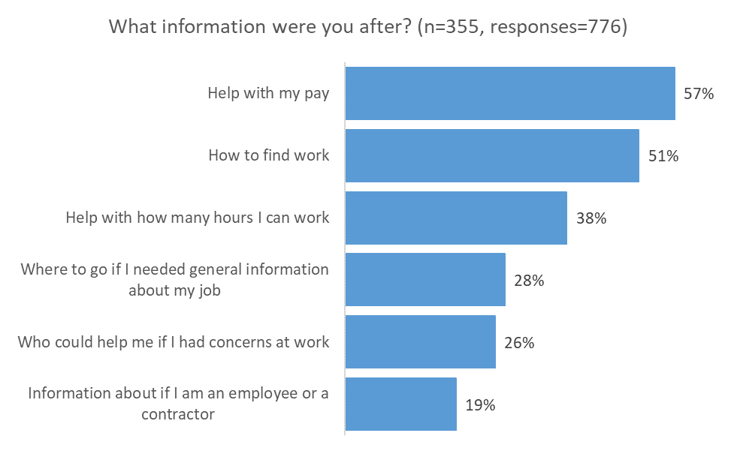
Note: multiple responses allowed

For those who did not seek general information about workplace information it was mainly because they felt there was no need
For the remaining 1655 (82 per cent) migrant workers who reported having not sought workplace information (other than about how much they should be paid) while in Australia, almost half (49 per cent) said it was because they did not see a need, followed by a belief that their employer was doing the right thing (21 per cent).
Of concern is the 25 per cent (or 413) of respondents to the question who did not seek information about workplace laws because they were fearful they would get into trouble (15 per cent) or they do not want to get their employer into trouble (10 per cent). This is explored further in the qualitative research, in which participants said ‘getting into trouble’ could mean fear of losing their job for raising concerns, fear of creating a difficult situation for themselves at work, or fear of causing cultural offence if it is seen as though they were questioning an Australian work practice or work ethic that was different to their experience.
Figure 7: Reasons for not seeking information about Australian workplace laws
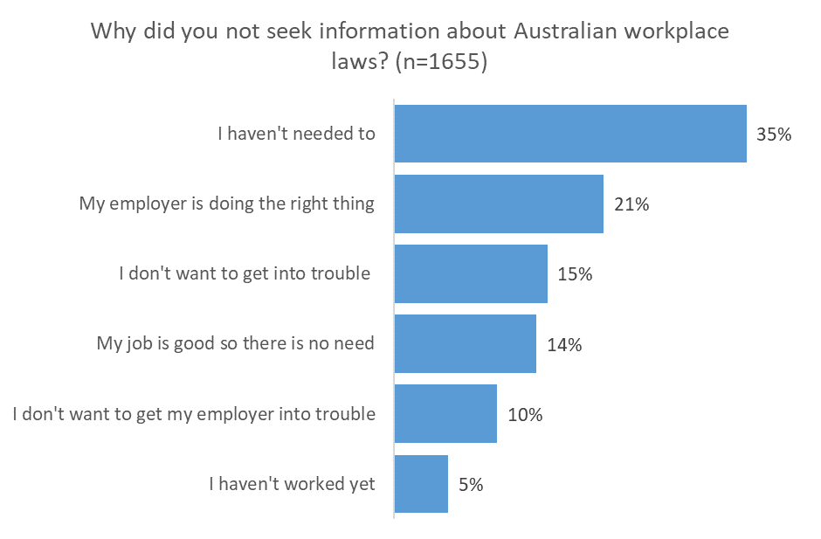

Views on current information needs

Despite a limited knowledge of workplace rights, only 29 per cent of respondents to the survey thought they needed more information
The survey results showed that a minority (29 per cent) of all respondents consider that they need more information about workplace laws and conditions. The groups most likely to indicate they need more information are international students (37 per cent of the student cohort) and WHMs (33 percent of the WHM cohort).
Figure 8: Workplace information needs by visa type
In your experience, do you need more information about workplace laws and conditions? | Number | Yes | No
Working Holiday Makers | 571 | (191) 33% | (380) 67%
Graduates | 209 | (48) 23% | (161) 77%
International students | 801 | (297) 37% | (504) 63%
457 visa holders | 429 | (56) 13% | (373) 87%
Total | 2010 | (592) 29% | (1418) 71%

By gender, 39 per cent of female migrant workers believed they needed more workplace information. This was almost twice as high as that of male respondents (21 per cent). Migrant workers from Hong Kong (42 per cent), Vietnam (38 per cent), China and Korea (37 per cent), were most likely to indicate the need for more information. The top industries or occupations migrant workers needing more workplace information were employed in were hospitality (52 per cent), cleaning (39 per cent) and courier/delivery/taxi service (38 per cent). Those working in petrol stations and automotive businesses (car wash, mechanics) (both 7 per cent), and call centres (9 per cent) were the least likely to consider they needed more information about workplace laws and conditions.
This position was supported in the qualitative findings:
To be honest I don't think I need to know too much and there is no point knowing workplace laws because in reality these laws often do not apply to the students and working holiday makers who need to work. Where I work now I get paid fine but if I wanted to look for another job, whether the new employer is going to pay legal minimum wage or not, is not an issue to me as long as they give me other benefits. For example: being able to work flexible hours, being employed and get paid without much English-speaking ability. Whether they are being fair legally or following fair work rules don't bother me.
Japanese, student, female

No, I have had no problems because, in the offer letter of my work, they gave me all the rules, rights, and regulations that I had to read before commencing my job so I was very clear on what to do and what not to do.
French, student, male
There was a recognition by migrant workers that once they arrived in Australia, a number of workplace issues arose which highlighted a need for more information and a better understanding.
I wish I had had a better understanding of the types of employee like part time and casual. I started working on a farm as casual but did as many hours as a full timer and did not realize there was meant to be a different contract with different benefits until I left. So I wish I'd understood that better.
French, WHM, female

In Japan once you are employed you don't get fired so easily but in Australia people get fired a lot, for example for being slow [and], not picking as much fruit as others. I simply wanted to know that can happen, regardless of if that is legal or not.
Japanese, WHM, female

Trial period is not clearly specified, especially for Asian employers. They'll ask you to trial for a few days, but do not specify for how long. After talking to career counsellors at university, they advised me that students should not take on trial period for more than a few hours. That's why I think it's important for international students to know how long work trials should be. I know many students can be asked to trial for three days and never get hired.
Vietnamese, student, female

The information considered most useful was varied
Those who felt they needed more information considered that they could use more information across a range of topics: 592 respondents selected an average of 4.6 out of 9 available responses to this question. Issues relating to minimum rates of pay were ranked highest (68 per cent), followed by where to get information about pay and conditions (63 per cent), information about allowable deductions from a workers’ pay (59 per cent), and who could help if they had concerns at work (56 per cent).
Figure 9: Workplace information needs
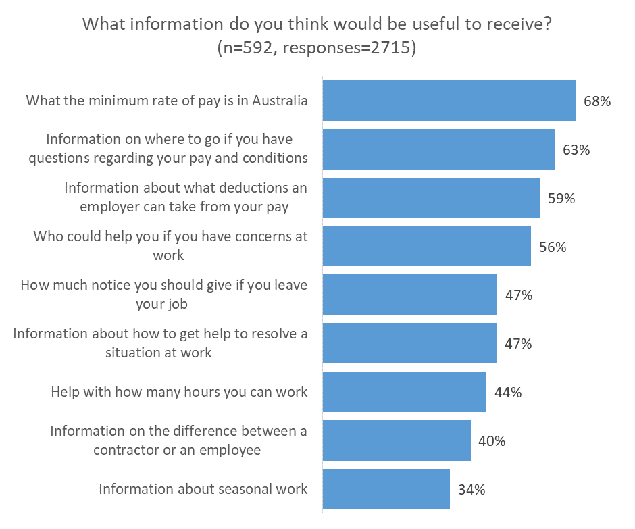
Note: multiple responses allowed
I want to know more about the benefits we are entitled to. There would be no harm in knowing more.
Mandarin, 457, male
The survey findings were supported by the qualitative research and overall, the qualitative discussions revealed a mixed interest in workplace rights. As the focus group discussion sessions progressed, some migrant workers began to become increasingly interested and keen to learn more. It was found that the longer visa holders had been in the country, the greater the likelihood of understanding workplace laws and conditions.
Before you arrive to Australia, you don’t know anything. You don’t know what a tax file number is. If you don’t know what it is, it doesn’t even interest you.
Italian, WHM, female
However, other participants stated that the information was of no use to them, as they were either not bothered (often identified as a reason for those who felt they had a ‘good’ job) or they misunderstood the difference between workplace laws and the work rights attached to their visa. Others considered workplace laws were only applicable to permanent residents or citizens, or they had no relevance for them because their employer was also from their country of origin and they could not expect to be treated the same way as an Australian worker. Still others were prepared to face exploitation in exchange for a paid job, as they considered it to be better than no job.
When I was looking for a job, I did not check much about the job’s employment conditions advertised on website as long as I thought the conditions were fine. However, I now realise that it would be helpful to know about workplace law when I get a job next time.
Korean, WHM, male

Almost everyone who works here knows the minimum pay, including the people who are getting underpaid. It's almost by default that all the… restaurants underpay those poor students… What can I do even if I know the minimum pay?
Mandarin, student, male
When discussion participants were asked what type of issues they wanted to know more about, or thought were important to know, the results were similar to the survey answers. These included; pay rates (including minimum pay, penalty rates, overtime allowances, award/industry rates, deductions, unpaid trials and internships), how many hours they can work, leave entitlements, taxation, superannuation, and who to contact if they are being treating unfairly at work were most commonly raised. Other issues raised include the differences between employee and contractor and the appropriateness of being determined as the latter, how to calculate farm days to meet the specified work requirements for the purposes of securing a second year visa for WHM, and unfair dismissal. In addition, focus group participants indicated they would be interested in finding out more about maternity leave, access to insurance cover for work accidents, general information about the concept of awards, job security, unfair dismissal and complaints procedures.

Awareness of the Fair Work Ombudsman

Just over one in five respondents had heard of the FWO
Based on the survey results, awareness of the FWO is low among migrant workers, with 21 per cent of respondents having previously heard of the FWO. The categories of migrant workers least likely to have heard of the FWO were 457 visa holders (11 per cent) and graduates (18 per cent). Migrant workers from Japan (16 per cent), Korea and Taiwan (17 per cent) were least likely to have heard of the FWO. Conversely, migrant workers from Hong Kong (40 per cent), France and Italy (both 31 per cent) were most likely to be aware of the FWO.
Awareness of the FWO was lowest among respondents working in petrol stations (5 per cent), data entry (7 per cent) and manufacturing (10 per cent). Workers in farming (41 per cent), courier/delivery/taxi (38 per cent) and receptionist/other office work (34 per cent) were most likely to be aware of the FWO. Awareness of the FWO among respondents working in hospitality — the largest occupation group in the survey — was also high in relative terms, at 34 per cent.
By age bracket, participants aged 45–54 had the lowest awareness of the FWO (8 per cent), however there were few participants in this age group. Participants aged 35–44 also had low awareness of the FWO, at 15 per cent. The respondents in these age brackets also had the lowest rates of seeking out information about pay and other workplace laws. Awareness of the FWO was higher in the 18$–$24 and 25–34 age brackets (23 per cent). The older age brackets are heavily dominated by 457 visa holders, while the youngest age brackets include mostly students and WHMs. As discussed previously, 457 visa holders in the research tended to have lower rates of awareness and seek less workplace information. It is reasonable to conclude that age is less a predictor of knowledge of workplace laws and conditions than visa type.
Figure 10: Awareness of the FWO by visa type
Have you heard of the Fair Work Ombudsman before today? | Number | Yes | No
Working Holiday Makers | 571 | 23% | 77%
Graduates | 209 | 18% | 82%
International students | 801 | 25% | 75%
457 visa holders | 429 | 11% | 89%
Total | 2010 | 21% | 79%

For those respondents that knew of the FWO most knew about its role
Of the 21 per cent (416) of survey respondents who had heard of the FWO, almost two-thirds (265) said they know what the FWO does. For those who said they knew what the FWO did, they were provided with a number of answers to choose from; 79 (210) per cent knew about the FWO’s investigative and support roles, while 72 per cent (192) knew about the FWO’s role in helping employees who have been unfairly or unlawfully dismissed.
Figure 11: Knowledge of the role of the FWO by visa type
Do you know what the Fair Work Ombudsman does? | Number | Yes | No
Working Holiday Makers | 132 | 70% | 30%
Graduates | 38 | 63% | 37%
International students | 199 | 61% | 39%
457 visa holders | 47 | 57% | 43%
Total | 416 | 64% | 36%

Figure 12: Knowledge of the responsibility of the FWO
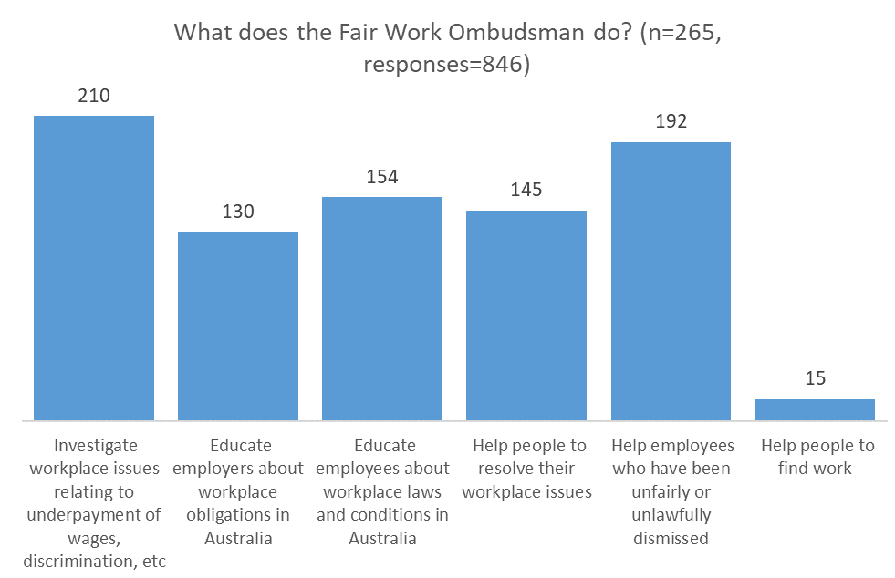

The feedback from the focus groups provides a different impression, in that about half of the participants had heard of the FWO and it was widely known by those who had participated in the in-depth interviews. Further, those that had heard of the FWO for the first time during the research were able to deduce its main function.
… my school and Interlatina agency told me that [the FWO] is the place to go if I need to find any information regarding workplace laws and employment condition and that the information is even in Spanish.
Spanish, student, female

I heard about it through that association I used to be a part of, Nomit. It's a body that regulates the workplace, protects employees and communicates that.
Italian, 457, female

Misconceptions and perceptions

Because of a number of misconceptions, migrant workers do not see the benefit of understanding their workplace conditions
While acknowledging that the Australian workplace relations system is complicated and migrant workers bring an understanding of their own countries’ systems, there are a number of misconceptions held by migrant workers that became clear during the qualitative research.
Of greatest concern is that some participants felt that they did not have the same workplace rights and responsibilities as Australian permanent residents, and their employers did not have the same obligations to them.
Are they [workplace rights] only for Australian residents, right?
Mandarin, WHM, female
This misapprehension creates an environment in which migrant workers may think that they are less equal than Australian citizens with regards to payment and conditions. Further, it creates a false belief that they have less power in the workplace and they may therefore be unwilling to speak out, or seek more information, when experiencing or witnessing exploitation.
It also became obvious that confusion arises by misunderstanding the difference between visa work rights and obligations, and workplace laws such as those set out in the Fair Work Act 2009.
I only sought information about Australian workplace laws for sub-class 500 specifically, because that's my visa sub-class... I looked into the regulations and laws that apply to international students.
Vietnamese, student, female
A number of participants raised concerns in the qualitative research that when they sought out online information, (usually on government websites) they were unsure if the information they were reading applied to their visa or not. This impression — that certain workplace laws and regulations do not apply to one’s visa type, or apply only to Australian residents — points to the need to promote clear messaging on access to workplace laws for migrant workers, regardless of visa type.

Barriers due to language
Many participants in the qualitative research advised that they were hesitant to make contact with government agencies in Australia due to a perceived language barrier. For example, in both the Mandarin and Korean focus groups, participants who rated their English proficiency as high, said they would look for information on workplace issues on official websites, whereas those who were less confident with English would use in-language social media, websites, online forums or ask friends.
I would expect the official government websites would have it [specific information about Australian workplace laws and employment conditions] but due to language restrictions, I am unable to access them so I cannot confirm that the information is there. I am limited to the Hispanic community.
Spanish, student, female
Similarly, several participants expressed a reluctance to contact the FWO because of the perception that they would have to speak English.
Yes, definitely [I would feel comfortable to contact the FWO]. However, I would hesitate to contact them if they do not provide the service in Korean. I’m afraid there might be some communication issue as I’m not really confident to communicate using English.
Korean, WHM, male

No, I am hesitant to contact them, mainly due to the language issue. If I can contact them in Japanese, I would be more likely to contact them.
Japanese, 457, male

If I had to choose channels to receive information regarding laws and employment conditions, the best option would be to be able to talk to a government official in Spanish, this way I would fully comprehend and I would be receiving official information…and if [it is] not going to be in Spanish, then through email so I can translate.
Spanish, student, female
This issue also comes through in the survey results. While those with lower self-rated English proficiency were almost equally likely to have sought information about workplace laws and conditions (38 per cent compared with 42 per cent), the better English-speakers were more than twice as likely to have sought that information from an Australian Government source (22 per cent compared with 8 per cent).
Figure 13: Workplace information source by self-rated English proficiency
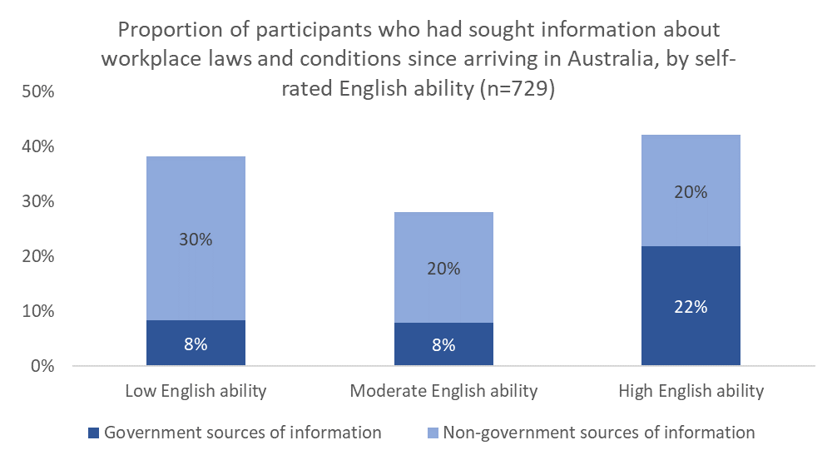
Note: multiple responses were allowed. Survey respondents who said they had sought information from any government source were grouped into ‘Government sources of information’ while those who only sought information from non-government sources were grouped into ‘Non-government sources of information’. Respondents rated their own English ability out of five; those who rated themselves 1 or 2 were grouped into ‘Low English ability’, those who rated themselves 3 were called ‘Moderate English ability’ and those who selected 4 or 5 were grouped into ‘High English ability’.

Participants consistently said that they trust information on government websites more than on other websites, social media or from friends. But the misconception that contact with government agencies — particularly the FWO — will require the use of English, appears to drive some migrant workers to potentially less reliable sources of information such as social media, or asking friends. This is despite the considerable resources the FWO has to assist people to make contact in their own language and the translated materials on the FWO website.
As the Department of Home Affairs is often the first point of contact migrant workers have with the Australian Government, it is worth ensuring that the information on its website informs migrant workers that the FWO provides in-language information and advice.
In addition, messaging from other government agencies regarding workplace laws and conditions should promote, where relevant, that information is available in language. This will help to alleviate incorrect views held that government information and services are provided in English only.

Barriers due to concern about lack of alternate employment opportunities
A consistent finding in previous research on migrant workers’ experiences in Australia is that their concerns about the difficulty of finding another job is a disincentive to seeking information or taking action when they have concerns in the workplace. This was also borne out in the qualitative research.
I looked for many jobs and none paid minimum wages. There is competition even when you are not receiving the minimum pay. I don't think there will be any use doing anything.
Mandarin, WHM, female
Stakeholders also supported this view in their interviews.
Because of the number of students looking for casual work, employers can make students feel dispensable by saying that ‘If you don't want the work, it’s okay. I can get someone else’.
Stakeholder
This highlights the secondary labour market that exists and the belief that ‘legal’ jobs are very hard to come by for some migrant workers.

Perceptions of stakeholders
Many of the findings from the quantitative research and qualitative interviews with migrant workers were endorsed by a number of stakeholders interviewed for the research. The stakeholders consulted were:
- Australian Chamber of Commerce and Industry
- Australian Council of Trade Unions
- Australian Meat Industry Council
- Council of International Students Australia
- Federation of Ethnic Communities’ Councils of Australian Government
- Growcom
- ISANA: International Education Association
- MADEC
- National Farmers’ Federation
- Restaurant and Catering Industry Association
- Redfern Legal Centre.
It is the view of industry organisation stakeholders that workplace rights information for migrant workers should come from employers. These industry organisations consider that employees will initially contact their employers about workplace issues. This view was supported in the survey findings. When asked what would be the best way to find out information about workplace laws or conditions, the most common response (17 per cent) identified employers as the best source of this information.
While industry representatives said it is important for the employee to inform themselves, there was a concern raised that migrant workers 'crowd-source' word-of-mouth information from personal contacts, family, and community members and that these sources are sometimes not the most reliable. The survey found that friends and family, and the FWO, were identified equal second (15 per cent of respondents) as the best way to find out about workplace laws and conditions.
Industry organisations were further concerned that employers from culturally and linguistically diverse cultures may not fully understand the Australian workplace relations system and are therefore not informing their migrant workers correctly. They suggest that targeted education and information programs for non-English speaking employers would be highly effective. Industry organisations said that one of the best ways for the government to educate migrant workers is by increasing efforts to educate culturally and linguistically diverse employers.
Industry organisations cautioned against the wholesale use of generic information. Instead, they stressed the importance of providing detailed or specific information such as pay entitlements, including piecework, industry-specific workplace health and safety information, and relevant information for rural workers. In terms of timing, industry organisations considered that information should be provided at several points, most importantly on commencement of employment.
Representatives from advocacy organisations for ethnically diverse communities, students and legal services were also interviewed for this research. Representatives reported that the culture that migrant workers come from adds to misunderstandings and confusion about workplace rights. This is because migrant workers may come from a place where workplace practices are very informal and not codified in law or regulations. These representatives also raised concerns that due to cultural or language barriers, employers from a migrant background may not understand Australian workplace laws and conditions well.
Most… are exploited by nationals from their home country who take advantage of their lower English language competency, need for income, lack of knowledge of Australian law and fewer personal support networks. There is an information gap in knowing about their workplace conditions for the various industries they may be employed.
Stakeholder
Advocacy stakeholders consider that migrant workers should be made aware of workplace rights and where they can get help before coming to Australia. In addition, they considered it important for migrant workers to know that, in cases of exploitation, government agencies will pursue unscrupulous employers, but not penalise workers with a valid visa.
Advocacy organisations considered that migrant workers do not know where to get help with workplace issues and that they are overly reliant on personal contacts — which may be unreliable — for support.
Representatives considered that awareness of workplace rights is better among migrant workers with strong English language skills. They reported that the common issues that create misunderstanding are piece rates, penalty rates, payslips, timesheets, superannuation and the requirements for WHMs to get a second-year visa. Because of the complexity of workplace laws, understanding existing information is difficult for migrant workers. Commonly, this difficulty is compounded by seeking clarification from supervisors and colleagues whose understanding may not be correct.
Advocacy stakeholders felt that it would benefit migrants to receive information on workplace rights, entitlements and responsibilities during the visa application process and educational institution enrolment. Other opportunities to distribute resources are at airports, and via key migrant contact points such as accommodation services and at universities.

Research objective 2: Identify which channels and formats best suit migrant workers in Australia and what types of content they need most
This component of the research aimed to find out the best channels (TV, radio, websites, social media) and formats (text, audio, video, fact sheets) for communicating with migrant workers about workplace information. Participants were asked what kinds of information they had received and how useful that information was to them, what topics they had sought information on, and how they usually received information. The method used to do this was both qualitative through focus groups and in depth interviews and quantitative through the survey.

Information sources used by migrant workers are diverse
The survey asked respondents about their sources for information on working in Australia before arriving and while in Australia. While the responses were very diverse, the most common avenue for migrant workers to receive information was from family and friends and social media sites both in English and in their language.
Respondents who had sought or received information about workplace information before coming to Australia indicated that the most prevalent sources were in-language social networking sites/internet chat rooms/discussion boards/sharing and review sites/blogs (30 per cent of those who did receive information), family and friends in Australia (30 per cent), and family/friends/colleagues in my home country (27 per cent). The visa grant notice and fact sheet sent by the Department of Home Affairs was also a common source of information (23 per cent).
Once in Australia, the main sources for information on pay rates were family and friends in Australia (29 per cent of those who had sought information about pay), and social networking sites/internet chat rooms/discussion boards/sharing and review sites/blogs both in language (28 per cent) and in English (20 per cent). The FWO was also a source of information about pay, with 20 per cent of respondents who sought information about pay receiving it from the FWO. Among those who had sought information about pay from the FWO, 63 per cent considered the information very useful or extremely useful – the highest proportion for any information source.
Among international students, a third of those who received information on pay received this information from university/college/school student services, making this the most common source of information about pay for international students. University/college/school student services rated highly in terms of the usefulness of information, with 57 per cent of those who sought information about pay from this source rating the information very or extremely useful.
I would seek advice from my university's student services. I like having someone to talk to in person and they can help me answer very specific questions.
Vietnamese, student, female
The top information sources for workplace laws and conditions (rather than pay information) were friends/family in Australia (34 per cent) and social networking sites in English and in-language (26 per cent and 25 per cent respectively). Sixty seven per cent of respondents who cited gaining this information from their university or college rated the information as very or extremely useful, followed closely by the FWO and the Fair Work Commission (66 and 65 per cent respectively). However, some caution needs to be applied here as numbers are small.
Among those who sought information about either pay or other workplace laws and conditions from Australian government sources, only a small number (71 out of 524 responses) considered the information either not at all useful or slightly useful. To understand this more, respondents were asked why they held this view; the responses indicated they could not find the information they wanted, or it was not clear if the information applied to their visa category or only to Australians.
For those respondents who sought out information about workplace laws and conditions from government services, the survey asked how they received the information. While the number of respondents is not large, overwhelmingly respondents looked online (81 per cent) with a small percentage calling a government department (10 per cent), emailing (7 per cent), or visiting a shopfront (1 per cent). This gives a strong indication of the importance of high quality online information.

Figure 14: Source of other information from government services
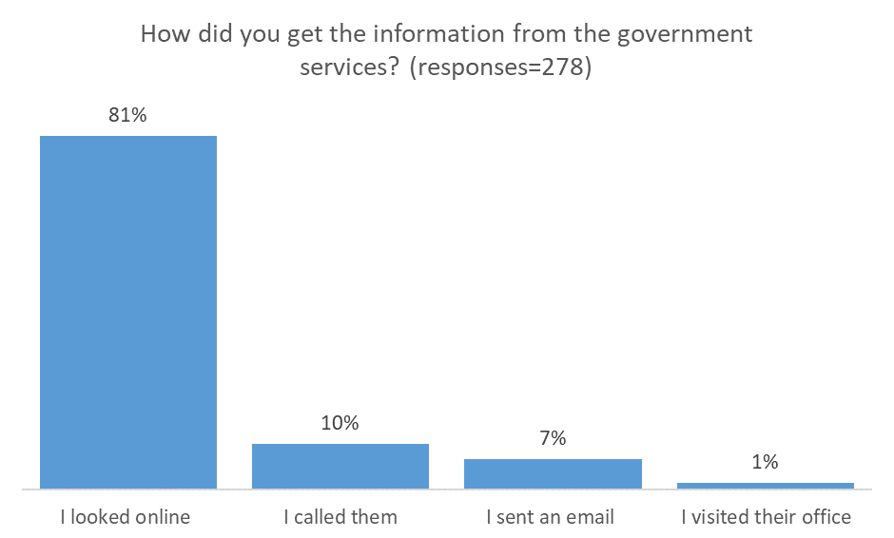

Those respondents who had sought information about workplace laws and conditions were asked when they sought the information, 32 per cent of respondents did so when they arrived in Australia, 26 per cent when they got a job, 15 per cent each when their visa was granted or as issues arose in their workplace.
Figure 15: Most common time to seek out workplace information when in Australia
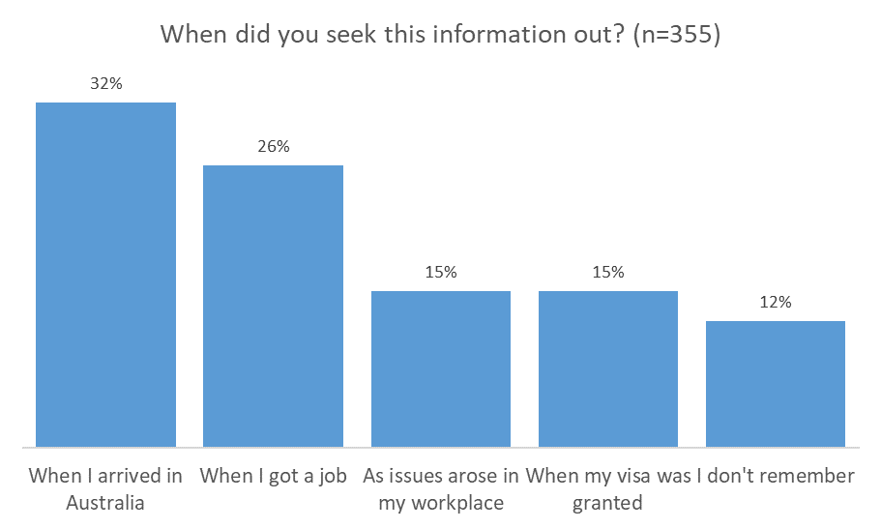

The best sources for receiving information varied
Having the hindsight of experience, respondents were asked what they now consider to be the best ways to find information if they had questions on workplace laws or their conditions at work. The respondents could give multiple responses to this question and while there was not a clear preferred option, the largest proportion of respondents would ask their employer (17 per cent), family, friends and colleagues (15 per cent), the FWO (15 per cent) and university/college student services (14 per cent). In-language social media sites were slightly less preferred (12 per cent).
This view was supported by the qualitative component of the research; while very few participants had actively looked for information, they advised that if they encountered an issue at work, they would most likely talk to colleagues or supervisors, talk to friends, look for information online using in-language search engines, or seek out government websites for information. They also nominated online Q&A sites, blogs, webpages, forums, social media and face-to-face in-language help as prospective sources of workplace information. Some notable differences were apparent for workers of different language groups: for example, French participants said they would contact their embassy or consulate if they needed help. Arabic and Italian participants indicated that their first step would be to talk to their colleagues, while Hindi participants would speak to their employer or their human resources representative.
I was inquiring about the taxes – taxes for casual jobs. At first, I asked the company itself. I searched their website and still could not find the information I was looking for so I went straight to Google. There I have reviewed some general websites and some reviews (Q&A's). However, it was not sufficient.
Arabic, student, male
While not an exhaustive list, some specific online resources mentioned in the research included the Department of Home Affairs website, Quora.com (online English-language forum where users may post questions and answers), Yahoo, Facebook groups, the FWO, WeChat, Reisebine, Yomeanimoyvos and Naver.

The best way to provide information is via the internet
When asked about the best way for government to provide migrant workers with information on workplace laws and conditions, 21 per cent of respondents indicated that they preferred to receive information via internet web pages. This preference was followed by email (17 per cent) and the visa grant notice (13 per cent).
Figure 16: The best way to provide information – top responses
In your experience, what would be the best way for the government to provide you with information on workplace laws and conditions? (Responses=1458) | Number | Percentage
Web/internet | 302 | 21%
Email | 246 | 17%
Visa grant | 183 | 13%
Letter | 166 | 11%
In-language information | 88 | 6%
Apps | 87 | 6%
Social media | 77 | 5%

Some participants suggested that the tax file number notification letter would be a good channel for communicating information about work rights to migrant workers, because it generally coincides with a migrant worker looking for, applying for, or starting a job. This was supported by survey findings, with 30 per cent of respondents indicating that they would like more information about workplace laws and just under 10 per cent of those saying that the best time to receive this information was when applying for a tax file number.
Another suggestion was a compulsory questionnaire asking migrant workers to answer a few questions regarding workplace laws to check they have read the information and ensure they have a basic knowledge of workplace rights.
Mandarin speakers preferred online information in their native language. They would look for resources such as chat groups, information from social media, and online forums.
I think more posts on social networking sites and apps such as Facebook, WeChat, Twitter or Line could be good. I can follow them and I will get all the information.
Mandarin, WHM, male
For migrant workers from mainland China, where Google is banned, Baidu is used to search and WeChat to socialise. Otherwise in Australia, they used Google.com.au to search and Facebook to socialise. They all used smartphones, and the majority have a laptop. When possible they preferred to use their smartphone, as it is convenient.
I get the event information from WeChat Moments and radio such as 101.9 and 97.5 in English, and I get breaking news from WeChat official accounts and WeChat Moments when my friends share the information.
Cantonese, 457, female

Before I came here, I also know about minimum wage in Australia from many Chinese WeChat groups, such as 澳洲打工度假群 (Australian working holiday group), 雪场工作信息交流 (working and exchanging information at ski resorts), 北领地集二签 (second year visa in NT), 澳新打工度假微信群 (Australia and New Zealand working holiday WeChat group).
Cantonese, WHM, female

The best time to provide information is when migrant workers are looking for work
Respondents advised that the best time to receive information about Australian workplace laws and conditions would be when they were looking or applying for work (26 per cent). This was followed by when they started in a job (17 per cent), when the visa is granted (16 per cent) and when arriving in Australia (12 per cent).
Figure 17: The best time to receive information about workplace laws and conditions in Australia
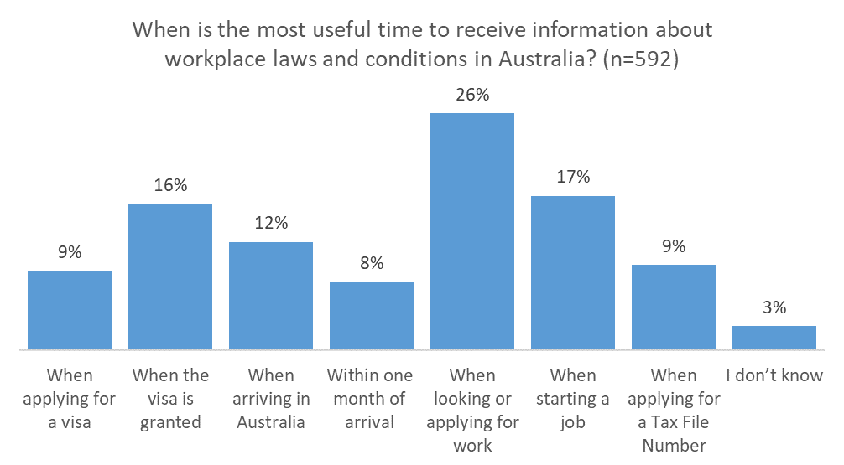

This data indicates that a key information point for government agencies to provide information on workplace laws and conditions is when a migrant worker is looking for or starting work .While receiving information at this time is ideal, there is not a responding trigger that would alert an agency that the migrant worker is looking for or starting work. Ensuring that migrant workers know where to go for information before they apply for or start work is the next best option.
These findings provide clear evidence that there are multiple sources, formats, channels and times for migrant workers to receive information on Australian workplace laws and conditions. Therefore, government agencies need to use a range of methods and different triggers to promote information. As the respondents to the survey use a number of different sources, it is imperative that the information is consistent across the agencies.

Promotion and distribution of government information
The participants in the qualitative component identified similar preferred information sources to the quantitative component with websites and official social media posts among those identified. Other sources highlighted included periodic newsletters, TV series with topics of workplace laws and conditions and live online chat sites.
In terms of the promotion of government services, the views were varied as to what was most effective. Traditional promotional channels like radio, TV and billboard advertisements were noted as being useful. Online advertising was preferred as well with participants suggesting advertisements before YouTube videos, on Facebook and in-language websites.
For the distribution of information, there was a preference for the information to be provided digitally. Participants in a number of focus groups said that email would be a useful source of information. Many migrant workers advised that they prefer to receive English-language information in a written form so that they can use machine translation tools such as Google Translate to help them understand the information. Further, when the information is in written form they can refer back to it later. There was also a preference for distribution through official social media channels, particularly those of the Department of Home Affairs and the FWO.
Given participants’ views that the best time to receive information about workplace laws and conditions in Australia is after arrival generally and when looking or applying for work in particular, and a relatively common preference for text information, the Government should consider ways to increase the collection of personal contact information to enable ongoing communication after migrant workers have arrived.

Research objective 3: Obtain migrant workers’ feedback on existing communications material provided by government agencies

This part of the research sought qualitative feedback from migrant workers about the effectiveness of existing communication materials developed by the FWO, the Department of Home Affairs and the ATO. The feedback was obtained through the 11 small-group evaluation sessions in Sydney, Melbourne, Brisbane and the Gold Coast. The materials discussed during these sessions included content from websites and social media, the myVEVO app, printed material and video resources.
In addition, quantitative evidence was obtained through the survey in relation to the FWO’s in-language website content, and the visa grant notice — which included a fact sheet — provided by the Department of Home Affairs to migrant workers.

General views on government information products was positive
The feedback provided during the evaluation sessions demonstrated that the participants appreciated the government's effort in producing many of the materials, and that some of the resources were considered best practice. Focus group participants were asked to complete a series of tasks, in which they searched online for information on mobile devices (tablets) and notebooks. The format of the discussion was challenging for some of the groups and they struggled to complete all the tasks in the allocated time. For example, some groups were unable to locate Australian government websites through online searches using in-language keywords.
A female participant said she tried to find work related information previously, but she didn’t know where to look and didn’t get to the FWO site at all, probably because she was using Japanese words to search.
Japanese group evaluation facilitator

To get the information, most important of all is to know the key words. On most occasions, you can’t search by Chinese and even in English, you need to know the exact key words, otherwise you will get rubbish and waste your time.
Mandarin, student, male

Translated information was preferred, however this information needs to be promoted to migrant workers
Some of the groups (e.g. Italian, Vietnamese) said they primarily used English resources. However, all language groups appreciated any in-language materials that were available. In line with the cultural and language expectations of the reader/listener, translated materials should be organised, clearly formatted, consistent, and structured. In addition, cultural differences in languages must be understood and reflected in the products.

Short, simple messages including real life scenarios and contact details for government organisations are useful
Short and simplified information, with links to more detail, was generally preferred over lengthy content. This includes avoiding the use of technical language and jargon, especially in English materials.
Participants appreciated real life examples in all materials. In addition, they felt that good design in all media was important. When considering the design of resources, it was apparent that the use of visuals and graphics was very popular, as was good use of colour. This is because good design can help migrant workers to identify the key messages and therefore act upon the relevant information.
Participants indicated that they trusted information which looked official; for example, information that includes a government logo and provides contact numbers or other contact details. These details were considered very valuable as they provide the worker with an alternate avenue for additional information or assistance if required.
In addition to preferring short, simple messages, participants expressed a desire to be provided with information that is tailored for varying levels of knowledge. This will help to ensure that migrant workers can continue to access information as they develop a basic understanding of their entitlements at work. Videos were considered to be a good medium for providing information at basic, average, and advanced levels of knowledge.
Overall, the pages [on the FWO in-language website] in Chinese look good, very easy to understand. Video is not too long but straightforward and informative. Some information, that we were not aware of, is extremely important such as extra pay for night shift and holiday pay.
Mandarin, 457, female

Search engine optimisation should be enhanced particularly in relation to in-language website content
Search times varied widely with some participants indicating that information was easy to find, while others found this more challenging. This was related to the keywords used as well as suspected poor search engine optimisation for some government web pages.
Search engine optimisation could be improved on English searches for people who have lower English proficiency, or who are less used to searching in English. This will help ensure that relevant information is accessed by those undertaking website searches by promoting official information over the current results which are often not links to information provided by the government.
Search engine optimisation should also be improved for in-language search engines, with particular attention given to the metadata attached to the translated information on both the FWO and ATO websites. While some agencies invest significant efforts in providing in-language content, if the metadata is not also translated then these websites will not be highly ranked in in-language search results. This will assist those migrant workers who are using in-language search engines to access official information in their preferred language.
My English is not so good, I mostly use Chinese search engines because it’s faster. I go to government websites only when I look for specific information, or when I must. For example, when dealing with visa application or paying tax, I will only look for information on government websites.
Cantonese, WHM, male
Information about tax and superannuation that migrant workers would be interested in is currently buried in the ATO website. Migrant workers looking for tax file number (TFN) information need to search the site; going from the main page to ‘Individuals’ => ‘Apply for a TFN’ => ‘Foreign passport holders, permanent migrants and temporary visitors’ before finding the answer to their query. Also, the ATO web page has only one meta tag that shows up in an online search: <TITLE> Foreign passport holders, permanent migrants and temporary visitors – TFN application | Australian Taxation Office</TITLE>. More effort is required so that migrant workers can find information easily and quickly on tax file numbers and recovering any tax overpayments or superannuation. A section, or links, on the ATO’s home page specifically for migrant workers, and meta tags in the HTML code, would make it much easier for migrant workers to find information that is relevant to them, particularly in online searches for terms like ‘Australia migrant workers’.

Translated information on government websites can be hard to find and should be promoted
To facilitate users’ access to online in-language material, it has become widespread practice to include a list or drop-down menu of languages available. This may include an icon to demonstrate that translated information is available. Users who prefer to read information in a language other than English typically know to look for such a list or icon.
Translated information on government websites should be easy to find and consideration should therefore be given to how the ‘language help’ information can be promoted.
In addition to promoting the ‘language help’ information, consideration should be given to ensuring that appropriate, translated pages are prioritised in the results from in-language site searches. For example, searches in Japanese on the FWO website should return the relevant Japanese content.
When considering the translated information provided by the FWO, participants noticed that the English links and headings still appeared in the website header. Participants considered this as counter-intuitive and unhelpful, as it would be difficult for non-English readers to understand the hyperlinks.
This is weird. It would be very difficult for people with little English. They wouldn’t be able to understand why the main hyperlinks on top that are still in English.
Cantonese, graduate, male

In fact, if they click one of those links they will be linked back to the English site. The links at the top should be displayed in Chinese too.
Cantonese, WHM, male

Translated information should accurately mirror the contents and design of English materials. Participants noticed when the English version had more information than the translated version.

Social media is a useful medium for communicating with migrant workers
In general, social media coverage was considered valuable, but community groups may be more effective than official pages. Recognising the preference to seek information from community groups and family/friends, consideration should be given to using targeted advertising on social media and posts to relevant groups.

Government agency apps should be easy to download and use
The participants advised that apps must be easy to find in Google Play and the iTunes Store. Further, they should be downloadable to non-Australian registered phones. Where translated information is available, a clear explanation of how to access the app language options is required.
The participants advised that they would be more likely to use an app if it was easy to install and login. Further, the app should be straightforward and avoid having too many steps. Recognising that many migrant workers have limited internet access, participants also advised that they would not download an app if the file size was too large.

Government information products should be widely promoted and distributed
There was a general impression during the discussions that the participants learned a lot about workplace rights from the exercise, the types of information available, and personally benefited from the sessions.
It’s really interesting how we have in Australia workplace rights, this are the best part of our discussion that I learnt from.
Arabic, student, female
The importance of knowing information about workplace rights and laws needs to be stressed to migrant workers, and participants also indicated that the promotion and distribution of all material is important. For example, they indicated that:
- The timing of the information is highly important - information should be provided to migrant workers at numerous touch points in the course of a visa, including when the visa is granted, when visa holders enter Australia, and when visa holders are looking for or starting work.
- Information should be provided at multiple touchpoints, on multiple occasions as this will reinforce key messages.
- Designers and writers need to appreciate the role culture plays in using the resources.
- Links to websites or social media should be included as this provides an additional source of information.
Participants advised that they would like to receive emails from relevant government departments with web links to key information or resources so that they can browse or download important information as required.
They also recommended that government agencies consider making links to key resources, such as videos, available at multiple contact points, or even playing videos in train stations. In addition, suggestions were made about ensuring printed materials were available in prominent locations, including at the airport immigration and customs areas and libraries used by international students. To this end, universities, employers, hostels and agencies could also be encouraged to distribute materials.

Feedback on existing government information products
In addition to the above general findings, specific feedback was provided in relation to many of the existing resources provided by the FWO, the Department of Home Affairs and the ATO. This feedback is summarised below:

FWO in-language website content was largely considered easy or very easy to understand
Participants provided feedback about the FWO’s in-language website content through both the survey and the group evaluation sessions. In all cases, participants were shown the website content in their preferred language.
Figure 18: Ease of comprehension of the FWO in-language web page
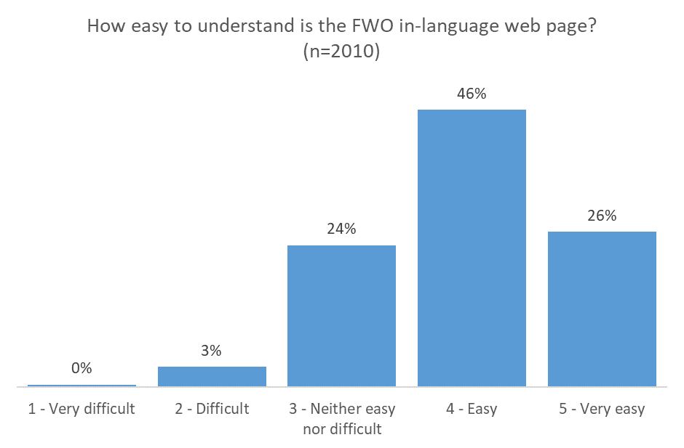

Most of the survey respondents found the FWO’s in-language web page easy or very easy to understand (72 per cent). Encouragingly, less than 0.5 per cent of respondents considered the page very difficult to understand, and just 3 per cent considered it difficult to understand. Migrant workers who worked in travel/tourism (19 per cent), horticulture (14 per cent) and construction (12 per cent) were most likely to consider the FWO in-language web page difficult or very difficult to understand.
Figure 19: Helpfulness of the FWO in-language web page
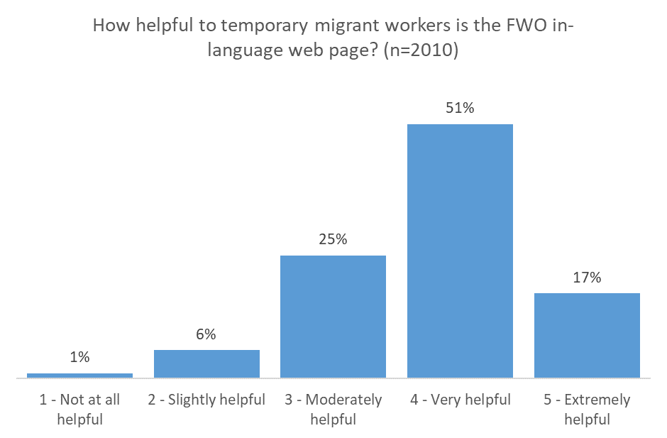

The majority of respondents believed the FWO in-language web page shown was helpful to migrant workers (69 per cent).
By visa type, 10 per cent of WHMs believed the FWO in-language web page was not at all helpful or only slightly helpful to migrant workers. By citizenship jurisdictions, 17 per cent of those from South Korea and 15 per cent of those from Hong Kong believed the web page was not at all helpful or only slightly helpful to migrant workers.
By type of work or industry, 15 per cent of those working in farming and childcare (including au pairs), and 13 per cent of those in health care (including aged care, dental technician) believed the web page was not at all helpful or only slightly helpful to migrant workers.
The survey findings were further validated by the feedback received from participants during the evaluation sessions with most groups indicating that they found the Language Help information easily and believed the information was comprehensive. However, some specific feedback was also provided, including:
- The Arabic participants felt that it wasn’t easy to find information directly in Arabic. They also said that the translated pages need to be re-structured to make them clearer and simpler.
They should improve the Arabic translated content in FWO website, change the structure of the page to match the English version.
Arabic, student, male
- Several groups advised that the content is comprehensive, but the key points could be emphasised. For example, the German group suggested using bullet points to summarise the most important areas, while the Hindi group thought that some step-by-step information would be useful.
- The groups had mixed views about the inclusion of English links to the downloadable resources on the in-language pages with some groups expressing their dislike but others just mentioned they noticed this.
- A number of groups reported that there were some translation issues. For example:
  - The Mandarin Chinese evaluation group advised that some of the translations were not accurate with the content appearing to be quite literal and therefore strange.
  - The Hindi group reported that the language used on the FWO website is too complex and old-fashioned.
  - The Vietnamese group advised that they found the Vietnamese pages easy to understand. However, they would have liked more information, less jargon and translations into modern Vietnamese.

Visa grant notice and fact sheet are not remembered as sources of workplace information
Prior to arrival in Australia, migrant workers are sent, via mail or email, a grant notice from the Department of Home Affairs (see Appendix 2). The grant notice provides advice on their visa application and includes a number of attachments. One of which is a fact sheet which, among other information, provides general information about workplace rights and contact details for the FWO.
Interestingly, when survey respondents were shown an image of the visa grant notice and the first page of the fact sheet, 61 per cent of them remembered receiving a letter like that when they were notified about the success of their visa application. So while, as detailed in findings about research objective one, 80 per cent of respondents didn’t receive or recall receiving information on workplace laws and conditions, many did take note of the grant notice, because it provides the information on their visa application.
Figure 20: Recall of the visa grant notice by visa type
Do you remember receiving a letter like this when you were notified that your visa application was successful? | Number | Yes | No
Working Holiday Makers | 571 | 70% | 30%
Graduates | 209 | 53% | 47%
International students | 801 | 62% | 38%
457 visa holders | 429 | 41% | 59%
Total | 2010 | 59% | 41%

A total of 66 per cent of female respondents remembered receiving the notice when they were notified of the success of their visa application, compared with 53 per cent of male respondents. Migrant workers from Hong Kong had the highest recall of the visa grant notice (80 per cent), followed by those from Italy (75 per cent) and France (74 per cent).
Migrant workers employed in petrol stations had the lowest recall of the visa grant notice (40 per cent). The highest recall rate was among those working in farming (82 per cent) and hospitality (78 per cent). From this, it could be surmised that while the grant notice is a very important contact point, the migrant worker is likely to mostly be interested in the result of their visa application, not the information provided in the fact sheet.
The lack of engagement with the grant notice and fact sheet was consistent among focus group participants. In most groups, participants remembered receiving the grant notice but could not remember the attached fact sheet, or else they remembered it but did not read the information at the time. Participants in the Mandarin group explained that as the fact sheet was in English, the effort to translate the information was too difficult for them.
I did not even realise that there was information on workplace laws on [the visa grant notice and fact sheet]. I only thought, 'Great, I got my visa' and that's it.
German, WHM, female
While participants of the in-depth interviews were not explicitly asked if they remembered the grant notice and fact sheet, only one interviewee recalled receiving the factsheet outlining workplace rights as information she had been sent before leaving her home country.
I can say that with the visa, there were some documents provided. But other than that, there's nothing that was provided upfront. There was some grant sheets where they mentioned and defined the workplace laws in Australia in a fact sheet.
Hindi, 457, female
A fifth (19 per cent) of survey respondents found the grant notice and fact sheet difficult or very difficult to understand. By visa type, 26 per cent of the 457 visa holders found the grant notice and fact sheet difficult or very difficult to understand, as did 21 per cent of WHMs.
Figure 21: Ease of comprehension of the visa grant notice
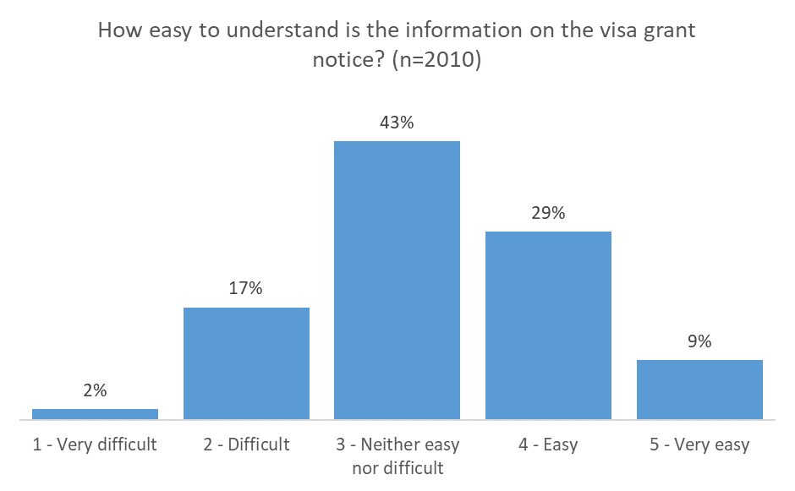

Nearly half of all respondents (48 per cent) found the grant notice and fact sheet moderately helpful to migrant workers and another 37 per cent found them very helpful to extremely helpful.
Figure 22: Helpfulness of the visa grant notice
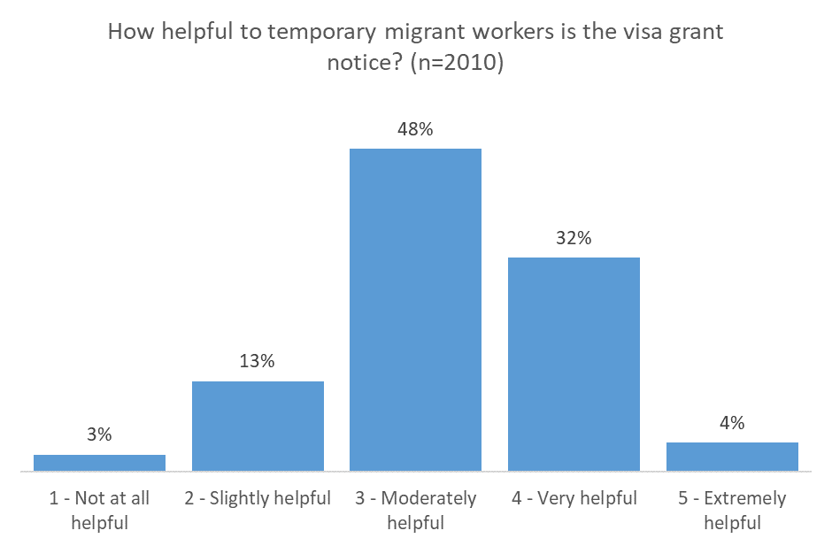

By visa type, 24 per cent of WHMs believed the grant notice and fact sheet were not at all helpful or only slightly helpful to migrant workers. By citizenship jurisdiction, 27 per cent of respondents from Korea believed the grant notice and fact sheet were not at all helpful or only slightly helpful. By industry/occupation, 23 per cent of survey respondents working in cleaning believed the grant notice and fact sheet were not at all helpful or only slightly helpful.
The grant notice and fact sheet were further considered during the qualitative research. Many participants agreed that information should arrive with the grant notice. The grant notice is sent out by mail or by email, but as many migrants to Australia use migration agents, either in Australia or overseas, to help them apply for their visa often the email address included in the application belongs to an agent. This makes it difficult for government agencies to have an ongoing, reliable communication channel directly to the migrant workers.
Various suggestions were made relating to the format of the fact sheet. In particular, the French evaluation group noted that while the information was important, the current format was unclear and the most important information was not highlighted. However, the German group liked that the fact sheet linked to other sources of information including the FWO website. They recommended that these links (and links to other government websites) be highlighted. The Hindi group also made this recommendation.
There were also suggestions that alternate distribution methods be considered for providing this information to migrant workers. This was on the basis of feedback that some groups did not read the fact sheet attachment. The workplace rights information should be prominent in the mail or email package when the visa is granted, or sent separately. Some groups recommended consideration be given to translating the information in the fact sheet. For example, the Spanish participants advised that while the content was clear in English, they would like a translated version.

Government agency web pages were considered good but some improvements could be made

Home Affairs
Participants provided feedback about various web pages including the Department of Home Affairs content relating to ‘Migration fraud and scams’ and ‘Workplace rights for all Visa Holders’. After considering this content, the groups indicated that they found the site was easy to navigate as the layout and colours are clear, clean and simple. However, the format could be improved by incorporating pictures and scenarios. Some groups also suggested incorporating bullet points to highlight the essential messages.
The FAQ content on the web pages was considered quite helpful as it is useful and practical. However, some participants would like to see this content refined as the number of words makes it seem quite complicated. The groups would also like to see translated options available and recommended avoiding jargon where possible.
When considering the ‘Migration frauds and scams’ content, some participants advised that the grey layout of the page was not useful in contextualising the state of alert related to scams. Some groups also recommend the use of video to convey some of this information as this may help them to visualise the situations being described.

ATO
Participants were asked to search for tax and superannuation information on the ATO website and found this information particularly difficult to find. A number of participants advised they could not find information about how to seek a tax refund, particularly after they leave Australia, and they struggled to locate information about how to claim their superannuation. However, when it was located the information was well received. Just under 60 per cent (42) of responses to the survey question, How useful was the information [about Australian workplace laws] you received from the ATO? indicated the information was very or extremely useful.
Participants found that the appearance of the ATO website communicates that the site is trustworthy. However, when the group evaluation participants searched keywords like ‘How to claim’ within the ATO website, the results were not what they were looking for. The information provided is more about the process you should follow to apply for a refund rather than how much money can be refunded, and whether the money can be refunded after leaving Australia. Participants also said they found information about superannuation on the ATO home page and opened the link, but most information was about how to pay superannuation rather than how to claim it back.
A specific section for migrant workers, or links, on the home page, would be helpful for migrant workers searching for tax and superannuation information.

Printed materials from government agencies could be improved
Participants provided feedback about various printed materials including the Department of Home Affairs’ ‘Workplace Rights for Foreign Nationals’ fact sheet, the ‘Paying for Visa Sponsorship’ fact sheet, the FWO’s ‘The Fairwork Ombudsman Can Help’ postcard and the ‘Guide to Starting a New Job’ product. After considering this content, the groups made the following observations:

Workplace Rights for Foreign Nationals
The content is easy to read for those with good English skills. Several participants recommended this content should be translated. Suggestions were also made that consideration be given to incorporating more pictures to make the content more appealing. In addition, the participants requested that the contact information be made more prominent.

Paying for Visa Sponsorship
Participants recommended this factsheet be updated to summarise the key issues and provide links to more detailed information. The scenarios were considered particularly useful and should be maintained. To improve on the accessibility of this information, participants recommended consideration be given to translating this content.

The Fairwork Ombudsman Can Help
This resource was found to be neither highly useful nor relevant. In addition, several groups indicated that they did not like the colours or layout of the content. Participants suggested if this resource were maintained, that additional languages be included. Several groups disliked that their preferred language was missing. Participants also suggested consolidating the ‘FWO can help’ messages to one side of the card so that further information about what the FWO does could be incorporated on the other side.

Guide to Starting a New Job
Most participants found this resource to be visually appealing in terms of its format and design. They also particularly liked receiving this information in their preferred language. This resource was considered to be very practical for new starters as the content was found to be clear and concise. The participants indicated that this resource provides an example of good use of layout, fonts and colours which means the information appeared easier to understand.

In-language video resources should be widely promoted
Participants provided feedback about a number of the FWO’s in-language video resources including the ‘Working in Australia’ video, the ‘Annual Leave’ video and the ‘Everyone has the same workplace rights in Australia’ storyboard. After considering these resources, the groups suggested they should be extensively promoted, particularly through social media.
The video resources were considered very useful, with participants indicating that they would like to see this content actively promoted by government agencies. However, they would like to see all of the text translated (including any labels which appear on screen and subtitles).
While most of the participants enjoyed watching the relevant videos, they did indicate that the pacing of these resources was important. The participants recognised that those with lower proficiency in English may need slower pacing than those more proficient in English.
Specific observations about each of the videos included:

Annual Leave
Generally, the feedback indicated that the participants found this video interesting and useful. Particular attention was drawn to the use of scenarios. However, some groups suggested consideration be given to the use of real people within the videos.
Participants liked the use of vivid graphics and good music. They commented that the animation was attractive, providing easy to understand information. However, they advised that all the text should be translated. The Chinese groups recommended that consideration be given to posting the Mandarin video in the ‘Traditional Chinese’ section.

Working in Australia
Participants felt this video provided a good overview helping them to identify any gaps in their knowledge. While, the content was considered to be very comprehensive, some participants expressed a concern that the different sections were not well connected. The inclusion of translated subtitles was commended.

Everyone has the same workplace rights in Australia
The participants who considered this video resource advised that they found the information to be clear and easy to understand. They thought that the animation was good and the voiceover was clear. However, some participants commented that the animation and voiceover could be faster, but acknowledged that the slower speed would help people not confident with English.

Social Media
Participants considered content available on both the FWO and the Department of Home Affairs Facebook pages and the feedback was mixed. Some participants indicated that they like the regular posts and current information provided on the Department of Home Affairs page, particularly the ‘Tip Tuesday’ content.
The FWO Facebook page was generally considered very useful, informative and interesting with participants commenting about the regular updates which include useful videos and photos. However, many participants indicated that they found the page difficult to find. Further, some participants said they would not follow the official Facebook pages and advised that the pages need to be more interesting and relevant to encourage followers.
When the participants searched for the FWO Facebook page, many of them landed on the ‘personal’ FWO Facebook page which has no information. This page has now been updated and directs individuals to the fairwork.gov.au page.

Visa Entitlement Verification Online (VEVO) App
Some participants considered that the myVEVO app was very intuitive and easy to navigate. While the app was considered effective, other participants were disappointed by its limited functionality and would like to see this resource expanded to include more functionality. In particular, this could include more detailed information about workplace rights and entitlements, as well as further links to other relevant departments such as the FWO.
Specifically, five of the evaluation groups considered the app useful in helping participants to understand the workplace conditions attached to their visa. However, the Italian group advised that they would not download and use the app as it only includes the visa details, and four other groups, who were disappointed by its limited functionality, saw no need in downloading it. There were suggestions that the app could be enhanced with push notifications about visa expiry dates and the functionality to renew a visa or apply for a new visa.

Appendix 1 – Survey respondent characteristics
Figure 23: Visa type
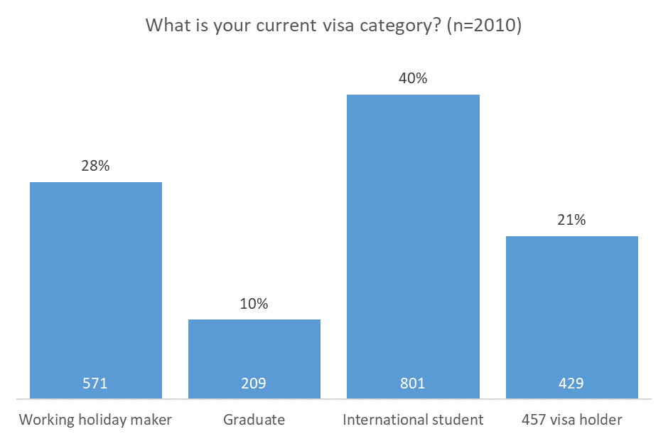
Figure 24: Native language
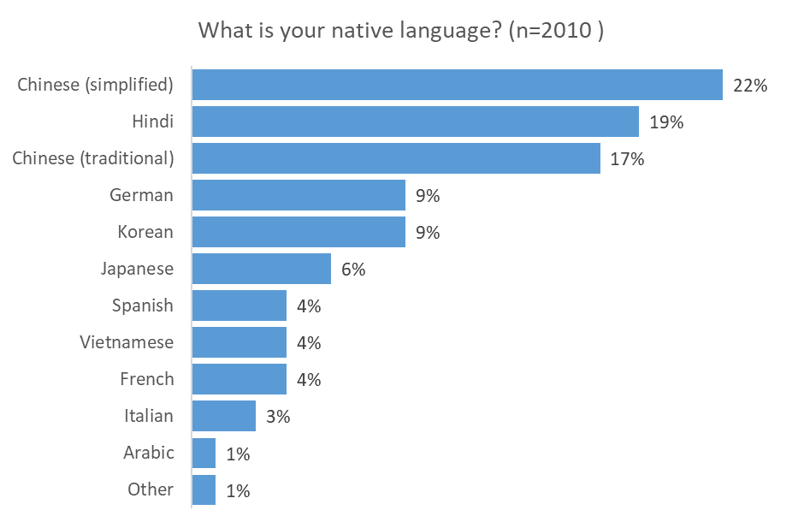
Note: subject to rounding

Figure 25: Work status
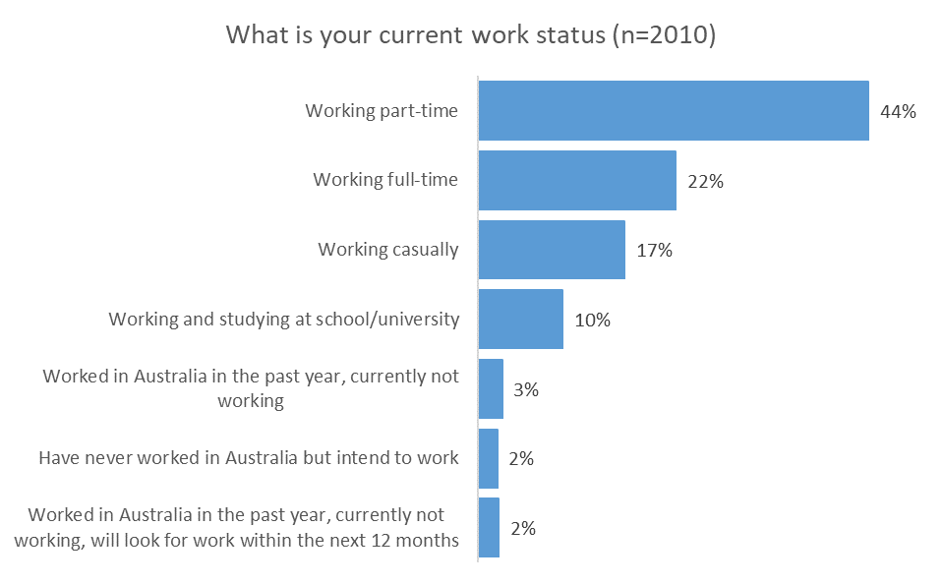

Figure 26: Age
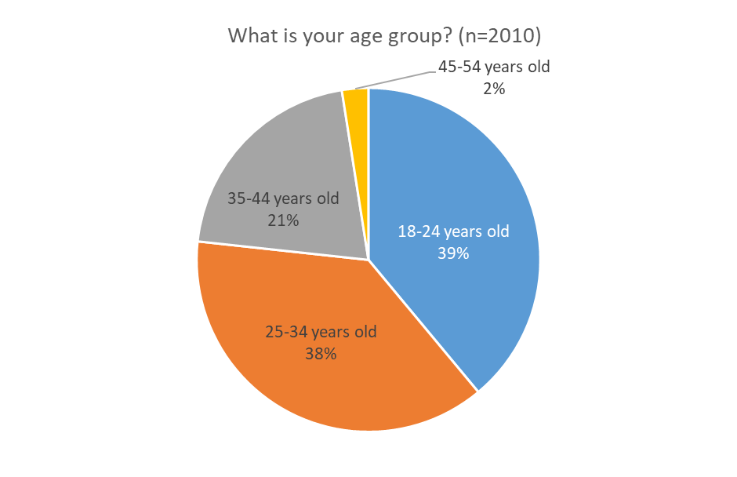
Figure 27: Visa category by age
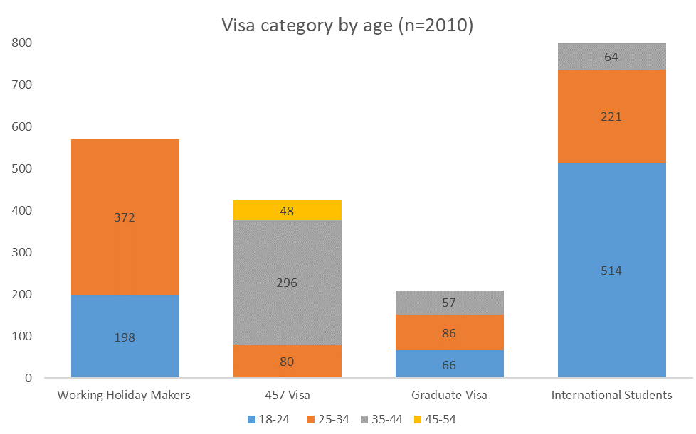
Note: age groups with five or fewer respondents are not represented in this graph

Figure 28: Gender
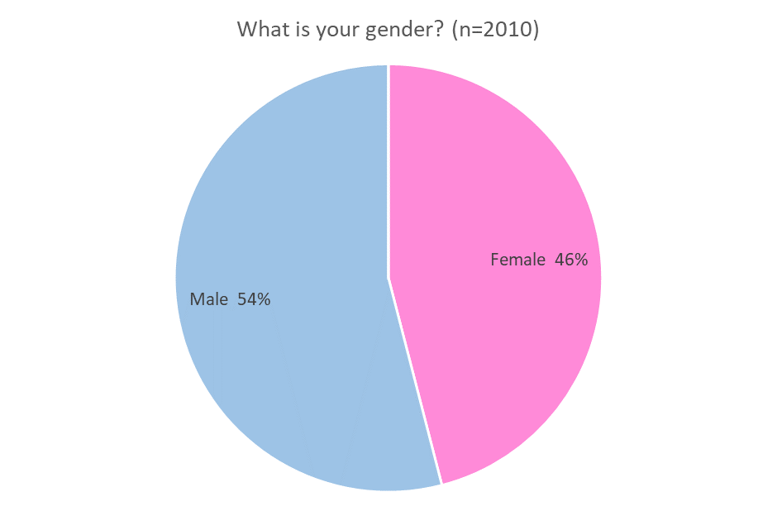
Note: gender categories of less than 20 responses are not represented in this graph
Figure 29: Citizenship jurisdiction
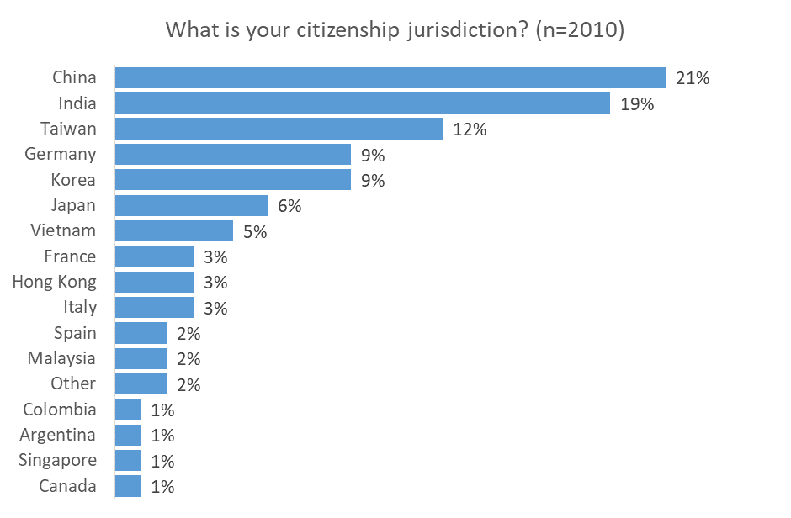

Note: responses with values of less than 10 are not represented in this graph

Figure 30: Location
Which area of Australia do you live in? | Number | %
Melbourne | 791 | 39%
Sydney | 449 | 22%
Brisbane | 329 | 16%
Perth | 140 | 7%
Adelaide | 87 | 4%
Queensland other than Brisbane | 69 | 3%
Hobart | 50 | 2%
NSW other than Sydney | 29 | 1%
Darwin | 25 | 1%
Victoria other than Melbourne | 22 | 1%
Australian Capital Territory | <20 | 0%
Western Australia other than Perth | <20 | 0%
Tasmania other than Hobart | <20 | 0%
Total | 2010 | 100%

Figure 31: Length of stay in Australia
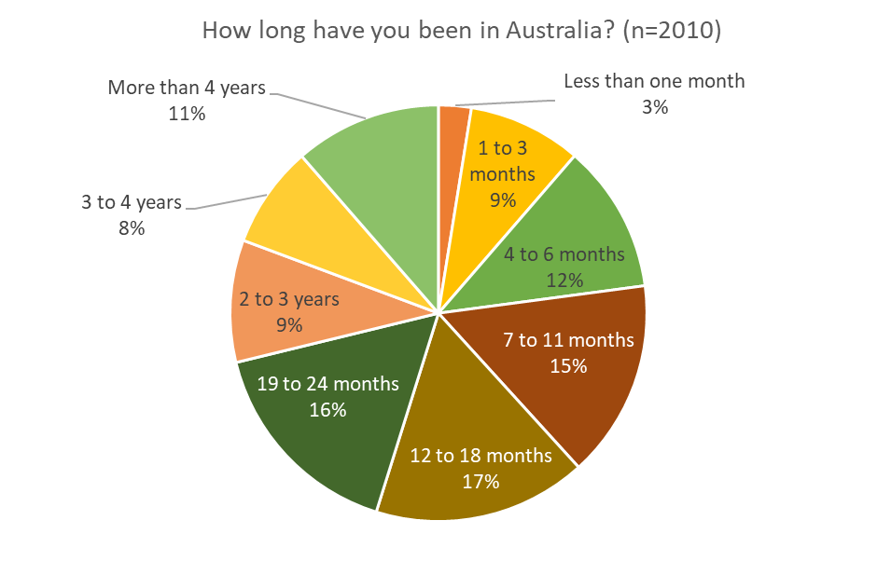
Figure 32: Length of time in current job
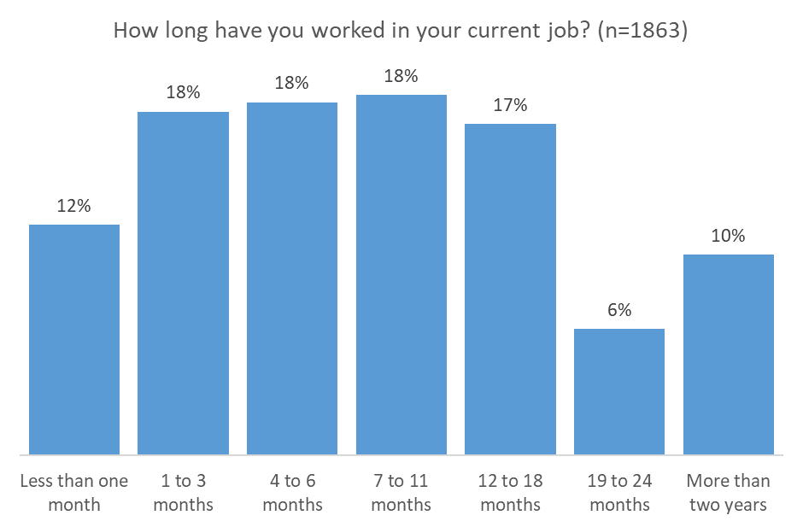
Figure 33: Time visa was granted
When was your Australian visa granted? | Number | Percentage
Before 2014 | 251 | 12%
2014 | 154 | 8%
2015 | 577 | 29%
2016 | 491 | 24%
2017 | 537 | 27%
Total | 2010 | 100%

Figure 34: Highest level of education completed
What is the highest level of education you have completed? | Number | Percentage
High school or lower | 236 | 12%
Vocational or trade school | 555 | 28%
University – bachelor's degree | 853 | 42%
Graduate school – master's degree | 331 | 16%
Graduate school – doctorate | 35 | 2%
Total | 2010 | 100%

Figure 35: Work status before coming to Australia
What was your work status before you came to Australia? | Number | Percentage
Working full time | 607 | 30%
Working part time | 460 | 23%
Working casually | 262 | 13%
Studying at school or university | 334 | 17%
Working and studying at school or university | 131 | 7%
Have never worked | 207 | 10%
Other | ,<20 | 0%
Total | 2010 | 100%
Figure 36: Electronic devices used to search for information
What type of device do you typically use to find information? (n=2010) | Responses | % per respondents
Smartphone | 1652 | 82%
Tablet | 882 | 44%
Desktop or laptop (PC or Mac) | 1402 | 70%
Total | 3936
Note: multiple responses allowed
Figure 37: Self-rated English language proficiency
How well do you rate your English-language ability? | Number | Percentage
1 - Not good at all | <20 | 1%
2 - Not good | 200 | 10%
3 - Average | 774 | 39%
4 - Good | 786 | 39%
5 - Very good | 233 | 12%
Total | 2010 | 100%
Figure 38: Industry/occupation currently working
Which job/industry do you currently work in? | Number | Percentage
Hospitality | 334 | 17%
IT (Information Technology) | 186 | 9%
Retail | 145 | 7%
Teaching, education | 129 | 6%
Cleaning | 102 | 5%
Sales | 93 | 5%
Technical work such as science or engineering | 84 | 4%
Call centre | 81 | 4%
Manufacturing | 73 | 4%
Data entry | 70 | 3%
Construction | 69 | 3%
Receptionist, other office work | 64 | 3%
Meat Industry/processing | 63 | 3%
Petrol station | 57 | 3%
Real estate | 55 | 3%
Convenience store (a small store such as EzyMart, 7-Eleven) | 50 | 2%
Communication, PR or marketing | 42 | 2%
Au pair, childcare | 41 | 2%
Farming (field crops, animals) | 39 | 2%
Health care (e.g. aged care, dental technician) | 39 | 2%
Travel/tourism industry (e.g. theme parks) | 31 | 2%
Courier/delivery/taxi service (Deliveroo, Uber) | 29 | 1%
Horticulture (fruits, vegetables, flowers) | 29 | 1%
Automotive (car wash, mechanics) | 27 | 1%
Hair and beauty | 22 | 1%
Forestry | <20 | 0%
Fishing | <20 | 0%
Have not worked in Australia | 47 | 2%
Total | 2010 | 100%*
* Subject to rounding

Appendix 2 – Example of visa grant notice and fact sheet
This is an example of the visa grant notice and fact sheet shown to respondents in the survey. The example below is for a student visa. Information on the visa grant notice is varied according to the nature of the visa (i.e. the student visa below contains an extra field for sector). The fact sheet was consistent across all visa types.

Department of Home Affairs quarterly reports as at 31 December 2016 and 30 June 2017
VEVO – Visa Entitlement Verification Online. Visa holders and registered VEVO organisations can check visa details and conditions via the VEVO website. Details include work rights, study rights, travel conditions and visa expiry date. myVEVO is a free app with the same information as the VEVO website.
The 572, 573 and 574 visa subclasses were closed to new applicants in July 2016. International students now apply for visa subclass 500 regardless of their education stream (school, vocational education and training, higher education, etc.).
In April 2017 the Australian Government announced that the Temporary Work (Skilled) visa (subclass 457) will be replaced by the Temporary Skill Shortage visa (this occurred in March 2018). Fieldwork for this research project was conducted from September to December 2017. Some changes to the occupation lists, validity period, English-language requirements and character requirements had taken effect during this period, however these changes would only have affected new entrants to this visa.
Department of Education and Training data collected in 2014 (the most recent data available).
Department of Home Affairs, Student visa and Temporary Graduate visa programme bi-annual report, as at 31 December 2016
Department of Home Affairs, Working Holiday Maker visa programme report, as at 31 December 2016
Department of Home Affairs, Subclass 457 visa holder pivot table, as at 31 December 2016
The Temporary Skilled Migration Income Threshold is the minimum salary that a sponsor employer must pay the 457 visa holder.
Interlatina is a group of organisations operating in predominately Spanish-speaking countries which assist young people to study or work abroad.
Nomit is the Italian Network of Melbourne [http://nomit.com.au/]. Nomit works with new Italian immigrants to assist with integration and community building
See ‘Wage Theft in Australia Report’ by L.Berg and B. Farbenblum, UNSW, 2017 p. 34, and ‘A Report of the Fair Work Ombudsman’s Inquiry into 7-Eleven’ Fair Work Ombudsman, 2016 p. 47

