


Fact Sheet: Overview of Australian Apprenticeship Support Loan applications in ADMS
This fact sheet introduces the components and process for Australian Apprentices completing Australian Apprenticeship Support Loan applications in ADMS. Use this fact sheet along with the other ADMS help and support resources to submit loan applications.
Visit Support for Australian Apprentices for further information about Australian Apprenticeship Support Loans.

ADMS Home Screen
To begin your application for an Australian Apprenticeship Support Loan, you will first need to log into ADMS.
After you have logged into ADMS, you will see the ADMS home page. Click the ‘Apply for Australian Apprenticeship Support Loan’ button in the Actions section to begin your application.
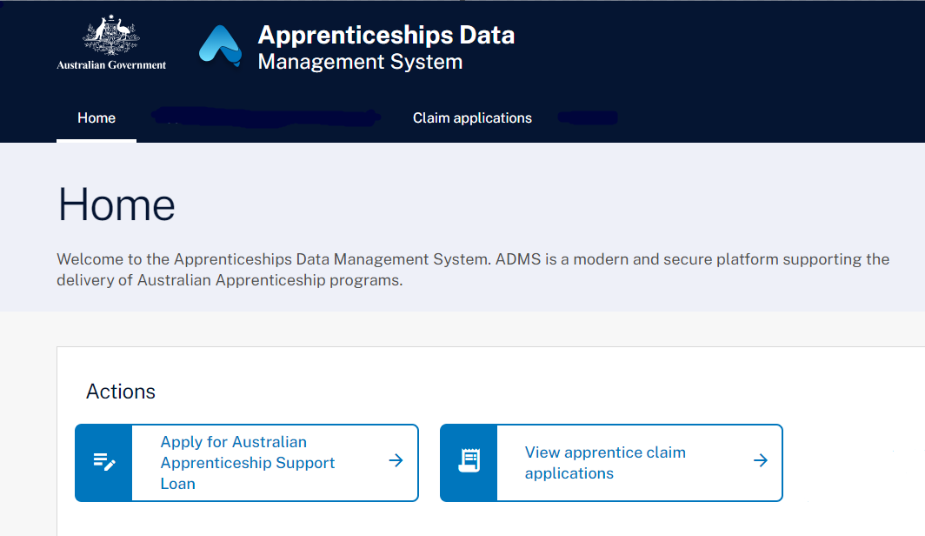

Apprentice Australian Apprenticeship Support Loan application
Clicking on the ‘Apply for Australian Apprenticeship Support Loan’ will open a page which will provide background information about Australian Apprenticeship Support Loans. Before clicking ‘Next’ at the bottom of the page, make sure you carefully read the information provided. Once you have clicked ‘Next’, your Australian Apprenticeship Support Loan application will open. When completing your application, you will need to add information and evidence to support your application before submitting.
The Australian Apprenticeship Support Loan application contains the following sections:

Apprentice details
The Apprentice details section displays your name and key contact information.
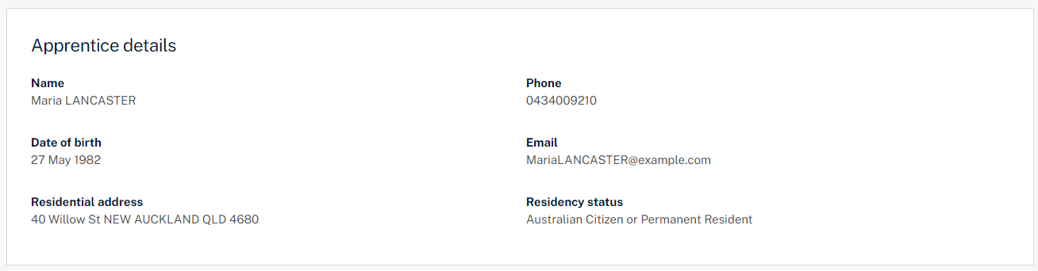

Tax file number
The tax file number section allows you to add or edit your tax file number (TFN). As repayments of your loan are made through the tax system, ADMS will attempt to verify your TFN with the Australian Tax Office. If your TFN is unable to be verified, check that you entered the correct TFN and that your details are up to date with the ATO.
You can still submit your application with an unverified TFN, but your application won’t be approved until it is verified. Your Australian Apprenticeship Support Network (AASN) provider will contact you to discuss when this is the case.
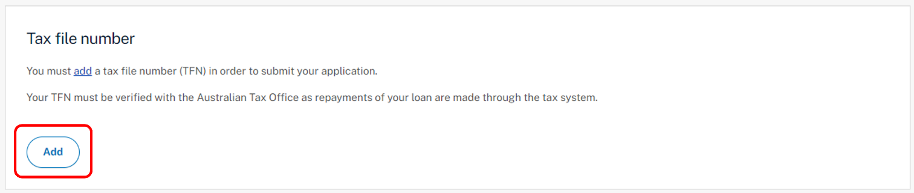

Apprenticeship details
The Apprenticeship details section displays your apprenticeship qualification and commencement details.
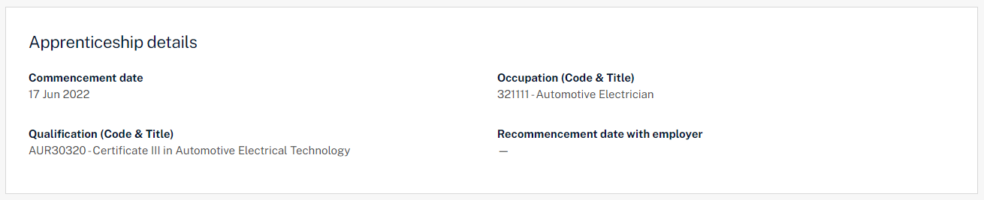

Employer details
The Employer details section displays your employer’s business details.


Bank details
The Bank details section allows you to select which bank account you would like your payment to be paid into.
Contact your Australian Apprenticeship Support Network (AASN) provider if the bank details on record are incorrect, or if you would like to add a new bank account.
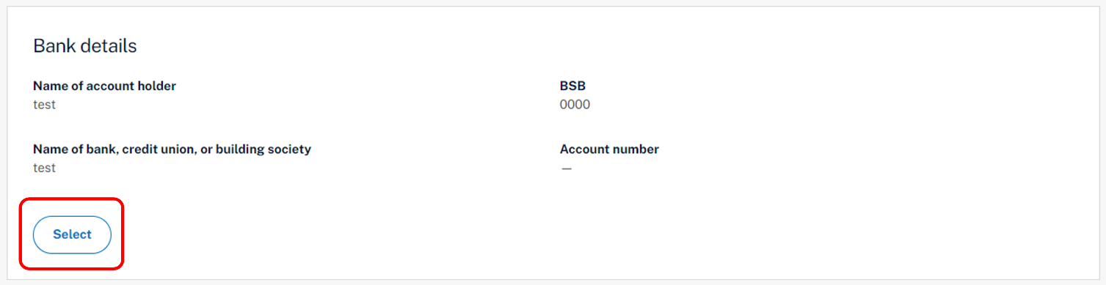

Provider details
The Provider details section displays details about your Australian Apprentice Support Network (AASN) provider.
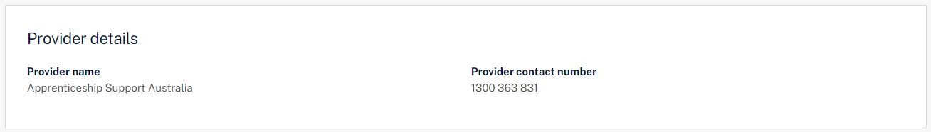

Document Evidence Required
Evidence to confirm your identity and residency status is required to support your loan application. Documents can be uploaded with the following format: ".jpeg", ".jpg", ".bmp", ".png", ".tiff", ".xls", ".xlsx", ".pdf", ".doc", ".docx", ".ppt", ".pptx".
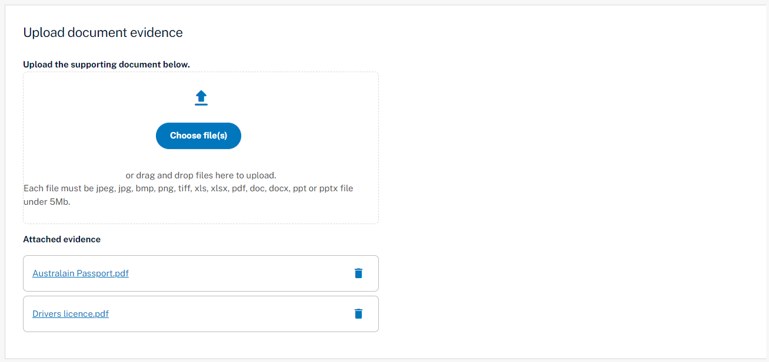

Apprentice declaration
The Apprentice declaration section is where you will need to declare that you checked all information on the application is accurate and that you understand providing false information is a serious offence.

Submitting your Australian Apprenticeship Support Loan application
Once you have completed all sections of the Australian Apprenticeship Support Loan application, you are ready to submit for processing.
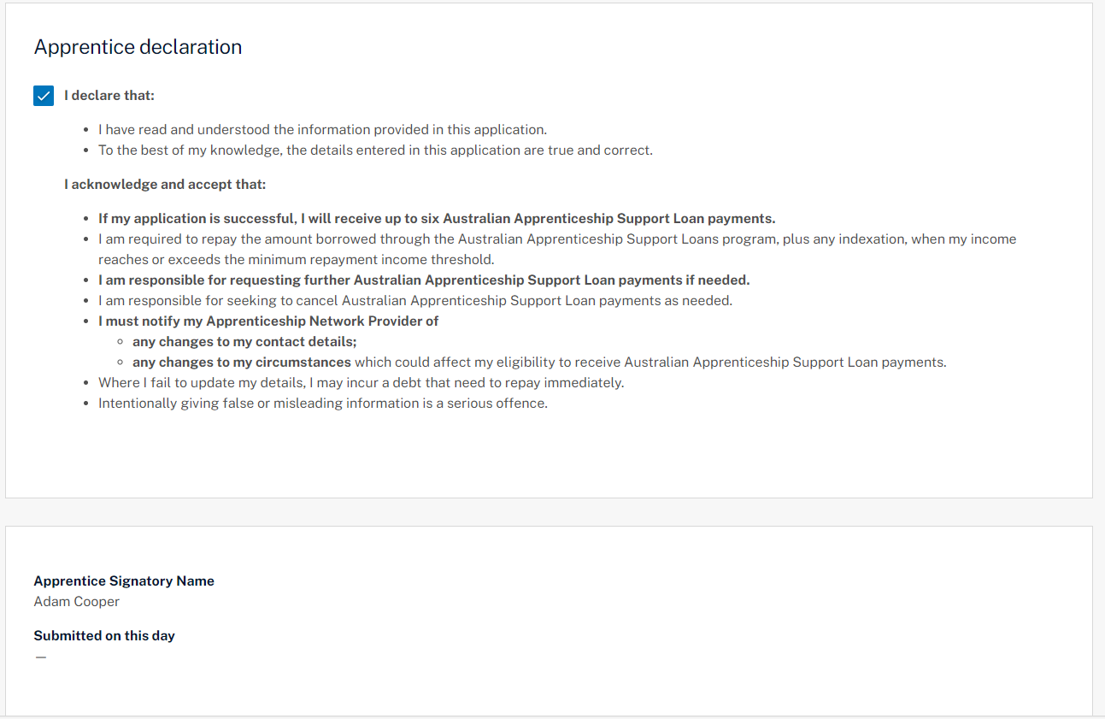

Support
For assistance with ADMS, contact your Australian Apprenticeship Support Network (AASN) provider.

