


New voluntary service for parents
  - Consultation Guide for providers
Together, we’ll design a new voluntary service that supports parents who care for young children.
The new service will be for parents who receive a Parenting Payment. It will help them to:
- plan for their future education and employment goals
- build their capabilities and skills
- work toward the type of paid work they want, when they’re ready.
Parent’s and children’s needs are the key focus of the new service. What you tell us will help build a supportive service that helps parents.

Who we’re consulting
We are consulting with:
- Parents: Parents on Parenting Payment with young children who may benefit from the new voluntary service. This includes parents who used the ParentsNext program, and potential users of the new voluntary service.
- Service providers: Organisations and businesses that provide services to parents and young children. This includes existing providers of government services, including self-employment services, and those that may be involved in future delivery.
- Businesses: This includes businesses and industry peak bodies who may want to hire more parents or become a more parent-friendly and flexible workplace.
- Community organisations: Not-for-profit organisations and advocacy groups that represent and support the interests of (or provide services to) parents, young children and diverse communities.
- Experts: Individuals and organisations with expertise in, and in-depth insights about, a range of topics relevant to the design of a new service. This includes experts like academics, researchers and other professionals.

Consultation timing
We’re talking to providers between July 2023 and September 2023. We’ll consult in 4 phases:
- Pre-design: We have sought people’s input to what our consultation should look like, and how our stakeholders prefer to participate (May to June).
- Design: Consult and collaborate to understand parents’ needs and goals, and the kind of supports we could provide (July to August).
- Check-in: Check-in with people about what we’ve learned, present our thoughts on what design could look like and get their feedback and advice (August).
- Design options: We’ll come back to people to talk about options, and seek their feedback and advice to inform our decisions (August to September).
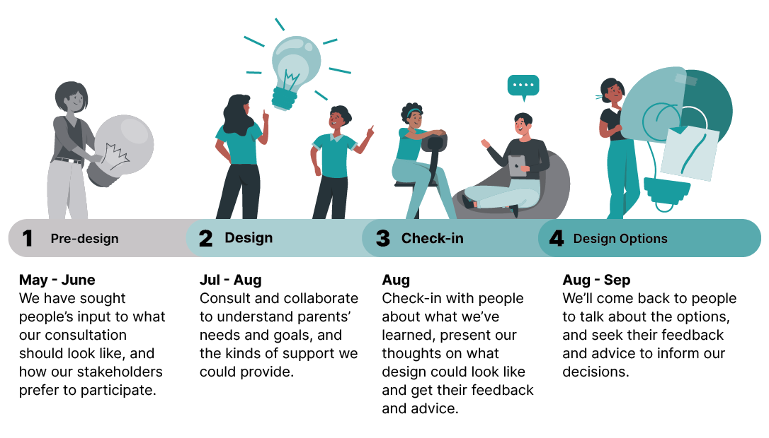

What we want to hear from you about
Our discussions with you will focus on the new voluntary pre-employment service to support parents. We’ve identified discussion topics on page 4.
Broadly, we’ll ask you about your:
- Ideas: The features of a new voluntary pre-employment service for parents to help them achieve their education and employment goals.
- Opinions: What you think of the service options we propose, based on what people have told us so far, and what would attract parents to use the new voluntary service.
We welcome conversations around the difficulties and complex circumstances some parents may face.

About pre-employment services
Pre-employment services help people prepare to join the workforce.
A pre-employment service may provide vocational support. For example, helping people with career advice or to build their skills through education and training to get a qualification.
It may also help people with other support they need before they can focus on their vocational goals. For example, this might include help to:
- access child care
- build confidence
- combat social isolation
- manage finances
- find more secure housing
- manage family relationships
- access health professionals
- improve health and wellbeing.
The result is the person is better placed to join the paid workforce. For full-time parents, this means when they’re ready, at a time that suits their family responsibilities.

Principles of the new service
The principles and objectives to guide the consultation for the new service include:
- targeted services which respond to individual needs, build confidence, combat isolation, and support aspirations
- valuing unpaid care (caring for and raising children) as legitimate, important work
- a focus on participants’ strengths, on addressing barriers to social and economic participation, and on achieving long term financial security
- a focus on job quality and security, as well as intersections between employment and social security, where a participant has employment as a goal.

Topics for discussion
We’ll discuss a range of topics through our conversations.
- Parents’ needs: What support parents get now, and what challenges they have that we can help with.
- Eligibility: Who can access the voluntary service, and which groups to prioritise.
- Timing: When parents can access the service, and for how long.
- Features: What features, information and support options to prioritise to best meet parents’ needs.
- Delivery: How the voluntary service should run, and its service deliverers should operate.
- Engagement strategies: What engagement strategies and incentives would encourage participation.
- Funding: How to structure and prioritise the funding for the service.
On pages 4-8 see example questions under each topic.

Example questions for discussion
Meeting parents’ needs
- How can the new service ensure that caring for children remains a priority for parents?
- How can the new service best meet the needs of parents and their children?

Eligibility
- Who would benefit most from a voluntary pre-employment service? Tell us why.
- What type of support should the new service target? How should it be targeted?
- Apart from parents who receive Parenting Payment, who might benefit from this service?
- Do you think other parents on other income support payments should also benefit?
- What support services should we consider for young parents who left school before completing high school? Do they need a more specialised service? If so, what do they need, and how should it be delivered?

Timing
- When do you think the opportunity to participate in voluntary pre-employment support should be offered to parents?
- In your experience, what is the ideal age of the youngest child to offer voluntary pre-employment support?
- Should parents be able to decide themselves when they want to participate in the service, regardless of the age of their child?
- How could we tailor the new service to the differing needs and levels of support for parents? What types of needs might require assistance for a longer duration and for how long? For example, parents who need more support may need assistance for a longer duration.
- How long should support be available to parents for? Why do you think that time period? Should support be available for as long as parents want to receive it, or should it be available for a year, or a few years? Consider the time needed to build good relationships with a service provider, and for parents to receive a range of support if they would like to and if they need it.

Features of the service
What we’ve heard so far
- We have heard from parents that they would like a service that:
  - has better and more useful content and communications that describes the features of the service
  - values and respects parenting as important, as paid employment
  - offers features and benefits parents want and need.
Do you agree with that the above statements? What else would you include in the new voluntary pre-employment service to assist parents to reach their education and employment goals?
- Stakeholders have suggested a new service should be respectful to parents and their children and recognise and value their role in caring for children.
  - What types of arrangements would make parents feel respected and valued in a new service?
Pre-employment support
- What support should be offered to parents as part of the new voluntary pre-employment service? For example, pre-employment support might include help with vocational needs such as career guidance, skills development, or study towards a qualification. It may also include help with any support parents, or their children may need to participate in the service. This may include non-vocational support such as help with confidence building, or with financial management, or accessing medical/mental health services or child care services, or with child wellbeing.
- Of the following types of support what could be included in the new service?
  - Accessing affordable and quality childcare
  - Finding secure housing
  - Managing your money, including budgeting
  - Relationship support , including for those experiencing family and domestic violence
  - Parenting support, including support for kids’ physical and mental health
  - Finding work, including developing resumes, help applying for jobs, or coaching for interviews
  - Organising work experience
  - Undertaking training and education
  - Accessing healthcare support.
Work Related Support (i.e. vocational support)
- Should this service support parents of young children who want to work to prepare for and find work? If so:
- What types of support should be available?
- What arrangements should be in place for providers to engage with businesses?
- Should the service include support for parents for the initial period of their employment, if so, what type of support?
- How do we ensure that work support is provided only to parents who want to look for work?
- How do we ensure that parents are supported into secure work?
- Would access to work experience opportunities be beneficial, and if so, how could this be delivered bearing in mind parents’ caring responsibilities for young children?
Communication strategy
- How should the new service be communicated and promoted?

Service delivery
- Should there be different services for parents from different communities or regions?
- Which vulnerable groups might need more or different help? What would that look like?
- How might this support be strengths-based and participant led? How can this be embedded in practice?
- What skills and qualifications should frontline staff have? Which of these might be mandatory requirements?
- Based on your experience, what delivery mechanism would be most effective? Face-to-face, online or a mix of the two.
- How might communities of practice be embedded as a feature of the new service? Do you think this would be valuable?
- How would referrals to local services enhance the new service? Would priority access be required and if so what types and why?
- If a dedicated point of contact for providers was established in Services Australia, what type of support would be required?
- How do we ensure a trauma informed approach to service delivery, and that services are culturally appropriate?

Engagement strategies
What we’ve heard so far
- Parents have told us that finding the time and energy to participate in services can be a challenge for parents caring for young children.
Engagement strategies
- How might we encourage parents to participate in the new voluntary pre-employment service? What strategies or assistance would make it easier for parents to participate in a voluntary service?
- What sort of incentive would encourage parents to participate in the new service? Do you think this would be necessary?
- What value of incentive would encourage parents to participate?
- When would be most benefit for parents to receive an incentive? For example, would this be after starting in the new service? Or after achieving certain milestones or outcomes? Or both?
- What other engagement strategies would be effective or required to encourage disadvantaged parents to participate in a voluntary service? For example:
- good promotion of the service so that parents understand the support available,
- service providers who can meet parents in the community at convenient locations or even undertake home visits
- initial face-to-face contact to start building rapport,
- assistance with transport costs for parents to attend appointments
- access to the same caseworker so parents can build good and ongoing relationships
- having discussions with the service provider by phone or face time etc.
Financial support
- Should a new service provide some financial assistance to enable parents to participate in the service or to achieve their education and employment goals? For example, to help with costs such as training, or for IT or phone access, or transport, or child care, or work-related expenses, or medical expenses.

Funding structure
- What should be the funding model for providers? For example, fee for service, up-front payments, graduated payments, or outcome payments or a combination of these?
- In your experience, what incentives drive providers to achieve the best outcomes? What are your thoughts on outcome payments to providers? If so, what types of outcomes, what value should they be, and how can they be measured? How do we ensure that outcome payments reward providers but do not create perverse incentives to push parents into particular activities for the purpose of securing a payment?
- What should be the provider funding arrangements to undertake engagement strategies? For example, should engagement strategies be funded separately such as financial incentives for participants, provider outreach, and promotional activities to ensure parents know the service is available and the support it can provide.
- How might the Participation Fund be a feature of the new service?
- Should credits be pooled? Or should every participant have access to funds? Or
- Should funding for participant interventions be rolled into provider fees, for providers to purchase based on participant need.
- What types of interventions should be funded for participants? For example, goods and services participants need to achieve goals or undertake activities.

Contact for more information
Contact the Department of Employment and Workplace Relations.
Email - ParentsConsultation@dewr.gov.au

