VET Student Loans (VSL)

Provider Newsletter – January 2024

A word from Nisette 2

Nisette’s fun fact 2

Legislation news 3

Changes to National Vocational Education and Training Regulator Act 2011 3

Update to VET Student Loans (VSL) Courses and Loan Caps Determination 2016 3

Provider notifications 3

Annual reporting requirements 3

Providers lapsing in 2024, seeking further VSL approval 3

Reminder for providers 4

New year, new staff – time to update contacts in HITS 4

TPS news 4

Consultation on the 2024 VSL levy settings 4

Compliance news 5

VSL student surveys 5

Assistance for students 5

Students can now claim the Tertiary Access Payment for this year 5

Stakeholder engagement news 6

Refresh of the VSL Provider Reference Group 6

Correction to VSL Provider Newsletter – December 2023 6

Subscribing to the VSL Provider Newsletter 6

# A word from Nisette

Welcome back to VSL for 2024.

So far, 32 providers have been re-approved to offer VET Student Loans (VSL) and 2 are currently pending approval. Thank you for continuing to support students to access vocational education and training with providers of high quality and integrity.

This year, we will continue to look at ways to streamline the VSL program. We are also continuing to improve our existing systems. Work on the new VSLConnect platform is progressing as is the review of provider and student communication material.

The [VSL Six-monthly Report July to December 2023](https://www.dewr.gov.au/vet-student-loans/resources/vsl-sixmonthly-report-july-december-2023) has been published on VET Student Loans Statistics. The VSL Data Collection provides data about student demographics, course enrolments, course completions, VET Student Loans and tuition fees. It also lets us know where the VSL program is providing the most benefit.

## Nisette’s fun fact

The top 5 VSL courses for the period from 2017 to 2023 were Diploma of Nursing, Diploma of Beauty Therapy, Diploma of Screen and Media, Diploma of Community Services and Diploma of Early Childhood Education and Care.

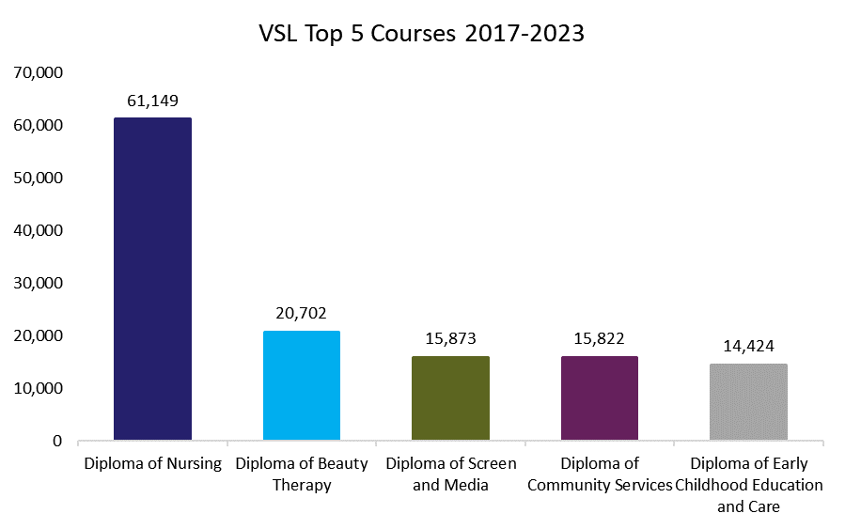

Note: Numbers for 2023 are as of 31 December 2023

To date the VSL program has helped 61,149 students train for career in nursing. That equates to $240.9 million in loan amounts for the Diploma of Nursing course. During the life of the VSL program, the Commonwealth has paid around $1.72 billion in VET Student Loans to approved providers enabling around 188,920 eligible students to study.

Nisette Anderson

# Legislation news

## Changes to National Vocational Education and Training Regulator Act 2011

The National Vocational Education and Training Regulator (NVETR) Amendment (Strengthening Quality and Integrity in Vocational Education and Training No. 1) Bill 2024 was introduced into the House of Representatives on 7 February 2024.

The purpose of the Bill is to make changes to the NVETR Act 2011 to support the integrity and quality of Australia's VET sector. It does this by strengthening and clarifying the powers of the Australian Skills Quality Authority (ASQA) to take swift action to deter and remove non-genuine or unscrupulous RTOs. ASQA will also be able to apply greater scrutiny to new RTOs seeking to enter the VET sector.

You can view the proposed changes to the Act at [National Vocational Education and Training Regulator Amendment (Strengthening Quality and Integrity in Vocational Education and Training No. 1) Bill 2024 – Parliament of Australia (aph.gov.au)](https://www.aph.gov.au/Parliamentary_Business/Bills_Legislation/Bills_Search_Results/Result?bId=r7138).

## Update to VET Student Loans (VSL) Courses and Loan Caps Determination 2016

The 2024 update for the VSL (Courses and Loan Caps) Determination has been registered. Several new courses, increased loan caps and replacement courses for non-current VSL approved courses were added to the [VET Student Loans (Courses and Loan Caps) Determination 2016](https://www.legislation.gov.au/F2016L02016/latest/text). These changes came into effect on 1 January 2024.

You can find further information at [VSL 2024 Course List and Loan Caps](https://www.dewr.gov.au/vet-student-loans/resources/vet-student-loans-2024-course-list-and-loan-caps). The fact sheet advises what you need to do to offer these courses using a VET Student Loan, and how to apply new loan cap bands.

# Provider notifications

## Annual reporting requirements

In October 2023, amendments were made to the VET Student Loans Rules 2016. These changes saw the removal of ‘annual forecasts’ and the commencement of ‘annual reporting’. The changes followed consultation with VSL providers and vocational education and training sector representative organisations in 2022.

The department will be undertaking further consultation regarding the manner and timing of the new annual reporting requirements. We will engage with members of the VSL Provider Reference Group, and you will be given the opportunity to complete a survey.

We will use your responses to inform our decisions regarding the annual reporting requirements.

## Providers lapsing in 2024, seeking further VSL approval

We will shortly be sending application forms, and relevant supporting documents, to providers whose approval lapses on 30 June 2024 and 31 December 2024.

The [VSL provider eligibility (refresher) quiz](https://www.dewr.gov.au/vet-student-loans/vet-information-providers/vet-student-loans-provider-eligibility-refresher) is a useful tool to refresh your knowledge of VSL program requirements. It will help you understand the information required when completing an application. We encourage you to take the quiz and submit a Notice to Apply for a further period before completing the application form.

Your Key Personnel, as well as your CEO and Primary VET Contact, in HITS should be up to date and reflect your current arrangements. Please ensure your key personnel are familiar with the *VET Student Loans Act 2016* and the VET Student Loans Rules 2016.

The form will also assess suitability requirements based on VSL data reported to the department. Your data must be accurate, current and up to date. You must also provide evidence of current Workers Compensation and Public Liability insurance.

Please complete your applications within 5 weeks of receiving the form. This will provide sufficient time for us to assess your application. You, and your students, will also have time to organise your circumstances for next year, well before the deadline. Any delay with the submission of a complete and valid application may impact the expected outcome date for the application. This includes payment of the application fee.

# Reminder for providers

## New year, new staff – time to update contacts in HITS

A reminder to update HITS with current contact information. Changes to your Contact List are required when a person leaves your organisation or new staff commence.

Page 53 of the [HITS User Guide](https://www.dewr.gov.au/vet-student-loans/resources/hits-user-guide) provides the steps required to update your Contact List. Key Personnel List changes commence from page 100 of the User Guide.

Please email [VSLProgramIntegrity@dewr.gov.au](mailto:VSLProgramIntegrity@dewr.gov.au) when you have completed the following in HITS:

updated the Contact List and Key Personnel List

uploaded documents notifying of changes to your organisation, including notifications to the relevant regulator.

You should also check email addresses in the Key Personnel List and Contact List routinely, including the spelling of names.

# TPS news

## Consultation on the 2024 VSL levy settings

The [TPS Advisory Board](https://www.education.gov.au/tps/tuition-protection-service-advisory-board) provides advice and makes recommendations to the TPS Director on the annual VSL levy settings. At its meeting on 8 March 2024, the Board will provide its draft advice on the 2024 VSL levy settings to the TPS Director.

From late March to May, the TPS Director will consult VSL providers and other key stakeholders on the draft levy settings proposed by the Board. There will be online and in-person sessions in most capital cities during the consultation period. We will notify you via email about how to take part in the consultation sessions ahead of the 2024 VSL levy settings being finalised and legislated.

Your feedback will be presented to the Board for consideration ahead of its 12 June 2024 meeting. At this meeting, the Board will provide its final advice on the 2024 VSL levy settings to the TPS Director.

You may direct any enquiries to the TPS via [operations@tps.gov.au](mailto:operations@tps.gov.au). We hope to see you at one of the consultation sessions from March through to May.

You can find further information about the VSL levy and how it is calculated at:

* [Tuition Protection Service - Department of Education](https://www.education.gov.au/tps)
* [*VET Student Loans (VSL Tuition Protection Levy) Act 2020*](https://www.legislation.gov.au/Series/C2020A00005).

# Compliance news

## VSL student surveys

The department surveys VSL students as a part of our risk identification and assessment approach. The surveys identify potential non-compliance risk indicators. These indicators are at the program, provider type and provider level. Responses in previous Random Sample Check (RSC) surveys indicated a high number of medium and high-risk flags relating to providers delivering aviation courses. As an identified key risk area, warranting further investigation, the latest Targeted Student Check (TSC) survey focussed on students enrolled in aviation courses.

In November 2023, 464 students participated in this survey. Overall, it was a positive response. However, the results identified areas where some providers will be required to take action. Of the students surveyed, 14% reported being offered an item of value to enrol; 14% did not know they had to complete a progression form. Some students identified some dissatisfaction with the quality of their training. These included:

the structure of the course delivery

charging of fees

out of date course content

learning materials not readily available

continued change of trainers and

limited help and support.

The department will be following up on issues highlighted by the survey responses. We will conduct this through further data analysis, desktop or site audits.

# Assistance for students

## Students can now claim the Tertiary Access Payment for this year

The Tertiary Access Payment helps eligible students with the costs of moving for study.

Students who move from inner regional areas get a one-off lump sum of $3,000. Students who move from outer regional and remote areas get up to $5,000 in two instalments.

To get the payment, students need to meet certain rules. These include:

starting their course within the year immediately after completing year 12 or equivalent

moving to study at a tertiary education provider that’s at least 90 minutes away from their family home by public transport

studying a full-time course that is Certificate IV or higher

studying a course with a minimum length of at least one academic year

Their parents or guardians combined income for the relevant tax year must also be less than $250,000.

Students can get the Tertiary Access Payment at the same time as other student payments, like Youth Allowance, ABSTUDY or the Relocation Scholarship.

They can only claim between 1 January and 31 December in their first year of tertiary study.

### What you can do

Direct students to the Services Australia website to read more about eligibility requirements for the [Tertiary Access Payment](https://www.servicesaustralia.gov.au/tertiary-access-payment).

Encourage eligible students to claim this payment now using their myGov account linked to Centrelink.

If requested, provide your students with a dated document confirming their study load and course enrolment. Services Australia will require this 6 weeks after their course starts, to pay eligible students the Tertiary Access Payment.

# Stakeholder engagement news

## Refresh of the VSL Provider Reference Group

The VSL Provider Reference Group (PRG) was formed in 2020 and refreshed in 2021. As some members have left, or are leaving the PRG, we are undertaking a refresh.

The VSL PRG provides the mechanism for us to consult, engage and communicate with VSL provider representatives. These consultations enable the program to test ideas and solutions and to ensure we consider provider’s views.

PRG Members must be prepared spend the requisite amount of time reading papers, providing feedback and attending meetings. The PRG usually meets quarterly via Microsoft Teams for an hour. There may be some additional consultations via email.

Please email your expression of interest to [VSLProviderReferenceGroup@dewr.gov.au](mailto:VSLProviderReferenceGroup@dewr.gov.au) by **1 March 2024.** We will forward you a nomination form, a Deed of Confidentiality and Conflict of Interest Form. Current members of the PRG are welcome to nominate.

# Correction to VSL Provider Newsletter – December 2023

Re-crediting a VET Student Loan

In the VSL Provider Newsletter - December 2023 we advised that to recredit a student’s loan you should report it in TCSI by updating the following value in the unit enrolment record:

E446 Remission reason code: If the student was not a genuine student this code should be ‘16’.

This should have read:

E446 Remission reason code: If the student was not a genuine student this code should be ‘01’.

# Subscribing to the VSL Provider Newsletter

The VSL Provider Newsletter is how we let you know about program updates and reminders about the program administrative requirements. Let your colleagues know they can subscribe to the newsletter at [VET Student Loans – subscribe](https://msg.dese.gov.au/subscribe-vsl). You can access previous copies of the newsletter at [VET Student Loans](https://www.dewr.gov.au/vet-student-loans) - *latest* *news*.