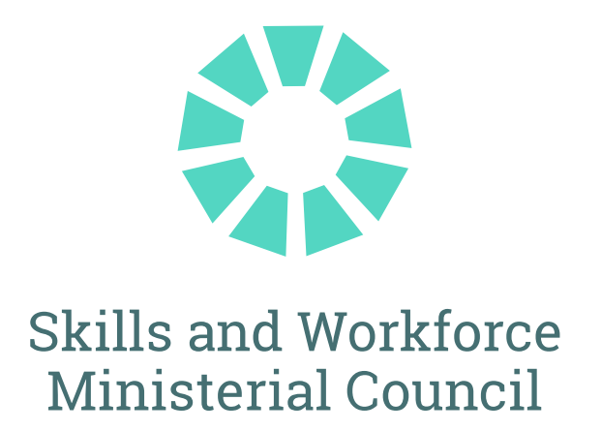

The Hon Andrew Giles MP
Minister for Skills and Training
The Hon Steve Whan MP
New South Wales
Minister for Skills, TAFE and Tertiary Education

The Hon Jo Hersey MLA
Northern Territory
Minister for Education and Training
The Hon Lance McCallum MP
Queensland
Minister for Training and Skills Development
The Hon Blair Boyer MP
South Australia
Minister for Education, Training and Skills

The Hon Felix Ellis MP
Tasmania
Minister for Skills and Training

The Hon Gayle Tierney MLC
Victoria
Minister for Skills and TAFE

The Hon Simone McGurk MLA
Western Australia
Minister for Training and Workforce Development

JOINT COMMUNIQUÉ
20 September 2024

COMMUNIQUE

MEETING OF SKILLS AND WORKFORCE MINISTERIAL COUNCIL
Federal, state and territory Skills and Training Ministers met in Melbourne today to launch a key part of the National Skills Agreement, the inaugural National Skills Plan. Ministers also discussed how to support workers and communities impacted by the net zero transition, opportunities for new and emerging higher-level apprenticeship models, revised Standards for Registered Training Organisations and approaches to accelerate action to meet Closing the Gap commitments.

National Skills Plan

The National Skills Plan (the Plan) will guide the work of all governments to deliver a shared vison for strengthening the national vocational education and training (VET) system. It will focus on national training priorities and outcomes by providing a vision for unions, employers and the VET sector.

The Plan reflects a new shared stewardship approach to the national VET system focused on collaboration as a guiding principle under the five-year National Skills Agreement. It recognises that TAFEs are valued and trusted public institutions at the heart of our VET sector. The shift towards a shared system of collaboration and stewardship will strengthen and expand the VET system across the country as well as maximise the impact of increased investment in skills and training delivered by the National Skills Agreement. The National Skills Plan is available here.

Net Zero Transformation

Skills Ministers received an update from the acting Chair of the Net Zero Economy Agency, Dr Iain Ross AO, on Commonwealth activities to support workers and communities impacted by the net zero transition. Managing the transition will require careful planning, coordination and stewardship across all levels of government. Skills Ministers discussed how the Commonwealth, states and territories will work together to support the workforce transition. This includes identifying opportunities and supports for workers, their families and communities in regions experiencing net zero transformation, such as employment, qualification recognition and training, and through initiatives including the National Energy Workforce Strategy.

Closing the Gap

Ms Pat Turner, Lead Convenor of the Coalition of Peaks, addressed the Council. Ms Turner reiterated the importance of working in partnership across all domains of the National Skills Agreement to address issues and priorities for Aboriginal and Torres Strait Islander people in skills and training. Ms Turner discussed with Skills Ministers the need for urgent funding to sustain and grow the Aboriginal Community Controlled and First Nations Owned training sector.

States and territories acknowledged a Commonwealth proposal to accelerate the release of funds through the Closing the Gap policy initiative. Skills Ministers noted the establishment of the Interim Partnership Committee to progress the development of the nationally networked VET policy partnership. Skills Ministers also committed to scoping a sector strengthening plan to ensure long-term and enduring measures to support this sector within the VET system.

Implementation of NSA Policy Initiatives
Skills Ministers are pursuing key policy reforms to give effect to the objectives of the National Skills Agreement. These include Closing the Gap, ensuring access to foundation skills training, improved completions, especially for priority groups, establishing TAFE Centres of Excellence, and measures to strengthen the VET workforce.
In the first 9 months of the National Skills Agreement, the Commonwealth, states and territories have collectively announced the establishment of 6 TAFE Centres of Excellence. Each of these focuses on an area of national priority, including supporting the Net Zero transformation, sustaining essential care services and developing Australia’s sovereign capability:
- The CIT Electric Vehicle Centre of Excellence in the ACT will support growth in the electric vehicle industry across Australia.
- The Clean Energy Skills National Centre of Excellence in WA will grow Australia’s clean energy skills and workforce capacity.
- The TAFE Queensland Health Care and Support Centre of Excellence in Queensland will strengthen capability and capacity for the aged care, disability support and mental health care sector.
- The TAFE SA Centre of Excellence in Early Childhood Education and Care in SA will train early childcare workers.
- The Western Sydney Advanced Manufacturing Centre of Excellence in NSW will equip workers with skills needed to support the Nation’s manufacturing sovereign capability and food security.
- The TAFE Queensland Centre of Excellence - Clean Energy (Batteries) will drive growth in the clean energy sector by improving and innovating the workforce required for clean energy battery technologies across Australia, source storage and grid connectivity.
New South Wales and the Commonwealth have agreed measures to strengthen access to foundation skills training; which will improve access to Adult and Community Education foundations skills training across NSW.
Skills Ministers agreed the focus for the remainder of 2024-25 is to continue to prioritise delivery of actions in support of the policy initiatives including establishing appropriate National TAFE Network arrangements.

Higher Apprenticeships
Skills Ministers discussed opportunities as well as the absence of a common definition for new and emerging higher-level apprenticeship models in both VET and higher education. Skills Ministers agreed to establish a working group to consider issues relating to regulation, funding and industrial relations settings and to work together with employer and employee representatives and other key stakeholders to progress solutions and shared terminology. The working group will provide a final report to the Council by July 2025.

Quality and Integrity measures

Skills Ministers discussed steps to implement the revised Standards for Registered Training Organisations (RTOs), which will be publicly released in the week of 23 September 2024. Skills Ministers agreed the wording of a preamble to the revised Standards for RTOs, recognising TAFE’s unique position in the VET system.

Skills Ministers also discussed the pathway to a more sophisticated approach to differentiated regulatory supervision in the VET sector by the Australian Skills Quality Authority (ASQA), with phased implementation to commence in line with the application of the revised Standards from July 2025. Taking a phased approach recognises that, in identifying an appropriate and effective approach for differentiated regulatory supervision, it will be critical to take into account the diverse nature of the VET sector, including the maturity of RTOs that operate within the sector, and the existing regulatory environment. Advice on approaches to differentiated regulatory supervision will be provided to Skills Ministers in early 2025.

National Centre for Vocational Education and Research (NCVER) Strategic Plan
Skills Ministers endorsed a Statement of Members’ Expectations to the NCVER Board of Directors and Managing Director. The Statement emphasises the key role of the NCVER in the VET system and as the National VET Data Custodian. The Statement reflects the expectations of Members that NCVER be an agile organisation that acts independently of any one government in delivering a modern and world class statistical, analytical and research service to support governments to improve the quality of the VET sector.
Skills Ministers will meet again in December to progress national priorities, including how to deliver the skills and training needs to secure Australia’s housing supply.

MEDIA CONTACTS:
Minister Giles (Commonwealth):
Toby Halligan
0455 452 765
Tobias.halligan@dewr.gov.au

Minister Whan (NSW):
Fee Chemke-Dreyfus
0430 337 607
fee.chemke-dreyfus@minister.nsw.gov.au

Minister Hersey (NT):
TBC

Minister McCallum (Qld):
Nicola Field
0497 940 285
Nicola.Field@ministerial.qld.gov.au

Minister Boyer (SA):
Nadine De Bono
0487 878 077
Nadine.DeBono@sa.gov.au

Minister Ellis (Tas):
James Whiteley
0467 869 963
james.whiteley@dpac.tas.gov.au

Minister Tierney (Vic):
Penny Davies
0409 385 358
Penny.davies@minstaff.vic.gov.au

Minister McGurk (WA):
Tegan Sapwell
0448 502 065
Tegan.Sapwell@dpc.wa.gov.au

