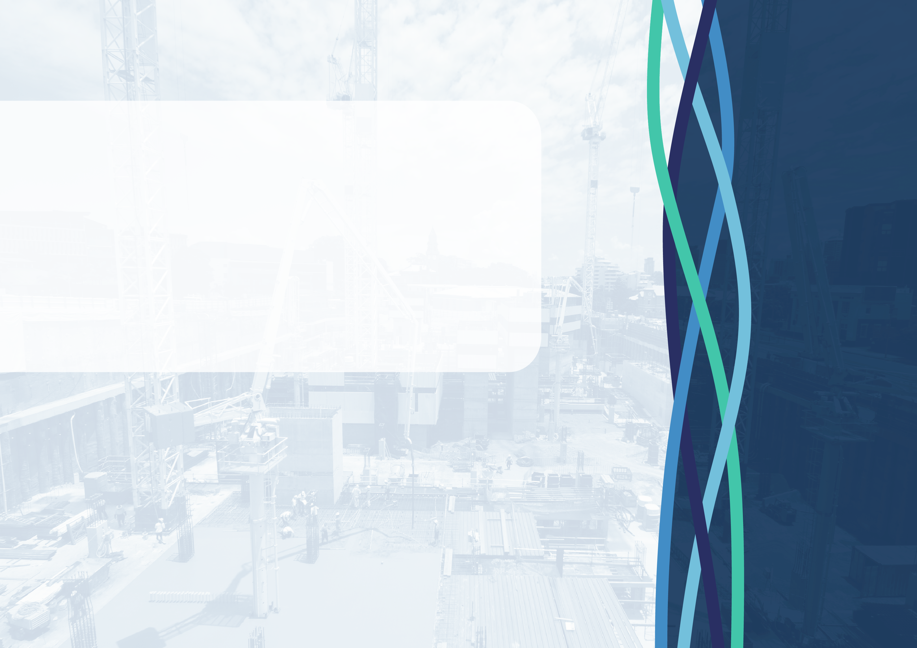
Blueprint
for the Future
A building and construction industry that works for everyone
  - National Construction Industry Forum 2025


The material in this document is licensed under a Creative Commons Attribution 4.0 International license.
More information on this CC BY license is set out at the creative commons website: www.creativecommons.org.
Enquiries about this license and any use of this document can be sent to: copyright@dewr.gov.au.
Use of all or part of this document must include the following attribution:
© Commonwealth of Australia 2025


Acknowledgement
of Country
The National Construction Industry Forum acknowledges the traditional owners and custodians of country throughout Australia and their continuing connection to land, waters and community. We pay our respects to them and their cultures, and Elders past, present and emerging.

Table of
Contents
NCIF foreword 2
How did we get here? 4
Industry snapshot 5
Challenges by theme 8
Priority challenges 9
System architecture 10
Key initiatives 11
Opportunities – forward workplan 12
National Construction Industry Forum 17

NCIF foreword
In October 2024, the National Construction Industry Forum (NCIF) recognised an unprecedented opportunity to collaboratively address the key challenges facing the construction industry. The NCIF unanimously agreed that a Blueprint for Change (the Blueprint) was needed to create lasting and tangible change in the industry. This decision was driven by a shared recognition of the urgent need to address significant immediate and long--term challenges across a range of areas, including industry culture.

About the National Construction Industry Forum
The NCIF’s work is critical to ensuring the construction industry works for everyone.
It was created to advise the Australian Government on a broad range of matters relating to work in the industry, including but not limited to:
- Workplace relations
- Skills and training
- Safety
- Productivity
- Diversity and gender equity
- Industry culture.
To this end, the NCIF draws on its collective experiences and unique perspectives to drive change and materially improve the industry.
The NCIF’s membership comprises a range of stakeholders within the industry representing workers, employers (including members with experience in representing contractors and small to medium-sized enterprises in the residential building sector), and government. Central to the NCIF’s work is tripartism – a principle of equal and shared collaboration between unions, industry and governments on matters that affect workers and businesses.
The NCIF works respectfully and collaboratively with a focus on evidence and finding common ground. It complements the important work of state, territory and Commonwealth bodies and other institutions as an enduring forum for strategic advice and industry leadership.

What is the purpose of the Blueprint?
This Blueprint represents government and the industry’s commitment to a better way of doing things. There are structural and cultural problems in the industry. We all accept it can be better.
The NCIF proposes a fundamental shift towards a better industry – a stable industry where procurement practices drive innovation and value, where fair payment practices strengthen the profitability and financial security of all businesses and workers, where adversarial relationships give way to a culture of collaboration and shared interests, where workplaces are inclusive and responsive to the needs of different employees, and where a skilled and diverse workforce is fairly remunerated and safe from all workplace harms, both physical and psychological.
This vision includes a firm commitment that criminality, serious and wilful misconduct and violence will not be tolerated by, or in, the industry.

The Blueprint sets a path to address challenges and build a stronger construction industry. Its purpose is to:
- Inform and guide: Provide an overview of the industry’s challenges and opportunities, as well as the factors underpinning a thriving building and construction industry, guiding the NCIF in its critical role of advising the Australian Government.
- Identify opportunities: Identify opportunities for the NCIF to work together and improve the industry, complementing and leveraging existing initiatives.
- Promote good practice and collaboration: Demonstrate good practice, defined by tripartite collaboration between the industry’s stakeholders to promote leadership, innovation, professionalism, and respect.
The Blueprint aims to provide a guide to ‘what good looks like’. Taking a holistic view, the NCIF identified and agreed to four threads that represent the key elements of a thriving construction industry. The threads are interrelated, with the recognition that they rely and depend on each other. These threads provided a framework to identify and agree to the challenges and opportunities in this Blueprint.
The NCIF envisions this Blueprint as a living document that the NCIF will regularly review so it remains aligned with the construction industry’s evolving needs. While the Blueprint provides a framework for action, it is the collective efforts of all stakeholders within the industry, including all levels of government, that will ultimately determine the Blueprint’s success. The NCIF invites all stakeholders to support the Blueprint, contribute to its ongoing development, and work together to create a construction industry that serves all Australians.


SAFETY |

A healthy, safe and secure work environment for all

CULTURE |
Positive, respectful, inclusive, lawful and cooperative

PRODUCTIVITY |
High quality, on time, on budget, through greater investment and innovation

SUSTAINABILITY |
Optimal economic, social and workplace outcomes

How did we get here?

NCIF members agree that urgent action is required to address the industry’s pressing challenges. Driven by this shared commitment, members came together through 4 workshops and out-of-session engagement over 5 months to develop this Blueprint.
The Australian Government engaged Dr Rod Harrison to facilitate the Blueprint’s development. A highly experienced industrial relations practitioner, Dr Harrison is a former Deputy President of the Australian Industrial Relations Commission (now Fair Work Commission) and former Deputy President of the New South Wales Industrial Relations Commission. Drawing on his experiences, Dr Harrison brought members together in productive and focused discussions.
The NCIF embraced tripartite collaboration, respecting members’ unique contributions, acknowledging the work of the organisations members represent, and leveraging experiences of the industry at large. This collaborative approach is an ongoing imperative for the Blueprint’s long-term success.
In Workshops 1 and 2, members identified and prioritised challenges using a conceptual framework based on the stages of the construction lifecycle, from project conception to building use and maintenance. This framework allowed members to consider and appreciate the interconnectedness of issues, the shifting roles and responsibilities of industry participants, and the ripple effects of decisions made in the early stages of construction work. The conversation template can be viewed here.
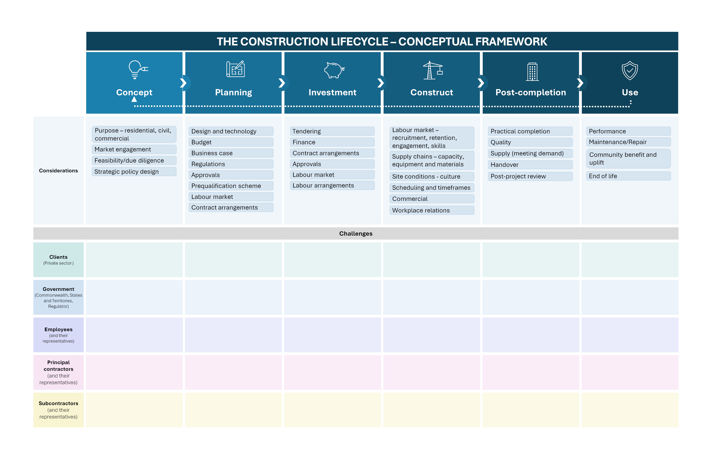
The identified challenges formed the backbone of the Blueprint’s workplan, which members developed in Workshops 3 and 4. The final Blueprint will be presented to the NCIF for endorsement in September 2025.
Discussions were enriched by guest speakers from BuildSkills Australia, the National Association of Women in Construction, MATES in Construction, Infrastructure Australia and the Productivity Commission. Dr Iain Ross AO, who led the Strategic Review of the Australian Apprenticeship Incentive System, also met with the group. These guest speakers set the scene for discussions, broadening the group’s understanding of industry challenges.

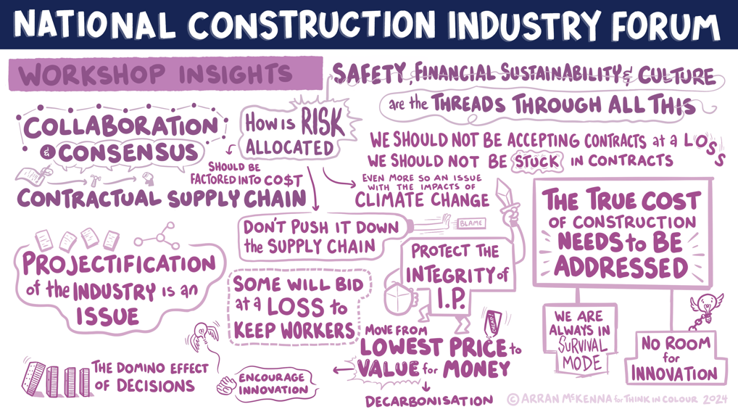
Workshop 1
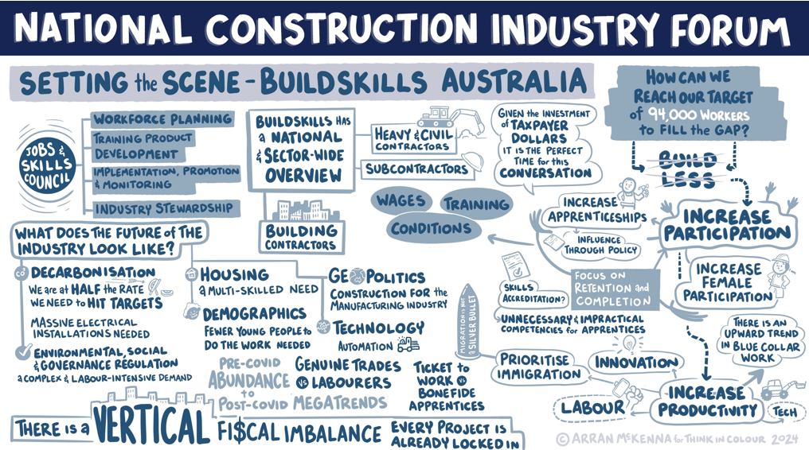
DEC 2024
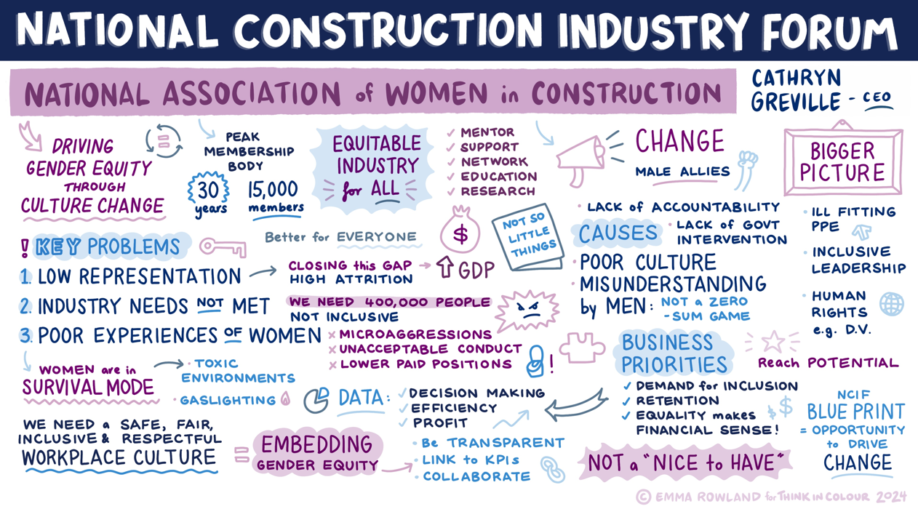
Considered challenges
and developed the
construction lifecycle

Workshop 2
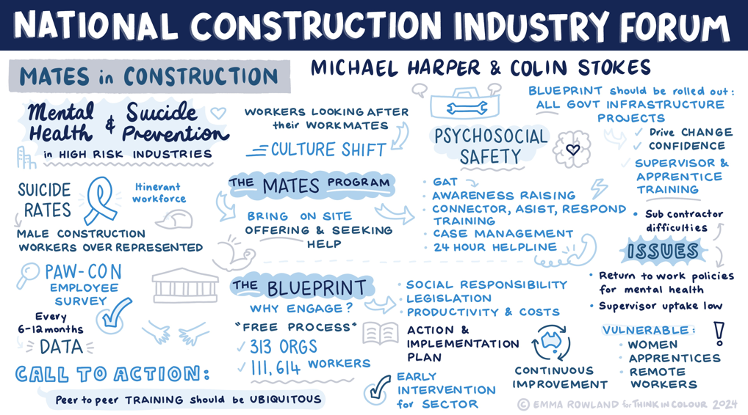
JAN 2025
Agreed and
prioritised challenges

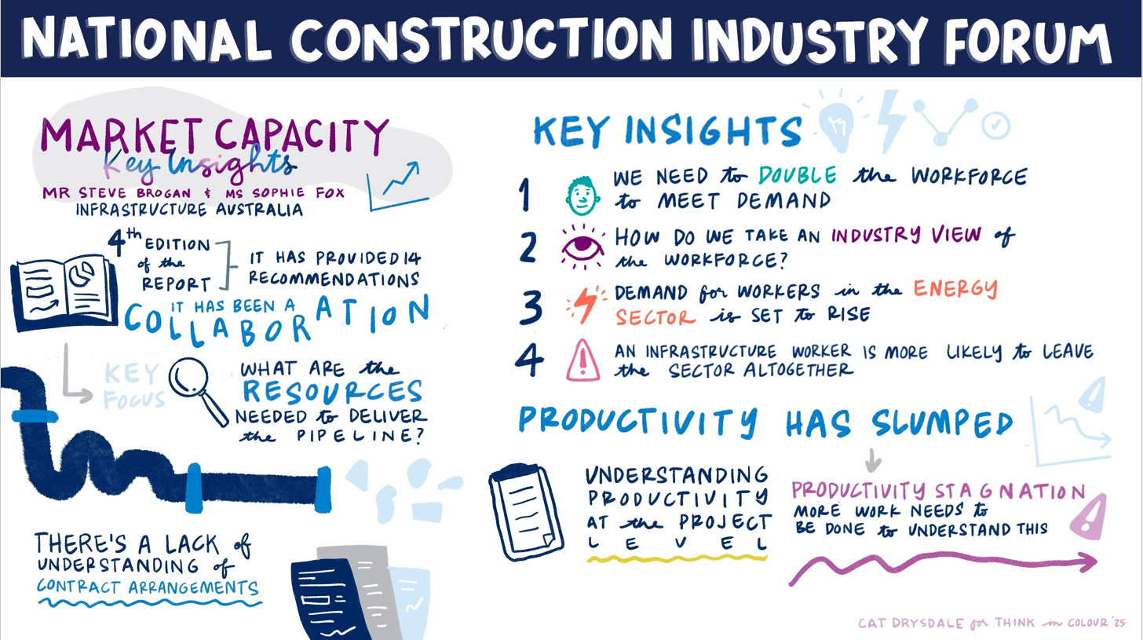
Workshop 3
FEB 2025
Identified matters
for staged workplan

Workshop 4
MAR 2025

Settled draft Blueprint


NCIF Meeting
JUN 2025
Agreed to finalise Blueprint

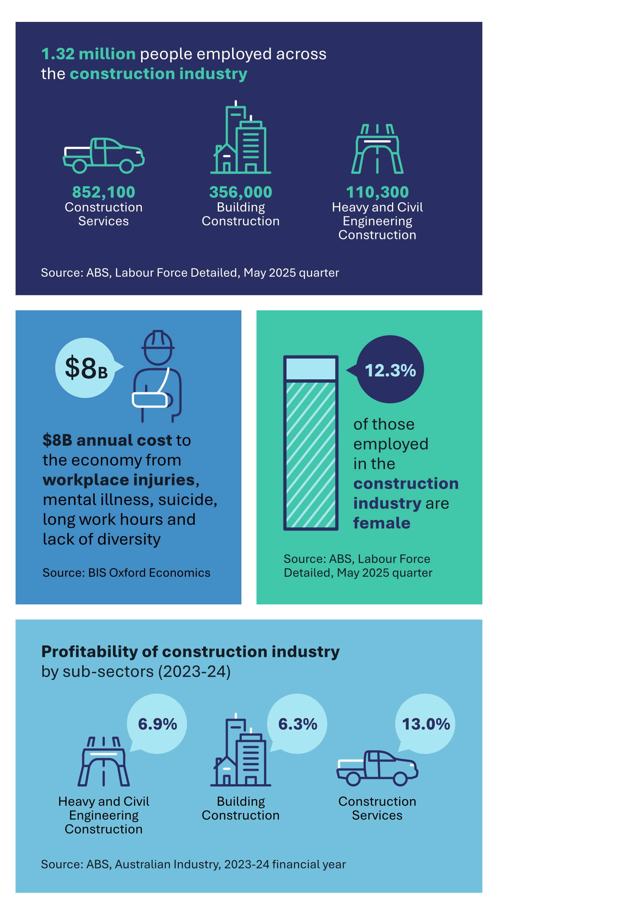
Industry snapshot

The Australian construction industry is a cornerstone of our country’s economy and prosperity. The construction industry accounts for the highest share of employees employed in small businesses across any industry. It provides jobs for millions of Australians across the country, from skilled tradespeople to architects, engineers, and project managers. The industry delivers the homes we live in, the schools our children attend, the hospitals that care for us, and the roads and railways that connect us. Australians around the country aspire to own quality and affordable housing, and they need trust and confidence that the industry will help achieve those aspirations.
The industry too often operates in survival mode, and the industry’s project-based nature provides an environment where some businesses take on unsustainable contracts, leading to financial instability and insolvency. Insurance requirements under construction contracts are becoming more onerous and difficult to place at a reasonable price. Evolving geopolitical factors and rapid technological advancements create uncertainties that require adaptability. The industry needs resilient supply chains in the face of unexpected vulnerabilities. To support the needs of consumers and financers, the industry often works with highly constrained output pricing while remaining subject to variable input prices for labour and materials across the duration of projects. Resilient, stable supply chains are essential to help minimise the risk of input shocks to price and availability that can have significant implications on delivery timeliness, project viability, and business viability.
The industry stands at the dawn of a new era. A more inclusive and diverse workforce requires active efforts to address gender inequities and foster a welcoming, supportive and lawful workplace culture. Critical skills shortages further demand new approaches to attract, retain and support talent.
The following data snapshot summarises the state of the industry, categorised by the four threads of safety, culture, productivity and sustainability, and reflects the evidence base underpinning the NCIF’s decision-making.
NOTE: Industry Snapshot data used data available as of 29 August 2025.

Safety
- $8B annual cost to the economy from workplace injuries, mental illness, suicide, long work hours and lack of diversity (Source: BIS Oxford Economics).
- Construction workers are 8 times more likely to die from suicide than a workplace incident (Source: MATES 2025).
- In the five years to 2022, women were significantly more likely to be harassed in Construction, at an estimated 29% of women compared to 8% of men (Source: Australian Human Rights Commission, Fifth National Survey on Sexual Harassment in Australian Workplaces, 2022).
- 36 fatalities in the construction industry in 2023-24 (19% of all workplace fatalities) (Source: Safe Work Australia).

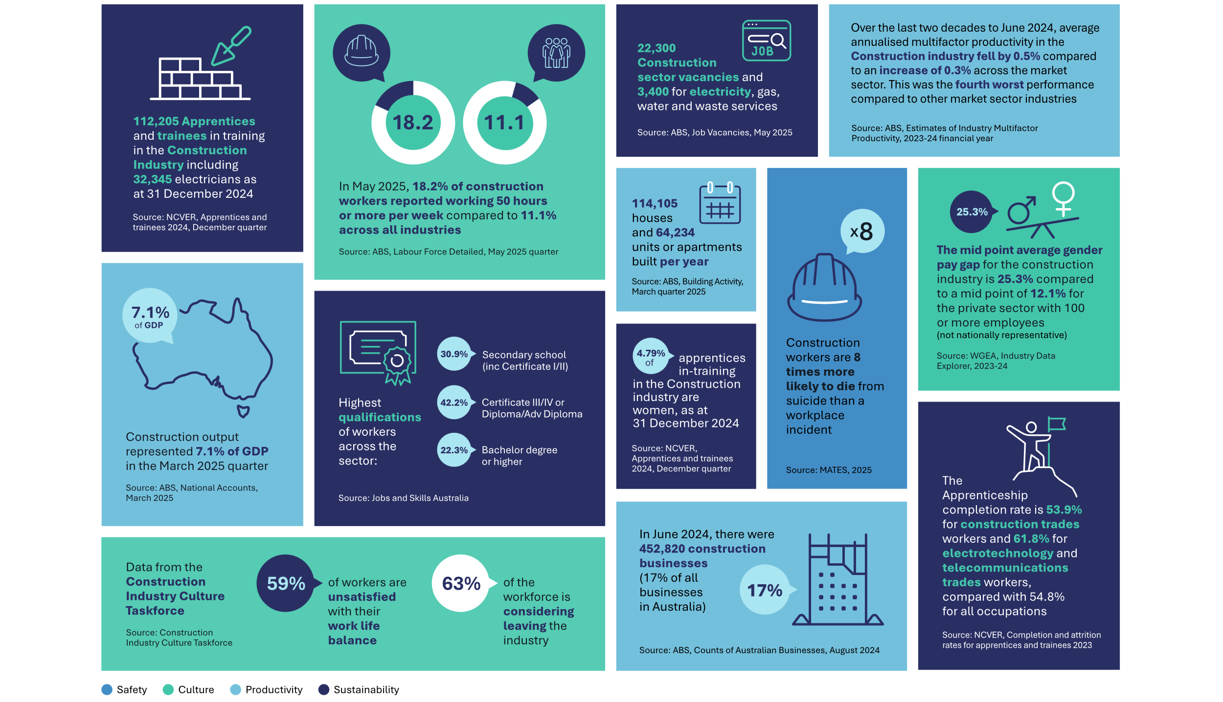
Culture
- 12.3% of those employed in the construction industry are female (Source: ABS, Labour Force Detailed, May 2025 quarter).
- In May 2025, 18.2% of construction workers reported working 50 hours or more per week compared to 11.1% across all industries (Source: ABS, Labour Force Detailed, May 2025 quarter).
- The mid point average gender pay gap for the Construction industry is 25.3% compared to 12.1% across all private sector employers with 100 or more employees (not nationally representative) (Source: WGEA, 2023-24).
- Data from the Construction Industry Culture Taskforce (Source: Construction Industry Culture Taskforce):
  - 59% of workers are unsatisfied with their work life balance
  - 63% of the workforce is considering leaving the industry.
- 2,735 women commenced an apprenticeship or traineeship in 12 months to 31 December 2024. More than 70% are either still progressing or have successfully complete (Source: NCVER, apprentices and trainees 2024, December quarter).
- In 2021, 10.0% of all employed Indigenous Australians were employed in the Construction industry (Source: ABS Census of Population and Housing, unpublished TableBuilder, 2021).

Productivity
- Profitability of construction industry by sub-sectors (2023-24) (Source: ABS, Australian Industry, 2023-24 financial year):
  - 6.9% Heavy and Civil Engineering Construction
  - 6.3% Building Construction
  - 13% Construction Services.
- Over the last two decades to June 2024, average annualised multifactor productivity in the Construction industry fell by 0.5% compared to an increase of 0.3% across the market sector. This was the fourth worst performance compared to other market sector industries. (Source: ABS Estimates of Industry Multifactor Productivity 2023-24 financial year).
- 114,105 houses and 64,234 units or apartments built per year (Source: ABS, Building Activity, March quarter 2025).
- Construction output represented 7.1% of GDP in the March 2025 quarter (Source: ABS, National Accounts, March 2025).
- In June 2024, there were 452,820 construction businesses (17% of all businesses in Australia) (Source: ABS, Counts of Australian Business, August 2024).
- 36% of employers in the Construction industry do not provide employer-funded paid parental leave (Source: WGEA, Industry Data Explorer, 2023-24).
- Over 98% of businesses in the construction industry have less than 20 employees (Source: ABS, Counts of Australian Businesses, 2024).
- Construction industry cost shares (2022-23) (Source: ABS Estimates of Industry Level KLEMS Multifactor Productivity, 2022-2023 financial year):
  - 47% Services - Intermediate inputs (incl Labour hire and equipment rentals)
  - 23% Materials - Intermediate inputs
  - 1% Energy - Intermediate inputs
  - 20% Labour Services
  - 8% Capital Services.
- Over the year to December 2024, there were 43.2 working days lost per 1,000 employees (WDL/000E) in the construction industry compared to 10.5 WDL/000E in all industries. Over the decade to December 2024, the Construction industry had the second highest yearly average WDL/000E at 26.6 behind the Coal mining industry at 178.9 WDL/000E. (Source: ABS Industrial Disputes, December 2024).

Sustainability
- 11.32 million people employed across the construction industry (Source: ABS, Labour Force Detailed, May 2025 quarter):
  - 852,100 Construction Services
  - 356,000 Building Construction
  - 110,300 Heavy and Civil Engineering Construction.
- 112,205 Apprentices and trainees in training in the Construction Industry including 32,345 electricians as at 31 December 2024 (Source: NCVER, Apprentices and trainees 2024, December quarter).
- 22,300 Construction sector vacancies and 3,400 for electricity, gas, water and waste services (Source: ABS, Job Vacancies, May 2025).
- Highest qualifications of workers across the sector (Source: Jobs and Skills Australia):
  - 30.9% Secondary school (inc Certificate I/II)
  - 42.2% Certificate III/IV or Diploma/Adv Diploma
  - 22.3% Bachelor degree or higher.
- 4.79% of apprentices in-training in the Construction industry are women, as at 31 December 2024 (Source: NCVER, Apprentices and trainees 2024, December quarter).
- The Apprenticeship completion rate is 53.9% for construction trades workers and 61.8% for electrotechnology and telecommunications trades workers, compared with 54.8% for all occupations (Source: NCVER, Completion and attrition rates for apprentices and trainees 2023).
- From 1 July 2022 to 31 December 2024, 30.9% of claims paid by the Fair Entitlement Guarantee (FEG) have been in the construction industry, amounting to $140.4m in FEG advances (Source: DEWR).
- Projected requirement of 188,700 built environment workers by June 2035 (Source: BuildSkills Australia)
- Construction represents 24.4% (2024-25), the first time a company enters external administration or has a controller appointed (Source: ASIC, Insolvency Statistics Series 1, Table 1.4.3, 2024-25).
- Using HILDA wave 23, DEWR estimate the share of employees in the construction industry that appeared to be receiving less than the National Minimum wage in 2023-24 at: (Source: DEWR estimated using HILDA wave 23)
  - 19.1% Construction Services
  - 11.1% Building Construction
  - 3.3% Heavy and Civil Engineering Construction
  - Compared to 11.8% for all industries
- The Fair Work Ombudsman recovered more than $13.5 million for 3,501 workers. (Source: 2020-21 to 31 December 2024, Fair Work Ombudsman)

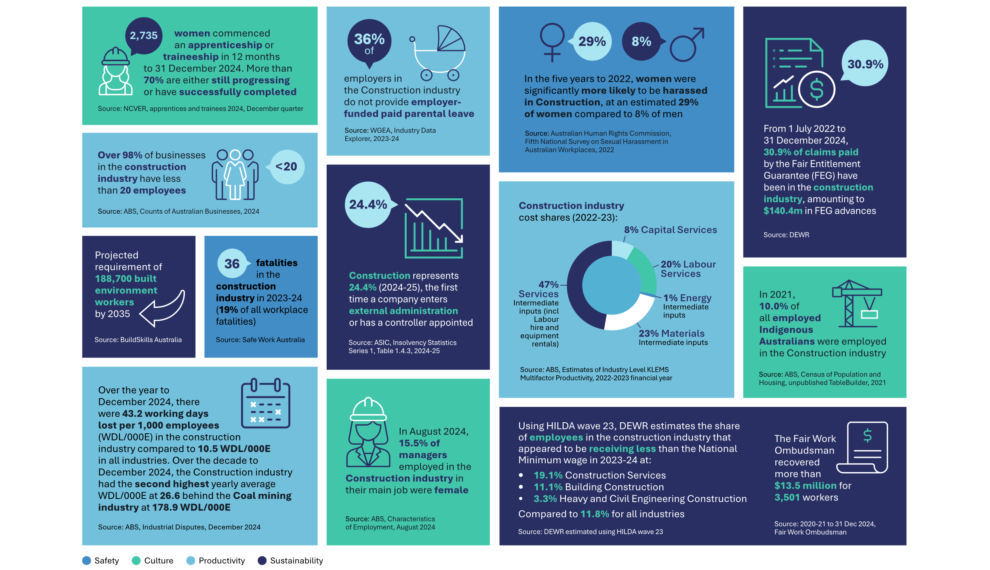

Challenges by theme
Eight key themes emerged from the NCIF's discussion of challenges facing the industry. The 8 themes link to the underlying threads of safety, culture, productivity and sustainability. The priority challenges identified and the subsequent actions in the workplan correspond to these 8 overarching themes.


Collaboration and alignment
The industry should move away from conflict-based relationships towards collaborative and cooperative models that take into account shared and divergent interests


Governance, lawfulness and compliance
The industry must create a culture of lawfulness, which actively combats non-compliance across all areas of the industry, including gender-based violence, intimidation corruption and criminality ​


Regulation and procurement
Governments can do more to ensure their levers are influencing change and driving mutually beneficial and lawful behaviour


Skills, workforce and participation
The industry must be able to meet current and future needs through a more diverse, stable and inclusive workforce


Financial viability
The industry must be able to meet ongoing financial obligations for all industry participants


Fragmented and project-based nature of industry (Industry projectification)
The industry must recognise the benefits of taking a longer-term, strategic view rather than moving from one project to the next


Risk allocation
The industry needs to identify, understand and manage risks and obligations fairly


Reporting and transparency
The industry can demonstrate accountability through robust reporting and auditing requirements

Priority challenges
This section outlines specific industry challenges identified by members in relation to the 8 overarching themes.
During workshops and using the construction project lifecycle framework, members identified a range of challenges facing the industry. By no means exhaustive, the following list represents the NCIF's perspective on the most significant industry challenges. While issues may manifest differently across the residential, commercial and civil sectors, these challenges affect the entire industry.
 Collaboration and alignment
- Contracts are not fair, equitable and transparent down the supply chain, and fail to align the interests of all parties
- Industrial arrangements can be a point of conflict​
- Adversarial relationships between stakeholders including a lack of trust and communication between parties

 Governance, lawfulness and compliance
- Health and safety issues including poor mental health outcomes, substance abuse, gender-based violence (including assault, sexual harassment and domestic and family violence) and high levels of suicide
- Allegations of bullying, intimidation and criminal conduct
- Commercial coercion and intimidation

 Regulation and procurement
- Procurement practices have a greater focus on lowest price, rather than overall value for money, best practice, and mutually beneficial and lawful behaviour
- Procurement practices that are costly and risk intellectual property
- Long planning processes increase costs down the line
- Planning and approval red tape stifles innovation and creates delays
- Barriers to innovation e.g. investment and procurement models do not incentivise or support innovation or sovereign capabilities
- Lack of supply chain resilience and local industry development

 Skills, workforce and participation
- Skills and workforce gaps and shortages
- Insufficient workforce to sustain multiple projects
- Limited workforce mobility across jurisdictions e.g. licensing arrangements and accreditation/qualification recognition schemes
- Lagging workforce productivity
- Insecure careers without long-term pathways
- Workplace inequality, gender inequities and discrimination, including systemic underrepresentation, inflexible work arrangements and inadequate amenities
- Lack of workforce diversity e.g. gender, age, people with a disability, First Nations people

 Financial viability
- Phoenixing, tax avoidance, insolvencies and unpaid entitlements
- Standards of commercial contracting and trading practices including security of payment
- Inflexible and unfair contract and payment terms
- Limited investment in innovation e.g. modern methods of construction, digitisation

 Industry projectification
- Project bundling may limit equitable market access for all contractors
- Precarious forms of employment including overreliance on labour hire

 Risk allocation
- Clients lack risk appetite, and risk is passed onto contractors e.g. uncapped liability
- Tendering practices that negatively impact parties, particularly throughout the supply chain e.g. ‘race to the bottom’
- Increased risk of climate disruption means adverse weather events increase pressure on parties, e.g. project timelines

 Reporting and transparency
- Limited benchmarking of performance

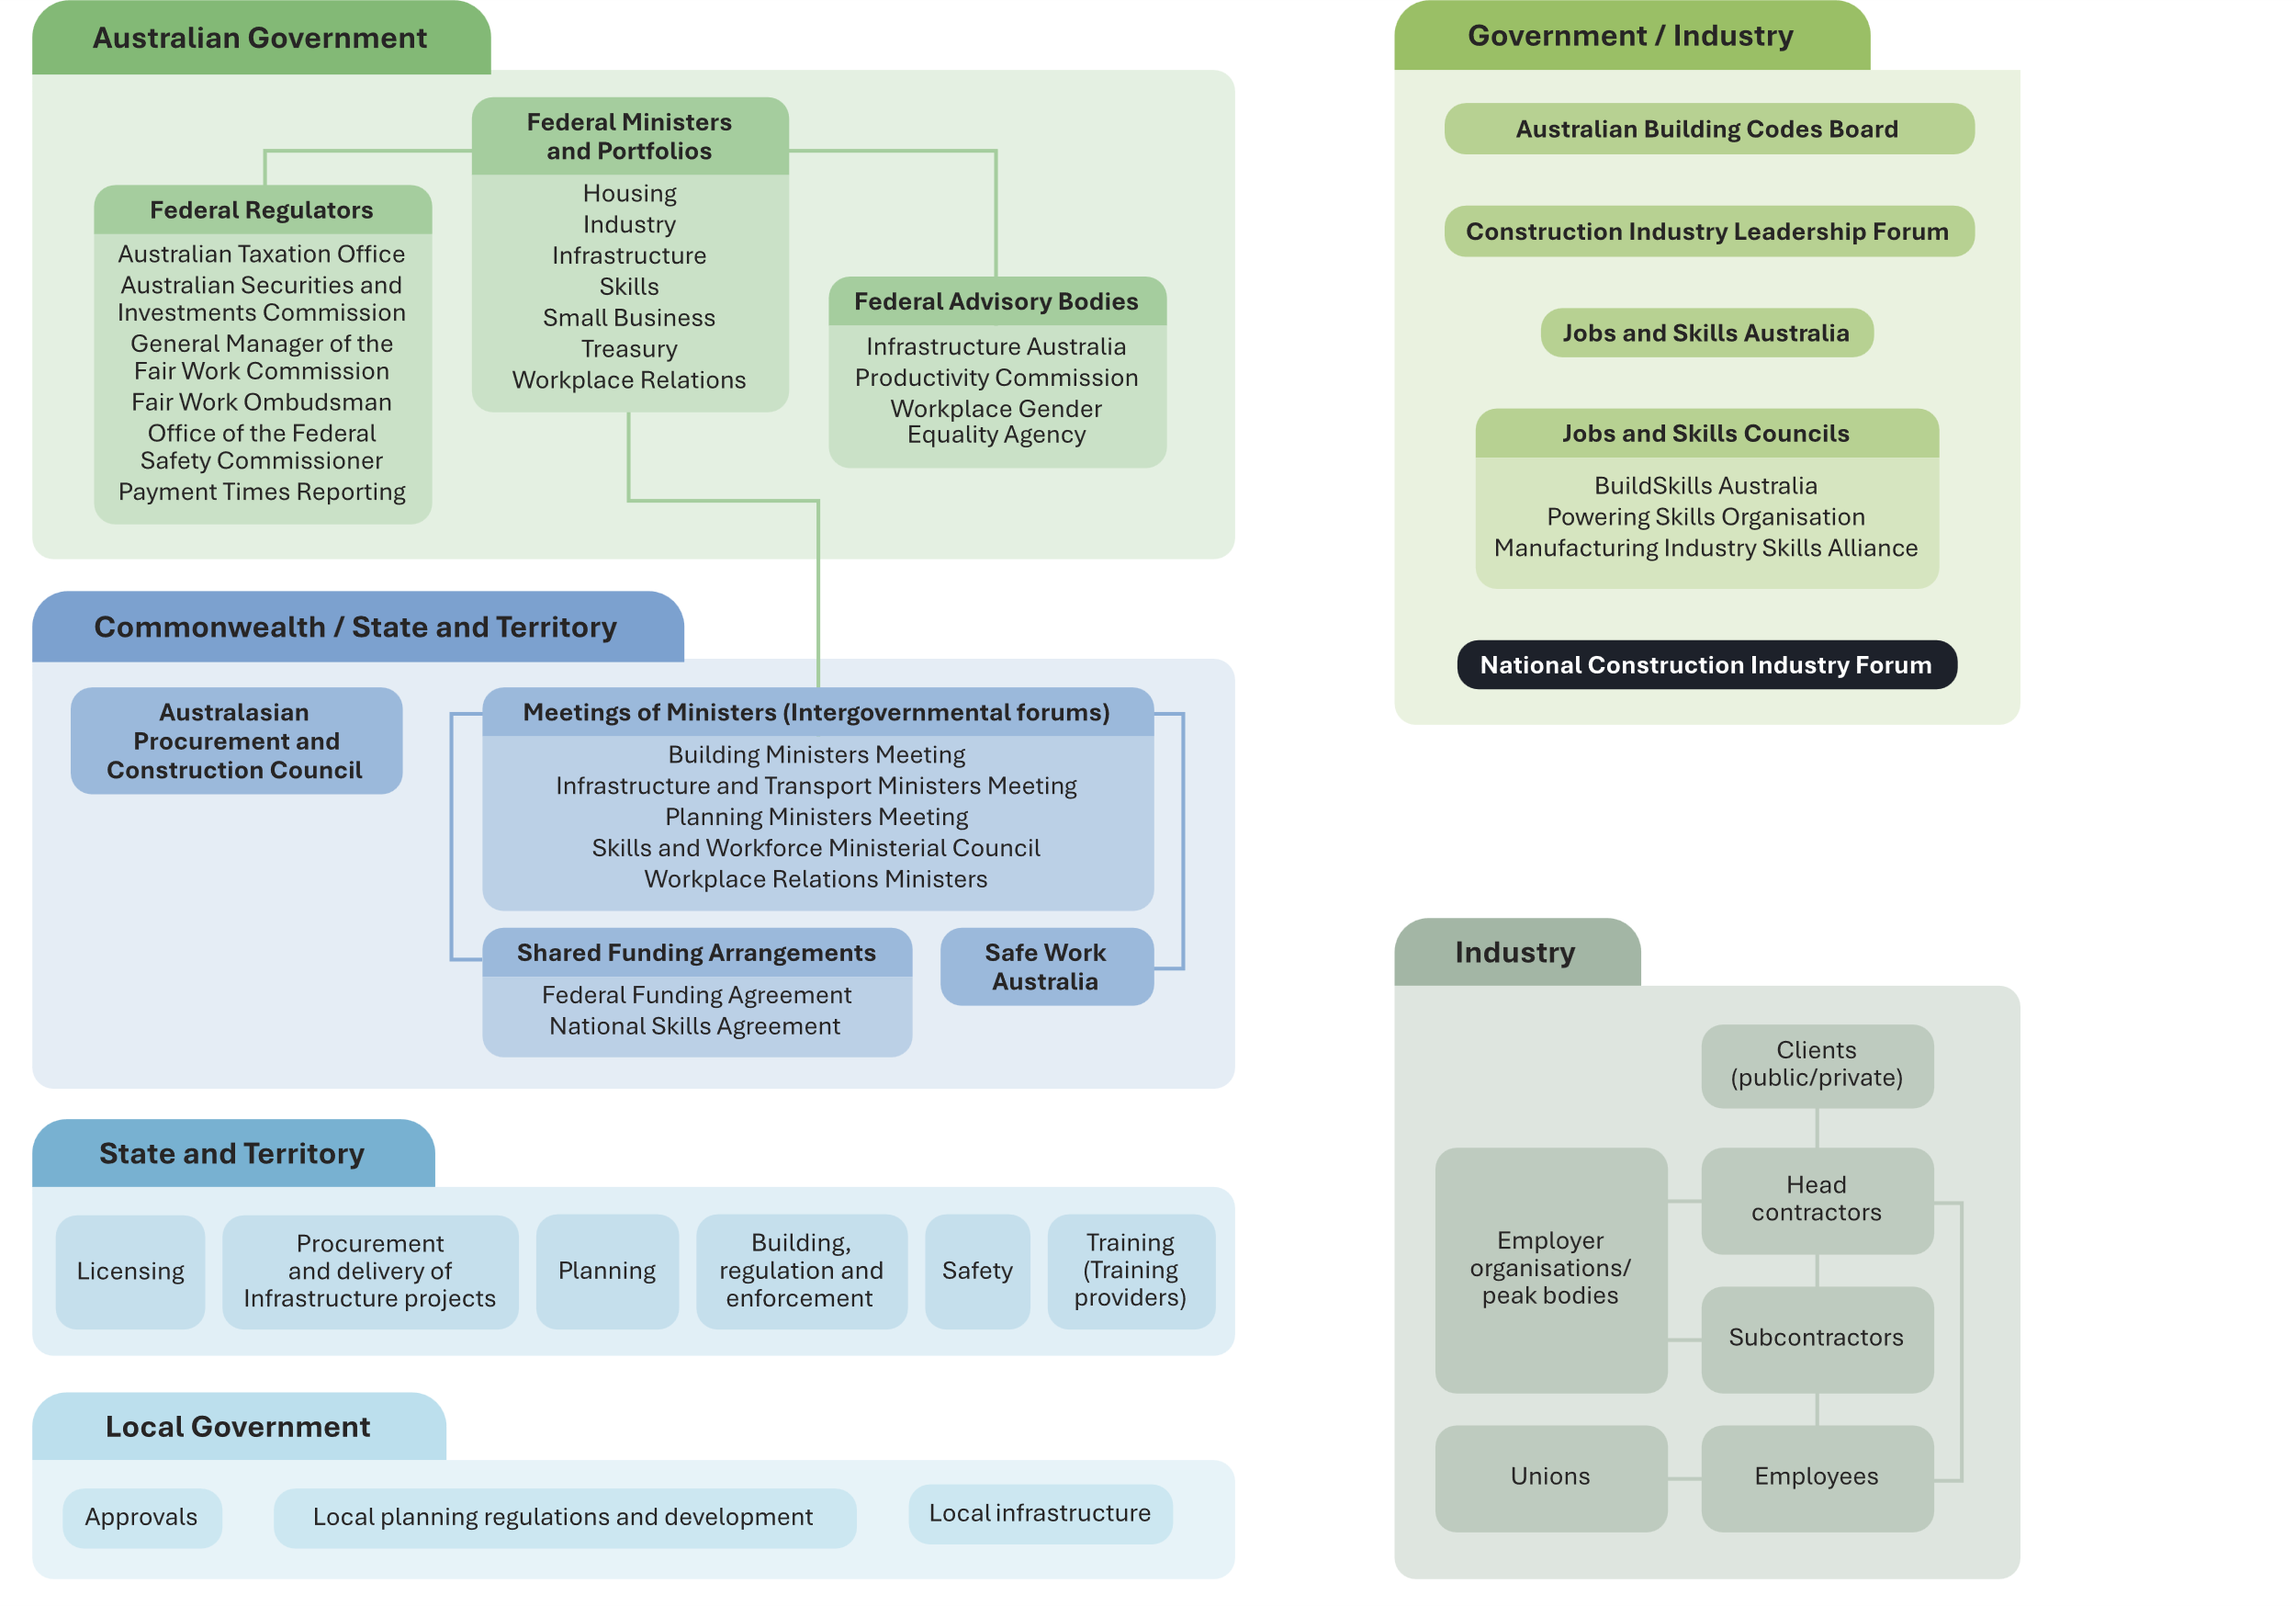
System architecture

In October 2024, the NCIF strongly agreed that the Blueprint should clearly articulate the roles and responsibilities of, and interactions between, other relevant bodies, including the States and Territories, other Australian Government building and construction forums and groups, and relevant regulators.
This diagram outlines the architecture of the building and construction industry, focusing on the roles and responsibilities most related to the Blueprint and the NCIF’s work more broadly.

Australian Government

Federal Ministers and Portfolios
- Housing
- Industry
- Infrastructure
- Skills
- Small Business
- Treasury
- Workplace Relations

Federal Regulators, which are an offshoot of Federal Ministers and Portfolios as they are created by the Federal Ministers
- Australian Taxation Office
- Australian Securities and Investments Commission
- General Manager of the Fair Work Commission
- Fair Work Ombudsman
- Office of the Federal Safety Commissioner
- Payment Times Reporting

Federal Advisory Bodies, which are an offshoot of Federal Ministers and Portfolios as they are created by the Federal Ministers
- Infrastructure Australia
- Productivity Commission
- Workplace Gender Equality Agency

Commonwealth/State and Territory

Australasian Procurement and Construction Council

Meetings of Ministers (Intergovernmental Forums), which are attended by the various Federal Ministers listed under the Australian Government. This includes:
- Building Ministers Meeting
- Infrastructure and Transport Ministers Meeting
- Planning Ministers Meeting
- Skills and Workforce Ministerial Council
- Workplace Relations Ministers

Shared Funding Agreements, which arise from the Meetings of Ministers and include:
- Federal Funding Agreement
- National Skills Agreement

Safe Work Australia, which is overseen by Meetings of Ministers

State and Territory
- Licensing
- Procurement and delivery of Infrastructure projects
- Planning
- Building regulation and enforcement
- Safety
- Training (Training providers)

Local Government
- Approvals
- Local planning regulations and development
- Local infrastructure

Government/Industry

Australian Building Codes Board

Construction Industry Leadership Forum

Jobs and Skills Australia

National Construction Industry Forum

Jobs and Skills Councils
- BuildSkills Australia
- Powering Skills Organisation
- Manufacturing Industry Skills Alliance

Industry
- This section conveys the interactions between stakeholders in the industry. Clients (public/private) interact with head contractors. Head contractors interact with subcontractors, and both head and subcontractors interact with employees and employer organisations/peak bodies. Employees interact with unions

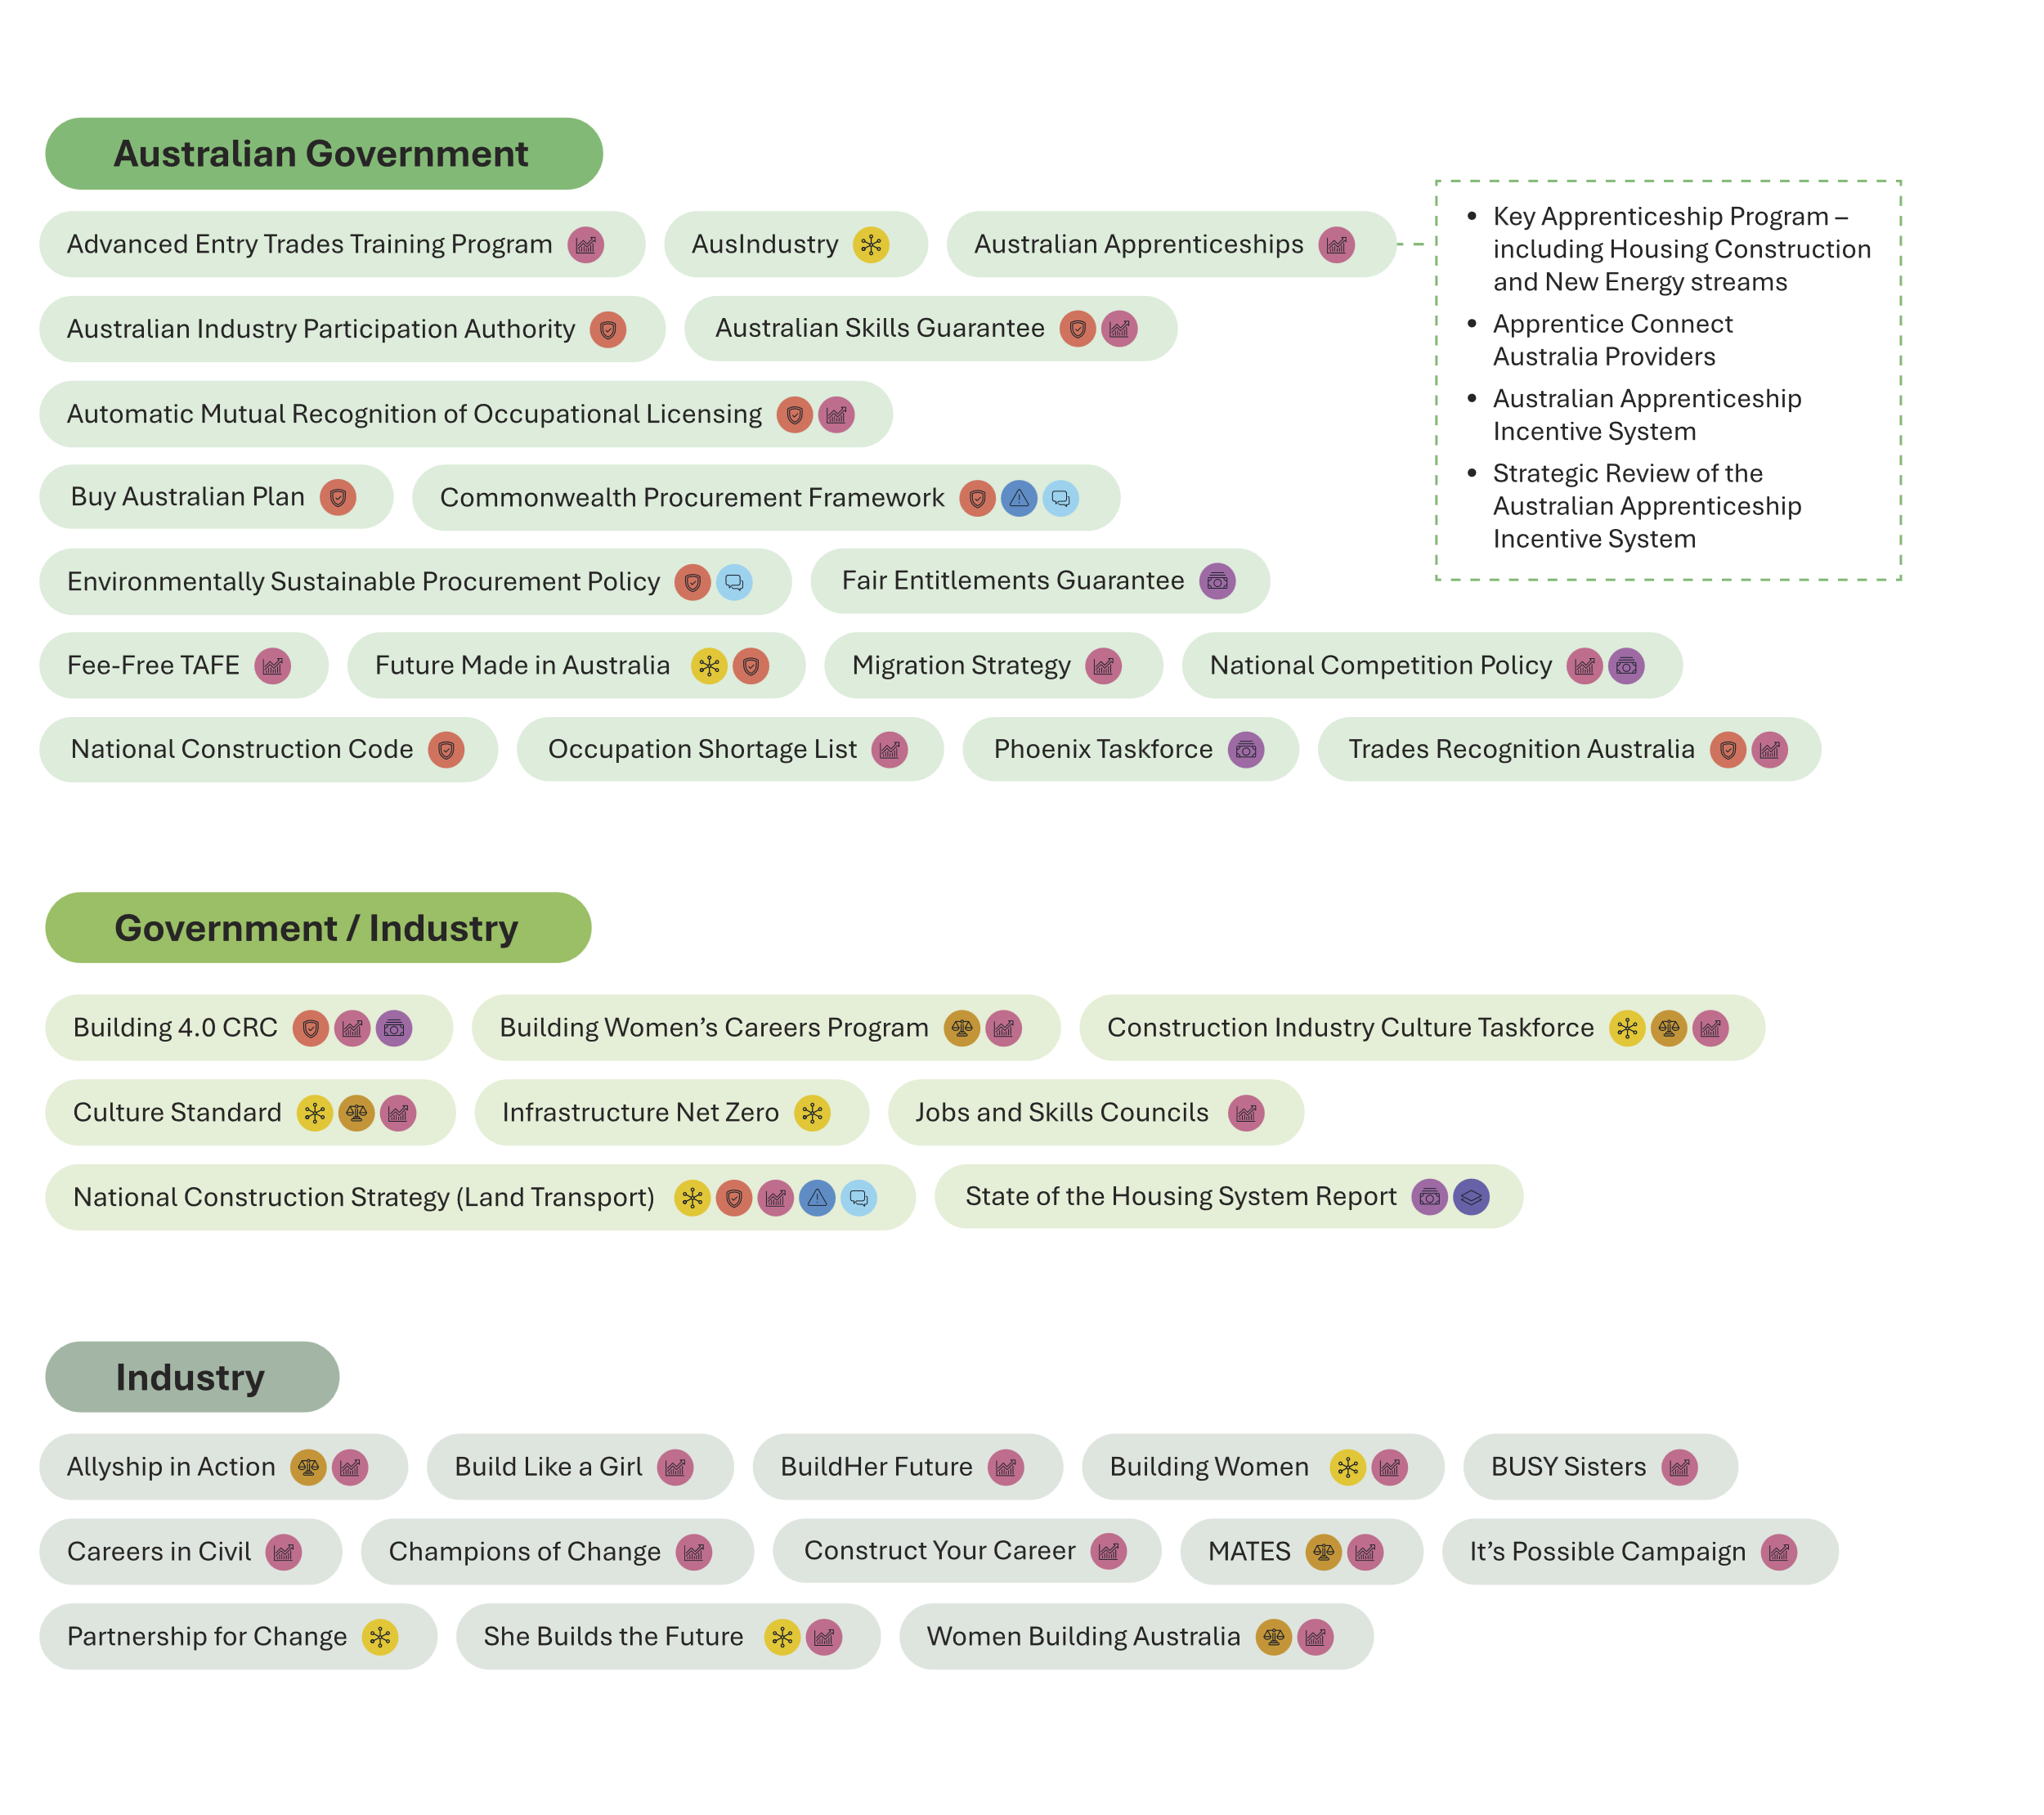
Key initiatives
Across the industry and all levels of government, valuable work is underway to address the challenges facing the industry. In October 2024, the NCIF emphasised that this Blueprint should complement the existing bodies and initiatives.
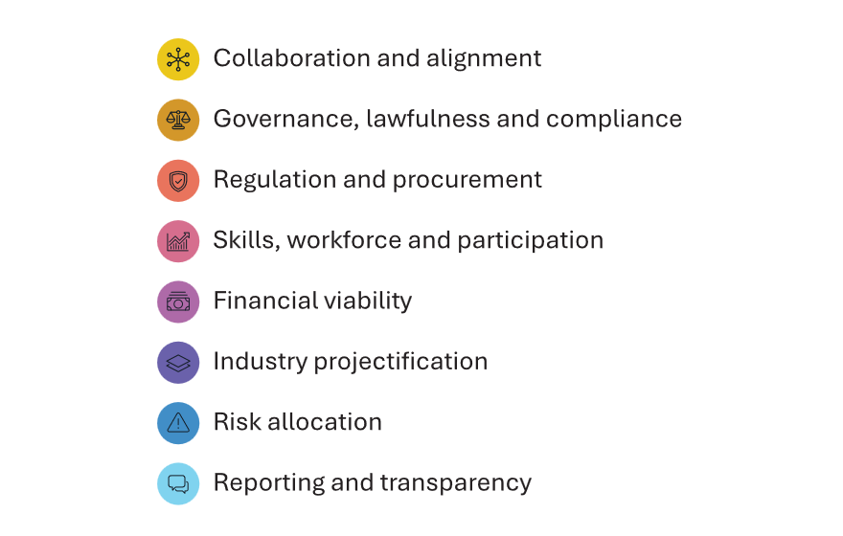
This diagram outlines the key initiatives specific to the building and construction industry. This is not an exhaustive list, focusing on the measures most related to the Blueprint and the NCIF’s work more broadly.

Australian Government
- Advanced Entry Trades Program, which relates to Skills, workforce and participation
- AusIndustry, which relates to Collaboration and alignment
- Australian Apprenticeships, which relates to Skills, workforce and participation
  - Key Apprenticeship Program – including Housing Construction and New Energy streams
  - Apprentice Connect Australia Providers
  - Australian Apprenticeship Incentive System
  - Strategic Review of the Australian Apprenticeship Incentive System​
- Australian Industry Participation Authority, which relates to regulation and procurement
- Australian Skills Guarantee, which relates to regulation and procurement and Skills, workforce and participation
- Automatic Mutual Recognition of Occupational Licensing, which relates to regulation and procurement and Skills, workforce and participation
- Buy Australian Plan, which relates to regulation and procurement
- Commonwealth Procurement Framework, which relates to regulation and procurement, risk allocation and reporting and transparency
- Environmentally Sustainable Procurement Policy, which relates to regulation and procurement and reporting and transparency
- Fair Entitlements Guarantee, which relates to Financial viability
- Fee-Free TAFE, which relates to Skills, workforce and participation
- Future Made in Australia, which relates to Collaboration and alignment and regulation and procurement
- Migration Strategy, which relates to Skills, workforce and participation
- National Competition Policy, which relates to Skills, workforce and participation and financial viability
- National Construction Code, which relates to regulation and procurement
- Occupation Shortage List, which relates to Skills, workforce and participation
- Phoenix Taskforce, which relates to financial viability
- Trades Recognition Australia, which relates to regulation and procurement and Skills, workforce and participation

Government / Industry
- Building 4.0 CRC, which relates to regulation and procurement, Skills, workforce and participation, and Financial viability
- Building Women’s Careers Program, which relates to Governance, lawfulness and compliance and Skills, workforce and participation
- Construction Industry Culture Taskforce, which relates to Collaboration and alignment, Governance, lawfulness and compliance and Skills, workforce and participation
- Culture Standard, which relates to Collaboration and alignment, Governance, lawfulness and compliance and Skills, workforce and participation
- Infrastructure Net Zero, which relates to Collaboration and alignment
- Jobs and Skills Councils, which relate to Skills, workforce and participation
- National Construction Strategy (Land Transport), which relates to Collaboration and alignment, regulation and procurement, Skills, workforce and participation, risk allocation and reporting and transparency
- State of the Housing System Report, which relates to financial viability and industry projectification

Industry
- Allyship in Action, which relates to Governance, lawfulness and compliance and Skills, workforce and participation
- Build Like a Girl, which relates to Skills, workforce and participation
- BuildHer Future, which relates to Skills, workforce and participation
- Building Women, which relates to Collaboration and alignment and Skills, workforce and participation
- BUSY Sisters, which relates to Skills, workforce and participation
- Careers in Civil, which relates to Skills, workforce and participation
- Champions of Change, which relates to Skills, workforce and participation
- Construct Your Career, which relates to Skills, workforce and participation
- MATES, which relates to Governance, lawfulness and compliance and Skills, workforce and participation
- It’s Possible Campaign, which relates to Skills, workforce and participation
- Partnership for Change, which relates to Collaboration and alignment
- She Builds the Future, which relates to Collaboration and alignment and Skills, workforce and participation
- Women Building Australia, which relates to to Governance, lawfulness and compliance and Skills, workforce and participation

Opportunities – forward workplan



To address these challenges in a constructive manner, the NCIF developed recommendations for a forward workplan. The recommendations seek to complement work underway by the industry, Australian Government, and state and territory governments.
The recommendations identified for the workplan are informed by the NCIF’s work, which focuses on:

Building a better understanding of the challenges facing the construction industry

Connecting with stakeholders, drawing on the relationships, expertise and work of other bodies and supporting key industry and government initiatives

Delivering evidence-based advice to government.
To ensure the Blueprint adapts to emerging challenges and the evolving needs of the industry, the workplan will be subject to ongoing review and update by the NCIF. At its June 2025 meeting, NCIF members agreed that 9 recommendations should be acted on as the first tranche of implementation of the Blueprint.

challenges | Recommendations
Collaboration and alignment | - Recommend that the NCIF’s role as a collaborative tripartite body is enhanced to support ongoing implementation and review of the Blueprint, including ensuring adequate and ongoing resourcing to support the NCIF.  TRANCHE 1  - Continue to strengthen and develop the role of the NCIF as an authoritative industry voice, including providing advice on the Strategic Review of the Australian Apprenticeships Incentive System, the Occupational Shortage List (formerly the Skills Priority List), the National Construction Code, the National Energy Workforce Strategy, the Secure Australian Jobs Code, the National Construction Strategy (for Land Transport), and relevant Productivity Commission Reports. (Ongoing)  - Recommend that Government consult with NCIF to investigate ways of better, and more timely dispute resolution procedures, including  - consideration of state and territory-based industry disputes panel models  - the creation of an expert industry panel within the FWC  - opportunities for greater use of the FWC’s suite of collaborative workplace initiatives, including interest-based, cooperative approaches, and good practice to bargaining, consultation and disputes  - consideration of adoption of the ‘Hunter model’ or alternative models that could be contained within enterprise agreements.  - NCIF to identify what best practice looks like at each stage of the construction project lifecycle, e.g. value stream mapping of key processes.  - Recognising the important role of states and territories, NCIF to explore opportunities to engage on relevant challenges and opportunities.  - NCIF to consider public information campaigns on positive relationships and workplace practices.  - NCIF to maintain oversight of existing reforms/initiatives to identify what works, what doesn't and opportunities to fill gaps as required. (Ongoing)  - NCIF to consider further ways to minimise adversarial disruption, including timely resolution of disputes.
Governance, lawfulness and compliance | - NCIF to develop a Joint Construction Industry Charter, setting out clear shared goals and expectations for a safe, sustainable and productive building and construction industry, including behavioural expectations, rules of engagement and dispute resolution processes amongst all industry participants.  TRANCHE 1  - Recommend regulators take a more joined-up, proactive and visible approach to enforcement across the entire building and construction industry.  - Recommend Government, supported by the NCIF, ask the Fair Work Ombudsman (FWO) to consider commencing a national investigation, alongside its current investigations into specific allegations, into sex discrimination and sexual harassment more broadly in the construction industry.  - Recommend Government, supported by the NCIF, ask the FWO to consider commencing a national investigation into treatment of apprentices, trainees, young workers, and other vulnerable cohorts in the construction industry.  - Recommend Government consider options to ensure the enforcement of statutory declarations for enterprise agreement approvals, including a role for the FWO.  - Recommend identifying opportunities for greater information sharing and cooperation between regulators and agencies including project funding/data.
Regulation and procurement | - NCIF to identify best practice and provide advice on procurement frameworks and settings with a view to developing a nationally consistent set of procurement principles, by  - reviewing current guidance and arrangements on value for money and how current practices are working (e.g. how to assess, how to report, what consequences for not delivering) to identify opportunities for potential improvements  - reviewing procurement frameworks (for example NSW Government guidelines limiting tenders) to determine what elements are effective or best practice  - reviewing procurement planning, approval and implementation red tape  - considering opportunities for greater transparency in tendering of goods and services  - considering standardised clauses for government construction contracts and subcontracts  - considering alignment of existing tendering prequalification schemes and support sovereign safe companies to obtain prequalification  - considering how procurement frameworks can operate to drive quality, productivity, mutually beneficial and lawful behaviour, and deliver safe, secure, well-paid jobs in the construction industry. This includes addressing the overreliance on labour hire, eliminating gender inequities and obligations to report unlawful behaviour, as part of the Secure Australian Jobs Code consultation process.  TRANCHE 1  - NCIF to advise on risks inherent in the announcement of unrealistic timeframes for projects.  - NCIF to assess the impact of workplace laws and identify opportunities for the industry.  - NCIF to provide advice on barriers to small and medium enterprise market entry, innovation, and unnecessary red tape.
Skills, workforce and participation | - NCIF to develop advice on delivering safe, secure, well-paid jobs in the construction industry.  TRANCHE 1  - NCIF to demonstrate early action on the Strategic Review of the Australian Apprenticeships Incentive System’s findings, where reviewers have identified a role for industry leaders to improve apprentice safety, specific to the construction industry.  - NCIF to provide advice to government about the pathways to the construction industry, to identify targeted strategies to address structural barriers to entry.  TRANCHE 1  - NCIF to explore structural barriers to women’s participation in the industry, e.g. support for care, access to childcare for shift workers, Paid Parental Leave entitlements, flexible work arrangements, adequate facilities, etc.  TRANCHE 1  - NCIF to consider opportunities to implement the Culture Standard developed by the Construction Industry Culture Taskforce, which aims to transform the industry by focusing on diversity and inclusion, wellbeing and time for life.  - Recommend Commonwealth and State and Territory Ministers consider nationally consistent skills accreditation, licensing and regulation.  TRANCHE 1  - Recommend BuildSkills Australia, as the relevant Jobs and Skills Council for construction  - build on its existing Housing Workforce Capacity Study to undertake analysis into public and civil construction workforces  - undertake a study as to the application of trade licensing in the building trades.  - Recommend Powering Skills Organisation, as the Jobs and Skills Council for the energy sector, map occupational licensing for electrical trades to inform the national licensing scheme for electrical trades, noting National Competition Policy work underway.  - Recommend Commonwealth and State and Territory WHS Ministers consider what more could be done to address risks of sex discrimination, harassment and assault in the workplace, including  - ensuring equitable and safe workplaces including mandatory access to appropriate and safe amenities and personal protective equipment on all construction sites  - strong compliance and enforcement action within their jurisdiction.  - Recommend industry mandates safe and respectful workplace training for workers with support for new and existing employees, supervisors and managers to undertake training.  - Recommend Jobs and Skills Councils work with industry to develop training resources to support the take-up of high-quality safe and respectful workplace training.  - NCIF to identify opportunities to increase training infrastructure, and the capacity of the VET system to support apprentices and trainees on Australia’s national priorities including energy, housing and Infrastructure.  - NCIF to consider opportunities to promote mentoring networks for women in construction.  - Recommend the relevant Jobs and Skills Councils (BuildSkills Australia and Powering Skills Organisation)  - work with industry to review building and construction-related qualifications for apprenticeships and traineeships to include skills and knowledge required to support safe and respectful workplaces and to address gendered violence in the workplace, which aligns with WHS obligations in relation to eliminating or minimising both physical and psychological risks in the workplace  - consider the construction component of net zero transformation  - analyse where and how training currently happens (i.e. head contractor, trade contractor or smaller contractor), the implication of training delivery in different settings and ways to support quality learning and assessment outcomes.
Financial viability | - NCIF to explore modern/collaborative standard forms of industry contracts and subcontracts, and options for greater use.  - Noting the government response to the 2017 Review of Security of Payment Laws, the NCIF to investigate and develop advice on effective arrangements to protect the security of payments for contractors down the supply chain.  TRANCHE 1  - NCIF to engage with the Phoenix Taskforce in the Australian Taxation Office (ATO) to provide advice on changing behaviours in the industry that lead to phoenixing.  - NCIF to engage with ATO to advise on procedures and actions available to limit insolvencies.
Industry projectification | - NCIF to consider:  - opportunities created under the Buy Australian Plan to strengthen our domestic industry, manufacturing capability and local supply chains to participate in the infrastructure pipeline by breaking up larger contracts to level the playing field for local companies  - reporting on steps taken to meet requirements of the Buy Australian Plan.  - reporting on steps taken to meet requirements of Local Industry Participation Plans.  - NCIF to develop a scope of work to undertake analysis of where, why and how labour hire is currently used, to inform industry and government on how procurement frameworks and practices might best address issues.  - NCIF to develop guidelines on project packaging, to ensure project bundling doesn’t limit equitable market access for all contractors.
Risk allocation | - NCIF to invite the Australian Banking Association, key developers and other like financial institutions in the industry to discuss and consider issues facing the industry, and collaborate with the finance sector, to influence good behaviour.  - NCIF to provide advice on surety and professional indemnity requirements for projects.  - NCIF to develop guidelines on appropriate risk management and risk allocation, including for head contractors.  TRANCHE 1
Reporting and transparency | - NCIF to develop performance indicators across the four Blueprint threads of safety, culture, productivity and sustainability to support ongoing monitoring and benchmarking of the industry.  - NCIF to develop advice on improvements to data collection to inform policy.

National Construction Industry Forum
This Blueprint is a collective declaration that we, as government and an industry, acknowledge the urgent need for change. It is the product of industry-wide collaboration, reflecting our shared determination to build a safe, positive, lawful, sustainable and productive industry. By incorporating the perspectives of workers, business and government in a genuine tripartite setting, the NCIF has produced recommendations that are practical, sustainable and owned by the industry into the future.
While the Blueprint offers a strategic direction for the future, all stakeholders must hold themselves accountable for addressing the industry’s challenges and drive the implementation of shared solutions.

Tony Callinan | Australian Workers’ Union
Brent Crockford | Australian Owned Contractors
Jon Davies | Australian Constructors Association
Paul Farrow | Australian Workers’ Union
Robyn Fortescue | Australian Manufacturing Workers’ Union
Oliver Judd | National Electrical and Communications Association
Jocelyn Martin | Housing Industry Association
Alison Mirams | Independent
Steve Murphy | Australian Manufacturing Workers’ Union
Nicholas Proud | Civil Contractors Federation Australia
Kristen Reid | Plumbing and Pipe Trades Employees Union
Zach Smith | Construction, Forestry and Maritime Employees Union
Denita Wawn | Master Builders Australia
Lucy Weber | Construction, Forestry and Maritime Employees Union
Michael Wright | Electrical Trades Union
Mike Zorbas | Property Council of Australia
The Hon Amanda Rishworth MP | Minister for Employment and Workplace Relations
The Hon Clare O’Neil MP | Minister for Housing, Minister for Homelessness, Minister for Cities
The Hon Catherine King MP | Minister for Infrastructure, Transport, Regional Development and Local Government

The Hunter model is a model of collaborative workplace relations defined by interest-based bargaining. Under this model, the Hunter region saw more than $15 billion in infrastructure and other works completed ahead of schedule, under budget, with no time lost due to industrial disputes, and an exemplary safety record.

