
I

DEWR 2024-25 Gender Pay Gap Employer Statement
The Department of Employment and Workplace Relations (DEWR) is committed to creating a workplace that is inclusive, diverse and respectful. We aim to reflect the Australian community we serve and set the standard as a model employer for workplace equality.
At the foundation of this commitment is our Diversity and Inclusion Action Plan. This plan outlines priority actions we are taking to attract, grow, retain and harness the proud diversity of our people. The plan is shaped by APS-wide initiatives and strategies and supported by employee-led networks including DEWR’s Gender Equity Network. These networks help ensure the voices of our people are reflected in our actions.

Our Gender Profile and Pay Gap

Gender Pay Gap Results
As at 31 December 2024:
- The department’s average gender pay gap was -0.9 percent, representing a 1.1 percentage point reduction from the previous year.
- Our result is 5.6 percentage points lower than that of other similar-sized Commonwealth public sector employers (the comparison group).
These results reflect the positive impact of our continued focus on gender equality. They also demonstrate DEWR is performing strongly compared with similar agencies, reinforcing our commitment to being a model employer in the APS.

Gender Pay Gap Trends
 | 2022 | 2023 | 2024 | 2024 Comparison Group
Average total remuneration | 1.5% | 0.2% | -0.9% | 4.7%
Median total remuneration | 8.2% | 3.1% | 0.6% | 3.0%
Average base salary | 0.9% | -0.3% | -1.2% | 3.5%
Median base salary | 10.6% | 0.0% | 0.0% | 0.0%
Key Management Personnel*^ | 2.4% | -4.8% | -15.9% | 3.2%
Note: A positive percentage indicates that men are paid more than women. A negative percentage indicates that women are paid more than men.
* WGEA define Key Management Personnel (KMP) for Commonwealth public sector employers as employees working at the Senior Executive Service Band 2, Senior Executive Service Band 3, and CEO/Agency Head level.
^ From 2024, CEO/Secretary salary has been included in the KMP category.

Workforce Composition
As at 31 December 2024:
- The department employed 4,375 APS employees.
- Women accounted for approximately 60% of the workforce, and men 40%.
- Less than 1% of our workforce identify as non-binary or use a different term.
Women represented the majority across all pay quartiles and role categories. Chart 1 shows the gender distribution across each pay quartile and the average total remuneration for each group. Chart 2 highlights the department’s workforce composition by role, which highlights that women hold a broad range of positions across the organisation.
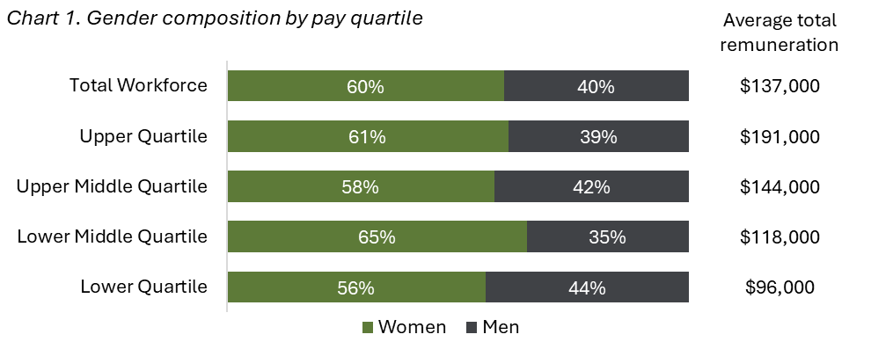

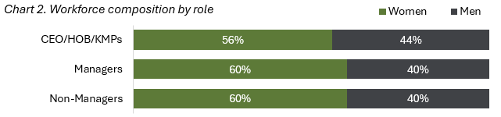

Note: CEO = Chief Executive Officer, HOB = Head of Business, KMP = Key Management Personnel
Chart 3 shows there was a notably higher number of women employed on a part-time basis than men. Part-time roles are often lower paid, and imbalance in the gender composition of these roles can be a significant driver of the gender pay gap.

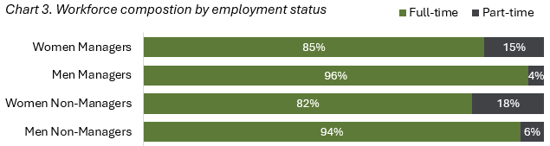

Future Steps
While our gender pay gap results demonstrate significant progress over recent years, we acknowledge that closing the gender pay gap requires sustained effort and dedication.
Key actions include:
- Increasing representation of women in Information, Communications and Technology (ICT) roles.
- Promoting flexible working arrangements and employer-funded parental leave for staff of all genders.
- Completing gender pay gap data analysis on a regular basis to identify trends and potential disparities.
- Communicating DEWR’s family and domestic violence framework to ensure employees can access assistance safely and confidently.
- Maintain memberships with peak diversity organisations, including the Diversity Council of Australia, to inform best practice and strengthen DEWR’s inclusion activities.
- Enhancing mentoring opportunities to improve participation, empowering employees to develop their leadership skills, seek career support and facilitate two-way learning.

