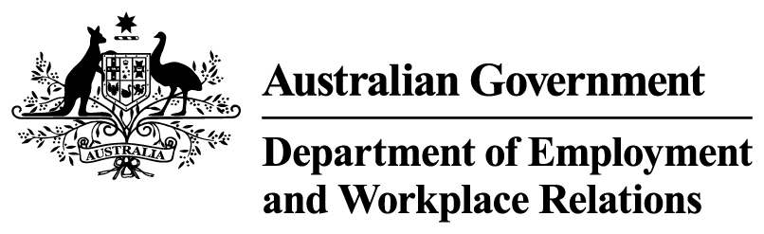


A new approach to supporting people to find work
The government is replacing the one-size-fits-all employment service model with an approach that matches the level and type of support to a person’s need.
Three new service streams will be introduced to replace Workforce Australia.
The new service streams will be calibrated to a person’s needs and support will be provided which reflects their circumstances and distance from the labour market.

Online and brief intervention services – Stream 1
Services will be available online and over the phone for people who are most work ready and digitally literate.
Services will be delivered through a redesigned, participant-led online platform, supported by targeted assistance where needed. Participants will be able to access supports to help them move into work quickly.
New features will include personalised career mapping and guidance tools, and more proactive supports.
This will make it easier for people to move quickly into employment without the need for a provider.

Targeted provider services – Stream 2
Targeted provider-led services will be available for people who have some barriers to finding work.
This service will provide personalised and targeted supports, stronger links to training and work-ready supports, and personalised coaching.
Providers will deliver quality services, support sustainable employment, and engage effectively with employers.

Intensive services – Stream 3
Intensive services will be available for people who have complex barriers to finding work.
This service will provide coordinated support delivered by skilled case managers.
Supports will include mentoring, work-like experience, volunteering, and support to navigate other local services to address barriers to employment.
The focus will be on building confidence, capability and stability to support progression towards suitable employment.
Services will be delivered by community organisations with strong connections to local services, employers and communities.

