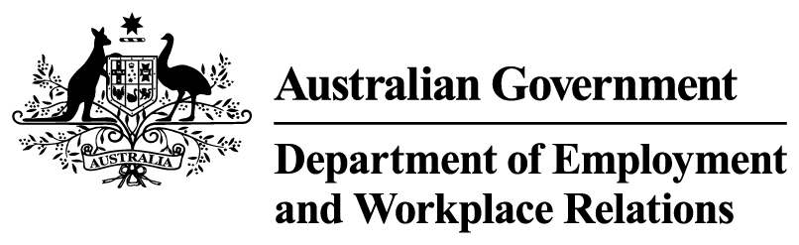


Investments in reform
in Budget 2026-27
The government has announced a $312.1 million package of measures to deliver early, significant changes to support a reformed employment services system and improve customer experience.
This includes:
- $205.5 million over 5 years to take first steps towards a redesigned, participant-led online service. This includes:
  - improving the digital platform’s accessibility, personalisation and usability
  - providing more proactive support for online participants
  - trialling a fully virtual digital advisory service for parents
- $27.5 million over 4 years to develop and trial a new initial assessment and triaging process.
  - New tools will be designed to improve people’s experience of entering the system.
  - The pathway from entry to services will be simplified.
  - Information gathered will also inform the activities a person will undertake and how they are serviced.
- $52.6 million over 5 years to fund the early targeted rollout of Intensive services – Stream 3, targeting those furthest from the labour market.
  - People will benefit from highly skilled case managers and strong connections to local services and supports, employers and communities.
  - Activities offered may include mentoring, work-like experiences, volunteering, skills development and specialist support.
  - Early rollout is expected to commence in late 2026 in several locations.
- $26.5 million over 3 years to increase resourcing for the National Customer Service Line to support job seekers and employers.
  - The National Customer Service Line will have greater capacity to meet demand for services.
  - System enhancements will enable people to access the information they need.

