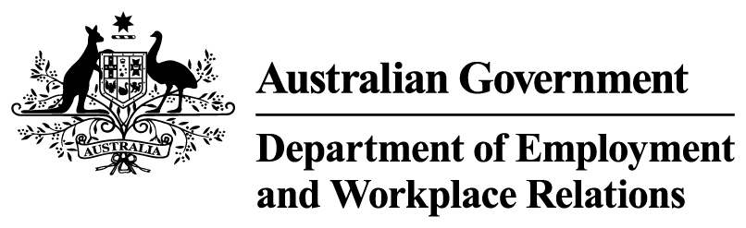


The future system
We need to move on from a one-size-fits-all employment service system. The government’s vision for employment services reform is to deliver a system that gives people the best opportunity to secure a well-paid job.
This vision is underpinned by 4 core ideals:
- Employment is the primary goal.
- Supports are meaningful to the participant
- An easy to navigate, high quality consistent service offering
- The system keeps improving over time
These core ideals underpin a service model of 3 distinct service streams with different service offerings:
- Online and brief intervention services – Stream 1 for people closest to the labour market. People in this stream will receive targeted support and brief interventions, focused on rapid reconnection to employment.

- Targeted provider services – Stream 2 for people moderately close to work. People in this stream will receive personalised servicing focused on active job coaching, employability support and stronger connections to skills development and short-term training that aligns with local labour market demand.

- Intensive services – Stream 3 for people furthest from the labour market, including people with complex barriers. People in this stream will receive more intensive servicing which has a greater emphasis on sustained engagement, mentoring and staged pathways that support participants to build confidence, capability and readiness for employment over time.
Each service stream is designed to respond to the needs of the people in that stream, with different mutual obligation requirements and different incentives.
The service streams will be funded to reflect the intensity of support someone needs to progress to sustainable employment.

