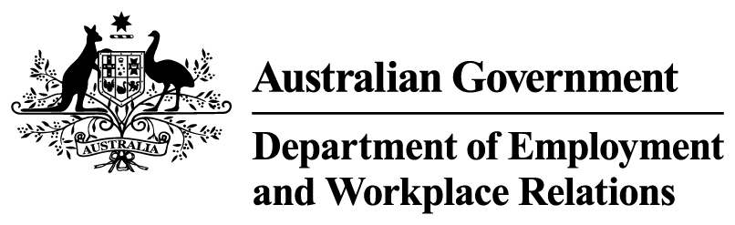


Employment Goal Plan
The new service model will introduce an Employment Goal Plan to support high quality, tailored servicing across all streams.

What is changing
A new Employment Goal Plan will be introduced to replace the Job Plan.
The Employment Goal Plan will bring together a person’s:
- employment goals,
- activities and
- mutual obligations requirements
This will create a clear servicing strategy to support them to move into work.
It will consider the jobs available in their community and the skills a person needs to gain suitable employment.
The Employment Goal Plan will be updated regularly to reflect changes in personal circumstances and where a participant is at in their employment journey.
This Employment Goal Plan will move with a person if they change providers or services, so people only have to tell their story once.
People across all service streams will have an Employment Goal Plan, with a simplified version available for those in online services.

Why this change is needed
Currently, when people enter employment services, they need to agree to a Job Plan.
The Job Plan is a static document outlining what a participant must do to receive their income support. It does not help a person find work.

