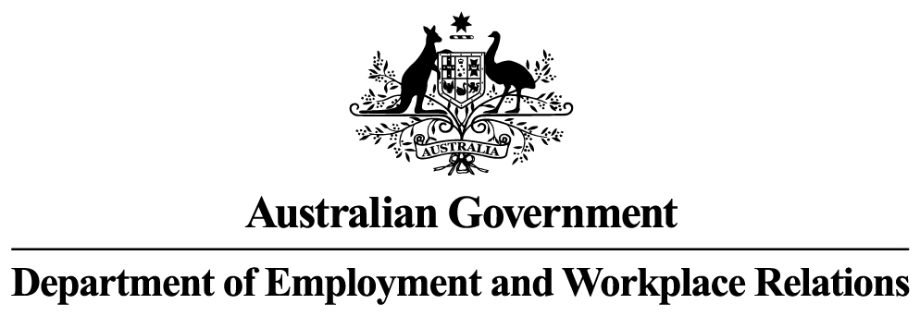

**Monthly Leading indicator of employment**

***September 2023***

RESULTS

The Monthly Leading Indicator of Employment (the Indicator) has fallen for the eighteenth consecutive month in September 2023. The Indicator’s decline in September is attributed to falls in three of the five Indicator components—the NAB Forward Orders Index, China’s Purchasing Managers Index for Manufacturing Output and the Westpac-Melbourne Institute Leading Index of Economic Activity.

There was a confirmed peak in the Indicator in March 2022, signalling that employment growth is expected to slow down to below its long-term trend rate of 2.2 per cent per annum in coming months. Employment growth (in trend terms) has been slowing gradually from 4.4 per cent over the year to September 2022 to 2.9 per cent over the year to August 2023.

Levels of Leading Indicator of Employment & Cyclical Employment

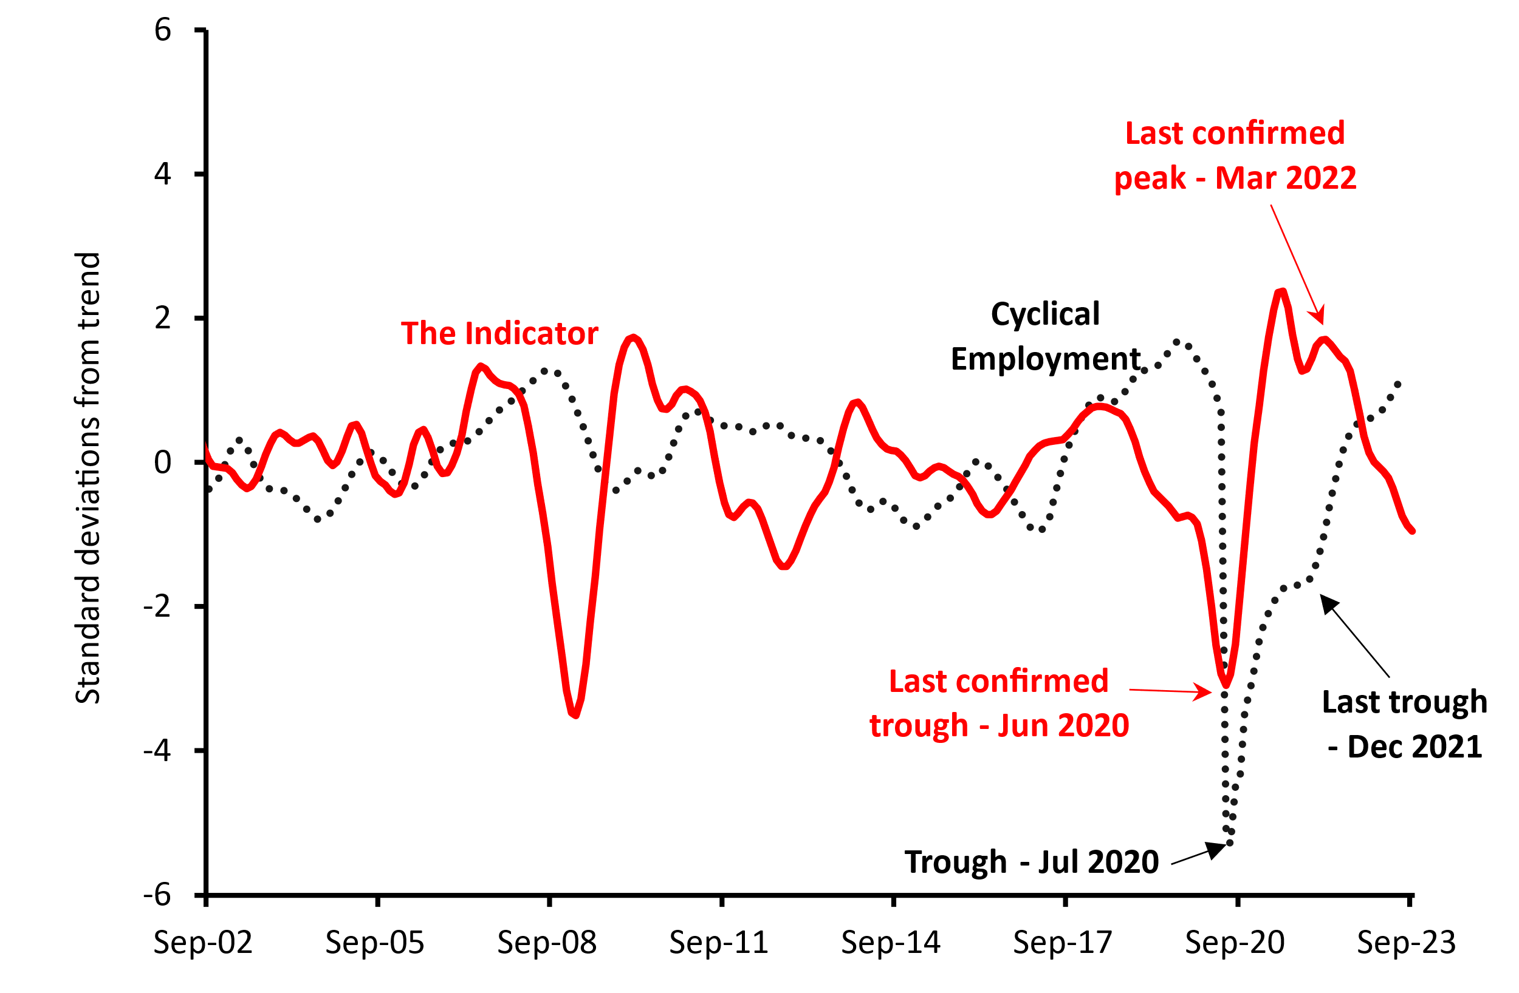

# Monthly CHANGES IN Value of Leading Indicator *

|  |  |  |  |  |  |  |
| --- | --- | --- | --- | --- | --- | --- |
|  | Apr-23 | May-23 | Jun-23 | Jul-23 | Aug-23 | Sep-23 |
| **Change in Leading Indicator** | -0.09 | -0.146 | -0.206 | -0.183 | -0.124 | -0.087 |
| *monthly changes in standard deviations from the cyclical trend | | | | | | |

# Components of the Leading Indicator **

|  |  |  |  |
| --- | --- | --- | --- |
| **Series** | **Contribution to Change in Leading Indicator** | | |
| **Jul-23** | **Aug-23** | **Sep-23** |
| **China’s Purchasing Managers Index for Manufacturing Output (September 2023 release)** | -0.071 | -0.040 | -0.035 |
| **US Yield Difference**  **(10-year vs. 3-month interest rates, September 2023 release)** | -0.002 | 0.012 | 0.015 |
| **NAB Forward Orders Index (August 2023 release)** | -0.080 | -0.067 | -0.055 |
| **Westpac-Melbourne Institute Leading Index of Economic Activity (August 2023 release)** | -0.035 | -0.035 | -0.031 |
| **Westpac-Melbourne Institute Consumer Sentiment Index**  **(August 2023 release)** | 0.005 | 0.007 | 0.020 |
| ***Change in Leading Indicator:*** | -0.183 | -0.124 | -0.087 |

**Note: The cyclical components of each series contribute to the monthly movements in the Indicator. Each series in the Indicator has the same weight of 20 per cent. The units of measurement for the contributions to change in the Indicator are monthly changes in the standard deviation from the long-term trend. NBSC stands for the National Bureau of Statistics of China.

### Technical Notes

The Indicator is designed to provide advance warnings of turning points in ‘cyclical employment’ (i.e. the deviation of the centred one-year trend in employment from the centred six-year trend). The average lead time of the Indicator over the series (i.e. the time between a peak or trough in the Indicator and the corresponding peak or trough in cyclical employment) is over a year. A ‘turning point’ in the Indicator is said to be confirmed when there are six consecutive monthly movements in the same direction after the turning point. A fall (or rise) in the Indicator does not necessarily mean that the level of employment will immediately fall (or rise). Rather, it implies that after a lag, the growth rate of employment may fall below (or rise above) its centred six-year trend rate.

The Indicator is the average of the normalised and standardised cyclical elements of the five series in the table above, which have been shown to lead cyclical employment consistently over a long period. The cyclical components and the composite Indicator for previous months are subject to revision when new statistics are incorporated.

The date of the issue of the Indicator, and the labels for the x-axis of the chart, relate to the month the Indicator is released. The data used to derive the cyclical employment, however, are two months behind the release month for the Indicator. The data for the NBSC Purchasing Managers’ Index and US Yield Difference are one month behind their release dates, while data for the other three component series are two months behind their release dates.

#### RELEASE DETAILS

The Indicator is available on the Department of Employment and Workplace Relations website at approximately 2pm AEDT on the day of its release. The next issue is scheduled for release on Wednesday 18 October 2023.

Contact Officer

Mr Kerry Guan

Economic Analysis Section, Department of Employment and Workplace Relations

Email: [**leading.indicator@dewr.gov.au**](mailto:leading.indicator@dewr.gov.au)