Quick Guide – Eligibility
This quick guide provides information on the student eligibility requirements for VET Student Loans

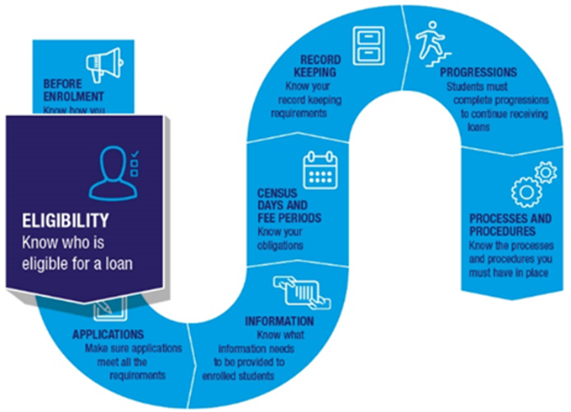

Student eligibility requirements

Eligibility Tool
Prospective students can check their eligibility for a VET Student Loan using the VET Student Loans Eligibility Tool on the My Skills website.

Citizenship requirements
Students must be:
- an Australian citizen or
- a permanent humanitarian visa holder who is usually resident in Australia or
- a qualifying New Zealand citizen.
You must collect and verify information to confirm that students meet these criteria.

Evidence needed to confirm Australian citizenship
A current Australian passport is suitable evidence of Australian citizenship for VSL purposes. If a student does not have a current Australian passport the evidence needed to confirm their citizenship will differ depending on the situation. See section 4.7.1 Student Eligibility for Loans of the VET Student Loans Manual for Providers for more information.

Permanent Humanitarian Visa Holders
You should contact the Department of Home Affairs to confirm if the visa class a student holds is a permanent humanitarian visa.

Qualifying New Zealand citizen
To be a qualifying New Zealand citizen a student must:
- hold a Special Category visa and
- have been usually resident in Australia for at least 10 years and
- have been a dependent child when they were first usually resident in Australia and
- have been in Australia for periods totalling 8 years during the previous 10 years and
- have been in Australia for periods totalling 18 months during the previous 2 years.
Most New Zealand citizens who arrive in Australia are holders of a Special Category visa. This visa allows its holder to visit, live and work in Australia indefinitely.

Permanent residents or visa holders
Other permanent residents or visa holders are not eligible for VET Student Loans.

HELP balance
Students need a HELP balance of more than $0 to be eligible for VET Student Loans. There are 2 websites to help students keep track of this.

MyHELPbalance
myHELPbalance keeps track of how much a student has borrowed under the various HELP loans from 2005 onwards. It shows loans received under HECS-HELP, OS-HELP, FEE-HELP, VET FEE-HELP and VET Student Loans but not SA-HELP. myHELPbalance does not show how much VET Student Loan debt (VETSL debt) has been repaid or what is owed to the Australian Taxation Office (ATO).
Students can use their Commonwealth Higher Education Student Support Number (CHESSN), their provider issued student identity number and other personal details to access myHELPbalance.
Students are able to see details of their HELP and VSL transactions when they access myHELPbalance including the name of the VSL (or Higher Education) approved course provider they studied with, the course code and unit code details, as well as the loan amounts and any loan fees they have incurred for each unit.
If the commencing student has not previously studied, and is a new student commencing tertiary study for the first time, the student’s USI will need to have been reported and verified in TCSI before the student is able to log into myHELPbalance.gov.au.
You can log into myHELPbalance.gov.au using your PRODA credentials and look up a student’s details. If the student has not previously drawn on their HELP loan limit you will see that they have the full HELP balance available. myHELPbalance will display the remaining available HELP balance where a student has already used some of their available HELP balance.

MyGov
myGov allows students to get more information about their HELP debt. Once a student’s myGov account is linked to the ATO it shows:
- all current VETSL debts
- any indexation that has been applied to the debt
- any repayments made to show how much is still owed.

Enrolment in an approved course with an approved provider
A VET Student Loan is only available for approved courses at the diploma, advanced diploma, graduate certificate and graduate diploma level. Approved courses are listed in Schedule 1 of the VET Student Loans (Courses and Loan Caps) Determination 2016.
Only students studying with an approved course provider are eligible for a VET Student Loan.

Study at a campus primarily in Australia
Students cannot access a VET Student Loan for courses taught primarily at an overseas campus.

Academic suitability
Students must be academically suitable to be eligible for a VET Student Loan. To show their academic suitability students can provide either:
- a copy of their Year 12 Certificate, or
- their International Baccalaureate Diploma Programme (IB) diploma, or
- a copy of a certificate showing they have been awarded a qualification at level 4 or above in the Australian Qualifications Framework (AQF) (where the language of instruction was English) or at a level in a framework that preceded the AQF and is equivalent to level 4 or above in the AQF
If students cannot provide this evidence they must sit an approved Language, Literacy and Numeracy (LLN) test. They will be considered academically suitable if the test shows them to be competent at Exit Level 3 in the Australian Core Skills Framework in both reading and numeracy.
You must report the results of an LLN test to the student as soon as practicable after the test.
A list of approved LLN tests, as well as information on how to get a test approved, can be found on Language, Literacy and Numeracy (LLN) tool information.

Tax File Number (TFN)
To be eligible for a VET Student Loan a student must have a valid TFN.
If a student cannot remember their TFN they should call the Australian Taxation Office (ATO) on 13 28 61. You cannot access a student’s TFN directly from the ATO.
A Certificate of Application for a TFN is required if students do not have a TFN. This certificate is available from the ATO after the student has applied for a TFN. If a Certificate of Application is used this must be attached to the student’s electronic Commonwealth Assistance Form (eCAF).
Once the student receives their TFN from the ATO they will need to contact you immediately. You should re-open the eCAF to let the student update their TFN.
To do this put the eCAF into ‘revision’ status. The student will receive an email telling them they can update their eCAF. After entering their TFN the student resubmits the eCAF.
This process must be done within 6 weeks of the ‘First census day of the loan application’ in the eCAF., The student will not be able to use the loan to pay their fees without a TFN.
A student’s TFN and personal information will be verified by the ATO once it is submitted. If the TFN cannot be verified by the unit’s census day the student will be ineligible for a VET Student Loan.

Unique Student identifier (USI)
Students need a USI to be eligible for a VET Student Loan. Students can create a USI at Unique Student Identifier.

Required documentation
Students must provide appropriate evidence to show their eligibility for a VET Student Loan.
You must retain all required information and documentation collected in relation to a VET Student Loan application for 5 years. Providers must be able to produce this evidence and documentation for us on request.

Further information
For further information on student eligibility requirements, refer to the following resources:
- VET Student Loans Manual for Providers (see Chapter 4.7 Student administration)
- VET Student Loans Information Booklet
- For the legislation governing citizenship and residency requirements, refer to section 11 of the
VET Student Loans Act 2016, and section 85 of the VET Student Loan Rules 2016.

For students that have attained a Victorian Certificate of Applied Learning (VCAL) – only the VCAL Senior and VCAL Intermediate levels meet this requirement.

