Contract regions and service providers for Skills for Education and Employment (SEE) program
There are 58 SEE contract regions for the SEE program. These regions align with the Australian Bureau of Statistics (ABS) Australian Statistical Geography Standard (ASGS) regions which are used by the Department of Education, Skills and Employment and the Department of Human Services to manage service delivery contracts.
SEE program services are delivered by a multi-provider model, so there may be more than one provider in some contract regions.
One service provider, TAFE SA, has been contracted to deliver SEE program distance learning services nationally.
Contract Regions
New South Wales / Australian Capital Territory Contract Regions 4
Sydney East Metro 5
Sydney Greater West 6
Sydney North and West 7
Sydney South West 8
Capital Region 9
Central West 10
Far West Orana 11
Hunter 12
Illawarra South Coast 13
Mid North Coast 14
Murray Riverina 15
New England and North West 16
North Coast 17
Remote New South Wales 18
Victoria Contract Regions 19
Inner Metro Melbourne 20
North East Melbourne 21
North West Melbourne 22
South East Melbourne and Peninsula 23
West Melbourne 24
Ballarat 25
Barwon 26
Bendigo 27
Gippsland 28
Goulburn / Murray 29
South Coast of Victoria 30
Wimmera Mallee 31
Queensland Contract Regions 32
Brisbane South East 33
Cairns 34
Darling Downs 35
Fitzroy 36
Gold Coast 37
Mackay 38
Somerset 39
Townsville 40
Wide Bay and Sunshine Coast 41
Wivenhoe 42
West Queensland 43
Central Queensland 44
Far North Queensland 45
South Australia Contract Regions 46
Adelaide North 47
Adelaide South 48
Mid North South Australia 49
Murray and South East 50
North West Country 51
Remote South Australia 52
Western Australia Contract Regions 53
Perth North 54
Perth South 55
Great Southern Western Australia 56
South West Western Australia 57
Kimberley 58
Pilbara 59
Gascoyne 60
Kalgoorlie 61
Tasmania Contract Regions 62
South Tasmania 63
North & North West Tasmania 64
Northern Territory Contract Regions 65
Darwin 66
Central Northern Territory 67
Top End Northern Territory 68

New South Wales / Australian Capital Territory Contract Regions
Contract Region | Service Provider | Region Type
Sydney East Metro | MTC Australia | Metropolitan
Sydney Greater West | MTC Australia  Navitas Skilled Futures | Metropolitan
Sydney North and West | MTC Australia | Metropolitan
Sydney South West | MTC Australia  Navitas Skilled Futures | Metropolitan
Capital Region | MAX Solutions | Regional
Central West | TAFE NSW | Regional
Far West Orana | TAFE NSW | Regional
Hunter | MAX Solutions | Regional
Illawarra South Coast | MAX Solutions | Regional
Mid North Coast | Nortec Training Solutions | Regional
Murray Riverina | TAFE NSW | Regional
New England | TAFE NSW | Regional
North Coast | Nortec Training Solutions | Regional
Remote NSW | TAFE NSW | Remote

Sydney East Metro
Region Name | Sydney East Metro
Region Type | Metropolitan
Service Provider | MTC Australia
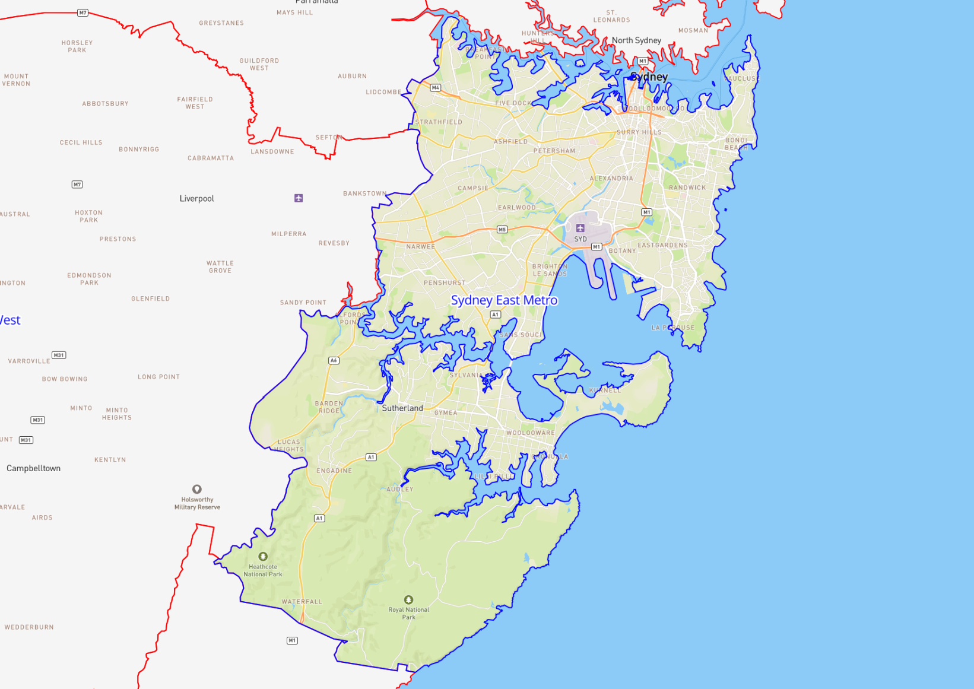

Sydney Greater West
Region Name | Sydney Greater West
Region Type | Metropolitan
Service Provider | MTC Australia  Navitas Skilled Futures
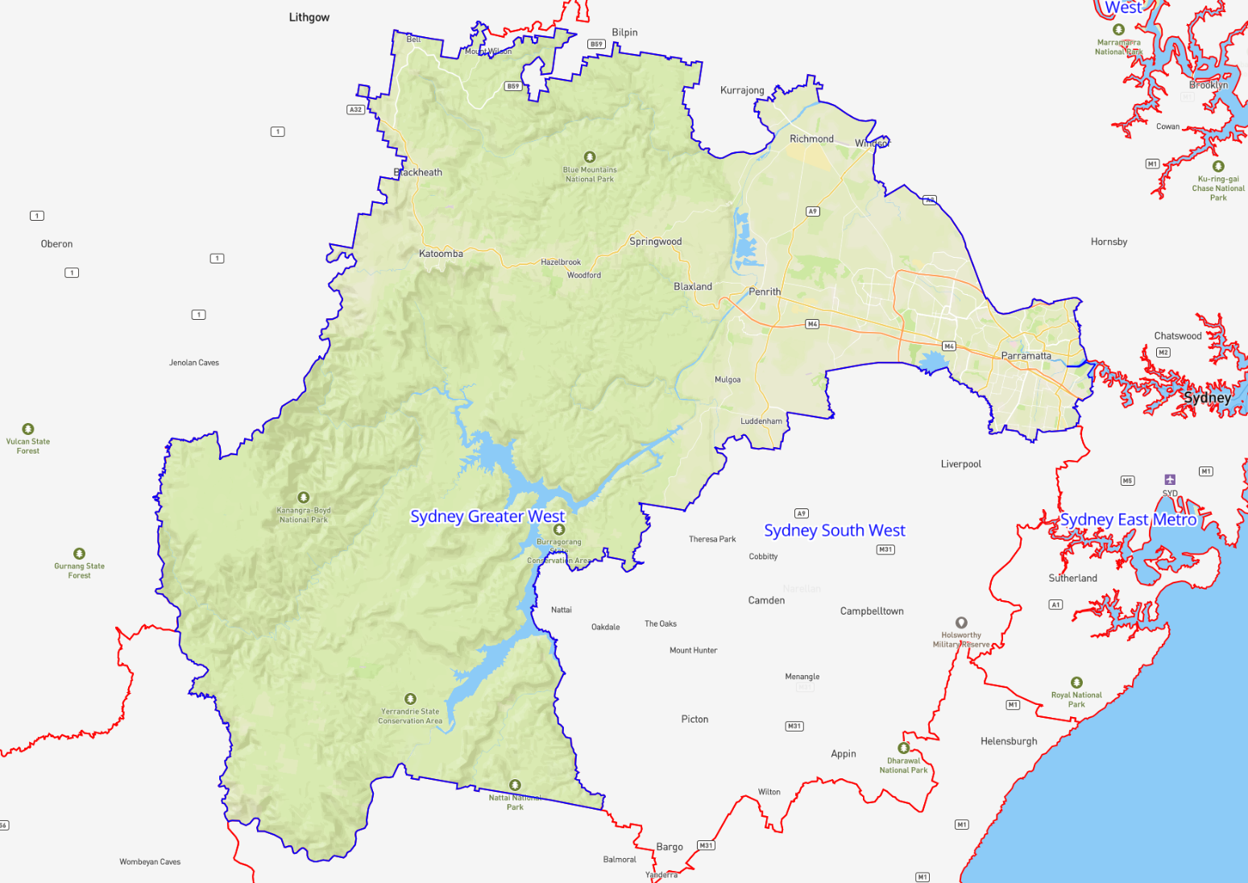

Sydney North and West
Region Name | Sydney North and West
Region Type | Metropolitan
Service Provider | MTC Australia

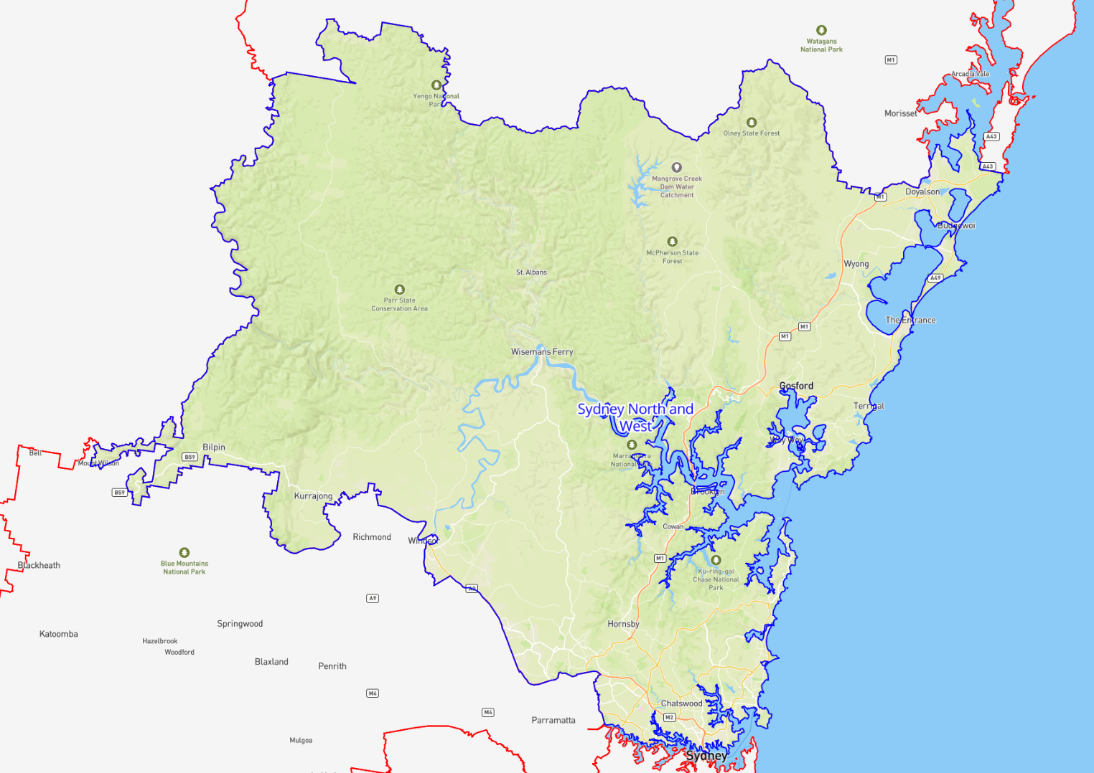

Sydney South West
Region Name | Sydney South West
Region Type | Metropolitan
Service Provider | MTC Australia  Navitas Skilled Futures

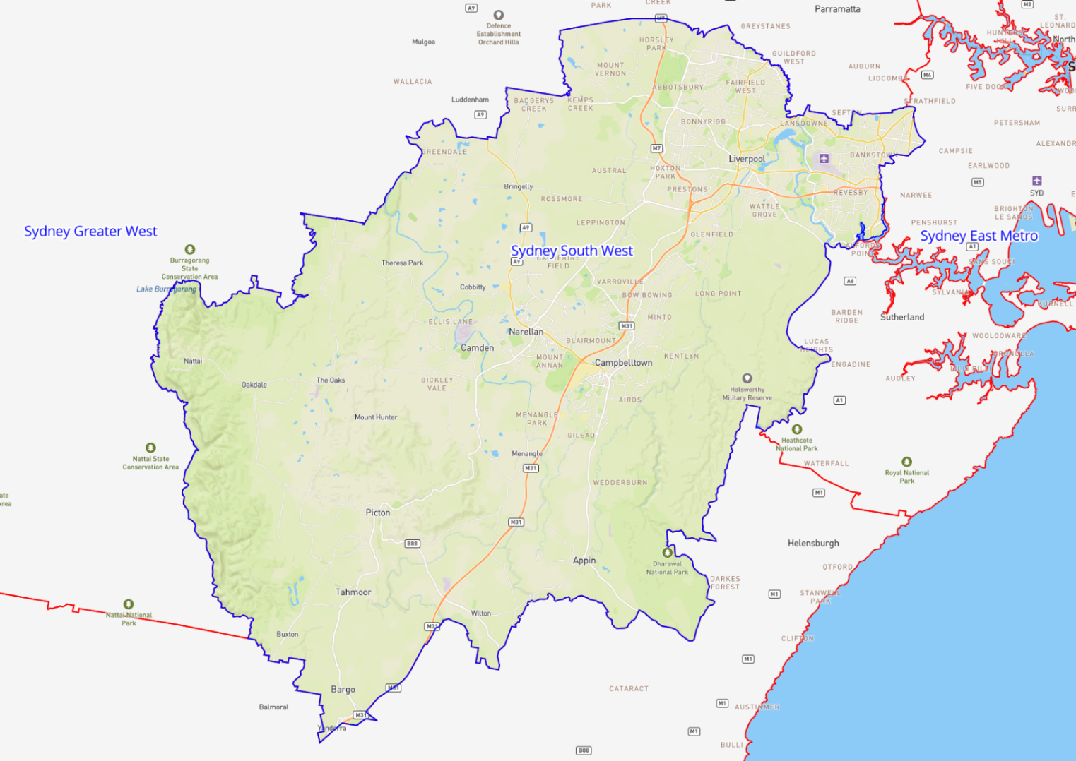

Capital Region
Region Name | Capital Region
Region Type | Regional
Service Provider | MAX Solutions

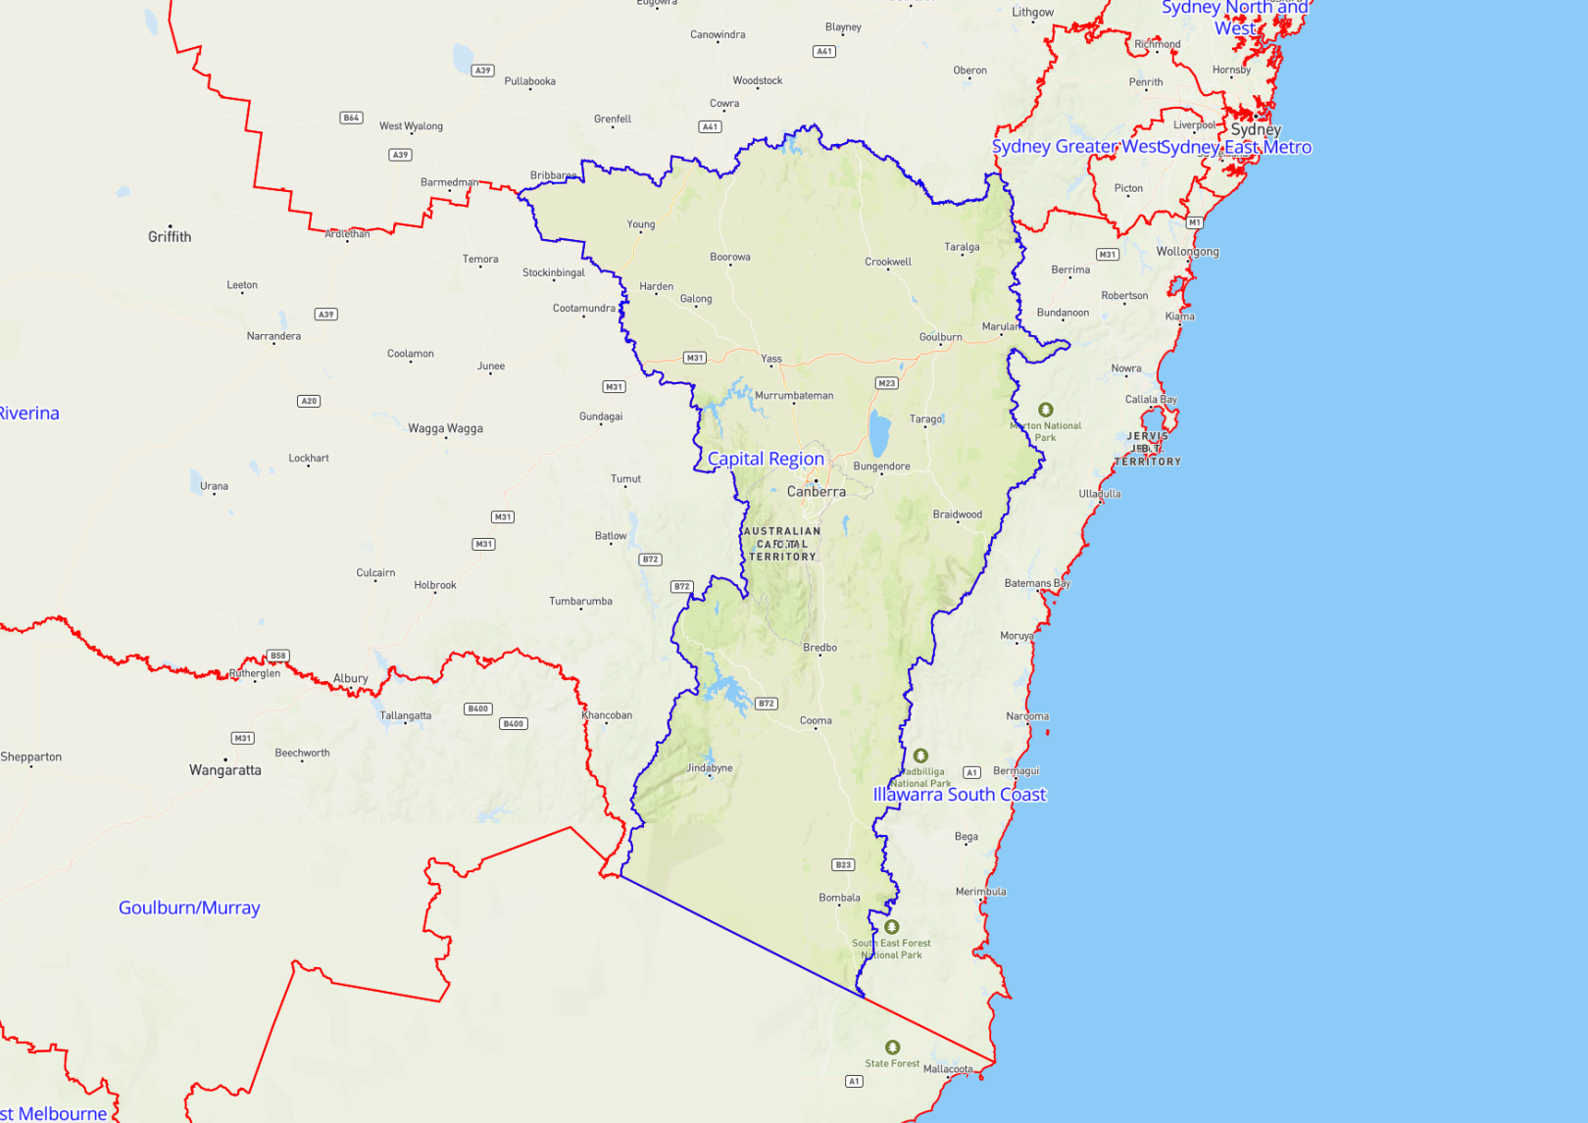

Central West
Region Name | Central West
Region Type | Regional
Service Provider | TAFE NSW

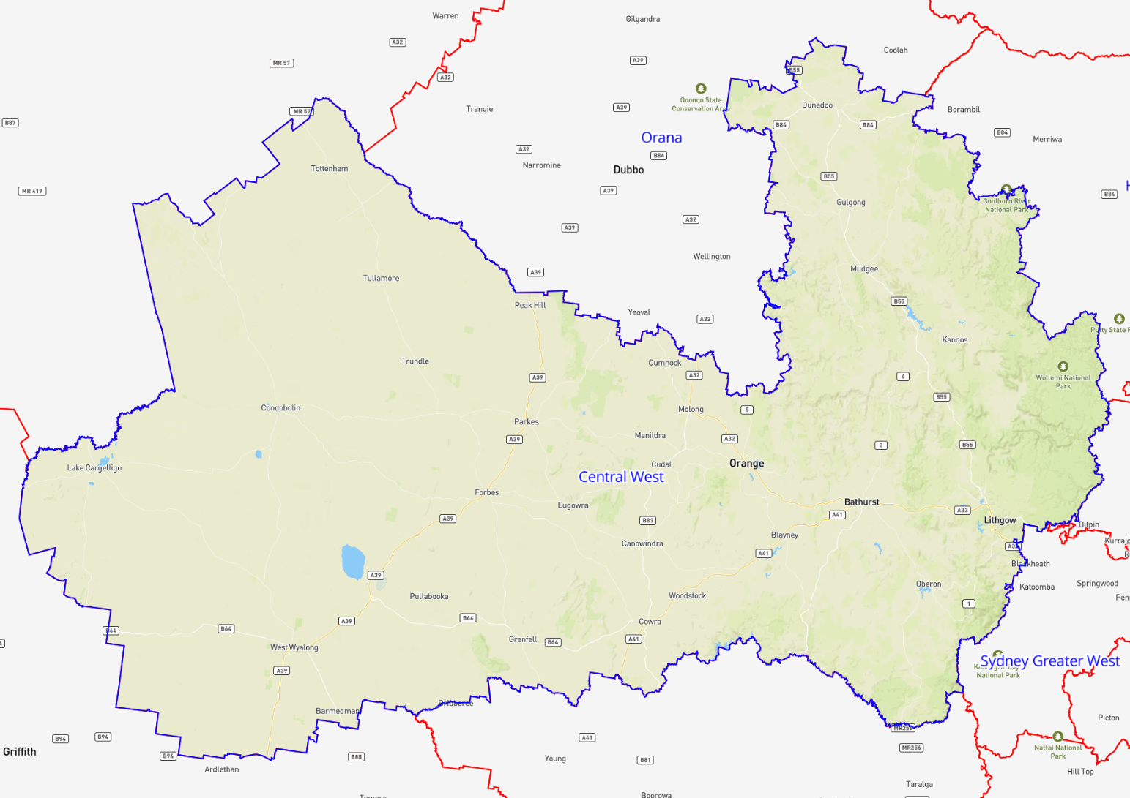

Far West Orana
Region Name | Far West Orana
Region Type | Regional
Service Provider | TAFE NSW

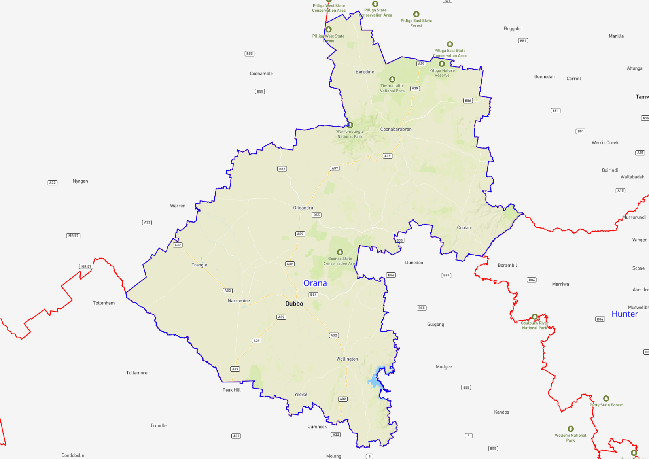

Hunter
Region Name | Hunter
Region Type | Regional
Service Provider | MAX Solutions

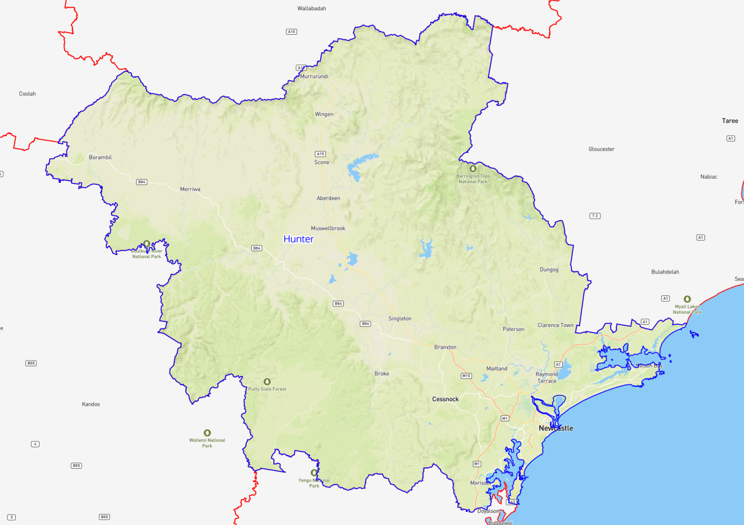

Illawarra South Coast
Region Name | Illawarra South Coast
Region Type | Regional
Service Provider | MAX Solutions

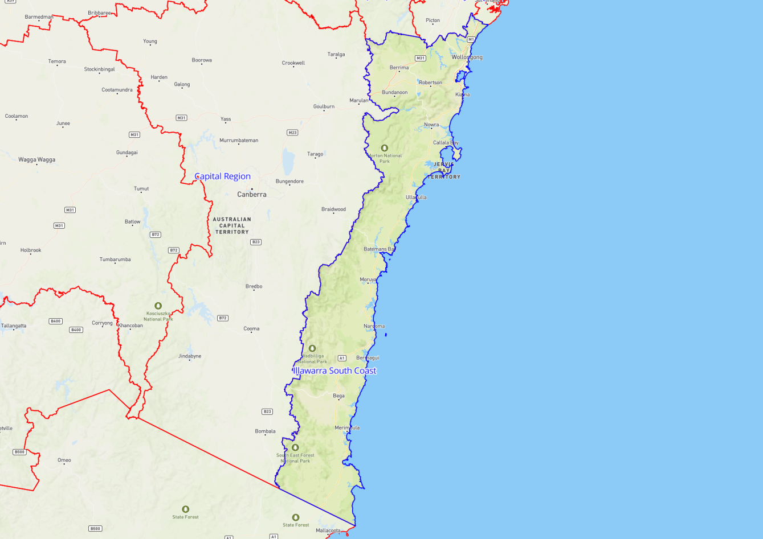

Mid North Coast
Region Name | Mid North Coast
Region Type | Regional
Service Provider | Nortec Training Solutions

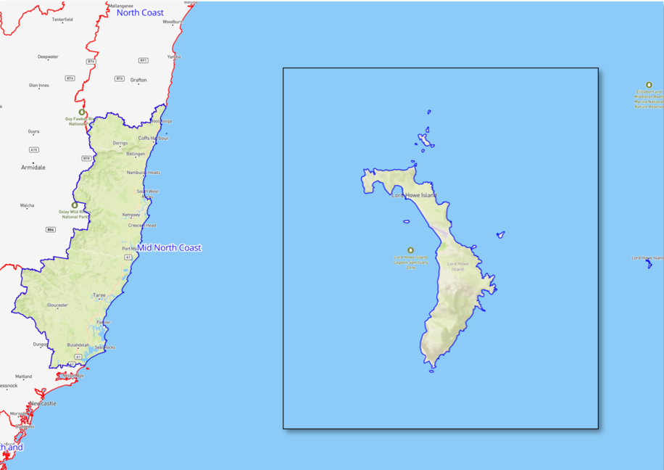

Murray Riverina
Region Name | Murray Riverina
Region Type | Regional
Service Provider | TAFE NSW

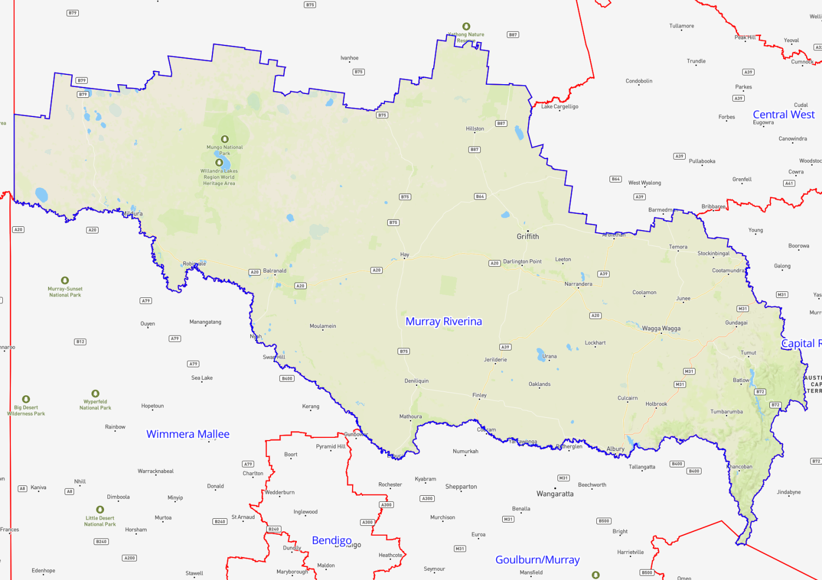

New England and North West
Region Name | New England and North West
Region Type | Regional
Service Provider | TAFE NSW

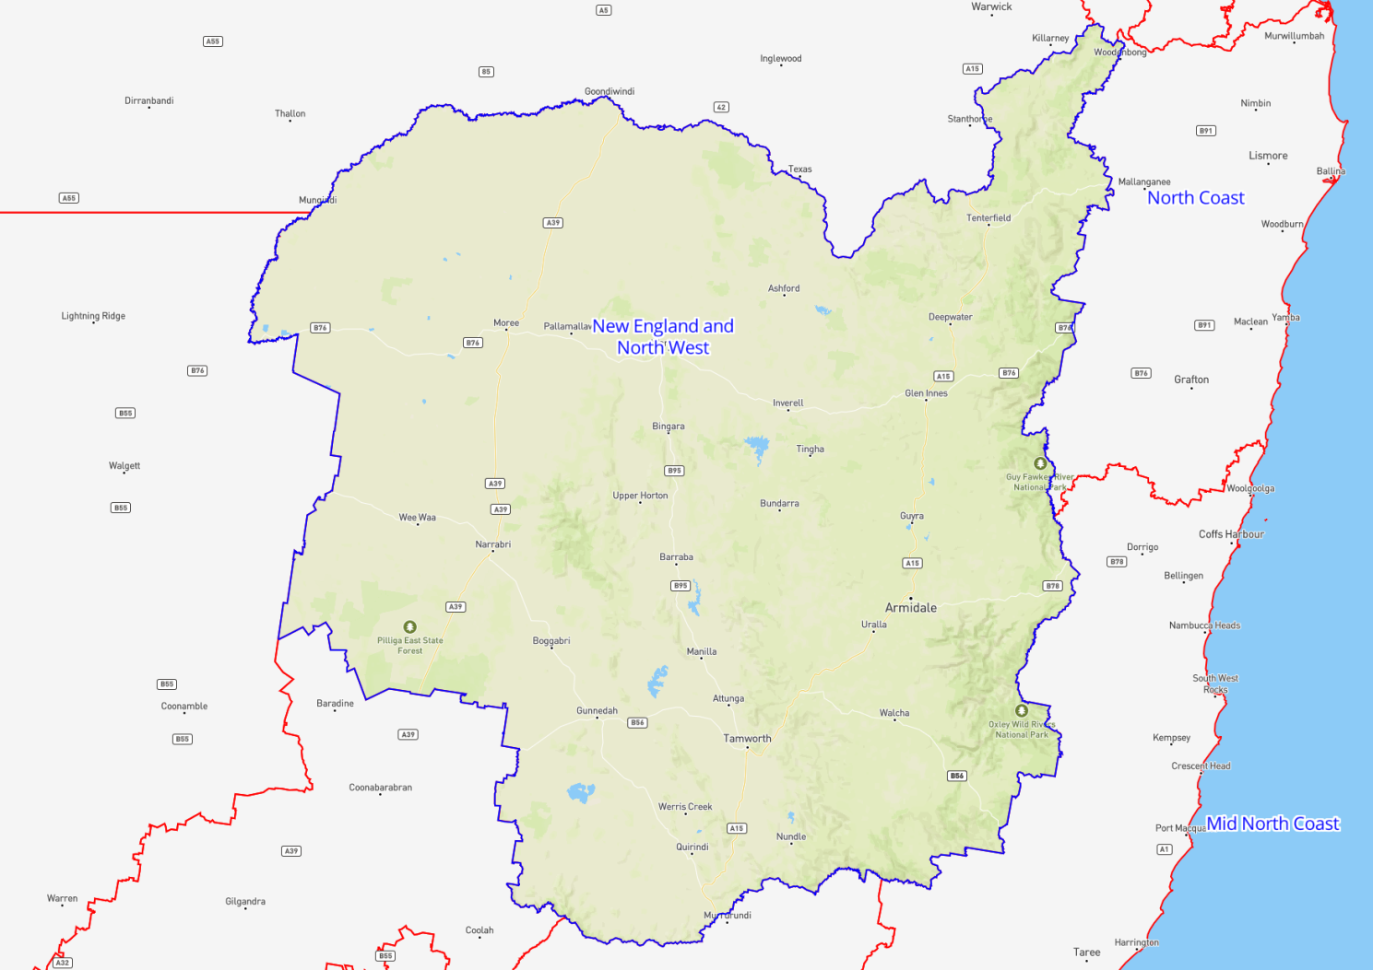

North Coast
Region Name | North Coast
Region Type | Regional
Service Provider | Nortec Training Solutions
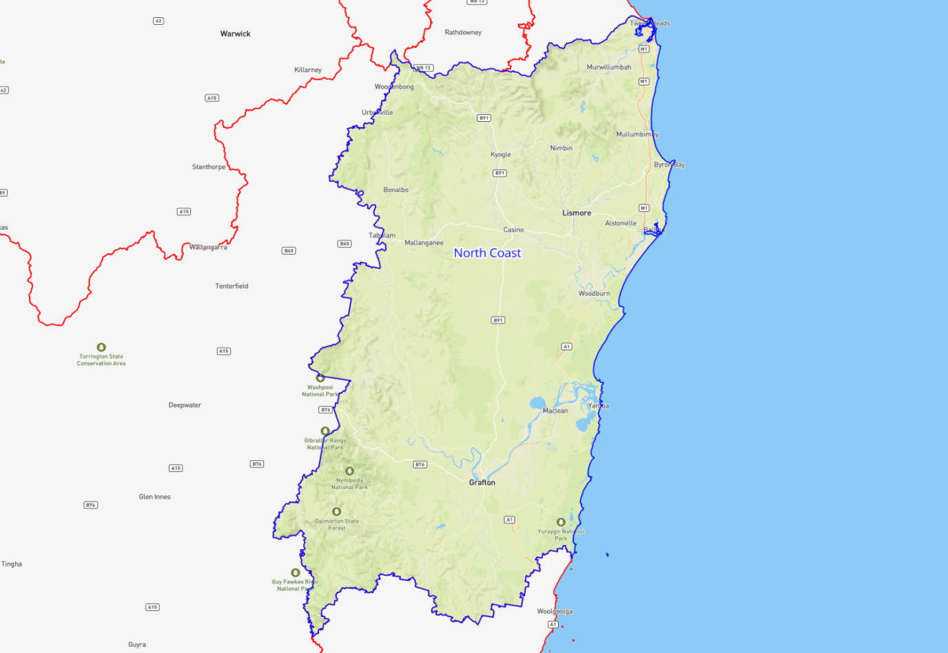

Remote New South Wales
Region Name | Remote New South Wales
Region Type | Remote
Service Provider | TAFE NSW

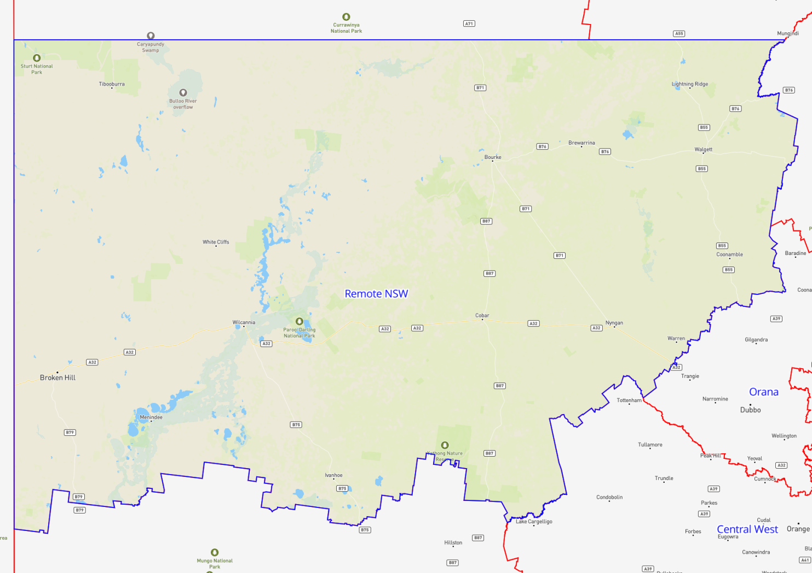

Victoria Contract Regions
Contract Region | Service Provider | Region Type
Inner Metro Melbourne | AMES Australia  Learning for Employment (LfE) | Metropolitan
North East Melbourne | Melbourne Polytechnic  Swinburne University of Technology | Metropolitan
North West Melbourne | Learning for Employment (LfE) | Metropolitan
South East Melbourne and Peninsula | AMES Australia  MAX Solutions | Metropolitan
West Melbourne | Learning for Employment (LfE) | Metropolitan
Ballarat | Learning for Employment (LfE) | Regional
Barwon | Learning for Employment (LfE) | Regional
Bendigo | Melbourne Polytechnic | Regional
Gippsland | Swinburne University of Technology | Regional
Goulburn / Murray | AMES Australia | Regional
South Coast of Victoria | TAFE SA (distance learning only) | Regional
Wimmera Mallee | AMES Australia | Regional

Inner Metro Melbourne
Region Name | Inner Metro Melbourne
Region Type | Metropolitan
Service Provider | AMES Australia  Learning for Employment (LfE)

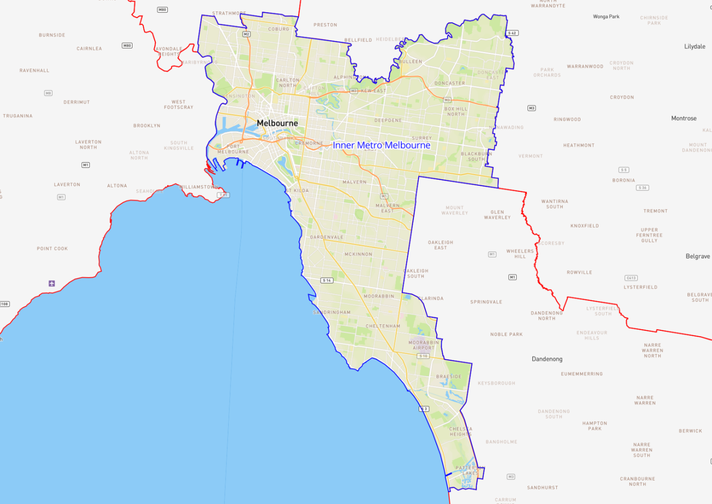

North East Melbourne
Region Name | North East Melbourne
Region Type | Metropolitan
Service Provider | Melbourne Polytechnic  Swinburne University of Technology

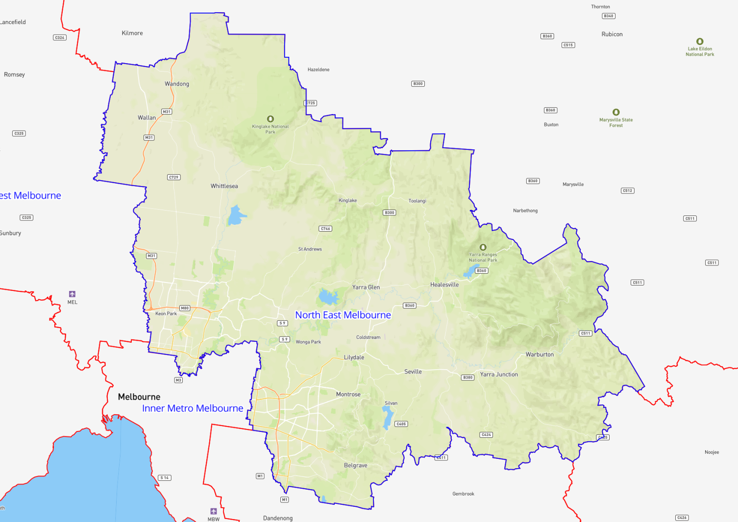

North West Melbourne
Region Name | North West Melbourne
Region Type | Metropolitan
Service Provider | Learning for Employment (LfE)

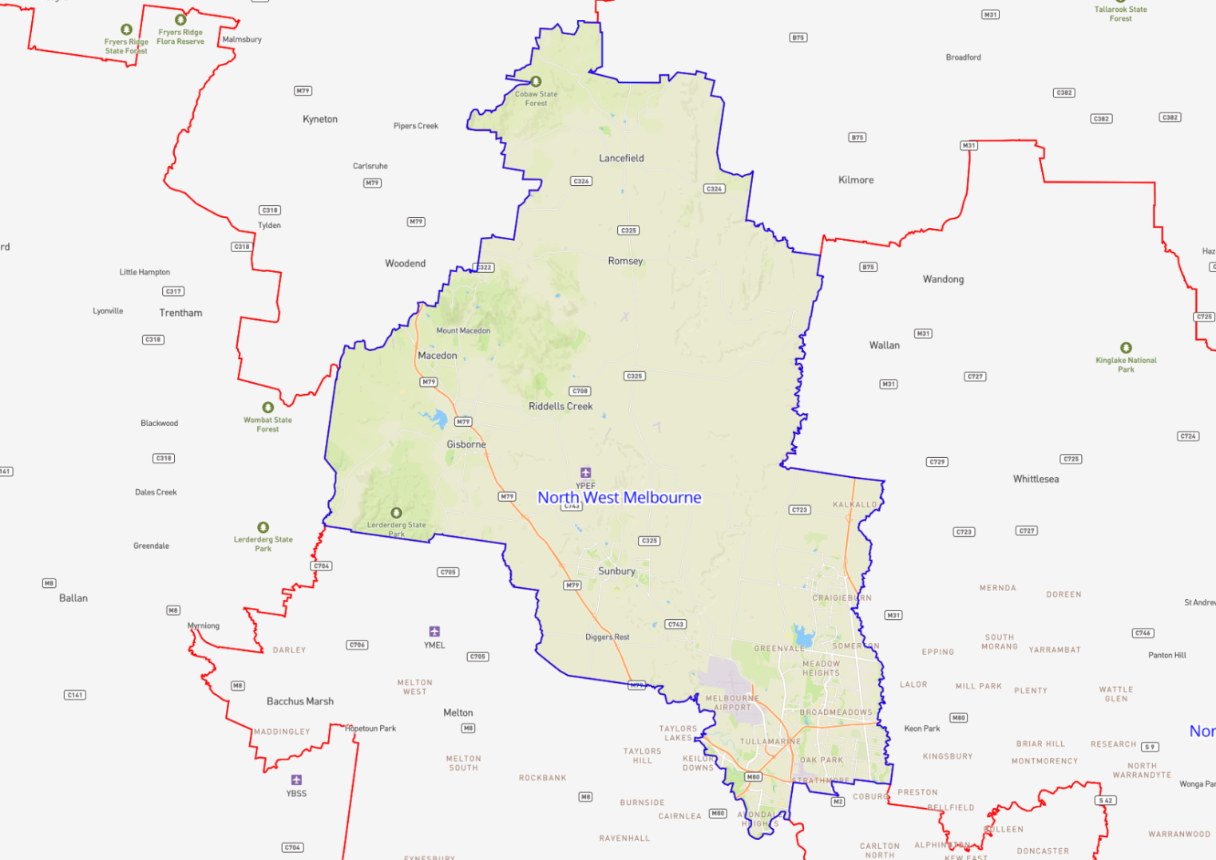

South East Melbourne and Peninsula
Region Name | South East Melbourne and Peninsula
Region Type | Metropolitan
Service Provider | AMES Australia  MAX Solutions

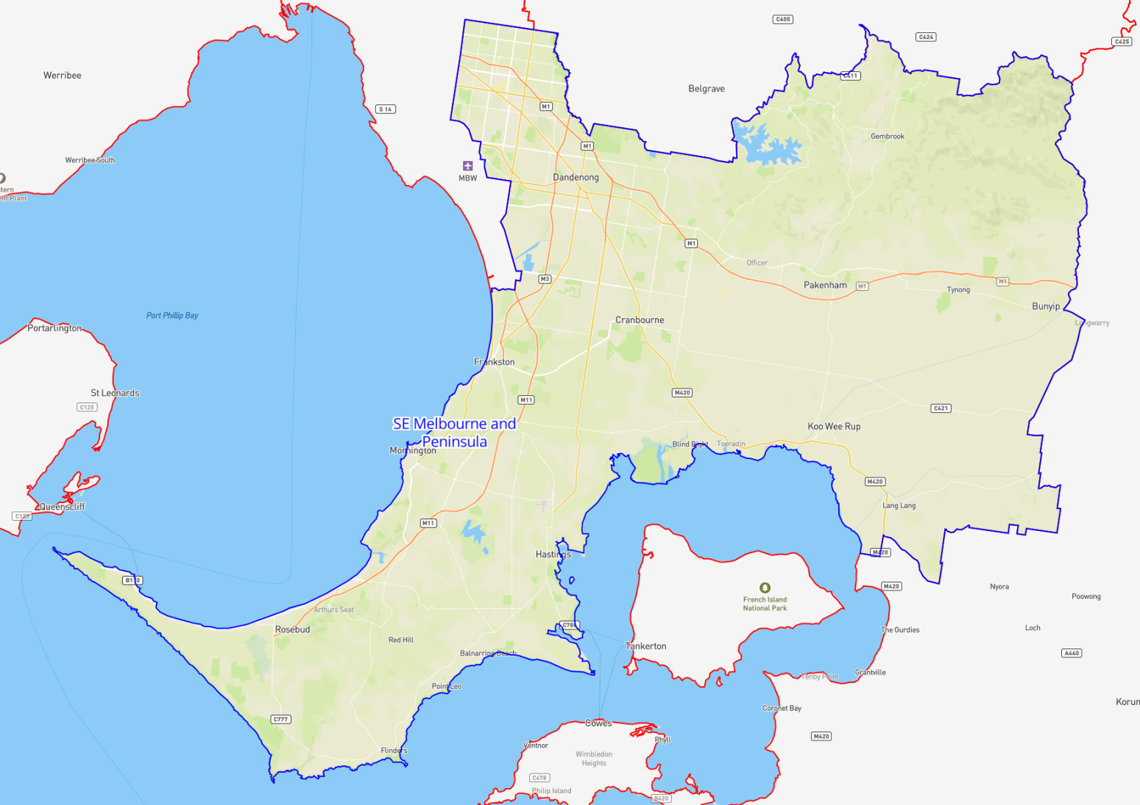

West Melbourne
Region Name | West Melbourne
Region Type | Metropolitan
Service Provider | Learning for Employment (LfE)

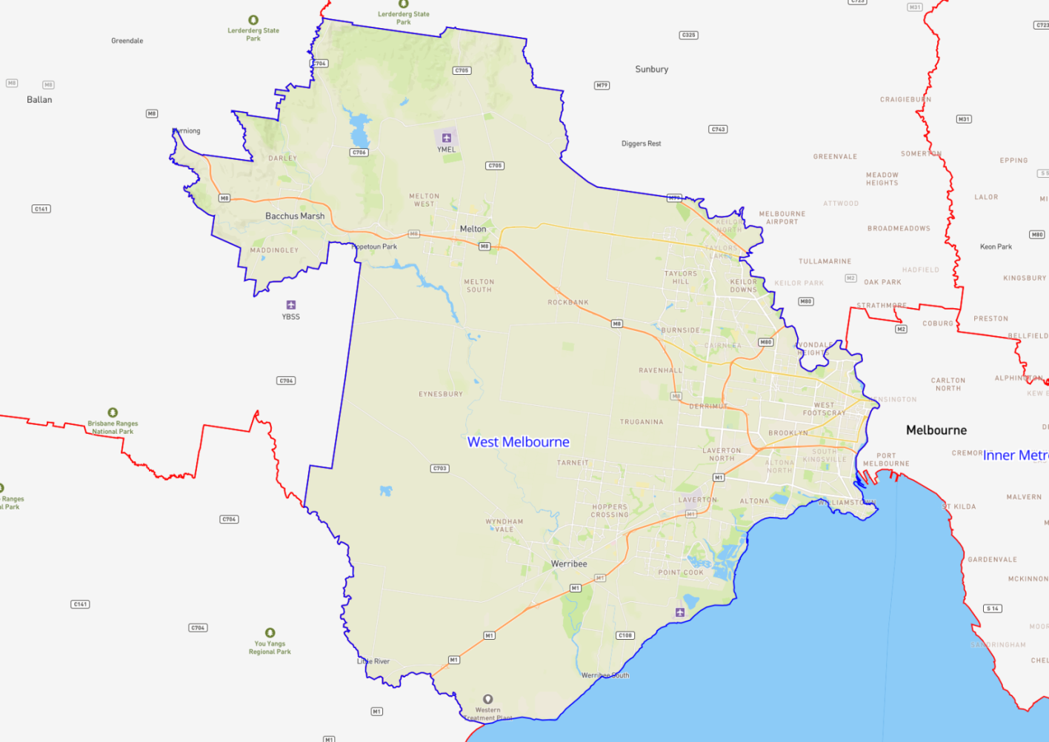

Ballarat
Region Name | Ballarat
Region Type | Regional
Service Provider | Learning for Employment (LfE)

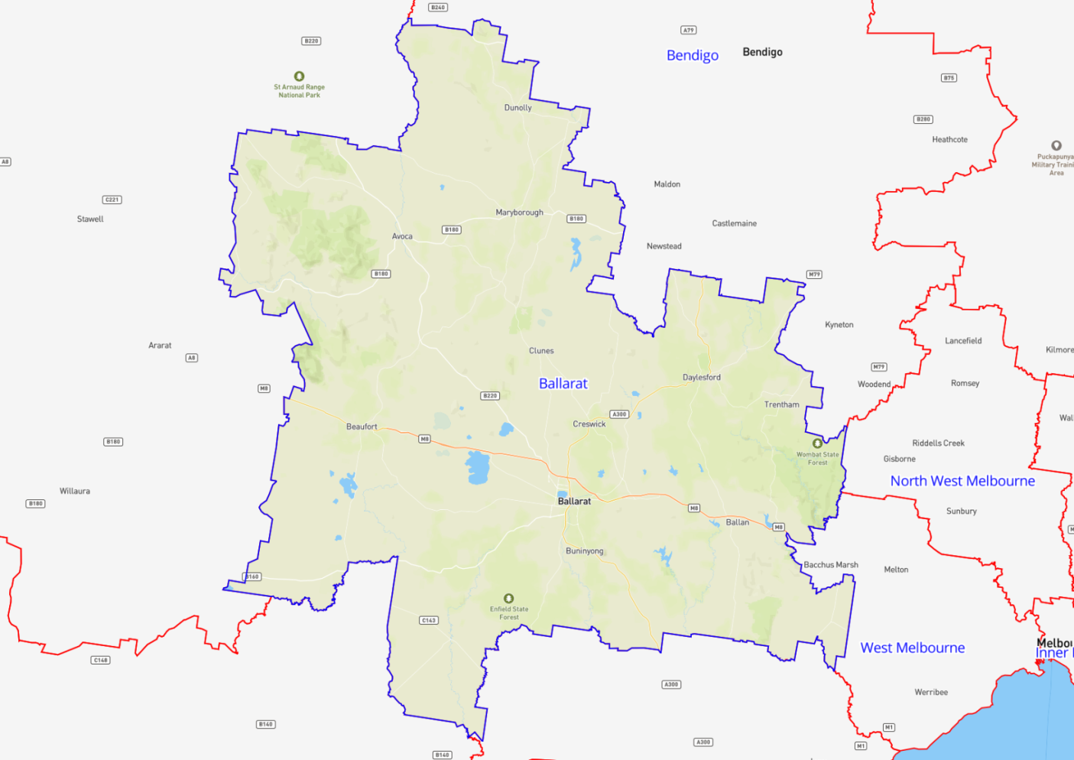

Barwon
Region Name | Barwon
Region Type | Regional
Service Provider | Learning for Employment (LfE)

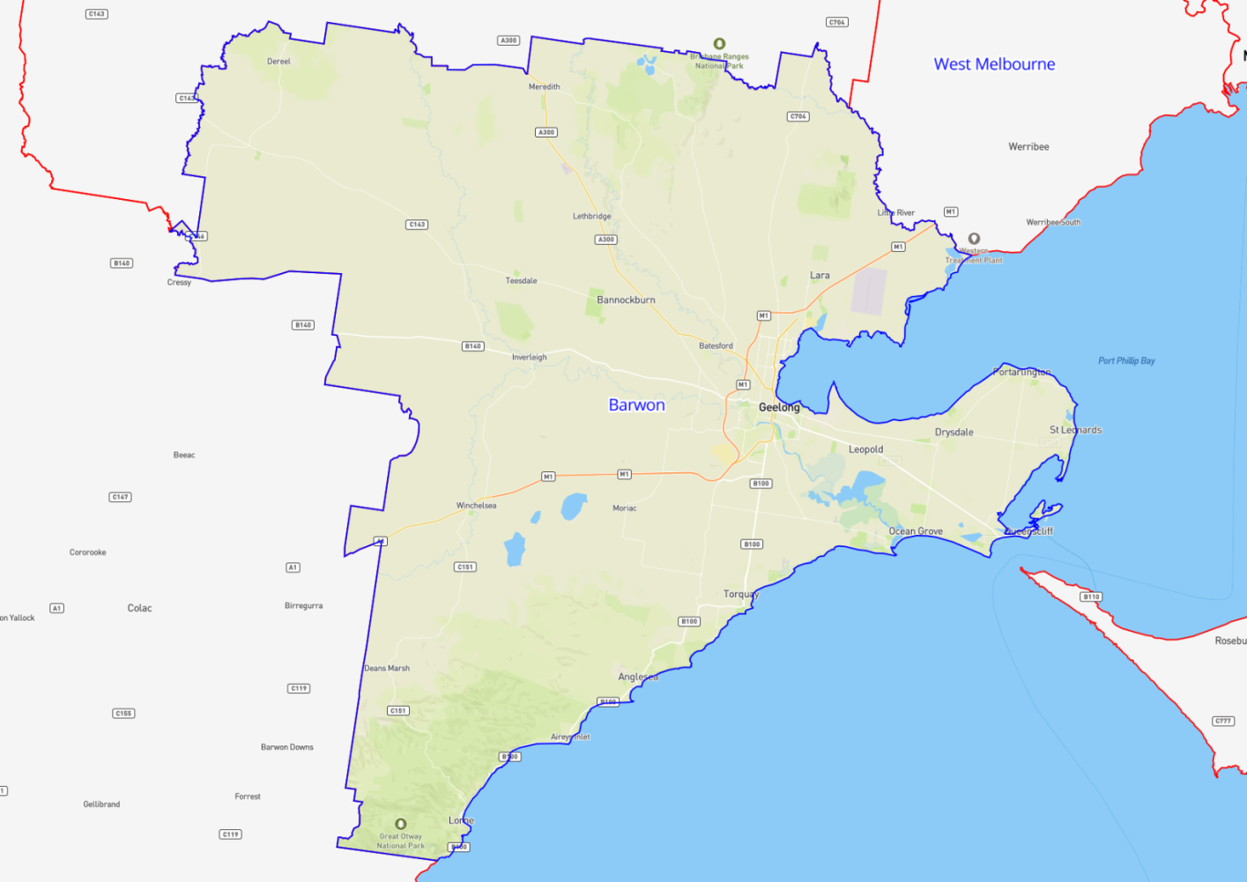

Bendigo
Region Name | Bendigo
Region Type | Regional
Service Provider | Melbourne Polytechnic

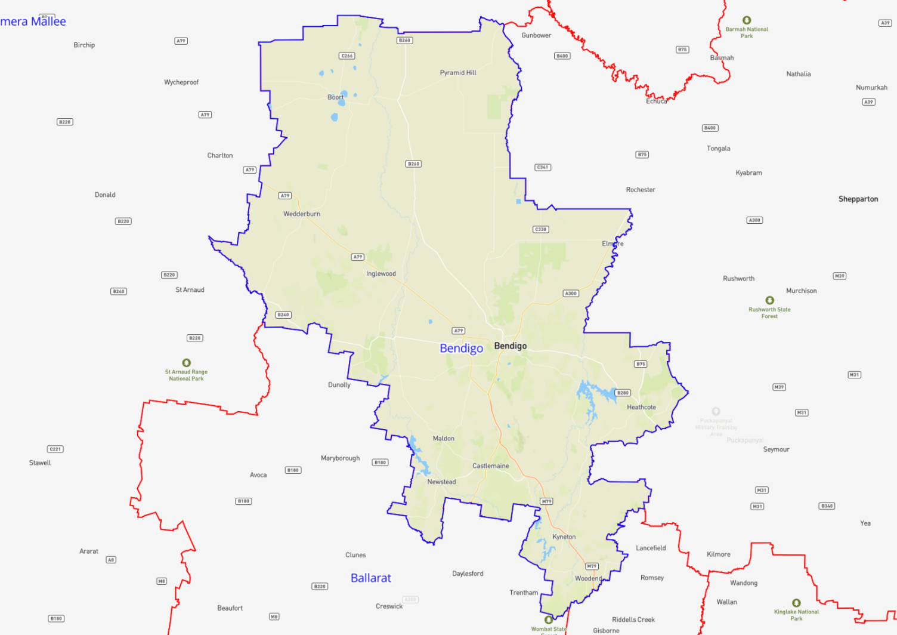

Gippsland
Region Name | Gippsland
Region Type | Regional
Service Provider | Swinburne University of Technology

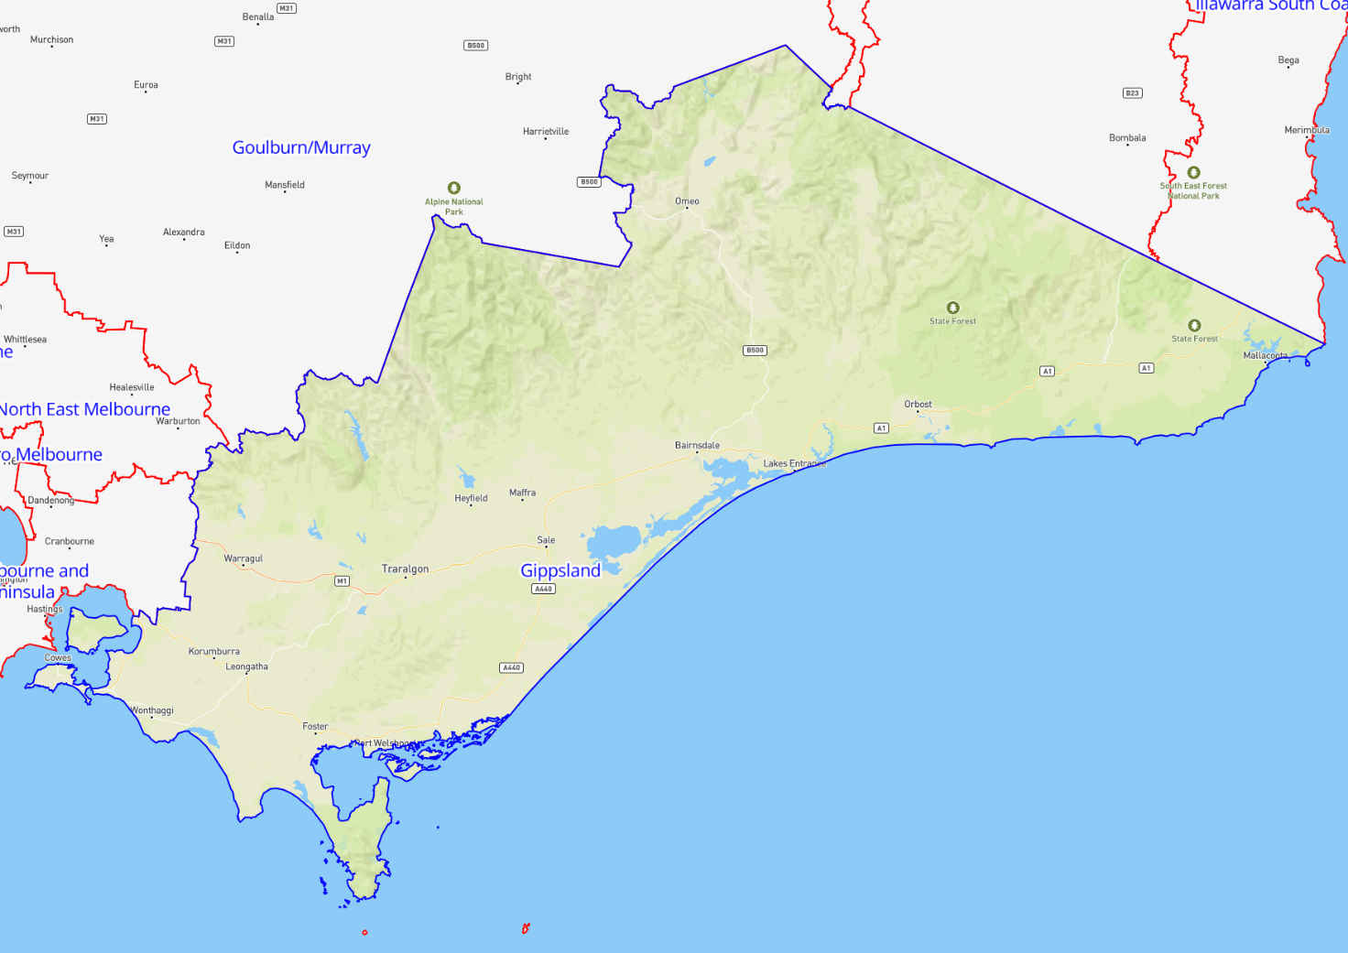

Goulburn / Murray
Region Name | Goulburn / Murray
Region Type | Regional
Service Provider | AMES Australia

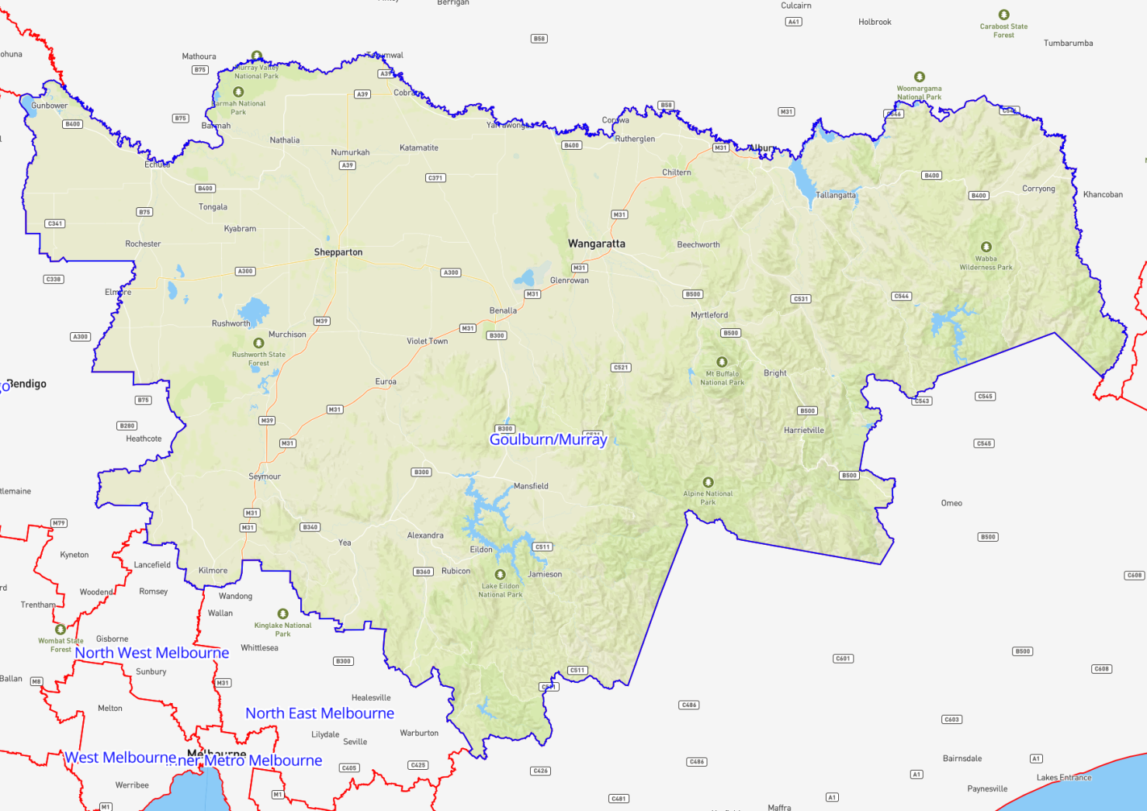

South Coast of Victoria
Region Name | South Coast of Victoria
Region Type | Regional
Service Provider | TAFE SA (distance learning only)

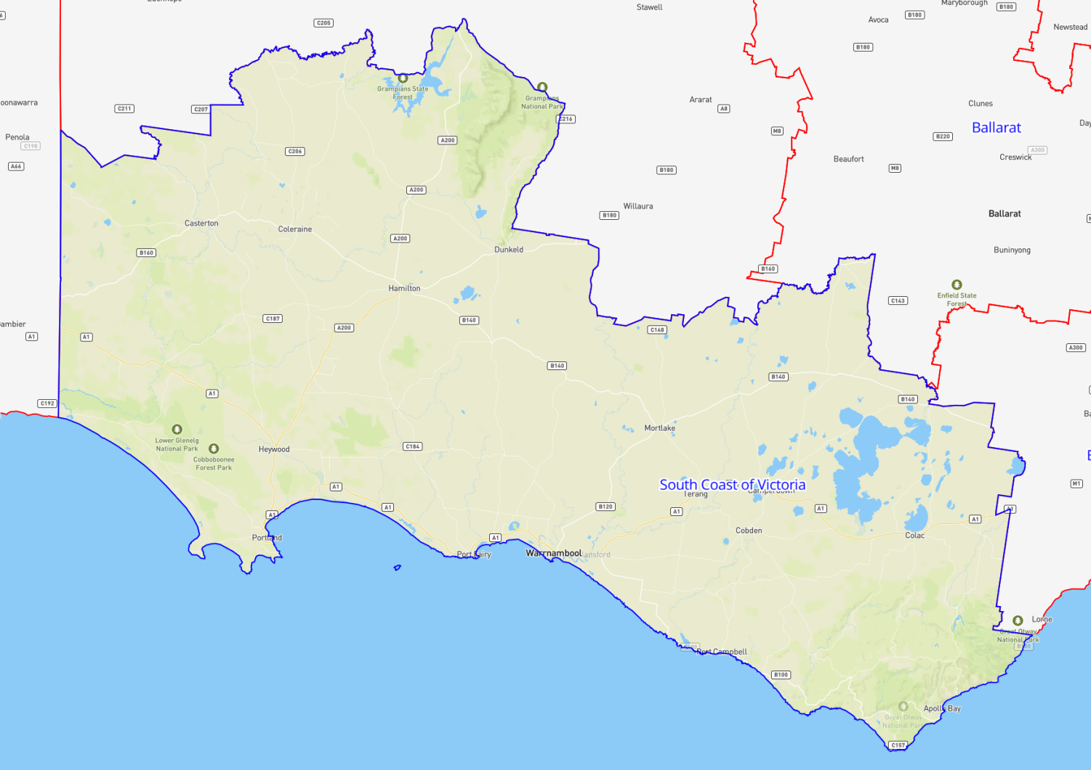

Wimmera Mallee
Region Name | Wimmera Mallee
Region Type | Regional
Service Provider | AMES Australia

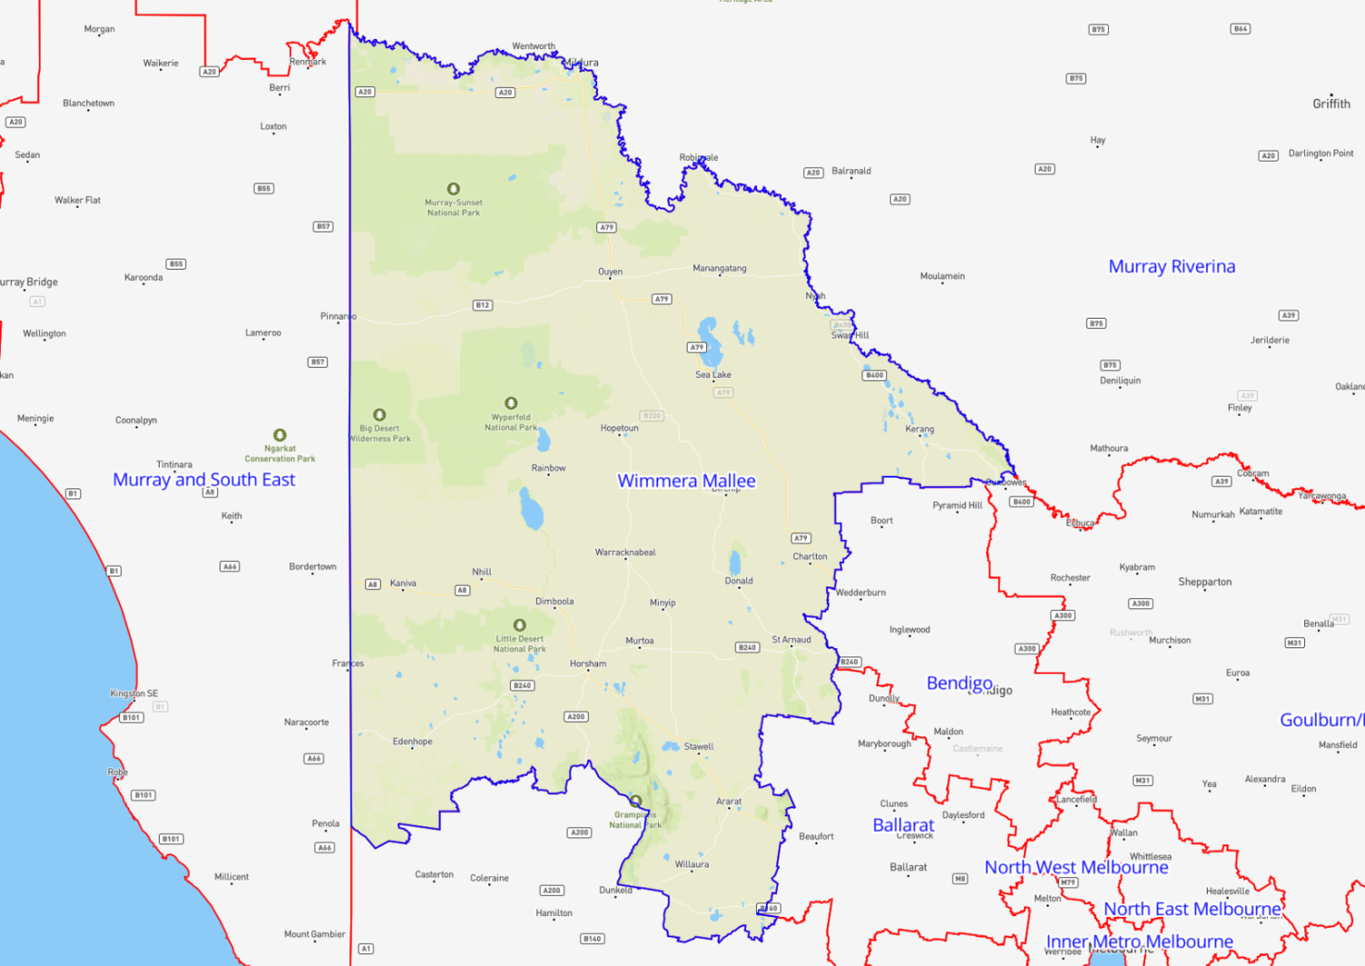

Queensland Contract Regions
Contract Region | Service Provider | Region Type
Brisbane South East | MAX Solutions  TAFE Queensland | Metropolitan
Cairns | STEPS Group Australia  TAFE Queensland | Regional
Darling Downs | Career Employment Australia  TAFE Queensland | Regional
Fitzroy | Career Employment Australia  TAFE Queensland | Regional
Gold Coast | TAFE Queensland  Nortec Training Solutions | Regional
Mackay | TAFE Queensland | Regional
Somerset | MAX Solutions  TAFE Queensland | Regional
Townsville | TAFE Queensland | Regional
Wide Bay and Sunshine Coast | Career Employment Australia  TAFE Queensland | Regional
Wivenhoe | Career Employment Australia  TAFE Queensland | Regional
West Queensland | TAFE Queensland | Remote
Central Queensland | TAFE Queensland | Remote
Far North Queensland | TAFE Queensland | Remote

Brisbane South East
Region Name | Brisbane South East
Region Type | Metropolitan
Service Provider | MAX Solutions  TAFE Queensland

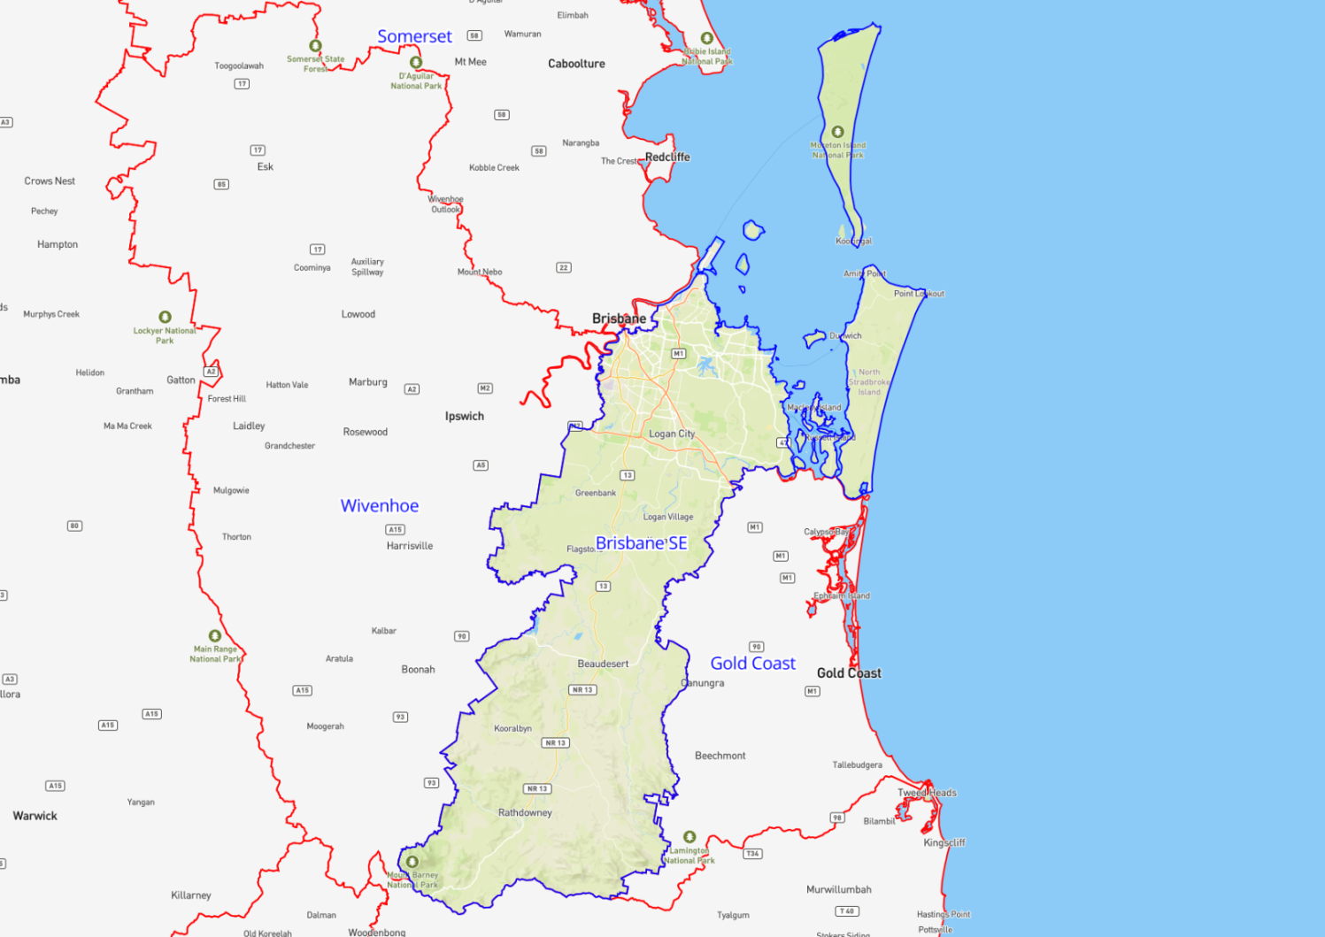

Cairns
Region Name | Cairns
Region Type | Regional
Service Provider | STEPS Group Australia  TAFE Queensland

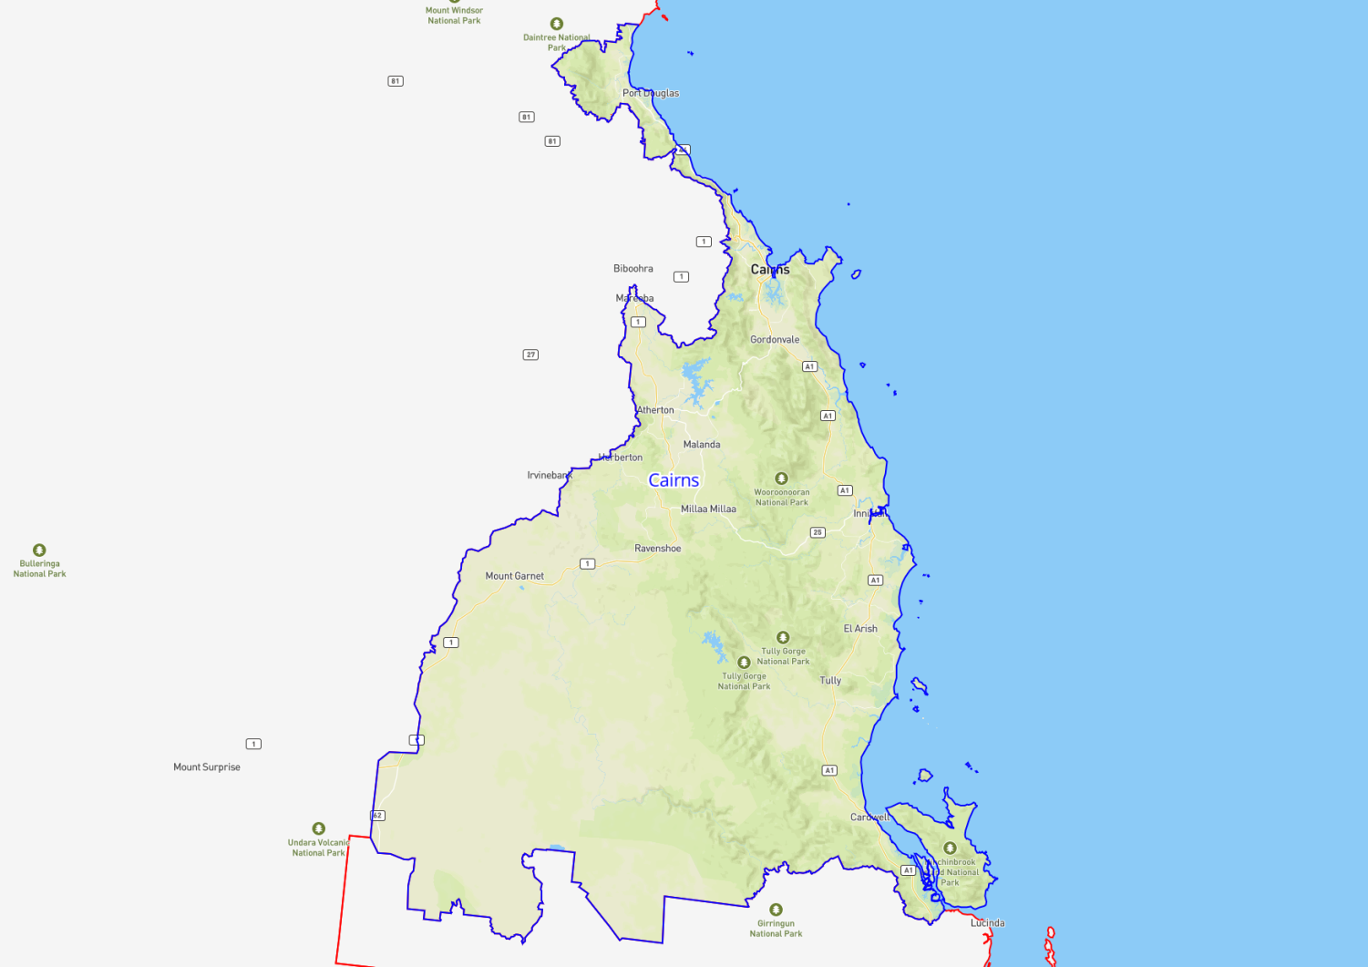

Darling Downs
Region Name | Darling Downs
Region Type | Regional
Service Provider | Career Employment Australia  TAFE Queensland

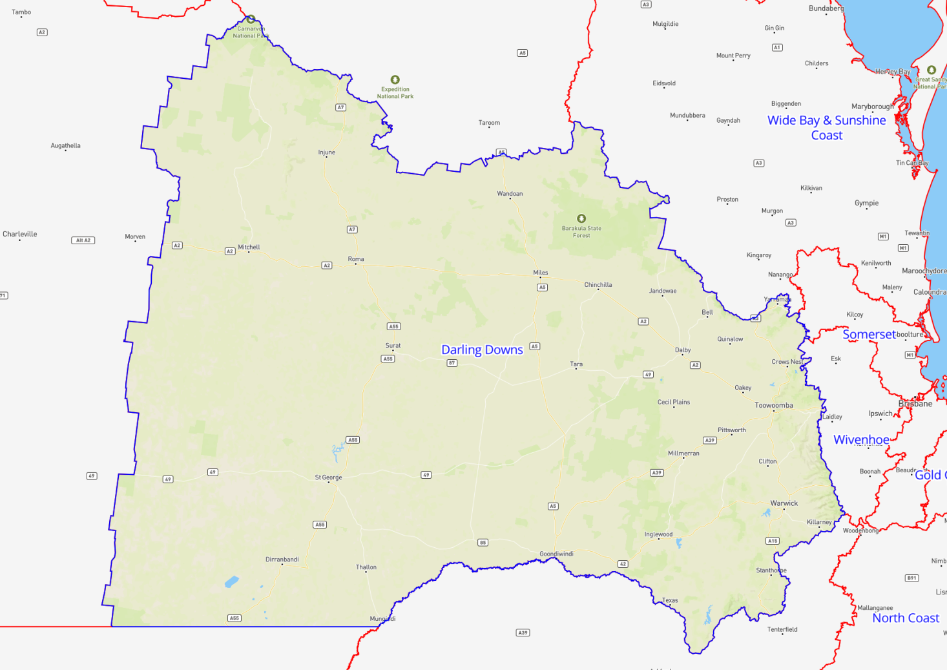

Fitzroy
Region Name | Fitzroy
Region Type | Regional
Service Provider | Career Employment Australia  TAFE Queensland

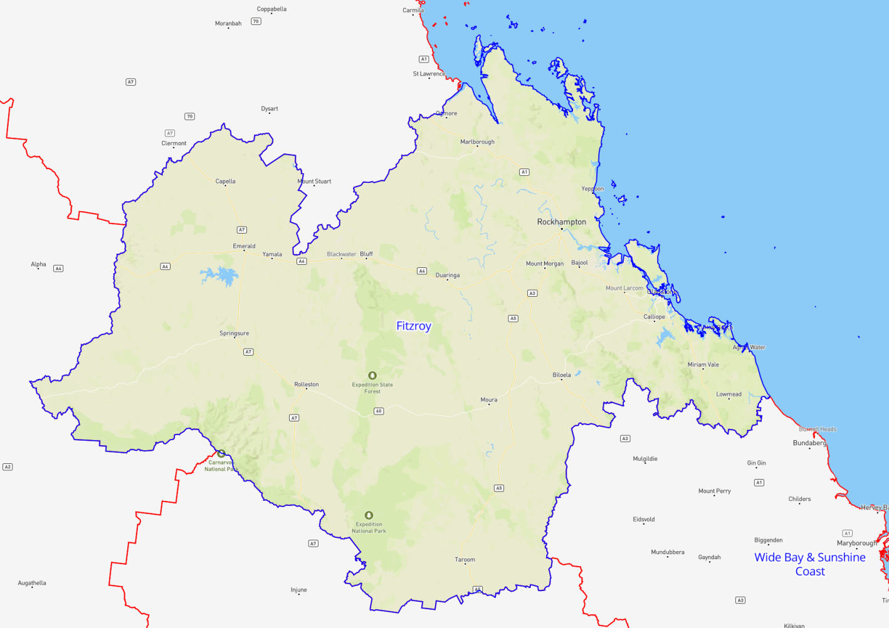

Gold Coast
Region Name | Gold Coast
Region Type | Regional
Service Provider | TAFE Queensland  Nortec Training Solutions

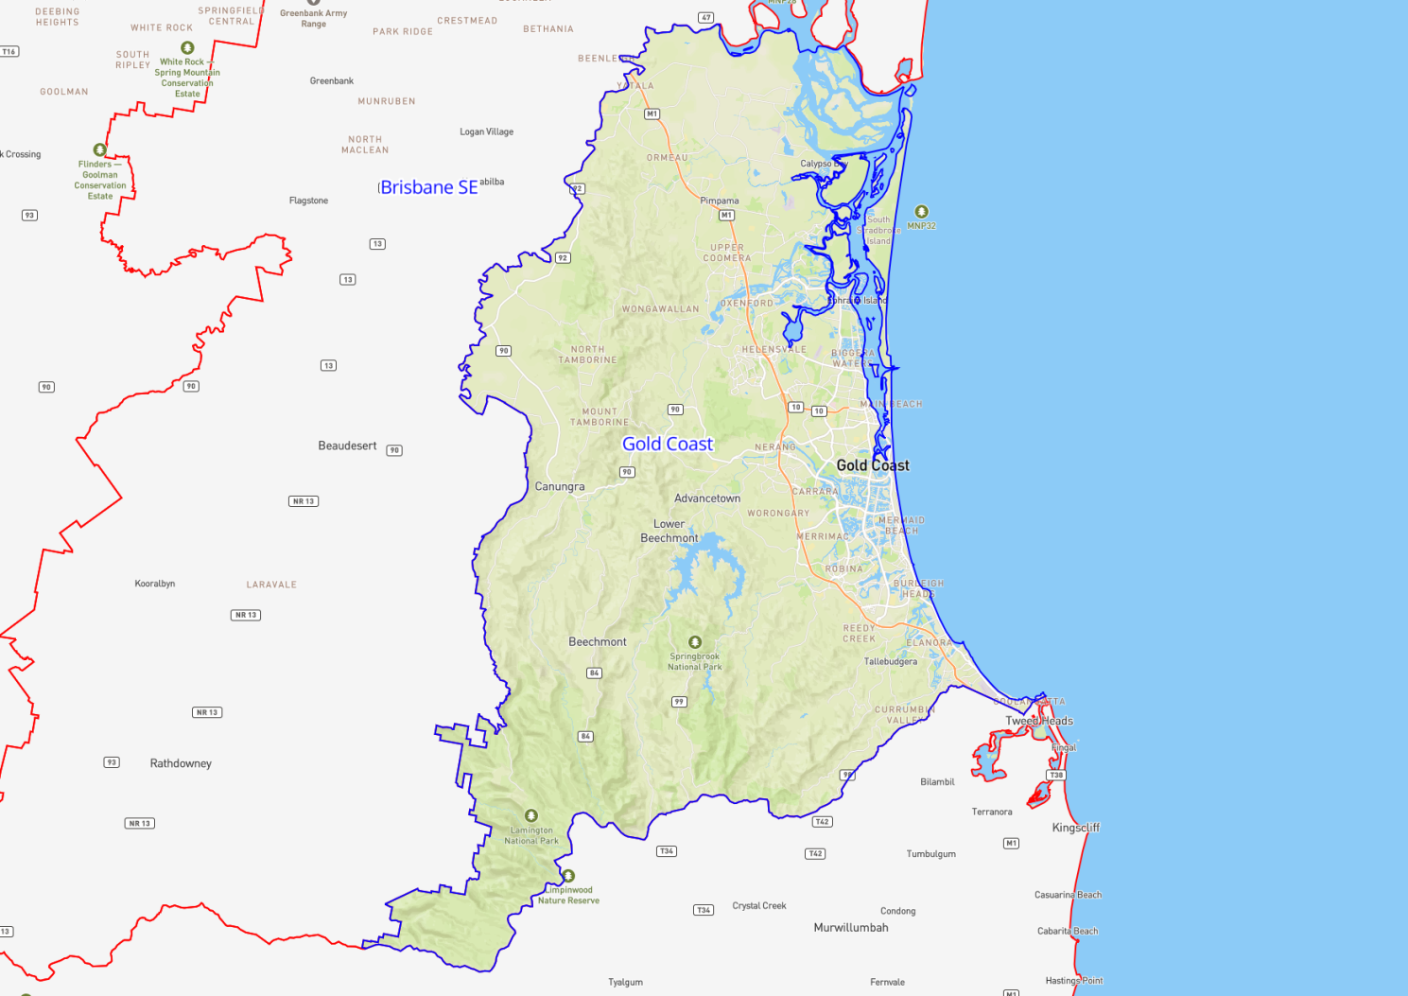

Mackay
Region Name | Mackay
Region Type | Regional
Service Provider | TAFE Queensland

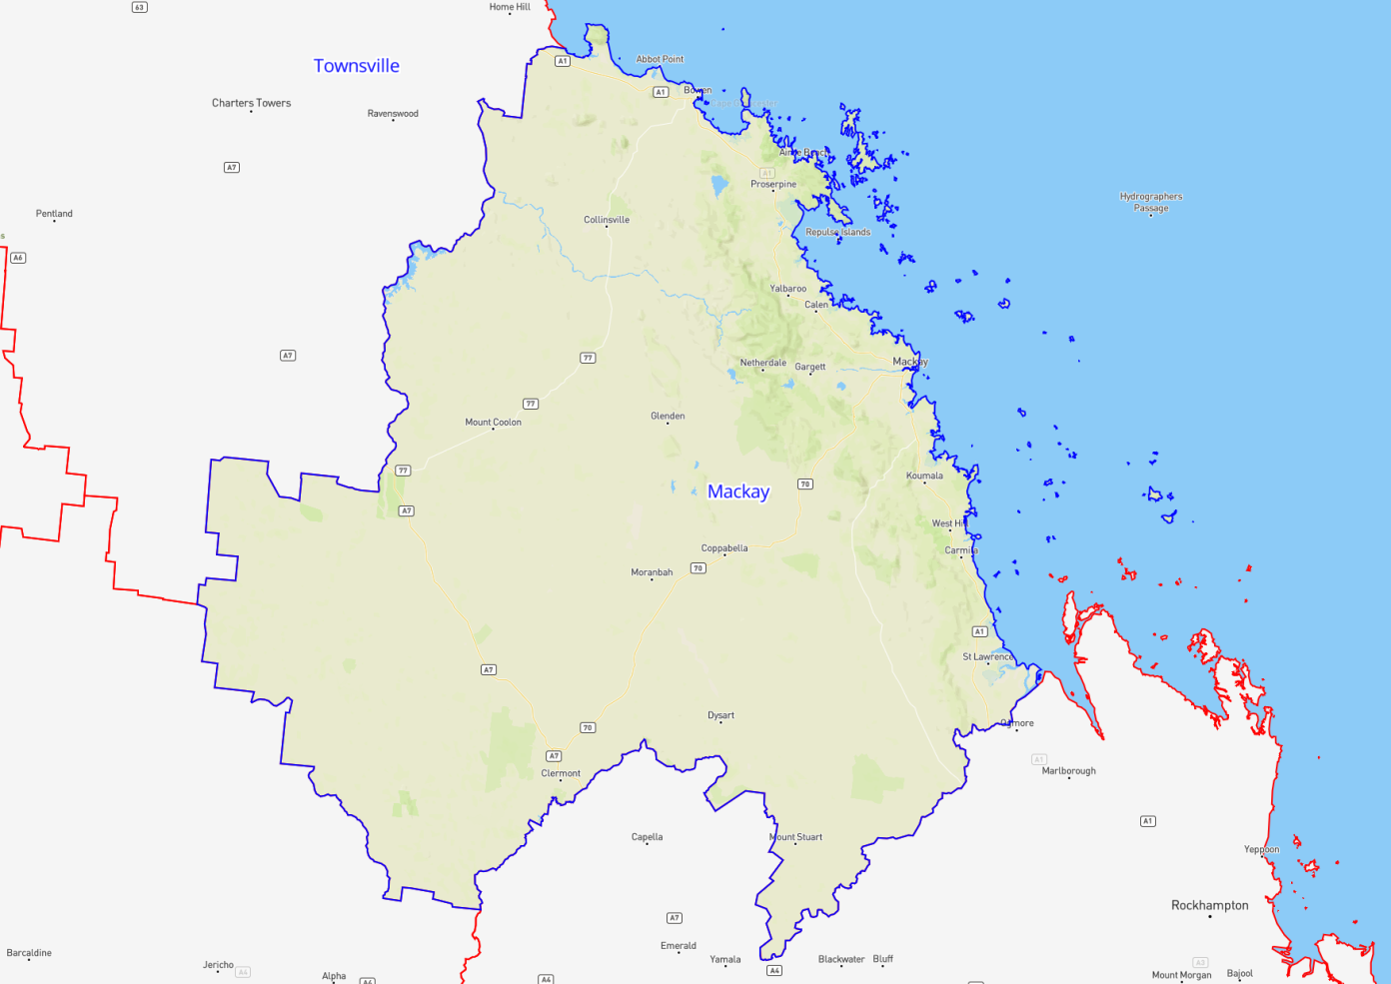

Somerset
Region Name | Somerset
Region Type | Regional
Service Provider | MAX Solutions  TAFE Queensland

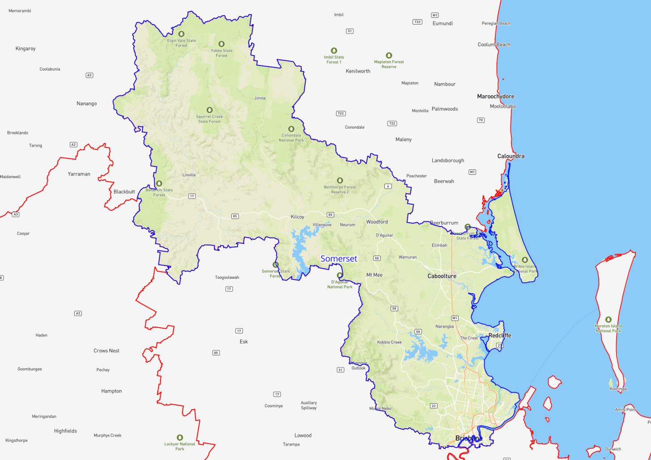

Townsville
Region Name | Townsville
Region Type | Regional
Service Provider | TAFE Queensland

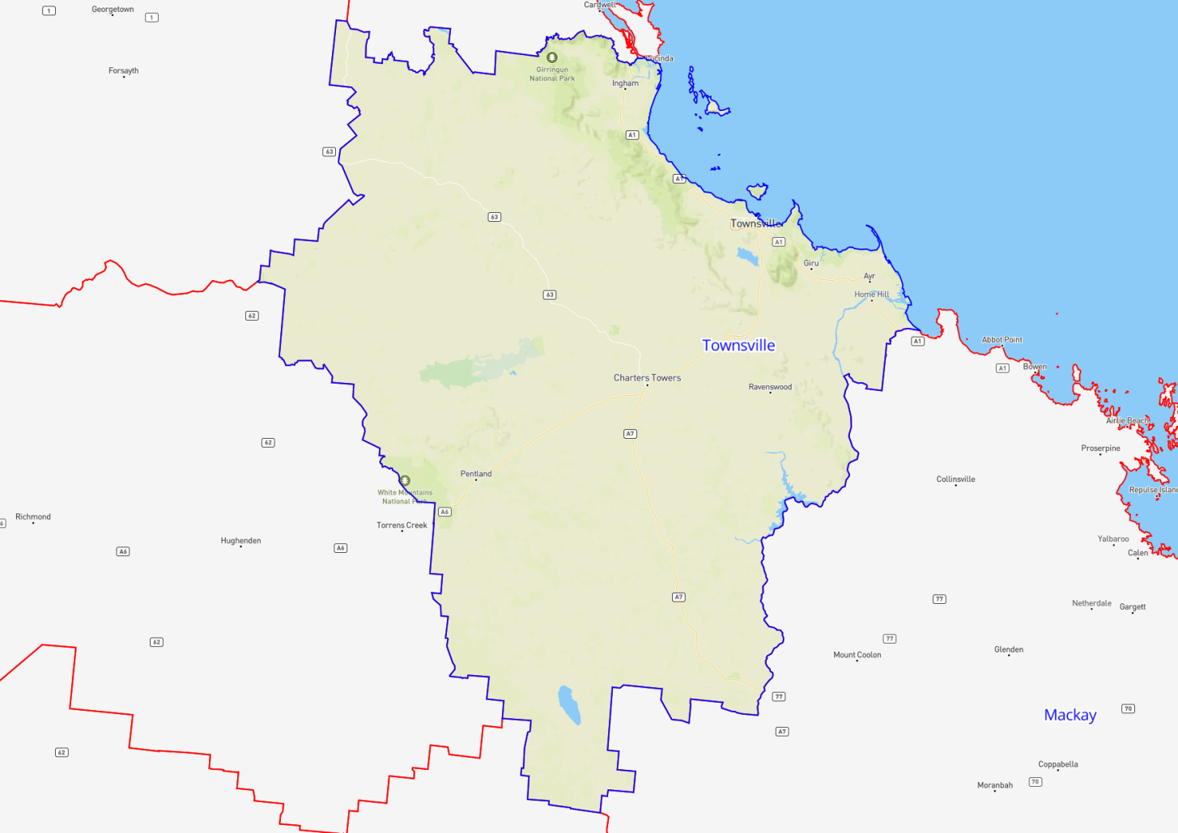

Wide Bay and Sunshine Coast
Region Name | Wide Bay & Sunshine Coast
Region Type | Regional
Service Provider | Career Employment Australia  TAFE Queensland

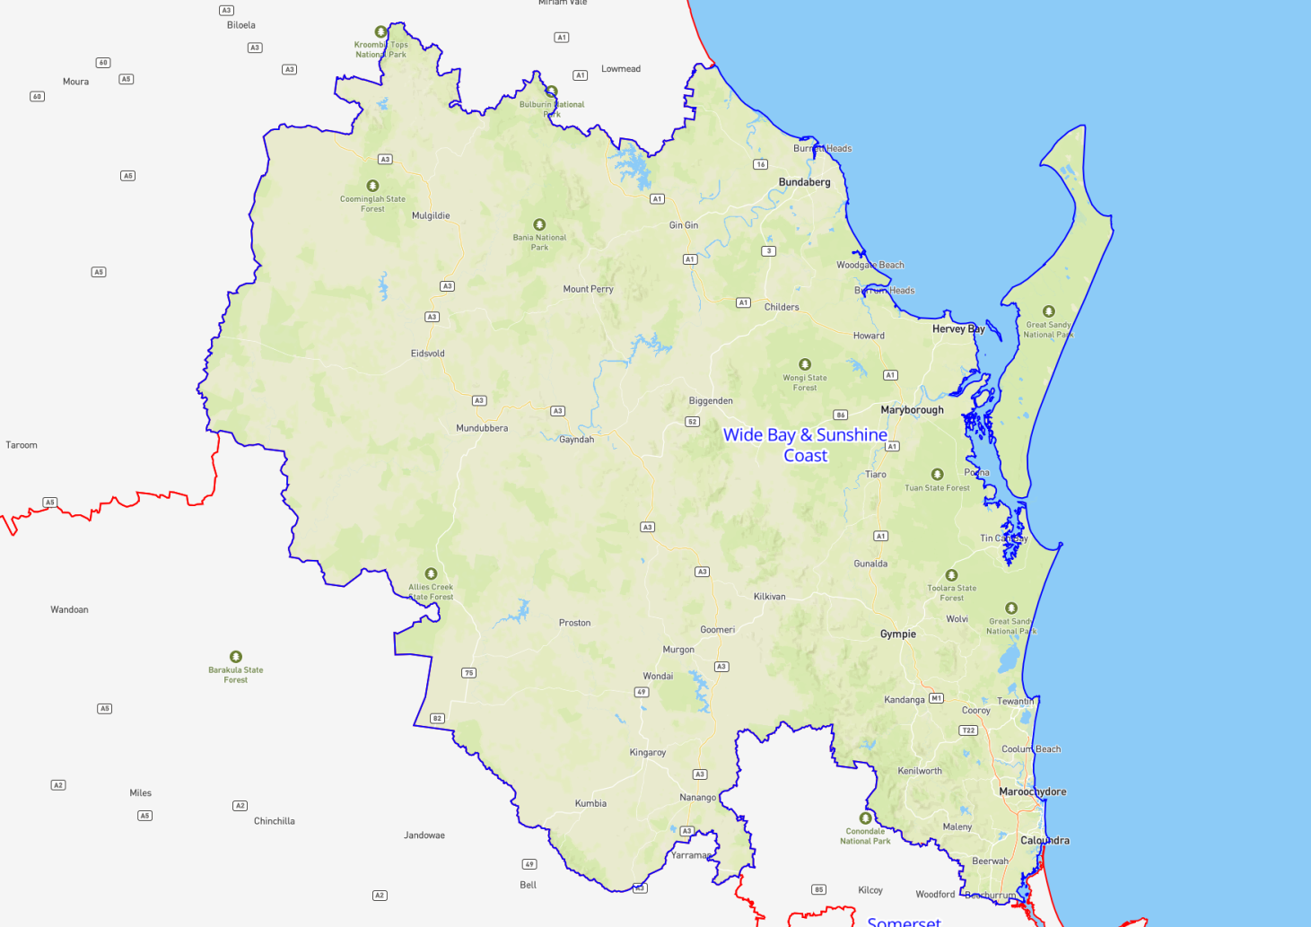

Wivenhoe
Region Name | Wivenhoe
Region Type | Regional
Service Provider | Career Employment Australia  TAFE Queensland

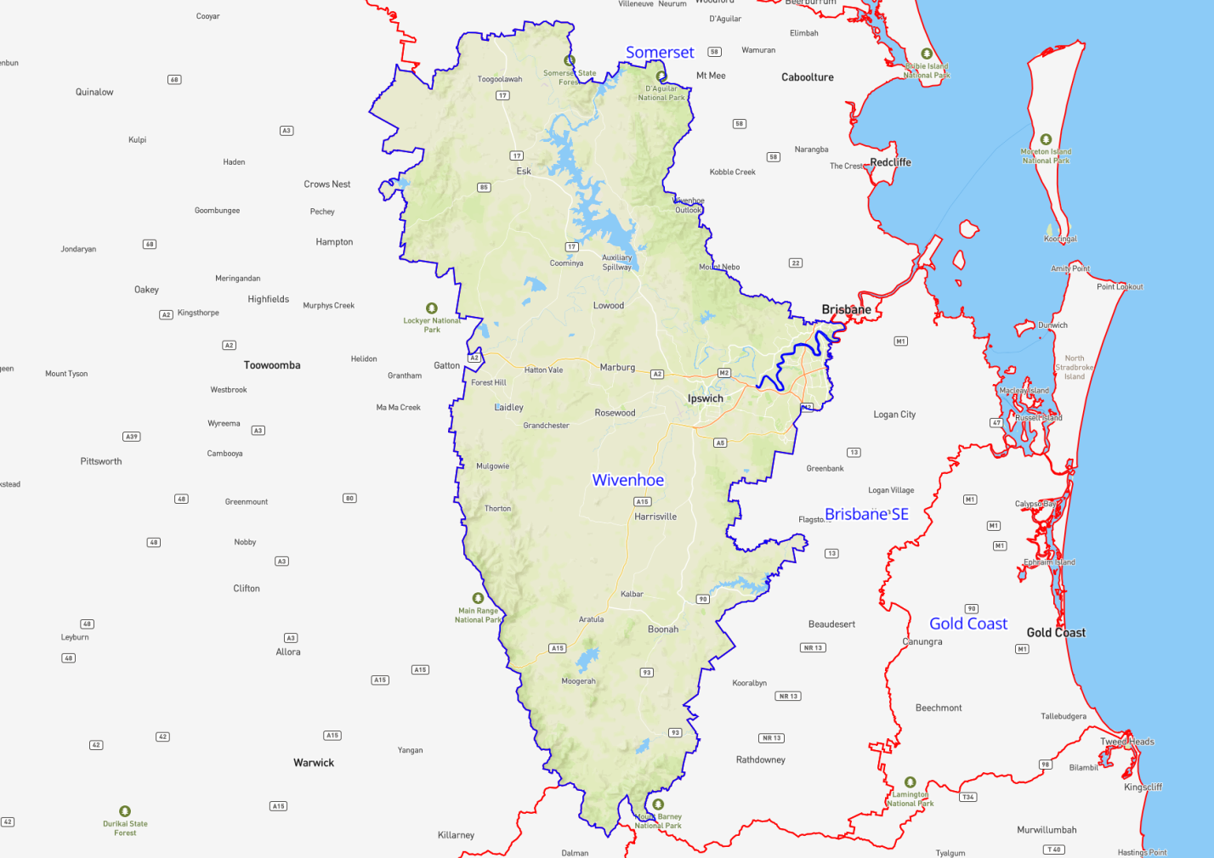

West Queensland
Region Name | West Queensland
Region Type | Remote
Service Provider | TAFE Queensland

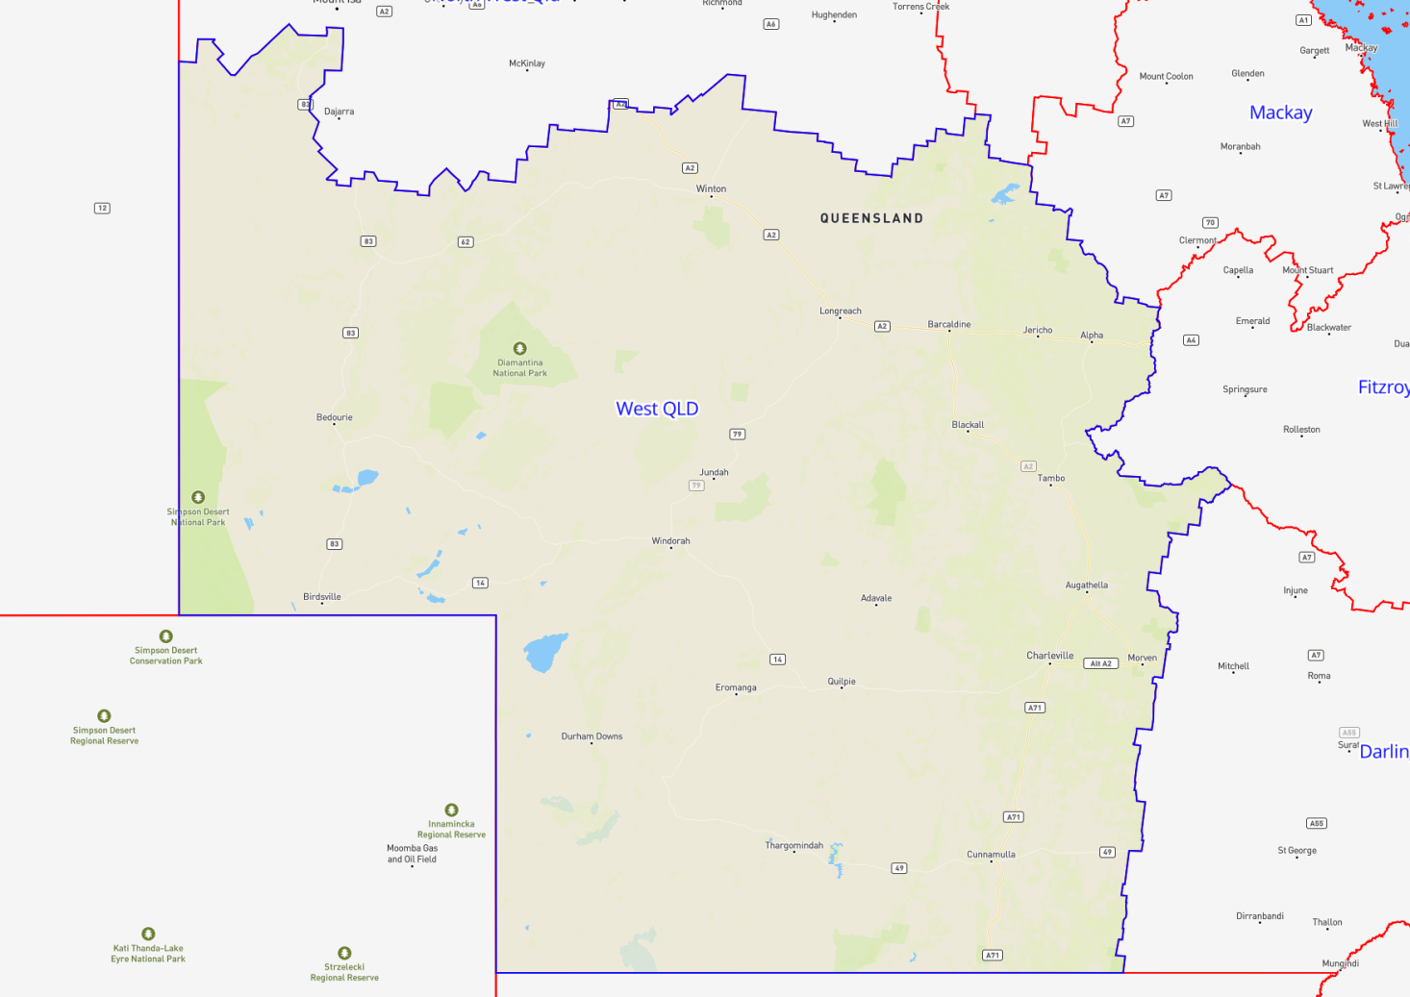

Central Queensland
Region Name | Central Queensland
Region Type | Remote
Service Provider | TAFE Queensland

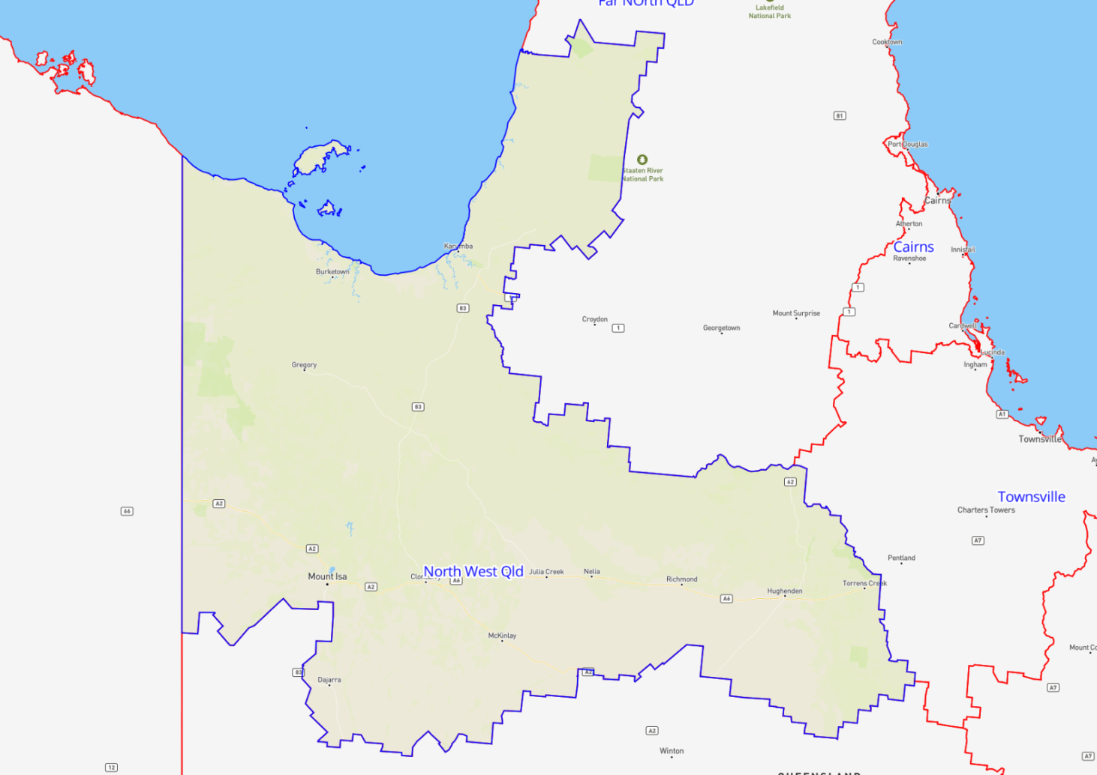

Far North Queensland
Region Name | Far North Queensland
Region Type | Remote
Service Provider | TAFE Queensland

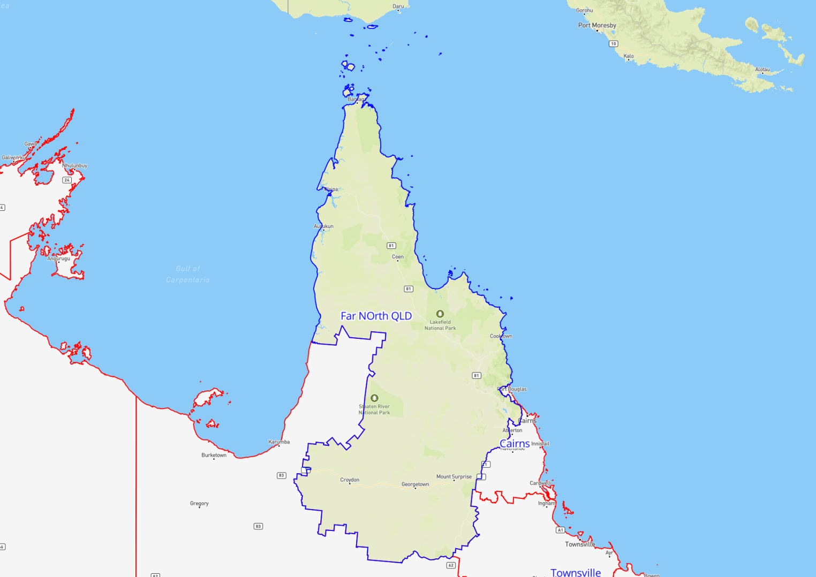

South Australia Contract Regions
Contract Region | Service Provider | Region Type
Adelaide North | MAX Solutions  TAFE SA | Metropolitan
Adelaide South | Status Employment Services  TAFE SA | Metropolitan
Mid North South Australia | TAFE SA | Regional
Murray and South East | TAFE SA | Regional
North West Country | TAFE SA | Regional
Remote South Australia | TAFE SA (distance learning only) | Remote

Adelaide North
Region Name | Adelaide North
Region Type | Metropolitan
Service Provider | MAX Solutions  TAFE SA

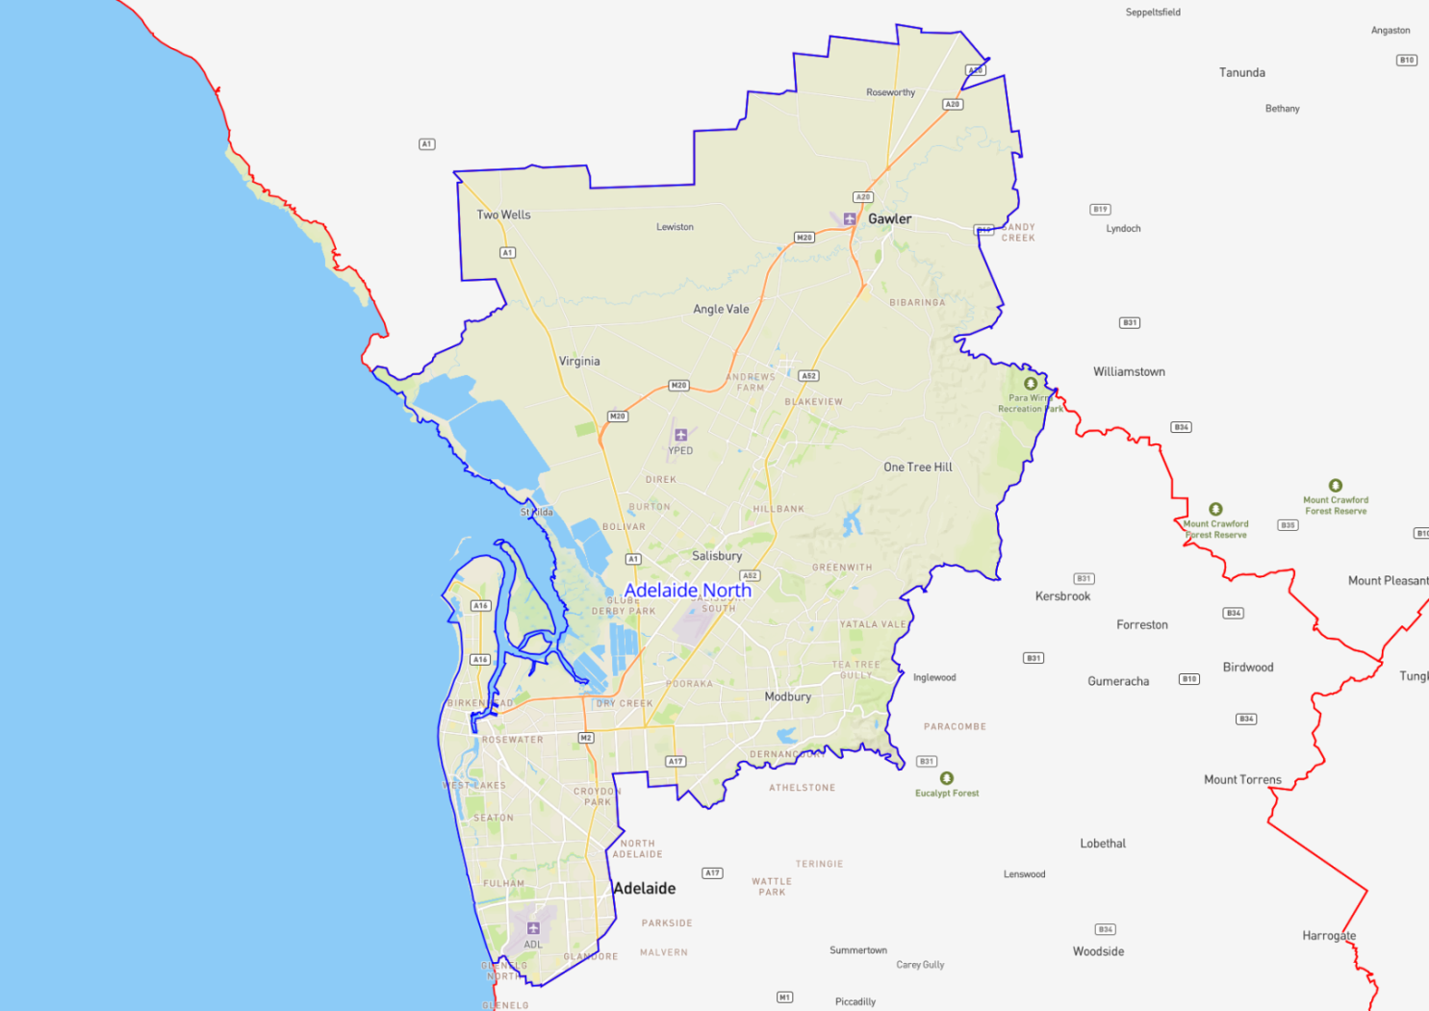

Adelaide South
Region Name | Adelaide South
Region Type | Metropolitan
Service Provider | Status Employment Services  TAFE SA

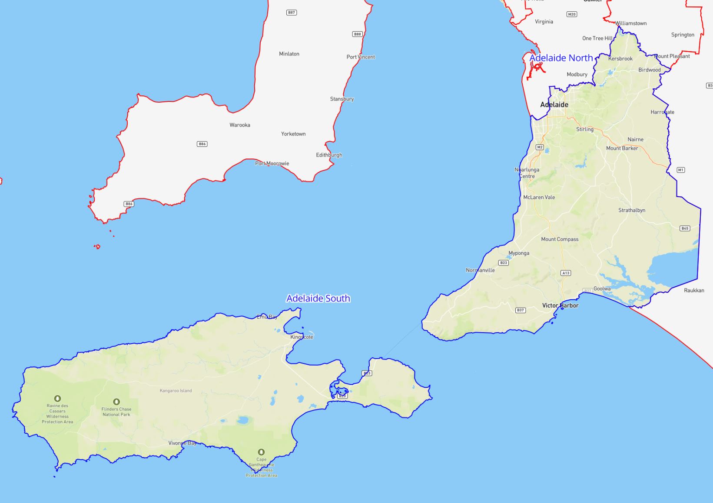

Mid North South Australia
Region Name | Mid North South Australia
Region Type | Regional
Service Provider | TAFE SA

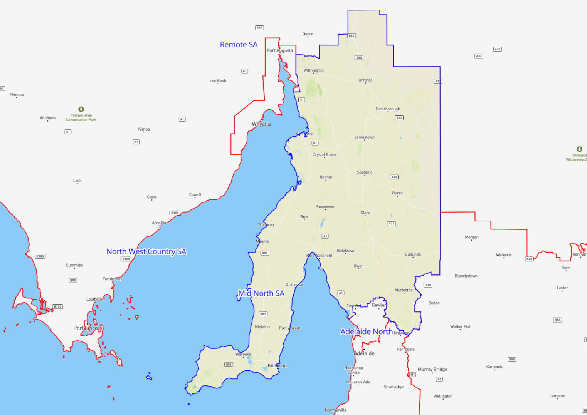

Murray and South East
Region Name | Murray and South East
Region Type | Regional
Service Provider | TAFE SA

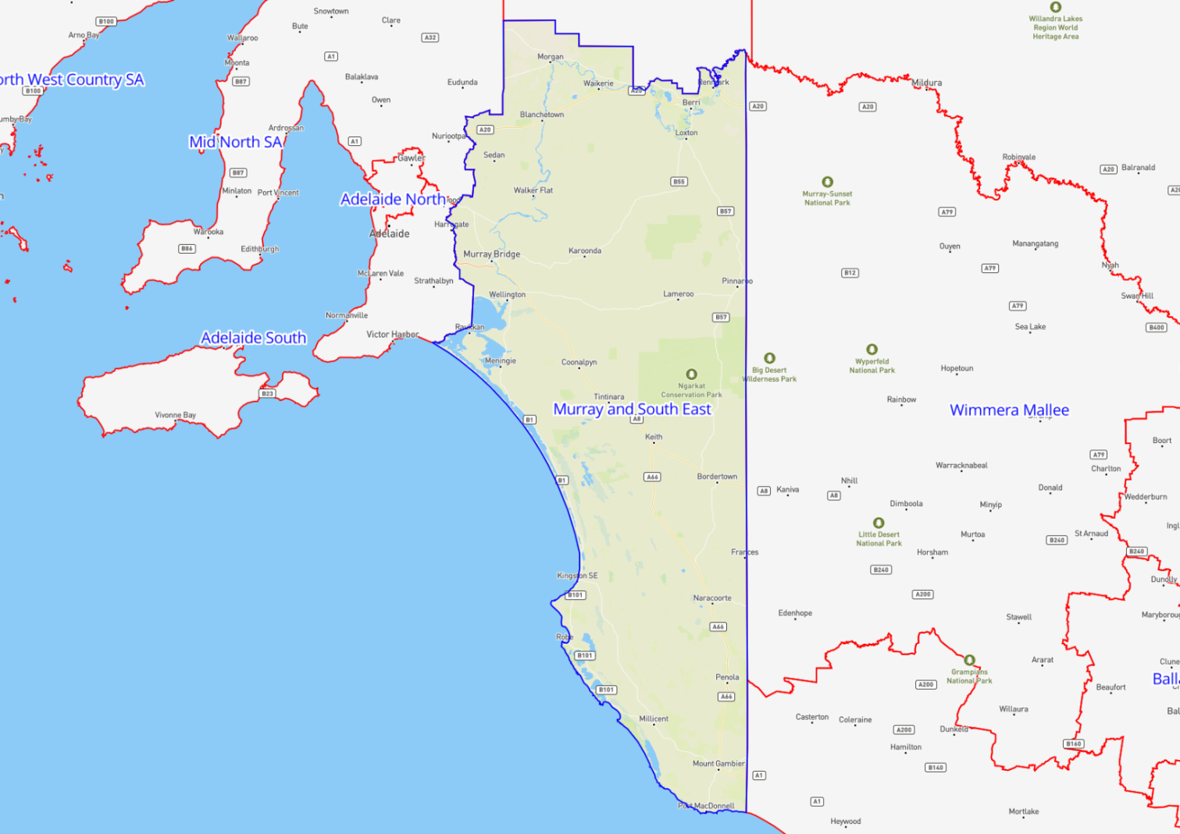

North West Country
Region Name | North West Country
Region Type | Regional
Service Provider | TAFE SA

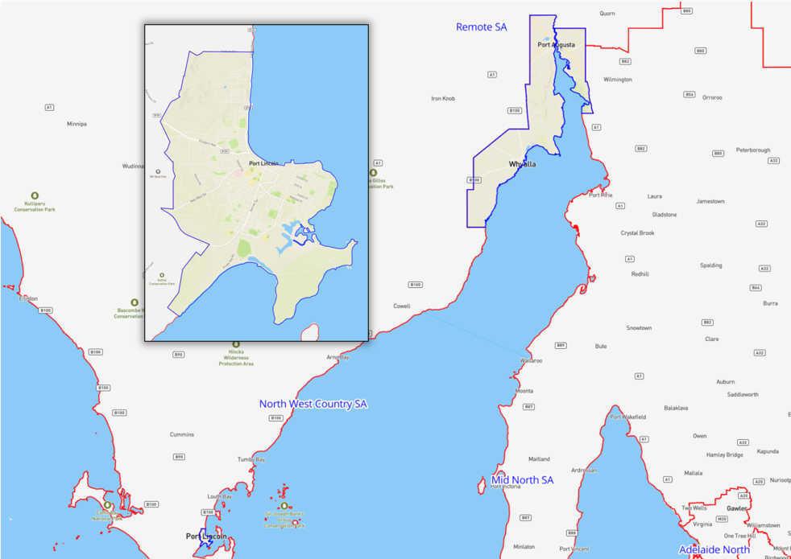

Remote South Australia
Region Name | Remote South Australia
Region Type | Remote
Service Provider | TAFE SA (distance learning only)

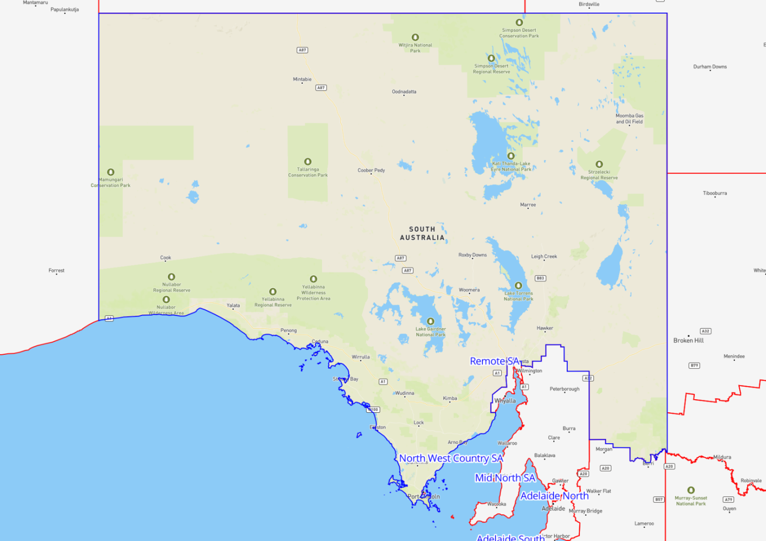

Western Australia Contract Regions
Contract Region | Service Provider | Region Type
Perth North | MAX Solutions  North Metropolitan TAFE | Metropolitan
Perth South | Centacare Employment and Training  Status Employment Services | Metropolitan
Great Southern Western Australia | South Regional TAFE | Regional
South West Western Australia | South Metropolitan Youth Link | Regional
Kimberley | Progressive Training | Remote
Pilbara | South Metropolitan Youth Link | Remote
Gascoyne | South Metropolitan Youth Link | Remote
Kalgoorlie | South Metropolitan Youth Link | Remote

Perth North
Region Name | Perth North
Region Type | Metropolitan
Service Provider | MAX Solutions  North Metropolitan TAFE

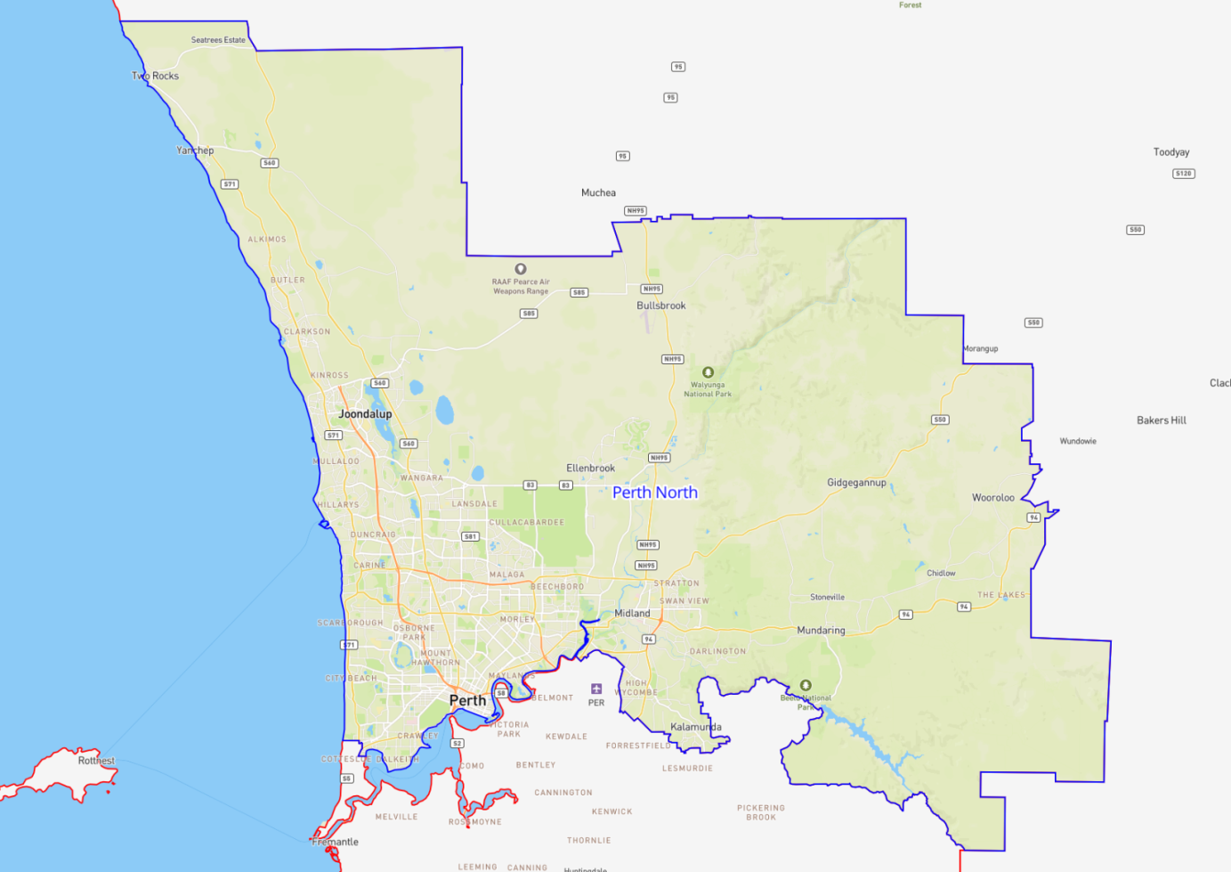

Perth South
Region Name | Perth South
Region Type | Metropolitan
Service Provider | Centacare Employment and Training  Status Employment Services

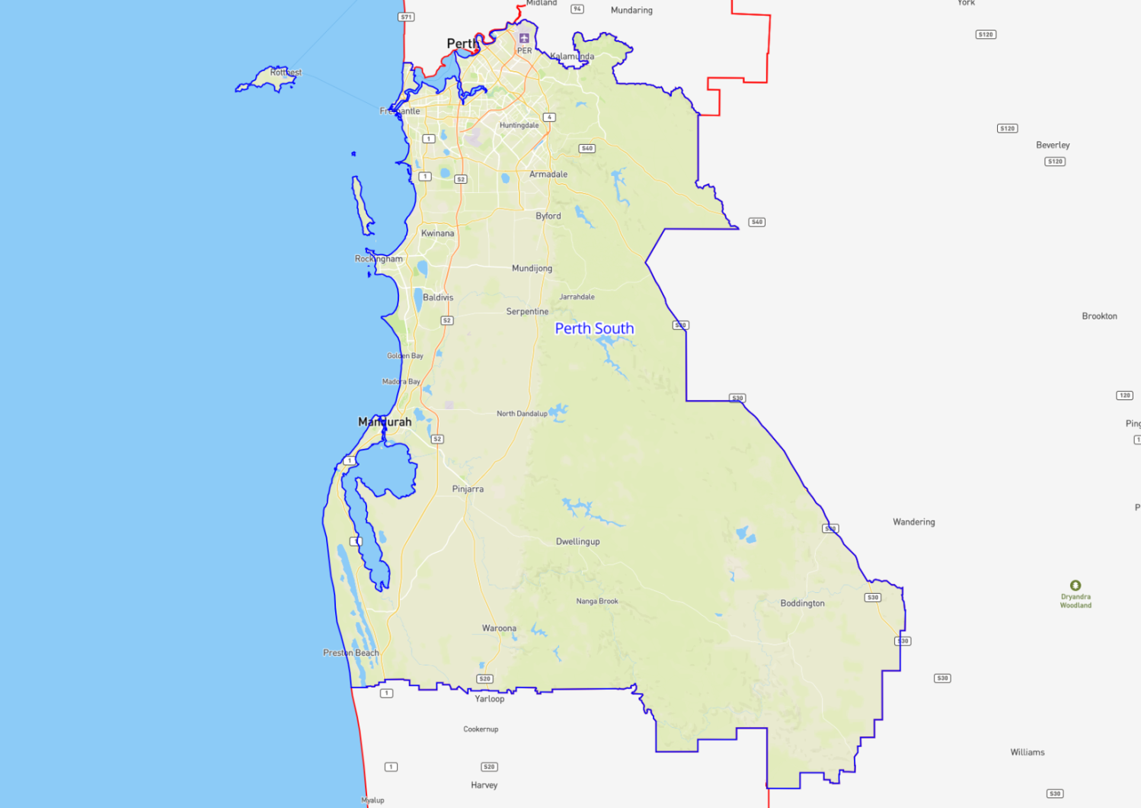

Great Southern Western Australia
Region Name | Great Southern Western Australia
Region Type | Regional
Service Provider | South Regional TAFE

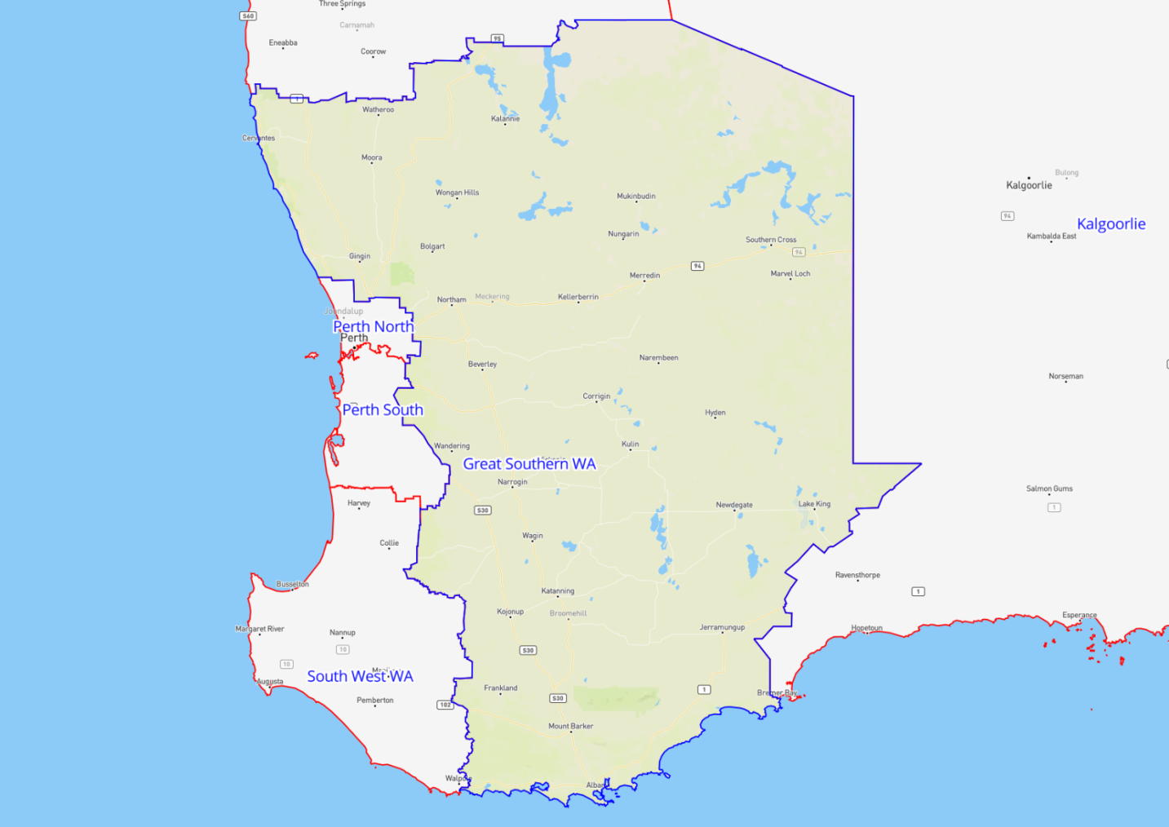

South West Western Australia
Region Name | South West Western Australia
Region Type | Regional
Service Provider | South Metropolitan Youth Link

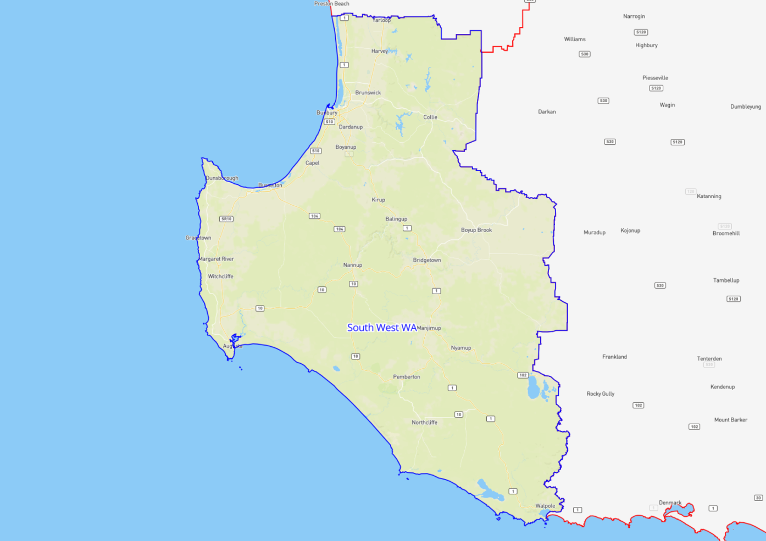

Kimberley
Region Name | Kimberley
Region Type | Remote
Service Provider | Progressive Training

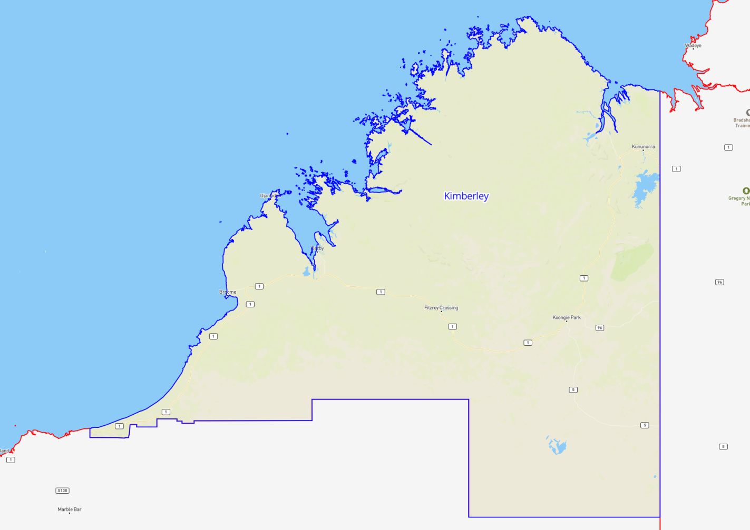

Pilbara
Region Name | Pilbara
Region Type | Remote
Service Provider | South Metropolitan Youth Link

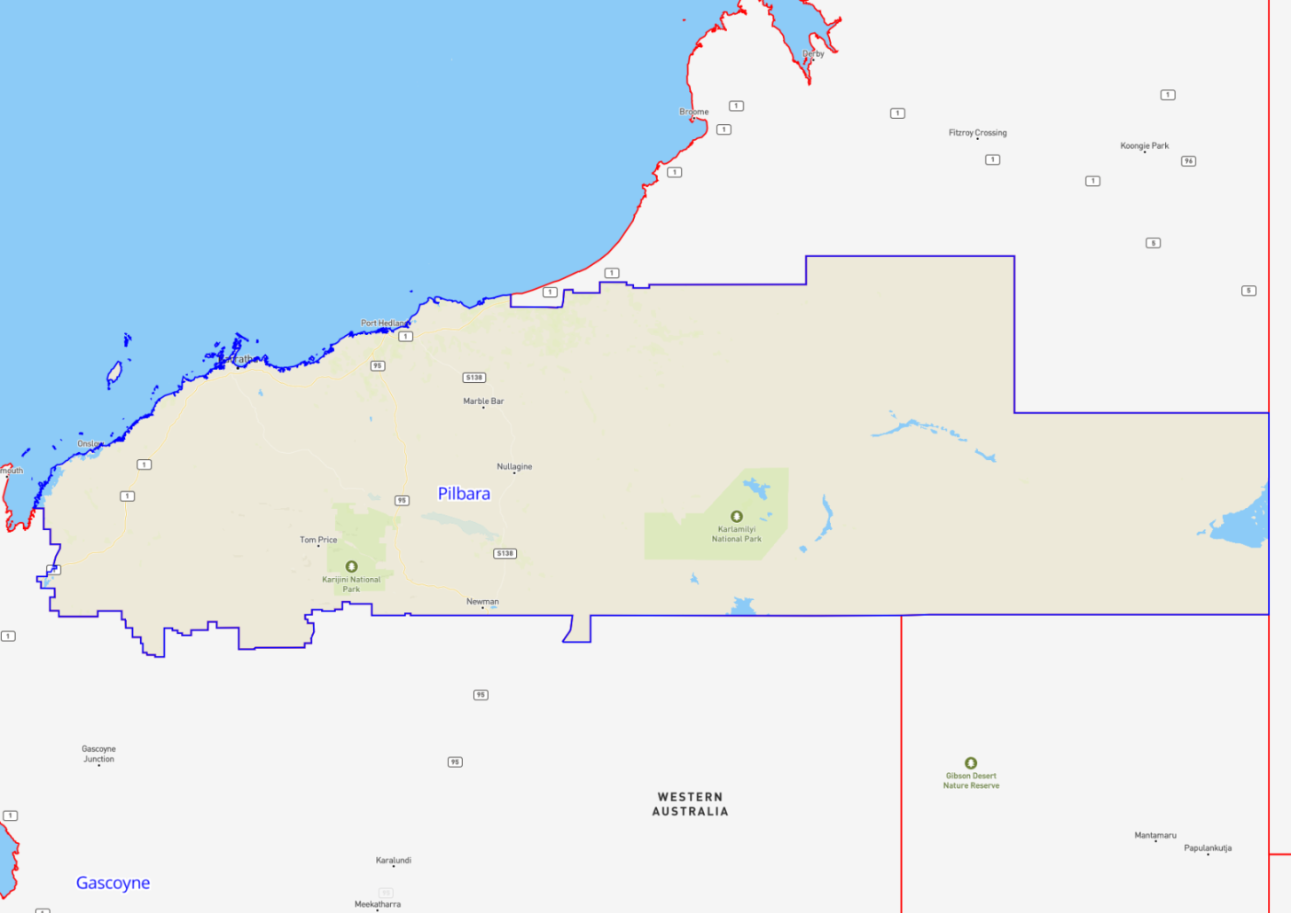

Gascoyne
Region Name | Gascoyne
Region Type | Remote
Service Provider | South Metropolitan Youth Link

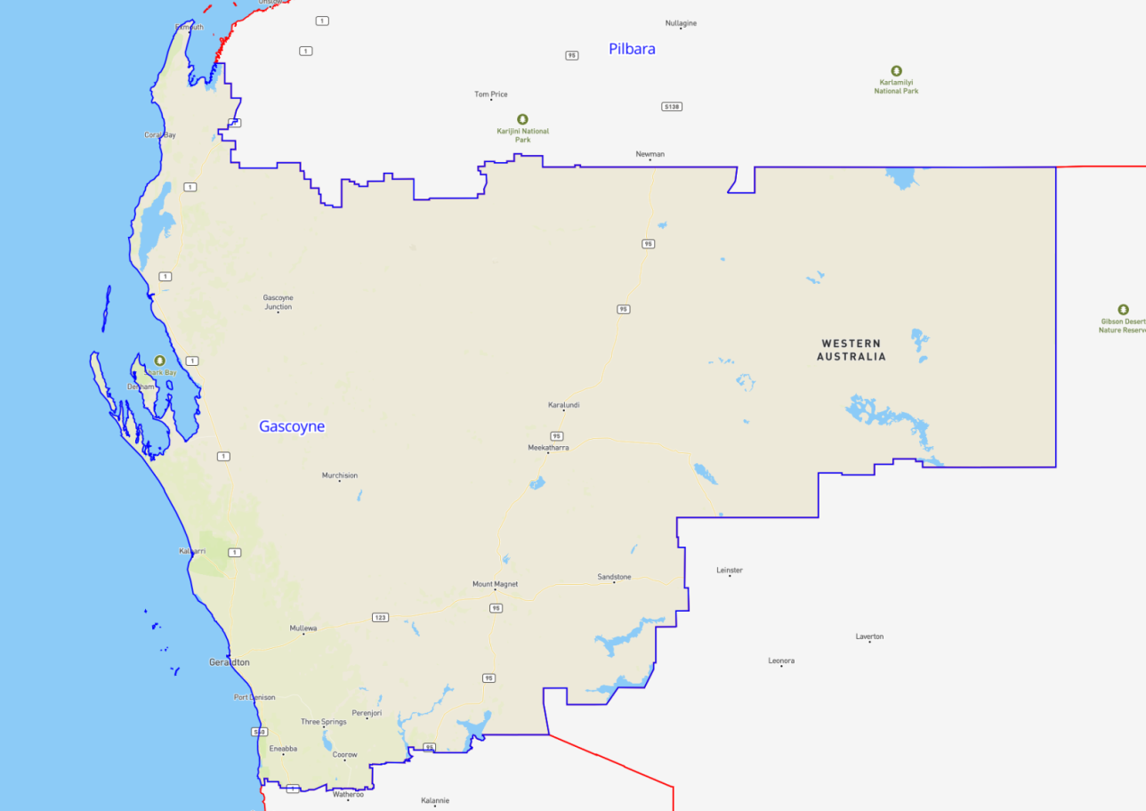

Kalgoorlie
Region Name | Kalgoorlie
Region Type | Remote
Service Provider | South Metropolitan Youth Link

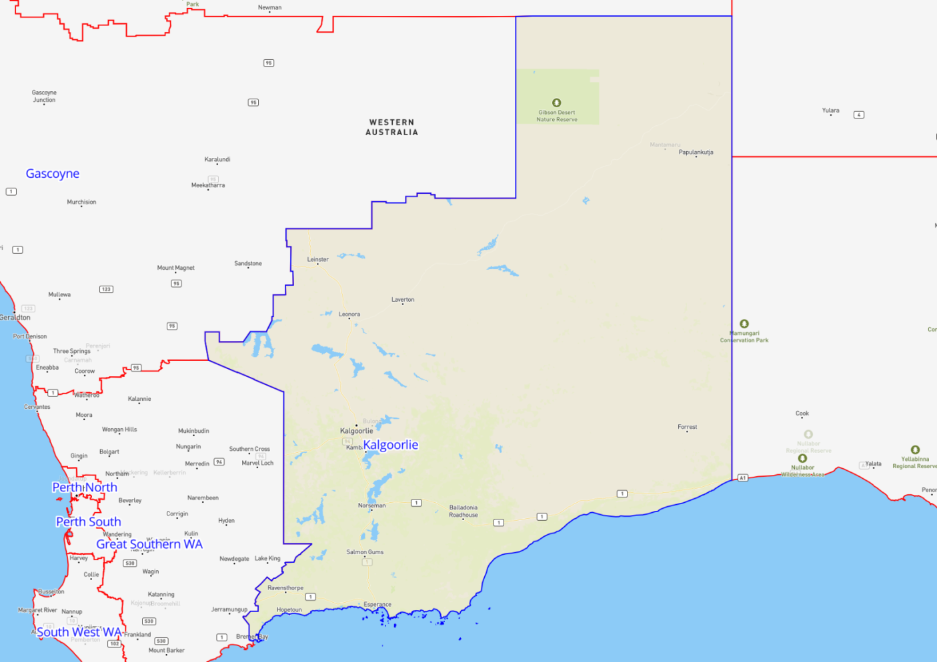

Tasmania Contract Regions
Contract Region | Service Provider | Region Type
South Tasmania | MAX Solutions | Regional
North and North West Tasmania | MAX Solutions | Regional

South Tasmania
Region Name | South Tasmania
Region Type | Regional
Service Provider | MAX Solutions

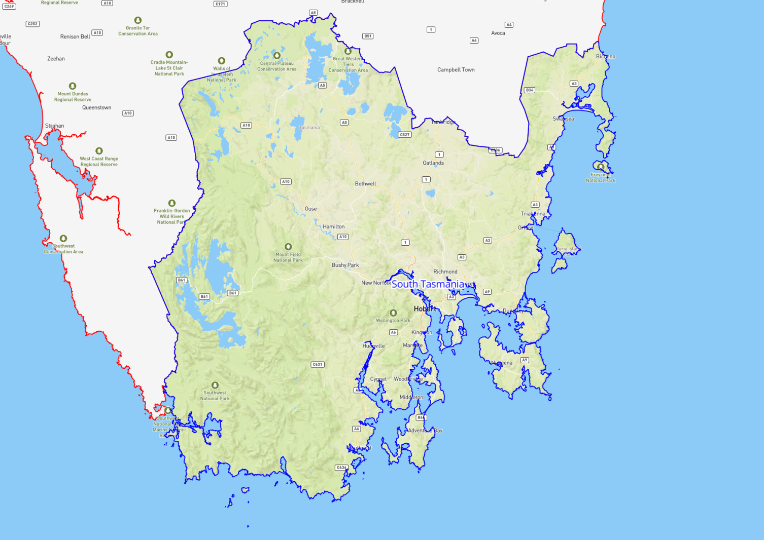

North & North West Tasmania
Region Name | North & North West Tasmania
Region Type | Regional
Service Provider | MAX Solutions

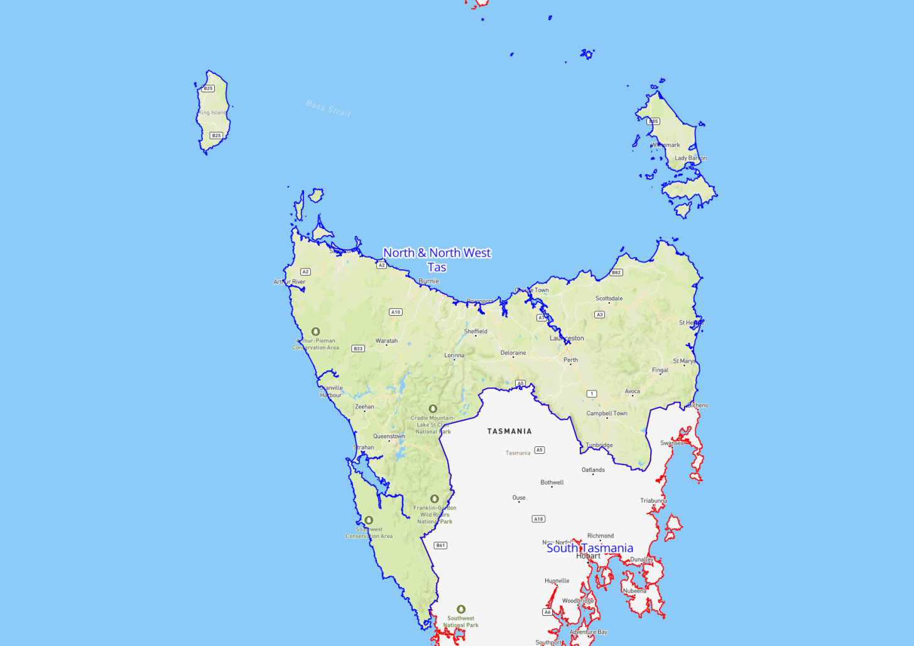

Northern Territory Contract Regions
Contract Region | Service Provider | Region Type
Darwin | STEPS Group Australia | Regional
Central Northern Territory | STEPS Group Australia | Remote
Top End Northern Territory | STEPS Group Australia | Remote

Darwin
Region Name | Darwin
Region Type | Regional
Service Provider | STEPS Group Australia

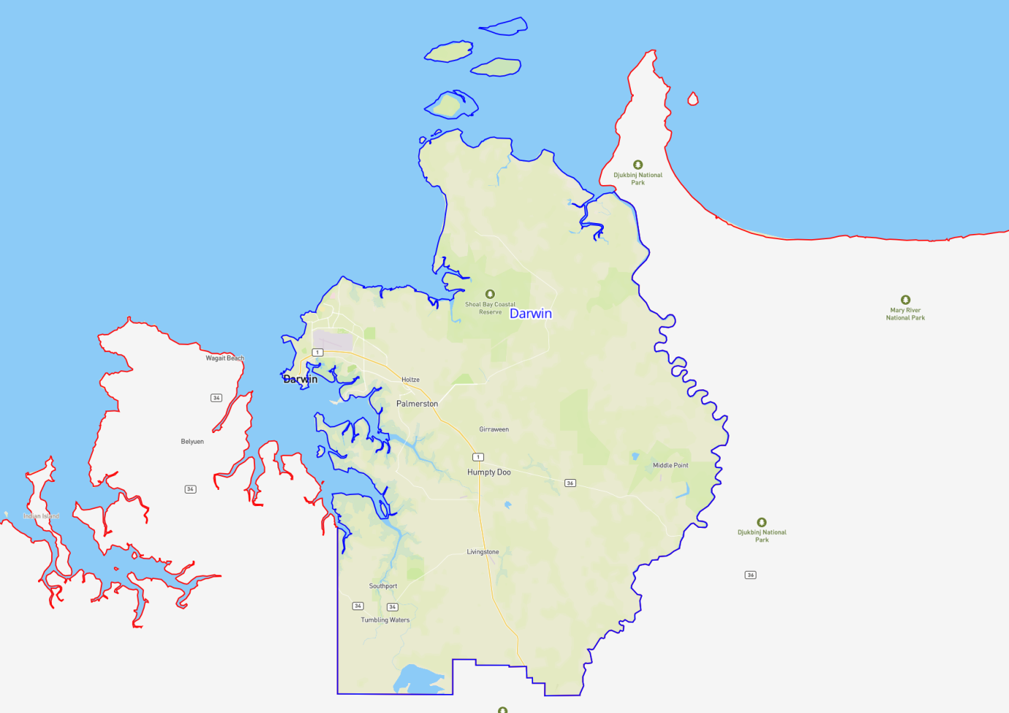

Central Northern Territory
Region Name | Central Northern Territory
Region Type | Remote
Service Provider | STEPS Group Australia

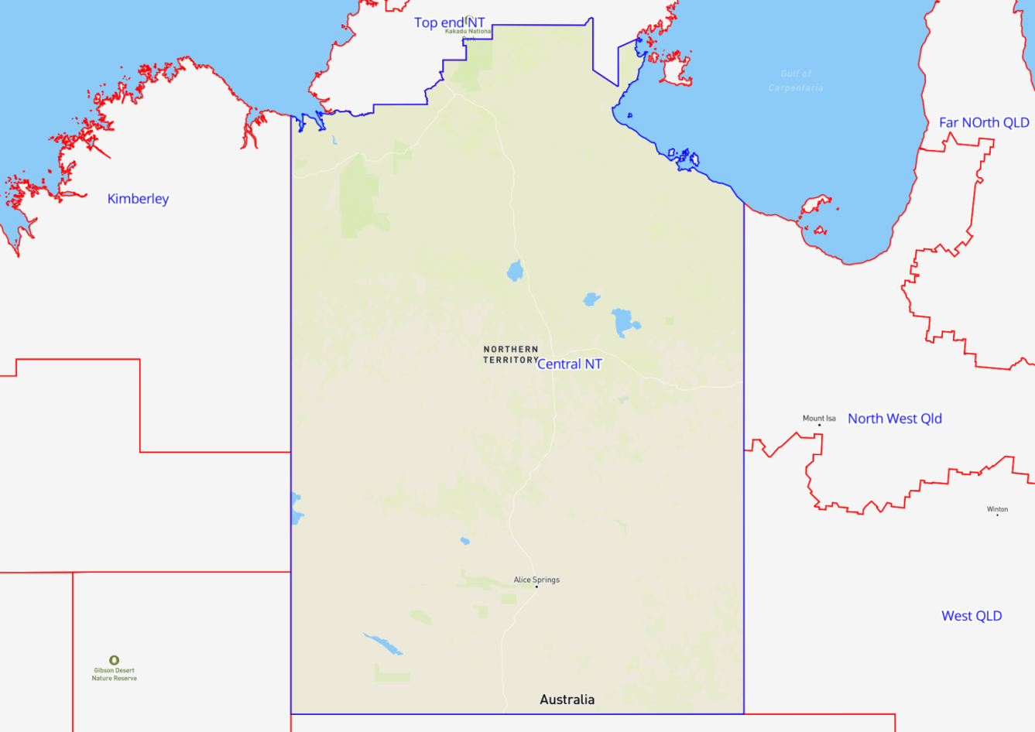

Top End Northern Territory
Region Name | Top End Northern Territory
Region Type | Remote
Service Provider | STEPS Group Australia

