

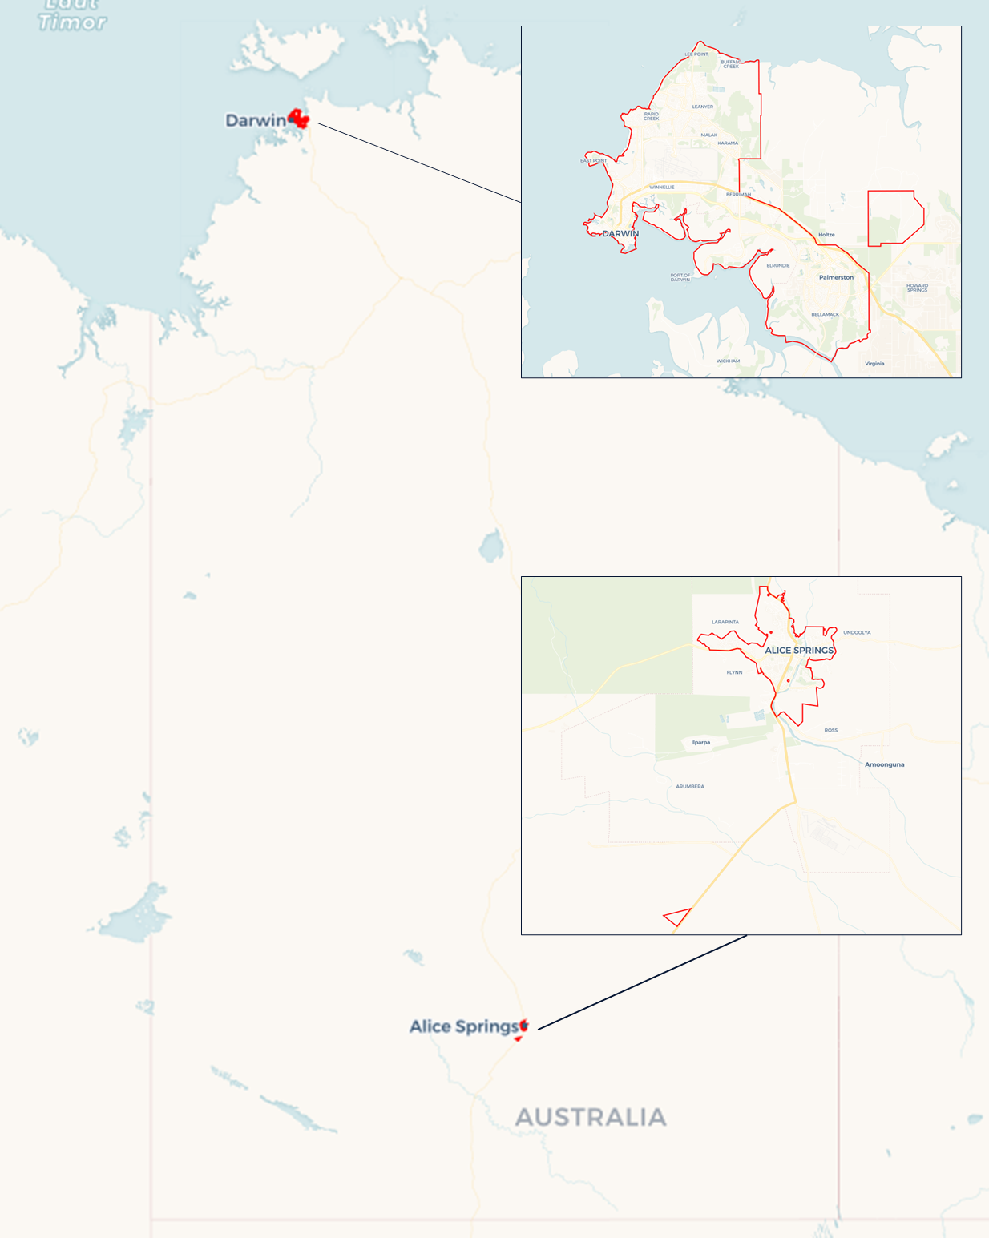Local Jobs Plan

Darwin (including Alice Springs) ****Employment Region**** | NT | February ****2023****

Workforce Australia Local Jobs (Local Jobs) is a program that supports tailored approaches to accelerate   
reskilling, upskilling and employment pathways in response to current and emerging local workforce needs.

## Local Jobs elements

### Local Jobs Plan

The Local Jobs Plan sets out the skills and employment challenges and priorities of the region, and associated strategies that will drive the design and implementation of activities to be implemented to address these challenges.

### Employment Facilitators

Employment Facilitators and Support Officers support the delivery of the program by bringing together key stakeholders including businesses, employment services providers, higher education and training organisations.

### Local Jobs and Skills Taskforce

Each Employment Region has its own Taskforce. Representatives include local stakeholders who have demonstrated experience in upskilling, reskilling, and an ability to represent, connect and collaborate with others in the region to meet labour market needs.

### Local Recovery and National Priority Funds

The Local Recovery Fund supports projects that meet the priorities identified in the Local Jobs Plan. The National Priority Fund provides funding for innovative local solutions to address structural barriers to employment.

Explore labour market insights for the   
[Darwin (including Alice Springs)](http://www.jobsandskills.gov.au/work/monthly-labour-market-dashboards) Employment Region

## Local labour market challenges in the region

* The Northern Territory (NT) is facing recruitment shortages across skill levels and numerous industries such as health care and social assistance, construction and mining, retail/trade and hospitality. With a relatively small population base compared to other regions, high participation rates, traditionally low unemployment rates, yet high levels of long-term unemployment there is an apparent disparity between the employment demand and the capabilities of the available labour market.
* The lack of experienced skilled workers in the existing workforce limits opportunities to develop place-based, entry level initiatives that could assist in addressing some of the recruitment demands. Skilling initiatives require collaboration across business, industry, training organisations, employment and skills support services and all government agencies to enable local individuals to transition into the available roles.
* Many individuals looking for work have multiple obstacles to successfully transitioning into employment. These include low literacy skills, reading and writing comprehension, language, digital literacy capabilities, criminal histories, low education, limited or no work experience, family and cultural responsibilities, inter-generational trauma, racism, prejudice, socioeconomic disadvantage, complex health conditions, access to secure accommodation and transport.
* Limited public transport access, including access to industrial growth centres across the Northern Territory, restricts local people from applying for and taking up the many employment opportunities in these locations.

## Local jobs and skills priorities and strategies in the region

### Priority 1 – Create effective pathways to growing and emerging employment opportunities within the Darwin and Alice Springs industry sectors. Ensure local participants are prepared and sufficiently skilled to meet employer and industry labour needs.

#### What are our challenges and opportunities?

#### Workforce development strategic rationale requires considerable planning, lead times, considerations, collaboration and knowledge sharing between Workforce Australia Employment Services providers, industry, governments and the broader community. There are opportunities to effectively prepare upskilling or reskilling projects that align with, and address, the labour market capabilities to industry demand. Planning considerations must consider the employment opportunity and the capabilities of the targeted cohort’s barriers to employment.

#### How are we responding?

* We are collaborating with industry stakeholders to identify employment opportunities and develop initiatives that will attract, train, and prepare participants to meet minimum entry-level labour requirements for local employers across the Employment Region.
* We work with key stakeholders to support them in the development and delivery of holistic pre-employment training. Training is aimed at individuals who are looking for entry-level roles across industry sectors.
* We promote the benefits of investment in language, literacy, numeracy, and digital skills for workers, with local employers and industry groups.
* We provide labour market intelligence to key stakeholders for optimising and customising employment pathway initiatives to meet labour market demand.
* We collaborate with local stakeholders to develop place-based skilling and work experience initiatives. These may include funding through the Local Recovery Fund or the Northern Territory Government’s grant programs. The aim is to provide individuals with pathways into employment through upskilling and reskilling opportunities.
* We facilitate industry and workforce development working groups that are outcome and solutions focused to address local recruitment demands and employment across all sectors.
* We collaborate with local businesses, Group Training Organisations, Industry Councils, Registered Training Organisations and Workforce Australia providers to showcase employment opportunities across the business sector.
* We work with the Northern Territory Government, Chamber of Commerce NT, Industry Skills Advisory Council NT and contractors appointed to major projects to identify and develop place-based initiatives that will promote and transition participants into employment opportunities.

### Priority 2 – Facilitate and support the participation in training and employment opportunities for our most disadvantaged individuals (Indigenous Australians, migrants, refugees, mature aged, females, youth, people with disabilities, and long-term and very long-term unemployed people).

#### What are our challenges and opportunities?

#### A high proportion of individuals on the caseload have many barriers to effective participation in training and employment opportunities, including low education, literacy capabilities, the effect of inter-generational trauma, length of unemployment, complex health conditions and socioeconomic disadvantage. The lack of work experience, skills, public transport accessibility to employment locations, accommodation, stable support networks, role models and health are some of the additional barriers in the Employment Region.

#### How are we responding?

* We collaborate with leaders from different sectors to improve youth employment pathways and outcomes for young people and businesses in our community.
* We work with local stakeholders to support them in the delivery of culturally appropriate training and support across various industry sectors.
* We connect Workforce Australia Employment Services providers to other employment support and community services providers. The aim is to facilitate collaboration in the delivery of wrap-around services to local individuals from the most disadvantaged cohorts and successful transition into sustainable employment.
* We collaborate with local stakeholders to support them in the delivery of place-based employment pathway programs through the utilisation of the Local Recovery Fund and where appropriate, the NT Government grants programs.
* We work with local governments and stakeholders to showcase employment opportunities to students and individuals looking for work.
* We facilitate industry-based workforce development working groups to identify and develop solutions to current issues relating to the transitioning of individuals into employment.
* We promote skilling programs and job vacancies to employment services providers and local individuals looking for employment through monthly newsletters, social media and online community groups.
* We maximise linkages between training and local employment opportunities to fill entry-level positions, including traineeships and apprenticeship positions with participants.

## Want to know more?

* Contact: Michelle Burgess, Employment Region Employment Facilitator: [mburgess@localjobsnt.com.au](mailto:mburgess@localjobsnt.com.au)
* Website: [Local Jobs](https://www.dewr.gov.au/local-jobs) or [Workforce Australia](https://www.workforceaustralia.gov.au/)
* Facebook: [Workforce Australia Local Jobs - Darwin and Alice Springs](https://www.facebook.com/workforceaustralialocaljobsNT)