

**Local Jobs Plan**

**Gold Coast**

**QLD**

July 2022

Contents

The Local Jobs Program 3

Key Employment and Training Priorities 3

Employment Region Overview 4

Challenges in the Gold Coast Employment Region 4

Local Stakeholders and Opportunities 5

Attachment A - Key employment and training priorities: strategies and stakeholders 9

Attachment B - Labour Market Data Dashboard (May 2022) 13

The Department of Employment and Workplace Relations acknowledges the traditional owners and custodians of country throughout Australia and acknowledges their continuing connection to land, water, and community. We pay our respects to the people, the cultures and the elders past, present and emerging.

# The Local Jobs Program

As part of supporting Australia’s economic recovery from the COVID-19 pandemic, the Australian Government’s Local Jobs Program (LJP) brings together expertise, resources and access to funding at the local level to accelerate reskilling, upskilling and employment pathways in 51 Employment Regions.

Recognising the importance of local knowledge in getting people back into jobs quickly, the LJP includes the following key elements in each region:

* a local Employment Facilitator
* a Local Jobs and Skills Taskforce
* a Local Jobs Plan
* a Local Recovery Fund to support small scale activities
* access to the National Priority Funding Pool.

The Taskforces, each chaired by the respective region’s Employment Facilitator, develop and update a Local Jobs Plan for their region that identifies key employment and training priorities and provides a framework for driving employment outcomes in the context of the local labour market.

The Local Jobs Plan for the Gold Coast Employment Region identifies the key LJP priorities with a focus on creating employment opportunities, actively upskilling or reskilling local job seekers and meeting local employer demands.

# Key Employment and Training Priorities

1. Collaborate withbusiness and employment services to promote greater take-up of opportunities which lead to skill development and employment for individuals.
2. Promote the uptake of apprenticeships and traineeships to meet projected growth industries and skills shortage areas and connect individuals to these opportunities.
3. Approach businesses that have diversity targets to identify supported training and employment pathways for disadvantaged cohorts including women, youth, Indigenous Australians, people with disability, mature aged and long term unemployed.

Promote existing plans, programs and strategies to skill and upskill individuals for employment opportunities.

1. Promote existing strategies and programs that skill and upskill individuals for employment opportunities.

A full description of the key priorities, including strategies to address these and key stakeholders can be found at **Attachment A**.

# Employment Region Overview

The Gold Coast Employment Region (ER) is located south of Queensland’s State Capital of Brisbane. In addition to the Gold Coast Local Government Area, the ER crosses the New South Wales border to include a small area of the Tweed Shire Council Local Government Area.

Gold Coast Employment Region Map.

With its sunny subtropical climate, surfing beaches, canal and waterway systems combined with the high-rise dominated skyline, nightlife and rainforest hinterland, the Gold Coast area is one of Australia’s major tourist destinations for both domestic and international travellers.

The New South Wales area of the Gold Coast ER includes the border-town city of Tweed Heads and Banora Points, Chinderah, Fingal, the Tweed Coast villages of Kingscliff and Casuarina. With relaxing beachside villages and riverside towns, this southern end of the Gold Coast ER offers tourists relaxing and unique experiences as a holiday destination.

The City of Gold Coast’s population is over 630,000 and the city is projected to be home to approximately one million people by 2050.

# Challenges in the Gold Coast Employment Region

The **Labour Market Data Dashboard (Attachment B)** shows the unemployment rate in the Gold Coast was 4.5% as at April 2022, which is slightly lower than March 2020 when the unemployment rate was 4.8%. The National unemployment rate was 3.9% as at April 2022, which is significantly lower than March 2020 when the unemployment rate was 5.2%. Since April 2020, there has been an increase in the number of participants in the employment services caseload who have been unemployed for over 24 months. This indicates the need to provide activities and strategies to address long term unemployment in the Gold Coast Employment Region.

The full extent of the impact of COVID-19 since March 2020 also needs to be considered in light of many of those counted as employed are underemployed (i.e. working shorter hours or fewer hours than they would like). Many of the workers across the Tourism and Hospitality industries were overseas students who returned to their home country during the pandemic, leaving a gap in the labour market for businesses once lockdowns were lifted and borders re-opened.

# Local Stakeholders and Opportunities

**Gold Coast Local Jobs Council**

The Gold Coast Local Jobs Council (Jobs Council) is facilitated by the Queensland Government Department of Employment, Small Business and Training in partnership with the Australian Government Department of Employment and Workplace Relations and the Queensland Government Department of Aboriginal and Torres Strait Islander Partnerships. The Jobs Council works within a Memorandum of Understanding and to a Statement of Principles regarding how employment services will respond to the recruitment needs of businesses in the Gold Coast Employment Region. Group members include representation from employment services providers. The Employment Facilitator works alongside the Jobs Council to ensure collaboration, maximising of resources and effective communication.

**City Heart Taskforce**

In August 2020, the City Heart Taskforce convened a think tank of over 100 leading business minds to begin the task of reengineering the pathway to jobs of the future. The think tank was designed to reimagine the future and develop targeted outcomes with a key focus on jobs, skills and industry in the changed economic conditions. The ‘Reimagine Gold Coast Insights Report August 2020’ provides key themes on jobs, skills and industry. The Local Skills and Jobs Taskforce has reviewed the insights outlined in the report and continues to ensure the Local Jobs Plan reflects the intelligence gathered from this event.

**Employment Services Provider Network**

A monthly Employment Services Provider meeting is chaired by the Employment Facilitator. This is a high-level meeting to provide a debrief on the latest **Labour Market Data Dashboard**. This also provides a regular platform to discuss current labour issues, Activities (Local Recovery Fund or other) and current vacancies. Additional Employment Services Provider briefings are held on an ad hoc basis and may include organising events for staff to attend business open days. This strategy enhances the awareness of location, sites and business requirements and encourages the matching of suitable candidates.

**Gold Coast Care Sector Reference Group**

The Health Care and Social Assistance sector is currently the largest employing industry in the region. This sector will continue to experience a high level of growth, resulting in an ongoing demand for a skilled workforce.

A Care Sector Reference Group chaired by the Employment Facilitator has been established to bring together industry stakeholders including businesses, employment service providers, Registered Training Organisations, Group Training Organisations, Labour Hire Agencies, Peak Bodies and other stakeholders that have an interest in skills and labour in the Health and Care sector with a particular focus on Aged Care, Disability and Child Care. The Reference Group shares intelligence and resources and uses a ‘Think Tank’ approach to developing strategies to attract, train and retain employees in this sector for the Gold Coast Employment Region.

**Current and Emerging Opportunities**

Several current and emerging developments will provide job opportunities in the Gold Coast Employment Region, as the region recovers from the impacts of the COVID-19 pandemic. Significant investment and consultation are also progressing with Gold Coast businesses by both the Australian Government and Queensland Government to prepare for emerging industries.

Projects in the Gold Coast Employment Region include: M1 upgrade; upgrade to The Spit; extension of the Light Rail; build, upgrades and extensions to health services; Inland Rail; continued upgrades to the Pacific Highway. Strategies and programs include: Naval Shipbuilding Strategy; Queensland Government Super Yachts Strategy; Modern Manufacturing Strategy; Boosting the Local Care Workforce Program; and Home Care Workforce Support Program.

**The National Skills Commission, Employment Outlook to November 2025** reports skill shortages occur typically in growth periods when skilled workers are already employed and industry cannot find the labour it needs. The National Skills Commission’s five‑year employment outlook projects that the long-term structural shift in employment towards services industries is projected to continue over the coming five years. **Health Care and Social Assistance** is projected to make the largest contribution to employment growth over the period (increasing by 249,500), followed by **Accommodation and Food Services** (139,900), **Professional, Scientific and Technical Services** (131,100), and **Education and Training** (118,600). Together, these four industries are projected to generate over three-fifths (or 64.4 per cent) of total employment growth[1] over the five years to November 2025.

* Employment is projected to increase in 17 of the 19 broad industries over the five years to November 2025.
* Declines in employment are projected for **Manufacturing** (5900)and **Information Media and Telecommunications** (7500).

##### Industry contribution to projected employment growth – five years to November 20251

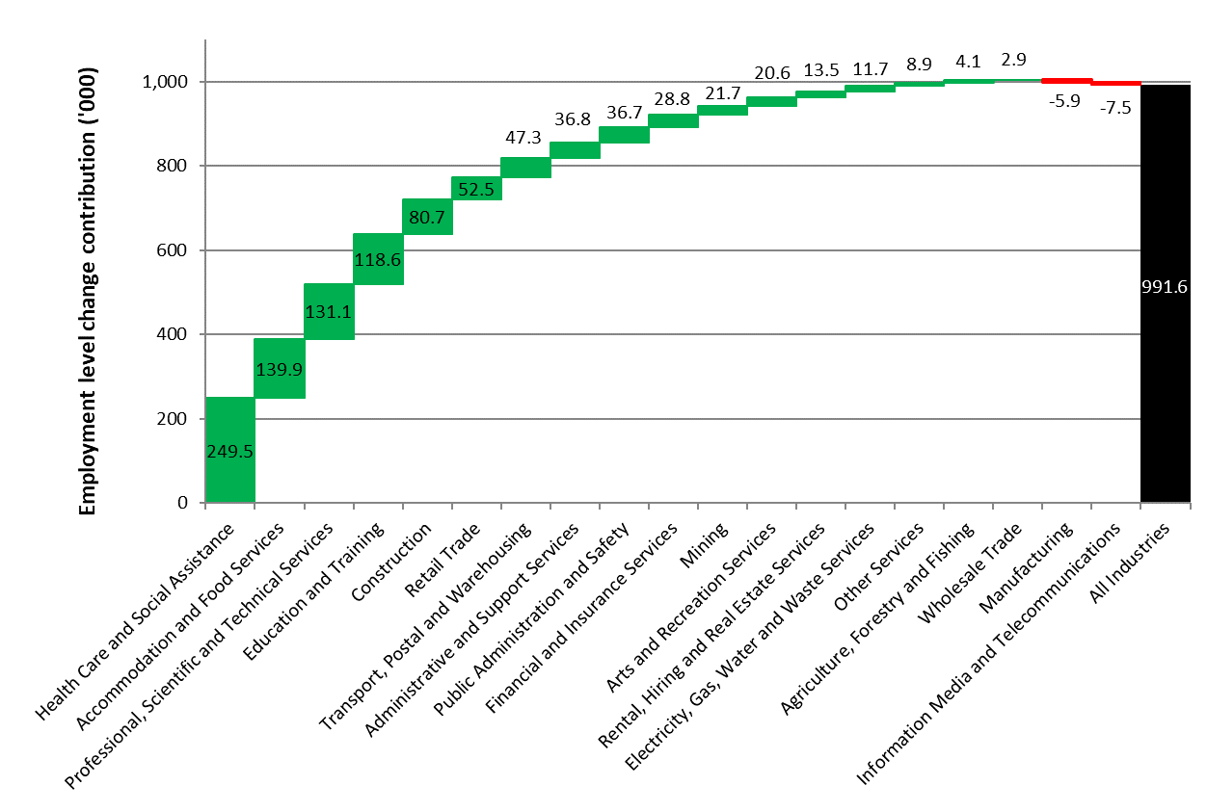

Total employment projected growth for the five years to November 2025 is based on the forecasted and projected total employment growth rates published in the 2020-21 Mid-Year Economic and Fiscal Outlook (MYEFO), November 2020 Labour Force Survey (LFS) data for total employment, and the November 2020 detailed quarterly LFS data. Based on these data, total employment is projected to increase by around 991,600 (or 7.8 per cent) over the five years to November 2025.

**Projected employment growth to November 2025 by major occupational group and skill level**[2]

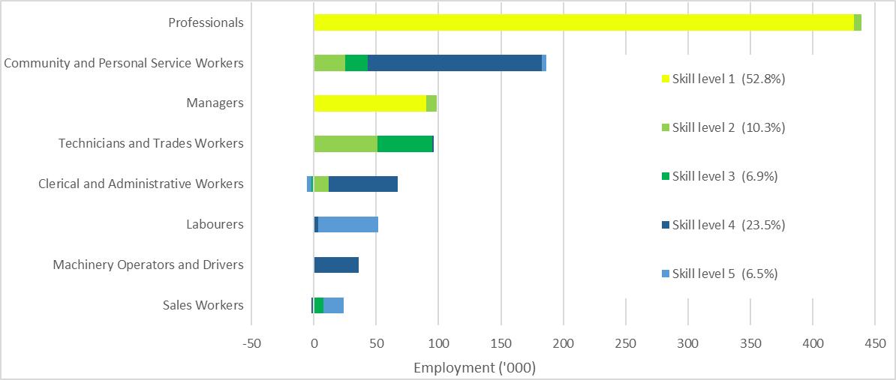

2 Employment in Community and Personal Service Workers fell by 21.9 per cent over the quarter to May 2020 and remained 10.3 per cent below its pre-COVID-19 level in November 2020.

2 The Australian Bureau of Statistics (ABS) classifies occupations according to five skill levels commensurate with the following qualification(s) or where relevant work experience with training may be a substitute for formal qualifications:

• Skill level 1: Bachelor degree or higher qualification

• Skill level 2: Advanced Diploma or Diploma

• Skill level 3: Certificate IV or Certificate III with at least two years on-the-job training

• Skill level 4: Certificate II or III

• Skill level 5: Certificate I or secondary education

Skilled occupations require significant lead time for training and often are a four-year commitment to become fully qualified. The strategies used during the implementation of the Local Jobs Plan will focus on skill shortage areas, including University level qualifications and apprenticeships required to target skilled occupations.

## Attachment A - Key employment and training priorities: strategies and stakeholders

**Priority One:** Collaborate withbusiness and employment services to promote greater take-up of opportunities which lead to skill development and employment for individuals.

|  |  |
| --- | --- |
| **Strategies - short and long term** | **Stakeholders** |
| • In partnership with all levels of government develop industry specific information sessions focused on business growth, workforce planning, tailored recruitment and programs and funding to support new workers.  • Trial job seeker and business connection events in growing and emerging industries, followed by tailored assistance to develop on boarding pathways.  • Filter employment opportunities through the Labour Market Council to ensure businesses have access to employment services and suitable applicants.  • Work with registered training organisations to ensure training meets business needs and funding is sourced to support the development of individuals’ skills.  • Where possible assist in facilitating connection with businesses recruiting redundant workers. | • Businesses  • Local Jobs and Skills Taskforce  • Employment Facilitator  • Regional Development Australia  • AusIndustry  • State Government  • Local Government  • Registered Training Organisations |

**Priority Two:** Promote the uptake of apprenticeships and traineeships to meet projected growth industries and skills shortage areas and connect individuals to these opportunities.

|  |  |
| --- | --- |
| **Strategies - short and long term** | **Stakeholders** |
| • Host connection events with apprenticeship providers and Group Training Organisations to enable participants to understand different industries, the apprenticeship system and connect to opportunities.  • Disseminate information to businesses on the benefits and funding associated with hiring apprentices or trainees.  • Develop innovative pathways to skill shortage areas, including trial workshops, try a trade days or work experience to encourage the take-up of apprenticeships in skills shortage areas. | • Businesses  • Local Jobs and Skills Taskforce  • Employment Facilitator  • Regional Development Australia  • AusIndustry  • State Government  • Local Government  • Registered Training Organisations  • Group Training Organisations  • Australian Apprenticeship Support Network providers |

**Priority Three:** Approach businesses that have diversity targets to identify supported training and employment pathways for disadvantaged cohorts including women, youth, Indigenous Australians, people with disability, mature aged and long term unemployed.

|  |  |
| --- | --- |
| **Strategies - short and long term** | **Stakeholders** |
| • Co-design with businesses pathways that include training, wrap-around supports and cultural awareness to attract vulnerable individuals to employment opportunities and ensure sustainable pathways.  • Develop pathways for women into non-traditional roles by accessing recruitment for major projects.  • Build on existing workforce pathways to diversify the target cohort including opportunities in Health Services.  • Identify local activities that support engagement and motivation to prepare these cohorts for pre-employment activities.  • Promote activities and events that enable individuals to become aware of industries and career pathways. | • Businesses  • Local Jobs and Skills Taskforce  • Employment Facilitator  • Regional Development Australia Gold Coast  • AusIndustry  • State Government  • Local Government  • Registered Training Organisations |

**Priority Four:** Promote existing strategies and programs that skill and upskill individuals for employment opportunities.

|  |  |
| --- | --- |
| **Strategies - short and long term** | **Stakeholders** |
| • Identify existing and new opportunities as they are announced and connect with key stakeholders to commence the conversation in relation to workforce needs.  • Participate in regional working groups to hear of opportunities early and drive the employment narrative.  • Connect with businesses to ensure individuals have the right skills needed to take advantage of employment opportunities and pathways are developed to support business needs. | • Businesses  • Local Jobs and Skills Taskforce  • Employment Facilitator  • Regional Development Australia Gold Coast  • AusIndustry  • State Government  • Local Government  • Registered Training Organisations |

## Attachment B - Labour Market Data Dashboard (May 2022)

This Labour Market Data Dashboard was published in May 2022 and provides a summary of the key indicators for the Gold Coast  labour market.
 
The dashboard combines a range of data for each of the 51 Employment Regions, to provide an overview of local labour market conditions. Dashboards are also available for each state and territory, and at the national level. The data used include the Labour Force Survey, Employment Services Caseload, Internet Vacancy Index and Small Area Labour Markets.

For any enquiries related to this dashboard, please contact EmploymentPathwaysAnalysis@skillscommission.gov.au”


1. .
2.