

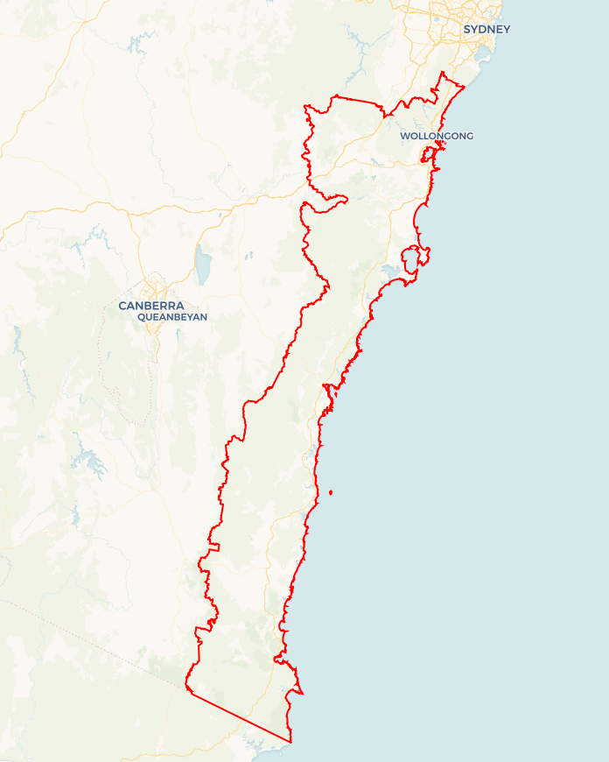Local Jobs Plan

****Illawarra South Coast**** Employment Region | NSW | ****January 2023****

Workforce Australia Local Jobs (Local Jobs) is a program that supports tailored approaches to accelerate   
reskilling, upskilling and employment pathways in response to current and emerging local workforce needs.

## Local Jobs elements

### Local Jobs Plan

The Local Jobs Plan sets out the skills and employment challenges and priorities of the region, and associated strategies that will drive the design and implementation of activities to be implemented to address these challenges.

### Employment Facilitators

Employment Facilitators and Support Officers support the delivery of the program by bringing together key stakeholders including businesses, employment services providers, higher education and training organisations.

### Local Jobs and Skills Taskforce

Each Employment Region has its own Taskforce. Representatives include local stakeholders who have demonstrated experience in upskilling, reskilling, and an ability to represent, connect and collaborate with others in the region to meet labour market needs.

### Local Recovery and National Priority Funds

The Local Recovery Fund supports projects that meet the priorities identified in the Local Jobs Plan. The National Priority Fund provides funding for innovative local solutions to address structural barriers to employment.

Explore labour market insights for the  
[Illawarra South Coast](http://www.jobsandskills.gov.au/work/monthly-labour-market-dashboards) Employment Region

## Local labour market challenges and opportunities in the region

* Disengagement by young people in the 15-24 age group since the COVID-19 pandemic from participation in employment or skills opportunities.
* Limited public transport options in some areas and a lack of consistent learner driver support reduces pathways for young people to sustainable employment and training opportunities.
* High incidence of Indigenous, mature aged, youth and long -term unemployment requires a tailored approach with an increased focus on partnerships with businesses and improved understanding of the needs of a range of individual cohorts to increase successful recruitment and retention.
* An ongoing difficulty for hospitality, tourism, and small businesses to recruit workers to meet demand. Experienced and skilled chefs, bar, front of house staff, cleaners and retail staff are all in short supply.
* Ongoing difficulties for the community services sector, in particular aged care, disability services and child care, to recruit workers to meet new staffing and quality requirements from the Aged Care Royal Commission and the labour market demands created through an ageing population, NDIS services and the need for increased child care places.
* The significant growth in the manufacturing and energy sector in the Illawarra and Shoalhaven region over the next 2 years will have a significant need for workers with skills in the engineering, civil construction, and project management.
* The demand for workers is creating challenges for Registered Training Organisations (RTOs) across the region as they are having difficulties attracting students to traditional courses. This requires RTOs to be linked to businesses to offer flexible and industry relevant short skills courses aligned to industry need.

**Local Jobs and skills priorities and strategies in the region**

### Priority 1 –Transport

#### What are our challenges and opportunities?

The lack of public transport in the more remote parts of the region combined with inconsistent delivery of learner driver support services is reducing employment opportunities for a range of unemployed cohorts, particularly youth and Indigenous people to successfully gain a driver licence and pathway to sustainable employment.

#### How are we responding?

* Utilising the Taskforce and the Transport Working Group membership to develop innovative, collaborative and proactive solutions for increasing coordination and access to consistent learner driver support services across the region.
* Utilising the Taskforce, Economic Development and Infrastructure and Transport Working Group membership to advocate for increased bus services aligned to employment and skills training opportunities particularly in the Bega Valley, Eurobodalla and Wingecarribee regions.
* Ensuring transport considerations are built into employment and skills activities and shared across industry working groups.

### Priority 2 – Indigenous unemployment

#### What are our challenges and opportunities?

Increasing sustainable employment opportunities for Indigenous individuals by increasing the range of employment opportunities and supporting businesses to offer a culturally safe and supportive workplace.

#### How are we responding?

* Utilising the expertise and the commitment for collaboration of our Indigenous and three industry focused working groups to develop and implement innovative strategies to build the cultural competence of businesses to increase recruitment and retention of Indigenous individuals.
* Working collaboratively across all our industry focused working groups to increase pathways to ensure all Local Recovery Fund activities consider the needs of Indigenous individuals during project design, implementation and offer tailored and integrated support utilising mentoring programs.
* Proactively promoting employment opportunities through good news stories that highlight successful employment outcomes.
* Developing partnerships and projects with local Workforce Australia providers and other key stakeholders to progress strategies that provide increased opportunities for Indigenous individuals.

### Priority 3 – Manufacturing

#### What are our challenges and opportunities?

The extensive growth of the manufacturing and emerging energy sector in the Illawarra and Shoalhaven areas requires a large pool of job-ready, skilled workers to successfully manage the project construction and business expansion phase to ensure timely delivery of the new and existing projects.

#### How are we responding?

* Building stronger links with the Illawarra manufacturing industry and working closely with I3Net, Business Illawarra and Shoalhaven Defence Industry Group to broaden the focus and priorities of the manufacturing working group to increase collaboration and employment opportunities.
* Working in partnership with manufacturing working group members and industry stakeholders to develop innovative opportunities and an increased understanding of the needs of the range of individual cohorts to maximise job opportunities in the manufacturing sector.
* Working with training services and partner RTOs to ensure pre-employment programs align with the needs of current and emerging industries and offer industry relevant pathways for individuals to build skills and gain sustainable employment.

### Priority 4 – Community services

#### What are our challenges and opportunities?

The community services sector is facing challenges to build a job ready skilled workforce to meet current and future labour demands. Quality requirements from the Aged Care Royal Commission requiring higher staffing ratios and skill levels, the current review into disability services and the changes for increased child care to support employment opportunities will add pressure on these industry areas for skilled workers.

#### How are we responding?

* Working with other strategic partners such as Aged and Community Care Providers Association, NSW Health, the Department of Health and Aged Care, and businesses to implement new initiatives in the region that focus on building the capacity of the workforce for the community services sector.
* Utilising the community services working members and industry stakeholders to develop campaigns that raise awareness of career opportunities in the sector.
* Trialling innovative recruitment strategies to increase pathways for a range of cohorts to maximise job opportunities in the sector.
* Working with training services and partner RTOs to ensure pre-employment programs align with the needs of the community services sector and offer industry relevant pathways for individuals to build skills and gain sustainable employment.

### Priority 5 –Hospitality, tourism and small business

#### What are our challenges and opportunities?

This sector has experienced considerable difficulties since the COVID-19 pandemic and is currently experiencing major skilled labour shortages which is reducing the ability of businesses to deliver services and maintain financial viability.

#### How are we responding?

* Working collaboratively with hospitality, tourism and small business working group members, the centre of excellence project and industry stakeholders to raise awareness of employment opportunities, trial innovative recruitment strategies and seek to build the profile of the sector as a desirable career choice for a range of cohorts.
* Working with training services and partner RTOs to ensure pre-employment programs align with the needs of the hospitality, tourism and small business sector and offer industry relevant pathways for individuals to build skills and gain sustainable employment.

### Priority 6 – Jobs and skills aligned to regional economic and infrastructure development

#### What are our challenges and opportunities?

The Illawarra South Coast region includes seven Local Government Areas, two regional NSW regions and three Regional Development Australia organisations that would benefit from working collaboratively with Local Jobs to ensure the skills and employment needs align with the economic and infrastructure needs of the region.

#### How are we responding?

* Expanding the previous Local Government working group to include regional NSW and Regional Development Australia representatives to develop two-way sharing of key information about economic development and the large infrastructure projects that will be implemented in the region to inform Local Recovery Fund skills and employment projects.
* Working group meeting every second month, with presentations from working group members for sharing of data, key project plans, labour workforce needs and current skills and employment initiatives.
* Developing collaborative employment and skills projects that can support the economic and infrastructure development needs of the Illawarra South Coast region.

## Want to know more?

* Contact: Sandra Gray, Illawarra South Coast Employment Facilitator: [sandra.gray@illawarrasouthcoastemployment.com.au](mailto:sandra.gray@illawarrasouthcoastemployment.com.au)
* Visit: [Local Jobs](https://www.dewr.gov.au/local-jobs) or [Workforce Australia](https://www.workforceaustralia.gov.au/)