


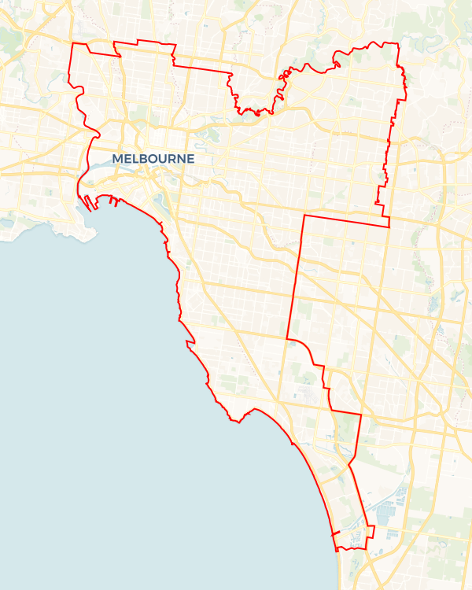
Local Jobs Plan
  - Inner Metropolitan Melbourne Employment Region | VIC |October 2025
Workforce Australia Local Jobs (Local Jobs) is a program that supports tailored approaches to accelerate
reskilling, upskilling and employment pathways in response to current and emerging local workforce needs.

Local Jobs elements

Local Jobs Plan
Each Employment Region has a Local Jobs Plan which outlines the labour market challenges in the region and the strategies to address these challenges.

Job Coordinators
Each Employment Region has a dedicated Job Coordinator who leverages existing resources, supports local labour markets through structural adjustments and retrenchments, and creates opportunities for collaboration between business and communities.

Local Jobs and Skills Taskforce
Each Employment Region has its own taskforce that meets regularly with the Job Coordinator to develop an understanding of challenges in the region and implement solutions. The taskforce is comprised of representatives from the region.

Local Jobs, Local People Grant
The Local Jobs, Local People grant funds activities that help people into ongoing employment or training. Activities must support local labour market needs.
Explore labour market insights for
Inner Metropolitan Melbourne Employment Region

Local labour market challenges

- Skills shortages: Persistent skills shortages such as for trades workers, aged and disability carers, registered nurses, child care workers, software and applications programmers. There is a mismatch of skills in demand and the available skills in labour supply.
- Transport: High proportions of jobseekers within the region lack drivers’ licences and access to a vehicle. Public transport is often impractical for travel to areas outside the central business district with gaps in cross-suburban public transport to neighbouring regions making it difficult for people from outer areas to access jobs, particularly jobs that vary in location and those with non-standard work hours.
- Skills: Culturally and Linguistically Diverse (CALD) communities, people with disability and First Nations peoples need further foundation and employability skills such as literacy, numeracy, basic digital skills and communication.
- Business engagement: Small to medium enterprises (SMEs) are unaware of the extensive range of existing programs, supports and funding available and lack know-how to engage with Workforce Australia providers and programs.

Local priorities
Priority 1 – Youth

What are our challenges?
Youth are disproportionately represented in the unemployment figures with the rate for youth unemployment in the IMMER continuing to rise and higher than the national average. There are skill shortages in construction, health care and social assistance and information media and telecommunications.There is an opportunity to match young people in the region to these sectors, by creating a thorough awareness and understanding in the region about career pathways, apprenticeships and traineeships and employment opportunities.

How are we responding?
- Establishing a Taskforce led ‘youth’ subgroup with key influencers in the region to create a focussed and informed strategy to address youth unemployment and deliver targeted activities.
- Engaging with young people and local business to co-design and pilot activities to tackle youth unemployment such as: Industry site tours, taster days, work experience, industry speakers, mock interviews and forums to connect young people with local businesses.
- Co-designing career pathway information for young people, including apprenticeships and traineeships by engaging with businesses experiencing skills shortages, education providers, group training organisations and community organisations that support youth.
- Supporting businesses and education providers to develop youth specific pre-employment programs linked to employment outcomes by driving joint funding applications, facilitate wage support and connecting with existing programs – to combat common employment challenges, whilst addressing employer needs.
- Arranging focus groups, youth talk circles and forums in conjunction with Transition to Work providers, youth hubs and youth groups to better understand, engage, support and match youth to suitable employment and training opportunities.
- Creating awareness for employers on the benefits of employing young people, focusing on business outcomes such as growing skills, building loyalty and a reliable pipeline of workers.
- Identifying emerging and non-traditional apprenticeship and traineeship qualifications and develop a targeted campaign to employers and young people to drive the take-up, leveraging existing programs and funding.
- Connecting young people with existing programs and networks to help build their confidence and skills and prepare them for work.

Priority 2 – Business engagement

What are our challenges?
Inner Metropolitan Melbourne has a diverse employer sector from the professional, scientific and technical services, health care and social assistance to retail trade and accommodation and food services. Many employers in Inner Metropolitan Melbourne are unaware of or not fully utilising services available to them in Workforce Australia. There is an opportunity to engage businesses to increase awareness of these service offerings and to develop industry led training and employment initiatives.

How are we responding?
- Establishing a Taskforce led ‘business engagement’ subgroup with key influencers in the region to create a strategy to support industry labour force needs and deliver targeted activities.
- Identifying a cross-section of employers and meeting with them to understand their needs, structural barriers and incentives to better work with Workforce Australia participants.
- Creating and promoting open days, jobs expos, reverse expos and ‘Try-a-Trade’ events that connect participants with local businesses.
- Engaging with local businesses to create work experience opportunities to familiarise jobseekers with employment.
- Developing a clear value proposition and targeted campaign to employers experiencing persistent skills shortages to inform and educate them of supports, existing programs and wage support available to address their workforce needs.
- Educating and informing employers about working with youth, CALD communities, First Nations peoples and people with disability, including provision of culturally responsive and youth friendly practices and benefits of having a diverse, inclusive and safe workplace.

Priority 3 – Supporting CALD communities, First Nations peoples and people with disability

What are our challenges?
CALD communities, First Nations peoples and people with disability represent a high volume of Workforce Australia caseloads in the region. There is an opportunity to work with local government, Learn Locals, community organisations, social enterprises and others to address challenges to effective labour market engagement.

How are we responding?
- Establishing a Taskforce led subgroup with key influencers in the region to create a strategy with a focus on increasing participation of priority cohorts in the workforce by delivering targeted initiatives and activities.
- Connecting CALD communities, First Nations peoples and people with disability with existing programs, networks and training to improve the skills of these cohorts to meet the needs of skills in demand in growth industries.
- Facilitating the co-design and piloting of new place-based employment pathways for CALD communities, First Nations peoples and people with disability that align with the needs of local business.
- Meeting with employers to understand their barriers (capacity, cost, cultural) in order to address hesitancy in employing a diverse workforce.
- Creating a promotional campaign in conjunction with Workforce Australia Employment Services Providers to support CALD communities, First Nations peoples and people with disability into self-employment.
- Attending community specific events to build relationships with key stakeholders supporting CALD, First Nations people and people with disability in order to explore opportunities to create sustainable connections and employment outcomes for these cohorts.

Priority 4 – Health care and social assistance industry

What are our challenges?
The region has high levels of demand for entry-level workers in the child care services, aged and residential care services and disabilities assistance services with low-fill rates. Persistent and structural challenges impacting job uptake include minimum entry requirements, licencing, transport and entry level pay.

How are we responding?
- Establishing a Taskforce led ‘health care and social assistance industry’ subgroup with key influencers in the region to create a strategy to increase the number of people training and working in the care sector and to increase employer awareness of programs and supports available to combat workforce challenges.
- Engage with businesses in the health care and social assistance industry, training and Workforce Australia Employment Services Providers, the Jobs and Skills Council and industry peak bodies to identify and implement strategies to address labour force issues.
- Delivering a care jobs expo to connect jobseekers, students and businesses in the health care and social assistance industry, with employers advertising their vacancies at the event.
- Consolidating industry-specific health care advice and guidance for sector employers to support them to hire people from the Workforce Australia caseload.
- Delivering targeted information sessions with CALD jobseekers and care sector employers covering minimum requirements to work in the care sector and application process.

Want to know more?
- Contact: Carmel Veenstra, Inner Metropolitan Melbourne Job Coordinator: carmel@ljp.org.au
- Visit Local Jobs or Workforce Australia

