

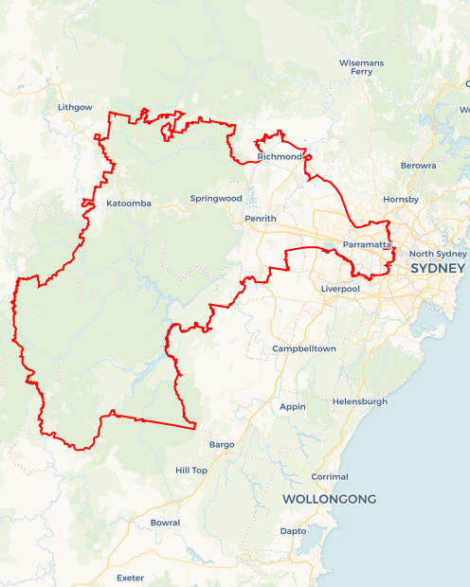Local Jobs Plan

Sydney Greater West Employment Region | NSW | ****January 2023****

Workforce Australia Local Jobs (Local Jobs) is a program that supports tailored approaches to accelerate   
reskilling, upskilling and employment pathways in response to current and emerging local workforce needs.

## Local Jobs elements

### Local Jobs Plan

The Local Jobs Plan sets out the skills and employment challenges and priorities of the region, and associated strategies that will drive the design and implementation of activities to be implemented to address these challenges.

### Employment Facilitators

Employment Facilitators and Support Officers support the delivery of the program by bringing together key stakeholders including businesses, employment services providers, higher education and training organisations.

### Local Jobs and Skills Taskforce

Each Employment Region has its own Taskforce. Representatives include local stakeholders who have demonstrated experience in upskilling, reskilling, and an ability to represent, connect and collaborate with others in the region to meet labour market needs.

### Local Recovery and National Priority Funds

The Local Recovery Fund supports projects that meet the priorities identified in the Local Jobs Plan. The National Priority Fund provides funding for innovative local solutions to address structural barriers to employment.

Explore labour market insights for the  
[Sydney Greater West](http://www.jobsandskills.gov.au/work/monthly-labour-market-dashboards) Employment Region

## Local labour market challenges in the region

* High levels of unmet demand for entry-level workers in growth employment areas such as social assistance services  
  (including aged and disability care), hospitality, and retail.
* Known and predicted skills gaps in high value sectors characterised by projected growth, including construction, advanced manufacturing, scientific and technical services, health care, and tertiary education.
* Supporting the changing nature of employment opportunities across a region which incorporates an ‘established city’ versus an ‘establishing city’ (namely Bradfield City/Western Sydney Aerotropolis: $1.15 billion, 100-hectare advanced manufacturing capital of Australia).
* Fragmented awareness and delivery mechanisms for the available skills training and employment support options designed to aid economic recovery, resulting in potentially diminished access and benefit for local individuals and businesses.

## Local jobs and skills priorities and strategies in the region

### Priority 1 – Youth unemployment

#### What are our challenges and opportunities?

The Sydney Greater West Employment Region is characterised by high levels of youth unemployment. The region features high levels of youth disengagement and has pockets of intergenerational unemployment in areas of lower socio-economic demographics, particularly in the Cumberland, Penrith, and Blacktown LGAs.

#### How are we responding?

* Connecting identified businesses with employment vacancies to youth through “Try a Trade” days, career expos, place-based training, community & sports events, virtual events (online gaming, online webinars, etc), and business open days.
* Promoting employment opportunities that build on-the-job skills such as apprenticeships and traineeships including school-based, and entry-level jobs that build employability skills.
* Establishing pre-employment programs that target youth who have disengaged from education and employment. The programs provide an opportunity for youth to experience the industry, gain practical skills, develop employability attributes, overcome barriers, and receive onsite mentorship.

### Priority 2 – Indigenous Australians, Migrant, and Culturally and Linguistically Diverse Individuals

#### What are our challenges and opportunities?

The Sydney Greater West Employment Region is characterised by high levels of multicultural communities, as well as concentrations of Indigenous Australians. Comparatively higher rates and longer periods of unemployment can often be seen within these cohorts.

#### How are we responding?

* Delivering co-designed pre-employment pathway programs targeting the culturally and linguistically diverse, migrant and Indigenous Australian cohorts that leverage government-funded initiatives e.g., Skills for Education & Employment Program, Employability Skills Training, etc.
* Delivering place-based accessible training and upskilling opportunities in areas of disadvantage.
* Working with businesses to build culturally and linguistically diverse & migrant employment pathways that includes:
* Leveraging existing pre-employment programs and initiatives (Skills for Education & Employment Program, Employability Skills Training, etc).
* Providing entry-level employment opportunities enabling the individual to build communication and employability skills.
* Identifying roles within their organisation that would utilise overseas qualifications and prior experience.
* Mapping career plans for individual career advancement.
* Allowing for additional re-credentialing or training throughout the individual’s employment.
* Providing planned support and mentorship.

### Priority 3 – Transportation

#### What are our challenges and opportunities?

There are pockets in the Sydney Greater West Employment Region with limited access to public transportation services and experiencing extended travel times to adjacent regions with employment opportunities. Limited connections appear to be more apparent in areas of lower socio-economic disadvantage, and higher intergenerational unemployment. A large proportion of individuals do not own a car or hold the appropriate licences for work opportunities (car, Heavy Rigid, Medium Rigid etc).

#### How are we responding?

* Establishing community transport solutions that will connect marginalised communities to local employment hubs e.g., retail districts, industrial areas, and local infrastructure projects. This could include:
* Identifying projects that may allow for a private transport model to take individuals from one location to a business.
* Engaging with Transport for NSW and advocate for improved transport connections and understand the future planned supportive infrastructure.
* Implementing programs and raising awareness of opportunities that allow individuals to work towards gaining their licence through programs that increase their required driving hours.
* Assisting businesses to develop carpooling strategies to attract individuals who don’t have access to local transport to gain employment.
* Establishing new routes of transport connectivity to the Aerotropolis and surrounding infrastructure and development projects that align with construction hours of operation.

### Priority 4 – Women in non-traditional roles

#### What are our challenges and opportunities?

Employment opportunities in the Sydney Greater West Employment Region are predominantly in male-dominated industries such as construction, transport, and manufacturing. Research demonstrates women that have pursued a non-traditional pathway are focused to succeed and offer longevity to businesses as well as diversity, communication, and analytical viewpoints. However, there remain businesses in the region that have never previously considered employing women in non-traditional roles.

#### How are we responding?

* Delivering pre-employment pathway programs for women to gain access to non-traditional roles leading to employment outcomes including apprenticeships and traineeships.
* Facilitating trade shows targeting the female cohort that provide practical hands-on activities to promote career awareness of trades and pathways available in the region.
* Connecting Employment Service Providers, community groups, and schools with promotional collateral featuring non-traditional career pathways for women.
* Delivering female ex-offender programs connecting this cohort to trade-based pre-employment or apprenticeship/traineeship pathways in the industry.
* Establish and deliver a childcare or child-minding model that will allow women who are upskilling or reskilling into non-tradition pathways to prepare for employment.
* Delivering forums targeting businesses and contractors, discussing the benefits of employing females in non-traditional roles, and the considerations needed to develop an inclusive work environment. The forum should also provide an opportunity to connect with Employment Services and individuals in the region.

### Priority 5 – Western Sydney Aerotropolis & Surrounding Infrastructure Projects

#### What are our challenges and opportunities?

The Western Sydney Aerotropolis is anticipated to become a thriving economic centre and will contribute to upwards of 200,000 employment opportunities, generated during the construction of the airport and surrounding infrastructure, and post-construction. A significant challenge is meeting the needs for skilled and general labour during construction of the airport, transportation, residential, and community infrastructure as well as agricultural spaces to support a new city.

#### How are we responding?

* Delivering on-site pre-employment programs via a trades-based model that will allow individuals to gain practical skills in construction while building employability attributes.
* Establishing a coordinator who will assist with:
  + Leveraging existing frameworks already in place (such as Multiplex’s Connectivity Centre and CPB’s Academy) or establish relationships with contractors and or sub-contractors where existing frameworks do not exist.
  + Promoting skillsets in demand and entry-level pathway opportunities to employment service providers and community groups in the region.
  + Undertaking job matching services connecting individuals to employment opportunities with contractors and sub-contractors on the Western Sydney Aerotropolis and surrounding infrastructure projects.
  + Supporting recently graduated students or aspiring apprenticeship candidates from the region to gain employment on these projects.

## Want to know more?

* Contact: Jamie Petschy, Sydney Greater West Employment Facilitator: [Jamie.PetschySGW@localjobsfacilitator.com.au](mailto:Jamie.PetschySGW@localjobsfacilitator.com.au)
* Visit: [Local Jobs](https://www.dewr.gov.au/local-jobs) or [Workforce Australia](https://www.workforceaustralia.gov.au/)