

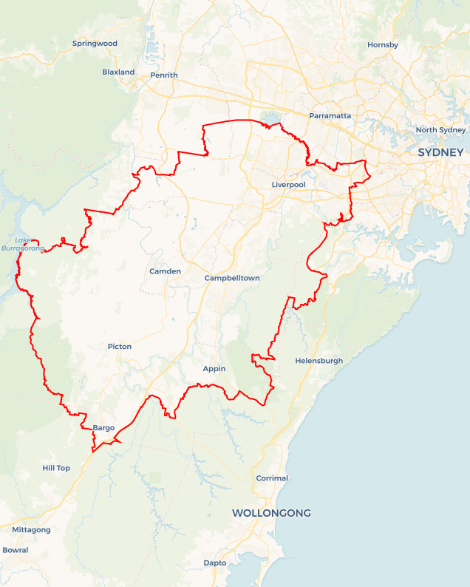Local Jobs Plan

Sydney South West ****Employment Region**** | NSW | ****January 2023****

Workforce Australia Local Jobs (Local Jobs) is a program that supports tailored approaches to accelerate   
reskilling, upskilling and employment pathways in response to current and emerging local workforce needs.

## Local Jobs elements

### Local Jobs Plan

The Local Jobs Plan sets out the skills and employment challenges and priorities of the region, and associated strategies that will drive the design and implementation of activities to be implemented to address these challenges.

### Employment Facilitators

Employment Facilitators and Support Officers support the delivery of the program by bringing together key stakeholders including businesses, employment services providers, higher education and training organisations.

### Local Jobs and Skills Taskforce

Each Employment Region has its own Taskforce. Representatives include local stakeholders who have demonstrated experience in upskilling, reskilling, and an ability to represent, connect and collaborate with others in the region to meet labour market needs.

### Local Recovery and National Priority Funds

The Local Recovery Fund supports projects that meet the priorities identified in the Local Jobs Plan. The National Priority Fund provides funding for innovative local solutions to address structural barriers to employment.

Explore labour market insights for the  
[Sydney South West](https://www.jobsandskills.gov.au/work/employment-region-dashboards-and-profiles/monthly-labour-market-dashboards) Employment Region

## Local labour market challenges in the region

* High levels of unmet demand for entry level workers in growth employment areas such as construction, hospitality, retail, warehousing and logistics, and aged and disability care.
* Known and predicted skills gaps in high value sectors characterised by projected growth, including construction (especially engineering and project management), advanced manufacturing, scientific and technical services, health care and tertiary education.
* Significant pandemic employment impacts on migrants and refugees as well as young people, representing both sizable and historically disadvantaged cohorts within the Employment Region.
* Pre-employment checks such as criminal record and National Disability Insurance Scheme checks required to qualify for roles in various sectors.
* Heightened risk of further entrenchment in labour market disadvantage for the existing cohort of disengaged young people, migrants, refugees, and historically disadvantaged cohorts within the Employment Region.
* Fragmented awareness and delivery mechanisms for the range of available skills training and employment support options designed to aid economic recovery resulting in potentially diminished access and benefit for local individuals and businesses.
* Lack of transport options that align with the demands of shift work and a high volume of individuals who do not have a driver's licence or suitable transport to where the jobs are.

## Local jobs and skills priorities and strategies in the region

### Priority 1 – Employment pathways

Meet the needs of businesses by engaging individuals into pathways to develop skills and attributes required to ensure sustainable employment.

#### What are our challenges and opportunities?

Meeting businesses needs by matching the current vacancies with long-term unemployed participants without current work skills is the most pronounced barrier to sustainable employment. Sydney South West Employment Region is characterised by strong labour market demand in health care and social assistance, retail trade, hospitality, construction, and education and training, particularly as the economy emerges from the effects of the COVID-19 pandemic. Knowledge about, and access to, the range of available training options and pathways to reskill or upskill for available local jobs is not always sufficiently clear and coherent to optimise outcomes for individuals and businesses.

#### How are we responding?

* Coordinating the range of training options (full qualification, short course, micro-credential) directly linked to current labour demand in the region to provide individuals with a single, streamlined pathway to upskilling and reskilling information.
* Developing and implementing overarching industry-specific recruitment models in areas of regional skills shortages (e.g., health care and social assistance) that expedite business and individual connections in a way that can be both tailored to individual business needs and enable business collaboration across the industry.
* Supporting local individuals and businesses to build entrepreneurial capability and innovate in response to new and emerging economic opportunities in the region.

### Priority 2 – Meeting local businesses’ workforce diversity needs

Effectively meet the recruitment needs and diversity targets of businesses delivering major infrastructure and development projects in the Employment Region, including projects fast-tracked by governments as part of economic recovery measures.

#### What are our challenges and opportunities?

Business apprehension towards individuals with long-term unemployment or lack of local work experience is a key challenge. The Sydney South West Employment Region is the focus of significant infrastructure investment across all three tiers of government. This includes construction of the Western Sydney airport and development of the surrounding Aerotropolis precinct as part of the Western Sydney City Deal. Tapping into large projects and educating smaller contractors will help to break down these barriers.

#### How are we responding?

* Developing a regional register of current and pending infrastructure and development projects to identify recruitment needs, required skills and timelines.
* Undertaking a skills mapping exercise to align identified skills in demand with the skills profiles of participant caseloads in the region.
* Developing and delivering recruitment solutions informed by regional skills mapping. These may include:
* direct recruitment
* short course upskilling to support skills transferability into the construction industry
* pre-employment programs comprising employability and industry specific skills training as preparation for entry level traineeships.

### Priority 3 – Migrants and refugees

Facilitate pathways for migrant and refugee individuals in the Employment Region to build the required skills and vocational language literacy, to move into available employment opportunities, including supporting skilled refugees into their trained professions.

#### What are our challenges and opportunities?

The most prominent barriers to employment for migrants and refugees are lack of English language, recognition of overseas qualifications and education level overall. The Sydney South West Employment Region is characterised by significantly higher levels of people from culturally and linguistically diverse (CALD) backgrounds reflecting the concentration of migrant and refugee populations within the Employment Region. Historically, the local government areas of Fairfield and Liverpool have represented some of the highest concentrations of refugee resettlement nationally. Comparatively higher rates and longer periods of unemployment are typical of this cohort.

#### How are we responding?

* Designing and delivering a promotional campaign targeting local businesses to highlight the benefits of workforce diversity and the range of available resources (government, community) to support the recruitment and retention of migrants and refugees.
* Developing a consolidated register of potential collaboration opportunities with businesses and industry in high growth areas in the context of workforce diversity goals.
* Facilitating the development and delivery of business bespoke training and recruitment pathways that draw on the full range of available programs and services supporting migrants and refugees.

### Priority 4 – Disengaged youth

Develop and implement local strategies to support disengaged youth to connect with education and training pathways linked to available jobs.

#### What are our challenges and opportunities?

The Sydney South West Employment Region is characterised by significant youth unemployment well in excess of NSW and national youth unemployment rates. While a historical feature of the Employment Region, youth unemployment has been exacerbated by the impact of the COVID-19 pandemic. The Employment Region also features comparatively high levels of youth disengagement where young people are not studying or looking for work.

#### How are we responding?

* Developing a consolidated picture of locally available youth services, programs, and initiatives to effectively inform the streamlined design of potential education, training and employment pathways that will address local needs.
* Designing and delivering industry-specific preparatory programs to support young people to engage with and develop required capability to take up apprenticeship and traineeship opportunities in growth areas.
* Identifying opportunities and create skills development pathways aligned with growth economies to support youth entrepreneurship.

### Priority 5 – Indigenous community

Reflecting the large and enduring disadvantage of the Indigenous population, it will also be a particular focus for Priorities 1, 2 and 4.

#### What are our challenges and opportunities?

The Sydney South West Employment Region is characterised by Indigenous unemployment disproportionately higher than the NSW and national unemployment rates. Indigenous unemployment has been exacerbated by the impact of the COVID-19 pandemic.

#### How are we responding?

* Developing a consolidated picture of locally available Indigenous services, programs and initiatives to effectively inform the streamlined design of potential education, training and employment pathways that will address local needs.
* Designing and delivering industry-specific preparatory programs to support Indigenous people to engage with and develop required capability to take up pathway programs to opportunities in growth areas, including apprenticeships and traineeships.
* Identifying opportunities and create skills development pathways aligned with growth economies to support entrepreneurship.

## Want to know more?

* Contact: Oggie Bosnjak, Sydney South West Employment Facilitator, [oggie.bosnjak@localjobsprogram.org.au](mailto:oggie.bosnjak@localjobsprogram.org.au)
* Visit: [Local Jobs](https://www.dewr.gov.au/local-jobs) or [Workforce Australia](https://www.workforceaustralia.gov.au/)