Local Jobs Plan

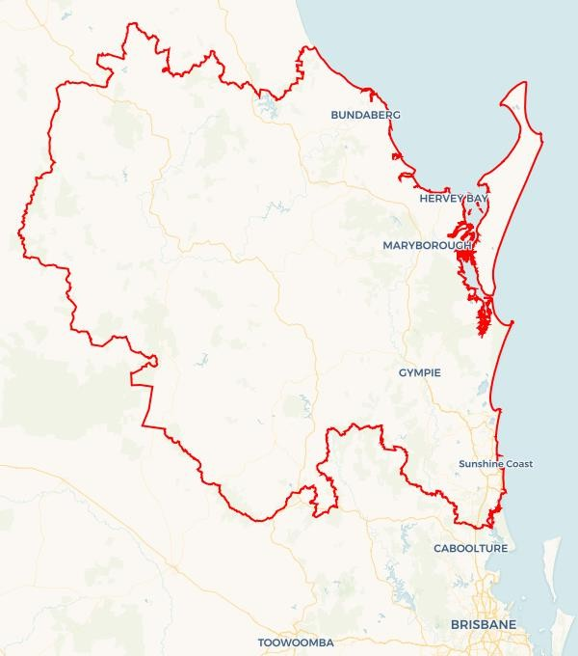
Wide Bay and Sunshine Coast | Queensland |February 2026
Workforce Australia Local Jobs (Local Jobs) is a program that creates partnerships between business
and communities to meet local workforce needs, thereby improving employment outcomes.
Local Jobs operates in all 51 Employment Regions in Australia.
Explore labour market insights for
Wide Bay and Sunshine Coast Employment Region
Local Jobs Overview
Local Jobs Plan
Each Employment Region has a Local Jobs Plan which outlines the labour market challenges in the region and the strategies to address these challenges.

Local Jobs and Skills Taskforce
Each Employment Region has its own taskforce that meets regularly with the Job Coordinator to develop an understanding of challenges in the region and implement solutions. The taskforce is comprised of representatives from the region.

Job Coordinators
Each Employment Region has a dedicated Job Coordinator who leverages existing resources, supports local labour markets through structural adjustments and retrenchments, and creates opportunities for collaboration between business and communities.

Program Funds
The Local Jobs, Local People grant funds activities that help people into ongoing employment or training. Activities must support local labour market needs.

Local labour market challenges in the region
- Ongoing high demand for entry-level workers in the hospitality, aged care and disability sectors.
- Long term unemployed, mature age individuals, youth and First Nations cohorts require on-going targeted support towards training and employment opportunities.
- There is a significant gap between current business needs and available workforce skills in the region.
- A large and geographically dispersed region with diverse population demographics, where limited transport access affects workforce participation and retention.
- Skills gaps and limited local labour supply affecting large infrastructure projects, including but not limited to the Queensland Train Manufacturing Program.
- The Wide Bay and Sunshine Coast Employment Region is currently experiencing low unemployment rates resulting in a limited supply of suitable candidates for businesses seeking staff.
- A low level of awareness regarding the spectrum of career and employment opportunities in current and emerging industries.




Local jobs and skills priorities and strategies in the region

Priority 1 - Health and social services sector

What are our challenges?
The health and social services sector are the largest employers across the Wide Bay and Sunshine Coast Employment Region. The industry has a growing demand for a suitably skilled workforce. The industry is predicted to grow exponentially, and demand is currently exceeding labour supply in the region.

How are we responding?
- Leveraging and connecting existing programs to empower participants through upskilling and reskilling initiatives, ensuring they are well-prepared to meet local labour market needs to maintain and maximise sustainable employment opportunities.
- Promoting opportunities to relevant cohorts such as mature age workers, who bring significant experience to the industry, and young people seeking meaningful careers, highlighting pathways for growth and development.
- Consulting with industry representatives, employers and associations to develop and refine strategies to strengthen recruitment and support long-term career progression for the sector.
- Delivering industry and career forums that showcase the sector’s opportunities, strengthen professional networks, and facilitate meaningful connections between employers and Workforce Australia Employment Services Providers.
- Utilising various media platforms strategically to highlight employment opportunities and connect job seekers, particularly those currently outside the support of providers.

Priority 2 - Youth

What are our challenges?
Traditionally, the Wide Bay Burnett region has endured systemic high youth unemployment. Whilst significant improvement has been realised over the past 2 years, ongoing strategic focus is required to ensure this can be sustained and optimised into the future.

How are we responding?
- Engaging with local businesses and industry to understand their workforce needs and design employment pathway opportunities that are well-suited for young job seekers, supporting their successful entry into the labour market.
- Consulting with employers in retail, hospitality, and other youth-intensive sectors to identify and promote entry-level roles, fostering meaningful pathways for young people to gain work experience and develop careers.
- Hosting forums to showcase current and emerging projects in the region that offer employment and career opportunities with strong emphasis on career pathways for the youth cohort via Apprenticeships and Traineeships.
- Collaborating with Transition to Work Providers across the region to customise programs and other bespoke initiatives that enhance engagement and improve employment outcomes for young job seekers.
- Interfacing with Skilling Queenslanders for Work providers who specialise in supporting youth, to maximise training and employment opportunities across the region.

Priority 3 - Tourism and hospitality industry

What are our challenges?
The tourism and hospitality sectors present strong opportunities for workforce growth, with increasing demand for roles such as waiters, commercial cooks, chefs, and room attendants to meet current and future industry needs. The current housing and affordable accommodation crisis in the region are suppressing labour supply for the sector. This is impacting employers in areas such as Sunshine and Fraser Coast regions.

How are we responding?
- Engaging proactively with employers, Registered Training Organisations (RTOs), and providers of pre-employment programs to promote available vacancies and strengthen workforce participation in the sector.
- Supporting and guiding employers to adopt inclusive and innovative recruitment strategies that attract and identify the most suitable candidates, enhancing sector workforce capability.
- Supporting and encouraging employers to consider and adopt a variety of recruitment strategies that attract, identify, and secure the most suitable candidates, thereby strengthening workforce capacity and meeting industry needs.
- Leading career forums that empower and educate local people and relevant stakeholders about pathways and opportunities within the sector, fostering informed career choices.
- Hosting small working-group meetings with representatives from various industries, feeding insights and recommendations directly to the Taskforce to support place-based sector strategies.

Priority 4 - Construction, agriculture, manufacturing and the renewable energy sectors

What are our challenges?

The region is experiencing strong growth across key sectors, including construction, agriculture, manufacturing, and renewable energy. There is a high demand for workers across these industries, which remain critical to addressing both current and future workforce needs. Major housing developments such as Aura on the Sunshine Coast and the growing Hervey Bay region, including the construction of the new Bundaberg Hospital, requires an on-going supply of skilled labour. Agriculture and forestry continue to evolve, with opportunities to strengthen workforce attraction and retention in labour-intensive roles, while meeting rising demand and navigating supply chain challenges.

How are we responding?
- Identifying new employment opportunities, across the renewable energy sectors such as solar, pumped hydro and various other major infrastructure and supply chain projects that will strengthen regional workforce capability.
- Delivering engaging forums and coordinating employer presentations that showcase skills, career pathways, and growth opportunities. Partnering with Workforce Australia Employment Services Providers, training organisations, and other key stakeholders to highlight and promote the expanding energy-based industries across the region.
- Collaborating with manufacturing employers across the region to support them to develop and implement targeted workforce strategies that attract, develop, and retain employees, fostering sustainable growth and capability within the sector.
- Collaborating with stakeholders in the agricultural sector to co-create advocacy initiatives that inspire and incentivise candidates to explore meaningful and long-term career opportunities within the industry.
- Collaborating with Construction Skills Queensland to promote the construction sector across the region.
- Developing and delivering career forums that highlight sectors and the expansive employment pathways they offer.
- Engaging with local RTOs to identify, understand, and promote emerging skill sets required within a Net Zero industry framework, ensuring training and workforce readiness for the future economy.

Priority 5 - Mature age, Culturally and Linguistically Diverse, and First Nations peoples

What are our challenges?

The Wide Bay and Sunshine Coast Employment Region prioritises enhanced support for four key cohorts: mature age individuals, youth, First Nations people, and Culturally and Linguistically Diverse (CALD) communities. These groups bring valuable skills, experiences, and perspectives to the workforce. By strengthening and tailoring access to training and support pathways, the region can further empower these cohorts to leverage their unique strengths and achieve sustainable and meaningful employment outcomes.

How are we responding?
- Collaborating with Regional Jobs Committees in Bundaberg, Fraser Coast, and the Sunshine Coast to co-design strategies, promote pre-employment and entry-level opportunities, and initiate a working group to further strengthen regional workforce participation.
- Promoting the Real Jobs, Real Wages initiative to empower long-term job seekers with pathways into the labour market, supporting confidence, skill development, and sustainable employment outcomes.
- Engaging collaboratively with providers, schools, and stakeholders to strengthen awareness of employment pathways aligned with current and emerging labour market opportunities, helping individuals connect their strengths with future workforce needs.
- Partnering with specialist providers and First Nations organisations to co-design culturally informed and relevant training and employment strategies that celebrate community strengths and contribute to Closing the Gap outcomes.
- Co-developing culturally informed and practical strategies with providers and community centres to empower Cald communities to engage confidently with local labour market opportunities and showcase their diverse skills and experiences.
- Collaborating with Career Transition Assistance Providers to identify and enhance initiatives that recognise the experience and capabilities of the mature age workforce, supporting meaningful and sustainable employment outcomes.
- Consulting with Regional Jobs Committees across the Employment Region on strategies to engage, educate and promote employment pathways for the mature age cohort.
- Engaging with organisations delivering Skilling Queenslanders for Work pre-employment programs to connect program coordinators and employers, creating pathways for identified cohorts to access entry-level roles and contribute their skills, attributes and strengths to the local workforce.

Want to know more?
- Contact: Austin Ryann, Wide Bay and Sunshine Coast Job Coordinator: austin@ljpemploymentfacilitator.com.au
- Visit: Local Jobs or Workforce Australia

The Department of Employment and Workplace Relations acknowledges the traditional owners and custodians of country throughout Australia and their continuing connection to land, waters and community. We pay our respects to them and their cultures, and Elders past, present and emerging.

