


Stakeholder Kit
  - Self-Employment Assistance

Last updated: July 2023

Introduction
Workforce Australia Self-Employment Assistance helps individuals turn a business idea or existing small business into a viable business.

Spread the word
You have received this stakeholder kit to share information about the Self-Employment Assistance program with anyone interested in starting a business or small business owners needing support with their existing business. In this kit you will find a range of promotional resources and information, including social media posts, videos and case studies, to help you promote the small business support and training services available.

Referrals to Self-Employment Assistance
Workforce Australia Employment Services Providers are reminded that under clause 135.2 of the Workforce Australia Deed, all Providers must ensure that any individual expressing an interest in self-employment are made aware of the Self-Employment Assistance Program and interested individuals are referred to a Self-Employment Assistance provider for an eligibility assessment.

Visit Workforce Australia - Activities - Referring a Participant to Self-Employment Assistance for information on how to refer individuals to Self-Employment Assistance.
Promoting on social media
Social media is a great promotional tool to use as you can reach a large number of people with one post. This includes the ability for your audience to like and share posts with a wider range of people. We encourage you to share these posts on your own social media networks to help spread the word about the Self-Employment Assistance program. More information on how to do this is below. Don’t forget to tag us in your social media posts and use the hashtag, #SelfEmploymentAssistance


@Workforce Australia

@SelfEmploymentServices
@WorkforceAusGov

@Workforce Australia for Business

Key messages
Self-Employment Assistance
The Self-Employment Assistance program is an exciting initiative that helps individuals turn a business idea or existing small business into a viable business.
- Self-Employment Assistance offers free and flexible services to both existing small business owners and people interested in becoming self-employed. Services available include:
  - Exploring Self-Employment Workshops
  - Business Plan Development
  - Small Business Training courses
  - Business Advice Sessions
  - Business Health Checks
  - Small Business Coaching
- Self-Employment Assistance replaced the New Business Assistance with NEIS program in July 2022.
- Self-Employment Assistance is delivered in 51 Regions across Australia by a network of Self-Employment Assistance providers. Find a Self-Employment Assistance provider near you to discuss your eligibility and options.

Self-Employment Assistance videos and social media
Promotional videos about Self-Employment Assistance are available for you to promote online on a website or through social media.

Case study video
This case study video provides an overview of the support available under the Self-Employment Assistance program, for anyone interested in starting their own business or anyone needing help with their existing small business. It features Small Business Coach Philip, and small business owner Luke.

The full video can be viewed on DEWR Self-Employment Assistance.

Website content
For promotion of the videos on webpages, you may use the content below or tailor to your own website.

Self-Employment Assistance can help you start or grow your small business!
Self-Employment Assistance providers offer accredited training, workshops, tailored business advice sessions and small business coaching services to help your business thrive!

Find out more by visiting Self-Employment Assistance online.

Aspiring and existing small business owners: self-employment can be challenging and the Self-Employment Assistance program is here to help!
It’s a FREE Australian Government program that offers a range of training and support services to choose from.

Find out more by visiting Self-Employment Assistance online.

Social media
Below are ways you can promote the video on your social media channels – just copy and paste the content and download the video file folder by visiting this link.

Channel | Content | Video file name in folder
Twitter | See how Self-Employment Assistance can help you!  Small Business Coaches support you to run your small business, through accredited training, workshops, coaching and it’s all FREE!  Find out more at:  https://www.workforceaustralia.gov.au/individuals/training/activities/self-employment-assistance | 22-1873_DEWR_ Self-  Employment Assistance_Your  Good Foods_C1_CC.mp4  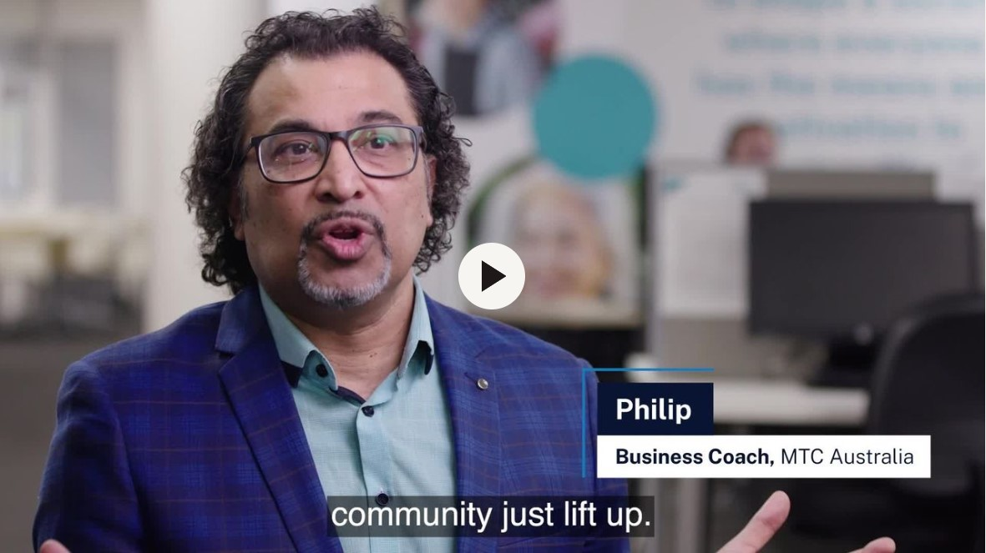
Facebook | Are you thinking of starting a business, or need help with your existing small business?  Self-Employment Assistance offers FREE small business advice, workshops, 12 months coaching and much more – find out if you’re eligible today!  Find out more at:  https://www.workforceaustralia.gov.au/individuals/training/activities/self-employment-assistance | 22-1873_DEWR_ Self-  Employment Assistance_Your  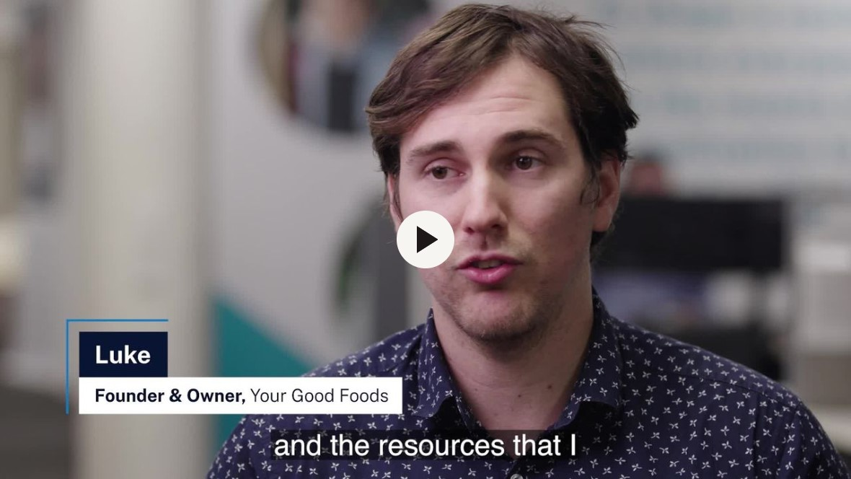  Good Foods_C2_CC.mp4
LinkedIn | Turn your business idea or existing small business into a thriving operation with Self-Employment Assistance!  FREE accredited training, coaching, workshops, business plan support and expert business advice are available now.  Find out more at: https://www.workforceaustralia.gov.au/individuals/training/activities/self-employment-assistance | 22-1873_DEWR_ Self-  Employment Assistance_Your  Good Foods_C2_CC.mp4

Animated video
This animated video provides an overview of the Self-Employment Assistance program, eligibility and the range of services available.

The full animation video can be viewed on Workforce Australia Self-Employment Assistance.
Channel | Content | Video file name in folder
Twitter | Calling all small business owners and aspiring entrepreneurs! Do you need help to start or run your own small business?  There are a range of FREE services you can access to help your business grow and thrive!  https://www.workforceaustralia.gov.au/individuals/training/activities/self-employment-assistance | 22-1873_DEWR_ Self-  Employment Assistance_  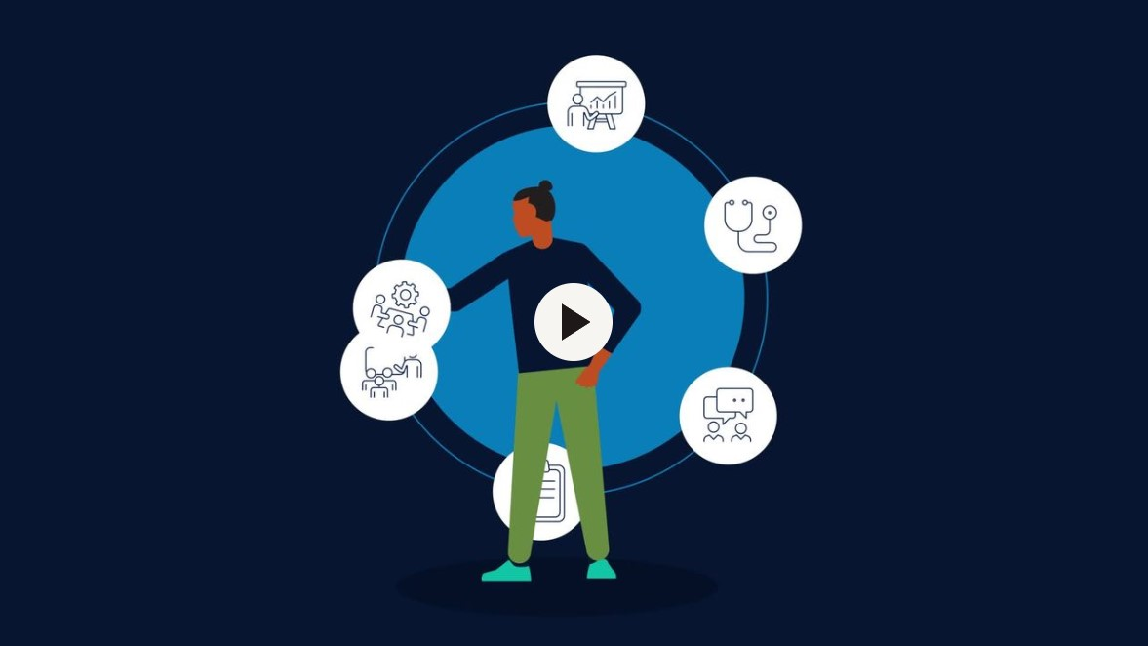  Animation C1_CC.mp4
Facebook | Free support is available for small and aspiring business owners!  The Self-Employment Assistance is a FREE Australian Government program that offers a range of services that participants can choose to support their business.  Find out more at:  https://www.workforceaustralia.gov.au/individuals/training/activities/self-employment-assistance | 22-1873_DEWR_ Self-  Employment Assistance_  Animation C2_CC.mp4  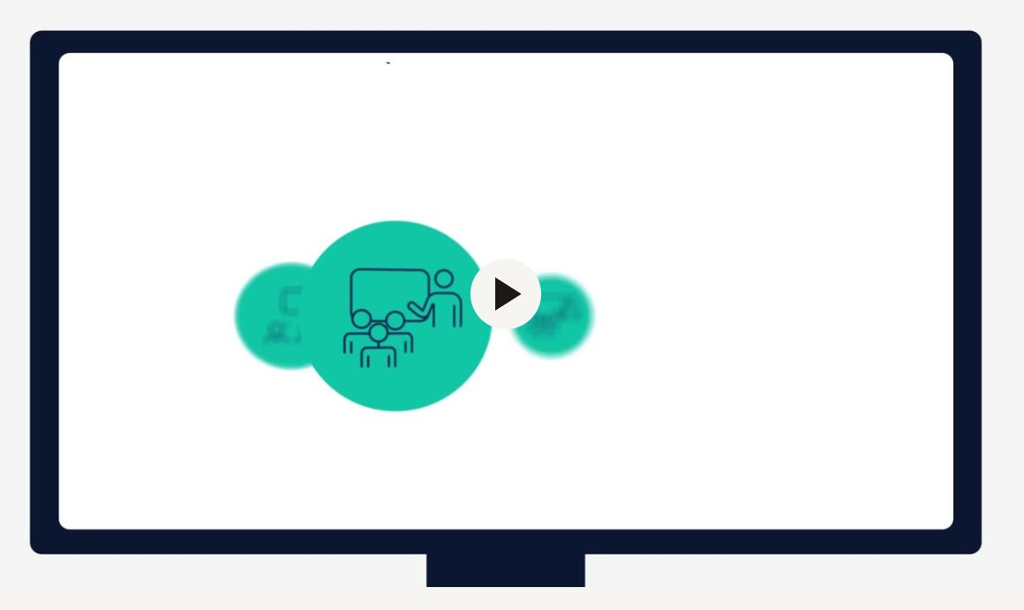
LinkedIn | Business owners: we know self-employment can be complicated. The Self-Employment Assistance program is here to help!  It’s a FREE Australian Government program that offers a range of services that participants can choose to support their business.  Find out more at:  https://www.workforceaustralia.gov.au/individuals/training/activities/self-employment-assistance | 22-1873_DEWR_ Self-  Employment Assistance_  Animation C2_CC.mp4

Newsletter and website content – Self-Employment Assistance
Below is information you can use to further promote the Self-Employment Assistance program, either through a newsletter or on your website. You can copy and paste the content below or you are welcome to tailor it accordingly.

Looking for help with starting or growing your small business?
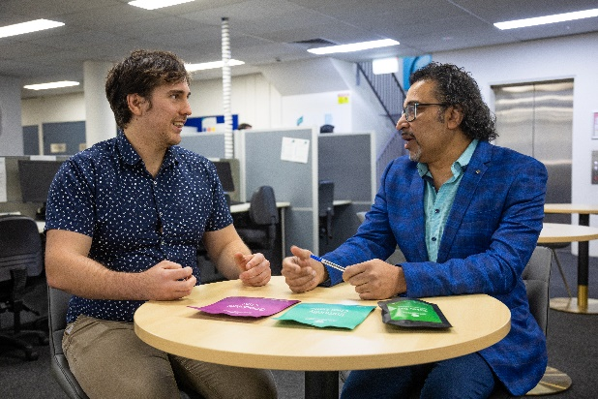

The Australian Government provides support to help you explore your business ideas, start a business, or grow your existing small business, through Workforce Australia Self-Employment Assistance.

The Self-Employment Assistance program is delivered in 51 regions across Australia, and provides:
  - Exploring Self-Employment Workshops
  - Business Plan Development
  - Small Business Training courses
  - Business Advice Sessions
  - Business Health Checks
  - Small Business Coaching.
To be eligible for Self-Employment Assistance you must:
- be at least 15 years of age (or 18 years of age to access Small Business Coaching)
- be an Australian citizen, or the holder of a permanent visa, or a nominated Visa Holder (including a New Zealand Special category Visa, Temporary Protection Visa Holder and a Safe Haven Visa Holder)
- not be undischarged bankrupt

The Self-Employment Assistance program is funded by the Department of Employment and Workplace Relations. You can learn more about Self-Employment Assistance at: https://www.workforceaustralia.gov.au/individuals/training/activities/self-employment-assistance

You can also phone 1800 805 260 or ask your Workforce Australia Provider to refer you.

Frequently Asked Questions

What if my audience live in different states and territories across Australia?
The information provided in this pack is applicable across Australia.

Can I modify the suggested posts and example articles contained in the toolkit?
Yes. The sample posts and articles provided in this pack are provided as a guide only, please feel free to tailor to your audience.

I have written a specific post to promote these programs. Can the department share my posts on Workforce Australia social media channels?
Yes, where appropriate. Please tag our accounts as referenced above, for us to consider sharing your post.

Contact
For more information, or additional content you might like to use on your communication channels, please email communication@dewr.gov.au.

How to use the promotional videos
The videos are located on DEWR Self-Employment Assistance.

On the Self-Employment Services videos page, you will find:
- three videos and
- download files links.

- Simply click on the ‘download the files’ button and you will be taken to the video’s download page.
- Then click on the ‘Download ZIP’ button to download the zipped folder containing videos and transcript files.

Captions and transcripts
The mp4 videos have captions and can be downloaded for you to share on any social media platform.

The transcripts contain audio and visual descriptive video information and have been supplied for people who are vision and hearing impaired. These can be downloaded and posted alongside the mp4 files.

