FIRST NATIONS VET POLICY PARTNERSHIP
COMMUNIQUE

Inaugural Meeting: 28 – 29 July 2026

MEETING SUMMARY
On 28 and 29 July 2026, the First Nations Vocational Education and Training (VET) Policy Partnership (VETPP) held its inaugural meeting in Meanjin (Brisbane, Queensland). Members were welcomed to Country by Shannon Ruska, who descends from the Yuggera, Nunukul and Yugambeh peoples.
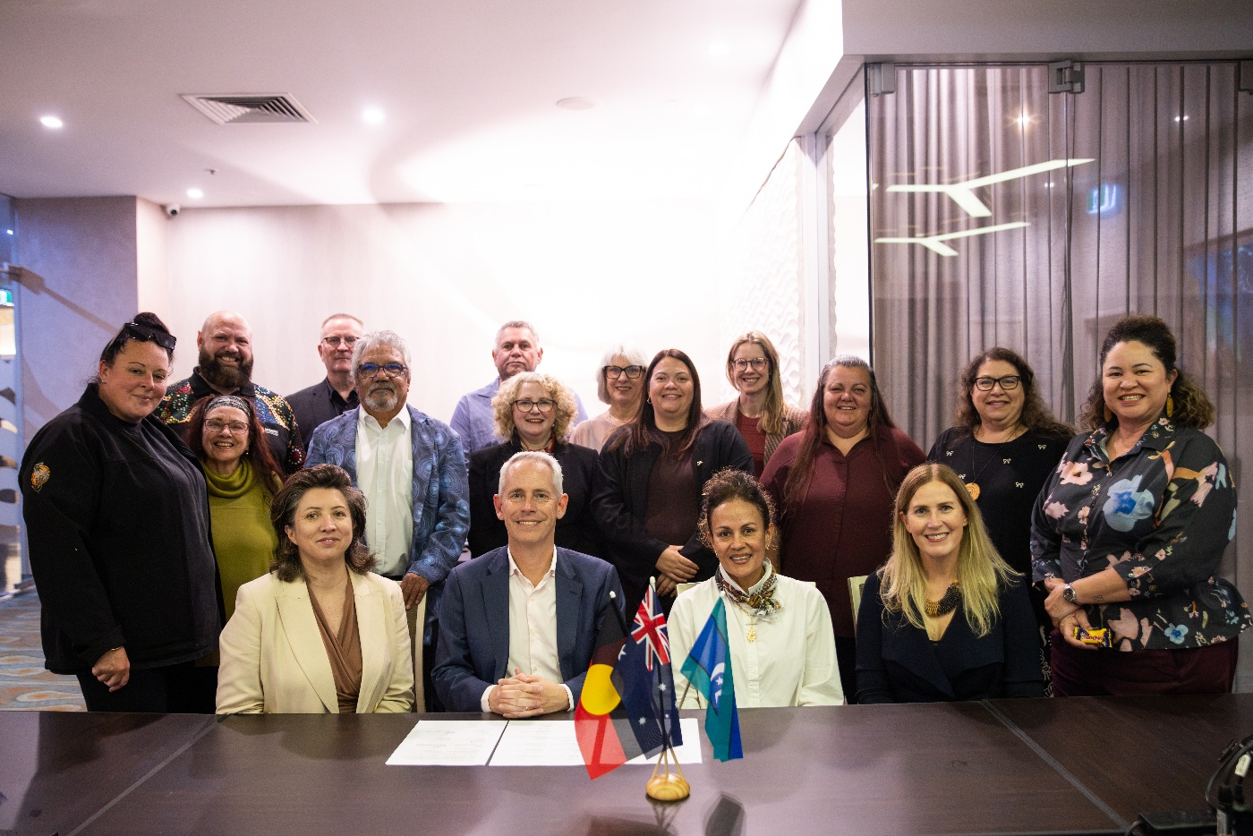
Pictured: VETPP members with Minister Giles and Lead Convenor Donnella Mills at VETPP Meeting 1
Established under the National Skills Agreement (NSA), the VETPP is a mechanism for engagement on national First Nations VET policy and reform. The VETPP supports efforts under the National Agreement on Closing the Gap by strengthening partnerships, embedding shared decision-making, and working towards improved training, employment and social outcomes for First Nations communities.
Co-chaired by Anna Faithfull, Deputy Secretary, Skills and Training Group, Department of Employment and Workplace Relations, and Dr Belinda Russon, Chief Executive Officer, Indigenous Centre of Vocational Excellence (ICOVE), the VETPP comprises equal government and Aboriginal and Torres Strait Islander representatives.
The inaugural meeting, themed Setting the Course, focused on relationship-building, establishing ways of working and identifying priorities for the partnership.
The Minister for Skills and Training, the Hon Andrew Giles MP, addressed members, reflecting on the significance of the VETPP as a mechanism under the NSA to support implementation of the National Agreement on Closing the Gap.
Ms Donnella Mills, Lead Convenor of the Coalition of Peaks, addressed members, emphasising the importance of the VETPP and the opportunity it provides to make a lasting impact for First Nations peoples. She emphasised the VETPP is established in alignment with Closing the Gap Priority Reform One, with a commitment to shared decision-making between governments and First Nations representatives.
Ms Catherine Liddle, Deputy Lead Convenor of the Coalition of Peaks, and Ms Anna Faithfull, as
co-chairs of the First Nations VET Interim Partnership Committee (IPC), acknowledged the significant contribution of IPC members in the co-design and development of the VETPP Agreement to Implement. With the formal endorsement of the VETPP Agreement to Implement, members agreed to formally close the IPC.
The meeting concluded with a signing ceremony, with Minister Giles, Coalition of Peaks Lead Convenor Ms Donnella Mills and VETPP members signing the VETPP Agreement to Implement.

MEETING OUTCOMES

Establishing the First Nations VET Policy Partnership
Members endorsed the VETPP Agreement to Implement, which sets out how the parties will work together across jurisdictions where there is shared responsibility, with the aim of reducing gaps in skills and training outcomes and improving VET outcomes for Aboriginal and Torres Strait Islander people.
VETPP members also endorsed the VETPP First Year Workplan including the strategic priorities and key actions that the partnership will prioritise. Skills Ministers will be asked to formally endorse the VETPP First Year Workplan at the September Skills and Workforce Ministerial Council.

Strengthening the First Nations Training Sector
VETPP members noted the findings of the Sector Capability Analysis and Government Supports Mapping projects. Members agreed that the VETPP will provide advice to skills ministers on the potential development of a Sector Strengthening Plan for Aboriginal Community Controlled (ACC) and First Nations Owned (FNO) Registered Training Organisations (RTOs).
The ICOVE provided VETPP members with an update on its establishment. The ICOVE is an ACC, national, evidence-informed best practice VET hub that promotes high-quality, culturally responsive training opportunities for Aboriginal and Torres Strait Islander learners and supports strong pathways to employment. The ICOVE will embed the VETPP First Year Workplan into its strategic plan and operations.
The VETPP considered proposed measures and indicators to make the NSA Outcomes Framework more relevant and meaningful to First Nations people. Developed in partnership with First Nations and technical partners, the proposed measures better reflect First Nations priorities and are intended to strengthen the ability of governments and communities to monitor progress and improve VET outcomes for First Nations people.

Looking Ahead
Two further VETPP meetings are scheduled for 2026 to support the delivery of priorities outlined in the 2026 Work Plan.

ATTENDEES

First Nations Member Representatives
Dr Belinda Russon, Chief Executive Officer, Indigenous Centre of Vocational Excellence (Co-Chair)
Coalition of Peaks Representatives
David Roberts, Director of Innovation and Training, Aboriginal Health College, Aboriginal Health and Medical Research Council of NSW
Christine Stokes, Director, VET Workforce Programs, National Aboriginal Community Controlled Health Organisation
Christine Thyer, Chief Executive Officer, South Australian Aboriginal Education and Training Consultative Council
Sherry-Ann Toomey, Director of Sector Engagement, AbSec Learning and Development Centre - Child, Family and Community Peak Aboriginal Corporation NSW
Independent First Nations Representatives
Harold Graham
Catherine Law
Tanya McGregor
Peter Renehan
Jim O’Shea

Government Member Representatives
Commonwealth Government – Anna Faithfull, Deputy Secretary Skills and Training, Department of Employment and Workplace Relations (Co-Chair)
Commonwealth Government – Joshua Smith, Deputy CEO of Policy and Program, National Indigenous Australians Agency
Australian Capital Territory Government – Kate Starick, Executive Group Manager, Economic Development Division, Chief Minister, Treasury and Economic Development Directorate
New South Wales Government - Michele Hall, Executive Director, Aboriginal Education and Communities, Department of Education
South Australian Government - Kim Eldridge, Executive Director, Skills South Australia
Tasmanian Government – Libby Doughty, Director, Strategy and Reform, Skills Tasmania
Victorian Government – Susan Thomas, Executive Director, TAGE Partnerships and Governance, Department of Jobs, Skills, Industry and Regions
Western Australian Government – Ross Kelly, Executive Director, Policy, Planning and Innovation, Department of Training and Workforce Development

