
NSA Stewardship Model Independent Review
Executive Report
October 2026

Nous Group acknowledges Aboriginal and Torres Strait Islander peoples as the First Australians and the Traditional Custodians of Country throughout Australia. We pay our respect to Elders past and present, who maintain their culture, Country and spiritual connection to the land, sea and community.
This artwork was developed by Marcus Lee Design to reflect Nous Group’s Reconciliation Action Plan and our aspirations for respectful and productive engagement with Aboriginal and Torres Strait Islander peoples and communities.
Disclaimer:
This is an independent report prepared by Nous Group (Nous), which has been commissioned by the Department of Employment and Workplace Relations (Client).
The analyses, opinions and conclusions contained in this report are those of Nous. This report does not constitute or contain any legal, financial, or commercial advice and should not be relied upon as such.
This report has been prepared based on information provided by the Client and by other persons as at the date of this report. Nous has relied on that information and has not independently verified or audited that information. Nous does not accept responsibility to update or revise this report.
This report may contain forward-looking statements, conclusions, and recommendations. Whilst Nous has prepared this report with care and diligence, Nous makes no representations or warranties, express or implied, regarding the completeness or accuracy of the information in this report. In particular, nothing in this report represents or guarantees future outcomes, and no representation or warranty is made to this effect.
Any use of this report by third parties is at their own risk. Nous accepts no liability or responsibility for any consequences (direct or indirect) arising from such use.

© Nous Group

Contents
1 Executive Report 2
2 Context for the Review 4
3 Stewardship is about ‘steering’ towards long-term outcomes 5
4 The NSA stewardship model is innovative and ambitious 7
5 Stewardship is distinct from intergovernmental relations 9
5.1 Collaboration alone does not distinguish stewardship from IGR 9
5.2 Stewardship aligns the full system to drive performance 10
6 The stewardship model is established but not fully realised 13
6.1 A strong start, with good foundations 13
6.2 Challenges in taking stewardship to the next level of maturity 15
7 Recommendations 17

Executive Report
The National Skills Agreement’s (NSA) introduction of a stewardship model to govern the VET system heralded a shift from transactional intergovernmental arrangements to coordinated, evidence-informed oversight of system performance and priorities.
As articulated in the NSA, stewardship emphasises alignment across the system, and not just collaboration among governments, as well as shared responsibility for system performance. It is informed by system data and enabled through collective decision-making on how best to steer the system to achieve agreed outcomes. It is a novel and relatively untested model in an intergovernmental context, meaning that clarity on how it should operate in practice (and be assessed) is evolving.
The NSA stewardship model independent review (the Review) found the model is established and delivering early benefits, including stronger collaboration, clear system architecture, aligned priorities and an improving evidence base. As is to be expected in this early stage of implementation, the model has not yet realised its full potential. Further attention is needed to: translate collaboration into system ‘steering’, embed feedback loops in decision-making and establish more strategic, networked ways of working.
Building on the architecture and processes put in place, the opportunity now is to strengthen the model through a deliberate shift in focus to the practice of stewardship. This shift is underway, but experienced unevenly. Achieving consistency involves moving beyond coordination among governments towards a more integrated and active approach to ‘steering’ the system.
This shift does not require producing more ‘things’: governments are keen to consolidate and leverage what has already been agreed. Rather, it concerns adopting the mindsets and ways of working that nurture stewardship as a practice. The overarching constraint, which we heard in virtually all our consultations, was the administrative load and time impost of ‘doing’ stewardship, particularly for smaller jurisdictions.
The Review notes the difficulty in distinguishing between effort related to normal intergovernmental relations (IGR) work, which is more ‘vertical’ from the stewardship model, which is more ‘horizontal’. It sees the need to balance the two orientations to ensure system alignment and strengthen the evidence base to inform ministerial steerage. As fulfilling the full expectations of stewardship under the NSA takes time, we propose that IGR processes and reporting be streamlined to unlock more capacity. Specifically, we offer the following recommendations for consideration and action over the balance of the current NSA.

Recommendations:
- Focus on the practice of stewardship and reaffirm its intent.
  - Separate the annual stewardship cycle from intergovernmental business-as-usual.
  - Embed stewardship principles and networked governance mechanisms in the stewardship cycle.
  - Reaffirm the intent of the stewardship model, including drawing on the findings of this Review.
  - Promote stewardship mindsets and behaviours across the system.
- Strengthen system-level evidence, learning and feedback loops.
  - Strengthen the strategic advice function for the evidence base.
  - Draw more deliberately on the feedback loops jurisdictions can facilitate.
  - Foster information sharing and officials-level learning.
- Streamline intergovernmental activity to unlock more capacity for stewardship.
  - Refocus intergovernmental forums on high-value decisions.
  - Reduce and consolidate reporting requirements.

Context for the Review
The National Skills Agreement (NSA) is a five-year agreement between the Australian Government and state and territory governments that commenced on 1 January 2024. A central feature of the NSA is the implementation of a new model for Vocational Education and Training (VET) system stewardship.
In Australia’s federal system, responsibilities for policy, regulation and delivery in VET intersect across the top two tiers of government. This results in a complex, multi-jurisdictional system where roles and responsibilities are not always clearly delineated, and jurisdictional priorities may differ.
The stewardship model recognises these complexities and the need for coordinated governance of the system, where responsibility is shared and there is strong collaboration among all parties. The centring of stewardship in the NSA, and its articulation of explicit stewardship mechanisms, represents a deliberate departure from previous intergovernmental agreements.
Part 3 of the NSA requires an independent review (this Review) of the system stewardship model. This Executive Report distils the key findings and recommendations from the Review, which was conducted by Nous Group (Nous) in April and May 2026.
The Skills and Workforce Ministerial Council (SWMC) were additionally provided with the evaluation framework, research and findings.
The Review did not examine the implementation of and/or progress towards the NSA objectives beyond the stewardship model, nor achievement of NSA outcomes. Rather, it was intended only to inform the future focus and development of the stewardship model.

Stewardship is about ‘steering’ towards long-term outcomes
Stewardship, broadly defined, is the governance of a domain – a system, population, resource or institution – entrusted to a ‘steward’, as distinct from a ‘manager’ or ‘controller’. It emphasises acting in the long-term interest, balancing competing needs and exercising responsibility with, and on behalf of, others.
System stewardship, the focus of this Review, is the application of the concept of stewardship to the governance of complex service systems. Drawing on systems thinking and network governance, system stewardship foregrounds influence over control, ‘steering’ over directing, with governance and the achievement of agreed system outcomes accepted as a shared responsibility.
The UK’s Institute for Government’s paper ‘System Stewardship: The future of policy making?’ provides the best encapsulation of what system stewardship seeks to achieve. It envisages stewardship as an ongoing and dynamic process of monitoring, ‘steering’ and influencing system behaviour.
In this construct (depicted in Figure 1), for system stewardship to be effective, there must be: aligned goals and effort, sufficient trust to overcome the instincts to control, timely and strategically useful data and well-calibrated interventions to improve system performance and thereby deliver public value. Research shows that other critical success factors for stewardship to operate effectively in practice include: a unifying purpose, clearly defined roles and responsibilities, effective collaboration, coordination and engagement and well-targeted performance measurement.
Figure 1 | Adapted from the UK Institute for Government’s system stewardship model
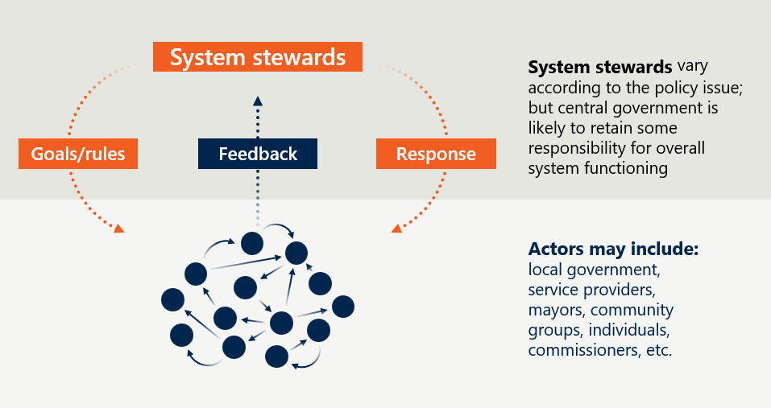
[Detailed image description:
This image presents a conceptual framework for system stewardship, emphasising the dynamic interactions between different components of a policy system.
Key Components
System Stewards
Positioned at the top of the diagram, system stewards oversee the functioning of the system.
System stewards vary depending on the policy issue, but central government typically retains responsibility for overall system functioning.
Goals/Rules
- Represented on the left side, goals/rules are inputs into the system, guiding its operation.
- An orange arrow connects goals/rules to the actors, indicating their influence on system evaluation.
Feedback
- Located in the centre, feedback is the mechanism through which the system evaluates its performance against goals/rules.
- Feedback informs adjustments to responses and goals/rules.
Response
- Shown on the right side, response represents the actions taken based on feedback.
- An orange arrow connects response back to feedback, illustrating the cyclical nature of the system.
Actors
- A cluster of interconnected circles at the bottom symbolises the diverse actors involved in the system.
- The accompanying text lists potential actors, including local government, service providers, mayors, community groups, individuals, and commissioners.
End of detailed image description]

The NSA stewardship model is innovative and ambitious
System stewardship is an emerging concept, however, with few examples of its adoption in practice, and none applied in an intergovernmental context to the same degree as has been done in VET. This underlines the originality and ambition of the NSA in centring stewardship in national system governance. The model is underpinned by the following principles:
- Joint Responsibility - leadership by all governments to achieve long term reform of the skills sector.
- Collaboration and Engagement - working together, including tripartite engagement and collaboration with key stakeholders from across the community, to set shared outcomes for skills and workforce development and agree on reforms.
- Evidence Informed - leading results-based decision making and continuous review and improvement.
- Transparency – Communication of agreed actions, targets, and progress of reform.
Under the NSA, the stewardship model is designed to follow an annual stewardship cycle that supports collaboration, learning and results-based decision-making (as illustrated in Figure 2 below). This is intended to build on existing arrangements for the skills sector with a central role for the SWMC.
Figure 2 | NSA stewardship model establishes an annual stewardship cycle
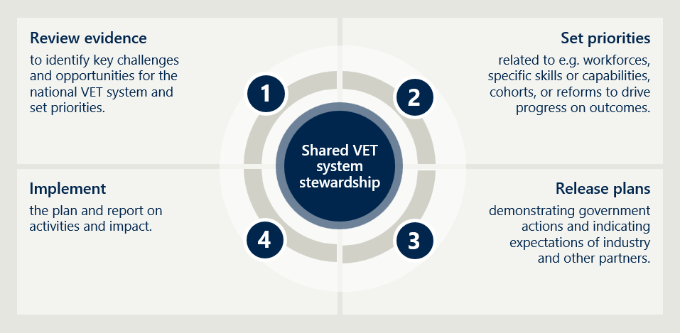

[Detailed image description:
This image presents a circular diagram outlining the four-step process of shared stewardship for the national vocational education and training (VET) system. The steps are arranged sequentially around a central circle labelled “Shared VET system stewardship.”
Steps in the Process
- Review evidence to identify key challenges and opportunities for the national VET system and set priorities.
- Set priorities related to e.g. workforces, specific skills or capabilities, cohorts, or reforms to drive progress on outcomes.
- Release plans demonstrating government actions and indicating expectations of industry and other partners.
- Implement the plan and report on activities and impact.
End of detailed image description]

Stewardship is distinct from intergovernmental relations
The shift to system stewardship brings new, high expectations and raises questions about the difference between ‘stewardship’ under the NSA and effective intergovernmental relations (IGR). This was a distinction that many stakeholders we spoke with drew out. This is important, for if governments and others have a different understanding of what stewardship ‘looks and feels’ like, then there are high probabilities of some being disappointed and others satisfied.
Our interviews for the Review revealed variance in levels of satisfaction with the stewardship model, and in how the model itself is interpreted. Some stakeholders saw no apparent difference between the stewardship model and collaborative IGR, while others attributed progress in areas such as national priority setting to the stewardship model. Having a clearer view of what is genuinely one or the other assists with expectation setting and provides a basis for understanding how to strengthen the stewardship model.

Collaboration alone does not distinguish stewardship from IGR
Of the principles of the stewardship model, set out in the NSA and above, stakeholders most frequently cited ‘collaboration’ as the defining feature. However, collaboration alone is not unique to stewardship, it could easily be regarded a feature of effective IGR. For the purposes of drawing a clearer comparison between IGR and system stewardship, the Review finds that conceptually:
- System stewardship is best understood as a network model, where interconnected participants share information ‘horizontally’ and the centre of gravity for any one decision can potentially shift. The function is to promote alignment of all key system anchors around a common set of goals and to collectively assess system performance and respond accordingly. This overlaps with ‘networked governance’ models that are more commonly associated with community-level or else transnational arrangements. But its tenets of collective decision-making around shared goals, the need for a strong foundation of trust and an approach to coordination that is akin to facilitation and brokerage rather than control, all resonate with the concept of stewardship.
- By contrast, IGR largely operates as a hub-and-spokes model, centred on funding arrangements that articulate nationally agreed outcomes, but which fundamentally function as bilateral accountability mechanisms. This is an outcome of the requirements under the Intergovernmental Agreement on Federal Financial Relations and the need for clear accountability for the use of public funding. It still involves collaboration and goodwill, as well as aligned objectives, but there is an unambiguous ‘first among equals’ status that attaches to the Commonwealth as the prime funder.
- These two concepts imply a distinctly different tenor to ‘collaboration’ and colour how power sharing, shared responsibility, transparency and accountability might be viewed. This is not to say that the NSA adopts this same conception of stewardship, rather it is to draw out what might be seen or experienced as a qualitatively different form of collaboration within the stewardship model.

Stewardship aligns the full system to drive performance
A second key principle in the NSA stewardship model that stakeholders value is the commitment to
evidence-informed decision-making. In the UK Institute of Government framework, system performance depends on the effectiveness of feedback loops. This terminology highlights the flow of information needing to be two-way: it requires the stewards to collect data on key indicators of system performance, and to share information and analysis with the broader system. The work of Jobs and Skills Australia (JSA) and the National Centre for Vocational Education and Research (NCVER) are prime examples of this two-way information exchange. The development and release of Jurisdictional Action Plans is another example.
Such data collection and information sharing occurs as part of IGR as well. However, the key question is how that data is used at the system governance level. Under system stewardship, there is a clear expectation that there will be joint deliberations on what system performance data reveals about progress towards agreed outcomes. In IGR, the gaze is lower, it is focused on delivery on respective commitments under a framework agreement (which admittedly would include strategic system-wide objectives) and under individual implementation plans. The idea of a feedback loop relates also to the concept of ensuring that system governance supports an environment for collective and shared learning.
Fundamentally, then, stewardship is concerned with integrating all key parts of the system – governments as well as the service delivery system – to work in concert, informed by a shared understanding of what is contributing to or detracting from achievement of shared goals. The stewards drive and facilitate this process of extracting system intelligence, learning from it and collectively agreeing on the necessary interventions or adjustments for system settings to improve performance and outcomes.
This process is illustrated in Figure 3 below, which shows how system stewardship reflects a distinctive, if overlapping role to that of governments in their ‘BAU’ mode, or service providers in their delivery role. These overlaps are not something to remove, but rather something to acknowledge, for they indicate how a stewardship approach enables the necessary feedback loops, contributes to effective IGR and complements the alignment of delivery to agreed policy objectives.
Figure 3 | System stewardship is a whole-of-system alignment model
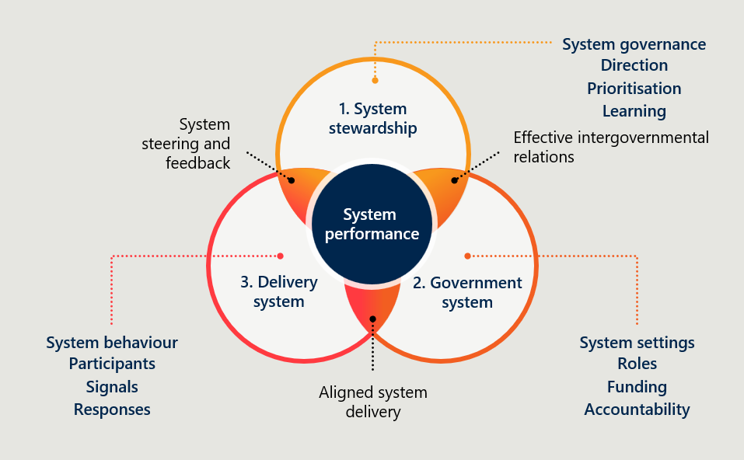
[Detailed image description:
This Venn diagram represents a framework for achieving system performance by integrating three key components: system stewardship, government system, and delivery system. Each component interacts dynamically, supported by system governance, settings and behaviour.
Key Components
System stewardship
- Focuses on system governance, including direction, prioritisation, and learning.
Government system
- Focuses on system settings such as roles, funding, and accountability.
Delivery system
- Focuses on system behaviour, including participants, signals, and responses.
Central Element: System performance
- Represented at the centre of the diagram.
- Serves as the outcome of aligned system stewardship, government and delivery systems.
Supporting Elements
- Effective intergovernmental relations: connects system stewardship and government system
- System steering and feedback: connects system stewardship to delivery system.
- Aligned system delivery: links the delivery system and government system
End of detailed image description]

This representation highlights the role of stewardship in better integrating the government system and its settings on the one hand, with the delivery system and its drivers and responses on the other. This is different to seeing it as operating primarily as a mechanism for a different type of intergovernmental collaboration in pursuit of shared priorities. It shifts the focus from coordination between governments to alignment across the full system, in the interests of stronger system performance.
The Review notes that this view of stewardship may not be shared by all stakeholders. However, we found that, in order to assess the model even on its own terms (i.e. as set out in the NSA), it was necessary to consider more deeply the theoretical underpinnings of the system stewardship and its comparison with traditional IGR.

The stewardship model is established but not fully realised
The stewardship model is still in its early years of establishment and operation. As with most major reforms, realising the full intent of system stewardship as articulated in the NSA will be a staged process, starting with establishing the model, embedding new ways of working and ultimately delivering sustained improvements in system performance. Figure 4 overleaf sets out the Review’s view on the maturity pathway for the NSA stewardship model. On this trajectory, the system is in an intermediate phase – where stewardship as defined in the NSA – is established and functioning, but not yet consistently understood, or arguably operating at its full potential.

A strong start, with good foundations
Consultation with stakeholders confirms that, largely, the model is operating in line with the principles and commitments in the NSA. While there were differing views as to the reason for positive changes (i.e. not all attributed this to ‘stewardship’ per se), all acknowledged that progress has been evident in:
- Interjurisdictional collaboration.
- Operation of the annual stewardship cycle that is centred on data collection, analysis and review.
- Alignment to agreed national priorities.
- Delivery of the National Skills Plan and Jurisdictional Action Plans.
- Closer partnership with NCVER, JSA, and the Jobs and Skills Councils (JSCs).
This progress is significant and commendable, and reflects sustained effort by all parties to the Agreement. Importantly, these foundations have enabled Ministers and officials to align priorities, activity and delivery in new and meaningful ways. This in itself represents an important shift in how the system is governed.
That said, stewardship is not yet consistently operating as well as it might to be an effective lever for evidence-based decision-making. This is illustrated in Figure 4 below, which shows that progress has been clear with respect to direction-setting, prioritisation and establishing feedback loops, as well as in clarifying roles and accountability. However, more could potentially be done to broaden the evidence base and better leverage it for the purposes of ‘steering’ the system.
Of note is that the production of key evidence and documents has taken longer than expected. These delays, considered alongside the crowded agendas of SWMC and Skills Senior Officials’ Network (SSON) meetings, mean there has yet to be an opportunity to use stewardship as a mechanism to ‘lift up’ the discussions and engage with partners in evidence-based decision-making focused on overall system performance.
Further, while JSA, NCVER and the JSCs are all seen as vital parts of the system architecture, the sense has yet to build that stewardship embraces the full system, with strong system-wide feedback loops flowing into the stewardship cycle.
Figure 4 | The maturity pathway for system stewardship under the NSA
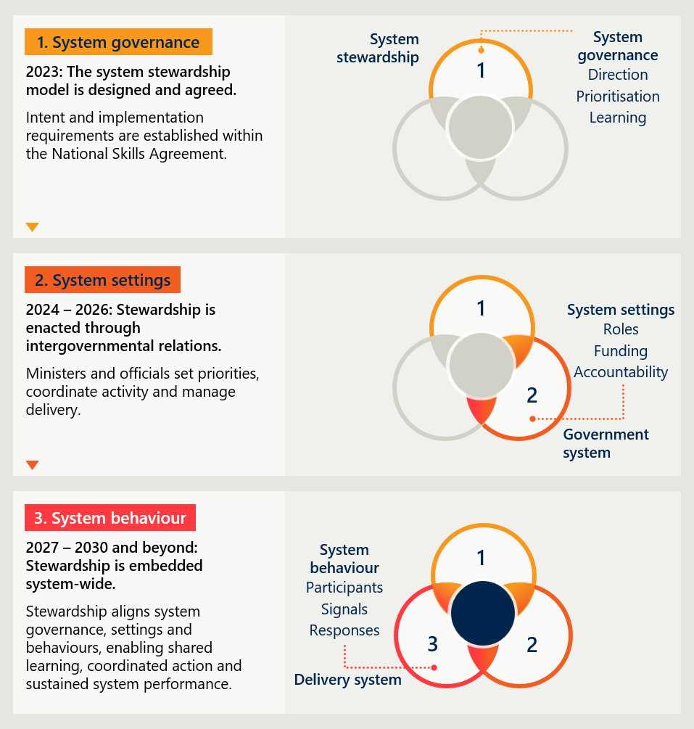
[Detailed image description:
This image builds on the previous System stewardship diagram (figure 3) and outlines the timeline and progression of system stewardship across three phases: system governance, system settings, and system behaviour. Each phase is accompanied by a description and a visual representation using interconnected circles to highlight key elements.
1. System governance (2023)
The system stewardship model is designed and agreed upon.
Intent and implementation requirements are established within the National Skills Agreement.
Key elements:
- Direction
- Prioritisation
- Learning
Visual representation:
- Three interconnected circles with the “system governance” circle highlighted
2. System settings (2024–2026)
Stewardship is enacted through intergovernmental relations.
Ministers and officials set priorities, coordinate activity, and manage delivery.
Key elements:
- Roles
- Funding
- Accountability
Visual representation:
- Three interconnected circles with the “system settings” and “system governance” circle highlighted
3. System behaviour (2027–2030 and beyond)
Stewardship is embedded system-wide.
Stewardship aligns system governance, settings, and behaviours, enabling shared learning, coordinated action, and sustained system performance.
Key elements:
- Participants
- Signals
- Responses
Visual representation:
- Three interconnected circles all highlighted
End of detailed image description]

Challenges in taking stewardship to the next level of maturity
It follows that the next phase of maturity involves a deliberate shift towards the active practice of stewardship – that is, to better use the structures and mechanisms that are in place, and further ‘bring to life’ the principles of collaboration and shared responsibility. This shift is already underway, but uneven. Effort is required to change how evidence is viewed and used to inform productive deliberations on system performance. In essence, there is an opportunity to move beyond coordination between governments towards a more integrated and active approach to ‘steering’ the whole system.
This shift does not require producing more ‘things’: governments are keen for there to be a focus on implementing what has already been agreed. Rather, it concerns adopting the mindsets and ways of working that nurture stewardship as a practice. This means:
- Balancing the ‘vertical’ relationships with the ‘horizontal’ – system stewardship is not effective if only the stewards themselves are aware of what they are trying to achieve and how. Awareness of the model as a new form of governance should infuse and inform working relationships at all levels and across all parts of the system. It does not become meaningful until key system stakeholders can see a difference in how the system is operating.
- Ensuring breadth of scope while minimising burden – a stewardship model demands a macro and long-range view of the system. However, the broader the scope of coverage, the more likely there is to be a large number of priorities to manage and initiatives to deliver – all of which generates a heavy burden in negotiation and reporting (activities that, in this case, are part of normal IGR rather than stewardship). The business of providing genuine stewardship requires a significant investment of time (e.g. through more iteration and co-design). But it should not crowd out capacity of stewards to engage in strategic thinking about system performance and how to adjust settings accordingly.
- Building evidence that offers system-level learnings – effective stewardship means tracking the right indicators of system performance. For example, we heard from several key stakeholders that there was an inappropriate focus on ‘input’ indicators (e.g. enrolments), rather than outcomes. Maintaining discipline on this can be difficult if the data sources are not reliable or attention is diverted to the present-day priorities. Yet, as noted above, a key function of stewardship is to foster a ‘learning system’ founded on effective feedback loops and on a disposition to openly and collaboratively engage with insights from system-level data.
- Maintaining continuity through changeover of personnel – sustaining stewardship requires building resilience to the turnover of people involved at the beginning of the model’s design and who have been its champions. To have long-term impact, the model needs to be able to endure steady turnover in participants due to both political cycles and highly mobile professions.

Recommendations
The Review is cognisant of the practical constraints in delineating standard IGR from good stewardship practice, and in embedding new mindsets and ways of working. However, the overarching constraint, which we heard in virtually all our consultations, was the administrative load and time impost of ‘doing’ stewardship. This raises two points:
- Having come to the end of protracted implementation of the NSA, now is not the time to start implementing major changes to the model. Rather, the focus should be on realising the potential value of stewardship in practice by better working together to collectively lift system performance.
- There is no additional capacity for stewardship across jurisdictions, data agencies and key representative bodies. The capacity needed for the model to mature and flourish must come from an easing of the intergovernmental oversight processes, where possible, and a sharper view of what activities (across governments, data agencies and representative bodies) are the most value-adding.
With those points in mind, we offer the following recommendations for consideration and action over the balance of the current NSA.
Recommendation 1: Focus on the practice of stewardship and reaffirm its intent.
Make stewardship visible and effective through existing mechanisms, and through inculcating a deeper understanding of what stewardship looks and feels like. This requires a clearer distinction between stewardship and IGR processes, and a more deliberate focus on leveraging stewardship forums to support system-level decision-making and ways of working. Specifically:
  - Separate the annual stewardship cycle from intergovernmental business-as-usual. More clearly distinguish the annual stewardship cycle from intergovernmental meetings, with different inputs, agendas and expectations. Reinforce this distinction by clarifying stewardship roles and, through intentional induction, supporting new participants to understand how stewardship differs in practice.
  - Embed stewardship principles and networked governance mechanisms in the stewardship cycle. This could include the establishment of feedback loops that reach deeper into the sector (via jurisdictions or peak bodies), having a rotating chair for the annual stewardship meeting and co-developing agendas for SWMC through a collaborative process of identifying the strategic discussions that are likely to enable stewards to best influence system performance.
  - Reaffirm the intent of the stewardship model, including drawing on the findings of this Review. This will contribute to the sparse stewardship literature and provide a shared reference for a more consistent understanding of stewardship in both purpose and practice in the skills system.
  - Promote mindsets and behaviours across the system. Promote stewardship principles through agencies in the system architecture to reduce dissonance between governance, policy and delivery. To date, the intent of stewardship has not permeated much beyond SSON into working levels of skills departments, nor much beyond the NCVER, JSA and JSCs into and across other system stakeholders.
Recommendation 2: Strengthen system-level evidence, learning and feedback loops.
Continue to improve what information is produced, shared and applied through the stewardship cycle, focusing on feedback loops that help identify the issues and risks which should inform strategic decisions on matters influencing system performance. In practice:
  - Strengthen the strategic advice function for the evidence base. Ensure agencies such as NCVER and JSA are positioned to provide more forward-looking, system-level advice to inform SWMC decision-making, with a clear concentration on what matters most for the system. This could include NCVER and JSA facilitating a workshop in advance of SWMC annual stewardship meeting to present data insights and draw out the strategic issues for SWMC annual stewardship meeting agenda.
  - Draw more deliberately on the feedback loops jurisdictions can facilitate. Encourage jurisdictions to use their networks to surface and share information about the system, from data and insights to lessons and opportunities, to strengthen the diversity of feedback loops informing the annual stewardship cycle.
  - Foster information sharing and officials-level learning. Encourage experimentation in how data agencies and departmental officials collectively explore (e.g. in forums facilitated by data agencies for this purpose across jurisdictions) the available data, trends, risks and opportunities. Good information sharing at all levels deepens understanding and capability and builds a learning system.
Recommendation 3: Streamline intergovernmental activity to unlock more capacity for stewardship.
Develop a more focused and proportionate approach to intergovernmental agendas, the pursuit of national priorities and to planning and reporting. The volume and complexity of intergovernmental activity is constraining the ability of jurisdictions to engage in effective stewardship. In particular:
  - Refocus intergovernmental forums on high-value decisions. Tighten agendas to prioritise a small number of strategic issues and move detailed updates and lower-order items out of central forums. Changes should support SSON and SWMC to create more capacity for stewardship by better containing the effort drawn into IGR.
  - Reduce and consolidate reporting requirements. Review reporting requirements across the NSA architecture to reduce duplication, improve proportionality and remove administrative burden where possible. Changes should support a more trust-based approach to compliance, with less time monitoring inputs and more time analysing outcomes to inform national-level action.

Commonwealth of Australia, National Skills Agreement, January 2024. National Skills Agreement.
Department of Employment and Workplace Relations, National Skills Agreement, 2024. National Skills Agreement
Michael Hallsworth, System Stewardship: The Future of Policy Making? Working Paper, Institute for Government, 2011. System Stewardship: The Future of Policy Making? Working Paper
Hart et al., “Looking at quality through a systems lens—Applying systems thinking to the Australian National Disability Insurance Scheme”, Australian Journal of Public Administration, 2026, (accessed 7 May 2026). Looking at quality through a systems lens—Applying systems thinking to the Australian National Disability Insurance Scheme
William D. Eggers, "The changing nature of government: network governance", in Collaborative Governance, ANU Press, 2008. The changing nature of government: network governance
Michael Hallsworth, System Stewardship: The Future of Policy Making? Working Paper, Institute for Government, 2011. System Stewardship: The Future of Policy Making? Working Paper
Department of Employment and Workplace Relations, Stewardship in the National Skills Agreement, 2024. Stewardship in the National Skills Agreement
Department of Employment and Workplace Relations, Stewardship in the National Skills Agreement, 2024. Stewardship in the National Skills Agreement

