

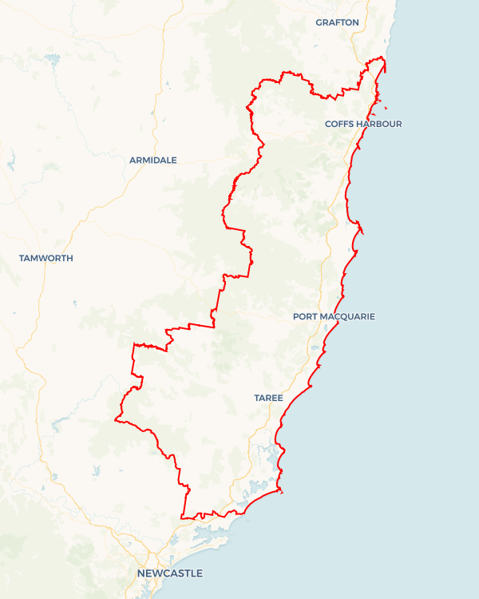Local Jobs Plan

Mid North Coast ****Employment Region**** | NSW | ****June 2025****

Workforce Australia Local Jobs (Local Jobs) is a program that supports tailored approaches to accelerate   
reskilling, upskilling and employment pathways in response to current and emerging local workforce needs.

## Local Jobs elements

### Local Jobs Plan

The Local Jobs Plan sets out the skills and employment challenges and priorities of the region, and associated strategies that will drive the design and implementation of activities to be implemented to address these challenges.

**Job Coordinator**

Job Coordinators and Support Officers support the delivery of the program by bringing together key stakeholders including businesses, employment services providers, higher education and training organisations.

### Local Jobs and Skills Taskforce

Each Employment Region has its own Taskforce. Representatives include local stakeholders who have demonstrated experience in upskilling, reskilling, and an ability to represent, connect and collaborate with others in the region to meet labour market needs.

### Program Funds

The Employment Region’s Local Initiatives Fund enables targeted local investments that support local labour market functioning. Further, from 2025/26, a central grants-based fund will respond to local needs and help progress broader employment service reform objectives.

Explore labour market insights for the  
[Mid North Coast](https://www.jobsandskills.gov.au/work/employment-region-dashboards-and-profiles/monthly-labour-market-dashboards) Employment Region

## Local labour market challenges in the region

* There are issues in securing adequately skilled entry level workers in growth and demand sectors. For example: aged care, disability, tourism, construction and manufacturing.
* The region has structurally high unemployment rates in specific locations including Nambucca, Kempsey and Taree.
* There are high levels of disengagement among young people both in seeking work and schooling. This reflects limited understanding among youth of apprenticeship and traineeship opportunities, limited knowledge by them and employers of mentoring and support services (including the state-led Better Supervision program) and insufficient investment in developing pre-employment skills (including soft skills).
* The region has had significant impacts from natural disasters since 2019 including drought, bushfire and multiple flooding events.
* The region has a high incidence of unemployment among First Nations Australians and mature aged individuals with these cohorts facing unique labour market disadvantages.
* Housing availability and affordability make it challenging to attract and retain workers in the region with a rising rate of homelessness being experienced in the region.
* Transport is an ongoing issue with limited to no available public transport options, especially outside the main centres. This is compounded by limited access to driver training / supervised learner driver support.
* The Mid North Coast has one of the largest skills gaps in Australia when there is a mismatch between the skills required and the skills available in our local workforce.
* Economic development trends predominantly benefit coastal areas, especially larger conurbations attracting retirees. Ensuring ongoing employment opportunities in the hinterland is therefore important.

## Local jobs and skills priorities and strategies in the region

### Priority 1 – Disengaged Youth

#### What are our challenges and opportunities?

#### The Mid North Coast Employment Region is characterised by significant youth unemployment and comparatively high levels of youth disengagement.

#### How are we responding?

* Facilitating collective advocacy around the need to develop new hybrid models of education that integrate direct work experience with the development of core academic competencies and both soft and trades skills. This includes engagement with local educational innovations (especially with a VET focus), TAFE, state and national government and industry-specific registered training organisations and group training organisations.
* Leveraging locally available youth services, programs and initiatives to effectively inform and contribute to the streamlined design of training and employment pathways to help address local labour market needs.
* Working with local providers to design and develop supported learner driver programs.
* Building awareness of career opportunities and available pathways for youth that are available within the region as early as possible (i.e. from at least year 9 onwards and even earlier where appropriate).
* Designing and delivering industry-specific programs and projects that support young people to engage with and develop the required capabilities to take up apprenticeship and traineeship opportunities as early as possible, including through the SBAT and TVET training opportunities, improved and extended work experience and developing independent businesses with support through the Self Employment Assistance program.
* Engaging with business, industry, government and schools in the region and across the country to develop strategies that help engage youth (including education around engaging with and employing neurodivergent youth and young people with disabilities). This is not limited to a focus on retention in school but also helping young people identify appropriate pathways into work, including non-academic pathways (e.g. through trades-based school, VET programs and entrepreneurial approaches)
* Building collaborative employment and training solutions that align to growth industries such as health care and social assistance, retail and hospitality, accommodation and tourism services and important legacy sectors including construction, manufacturing, agriculture and food processing.

### Priority 2 – Health Care and Social Services

#### What are our challenges and opportunities?

There is high demand for staff in growth sectors including healthcare, aged care, disability support and childcare. Challenges include the need for improved visibility and streamlined access for local employers and improved training and placement pathways including increasing access to micro-credentialling and traineeships.

#### How are we responding?

* Continuing to promote Australian Government initiatives and working with local businesses, registered training organisations and Workforce Australia Employment Services Providers to leverage key partnerships facilitating reskilling and upskilling of participants into healthcare and support sectors.
* Continuing to collaborate with healthcare and social assistance businesses, and other stakeholders to develop campaigns such as The Welcome Experience to raise awareness of employment opportunities and ancillary services for individuals and their families.
* Building a job-ready workforce through observational work experience, pre-employment training and job readiness programs to support the aged, disability, childcare and social support sectors.
* Generating awareness of career pathways available in the sector (particularly for young people) and linking employment with traineeships and apprenticeship opportunities to showcase the variety of jobs and careers on offer.
* Ensuring participants and industry stakeholders are included in the design of activities developed to meet Local Jobs priorities.

### Priority 3 – Manufacturing, Construction and Trades

#### What are our challenges and opportunities?

#### The ongoing increase in workforce demand coupled with a generational slow-down in regional skills development and challenges accessing relevant training in the region is putting pressure on an industry with important social and economic relevance in the region. There is a need to meet these demands by developing the skillsets required for the advanced manufacturing requirements inherent in the net zero-focussed industrial development in our two neighbouring Regional Energy Zones (Hunter and New England)

#### How are we responding?

* Collaborating with industry to develop clear pathways into local manufacturing, construction and traditional trades and increasing gender diversification.
* Building the relationship between Workforce Australia Employment Services Providers and the manufacturing and construction sectors, including addressing barriers faced by job seekers and equipping employers to adjust practices to enable better integration of job seekers into workforces.
* Working with businesses to create streamlined access to programs and projects that provide a direct pathway to employment. This means both improving understanding and access to existing programs for employers but also identifying and advocating to both state and federal government and local service providers for new pathways where the need is identified.
* Working with industry and the training sector to ensure there are local training opportunities and ensure the training meets future workforce demands.
* Improving traditional skills via the promotion of apprentice and trainee opportunities in the sectors.
* Streamlining access to opportunities for cohorts such as First Nations people, young people, mature aged people, women, people from multicultural communities and refugees.

### Priority 4 – Integrating the Hinterland

#### What are our challenges and opportunities?

#### The economic trajectory and availability of services between the coastal and inland communities across the Mid North Coast is quite different. Economic development and employment figures tell a story of expanding opportunities along the coast driven largely by growth in the retirement and tourism sectors but the same economic development has not occurred in the hinterland.

#### How are we responding?

* Meeting immediate workforce demands in the equine, agriculture and food processing sectors through pre-employment and skill-based training programs.
* Building engagement with local governments in the hinterland to determine their industry priorities and economic development outlook and responding to employment opportunities as they emerge.
* Engaging with local government and community leaders to develop and integrate service delivery and economic development plans, including leveraging existing funding across federal, state and local government.
* Supporting self-employment and entrepreneurship opportunities across the hinterland.
* Mapping future workforce and skill requirements within the region.
* Leveraging existing programs – including the Self Employment Assistance program and the Learning the Macleay program – and collaborating with stakeholders including TAFE, registered training organisations, and Workforce Australia Employment Services Providers.
* Building regional skill capability by streamlining access to local opportunities for cohorts such as First Nations people, young people, mature aged people, women, people from multicultural communities and refugees.

## Want to know more?

**Contact**: Sonny Neale, Mid North Coast Jobs Coordinator [sonny.neale@dewr.gov.au](mailto:sonny.neale@dewr.gov.au)

**Email**: [AGEF-MNC@dewr.gov.au](mailto:AGEF-MNC@dewr.gov.au)

**Visit**: [Local Jobs](https://www.dewr.gov.au/local-jobs) or [Workforce Australia](https://www.workforceaustralia.gov.au/)