

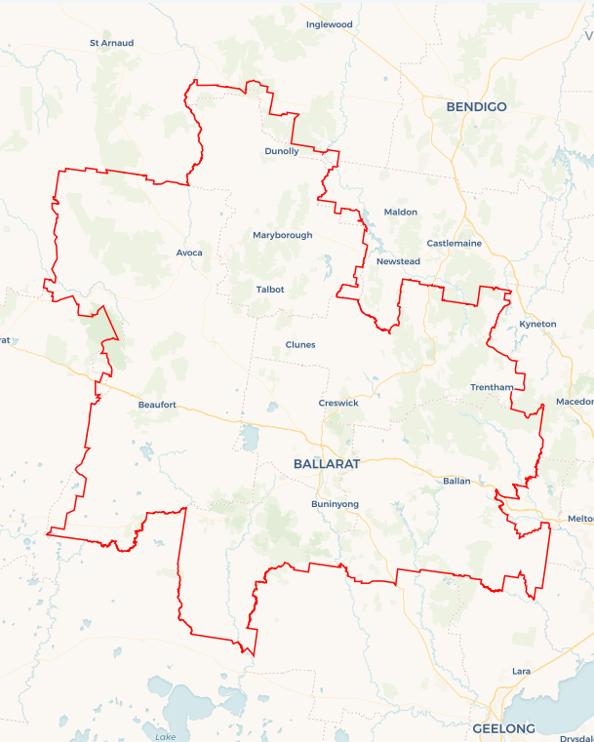Local Jobs Plan

Ballarat Employment Region | VIC | October 2023

Workforce Australia Local Jobs (Local Jobs) is a program that supports tailored approaches to accelerate   
reskilling, upskilling, and employment pathways in response to current and emerging local workforce needs.

## Local Jobs elements

### Local Jobs Plan

The Local Jobs Plan sets out the skills and employment challenges and priorities of the region, and associated strategies that will drive the design and implementation of activities to be implemented to address these challenges.

### Employment Facilitators

Employment Facilitators and Support Officers support the delivery of the program by bringing together key stakeholders including businesses, employment services providers, higher education, and training organisations.

### Local Jobs and Skills Taskforce

Each Employment Region has its own Taskforce. Representatives include local stakeholders who have demonstrated experience in upskilling, reskilling, and an ability to represent, connect and collaborate with others in the region to meet labour market needs.

### Local Recovery Fund, Local Initiatives Fund and National Priority Funds

The Local Recovery Fund supports projects that meet the priorities identified in the Local Jobs Plan. The National Priority Fund provides funding for innovative local solutions to address structural barriers to employment.

Explore labour market insights for the  
[Ballarat](https://www.jobsandskills.gov.au/data/employment-region-dashboards-and-profiles/monthly-labour-market-dashboards) Employment Region

## Local labour market challenges in the region

* **Mature age** **-** Mature age participants may face specific challenges to gaining employment due to their age and the changed labour market. Barriers may include difficulty accessing training and difficulty arranging flexible work opportunities.
* **Youth****-** For many young people, the transition from school to work was disrupted by the COVID-19 pandemic. These young people may face multiple barriers to entering the workforce including a lack of access to career guidance, limited work experience, part-time job opportunities and the casualisation of available positions.
* **Aboriginal and Torres Strait Islander peoples –** The unemployment rate for Indigenous Australians tends to be higher than non-Indigenous Australians in the Ballarat Employment Region. There are opportunities to increase levels of educational attainment, skills and training, job retention, improve health and eliminate discrimination.
* **Transport -** Participants located in smaller local government areas, including Golden Plains, Hepburn, Central Goldfields, Moorabool, and Pyrenees Shire have limited access to public transport which can be a barrier getting to and from the workplace. Participants in these locations also have limited access to driver licence initiatives.
* **Females -** Women may face additional barriers finding suitable and sustainable employment due to the availability and cost of childcare, caring responsibilities, work-life balance, pay inequality, lower wages in female dominated industries and lack of flexible working arrangements.
* **People with disability -** Working-aged people living with a disability are unemployed longer and may experience several unique barriers and challenges, including discriminatory recruitment practices, a lack of understanding of the supports available, difficulties negotiating reasonable adjustments in the workplace and flexible working arrangements and limited access to transport.

## Local jobs and skills priorities and strategies in the region

### Priority 1 – Upskill participants to meet the needs of local employers and industry

### What are our challenges and opportunities?

#### Participant skill sets and experience may not align with emerging opportunities in the Ballarat Employment Region.

### How are we responding?

* Codesigning programs in partnership with Workforce Australia Employment Services Providers.
* Engaging with local industry and business groups to create pathways into local jobs.
* Meeting emerging employment needs through linking strategic economic development projects to employment programs.
* Identifying transferrable and entry level skills that provide participants access to jobs within sectors of critical workforce shortages.
* Promoting programs to enhance local employment and training opportunities for specific cohorts.

### Priority 2 – Broker opportunities for youth skill development and employment, including apprenticeships and traineeships

### What are our challenges and opportunities?

Young people in the Ballarat Employment Region may have limited qualifications and work history, as well as a limited knowledge of career pathways into employment.

### How are we responding?

* Collaborating with Workforce Australia Employment Services Providers, businesses, Transition to Work Providers, the Australian Apprenticeships Service Network, and Registered Training Organisations to identify apprenticeship, traineeship, and job placement opportunities for young people.
* Promoting available federal, state, and local government department programs that generate opportunities for youth with Workforce Australia Employment Services Providers and community organisations.
* Engaging with large-scale infrastructure and development projects to identify and link youth participants to suitable local vacancies.
* Identifying training opportunities for youth that align with current local employment needs.
* Collaborating with local Registered Training Organisations to develop taster programs for in-demand vocations.

### Priority 3 – Support Indigenous participants to access local employment and training opportunities

### What are our challenges and opportunities?

### Indigenous participants may experience disadvantage in gaining employment due to the location of jobs and structural changes in the labour market. There is an opportunity to boost employment and training in priority areas in collaboration with existing local organisations, including supporting ongoing Closing the Gap targets.

### How are we responding?

* Boosting employment and training opportunities for Aboriginal and Torres Strait Islander participants in collaboration with local Indigenous organisations.
* Promoting existing programs and initiatives available for Indigenous participants.
* Assisting with developing culturally appropriate recruitment models, in collaboration with industry and Indigenous organisations.

### Priority 4 – Broker employment opportunities for mature aged participants

### What are our challenges and opportunities?

### Mature aged participants may experience disadvantage gaining employment due to participant skill sets and digital capability, particularly with online recruitment processes and qualifications and the location of the positions.

### How are we responding?

* Working with industry to review their recruitment practices and encourage job flexibility.
* Promoting existing programs to enhance local employment and training opportunities.
* Engaging with organisations to identify and link participants to suitable local vacancies.

## Want to know more?

* Contact: Margi Cousins, Ballarat Employment Facilitator: [margi.cousins@ballaratemploymentfacilitator.com.au](mailto:margi.cousins@ballaratemploymentfacilitator.com.au)
* Visit: [Local Jobs](https://www.dewr.gov.au/local-jobs) or [Workforce Australia](https://www.workforceaustralia.gov.au/)